Department of Health
Implementing the Community Sector Workforce Capability Framework
Trainer Notes

To receive this publication in an accessible format, email communitysector@dhhs.vic.gov.au
Authorised and published 2011, republished by the © State of Victoria, Department of Health and Human Services 2017
© Copyright State of Victoria 2011
This publication is copyright. No part of it may be reproduced by any process except in accordance with provisions of the Copyright Act 1968.
Authorised by the Victorian Government, Melbourne
Project Consultants – Precision Consultancy
Available at providers.dhhs.vic.gov.au/workforce-capability-framework-implementation

Contents
Agenda 4
Session 1 4
Session 2 4
Purpose of session 5
Housekeeping 6
What is a capability framework? 7
Why is a capability framework important? 8
Background to the Capability Framework 9
Capability Framework structure 10
Levels 11
Streams 12
Descriptors 13
Personal attributes 14
Access and availability 15
Case study: Emerging Leaders in Community Arts 16
Levels 17
Activity: Using the Capability Framework for recruitment and selection 18
Activity preparation: Performance appraisal 19
Activity: Performance appraisal 20
Activity: Learning and development 21
Activity: Career planning 22
Learning styles 23
Summary of the Capability Framework 24
Uses of the Capability Framework - leaders 25
Uses of the Capability Framework - managers 26
Uses of the Capability Framework - people in the community sector 27
Questions? 27

Agenda

Session 1
- Introduction
- Overview of Workforce Capability Framework
- Familiarisation
  - Recruitment and Selection
BREAK

Session 2
- Performance Appraisal
- Learning and Development, Career Planning
  - How can we use the Capability Framework?

Purpose of session

Understand the Community Sector Workforce Capability Framework
- development
- content
  - possible uses
Implement the Capability Framework
- use tools developed
  - adapt to meet requirements of own organisation

Housekeeping

- Emergency exits
- Mobile phones off or silent
- Break times
  - Facilities

What is a capability framework?

- Describes the skills and behaviours that people will demonstrate if they are doing high quality work
- Covers a range of job roles and/or work contexts
- Used to assist with:
    - job design
    - recruitment and selection
    - self assessment
    - performance appraisal
    - learning and development
    - other HR functions

Why is a capability framework important?

- Complexity of client needs and contexts
- Problems finding people with right skills for the work
- Problems with retaining skilled staff
- Career progression / pathways
- Lack of recognition of skills and their transferability
- Multiple qualifications, awards and pay levels
  - Smaller organisations without dedicated HR practitioners or infrastructure resourcing......but lots of examples of brilliant and innovative work, commitment and optimism

Background to the Capability Framework

- Developed with help of NFP peak bodies, community organisations and individuals within sector – 2010
- Trialled and implemented in number of organisations – 2010 and 2011
  - Set of tools developed to assist with implementation

Capability Framework structure

- 4 levels or groupings of the workforce
    - Capabilities that describe behaviours for that level
- 9 streams for capabilities
    - Descriptors to explain the streams
- 14 personal attributes (no levels)
  - Option to provide further detail and change wording to suit needs of organisation

Levels

Table 1 Levels
Level | Descriptor
4 | CEO and Executive  (e.g. CEO, Regional Manager, Area Manager, Director of Client Services)
3 | Manager, Supervisor and Lead Practitioner  (e.g. Manager clinical services, Program coordinator, Manager community arts)
2 | Advanced Practitioner  (e.g. Social worker, Psychologist, Family counsellor, Volunteer coordinator, Drug and alcohol counsellor, Case manager)
1 | Practitioner  (e.g. Disability support worker, Personal care attendant, Residential care assistant, Community arts assistant)

Streams

Stream | Descriptor
1 | Community and inter-agency relations
2 | Professionalism
3 | Communication
4 | Leadership and teamwork
5 | Resources, assets and sustainability
6 | Service delivery
7 | Program management and policy development
8 | Change and responsiveness
9 | Governance and compliance

Descriptors

- Each stream has 5 descriptors
- Show indicative behaviours at each level

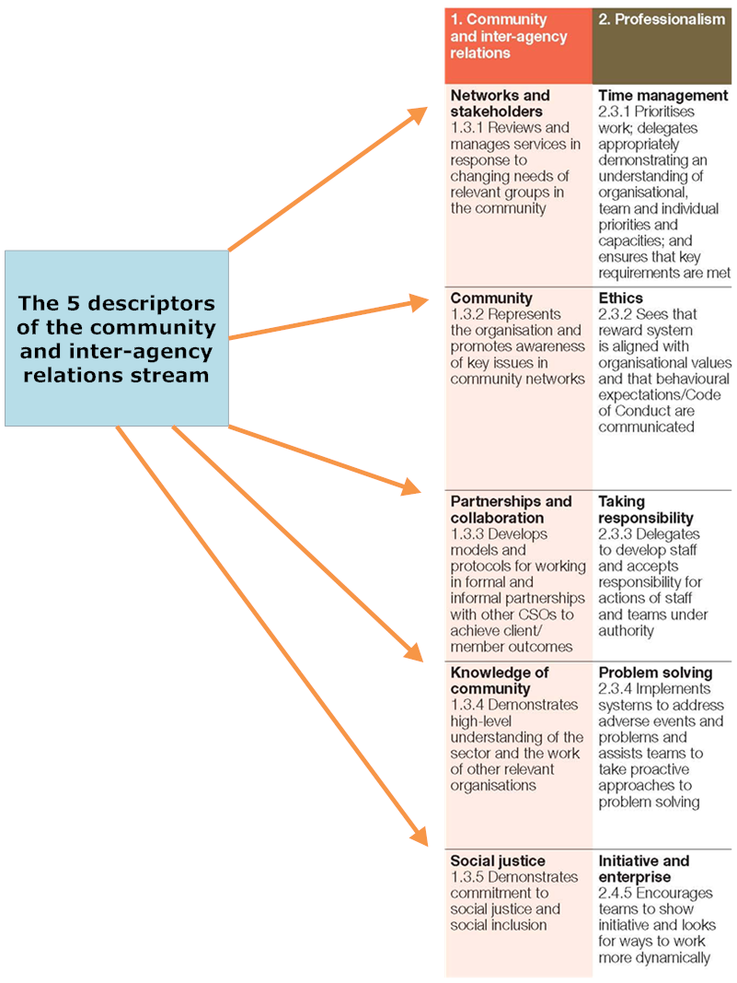

Personal attributes

- Describe qualities expected of people in this sector
- Emphasis on particular qualities will vary depending on organisational focus and the job role
- Relevant to organisation; or relevant to job role
- No levels
  - Can be modified or added to

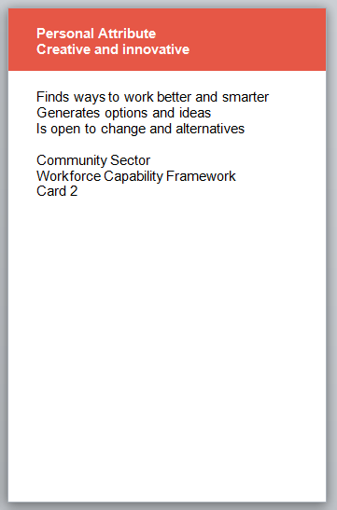

Access and availability

Resources available free from the website:
providers.dhhs.vic.gov.au/workforce-capability-framework-implementation

Case study: Emerging Leaders in Community Arts

- Would you be able to use this model within your own organisation to determine individual or organisational development needs?

Levels

Table 2 Levels
Level | Descriptor
4 | CEO and Executive  (e.g. CEO, Regional Manager, Area Manager, Director of Client Services)
3 | Manager, Supervisor and Lead Practitioner  (e.g. Manager clinical services, Program coordinator, Manager community arts)
2 | Advanced Practitioner  (e.g. Social worker, Psychologist, Family counsellor, Volunteer coordinator, Drug and alcohol counsellor, Case manager)
1 | Practitioner  (e.g. Disability support worker, Personal care attendant, Residential care assistant, Community arts assistant)

Activity: Using the Capability Framework for recruitment and selection

- Choose a job role to discuss and develop a position description for
- Use the Capability Cards and:
    - choose approximately 6 – 9 Capabilities which are critical to the role, including the stream, descriptor and level
    - choose 4 – 5 critical Personal Attributes
    - change the wording of the capabilities and attributes to fit better with the organisational requirements, if necessary
  - Complete the Position Description worksheet

Activity preparation: Performance appraisal

- Read and discuss the case study; you may wish to embellish it a bit more by adding other strengths and weaknesses to Suzie’s description
- Find the Capability Assessment Tool proforma which has the eight (8) capabilities which the organisation feels are essential for the job role; you can add more if you want
  - Note the key to the rating system which is provided at the bottom of the proforma

Activity: Performance appraisal

- Discuss the case study and its implications
- Consider whether there are any other level 2 capabilities for Suzie’s job role that you would like to add to the Capability Assessment Tool
  - Using the case study provided, work through and complete the Capability Assessment Tool to review Suzie’s performance

Activity: Learning and development

- Go to the 3 capabilities you entered previously into the My Capabilities worksheet, which you feel need some development
  - Jot down some ways you can develop these competencies

Activity: Career planning

- Think of a position you may wish to take on in the future
- Look at the Capability Cards – comparative view
- Choose three (3) capabilities required for a higher level position
  - Enter into Career Planning worksheet, and add possible development methods

Learning styles

Felder and Solomon’s theory
- Active
- Reflective
- Sensing
- Intuitive
- Visual
- Verbal
- Sequential
  - Global

Memletics learning styles inventory
- Visual
- Logical
- Aural
- Social
- Verbal
- Solitary
  - Physical

Summary of the Capability Framework

- Not mandatory
- Guide to use and adapt to suit your organisation
- Covers a broad workforce and many different occupations and organisations of different sizes and missions
- Generic
- Language can be changed to suit the terminology used in your own organisation
  - Useful to smaller organisations that do not have a dedicated human resource team

Uses of the Capability Framework - leaders

- Align staff capability to strategic needs of organisation
- Assist with range of HR functions:
    - job design
    - recruitment and selection
    - performance management and development
      - career planning

Uses of the Capability Framework - managers

- Identify capabilities required by their people
- Identify capabilities required of themselves as managers
- Develop selection criteria
- Staff development and performance appraisal
- Support individual career planning
  - Training program design

Uses of the Capability Framework - people in the community sector

- Understand capabilities required at their level
- Understand capabilities required to progress
- Identify opportunities for professional development
- Identify gaps
- Career planning guide
- Framework for volunteers to understand the capabilities required of a role
  - Recognition of prior learning for course entry

Questions?

