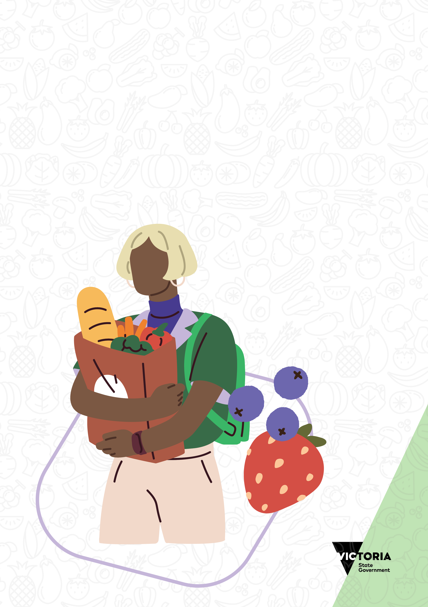

Victorian healthy food relief guidelines

To receive this document in another format, phone the Food Relief Team on (03) 9285 3816, or email the Food Relief Team [foodrelief.team@dffh.vic.gov.au](mailto:foodrelief.team@dffh.vic.gov.au)

**Help for people with hearing or speech communication difficulties**

Contact us through the National Relay Service (NRS). For more information about the NRS visit National Relay Service <https://www.accesshub.gov.au/about-the-nrs>, or call the NRS Helpdesk on 1800 555 660.

Authorised and published by the Victorian Government, 1 Treasury Place, Melbourne.

© State of Victoria, Australia, Department of Families, Fairness and Housing, December 2024.

ISBN 978-1-76130-738-6 (online/PDF/MS Word)

Available at [Community Food Relief](https://providers.dffh.vic.gov.au/community-food-relief) https://providers.dffh.vic.gov.au/community-food-relief

Contents

Acknowledgements 4

Introduction 5

Principles 6

Community-centred – design services around the needs of community members 6

Dignified, respectful and accessible – create welcoming, inclusive and culturally safe experiences 6

Healthy – prioritise safe, nutritious and culturally appropriate food 6

Collaborative – work with others to provide food relief and further assistance 7

Accountable – measure the quality and impact of services 7

Healthy food relief 8

Food classification guide 9

GREEN (best choice) 9

AMBER (choose carefully) 9

RED (limit) 9

Food classification table 11

Implementation guide 14

Step 1: Getting started 14

Step 2: Conduct a baseline assessment 14

Step 3: Implementation 14

Step 4: Maintaining change 14

# Acknowledgements

The Department of Families, Fairness and Housing proudly acknowledges Victoria’s Aboriginal communities and their rich culture. We pay respect to their Elders past and present. We acknowledge Aboriginal people as Australia’s first peoples and as the Traditional Owners and custodians of the land and water on which we rely. We recognise and value the ongoing contribution of Aboriginal people and communities to Victorian life and how this enriches us. We embrace the spirit of reconciliation, working towards the equality of outcomes and ensuring an equal voice.

The department also acknowledges the Victorian Food Relief Taskforce, Department of Health and VicHealth for their leadership and contributions to developing these guidelines to strengthen food relief activities across Victoria.

# Introduction

The *Victorian healthy food relief guidelines* aim to help food relief providers to offer a variety of nutritious foods to support the health and wellbeing of those needing food relief.

A human rights–based approach underpins these guidelines. This recognises the right to adequate food and food security for all Victorians.

Everyone living in Victoria has the right to nutritious food to thrive. Those experiencing food insecurity may need to access food and other assistance from food relief providers to meet this essential need.

Community food relief is delivered to Victorians through an ecosystem of statewide, regional and community organisations. A variety of food suppliers, financial donors and volunteers support food relief providers. They are also funded through local, state and federal governments.

These guidelines aim to:

* strengthen efforts to provide food relief to meet the needs of communities
* promote providing food relief in dignified and respectful ways
* help to ensure a variety of nutritious, minimally processed and culturally appropriate food options are available.

These guidelines are aspirational. Food relief providers should work towards meeting these over time.

# Principles

The following principles have been developed to support food relief providers to deliver the best possible experience for people accessing food relief services.

## Community-centred – design services around the needs of community members

* Listen to and respect the views of a diverse range of community members. Use this to improve the way food relief is provided. Deliver place-based, community-led solutions.
* Provide meaningful opportunities for community members to be involved in providing food relief. This includes paid or volunteer work.
* Work with communities and other key partners to address the structural barriers that create inequalities in access to food. Connect people to pathways out of food insecurity.

## Dignified, respectful and accessible – create welcoming, inclusive and culturally safe experiences

* Provide food relief to community members experiencing food insecurity fairly, equitably and without discrimination. Show respect for each person’s inherent value, dignity, agency and time.
* Create opportunities to provide food relief where community members feel free of judgement and can realise their fundamental right and capacity to make food choices that work for them.
* Consider community members’ holistic experience when accessing food relief. Strive to make environments accessible and inclusive, and interactions positive.
* Work to understand and appreciate the rich diversity of cultures in our communities. Be sensitive to cultural and religious beliefs, values and customs. Provide training to staff members and volunteers such as training for working with multicultural communities and [VACCHO cultural safety training](https://www.vaccho.org.au/cultural-safety-services/aboriginal-cultural-safety-training/) https://www.vaccho.org.au/cultural-safety-services/aboriginal-cultural-safety-training/. Support community members who may experience language or other access barriers or who have disability access requirements.

## Healthy – prioritise safe, nutritious and culturally appropriate food

* Work towards increasing the variety and quantity of nutritious and good-quality foods that contribute to healthy dietary patterns (Align this with the food classification guide in these guidelines).
* Work to offer food options for diverse dietary needs and preferences that are culturally appropriate for local communities.
* Prioritise sourcing Victorian-grown, sustainably produced food.

## Collaborative – work with others to provide food relief and further assistance

* Work with others in the food relief sector to openly share ideas and information. Learn from each other’s varied experiences. This will help create resilience and adaptability in the food relief sector.
* Explore emerging opportunities to improve access to food relief. This includes through place-based, community-led solutions to food insecurity.
* Provide avenues and links to other community-based or related services. Examples include material aid and legal and health services. These may benefit community members experiencing food insecurity.
* Foster opportunities to support individuals and families to build their community food skills and confidence. Connect them with local support services that help address factors contributing to food insecurity.

## Accountable – measure the quality and impact of services

* Evaluate service demand and quality against the principles of the guidelines and identify opportunities to improve practices.
* Gather data to better understand food relief demand and service quality.
* Provide visible and accessible feedback and complaint processes.

# Healthy food relief

These guidelines have been developed to help food relief staff and volunteers to provide nutritious foods and drinks to those seeking food relief.

The guidelines are adapted from the Victorian Government’s *Healthy choices: food and drink classification guide*. The guidelines use a food classification system that groups food and drinks as either GREEN, AMBER or RED based on their nutritional value.

Consistent with the *Australian dietary guidelines*, this classification system encourages supplying foods from across the 5 core food groups including:

* fruits
* vegetables
* grain (cereal) foods
* meat (or meat alternatives)
* milk, yoghurt and cheese.

These are the foods needed for good physical and mental health. They are essential for fuelling growth and healthy development.

The system also aims to encourage donors and food relief providers to reduce their supply of ‘discretionary’ foods and drinks (also known as ‘occasional’ foods). These are often highly processed items such as soft drinks, chocolate and potato chips. These contain added sugar, salt and fat. They offer limited nourishment while increasing the risk of diet-related chronic diseases.

However, we don’t recommend publicly labelling foods as GREEN, AMBER or RED. This is to avoid stigmatisation for those seeking food relief. The food classification guide is intended to be used ‘behind the scenes’ as an education and planning tool.

# Food classification guide

As noted, these guidelines are aspirational. Food relief providers are encouraged to work towards improvements over time. For example, depending on the starting point, it may be more achievable for food relief providers to start working towards a particular target, such as ‘at least 50% GREEN and no more than 20% RED’.

The classification guide has been designed to inform and educate staff and volunteers on food categories. However, ingredients and nutritional value will vary across different products and brands.

For nutritional information about specific brands and products, there is a free digital tool that notes if a product is classified GREEN, AMBER or RED. This tool is called [FoodChecker](https://foodchecker.au/) https://foodchecker.au/.

## GREEN (best choice)

Foods and drinks in the GREEN category are the most nutritious choices. They are usually:

* good sources of important nutrients
* lower in saturated fat, added sugar and/or salt
* lower in energy (kilojoules)
* higher in fibre.

GREEN foods and drinks should always be available. Promote these as the best choices for food donors and clients.

The guidelines encourage food relief providers to aim for at least 70% of foods and drinks donated or procured to be from the GREEN category.

## AMBER (choose carefully)

AMBER foods and drinks are less nutritious and should be eaten in moderation. Although AMBER items may provide some valuable nutrients they can:

* lead people to take in too much energy (kilojoules)
* contain moderate amounts of saturated fat, added sugar and/or salt.

AMBER foods and drinks may be offered but should not dominate the food selection. They should also not be promoted over GREEN choices.

The guidelines encourage food relief providers to aim for 20% of foods and drinks donated or procured to be from the AMBER category.

## RED (limit)

Foods and drinks in the RED category are not essential as they are highly processed and offer little nutrition. If they are consumed too often, or in large amounts, they can lead to weight gain and diet-related chronic diseases.

In general, RED choices are:

* high in energy (kilojoules)
* high in saturated fat, added sugar and/or salt
* low in important nutrients such as fibre.

The guidelines encourage food relief providers to aim for no more than 10% of foods and drinks donated or procured to be from the RED category.

## Food classification table

GREEN represents everyday foods and drinks for nourishing the body and mind.Aim for 70% of total stock.

AMBER represents less nutritious foods and drinks – they are more processed than green foods. Aim for up to 20% of total stock.

RED represents highly processed foods and drinks offering little nutrition. These are typically high in saturated fat, added sugars and salt, and low in fibre. Aim for less than 10% of total stock.

| **Food group** | **GREEN** | **AMBER** | **RED** |
| --- | --- | --- | --- |
| Fruit | * Fresh and frozen * Canned (in natural juice) | * Dried fruit * Canned or stewed fruit in syrup * Fruit puree | * Fruit leathers (like roll-ups) * Glacé fruit * Dried fruit coated in chocolate or yoghurt |
| Vegetables | * Fresh and frozen * Canned (preferably no added salt) | * Oven-baked potato products (like wedges or potato gems) * Marinated or pickled vegetables (like artichokes in oil, olives, sundried tomatoes) | * Deep-fried items (like hash browns, deep-fried chips) |
| Grains and cereals | * Offer mostly wholegrains and/or high-fibre cereal varieties * Rice, noodles, pasta, couscous, polenta, semolina, bulgur, freekeh, buckwheat, amaranth, spelt, barley, quinoa, rye * Bread, rolls and flatbread * Plain English muffins * Wholegrain breakfast cereals (like oats/porridge, Weet-Bix, untoasted muesli) * Popcorn – air-popped, unsalted and unflavoured * Wholegrain crackers or crispbreads – unflavoured | * Fruit toast and fruit muffins * Pikelets/scones (plain, fruit or savoury) * Savoury-topped (no meat toppings) breads, cheese breads, twists, pull-aparts, scrolls, garlic/herb breads * Muesli bars | * Sugary breakfast cereals (like Milo cereal, Fruit Loops, Nutri Grain, Coco Pops) * Sugar-coated or flavoured popcorn * Plain, savoury or sweet croissants * Savoury bread/scrolls topped with processed meat such as ham, bacon, salami, frankfurts |
| Lean meat and poultry, fish, eggs, legumes/beans, tofu | * Chicken, turkey, beef, lamb, pork, veal, goat, kangaroo, duck and fish (fresh and frozen cuts; mince) * Canned tuna, salmon or sardines * Eggs * Tofu * Falafel or legume/vegetable patties * Fresh, dried and canned lentils, beans, chickpeas, split peas * Hummus * Baked beans | * Crumbed or coated meat, poultry, fish or vegetable-based meat alternatives (oven-baked, not deep-fried) | * Deep-fried, crumbed or coated meat, poultry or fish * Deep-fried crumbed or coated vegetable-based meat alternatives * Processed and cured meats (like ham, bacon, salami, prosciutto, sausages, devon/strass) |
| Milk, yoghurt, cheese and alternatives | *Includes regular-fat and reduced-fat products:*   * Milk – fresh, long life (UHT), evaporated or powdered * Soy milk, almond milk or other milk alternatives (calcium-fortified) * Buttermilk * Yoghurt – plain and flavoured * Cheese * Custard – plain vanilla * Yoghurt-based dip (like tzatziki) | * Flavoured milk * Rice pudding and creamed rice * Ice-creams and dairy desserts – reduced-fat or low-fat and uncoated | * Regular ice-cream (dairy and non-dairy based); and ice-cream products that contain chocolate, lollies, crumble, cookies, fruit syrups or other confectionery * Dairy desserts (dessert-style custard or yoghurt with confectionary, crème caramel, mousse, panna cotta, tiramisu) * Cream (including reduced-fat varieties) * Sour cream (including reduced-fat varieties) |
| Pantry staples and freezer items | * Nut and seed pastes (like peanut butter or tahini) * Flour (plain, white, self-raising, rice flour and glutinous rice flour) * Herbs and spices * Cooking sauces (like pasta sauce, simmer sauce; preferably reduced salt) * Soup – canned or pouch (preferably reduced salt) * Salsa | * Instant/dried soups * Instant noodles * Canned spaghetti * Frozen dumplings, spring rolls and dim sims * Margarines and oils such as canola, olive, peanut, sesame, sunflower, safflower, soybean, flaxseed * Reduced-fat/light coconut milk | * Sweet biscuits (plain, iced, chocolate-coated) * Cakes, slices, doughnuts, sweet pastries and muffins * Chocolate, lollies and confectionary * Plain or flavoured potato chips * Flavoured savoury biscuits (like BBQ Shapes) * Meat pies, sausage rolls and pasties * Butter and animal fats (like lard, ghee) * Regular coconut milk and coconut cream * Coconut oil and palm oil * Jam, honey, sweet spreads (like Nutella, Biscoff) * Icy poles and ice confections * Sweetened condensed milk |
| Mixed meals | * Sandwiches, rolls or wraps made with salad and/or lean meat, tinned fish or cheese * Ready-to-eat meals that contain vegetables; legumes or lean meats/chicken/fish; wholegrains; and free from cream or cheese-based sauces | * Sandwiches, rolls or wraps made with processed or fattier cuts of meat (like ham) * Ready-to-eat meals of all cuisines based on meat (or alternatives) and/or vegetables and/or grain (cereal) foods – frozen, chilled, shelf stable (like chicken curry, spaghetti bolognaise, Irish stew, dahl, lasagne) | * Sandwiches, rolls or wraps made with deep-fried ingredients (like schnitzel) or fatty and salty processed meats (like salami) |
| Nuts and seeds | * Nuts and seeds – unsalted and unflavoured | * Nuts and seeds – salted and/or roasted in oil | * Coated nuts (for example, coated in honey, chocolate or yoghurt, or savoury coating) |
| Drinks | * Plain, still and sparkling water * Water flavoured with natural essence only (no sugar or artificial sweetener) * Tea bags and instant coffee | * Fruit and vegetable juices (at least 99% with no added sugar) * Drinks containing artificial sweetener (with/without added sugar) | * Drinks containing added sugar (like soft drinks, cordial, fruit and vegetable drinks, energy drinks and sports drinks) * Drinking powders (like Milo, hot chocolate, Nesquik) * Alcohol |

# Implementation guide

Use the following step-by-step guide to help meet the guidelines.

## Step 1: Getting started

* Take time to read these guidelines and identify a team of people or a key person to lead implementation.
* Engage with a diverse range of people from the communities you serve. This could include those with disability, experiencing homelessness, young people, women and older community members. Encourage input from First Nations communities and multicultural communities on the need for culturally appropriate foods.
* Identify and inform key stakeholders (such as main food donors) and community members of the plan to implement the guidelines. Discuss what implications this may have for them. Update them on the implementation progress and changes.

## Step 2: Conduct a baseline assessment

* Conduct an audit of the foods and drinks commonly donated/procured to determine the approximate percentage of GREEN, AMBER and RED foods and drinks currently available.
* Identify which foods and drinks from the RED category could be reduced. Identify other GREEN and AMBER foods and drink that could be substituted for RED.
* Assess available storage facilities and equipment to identify whether more infrastructure is required (such as refrigerated transport vehicles or fridges) if more GREEN foods are made available. Explore funding options if any extra infrastructure is needed.

## Step 3: Implementation

* Develop and implement an action plan based on input from stakeholders and community members to coordinate how the guidelines will be rolled out. Agree on percentage targets of GREEN, AMBER and RED foods and drinks to work towards. Remember that the guidelines targets are aspirational and can be worked towards progressively.
* Consider like-minded community-based initiatives that could help implement the guidelines. For example, consider partnering with local school breakfast programs to encourage education and awareness about healthier foods. Build skills in shopping, preparing and cooking nutritious meals on a budget.

## Step 4: Maintaining change

* Embed any changes to practices to align with the guidelines into operational policies and procedures.
* Regularly review and update the action plan. This includes monitoring progress on the proportion of GREEN and RED foods and drinks. Celebrate and share successes along the way.
* Provide regular updates to community members, donors and suppliers about the healthy changes that have been made or are planned. Offer regular opportunities to give feedback on implementing the guidelines to ensure their needs are being met.