

Universal design grants funding round 2022

Guidelines

To receive this document in another format, phone (03) 9595 1295, using the National Relay Service 13 36 77 if required, or [email Disability and Communities branch](mailto:changingplaces@dffh.vic.gov.au) <changingplaces@dffh.vic.gov.au>

Authorised and published by the Victorian Government, 1 Treasury Place, Melbourne.

© State of Victoria, Australia, Department of Families, Fairness and Housing, July 2022.

**ISBN/ 978-1-7609669-872-4 (online/PDF/Word)**

Available at [DFFH Service Providers – Disability – Universal Design](https://providers.dffh.vic.gov.au/universal-design) <https://providers.dffh.vic.gov.au/universal-design>

# Minister’s foreword

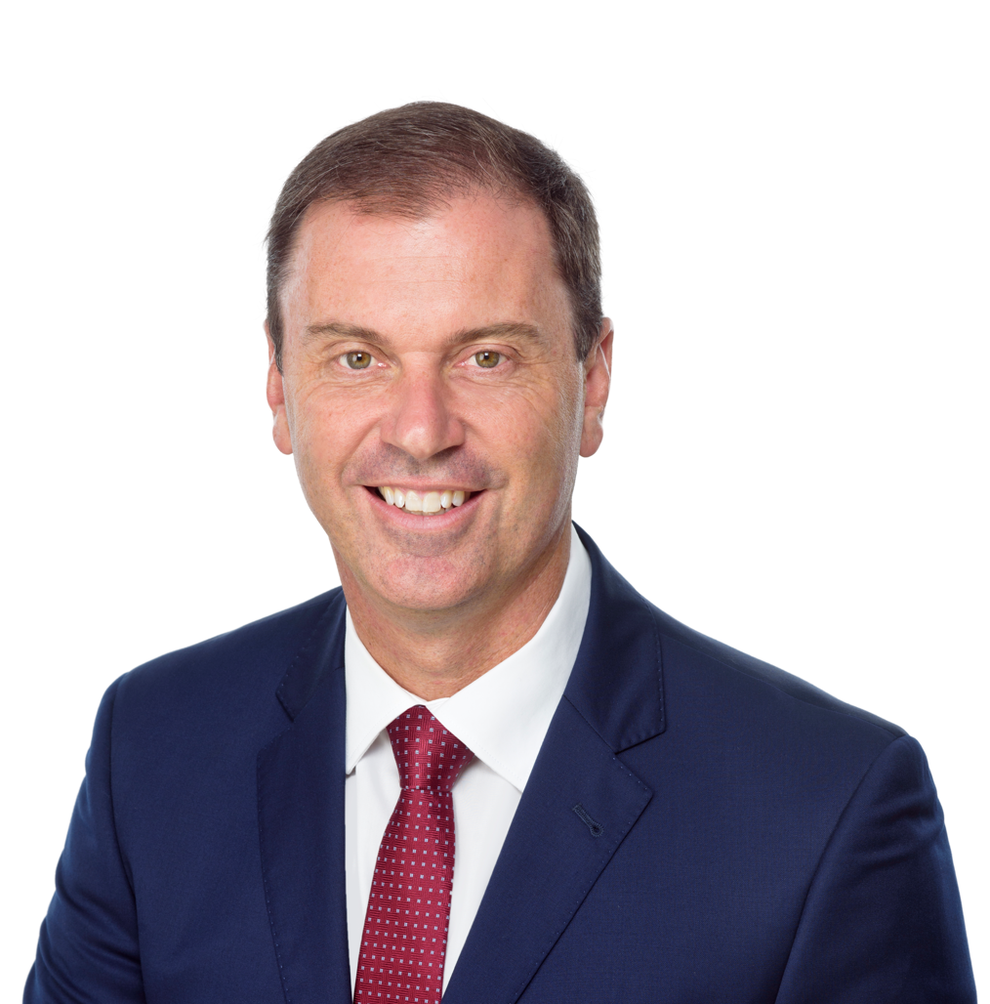

**Inclusive Victoria: state disability plan (2022–2026)** is Victoria’s plan for making things fairer for people with disability. The plan is a key way for the Victorian Government to be accountable for making all parts of the community inclusive and accessible for everyone.

The plan commits to implementing six systemic reform directions. Across the Victorian Government, all departments have agreed that over the next four years they will embed the six systemic reforms in their policies, programs, and services. This includes embedding universal design into infrastructure projects.

Accessible communication and universal design are one of the six systemic reform areas. Universal design principles such as ‘equitable and flexible use’ aim to ensure policies, programs and services are accessible to as many people as possible, inclusive of age, ability, gender identity, culture, language, and any other social characteristics. Victoria is proudly leading the way in creating public spaces that are welcoming and inclusive for all.

It’s one part of the Victorian Government’s work to help realise the social, economic, and civic aspirations of people with disability.

We are working with Victorians with disability to tackle the barriers and discriminatory attitudes that people with disability experience daily so they can live and participate in Victorian society on the same basis as everyone else.

We are implementing universal design principles to ensure that all government buildings, public infrastructure and other facilities are accessible for Victorians to use every day.

It therefore gives me great pleasure to announce that the Victorian Government is providing $2.5 million for the Universal design grants funding round 2022 via small grants of $10,000 to $100,000 and larger grants of between $100,000 to $500,000 to eligible organisations to improve the accessibility of buildings and public spaces.

Small renovations to existing community facilities can make a very real difference. Grants will be used to improve access, enabling more people, including people with disability, dementia and autism, to participate in community and social activities.

Local and state government entities and not for profit organisations that own or manage community facilities and public spaces are eligible.

I look forward to seeing more people with disability enjoying greater opportunity to participate in their community as a result of new accessible community infrastructure projects.

 **Hon Colin Brooks MP**Minister for Disability, Ageing and Carer  
Minister for Child Protection and Family Services

Contents

Minister’s foreword 3

Program overview 5

What is universal design? 5

Why is the Victorian Government funding these grants? 6

Universal design grants funding round 2022 7

Universal design grants objectives 7

Eligibility 8

Who can apply? 8

What can be funded? 8

Funding streams 8

Application and assessment process 9

Timelines 9

Application process 9

Information session 9

Further information 10

Assessment process 10

Assessment criteria 11

Criterion 1: Why do you want to build accessible infrastructure and how have you consulted with your local community? (30% weighting) 11

Criterion 2: What are you going to build? (30% weighting) 11

Criterion 3: How will you deliver your project? (40% weighting) 12

Other access and equity considerations 12

Funding conditions 13

Funding agreement 13

Project monitoring and delivery 13

How can I improve my chances of being approved for funding? 15

Clearly explain the problem, the solution and why you think your project will be a success 15

Provide a detailed budget supported by quotes or cost estimates 15

Provide evidence to support your application 15

Explaining project need 15

Explaining what your project will do and deliver 15

Explaining why your project will be a success 15

Final tips 16

Victorian Government universal design resources and additional information 17

# Program overview

## What is universal design?

Universal design principles such as ‘equitable and flexible use’ aim to ensure policies, programs and services are accessible to as many people as possible, inclusive of age, ability, gender identity, culture, language, and any other social characteristics.

Through **Inclusive Victoria: state disability plan 2022-2026**, the Victorian Government has committed to embed universal design principles in all elements of the design and delivery of infrastructure.

Universal design is a design philosophy that ensures that products, buildings, environments, programs, services, and experiences are innately accessible to as many people as possible, regardless of age, disability, cultural background, or any other differentiating factors.

Victorian Government departments will be guided by the whole-of-government Universal design policy which is intended to support Victorian Government departments, agencies, and delivery partners to incorporate universal design principles consistently across infrastructure projects. The policy provides guidance on how Victorian Government funded infrastructure can be designed and delivered to advance universal design principles and goals. This includes small to medium sized infrastructure projects that are funded through grants programs or any other funding mechanism. Insert link to Vic Gov Universal Design policy.

Universal design distinguishes itself from accessible design by focusing on user-centred design from the earliest stages of a project.

The principles of universal design include:

1. Equitable use - design is useful and marketable to people with diverse abilities. Ideally how people use the setting should be the same, for example, providing one means of entry to a building that works well for everyone, not a mix of stairs and a ramp.
2. Flexibility in use - design accommodates a wide range of individual preferences and abilities. The setting should allow people to use elements in more than one prescribed way, for example, providing a countertop orientation map that is viewable from either a seated or standing position.
3. Simple and intuitive use - use of the design is easy to understand regardless of the user's experience, knowledge, language skills or current concentration level. The building should make it easy for everyone to understand the purpose of each element and how to use it, for example, providing a bathroom basin tap that makes the method of operation readily apparent and relatively easy to use.
4. Perceptible information - design communicates necessary information effectively to the user, regardless of ambient conditions or the user's sensory abilities. The setting should provide all essential information in a variety of modes, for example, written, symbolic, tactile, and verbal.
5. Tolerance for error - design minimises hazards and the adverse consequences of accidental or unintended actions. When potentially dangerous conditions are unavoidable, people should receive warnings as they approach the element, for example, providing proximity warnings in a variety of sensory modes near the top of stairs.
6. Low physical effort - design can be used efficiently and comfortably and with a minimum of fatigue. The setting should employ design features that require little or no physical force to use them, for example, replacing a traditional doorknob with a lever handle that does not require the ability to grasp and turn the wrist.
7. Size and space for approach and use - appropriate size and space is provided for approach, reach, manipulation, and use regardless of user's body size, posture, or mobility. A setting should provide an adequate amount of space that is appropriately arranged to enable everyone to use them, for example, providing knee space under a washroom basin to enable use by someone in a seated position.

# Why is the Victorian Government funding these grants?

Grants will be used to improve access, enabling more people, including people with disability, dementia, and autism to participate in community and social activities. Small renovations to existing community facilities can make a very real difference.

It is expected that you will incorporate the principles of universal design and co-design into your project from the very beginning.

The process of co-design involves:

* identifying who will use the facility and how it will be used
* understanding the physical and emotional needs of the users
* involving as many as users as possible in the planning of the project
* before proceeding, testing the proposed developments with a range of users including those with different functional ability.

Projects which demonstrate that consultation and co-design with people with disability has helped to shape the project or that will provide opportunities for people with disability to be involved in the design of the infrastructure will be prioritised for funding.

Making venues more functional and user-friendly results in greater use and participation by people with disability. Venues and facilities which provide or are situated near other community facilities and infrastructure providing community participation activities also create choices for people with disability.

# Universal design grants funding round 2022

The Universal design grants funding round 2022 provides $2.5 million for small grants of $10,000 to $100,000 and larger grants of between $100,001 to $500,000 to eligible organisations to improve the accessibility of buildings and public spaces.

Small renovations to existing community facilities can make a very real difference. Grants will be used to improve access, enabling more people, including people with disability and dementia, to participate in community and social activities.

Eligible projects could include the construction of quiet areas/sensory rooms for people with autism/neurodiversity, culturally safe places and spaces, installing accessible and/or gender-neutral toilets, door-widening, creating accessible entrances and doors, accessible pathways and outdoor areas, dementia-friendly and autism-friendly designs and clearer wayfinding signage.

Local and state government entities and not for profit organisations that own or manage community facilities and public spaces are eligible. Examples of community facilities include community centres, libraries, community halls, Neighbourhood Houses, Men’s Sheds, parks and gardens, playgrounds, museums, art galleries.

# Universal design grants objectives

The Universal design grants funding round 2022 is seeking applications that aim to achieve the program’s objectives. The more of these objectives your application addresses, the stronger your chance of being approved for funding.

* Objective 1: Deliver projects which make the built environment usable for as many people as possible through the construction of accessible community facilities.
* Objective 2: Deliver projects which make the built environment safe (including culturally safe) for as many people as possible. Facilities designed with people with disability are more likely to respond to their concerns and needs and deliver better outcomes.
* Objective 3: Create spaces which strengthen community participation choices for people with disability.

# Eligibility

## Who can apply?

Funding is available to:

* Local and state government entities including:
  + local government authorities
  + public land managers
  + land management authorities
  + committees of management
* Not for profit organisations that either own or manage community facilities and public spaces.

Eligible community facilities and public spaces include community centres and hubs, libraries, community halls, Neighbourhood Houses, Men’s Sheds, parks, gardens, and playgrounds.

## What can be funded?

The following are examples of items which may be included in funding applications:

* renovations to existing structures to improve access to the site which are compliant with standards, but demonstrate universal design principles such as:
  + creating accessible entrances and doors
  + door-widening
  + installing accessible toilets
  + installing gender neutral toilets
  + installing Changing Places toilets
  + creating accessible pathways and outdoor areas
  + installation of wayfinding signage
  + compliant ramps or pathways
  + culturally safe and welcoming spaces such as breakout spaces and smoking ceremony areas
  + quiet areas or sensory rooms for people with autism/neurodiversity
  + spaces incorporating dementia and autism and dementia inclusive design
* creation of new spaces and structures within existing facilities which are compliant with standards but also demonstrate universal design principles such as accessible playgrounds and outdoor areas.

## Funding streams

Funding is provided in two streams:

### Small grants stream

Eligible organisations can apply for grants valued between $10,000 to $100,000 for minor fit outs or upgrades to existing community facilities and public spaces.

### Large grants stream

Eligible organisations can apply for grants valued between $100,001 and $500,000 for major upgrades of existing community facilities and public spaces.

# Application and assessment process

## Timelines

The Universal design grants funding round 2022 **opens on 19 July 2022**.

The funding round closes on **2 September 2022**.

Receipt of applications will be acknowledged via email.

**Late or incomplete applications will not be considered.**

# Application process

The Universal design grants funding round 2022 will utilise the SmartyGrants grants on-line application process for the submission of applications. The application form is located on the [SmartyGrants Universal design grants funding round 2022 webpage](https://cfr.smartygrants.com.au/Udgfr2022) <https://cfr.smartygrants.com.au/Udgfr2022>

When commencing your application, you will be required to create a password protected login-in to access the application form.

For general information about SmartyGrants please refer to [the SmartyGrants webpage](https://smartygrants.com.au) <https://smartygrants.com.au>.

All applications must be from an eligible agency such as:

* Local and state government entities including:
  + local government authorities
  + public land managers
  + land management authorities
  + committees of management
* Not for profit organisations that either own or manage community facilities and public spaces.

All applications must be endorsed by the entity’s Chief Executive Officer or equivalent and be submitted online via the SmartyGrants Portal and include relevant supporting documentation such as:

* proposed site plans
* project timelines
* project costings and budget (including quotes where available)
* communications plan
* complaints handling process.

## Information session

An information session will be held as below:

* Date: Wednesday, 3 August 2022
* Time:10.00 AM (EST)
* Platform: Microsoft Teams
* Register via Eventbrite: Information Session - Universal Design Grants Funding Round 2022

## Further information

For more information about the [Universal design grants funding round 2022](https://providers.dffh.vic.gov.au/universal-design)

<https://providers.dffh.vic.gov.au/universal-design>

[Email Disability and Communities branch](mailto:changingplaces@dffh.vic.gov.au) <changingplaces@dffh.vic.gov.au>.

## Assessment process

All applicants will need to demonstrate each of the following:

* how the proposed changes will improve accessibility for people with disability or dementia and lead to increased participation in everyday life
* an identified need from people with disability or dementia, their families, friends and carers for accessible community infrastructure in their local community and provide evidence of the extent of local support for the proposed project
* the social, economic and accessibility benefits that accessible community infrastructure will bring for people with a disability and dementia.

All applicants will also need to demonstrate:

* a sound approach to delivering the project, providing realistic timeframes for delivery
* the project is financially viable with clearly costed proposals and represents value for money
* how the project will make the built environment safe, including culturally safe
* how the project will strengthen community participation choices for people with disability.

# Assessment criteria

Applications for the Universal design grants funding round 2022 round will be assessed by a panel coordinated by the Department of Families, Fairness and Housing (the department). Applications will be assessed against three individual project assessment criteria and broader access and equity considerations. Percentage weightings are provided as a guide to the relative importance of each criterion.

Priority will be given to projects which demonstrate that consultation and co-design with people with disability have helped to shape the project application or how people with disability will be provided opportunities to be involved in the design and delivery of the project.

Information contained in applications may be shared with other Victorian Government agencies to assist with the assessment process and cross government coordination.

## Criterion 1: Why do you want to build accessible infrastructure and how have you consulted with your local community? (30% weighting)

Applicants will be required to demonstrate the extent to which the project addresses need as identified by people with disability, their families and carers and provide evidence of the extent of local consultation and support for the project.

Applicants will also need to identify the benefits to be delivered by the project to people with disability and their local community, including increasing participation in the community.

Applications must:

* describe how you have consulted with people with disability in choosing the location of your accessible infrastructure project
* demonstrate that the project proposal has support from the local community, including people with disability
* provide details of any requests for access by people with disability where a lack of access has limited their civic participation
* provide evidence of community consultations such as advisory groups and forums, interviews, consultations, focus groups, and or results of any surveys
* provide evidence of assessing community needs, such as requests from building or facility users, access audits, disability action plans, toilet strategies, tourism plans, economic development plans or demographic data
* clearly identify the expected social, economic and accessibility benefits the project will deliver to people with disability, their families, and carers in the community.

## Criterion 2: What are you going to build? (30% weighting)

Applicants must demonstrate the project meets the needs of people with disability, including through compliance with the universal design approach, opening hours, accessibility and the provision of ongoing maintenance. The project must demonstrate a commitment to provide a safe environment for people with disability and dementia (including cultural safety).

Applications must demonstrate:

* why this location and project meets universal design principles and is a good choice for building accessible infrastructure
* a commitment to accessibility, including an overall site design which incorporates universal design principles
* a commitment to providing safe environments for people with disability, autism or dementia, including elements of both physical and cultural safety.

Applications must also provide the following:

* a copy of the proposed site plan
* in instances where the site is not owned by the applicant, a copy of the relevant lease
* information about proposed opening hours

## Criterion 3: How will you deliver your project? (40% weighting)

Applicants must provide evidence of their ability to deliver the project in a timely manner and within budget, including:

* demonstrated experience or a sound approach to delivering the project, such as a fully costed project plan and strategies for successful completion
* timelines for project delivery, including project completion within 18 months from formal approval of funding
* a project budget detailing:
  + project income and expenditure (excluding GST)
  + how much funding you are seeking from the Universal design grants funding round 2022
  + other income sources for the project if any, (excluding GST)
* up to date quotations
* in instances where the universal design works are part of a larger project, such as the construction or refurbishment of an amenities block, information must also be provided about the larger project and its estimated total cost
* a communications plan for promoting the project once it is open to people with disability, their families and carers, and the local community
* a copy of your complaints handling process and evidence of how it will be implemented
* details of how you will implement culturally safe practices such as a cultural safety plan.

## Other access and equity considerations

The assessment panel will also consider broader access and equity considerations including:

* the geographic distribution of accessible community infrastructure projects across Victoria
* alignment with the priorities and themes of **Inclusive Victoria: state disability plan 2022-2026**, with particular focus on making the built environment usable for as many people as possible through the construction of accessible community infrastructure
* ensuring a broad variety of accessible community infrastructure projects are funded.

# Funding conditions

Successful applicants will need to:

* complete all works according to relevant construction and accreditation guidelines
* enter into a funding agreement (Victorian Common Funding Agreement) with the department within no more than four weeks of the date of the funding offer
* comply with all requirements of the funding agreement
* ensure appropriate arrangements are in place to sustain the project and its outcomes
* ensure compliance with all government regulations, including occupational health and safety and any other applicable laws
* let the department know if anything happens that might change your project, or the way it is delivered, before any changes are made
* complete the project within 18 months of receiving formal funding approval.

Recipients of funding must build their projects according to:

* any planning permit/s issued for the works
* the Building Act 1993 and regulations, the National Construction Code and all other applicable laws and standards
* **Disability Access to Premises Standards and Australian Standard suite AS1428**.

## Funding agreement

Funding agreements establish relevant parties and outline their commitments and obligations to each other, as well as general funding terms and conditions. It is recommended that applicants review the standard terms and conditions of the Victorian Common Funding Agreement before applying.

No funding will be released until the department and the applicant have executed the funding agreement and the appropriate milestone evidence identified in the funding agreement has been met. This includes confirmation of construction starting within the 18-month timeframe.

The department reserves the right to withhold payments in cases where there are concerns relating to the delivery of the project. In this instance, the department will release funding when appropriate actions have been taken to ensure the funded project is delivered within agreed timeframes.

## Project monitoring and delivery

Funding recipients are required to comply with project monitoring and reporting requirements as outlined in the funding agreement. Successful applicants must appoint a primary contact for all matters relating to reporting, monitoring and delivery. Successful applicants are responsible for project delivery, including any project cost overruns should they occur.

Successful applicants are to extend an invitation to the Office for Disability to participate in any project control board meetings (or similar) that occur throughout the duration of the project.

Successful applicants must also take full responsibility for the ongoing cost of operation and maintenance of any facilities through their asset management processes.

In cases where a project is delayed for an unreasonable length of time, or substantive changes to scope are made after funding has been approved, or where a project fails to be delivered, the department reserves the right to cancel the grant and, if applicable, recoup any payment that has already been provided.

A request to vary the timing of an approved project must be discussed with department prior to the submission of a variation request. Any timing variation over 6 months must be accompanied by a letter from the organisation’s Chief Executive Officer approving the request. Timing variation approvals are at the discretion of the department and may lead to a reduction or cancellation of the grant.

Mandatory project reporting requirements include:

* **6 Monthly Project Reports** throughout the life cycle of the funding agreement which are to be submitted through the department’s online system
* a **Final Project Report** with financial acquittal for all project income and expenditure and copies of:
  + building compliance or occupancy certificate
  + photographs of the completed facility
  + an invitation to the department to inspect the facility in operation
  + evidence of increased patronage of the community facility
  + media coverage material.

# How can I improve my chances of being approved for funding?

## Clearly explain the problem, the solution and why you think your project will be a success

Your application should clearly identify the accessibility issues your project aims to address and provide supporting evidence or data to help us understand the problem, what is causing it and what impact it is having on the local community. You should clearly say how your project will address these issues and how you will measure the impact and success of your project.

## Provide a detailed budget supported by quotes or cost estimates

Providing a detailed budget with your application shows that you have costed the individual activities and expenses that make up your project. Providing evidence to show how you have costed your project will be viewed favourably by the assessment panel.

## Provide evidence to support your application

Providing evidence with your application to help explain the following will also be viewed favourably by the assessment panel:

* the need for your project
* what your project will do and deliver
* why you think the project will be a success.

## Explaining project need

* requests for building modifications or access by people with disability
* community feedback demonstrating a need for physical or cultural safety
* community survey or community engagement results.
* local demographic information.
* media articles on the local problem your project aims to address.
* feasibility studies or consultancy reports.
* council information (for example, the number of complaints about a particular issue, work logs or
* maintenance records).
* community safety audits.

## Explaining what your project will do and deliver

* project plan that shows key tasks and dates
* maps, plans and photos
* detailed budget including quotes or cost estimates.

## Explaining why your project will be a success

* information on similar projects your organisation has managed and the outcomes achieved
* relevant research or project evaluations
* demonstrating your approach to risk assessment, outlining any potential challenges to achieving success and how these will be managed.

## Final tips

You don’t need to provide all this information, only what is relevant to your application. You might also share other information that is relevant to your project.

Also note that a shorter, well written application that clearly addresses each of the assessment criteria is often more effective than a long, overly detailed application, which can make key information difficult to identify.

# Victorian Government universal design resources and additional information

* [Victorian whole-of-government Universal Design Policy](https:/providers.dffh.vic.gov.au/universal-design)

< https://providers.dffh.vic.gov.au/universal-design>

* [Inclusive Victoria: state disability plan 2022-2026](https://www.statedisabilityplan.vic.gov.au)

<https://www.statedisabilityplan.vic.gov.au>

* [Design for everyone guide](https://sport.vic.gov.au/publications-and-resources/design-everyone-guide)

<https://sport.vic.gov.au/publications-and-resources/design-everyone-guide>

* [Guidelines for creating autistic inclusive environments](https://www.autismcrc.com.au/knowledge-centre/reports/guidelines-creating-autistic-inclusive-environments) <https://www.autismcrc.com.au/knowledge-centre/reports/guidelines-creating-autistic-inclusive-environments>
* [Universal design principles for veterans capital works projects](https://www.vic.gov.au/sites/default/files/2019-05/Universal%20Design%20Principles_0.pdf)

<https://www.vic.gov.au/sites/default/files/2019-05/Universal%20Design%20Principles_0.pdf>

* [Designing for dementia](https://www.vhba.vic.gov.au/designing-dementia)

<https://www.vhba.vic.gov.au/designing-dementia>

* [Victorian Common Funding Agreement](https://www.vic.gov.au/victorian-common-funding-agreement)

<https://www.vic.gov.au/victorian-common-funding-agreement>

* [Changing Places Design Specifications](https://changingplaces.org.au/wp-content/uploads/2020/03/Changing-Places-design-specifications-2020-1.pdf)

<https://changingplaces.org.au/wp-content/uploads/2020/03/Changing-Places-design-specifications-2020-1.pdf>