

|  |
| --- |
| CIMS examples: Targeted Care Packages |
| Implementation resource  December 2024 |
|  |

Contents

How to use these examples 1

CIMS Common clients: Targeted Care Packages 2

CIMS Policy 2

Implementation Guidance 2

Decision guide 3

TCP scenarios: Kinship care, TCP provider responsible for CIMS 4

TCP scenarios: Kinship care, Child Protection responsible for CIMS 5

TCP scenarios: Parental care 6

# How to use these examples

These examples have been prepared to assist with interpretation of CIMS policy when a Targeted Care Package (TCP) is in place for a child protection client.

These examples are not prescriptive or exhaustive. Application of the CIMS policy will be dependent on the individual context of each situation.

Section 1.3 CIMS principles and Section 3.4 Common clients of the CIMS Policy should guide discussions and decisions on the approach to managing and reporting incidents.

**Note:** Client refers to the child, in child protection contexts.

TCP providing 'case management' as part of the funding agreement does not equate to provision of a 24-hour service in CIMS, unless the TCP provider is case-contracted to provide 24-hour case management services on behalf of child protection.

# CIMS Common clients: Targeted Care Packages

## CIMS Policy

### Section 3.4

* The service provider whose service delivery the incident occurred in must complete the CIMS incident report and all required follow-up tasks. This includes the investigation or review.
* If the incident is disclosed to a different service provider:
* The service provider to whom the disclosure is first made must submit an incident report; or
* The service provider to whom the disclosure is first made informs the lead agency/relevant service provider of the incident (if known).
* When the service provider who is responsible for incident reporting and follow-up actions is not known by the service provider to whom the disclosure was made, Operations Support will:
* review the incident report submitted by the service provider to whom the disclosure was made
* notify the relevant service provider of the incident and need to submit an incident report
* withdraw the primary incident report with the notes withdrawn as incident out of scope of service provider. The service provider to whom the disclosure is made conducts information sharing within the care team where appropriate.
* The service provider to whom the disclosure is made conducts information sharing within the care team where appropriate.

## Implementation Guidance

### Targeted Care Packages

* Child Protection/ACAC clients may be supported by a Targeted Care Package (TCP). A TCP is a funding package, often supported by a key worker from a CSO/ACCO. The TCP provider is responsible for CIMS reporting and follow-up actions when the incident occurs during their service delivery.
* If the TCP provider becomes aware of an incident that occurred outside of their service delivery, the worker must inform the relevant service provider. The service provider may be:
  + a child protection/ACAC provider
  + another CSO or ACCO.
* The service provider whose service delivery the incident occurred in is responsible for submitting a CIMS incident report and conducting all required follow-up actions. For child protection/ACAC providers, they will need to work out whether the incident is in scope of CIMS, as described in section 1.7.

# Decision guide

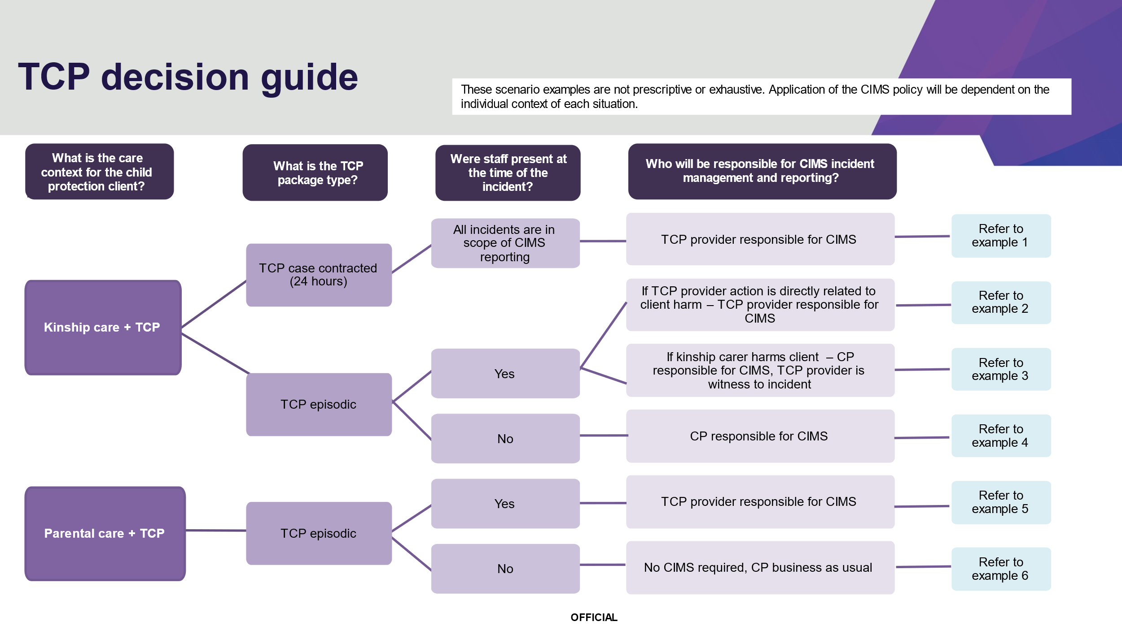

# TCP scenarios: Kinship care, TCP provider responsible for CIMS

| Example | * Incident scenario | * Application of CIMS policy |
| --- | --- | --- |
| 1. Kinship care TCP – case-contracted | * Client resides in a kinship care placement with child protection statutory involvement. * Client has a Targeted Care Package. * The case is **contracted to the TCP external service provider** by child protection to provide 24-hour case management services * The client **discloses to the TCP key worker** that the kinship carer had physically assaulted them the previous day, by punching him in the face and causing bruising and swelling. | * The incident has occurred during the TCP provider’s service delivery, as they are holding primary case management responsibility as a contracted case manager and therefore a 24-hour service. * The TCP provider is responsible for the CIMS reporting and follow up actions. * The incident should be recorded as **staff to client – physical abuse,** which will map to an incident investigation * Child protection and the TCP provider should collaborate and make decisions consistent with their business-as-usual to determine client safety in the kinship placement and consider whether changes are required. * The incident investigation and planning must occur in consultation with child protection.   Note: kinship carers are considered child protection ‘staff’ in CIMS.  **TCP provider responsible for CIMS** |
| 1. Kinship care TCP – not case-contracted | * Client resides in child protection managed kinship care placement. * Client has a Targeted Care Package. * The TCP provider provides an episodic, non-24-hour service. * TCP key worker is providing **therapeutic and practical support** to the client and the kinship carer. * **During the therapeutic appointment with the TCP key worker**, the client becomes distressed and self-harms in front of the TCP worker. | * The service provider whose service delivery the incident occurred in is the TCP provider - a **therapeutic session with the TCP provider** that has **led to** an incident of self-harm. * The TCP provider is responsible for CIMS reporting and follow up actions. * The incident has occurred while the kinship carer was present but has occurred during the TCP service delivery.   **TCP provider responsible for CIMS** |

# TCP scenarios: Kinship care, Child Protection responsible for CIMS

| Example | Incident scenario | Application of CIMS policy |
| --- | --- | --- |
| 3. Kinship care TCP – not case contracted | * Client resides in child protection managed kinship care placement * Client has a Targeted Care Package * The TCP provider provides an episodic, non-24-hour service. * An incident **occurs in the presence of the TCP key worker**, where **the kinship carer physically assaults** the client by punching them to the face during an argument and causing bruising and swelling. | * The incident has occurred while the TCP provider was present, but has occurred during child protection service delivery (incident directly related to the service delivery of the kinship care). Kinship carers are interpreted as a staff member of child protection in CIMS for child protection managed kinship care placements. * The TCP staff member was present during the incident and is a witness. They will need to inform child protection so child protection can complete the CIMS and conduct the investigation. * The incident should be recorded as staff to client – physical abuse, which will map to an incident investigation. * This incident may be in scope of an RCS investigation for the department. Child protection to consult DFFH Integrity team to confirm if an RCS investigation is required.   *Note: kinship carers are considered child protection ‘staff’ in CIMS.*  **Child protection responsible for CIMS** |
| 4. Kinship care TCP – not case contracted | * Client resides in a child protection managed kinship care placement * Client has a Targeted Care Package * The TCP provider provides an episodic, non-24-hour service. * The client **discloses to the TCP key worker** that the **kinship carer had physically assaulted them** the previous day, by punching him in the face and causing bruising and swelling. | * The service provider whose service delivery the incident occurred in is child protection. Kinship carers are interpreted as a staff member of child protection in CIMS for child protection managed kinship care placements. * The incident has not occurred during the TCP provider service delivery, under the CIMS service delivery definition. * The TCP provider has received the disclosure and should inform child protection. Child Protection are responsible for completing the incident report and follow up actions * The incident should be recorded as **staff to client – physical abuse**, which will map to an incident investigation. * Collaboration and information sharing should occur between the TCP provider and child protection in completing the CIMS investigation and responding to any recommendations, to improve client safety and reduce the risk of further incidents.   *Note: kinship carers are considered child protection ‘staff’ in CIMS.*  **Child protection responsible for CIMS** |

# TCP scenarios: Parental care

| Example | Incident scenario | Application of CIMS policy |
| --- | --- | --- |
| 5. Parental care TCP | * Client resides in parental care, with statutory child protection involvement * Client has a Targeted Care Package * The TCP provider provides an episodic, non-24-hour service. * An incident **occurs in the presence** of the TCP provider, where the parent physically assaults the client by punching them to the face during an argument and causing bruising and swelling. | * The incident has occurred while the TCP provider was present and has occurred during their service delivery. * The TCP provider is responsible for completing a CIMS * The incident should be recorded as **other to client – physical abuse,** which will map to an incident review.   *Note: a parent is not considered a carer / staff member in CIMS, and when submitting a CIMS for child protection clients, should be recorded as ‘other.’*  **TCP provider responsible for CIMS** |
| 6. Parental care TCP | * Client resides in parental care, with statutory child protection involvement * Client has a Targeted Care Package * The TCP provider provides an episodic, non-24-hour service. * An incident is **disclosed to the TCP key worker**, alleged to have occurred the previous evening when no worker was present. * It was alleged that **the parent** has physically assaulted the client by punching them to the face during an argument and causing bruising and swelling. | * The incident has occurred while the TCP provider was not present, but was disclosed to the TCP provider * This has not occurred during TCP provider service delivery * The TCP provider reports the information to child protection, who responds to the incident as part of their business as usual (child resides in parental care) * No CIMS is required.   **Child protection business as usual – CIMS not required** |

To receive this document in another format [email CIMS Review](mailto:CIMS.Review@dffh.vic.gov.au) <CIMS.Review@dffh.vic.gov.au>.

Authorised and published by the Victorian Government, 1 Treasury Place, Melbourne.

© State of Victoria, Australia, Department of Families, Fairness and Housing, December 2024

In this document, ‘Aboriginal’ refers to both Aboriginal and Torres Strait Islander people. ‘Indigenous’ or ‘Koori/Koorie’ is retained when part of the title of a report, program or quotation.

Available at the CIMS webpage <providers.dffh.vic.gov.au/cims>