

|  |
| --- |
| Support for High Risk Tenancies (SfHRT) |
| Fact sheet |
|  |
| OFFICIAL |

## Operating model

Support for High Risk Tenancies (SfHRT) provides a continuum of support for people with multiple and complex needs who are at risk of losing their tenancy. This support includes information provision, consultation, time limited service coordination and provision of brokerage (public housing only) to maintain the at-risk tenancy.

There are various services that can be accessed for tenancy assistance prior to a referral to SfHRT. It is anticipated that these tenancy management options have been explored prior to making a referral to SfHRT. The primary provider of support to social housing tenancies is the Department of Families Fairness and Housing’s funded Tenancy Plus Program which provides a mixture of early intervention and at-risk tenancy responses.

SfHRT is delivered as part of the department’s complex needs service responses and complements the existing integrated community services, family violence initiatives and broader reform agenda. Collaborative practice with housing support services, including departmental staff, Tenancy Plus providers and community housing providers is crucial to understanding the relationship with the renter and factors that have led to a request for intervention.

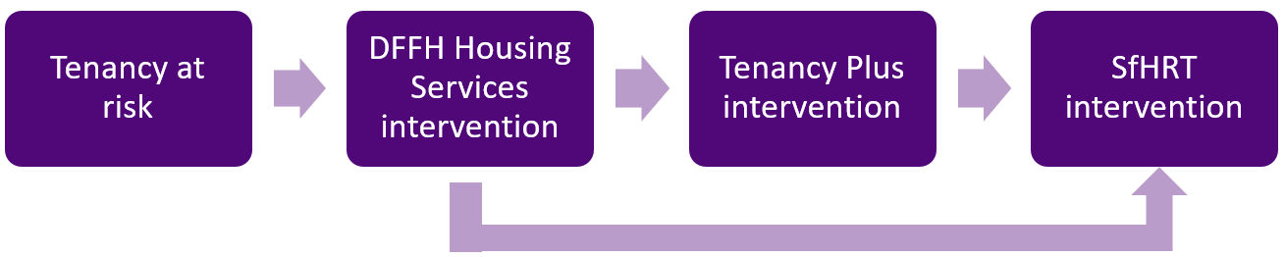

## Eligibility

The target group is public housing renters, however consultation support can also be offered to renters in community housing or transitional housing, where those tenancies:

* are at imminent risk of failure
* involve renters who have complex support needs, including mental health, alcohol and other drug, and behaviours of concern to themselves and/or others, which may prevent them from effectively engaging with support services
* have had multiple intervention attempts from housing support providers.

Only public housing renters have access to brokerage support.

## Complex Needs Coordinators

The department has seventeen local areas, where each has a Complex Needs Team of Complex Needs Coordinators. For SfHRT, Complex Needs Coordinators:

* undertake initial eligibility screening
* provide consultation, information and advice
* use brokerage to assist with maintaining the tenancy (for public housing renters only)
* provide service coordination (time limited, less than 4 hours per week per household)
* advocacy or liaison within the department
* facilitate sector capacity-building.

Complex Needs Coordinators do not provide direct client support. A renters lead service provider will continue to maintain their primary role with the client while the Complex Needs Coordinator is engaged.

Consultation involves supporting services to improve and stabilise their capacity to meet the needs of renter with complex needs.

Service coordination is focused on service system collaboration and integration so that engaged services can more effectively meet the needs of the renter.

### Brokerage – public housing tenancies only

Complex Needs Coordinators have access to limited client-attached brokerage to fund support interventions for renters in an at-risk tenancy. Examples of brokerage use include: to prevent a tenancy breach, to prevent the advancement of commenced legal proceedings, to purchase engagement of a specialist service, capacity building, or cleaning services when required.

## Frequently asked questions

### Can Complex Needs Coordinators provide consultation to services for other tenancies at risk e.g.: for people in community housing?

Yes, the Complex Needs Coordinator can provide consultation, advice, offer best practice solutions for a person who is not residing in public housing.

### Can SfHRT brokerage be used for all renters, when their tenancy is at risk?

No, only renters in public housing can access brokerage. The Complex Needs Coordinator can direct to you other programs such as the Private Rental Assistance Program (PRAP) through housing providers or Aboriginal Housing Victoria.

### Can SfHRT brokerage be used to pay rental arrears, bills and/or other debts?

No, the brokerage is specifically for interventions to support improved outcomes for the renter such as assessments to assist with aligning supports, trauma cleans and capacity building.

### Can Complex Needs Coordinators provide service coordination for renters?

Yes, although a service may be requesting brokerage only, the Complex Needs Coordinator can assist the involved service/s with service coordination to assist with management of the issues in scope and to try to prevent the situation from re-occurring.

|  |
| --- |
| To receive this document in another format, [email the Central Complex Needs Team](mailto:Central.ComplexNeeds@dffh.vic.gov.au) <Central.ComplexNeeds@dffh.vic.gov.au>.  Authorised and published by the Victorian Government, 1 Treasury Place, Melbourne.  © State of Victoria, Australia, Department of Families, Fairness and Housing, September 2023.  ISBN 978-1-76130-338-8 (online)  Available at [Complex needs services - DFFH Service Providers](https://providers.dffh.vic.gov.au/complex-needs-services) <https://providers.dffh.vic.gov.au/complex-needs-services> |