

|  |
| --- |
| Supported Residential Services |
| Facility guidelines  October 2021  Revision 7 |
|  |

|  |
| --- |
| To receive this document in another format, email the Human Services Regulator <srs.registration@dhhs.vic.gov.au>.  Authorised and published by the Victorian Government, 1 Treasury Place, Melbourne.  © State of Victoria, Australia, Department of Families, Fairness and Housing, October 2021.  Except where otherwise indicated, the images in this document show models and illustrative settings only, and do not necessarily depict actual services, facilities or recipients of services.  Available at [Forms and templates for SRS proprietors](https://www2.health.vic.gov.au/ageing-and-aged-care/supported-residential-services/operating-an-srs/forms-and-templates) <https://www2.health.vic.gov.au/ageing-and-aged-care/supported-residential-services/operating-an-srs/forms-and-templates> |
|  |

Contents

Purpose of this document 4

Interpretation 4

Part 1: General 5

About Supported Residential Services 5

Objective and principles of the SRS Act 5

Other legislative requirements 6

Part 2: Registration requirements 9

Assessment process 9

Process and checklist for approvals 10

Premises not currently registered 10

Registered premises: alterations/renovations 10

Part 3 Facility Guidelines 12

Site considerations 12

Building design expectations 13

Resident Areas 16

Communal living spaces 18

Administration areas 21

Service and support areas 21

Other requirements 23

Glossary of Terms 25

Supported Residential Service (SRS) Building Surveyors Statement of Compliance 26

Supported Residential Service (SRS) Checklist Extension or Alteration 28

Appendix A: Summary of variations from BCA deemed-to-satisfy provisions; SRS Guidelines; and Partial Compliance consideration matters, comments and recommendations (where applicable) 40

Supported Residential Service (SRS) Checklist for a new building 41

Appendix A: Summary of variations from BCA deemed-to-satisfy provisions; SRS Guidelines; comments and recommendations (where applicable) 53

# Purpose of this document

The Department of Families, Fairness and Housing has developed this document to provide guidance about the department’s assessment of premises as being fit for the purpose of operating a Supported Residential Service (SRS).

These guidelines are intended for use by:

* prospective proprietors or developers and their building consultants who plan to build a new SRS
* prospective proprietors who intend to lease or purchase existing SRS premises for use as an SRS
* existing SRS proprietors or property owners who are considering altering or extending an existing registered SRS

They replace the *SRS design guidelines* produced in 2016.

**Please note:** The onus is on the party purchasing/leasing, developing or upgrading premises intended for use as a SRS to ensure these guidelines are appropriately addressed before an application for registration is made. The Department of Families, Fairness and Housing does not provide specific advice on building or design suitability prior to an application being lodged.

**Offence provisions**

SRS Act ss. 9 & 10 states a person must not operate a supported residential service if the supported residential service is not registered under this Act or if the person is not the holder for the time being of a certificate of registration for the supported residential service.**:**

The [department’s website](https://www2.health.vic.gov.au/ageing-and-aged-care/supported-residential-services/becoming-a-proprietor/srs-registration) <www.health.vic.gov.au/ageing-and-aged-care/supported-residential-services/becoming-a-proprietor> has the most up-to-date information about the registration process, including current registration application forms, application fees, and the information required.

# Interpretation

In these guidelines:

A reference to “the Act” or “the SRS Act” is a reference to the *Supported Residential Services (Private Proprietors) Act 2010*, or its most recent amendment..

A reference to “the regulations” or “the SRS Regulations” is a reference to the Supported Residential Services (Private Proprietors) Regulations 2012, or its most recent amendment.

The **Acts and Regulations, and other relevant legislation listed in this guide can be found on** the [Victorian Legislation and Parliamentary Documents website](https://www.legislation.vic.gov.au/) <https://www.legislation.vic.gov.au/>.

A reference to an Australian Standard (AS) should be read as a reference to the latest version of the particular standard.

Please refer to the Glossary of Terms on Page 26.

# Part 1: General

## About Supported Residential Services

Supported residential services (SRS) are defined in the SRS Act as premises where accommodation and personal support are privately provided or offered to residents for a fee or reward. Personal support means the provision of one or more of the following:

* assistance with personal hygiene, toileting or dressing
* assistance to achieve and maintain mobility
* support to seek out and maintain contact with health professionals, social networks, family, friends and the community
* emotional wellbeing support
* assistance with or supervision in administering medication
* assistance with eating and maintaining of adequate nutrition

SRS provide accommodation and support for people of varying ages and differing needs.

Registration of an SRS is based on an assessment of both the prospective proprietor and the premises the SRS will operate from. The legislative provisions regarding applications and assessment for registration of an SRS are set out in ss.14- 27 of the Act.

Once registered, the law requires proprietors to comply with the SRS Act and the SRS Regulations. There are significant sanctions and penalties for non-compliance. Hence it is important the premises support and not hinder the ability of the proprietor to meet compliance requirements with the principles and objectives of the legislation.

## Objective and principles of the SRS Act

Part 2 of the SRS Act sets out the objective and principles applying to the support and accommodation of residents in SRS. It states:

**6 Objective of the ACT**

The objective of this act is to protect the safety and wellbeing of residents living in private supported residential services.

**7 Principles**

1. Residents of supported residential services have the same rights and responsibilities as other members of the community and should be empowered to exercise those rights and responsibilities.
2. For the purposes of subsection (1), the following principles apply—
   1. the individual rights of residents should be respected by recognising a resident’s right to—
      1. privacy; and
      2. freedom of expression; and fair and equal treatment; and
      3. dignity and respect; and
      4. freedom from abuse, neglect or exploitation;
   2. proprietors should support residents to live as independently as possible by—
      1. recognising the resident’s right to make decisions, provided those decisions do not unreasonably affect the rights of others; and
      2. supporting them to participate in decisions regarding the services they receive; and
      3. allowing them the right to choose their service providers; and
      4. recognising their right to participate in activities involving a degree of risk;
   3. proprietors should support residents as far as possible by—
      1. providing residents with information that will assist in decision making; and
      2. facilitating access to activities;
   4. proprietors should provide safe and comfortable surroundings and ensure that support services take account of the needs of individual residents as far as possible.

## Other legislative requirements

In addition to the SRS Act and SRS Regulations, there are other legislative requirements that must be met.

### Planning, Building and other legislation

Contact local government authorities and or private consultants to check compliance requirements with relevant planning schemes, building codes and regulations before proceeding with any design or construction work for an SRS.

All building works must comply with the relevant applicable planning scheme and building control legislation under the (most recent version of):

* Planning and Environment Act
* Building Act 1993 (Building Act)
* Building Regulations 2006 (Building Regulations)
* National Construction Code Series - Building Code of Australia (BCA) (current at time of design).

Local government authorities are the responsible authorities for planning and either the municipal building surveyor or a private building surveyor (registered building surveyor) is the responsible authority for the Building Act and Building Regulations where appointed as the Relevant Building Surveyor by the building owner to the project.

### Planning permit

The requirement for a planning permit will be dependent upon the relevant planning scheme that applies to the site. The relevant local government planning department should be contacted to check on planning requirements. In general terms is required for:

* buildings and works associated with a new development, alterations or upgrade works
* change of use associated with a new registration of an existing building previously used for purposes other than an SRS

Where a change of use is proposed and an existing planning permit is in place for the site/building, there is a requirement to seek written confirmation the planning permit is acceptable for the new use. In some cases the responsible authority (council) may require a new or amended planning permit for the SRS use. This may occur, if the planning scheme deems the existing use as a very particular approved use eg residential aged care, wherein the intended use for the SRS may not be associated with aged care. A template letter is available to assist in seeking a written response.

### Building legislation and regulations

#### BCA class of occupancy: A3.2 ‘Classifications’

Under the BCA, an SRS premise is usually a class 3 building. This is a residential building which is a common place of long-term or transient living for a number of unrelated persons, including accommodation for the aged, children or people with disabilities.’

The premise of an SRS where all residents are aged may also be a Class 9C building which are defined as residential aged care buildings. The department may accept an occupancy permit for a class 9C building issued by the Relevant Building Surveyor where the use is proven to be acceptable for SRS purposes; in circumstances where the building is consistent with the requirements of a A3.2 Classification.

#### Building Permits and Occupancy Permits

The department may rely on an occupancy permit has been issued by a building surveyor, as evidence of compliance with the Building Regulations and BCA.

The occupancy permit is issued at the conclusion of works when all requirements of the building permit are met and the relevant building surveyor is able to confirm compliance.

An occupancy permit is also required where the building is required to be reclassified from a use not consistent with an SRS. Such an occupancy permit is likely to be as a result of additional works for which a building permit is issued to enable the new class of occupancy.

### Food handling

All SRS premises must comply with the *Food Act 1984*.

The relevant local government authority should be contacted regarding the requirements of this legislation. There are specific design requirements in relation to kitchens and other food handling regulations and guidelines that should be followed

### Occupational health and safety

In Victoria, the enforcement of occupational health and safety requirements is the responsibility of WorkSafe Victoria (WorkSafe). These include work practices, working environment and reporting procedures.

Proprietors and prospective proprietors should contact WorkSafe for compliance requirements.

### Disability Discrimination Act

The Disability Discrimination Act 1992 (DDA) needs to be considered when designing buildings, to ensure people with disabilities are not discriminated against. The technical provisions of the DDA relating to access to buildings is as of May 2011 addressed under the BCA, therefore if a Building Permit is granted for a new design then compliance with the DDA should be satisfied. Existing buildings, pre-dating May 2011 may have design features in buildings that could present a DDA claim and it is therefore advisable to seek expert opinion from an accredited Access Consultant.

The Australian Standard AS1428 series provides additional information relating to disability access.

# Part 2: Registration requirements

*The criteria for registering an SRS are found in section 15 of the SRS Act. These include criteria relating to the suitability of the premises and the suitability of the proposed proprietor. These guidelines deal only with building suitability****.***

## Assessment process

When reviewing proposals for an SRS, the department will assess the proposal, including the property plans, against the criteria outlined in this document. Assessment against those criteria is intended to contribute to the achievement of an appropriate environment for residents, staff and visitors and is based on the principles and standards of the SRS Act and SRS Regulations.

### Legislated requirements

Unless otherwise indicated on the application form, a registration application must include either

* a valid planning permit; or
* a statement from the responsible authority confirming a planning permit is not required; or the existing planning permit is sufficient.

### Departmental expectations

The departmental expectations outlined in this document are additional to other legislation or are an expectation stemming from the SRS Regulations. These expectations or guidelines must be met before registration of an SRS is granted.

These departmental expectations have been developed to provide clear guidelines upon which the department will base decisions as to whether a building can be registered as an SRS.

Buildings not currently registered must, under normal circumstances, comply with all departmental expectations. In individual cases the department may consider a variation of this expectation where it can be demonstrated residents’ safety and amenity will not be affected (on a case-by-case basis).

These guidelines should be read in conjunction with appropriate advice from professional design and building consultants, and all sites and buildings must comply with any other relevant legislative requirements.

### Proof of compliance

The department will require evidence from a registered building surveyor the building, as constructed, complies with the BCA and these facility guidelines. The Relevant Building Surveyor or Consultant Building Surveyor should complete one of the attached template checklists and Statement of Compliance template to accompany the application for department review.

# Process and checklist for approvals

For new registrations, where a building is to be constructed or is not currently registered as an SRS, there is a requirement to obtain the appropriate planning and building permits and ensures the building is constructed in compliance with those documents.

## Premises not currently registered

The proposed business operator must:

* apply to the department for registration of the premises. Application forms and lodgement details must be in accordance with Schedule 1 of the SRS Regulations. Further details can be obtained from [the department’s website](https://www2.health.vic.gov.au/ageing-and-aged-care/supported-residential-services/becoming-a-proprietor/srs-registration) <www.health.vic.gov.au/ageing-and-aged-care/supported-residential-services/becoming-a-proprietor>.
* provide evidence of a current planning permit permitting the use of the premises as an SRS, and or a statement from the responsible authority (usually Council), that a planning permit is not required for the use of an existing building for the SRS use
* provide a copy of an occupancy permit issued pursuant to the Building Act and Building Regulations for a use suitable for the SRS
* provide a copy of the ‘as-built’ drawings
* provide a report from a registered building surveyor that the building, as constructed, complies with the Building Code of Australia (BCA) Building Regulations, and the SRS facility guidelines (refer to the Building Surveyor’s Statement of Compliance and Checklist template).

The department will consider the application and supporting information. If consistent with the BCA, SRS Act, SRS Regulations, departmental expectations outlined in these guidelines and suitability criteria for the proposed proprietor, will approve the building use for an SRS to enable the application for registration to proceed.

## Registered premises: alterations/renovations

For alterations or extensions at already registered premises, the proprietor must, if the proposed alterations or extensions would result in an increase in the number of beds; or result in a foreseeable threat to the safety of residents; or a significant disruption to residents:

* apply to the department for approval to carry out the proposed works before the works are commenced. Application forms and lodgement details can be obtained from [the department’s website](https://www2.health.vic.gov.au/ageing-and-aged-care/supported-residential-services/becoming-a-proprietor/srs-registration) <www.health.vic.gov.au/ageing-and-aged-care/supported-residential-services/becoming-a-proprietor>.
* provide a copy of working drawings for new works proposed
* provide a copy of the building permit for the proposed works appropriate to the class of occupancy suitable for the SRS use
* provide a copy of a planning permit where required for the building work, and/or a statement from the responsible authority (usually Council), that a planning permit is not required for the building works.

The department will consider the application and drawings. If consistent with the BCA, SRS Act, SRS Regulations, departmental expectations outlined in these guidelines and suitability criteria for the proposed proprietor will approve the proposed works.

Once the alterations/renovations have been completed, an application for variation of registration accompanied by a Certificate of Final Inspection or Occupancy Permit issued by the Relevant Building Surveyor must be lodged before the altered or renovated areas can be considered for approval.

# Part 3 Facility Guidelines

## Site considerations

### Location

The premises or proposed premises will:

* be located in an environment suitable for residential use and provision for supported residential use
* avoid problem sites subject to contamination and extreme environmental concerns
* have reasonable access to shops, public transport and community services
* have suitable access for frail aged or other residents with a disability
* comply with all planning and other relevant regulations
* provide access to suitable outdoor recreational space for residents, staff and visitors.

### Site

The size, orientation and shape of the site will:

* allow for safe movement around outdoor areas accessed by residents, including access for people with a disability and a safe path of travel from the car park to the entrance for residents, staff and visitors
* allow for safe entry and egress to and from the building by residents, staff and visitors
* allow for the introduction of good passive solar design for both the external and internal spaces of the SRS

### Bushfire, Flooding and Alpine Regions

Where the site is located in any of these specific areas the design of the building will need to be approved by the Relevant Building Surveyor as meeting the specific requirements of the BCA and Reporting Authorities.

The department will require the proprietor to provide management plans designed to ensure the safety and health of the occupants are assured. The management plans shall specify the procedures that are in place to deal with the risks associated with the site location being prone to bushfire; flooding or located in alpine regions. Issues which need to be demonstrated include:

* available access emergency services vehicles
* risk mitigation measures
* procedures that may require building evacuation, especially during extreme bushfire conditions as determined by the fire danger declaration severity; or alerts in relation to flooding peaks as determined by catchment management authorities etc.

### Vehicle access and parking

The site must allow for easy access to the premises for emergency service vehicles at all times.

### Landscaping and external living areas

The siting of the buildings should allow for passive and other external recreation activities. Where necessary, external shedding may be required to house activity and garden equipment and implements, and the securing of garden chemicals and hazardous materials.

The outdoor living spaces should be accessible from the main internal communal areas and should be fenced in a manner to provide security for residents (especially those who may come to harm from wandering), without being imposing or fortress like.

## Building design expectations

### Resident’s amenity

Privacy must be considered in all aspects of the design and residents should have a sense of personal space in bedrooms and living areas. This includes the capacity to accommodate personal visitors privately, appropriately scaled communal areas and adequate external spaces that are easily accessible and safe for residents.

### Staff amenity

A design that enables staff to carry out their duties effectively and caters for the needs of staff will enhance the quality of the service.

### Visiting Services

Consideration should be given to the provision of adequate space and facilities for visiting support services to see residents at the premises.

Where rooms are used for visiting services privacy is an important consideration. Care should be taken to avoid transfer of conversations to adjacent areas e.g. door grilles in these areas should be avoided, and wall construction designed to prevent sound transmission.

### Accessibility

The design of the buildings must comply with the BCA and AS 1428.1 in respect of accessibility to and within the facility. There are minimum ratios of accessible bedrooms, bathrooms, water closets and ensuites where provided and these will be the minimum requirements.

There is an expectation additional design consideration is given to the provision of additional rooms and facilities where the resident type warrants additional needs. The proposed resident profile may influence additional design considerations to be incorporated, such as handrails in corridors and additional grab rails in sanitary facilities and bathrooms.

The design of joinery where particular to the needs of residents with disabilities should also be a consideration in the design. The use of large format light and power switches and other controls is important to accessibility.

The services of a specialist access consultant to assist in the design of the building to cater for special needs may be appropriate.

### Fire safety

The design of the building needs to be undertaken in accordance with the BCA in respect of fire safety. As well as minimum fire safety measures, the design should consider incorporating additional measures especially where the resident profile warrants. Additional measures (where not mandatory) such as fire sprinklers to provide additional life safety and asset protection may be appropriate.

### Security systems

Safety and security for residents and staff is required. This may be by an electronic system providing this does not compromise emergency and evacuation requirements. Electronic security and locking should be integrated with the fire-detection system in accordance with the BCA.

Care should be taken to ensure security systems that impact on the movement of residents within the SRS is not only for staff convenience at the expense of the proper monitoring by staff of residents’ movements.

### Door and window hardware

To allow for checking and evacuation in the event of an emergency, staff must have access to all areas within the premises at all times, including resident bedrooms. The use of keyed-alike and master key door lock systems may facilitate appropriate access. Such master keying should also ensure the privacy of the residents is protected from other residents and visitors.

Minimum door widths need to be demonstrated in building designs to accommodate the needs of residents. Door widths should comply as a minimum to the requirements of AS 1428, and be increased where the BCA requires wider clear openings, such as in buildings also deemed as Residential Aged Care Buildings.

### Acoustics

The BCA governs sound transmission between bedrooms, bedrooms to noisy utility areas and in some cases bedrooms to corridors and construction practices to resist nuisance sound transmission. It is expected designs will respect these requirements to ensure the amenity of residents. Where necessary proprietors undertake additional steps to deal with specific known problem areas not governed by the BCA, for example sites adjacent to highways and airports.

### Building fabric and finishes

Building fabric and finishes should be fit for purpose.

Materials and finishes generally used in a SRS facility may include the following floor finishes - The function of the area should be taken into consideration:

* living areas to be fire/smoke retarding and easy to clean, e.g. carpet
* in kitchens and the like easy to clean non slip and suitable for food safety
* wet areas to be slip resistant, e.g. non slip materials

High fire hazard materials should not be used in the construction and fitting out of buildings. Materials used as construction linings are governed by the BCA, and it is important to ensure any replacement materials conform to the original low hazard properties. Furniture and furnishing materials should also be selected with fire retardant or low fire hazard properties to limit risks as an additional precaution.

### Signs and graphics

The BCA requires statutory signage for a range of appliances and facilities. These signs are important to identify the location of emergency equipment; exits; and common accessible and general sanitary facilities. In some cases signs will need to incorporate Braille characters to assist residents and visitors with sight impairments. It is expected buildings will comply with the minimum BCA requirements and where necessary additional wayfinding signs provided to assist residents and visitors.

### Hydraulic services

Hot water installations must comply with BCA and Australian Standards. The BCA references AS 3500.4 where requirements are nominated to limit hot water temperatures to resist scolding. It is important warm water temperature installations are also compliant with AS 3666, to ensure these measures do not create other risks from bacteria eg. legionella. The ongoing maintenance of temperature control installations is of equal importance to the initial installation. Other important design measures to consider include:

* handfree taps over basins for staff use in high need areas and kitchens
* floor wastes to assist in cleaning and hygiene
* the selection of fittings and fixtures to ensure safety, longevity, anti vandalism, energy efficiency and ease of use.

### Lighting and electrical services

Avoid the use of double adaptors and extension cords by providing well positioned and sufficient general purpose power outlets. All buildings, including existing buildings, should be fitted with earth leakage/residual current devices to limit the risk of electrocution.

Lighting in buildings should comply with Australian Standards and cater for the specific needs of residents to improve their amenity and safety of their environment. The department expects that provision for bedside lighting will be designed. Other specific lighting expectations and requirements are mentioned under other parts of this guideline.

### Heating, cooling and ventilation

Building designs must incorporate heating and cooling to maintain comfortable temperature for residents, relative to the location of the site, climatic conditions and temperature extremes. Heating and cooling systems installed should not pose a fire or burns risk to residents, such as Portable heating appliances should be avoided.

The ability for residents to have individual temperature control within their own personal living spaces is encouraged to enhance individual comfort.

Natural ventilation of resident spaces is encouraged to improve amenity. Additional to BCA requirements, the building services design should incorporate consideration of additional mechanical ventilation for areas subject to odours and steam.

### Waste disposal

Facilities for the storage, handling or disposal of solid and liquid waste materials should be vermin proof and not located near bedrooms or other areas frequented by residents.

### Electronic communication system (Call Bells)

“Call bells” is a term used in the SRS regulations. It is recognised that modern technology centres around electronic communication systems designed to summon staff using a variety of methods and these systems are equally acceptable. Electronic communication systems are required to be tested regularly to ensure continuous operation.

Where the services are designed as a Residential Aged Care facility, the BCA determines the minimum requirements. Given the needs of residents in SRS facilities, it is expected a similar installation is provided to all SRS facilities as is required in Residential Aged Care facilities. Staff summoning points are required to be installed:

* in all bedrooms and within reach of the bed
* ensuites, in both the shower (within reach of a fallen resident) and close to a water closet pan
* in common bathrooms and water closets; and
* in all common living, dining, sitting rooms etc.

The electronic communications (staff summoning) system must attract relevant staff attention whether awake or sleeping. Staff must be able to identify the source of the call and only be able to cancel the call at point of origin. Systems must have a backup power system.

Building design should allow for the provision of data points to facilitate common television aerials; computer services; and telephones for resident and staff use. Points should be provided for resident common and personal spaces.

## Resident Areas

### Personal living space

Residents have a right to privacy, dignity and confidentiality. This means residents have facilities that enable personal activities to be undertaken in private and where rooms are shared this must also apply.

A resident’s personal living space includes a bed and surrounding area and may include additional lounge/bedsit area.

The minimum space dedicated to the bed component of the room is a space on three sides of the bed of 1100mm or 12m² if bedroom only.

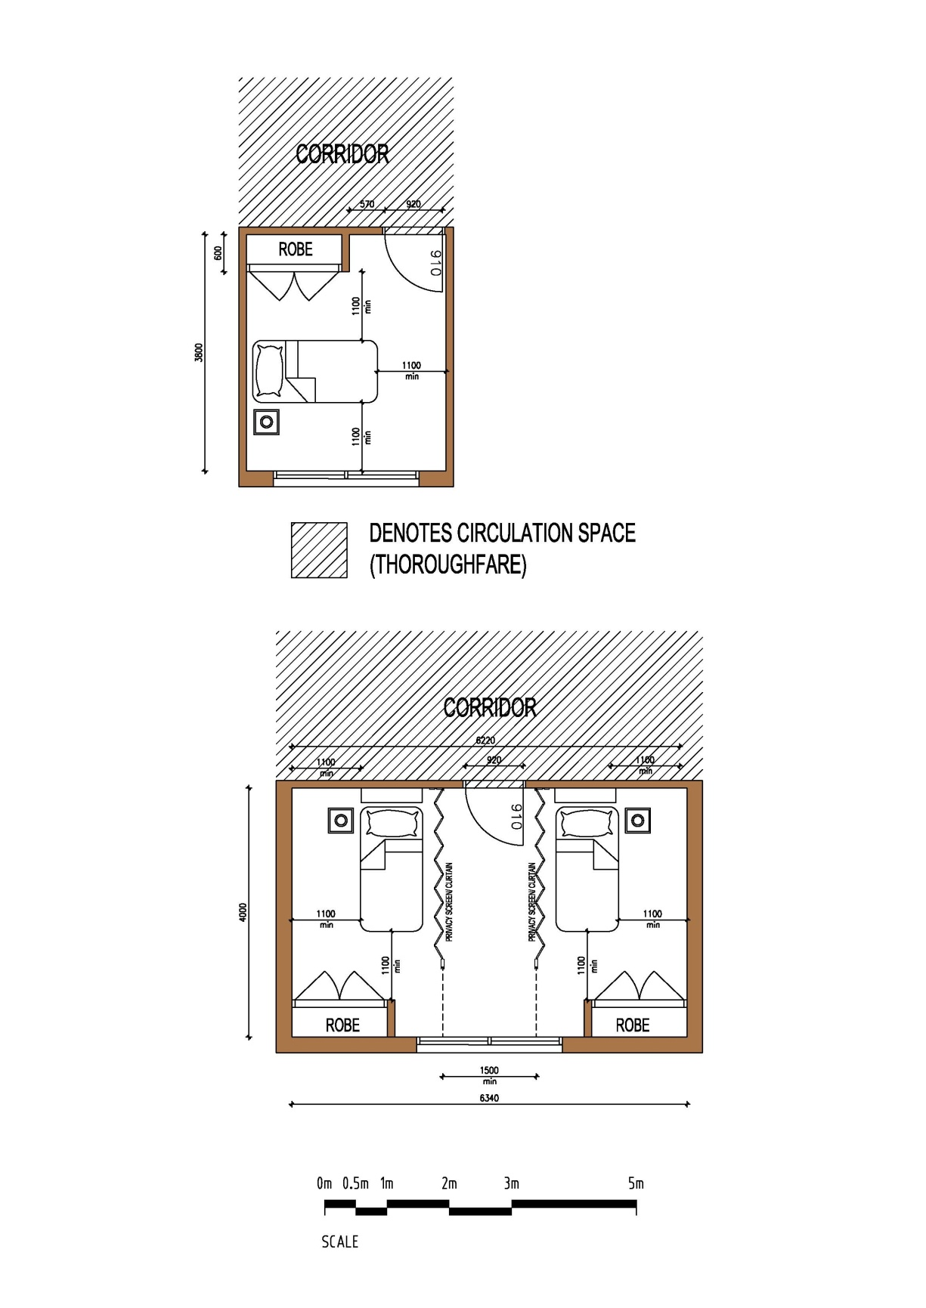

Minimum 24m² for 2 persons sharing

Minimum 12m²

**Figure 1. Personal Living Space**

Community expectation is for one only person per room. If a room is shared there is not to be more than two residents accommodated in any bedroom.

Exclusive storage spaces within the bedroom must be provided for each resident including some capacity to lock away valuable items.

In double bedrooms there must be a minimum distance of 1100mm from the bed-end to any fixed object, wall or other bed, and a minimum 1500mm between beds placed side by side.

Every bedroom must have a door directly from the corridor and not through another bedroom or directly from a communal area.

Residents must also have unimpeded access to their bedrooms and movement around their own rooms.

Bedroom doors fitted with an internal lock must have an escape latch release mechanism and must be suitable for single-handed operation.

Every bedroom must have a window. Bedroom windows must be provided with curtains or blinds to promote privacy, reduce glare and assist with temperature control. There must not be a direct view from one bedroom window to another over a distance of less than three metres.

### Bathroom, ensuites and toilets

It is important the location and design of bathrooms, ensuites and toilets address issues of accessibility and safety. As a minimum the BCA ratio of accessible bathrooms, and ensuites attached to accessible bedrooms must be provided. Designs should consider additional accessible ensuites where the facility and resident profile warrants. If appropriate, grab rails are to be provided in each toilet, shower room and bathroom. (BCA and AS 1428.1 requirements as a minimum). The BCA requires a ratio of accessible bathrooms, and ensuites attached to accessible bedrooms and these must be provided. Designs should consider additional accessible ensuites where the facility and resident type warrants.

Flooring is to be non-slip type (sheet vinyl or tiles) with sufficient fall to prevent ponding of water.

Mechanical ventilation must be installed to each bathroom, ensuite and toilet.

The location of doors must be positioned to enable easy access and must open outward or be fixed with removable hinges to assist staff access in emergencies.

Each bathroom and ensuite should:

* have enough space for private dressing and contain a towel rail, clothes hook, shelf and space for a seat
* privacy locks or similar mechanisms must be fitted but openable from the outside in an emergency. In shared ensuites with dual access electronic privacy should be considered to restrict access by the other residents

It is the department’s preference baths are not to be used for residents. In some cases this may require discussion with the Relevant Building Surveyor where mandatory BCA provisions exist.

## Communal living spaces

### General Communal Space Requirements

The BCA and SRS regulations require a minimum aggregate floor area of communal living areas and must not be less than 3.5 square metres per resident. Designs must meet or exceed the requirements and Building Surveyors will be required to verify compliance in building permits and statements of compliance. The communal areas that make up the aggregate must be habitable spaces eg living rooms; sitting rooms; dining rooms and activity spaces. It does not include main circulation corridors and common rooms less than 7.5 square metres in area. Consideration should be given to providing communal space on each floor level.

Communal use areas with the capacity for privacy should be considered to enable residents to meet or dine with visitors on a more intimate environment.

**Multi use areas are also encouraged to provide for a range of activities, functions and special uses such as hair dressing, medical or professional consulting.**

### Lounge rooms

Consideration to be given to providing a variety of communal lounge spaces throughout the facility, each having minimum floor areas of 7.5 square metres. Communal spaces must be accessible for all residents, and comply with the access for people with disability requirements.

The lounge room, together with the dining room, is seen as the main hub of daily activities within an SRS, providing for recreational space, social interaction and therapeutic programs. They are used as communal areas for all residents and their visitors.

As this area will often be the main living area for most residents, it is important views and visual contact with external activities be incorporated into the design.

Direct external access is important and the use of verandas or covered area will extend the capacity and flexibility of the living areas.

Storage and connection points for televisions and other recreational equipment should be provided in each lounge room.

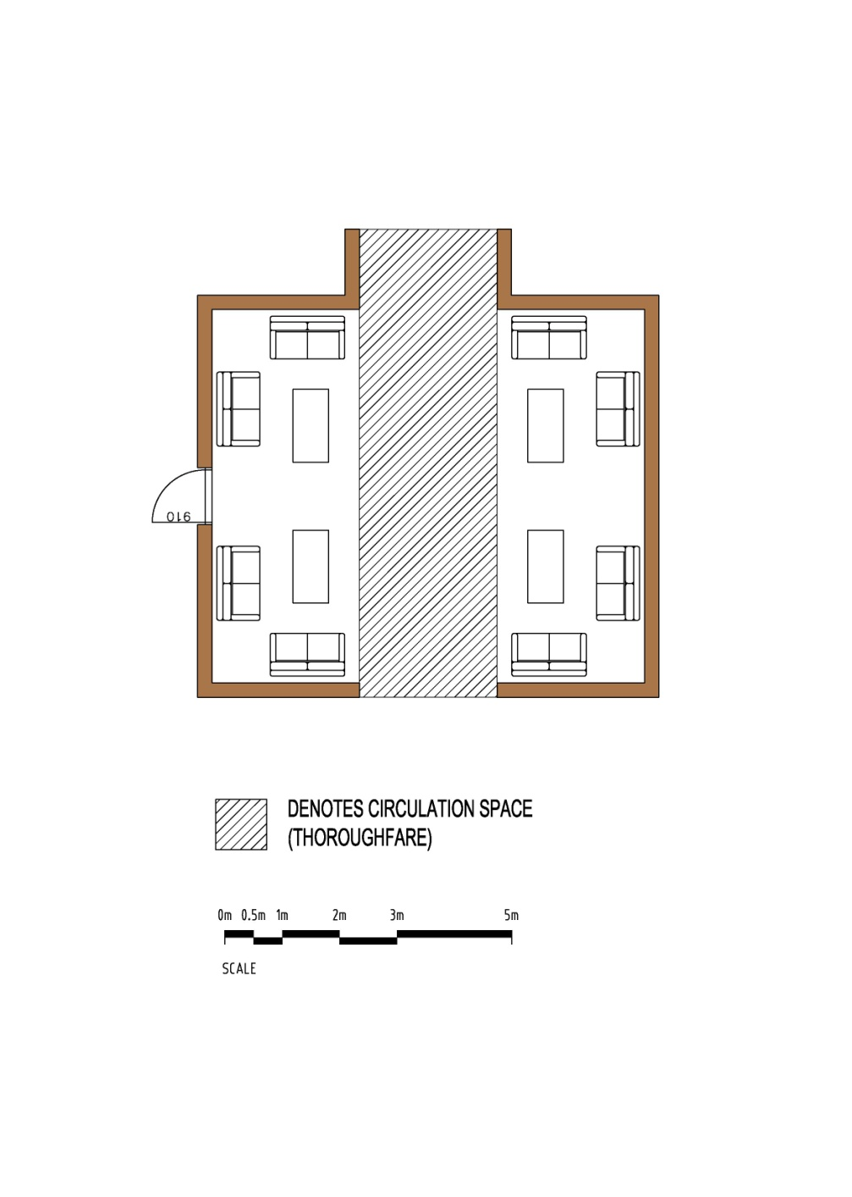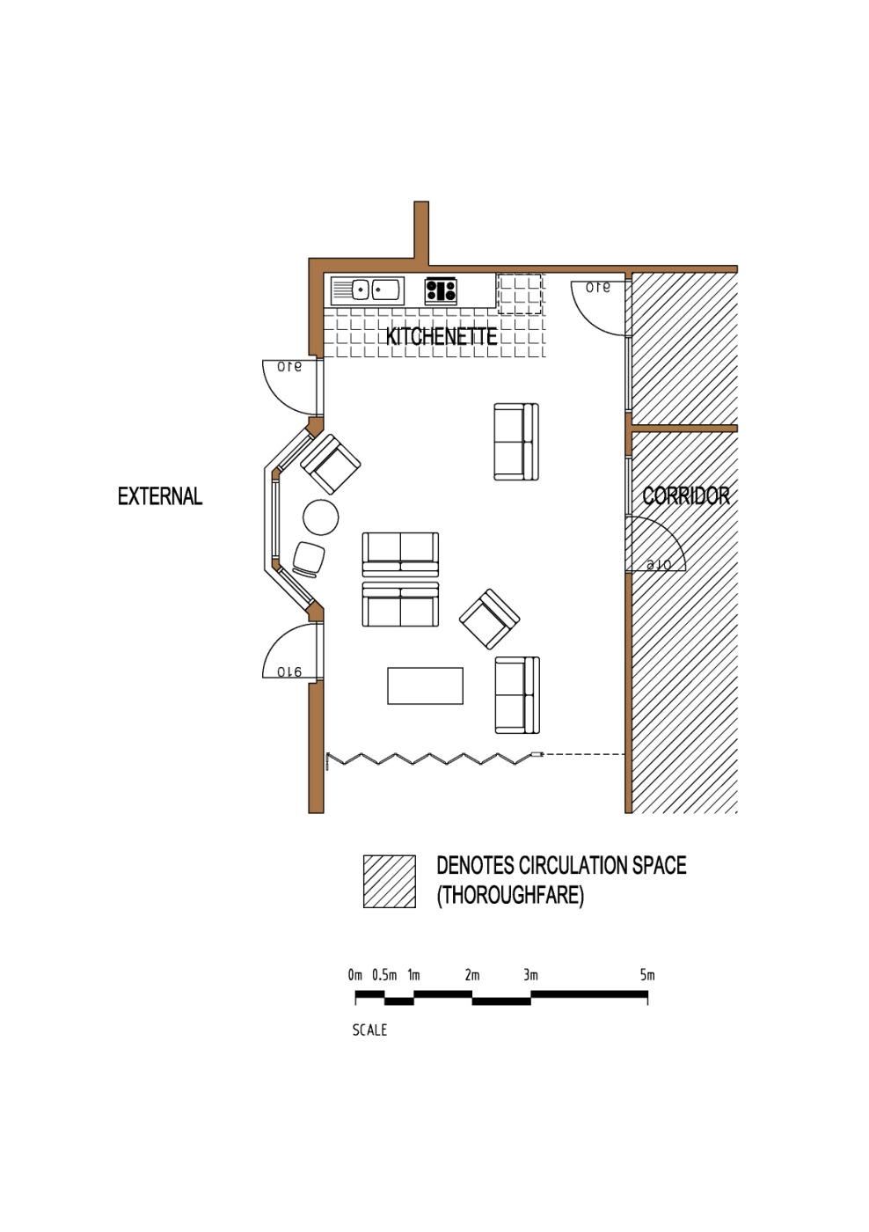

**Figure 2. Communal Lounge Room**

### Sitting Areas

A sitting room is an example of communal living area for residents as an alternative to the communal lounge room. They are areas that can provide residents with choice in relation to where they spend quiet time and with whom and may be helpful with behaviour management for those residents who have difficulties negotiating relationships with others. The sitting room provides residents with an area to meet with visitors away from their bedroom or larger communal lounge room.

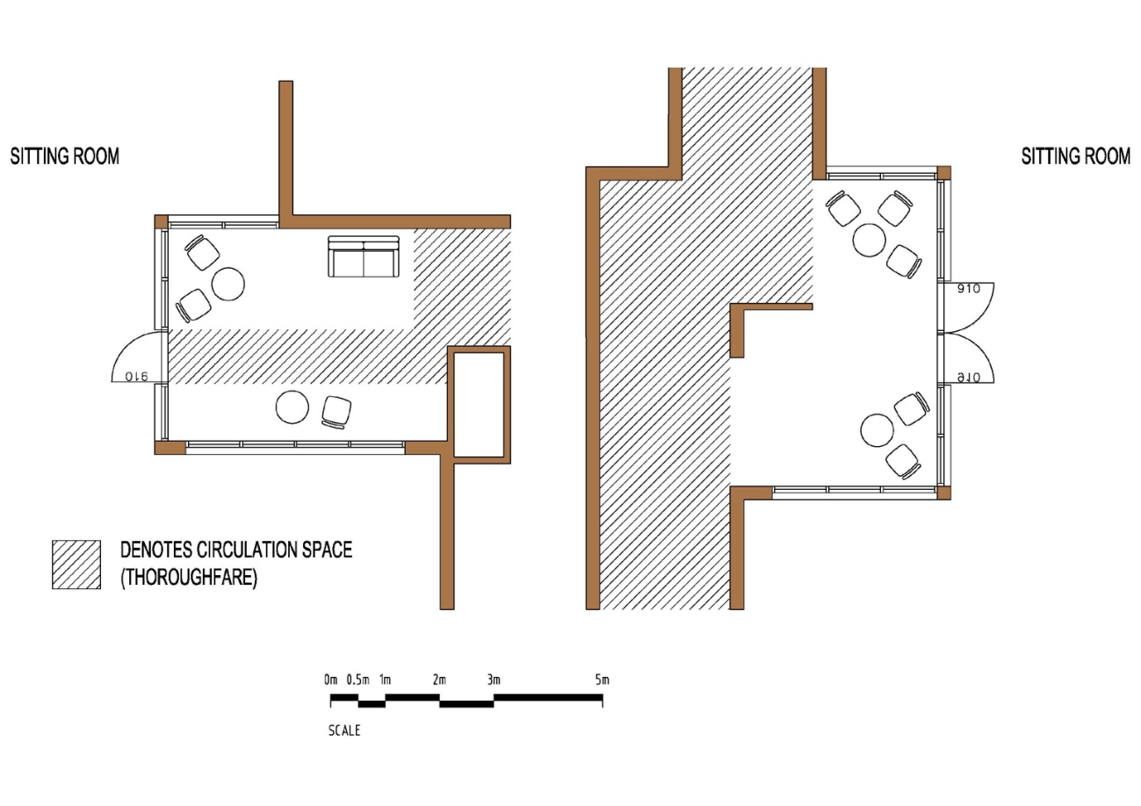

**Figure 3. Communal Living Spaces**

### Dining rooms

The dining room is an area where residents can sit down to have meals, and along with other living spaces meet, engage in leisure/recreational activities and generally socialise.

Residents should have easy access to the dining room from all areas of the SRS.

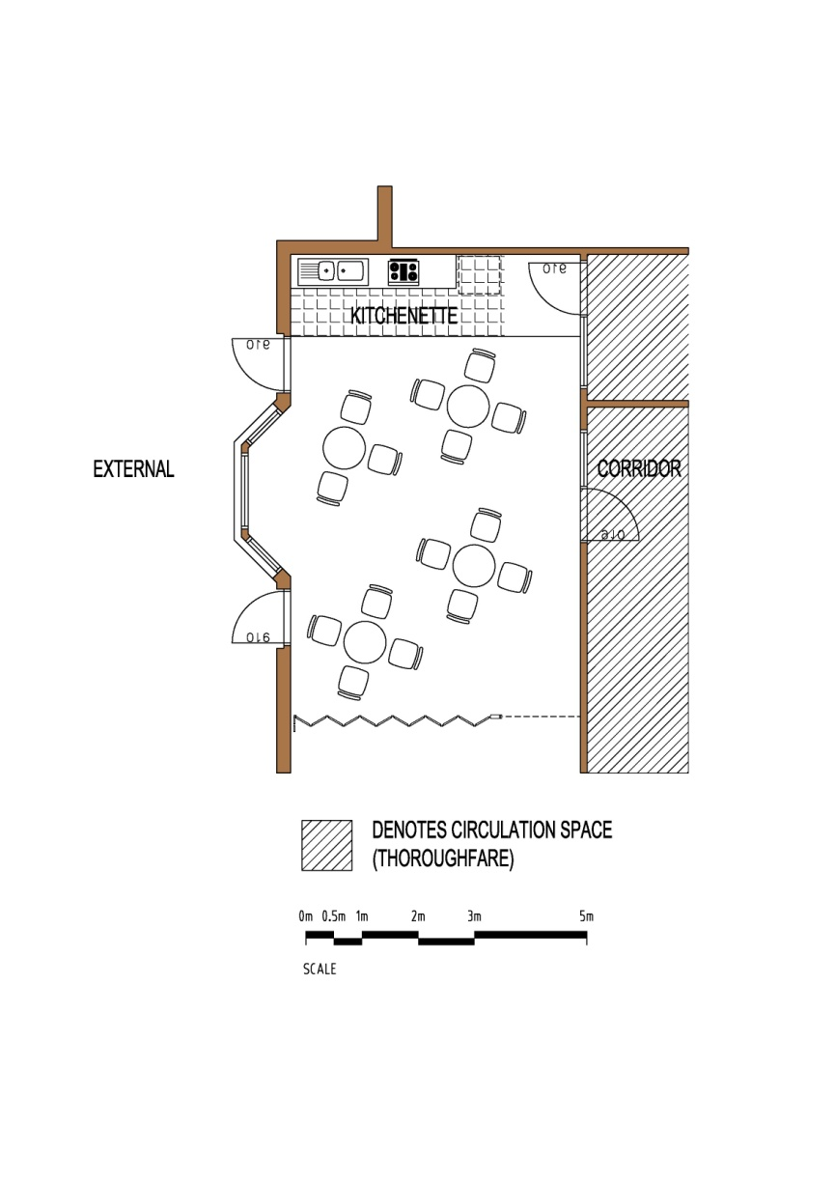 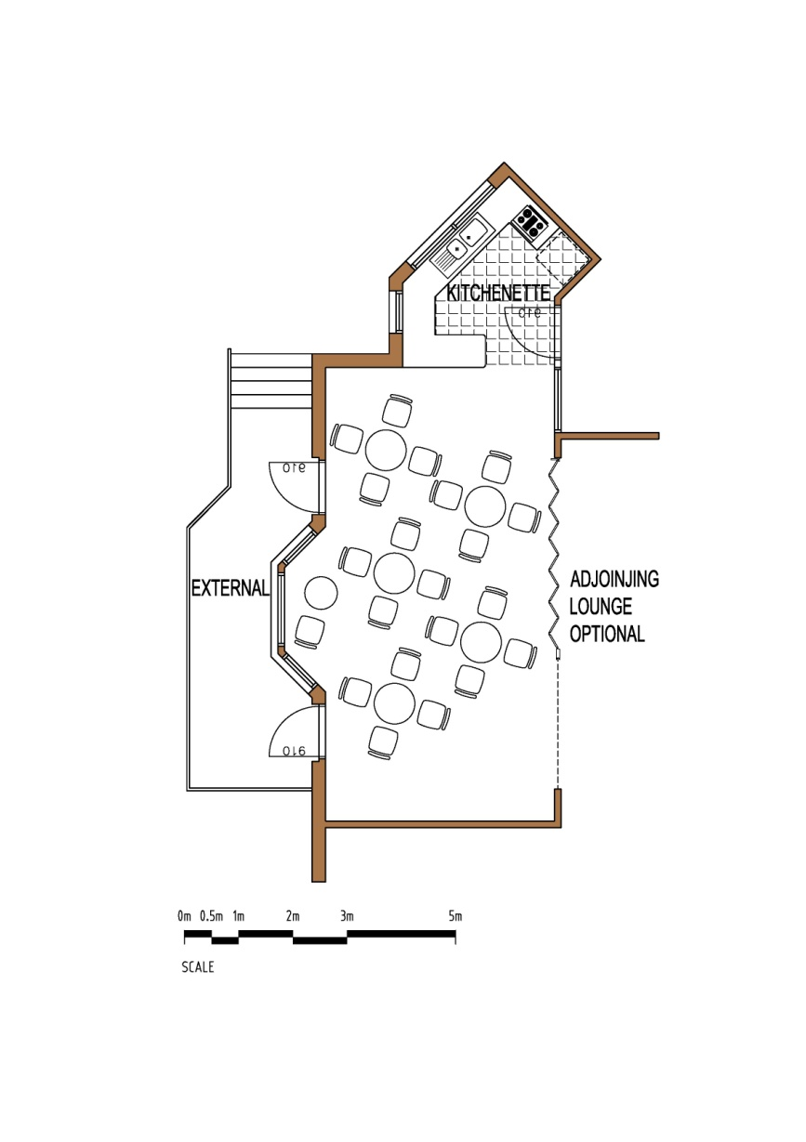

**Figure 4. Communal Dining Spaces**

### Tea-making facilities or kitchenette

Access to tea making facilities for residents, visitors and staff with appropriate storage and access for supplies should be considered.

### Residents’ courtyards and gardens

Courtyards, gardens and roof-tops provide residents with an external space to enhance the amenity for residents. They should include private areas as well as areas for socialisation and therapeutic activities.

Consideration should be given to providing a covered veranda, pergola or similar structure to allow protection from the weather, particularly if residents are expected to smoke outside. Other features commonly incorporated into outdoor areas include:

* discrete, secure areas for residents who have a tendency to wander
* BBQs and other appropriate furniture
* clotheslines
* aviaries or other pet accommodation.

Careful consideration needs to be given to protecting the privacy of residents whose bedrooms face onto external communal spaces. Courtyard areas should be located at least 1.5metres from a resident’s bedroom to maintain the privacy of residents. Areas within 1.5 metres will not be included in the external space allocation.

## Administration areas

### Offices

A general office for reception and administration may also serve as a staff work-base.

Medications are to be kept in a lockable cupboard in the office or another secure area.

To ensure residents’ privacy, records and other information are to be maintained in a locked cupboard/room.

A manager’s office may be provided.

## Service and support areas

### Entry and exits

All external doors must:

* be fitted with insect screens or automatic closing mechanisms. Designated and required exit doors may not be able to have flywire doors fitted as this may conflict with direction of swing of the door or doors. The Relevant Building Surveyor should be consulted on this issue
* be provided with adequate and appropriate lighting.

Exits are required to be fitted with latches capable of providing escape function in an emergency and may be fitted with security locking provided they release on activation of a fire alarm and with power failure safe functions

### Corridors and stairways

Handrails should be installed in all corridors used by residents where the resident population includes people who are frail, aged or those with mobility difficulties. Handrails must comply with the BCA and AS 1428.1.

Stairs and stairways should be kept to a minimum. Where provided, they must comply with BCA and AS1428.1, including the fitting of appropriate handrails, balustrading and contrasting nosings etc.

Adequate and appropriate lighting must be provided to all corridors and stairways.

Corridors should be sufficient width responding to the needs of residents. The minimum corridor width is determined by the BCA. In Residential Aged Care facilities (BCA class 9c), the minimum clear width is 1500mm and in other cases 1000mm. However, these minimum widths may need to be increased to cater for resident profile and needs. The widths must increase where required by the requirements of AS 1428.1 to accommodate wheelchair circulation and passing, especially in longer corridors.

### Handling of laundry

Laundry can be done onsite or by an external laundry service.

There must be adequate facilities to collect dirty laundry and keep it separate from clean laundry.

If there is an onsite laundry, adequate facilities must be provided to enable laundry contaminated with body fluids to be separated from the general wash. Infection control measures to ensure clean and dirty linen etc are separated is another important consideration and expectation.

Small domestic personal laundry/laundries to enable use by residents and families should be provided in addition to general laundry facilities.

Sufficient secure storage must be provided for detergents and other cleaning materials kept in the laundry. Cleaning chemicals used by staff and, where deemed harmful if inappropriately accessed and used by residents, should be separated and secured.

### Kitchen

The design of the kitchen must meet the Food Act 1984 which is administered by local council Environmental Health Officers (EHO).

The size, design and fit-out of the kitchen will vary depending upon the type of food service employed (for example conventional or cook-chill) and the number of meals being prepared. Early consultation and approval by the council EHOs is recommended.

### Storage and utility rooms

Adequate storage needs to be provided to cater for all the equipment and materials used in the facility. Consideration should be given to providing a storage room on each level of a multi-storey facility.

Utility rooms allow for the storing of cleaning materials, other non-food consumables and small equipment in one area. They may be used by staff for a variety of purposes, such as the storage of equipment maintenance and irregularly used items.

Utility rooms must have adequate lighting and ventilation and a lockable door to ensure resident and visitor safety.

Consideration may also need to be given for the need of additional storage facilities. Linen presses, medication cupboards and equipment stores are common features of most SRS facilities.

Wheelchairs and other mobility aids often create considerable storage problems and careful consideration needs to be given to their accommodation in facilities where they are required. Commonly adopted approaches include strategically located recessed storage bays in passageways and one or more dedicated storage rooms or cupboards.

Residents’ personal belongings should be stored in their own bedrooms though consideration should be given to providing additional storage for rarely used, large items such as suitcases. A safe should also be provided for valuable items.

### Staff Amenities

All employers, including SRS operators, are expected to provide sufficient facilities for staff to store personal belongings and attend to personal hygiene.

SRS operators need to provide appropriate overnight accommodation if stand-up staff are not being employed at night.

A small staffroom with a kitchenette and lockable storage for personal belongings is recommended. Staff must be able to hear and respond to the electronic communication system when in the staffroom.

If sleep-over staff are employed at the SRS, those staff must be provided with an appropriately furnished bedroom located conveniently to resident bedrooms.

Staff must be able to hear and respond in a timely manner to the electronic communication system when in staff areas.

## Other requirements

### Essential safety measures maintenance

Essential Safety Measures are the critical fire and equipment elements in buildings. They are required to be maintained to ensure they continue to perform to the levels required of the BCA and relevant Australian Standards. The essential safety measures will be identified by the Relevant Building Surveyor at the time of issue of an Occupancy Permit or Certificate of Final Inspection (where an Occupancy Permit is not required to be issued).

In the case of existing buildings, owners can apply to any registered building surveyor to have their buildings assessed and the issue of a determination that will schedule the essential safety measures; the BCA and Australian Standards that determine the level of performance; and the frequency of maintenance.

In Victoria, it is mandatory to maintain essential safety measures in accordance with the schedule provided by the Relevant Building Surveyor as described above, to log the maintenance and issue an annual report listing the measures, and who has undertaken the maintenance. Advice on these requirements and templates for the annual reports can be sought from Councils, Relevant Building Surveyors of the Victorian Building Authority. Municipal Building Surveyors and fire authorities can request a copy of the annual report and evidence of maintenance which must be produced within 24 hours of a request. Penalties apply where there is failure to meet the requirements.

# Glossary of Terms

|  |  |
| --- | --- |
| AS | Australian Standard |
| BCA | National Construction Code Series - Building Code of Australia (current at the time) amendments |
| Building Act | Building Act 1993 |
| Building Regulations | Building Regulations 2006 |
| Communal Living Space | Areas provided for the shared use of all residents and includes dining, lounge and sitting rooms, gardens and courtyards |
| DD Act | Disability Discrimination Act 1992 |
| the department | Department of Families, Fairness and Housing |
| SRS Act | Supported Residential Services (Private Proprietors) Act 2010 |
| OCEI | Office of the Chief Electrical Inspector |
| OHS | Occupational health and safety |
| Personal living Space | Area provided for the exclusive use of a resident and others by invitation only. |
| Registered building surveyor | Building practitioner in the class of building surveyor, either a municipal building surveyor or a private building surveyor. When appointed the registered building surveyor becomes the Relevant Building Surveyor |
| Reporting Authority | An authority defined in the Building Regulations that is required to be consulted in relation to certain matters as part of the building permit and occupancy permit process and includes Councils; water authorities; fire authorities. |
| SRS | Supported Residential Service |
| SRS Regulations | Supported Residential Services (Private Proprietors) Regulations 2012 |
| WorkSafe | WorkSafe Victoria |

# Supported Residential Service (SRS) Building Surveyors Statement of Compliance

The following statement of compliance template must be completed by a Registered Building Surveyor (as defined by the Building Act) and pursuant to schedule 1 section 4 of the Supported Residential Services (Private Proprietors) Regulations 2012.

The statement must be accompanied by a compliance checklist relevant to the works, and completed by the same Building Surveyor making the statement – refer to the attached checklist templates for different scenarios.

**Department of Families Fairness and Housing**

**Supported Residential Services (Private Proprietors) Regulations 2012**

**Schedule 1 Section 4**

Building Surveyors’ Statement of Compliance

**Building Surveyors Details**

|  |  |  |
| --- | --- | --- |
| Name: |  | |
| Building Practitioners Board Registration Number: | |  |
| Organisation name: |  | |
| Postal address: |  | |
| Contact Phone Number: |  | |

**Details of SRS**

|  |  |  |  |  |  |
| --- | --- | --- | --- | --- | --- |
| Name of SRS |  | | | | |
| Address |  | | | Postcode |  |
| Municipality |  | | | | |
| Building Use | |  | BCA Classification | |  |
| Building Permit Number | |  | Date of issue | |  |
| Occupancy Permit Number | |  | Date of issue | |  |
| Certificate of Final Inspection Number (where applicable) | |  | Date of issue | |  |

**Compliance statement**

1. I am the relevant building surveyor/registered building surveyor as defined in the Building Act 1993 appointed to the project to which the registration for Supported Residential Service applies for the purpose of issuing this statement of compliance
2. I am a registered building practitioner as defined in the Building Act 1993, in the Category of building surveyor (unlimited) or category of building surveyor (limited), as appropriate
3. I have examined the building design and completed works and certify the building complies with the National Construction Code Series Building Code of Australia current at the time of design and issue of the building permit
4. I have examined the building against the SRS Facility Guidelines document and have completed and attached a copy of the prescribed checklist and certify the building complies with the SRS Facility Guidelines issued by the Department of Families, Fairness and Housing

**Signature of Building Surveyor**

|  |  |  |  |
| --- | --- | --- | --- |
| Name: |  | | |
| Signature |  | Date of Issue |  |

# Supported Residential Service (SRS) Checklist Extension or Alteration

This checklist is intended for use by:

* the Registered Building Surveyor nominated by the applicant under the Supported Residential Services (Private Proprietors) 2012 Regulations to issue a statement of compliance
* existing SRS proprietors or property owners who are considering altering or extending an existing registered SRS as a guideline to assist in design and or evaluation.

This checklist is to be read in conjunction with *the Supported Residential Services (Private Proprietors) Act 2010*, the Supported Residential Services (Private Proprietors) 2012 Regulations and the SRS Facility Guidelines.

Registration of an SRS is based on an assessment of both the prospective proprietor as well as the premises from which the SRS will operate. An approval from the department is required for the extension or alteration of a Registered SRS prior to commencement of any building works.

**SUPPORTED RESIDENTIAL SERVICES FACILITY GUIDELINES**

**SRS BUILDING SURVEYING REPORT**

**ALTERATIONS/ADDITIONS/CHANGE OF USE**

**Facility:**

**Address:**

**Date of Inspection:**

**Date of Report:**

**Building Surveyor Assessing:**

This report is based on review of the existing building with the Supported Residential Service Facility Guidelines 2015 as part of the owner’s submission for registration under Supported Residential Service (Private Proprietors) 2012 Regulations.

**Building Description and BCA Requirements**

|  |
| --- |
| Building description and use |
|  |

|  |  |  |  |  |  |
| --- | --- | --- | --- | --- | --- |
| BCA Class of Occupancy | No. of storeys | Rise in storeys | Floor area  (approx) | BCA Type of Construction | Number of beds |
|  |  |  | m2 |  | Clients  Staff |

|  |
| --- |
| Client Profile eg Ambulant; degree of assistance required; needs etc |
|  |
| Staff Profile eg Sleepover; 24 hour staffed |
|  |

|  |  |  |
| --- | --- | --- |
| Legislative requirements associated with works or Change of Use | Yes | No |
| The inspection of the building and or plans has determined there will be a requirement for a partial compliance assessment under the Building Regulations |  |  |
| A building Permit will be required for the alterations and or change of use of the building |  |  |
| A Planning Permit will be required for the works associated with the building alteration or change of use |  |  |

|  |  |  |  |
| --- | --- | --- | --- |
| Building permits; Occupancy Permits and Reporting Authority Consents  Note all relevant documents below are required to be attached to the report | Yes | No | Attached |
| Are there previous building permits issued for the building for any previous works? |  |  |  |
| Are there current building permits issued for the current works or change of use? |  |  |  |
| Are there Occupancy Permits or Certificates of Final Inspection issued for any previous works? |  |  |  |
| Are there Occupancy Permits or Certificates of Final Inspection issued for the current works or change of use? |  |  |  |
| Are there any reporting authority consents eg CFA, MFB, Council issued in relation to any previous works? |  |  |  |
| Are there any reporting authority consents eg CFA, MFB, Council issued in relation to current works or change of use? |  |  |  |

**Introduction**

The following table is a summary of the audit findings with the SRS Facility Guidelines as well as recommendations from the review:

**SRS Facility Guideline Provisions**

|  |  |  |  |  |
| --- | --- | --- | --- | --- |
| Section 1 | Planning and Building Legislation | Yes | No | Comments |
| 1.1 | Does the building design comply with the Building Code of Australia and Building Regulations applicable at the time of design |  |  |  |
| 1.2 | Is a planning permit required for the works or change of use for an SRS facility?  If so, is there documentary evidence of a Planning Permit or statement of exemption? |  |  |  |
|  |  |
| 1.3 | Will the design of the kitchen meet the Food Act 1984 requirements?  Is the design approved by the relevant council EHO? |  |  |  |
| 1.4 | Is the building in a designated Bushfire Prone area?  If so, has a Bushfire attack Level (BAL) been assessed?  If so, can the operator manage all of the risks the bushfire risk presents? |  |  |  |
|  |  |
| 1.5 | Is the site subject to flooding or inundation?  If so, will the site be compromised in respect of reasonable access for emergency services to ensure the safety of residents? |  |  |  |
|  |  |
| 1.6 | Is the site in an Alpine Area?  If so, will the site be compromised in respect of access for emergency services to ensure the safety of residents? |  |  |  |
|  |  |

|  |  |  |  |  |
| --- | --- | --- | --- | --- |
| Section 2 | Site Selection criteria | Yes | No |  |
| 2.1 | Is the site in an environment suitable for residential use and provision for supported residential use? |  |  |  |
| 2.2 | Does the site have reasonable access to shops, public transport and community services? |  |  |  |
| 2.3 | Is the site suitable for access by frail aged or other residents with a disability? |  |  |  |
| 2.4 | Does the site allow for safe movement around outdoor areas accessed by residents and a safe path of travel from the car park to the entrance for residents, staff and visitors? |  |  |  |
| 2.5 | Is the site suitable for outdoor recreation for residents, staff and visitors? |  |  |  |
| 2.6 | Is the site located in an area deemed a contaminated site or subject to special environmental controls |  |  |  |
| 2.7 | Does the site allow for easy access to the premises for emergency service vehicles at all times? |  |  |  |

|  |  |  |  |  |
| --- | --- | --- | --- | --- |
| Section 3 | Entries and Exits | Yes | No |  |
| 3.1 | Will the site allow for safe entry and egress to and from the building by residents, staff and visitors? |  |  |  |
| 3.2 | Is the path from the carpark to the building provided with adequate and appropriate lighting? |  |  |  |
| 3.3 | Are all exterior doors provided with adequate and appropriate lighting? |  |  |  |
| 3.4 | Is there sufficient means to secure the facility against unwarranted entry in a manner that will not compromise evacuation? |  |  |  |
| 3.5 | Is there complying access to the facility, required by the BCA and AS1428.1? |  |  |  |
| 3.6 | Are doors provided with measures to allow staff to access all areas in an emergency – master keying or electronic locking?  Do the devices installed ensure the resident’s privacy and while security is maintained? |  |  |  |
| 3.7 | Are all exterior doors fitted with insect screens as permitted by the BCA where the door is not a required or designated exit or fitted an automatic closing mechanism? |  |  |  |

|  |  |  |  |  |
| --- | --- | --- | --- | --- |
| Section 4 | Fire Safety and Essential Safety Measures | Yes | No |  |
| 4.1 | Has the building been designed with the fire safety requirements of the BCA and referred Australian Standards, and additional measures given the nature of the proposed residents? |  |  |  |
| 4.2 | Have essential safety measures been determined and scheduled for inclusion in the Occupancy Permit or Certificate of Final Inspection? |  |  |  |

|  |  |  |  |  |
| --- | --- | --- | --- | --- |
| Section 5 | Administration | Yes | No |  |
| 5.1 | Is there a general office to function as reception and/or staff work-base provided? |  |  |  |
| 5.2 | Is there a lockable cupboard in the office or another secure area to store medications? |  |  |  |
| 5.3 | Is there a lockable cupboard/room for, records and other confidential resident information? |  |  |  |

|  |  |  |  |  |
| --- | --- | --- | --- | --- |
| Section 6 | Resident Private Amenity | Yes | No |  |
| 6.1 | Do all residents have their own room?  If not, list how many residents per room |  |  |  |
| 6.2 | Does each resident will have personal living space (minimum bedroom area) of 12m²? |  |  |  |
| 6.3 | Do all bedrooms open directly off a corridor? |  |  |  |
| 6.4 | Do all bedrooms have a wardrobe and a lockable cupboard to store valuables? |  |  |  |
| 6.5 | Is there sufficient rooms and sanitary facilities in accordance with the ratio of accessible rooms and facilities set out in the BCA? |  |  |  |
| 6.6 | Where the nature of residents to reside in the facility requires it, are there additional facilities and rooms available to cater for these special needs? Needs a minimum area 7.5m2 |  |  |  |
| 6.7 | Does each bathroom and/or ensuite have enough space for private dressing and contain a towel rail, clothes hook, shelf and space for a seat? |  |  |  |
| 6.8 | Does each of the bathrooms and/or ensuite have privacy locks or similar mechanisms must be fitted but openable from the outside in an emergency |  |  |  |
| 6.9 | Where shared ensuites are provided are there adequate means to provide privacy of use of the ensuite? |  |  |  |
| 6.10 | In the resident’s ensuite of bathroom, is there provision of grab rails consistent with the minimum provisions of AS 1428.1 as required by the BCA, or additional given the nature of the residents |  |  |  |
| 6.11 | Is the construction of walls between bedrooms and where required between bedrooms and corridors and noisy utility areas, offering resistance to the transfer of sound as required by the BCA? |  |  |  |
| 6.12 | Are all resident bedrooms provided with openable windows? |  |  |  |
| Is there sufficient natural ventilation to resident areas? |  |  |
| Is there sufficient ventilation of spaces generally? |  |  |
| 6.13 | Are all openable windows fitted with insect screens? |  |  |  |

|  |  |  |  |  |
| --- | --- | --- | --- | --- |
| Section 7 | Communal Living Areas | Yes | No |  |
| 7.1 | Does the aggregate communal habitable living space provide a minimum floor area of 3.5 square metres per resident?  [A main circulation path (for example a corridor) through the room is not considered as part of the net floor area.] |  |  |  |
| 7.2 | Is there a sitting room on each level of the SRS? |  |  |  |
| 7.3 | Is the dining room accessible for all residents of the SRS? |  |  |  |
| 7.4 | Are there multi use rooms to cater for additional needs of the residents? |  |  |  |
| 7.5 | Are tea-making facilities provided for residents, visitors and staff with appropriate storage and access for supplies available? |  |  |  |
| 7.6 | Are recreational outdoor areas for residents provided? |  |  |  |
| 7.7 | Are discrete and secure outdoor areas provided for residents who have a tendency to wander? |  |  |  |
| 7.8 | Are BBQs and appropriate outdoor furniture provided in the resident’s outdoor recreation areas? |  |  |  |
| 7.9 | Is there a clothes line provided with sufficient hanging space given the number of residents? |  |  |  |
| 7.10 | Are outdoor resident areas located to protect the privacy of residents whose bedrooms face onto external communal spaces?  Are outdoor courtyard areas more than 1.5 metres from a resident’s bedroom, or adequately screened for privacy? |  |  |  |
|  |  |
| 7.11 | Are there sufficient signs (Braille and wayfinding) to assist residents and visitors in their occupation of the facility? |  |  |  |

|  |  |  |  |  |
| --- | --- | --- | --- | --- |
| Section 8 | Corridors and Stairways | Yes | No |  |
| 8.1 | Are the corridors of sufficient width to ensure proper function of the facility to cater for needs of residents / compliance with the BCA for the class of building and in addition increased width as required by AS1428.1? |  |  |  |
| 8.2 | Are corridors used by residents fitted with handrails?  If yes, do the handrails comply with AS1428.1?  If no, is there a need for the handrails to be fitted pursuant to the proposed resident profile? |  |  |  |
|  |  |
|  |  |
| 8.3 | Are stairs and ramps compliant with BCA provisions in relation to treads; risers; widths; construction; gradients; non slip construction etc |  |  |  |
| 8.4 | Are stairs and stairways compliant with AS 1428.1 in relation to handrails, tactile indication and other requirements? |  |  |  |
| 8.5 | Do corridors and stairways have appropriate lighting? |  |  |  |

|  |  |  |  |  |
| --- | --- | --- | --- | --- |
| Section 9 | Handling of Laundry | Yes | No |  |
| 9.1 | Is laundry done onsite?  If yes:  Are there adequate facilities provided to enable laundry contaminated with body fluids to be separated from the general wash?  Is there sufficient secure storage for detergents and other cleaning materials kept in the laundry? |  |  |  |
|  |  |
|  |  |
| 9.2 | Is there a domestic style laundry for direct use by residents and or families? |  |  |  |

|  |  |  |  |  |
| --- | --- | --- | --- | --- |
| Section 10 | Kitchen | Yes | No |  |
| 10.1 | Does the kitchen of a size, design and fit-out cater for the type of food service employed, the number of residents and the number of meals to be prepared? |  |  |  |

|  |  |  |  |  |
| --- | --- | --- | --- | --- |
| Section 11 | Storage and Utility Rooms | Yes | No |  |
| 11.1 | Does each level of the SRS have a storage room to cater for the equipment and materials used in the facility? |  |  |  |
| 11.2 | Is there an area for the storage of clean linen? |  |  |  |
| 11.3 | Is there an area to store resident’s personal belongings in addition to what is stored in their personal room? |  |  |  |
| 11.4 | Is there a safe for the storage of resident’s valuable items? |  |  |  |
| 11.5 | Is there sufficient means to store, handle and dispose of solid and liquid waste and in a manner that prevents access by vermin? |  |  |  |
| Are areas set aside for the storage, handling and disposal of solid and liquid waste sufficiently separated from resident rooms? |  |  |
| 11.6 | Is there sufficient storage directly accessible from outside the building to house garden and other resident external activity equipment? |  |  |  |

|  |  |  |  |  |
| --- | --- | --- | --- | --- |
| Section 12 | Staff Amenities | Yes | No |  |
| 12.1 | Are there staff only toilets and areas to store personal belongings? |  |  |  |
| 12.2 | Is there an area for staff breaks with a kitchenette? |  |  |  |
| 12.3 | Is there overnight accommodation for staff (if there is no stand-up staff overnight)? |  |  |  |

|  |  |  |  |  |
| --- | --- | --- | --- | --- |
| Section 13 | Visiting Support Services | Yes | No |  |
| 13.1 | Is there a room where visiting support services can consult with residents? |  |  |  |
| 13.2 | Do the rooms provided offer privacy for such consultations and are the rooms constructed to prevent the transfer of private conversations? |  |  |  |

|  |  |  |  |  |
| --- | --- | --- | --- | --- |
| Section 14 | Security Systems | Yes | No |  |
| 14.1 | Is the facility secure for residents and staff? |  |  |  |
| 14.2 | Does the security system disengage (electronic system) or enable unhindered egress (one way door locks) in event of fire/evacuation? |  |  |  |
| 14.3 | Is there a system to enable staff to enter all areas within the facility including resident bedrooms for checking and evacuation in the event of an emergency (master lock system)? |  |  |  |

|  |  |  |  |  |
| --- | --- | --- | --- | --- |
| Section 15 | Building Fabric and Finishes | Yes | No |  |
| 15.1 | Are the building fabric and finishes fit for purpose (fire retardant, easy to clean and slip resistant)? |  |  |  |
| 15.2 | Are the fittings and fixtures designed to ensure safety, longevity, anti vandalism, energy efficiency and ease of use |  |  |  |

|  |  |  |  |  |
| --- | --- | --- | --- | --- |
| Section 16 | Building Services | Yes | No |  |
| 16.1 | Are there means to control the temperature of hot water used by the residents in accordance with the BCA and Australian Standards? |  |  |  |
| 16.2 | Are there sufficient hands free operation basins for staff where required including the kitchen and utility areas? |  |  |  |
| 16.3 | Are there floor wastes to wet areas to assist in cleaning and hygiene? |  |  |  |
| 16.4 | Are there adequate GPOs to avoid the need for double adaptors and extension cords? |  |  |  |
| 16.5 | Are the rooms and corridors and general communal and circulation areas provided with sufficient artificial lighting? |  |  |  |
| 16.6 | Is there capacity to provide bedside side lighting in all resident rooms? |  |  |  |
| 16.7 | Are heating and cooling systems installed to ensure the comfort of residents is addressed and adequate for the climatic conditions of the site location? |  |  |  |
| 16.8 | Are the heating appliances positioned and designed to prevent fire or burns to residents? |  |  |  |
| 16.9 | Do residents have the ability to control temperature in their private areas? |  |  |  |
| 16.10 | Is there sufficient mechanical ventilation to deal with odours and steam in areas where these issues arise? |  |  |  |
| 16.11 | Are data points designed for the installation of computer, television and external communication systems? |  |  |  |
| 16.12 | Is there a functioning call bell/staff summoning system:  In each bedroom, bathroom, shower and toilets?  Attract relevant staff attention whether awake or sleeping?  Are staff able to identify the source of the call and only deactivate at point of origin?  Is there a backup power system  Is the installed system tested regularly |  |  |  |
|  |  |
|  |  |
|  |  |
|  |  |
|  |  |

## Appendix A: Summary of variations from BCA deemed-to-satisfy provisions; SRS Facility Guidelines; and Partial Compliance consideration matters, comments and recommendations (where applicable)

**Introduction**

The following table lists issues that in the opinion of the assessing Building Surveyor vary from the SRS Facility Guidelines and BCA. Note where alternative solutions have been applied against the performance based provisions of the BCA then these matters are not listed as they satisfy the BCA.

**Table 3: BCA non compliances**

|  |  |  |
| --- | --- | --- |
| Item | Variations from the BCA SRS Facility Guidelines; Partial Compliance matters | Comments and recommendations |
|  |  |  |
|  |  |  |
|  |  |  |
|  |  |  |

# Supported Residential Service (SRS) Checklist for a new building

This checklist is intended for use by:

* The Registered Building Surveyor nominated by the applicant under the Supported Residential Services (Private Proprietors) 2012 Regulations to issue a statement of compliance
* Existing SRS proprietors or property owners who are considering building a new registered SRS as a guideline to assist in design and or evaluation.

This checklist is to be read in conjunction with the Supported Residential Services (Private Proprietors) Act 2010 the Supported Residential Services (Private Proprietors) 2012 Regulations and the SRS Facility Guidelines.

Registration of an SRS is based on an assessment of both the prospective proprietor as well as the premises from which the SRS will operate. An approval from the department is required for the extension or alteration of a Registered SRS prior to commencement of any building works.

**SUPPORTED RESIDENTIAL SERVICES FACILITY GUIDELINES**

**BUILDING SURVEYING REPORT**

**NEW BUILDING**

**Facility:**

**Address:**

**Date of Assessment:**

**Building Surveyor Assessing:**

This report is based on review of the documents and/or the building proposed to be used for a Supported Residential Service against the Supported Residential Service Facility Guidelines as part of the owner’s submission for registration under Supported Residential Service (Private Proprietors) 2012 Regulations.

**Building Description and BCA Requirements**

|  |
| --- |
| Building description and use |
|  |

|  |  |  |  |  |  |
| --- | --- | --- | --- | --- | --- |
| BCA Class of Occupancy | No. of storeys | Rise in storeys | Floor area (pprox.) | BCA Type of Construction | Number of beds |
|  |  |  | m2 |  | Clients  Staff |

|  |
| --- |
| Client Profile eg Ambulant; degree of assistance required; needs etc |
|  |
| Staff Profile eg Sleepover; 24 hour staffed |
|  |

|  |  |  |
| --- | --- | --- |
| Legislative requirements associated with works or Change of Use | Yes | No |
| **The inspection of the building and or plans has determined there will be a requirement for a partial compliance assessment under the Building Regulations** |  |  |
| A Planning Permit will be required for the works and use of the building |  |  |
| A building permit will be required for the new building |  |  |

|  |  |  |  |
| --- | --- | --- | --- |
| Building Permits; Occupancy Permits and Reporting Authority Consents  Note all relevant documents below are required to be attached to the report | Yes | No | Attached |
| Is there a building permit issued for the current works? |  |  |  |
| Is there an occupancy permit issued for the current works? |  |  |  |
| Are there any reporting authority consents eg CFA, MFB, Council issued in relation to current works? |  |  |  |

**Introduction**

The following table is a summary of the audit findings with the SRS Guidelines 2016 as well as recommendations from the review:

**SRS Facility Guidelines Provisions**

|  |  |  |  |  |
| --- | --- | --- | --- | --- |
| Section 1 | Planning and Building Legislation | Yes | No | Comments |
| 1.1 | Does the building design comply with the Building Code of Australia and Building Regulations applicable at the time of design |  |  |  |
| 1.2 | Is a planning permit required for the works for an SRS facility?  If so is there documentary evidence of a Planning Permit or statement of exemption? |  |  |  |
|  |  |
| 1.3 | Will the design of the kitchen meet the Food Act requirements and is the design approved by the relevant council EHO? |  |  |  |
| 1.4 | Is the building in a designated Bushfire Prone area?  If so has a Bushfire attack Level (BAL) been assessed and if so will the operator be able to manage all of the risks the bushfire risk presents? |  |  |  |
|  |  |
| 1.5 | Is the site subject to flooding or inundation?  If so, will the site be compromised in respect of reasonable access for emergency services to ensure the safety of residents? |  |  |  |
|  |  |
| 1.6 | Is the site in an Alpine Area?  If so, will the site be compromised in respect of access for emergency services to ensure the safety of residents? |  |  |  |

|  |  |  |  |  |
| --- | --- | --- | --- | --- |
| Section 2 | Site Selection criteria | Yes | No | Comments |
| 2.1 | Is the site in an environment suitable for residential use and provision for supported residential use? |  |  |  |
| 2.2 | Does the site have reasonable access to shops, public transport and community services? |  |  |  |
| 2.3 | Is the site suitable for access by frail aged or other residents with a disability? |  |  |  |
| 2.4 | Does the site allow for safe movement around outdoor areas accessed by residents and a safe path of travel from the car park to the entrance for residents, staff and visitors? |  |  |  |
| 2.5 | Is the site suitable for outdoor recreation for residents, staff and visitors? |  |  |  |
| 2.6 | Is the site located in an area deemed a contaminated site or subject to special environmental controls |  |  |  |
| 2.7 | Does the site allow for easy access to the premises for emergency service vehicles at all times? |  |  |  |

|  |  |  |  |  |
| --- | --- | --- | --- | --- |
| Section 3 | Entries and Exits | Yes | No |  |
| 3.1 | Will the site allow for safe entry and egress to and from the building by residents, staff and visitors? |  |  |  |
| 3.2 | Is the path from the carpark to the building provided with adequate and appropriate lighting? |  |  |  |
| 3.3 | Are all exterior doors provided with adequate and appropriate lighting? |  |  |  |
| 3.4 | Is there sufficient means to secure the facility against unwarranted entry in a manner that will not compromise evacuation? |  |  |  |
| 3.5 | Is there complying access to the facility, required by the BCA and AS1428.1? |  |  |  |
| 3.6 | Are doors provided with measures to allow staff to access all areas in an emergency – master keying or electronic locking? |  |  |  |
| Do the devices installed ensure the resident’s privacy and while security is maintained? |  |  |
| 3.7 | Are all exterior doors fitted with insect screens as permitted by the BCA where the door is not a required or designated exit or fitted an automatic closing mechanism? |  |  |  |

|  |  |  |  |  |
| --- | --- | --- | --- | --- |
| Section 4 | Fire Safety and Essential Safety Measures | Yes | No | Comments |
| 4.1 | Has the building been designed with the fire safety requirements of the BCA and referred Australian Standards, and additional measures given the nature of the proposed residents? |  |  |  |
| 4.2 | Have essential safety measures been determined and scheduled for inclusion in the Occupancy Permit? |  |  |  |

|  |  |  |  |  |
| --- | --- | --- | --- | --- |
| Section 5 | Administration | Yes | No | Comments |
| 5.1 | Is there a general office to function as reception and/or staff work-base provided? |  |  |  |
| 5.2 | Is there a lockable cupboard in the office or another secure area to store medications? |  |  |  |
| 5.3 | Is there a lockable cupboard/room for, records and other confidential resident information? |  |  |  |

|  |  |  |  |  |
| --- | --- | --- | --- | --- |
| Section 6 | Resident Private Amenity | Yes | No | Comments |
| 6.1 | Do all residents have their own room?  If not, list how many residents per room. |  |  |  |
|  |  |
| 6.2 | Does each resident will have personal living space (minimum bedroom area) of 12m² |  |  |  |
| 6.3 | Do all bedrooms open directly off a corridor? |  |  |  |
| 6.4 | Do all bedrooms have a wardrobe and a lockable cupboard to store valuables? |  |  |  |
| 6.5 | Is there sufficient rooms and sanitary facilities in accordance with the ratio of accessible rooms and facilities set out in the BCA? |  |  |  |
| 6.6 | Where required given the nature of residents to reside in the facility, are there additional facilities and rooms available to cater for these special needs? Needs a minimum area 7.5m2 |  |  |  |
| 6.7 | Does each bathroom and/or ensuite have enough space for private dressing and contain a towel rail, clothes hook, shelf and space for a seat? |  |  |  |
| 6.8 | Does each of the bathrooms and/or ensuite have privacy locks or similar mechanisms must be fitted but openable from the outside in an emergency |  |  |  |
| 6.9 | Where shared ensuites are provided is there adequate means to provide privacy of use of the ensuite? |  |  |  |
| 6.10 | In the resident’s ensuite of bathroom, is there provision of grab rails consistent with the minimum provisions of AS 1428.1 as required by the BCA, or additional given the nature of the residents |  |  |  |
| 6.11 | Is the construction of walls between bedrooms and where required between bedrooms and corridors and noisy utility areas offering resistance to the transfer of sound as required by the BCA? |  |  |  |
| 6.12 | Are all resident bedrooms provided with openable windows? |  |  |  |
| Is there sufficient natural ventilation to resident areas? |  |  |
| Is there sufficient ventilation of spaces generally? |  |  |
| 6.13 | Are all openable windows fitted with insect screens? |  |  |  |

|  |  |  |  |  |
| --- | --- | --- | --- | --- |
| Section 7 | Communal Living Areas | Yes | No | Comments |
| 7.1 | Does the aggregate communal habitable living space provide a minimum floor area of 3.5 square metres per resident?  [A main circulation path (for example a corridor) through the room is not considered as part of the net floor area.] |  |  |  |
| 7.2 | Is there a sitting room on each level of the SRS? |  |  |  |
| 7.3 | Is the dining room accessible for all residents of the SRS? |  |  |  |
| 7.4 | Are there multi use rooms to cater for additional needs of the residents? |  |  |  |
| 7.5 | Are tea-making facilities provided for residents, visitors and staff with appropriate storage and access for supplies available? |  |  |  |
| 7.6 | Are recreational outdoor areas for residents provided? |  |  |  |
| 7.7 | Are discrete and secure outdoor areas provided for residents who have a tendency to wander? |  |  |  |
| 7.8 | Are BBQs and appropriate outdoor furniture provided in the resident’s outdoor recreation areas? |  |  |  |
| 7.9 | Is there a clothes line provided with sufficient hanging space given the number of residents? |  |  |  |
| 7.10 | Are outdoor resident areas located to protect the privacy of residents whose bedrooms face onto external communal spaces? |  |  |  |
| Are outdoor courtyard areas more than 1.5 metres from a resident’s bedroom, or adequately screened for privacy? |  |  |
| 7.11 | Are there sufficient signs (Braille and wayfinding) to assist residents and visitors in their occupation of the facility? |  |  |  |

|  |  |  |  |  |
| --- | --- | --- | --- | --- |
| Section 8 | Corridors and Stairways | Yes | No |  |
| 8.1 | Are the corridors of sufficient width to ensure proper function of the facility to cater for needs of residents / compliance with the BCA for the class of building and in addition increased width as required by AS1428.1? |  |  |  |
| 8.2 | Are corridors used by residents fitted with handrails?  If yes, do the handrails comply with AS1428.1?  If no, is there a need for the handrails to be fitted pursuant to the proposed resident profile? |  |  |  |
|  |  |
|  |  |
| 8.3 | Are stairs and ramps compliant with BCA provisions in relation to treads; risers; widths; construction; gradients; non slip construction etc |  |  |  |
| 8.4 | Are stairs and stairways compliant with AS 1428.1 in relation to handrails, tactile indication and other requirements? |  |  |  |
| 8.5 | Do corridors and stairways have appropriately lighting? |  |  |  |

|  |  |  |  |  |
| --- | --- | --- | --- | --- |
| Section 9 | Handling of Laundry | Yes | No |  |
| 9.1 | Is laundry done onsite? |  |  |  |
| If yes:  Are there adequate facilities provided to enable laundry contaminated with body fluids to be separated from the general wash? |  |  |
| Is there sufficient secure storage for detergents and other cleaning materials kept in the laundry? |  |  |
| 9.2 | Is there a domestic style laundry for direct use by residents and or families? |  |  |  |

|  |  |  |  |  |
| --- | --- | --- | --- | --- |
| Section 10 | Kitchen | Yes | No |  |
| 10.1 | Does the kitchen of a size, design and fit-out cater for the type of food service employed, the number of residents and the number of meals to be prepared? |  |  |  |

|  |  |  |  |  |
| --- | --- | --- | --- | --- |
| Section 11 | Storage and Utility Rooms | Yes | No |  |
| 11.1 | Does each level of the SRS have a storage room to cater for the equipment and materials used in the facility? |  |  |  |
| 11.2 | Is there an area for the storage of clean linen? |  |  |  |
| 11.3 | Is there an area to store resident’s personal belongings in addition to what is stored in their personal room? |  |  |  |
| 11.4 | Is there a safe for the storage of resident’s valuable items? |  |  |  |
| 11.5 | Is there sufficient means to store, handle and dispose of solid and liquid waste and in a manner that prevents access by vermin? |  |  |  |
| Are areas set aside for the storage, handling and disposal of solid and liquid waste sufficiently separated from resident rooms? |  |  |
| 11.6 | Is there sufficient storage directly accessible from outside the building to house garden and other resident external activity equipment? |  |  |  |

|  |  |  |  |  |
| --- | --- | --- | --- | --- |
| Section 12 | Staff Amenities | Yes | No |  |
| 12.1 | Are there staff only toilets and areas to store personal belongings? |  |  |  |
| 12.2 | Is there an area for staff breaks with a kitchenette? |  |  |  |
| 12.3 | Is there overnight accommodation for staff (if there is no stand-up staff overnight)? |  |  |  |

|  |  |  |  |  |
| --- | --- | --- | --- | --- |
| Section 13 | Visiting Support Services | Yes | No |  |
| 13.1 | Is there a room where visiting support services can consult with residents? |  |  |  |
| 13.2 | Do the rooms provided offer privacy for such consultations and are the rooms constructed to prevent the transfer of private conversations? |  |  |  |

|  |  |  |  |  |
| --- | --- | --- | --- | --- |
| Section 14 | Security Systems | Yes | No |  |
| 14.1 | Is the facility secure for residents and staff? |  |  |  |
| 14.2 | Does the security system disengage (electronic system) or enable unhindered egress (one way door locks) in event of fire/evacuation? |  |  |  |
| 14.3 | Is there a system to enable staff to enter all areas within the facility including resident bedrooms for checking and evacuation in the event of an emergency (master lock system)? |  |  |  |

|  |  |  |  |  |
| --- | --- | --- | --- | --- |
| Section 15 | Building Fabric and Finishes | Yes | No |  |
| 15.1 | Are the building fabric and finishes fit for purpose (fire retardant, easy to clean and slip resistant)? |  |  |  |
| 15.2 | Are the fittings and fixtures designed to ensure safety, longevity, anti vandalism, energy efficiency and ease of use |  |  |  |

|  |  |  |  |  |
| --- | --- | --- | --- | --- |
| Section 16 | Building Services | Yes | No |  |
| 16.1 | Are there means to control the temperature of hot water used by the residents in accordance with the BCA and Australian Standards? |  |  |  |
| 16.2 | Are there sufficient hands free operation basins for staff where required including the kitchen and utility areas? |  |  |  |
| 16.3 | Are there floor wastes to wet areas to assist in cleaning and hygiene? |  |  |  |
| 16.4 | Are there adequate GPOs to avoid the need for double adaptors and extension cords? |  |  |  |
| 16.5 | Are the rooms and corridors and general communal and circulation areas provided with sufficient artificial lighting? |  |  |  |
| 16.6 | Is there capacity to provide bedside side lighting in all resident rooms? |  |  |  |
| 16.7 | Are heating and cooling systems installed to ensure the comfort of residents is addressed and adequate for the climatic conditions of the site location? |  |  |  |
| 16.8 | Are the heating appliances positioned and designed to prevent fire or burns to residents? |  |  |  |
| 16.9 | Do residents have the ability to control temperature in their private areas? |  |  |  |
| 16.10 | Is there sufficient mechanical ventilation to deal with odours and steam in areas where these issues arise? |  |  |  |
| 16.11 | Are data points designed for the installation of computer, television and external communication systems? |  |  |  |
| 16.12 | Is there a functioning call bell/staff summoning system:  In each bedroom, bathroom, shower and toilets?  Attract relevant staff attention whether awake or sleeping?  Are staff able to identify the source of the call and only deactivate at point of origin?  Is there a backup power system  Is the installed system tested regularly |  |  |  |
|  |  |
|  |  |
|  |  |
|  |  |
|  |  |

## Appendix A: Summary of variations from BCA deemed-to-satisfy provisions; SRS Guidelines; comments and recommendations (where applicable)

**Introduction**

The following table lists issues that in the opinion of the assessing Building Surveyor vary from the SRS Facility Guidelines and BCA. Note where alternative solutions have been applied against the performance based provisions of the BCA then these matters are not listed as they satisfy the BCA.

Table 3: BCA non compliances

|  |  |  |
| --- | --- | --- |
| Item | Variations from the BCA SRS Facility Guidelines; Partial Compliance matters | Comments and recommendations |
|  |  |  |
|  |  |  |
|  |  |  |
|  |  |  |