Client Incident Management System

Policy and guidance



To receive this document in another format email Statewide CIMS [StatewideCIMS@dffh.vic.gov.au](mailto:StatewideCIMS@dffh.vic.gov.au)

Authorised and published by the Victorian Government, 1 Treasury Place, Melbourne.

© State of Victoria, Australia, Department of Families, Fairness and Housing, October 2024.

In this document, ‘Aboriginal’ refers to both Aboriginal and Torres Strait Islander people.

ISBN 978-1-76130-606-8 (Word)

Available at the [CIMS webpage](https://providers.dffh.vic.gov.au/cims) https://providers.dffh.vic.gov.au/cims.

Contents

Glossary 5

Chapter 1: Introduction to the Client Incident Management System 12

1.1 Introduction 12

1.2 What is CIMS? 13

1.3 CIMS purpose, objectives and principles 14

1.4 CIMS stages 15

1.5 Roles and responsibilities 16

1.6 Policy context 17

1.7 Scope 18

Chapter 2: Responding to an incident 19

2.1 Responding to an incident – overview 19

2.2 Immediate response 20

2.3 Service provider notifies the next of kin, guardian or key support person of the incident 22

2.4 Service provider reports the incident to Victoria Police 25

2.5 The subject of allegation is removed or relocated 28

2.6 Ongoing support 30

2.7 Supporting carers who are the subject of allegation 32

2.8 Staff members who are the subject of allegation 34

2.9 Responding to an incident – summary 35

Chapter 3: Reporting an incident 37

3.1 Reporting an incident – overview 37

3.2 Criteria for submitting an incident report 38

3.3 Reporting an incident 40

3.4 Common clients 46

3.5 Reporting historical incidents 48

3.6 Privacy requirements 52

3.7 Other reporting requirements 55

3.8 Reporting an incident – summary 57

Chapter 4: Investigating an incident 59

4.1 Reporting an incident – overview 59

4.2 Incident investigation minimum requirements 60

4.3 Investigation plans 62

4.4 Reportable Conduct Scheme investigation 64

4.5 Additional considerations for investigations 67

4.6 Joint investigations 69

4.7 Investigation reports 71

4.8 Reviewing an investigation outcome 73

4.9 Investigating an incident – summary 74

Chapter 5: Reviewing an incident 76

5.1 Reviewing an incident – overview 76

5.2 Incident review minimum requirements 77

5.3 Review report 79

5.4 Reviewing an incident – summary 81

Chapter 6: Analysis and learning from an incident 83

6.1 Analysis and learning – overview 83

6.2 Implementation of recommendations 84

6.3 Data analysis 86

6.4 System-wide sharing and learning 88

6.5 Mechanisms of monitoring and oversight 89

6.6 Analysis and learning – summary 93

Appendix 1: Incident types 94

Appendix 2: Descriptions of selected figures from this document 99

# Glossary

| Term | Definition |
| --- | --- |
| Abuse | For the purposes of this policy, abuse includes physical, emotional, financial and sexual abuse or neglect. The appendix has definitions of these incident types. |
| Aboriginal Children in Aboriginal Care (ACAC) | ACAC providers deliver child protection services.  ACAC providers are authorised Aboriginal agencies under s 18 of the *Children, Youth and Families Act 2005*. ACAC providers have been delegated powers and functions of the Secretary of the Department of Families, Fairness and Housing. These include decision-making and case planning responsibilities. |
| Aboriginal Child Specialist Advice and Support Service (ACSASS) | A service that provides specialist advice and consultation services to Child Protection. The aim is to improve outcomes for Aboriginal children and young people who come into contact with Child Protection.[1] The service must be involved in all significant decisions, including placement and case planning, during Child Protection involvement.  The Victorian Aboriginal Child and Community Agency (VACCA) operates the service in all locations except Loddon and Mallee. Bendigo and District Aboriginal Co-operative and Njernda Aboriginal Corporation support Loddon. Mallee District Aboriginal Services supports Mallee.  The VACCA-operated service is sometimes referred to as ‘Lakidjeka’. |
| Balance of probabilities | The civil standard of proof applied to decision making.  A person must be satisfied that it is *more likely than not* that something has happened.  For the CIMS, that it is *more likely than not* that abuse or neglect has occurred. |
| Business day | Monday to Friday, excluding public holidays. |
| Case management | A collaborative, client-focused approach in which services and responses are coordinated and delivered based on assessed risk and need to achieve a person’s self-identified goals. |
| Child protection services | Refers to Pt 4.2, s 164(a) of the *Children, Youth and Families Act 2005*.  An incident that harms a child or young person while receiving child protection services is in scope for CIMS when the child is with anyone other than their parent, approved by Child Protection/ACAC provider.  This means that all incidents that occur while the child is outside of parental care are in scope of CIMS reporting. This includes whether in a statutory or voluntary capacity.  (Note that ‘parent’ means the same as defined in the Children, Youth and Families Act.) |
| Client | A person receiving services delivered or funded by the department within the scope described in this guide. |
| Client incident | An event or circumstance that occurred during service delivery and resulted in harm to the client or is reasonably likely to cause serious harm to the client. |
| Cognitive impairment | Disabilities that affect a person’s ability to understand and process information. It is defined under s 3 of the *Criminal Procedure Act 2009*. It includes impairment because of mental illness, intellectual disability, dementia or brain injury. |
| Cumulative harm | The compound effects of multiple adverse or harmful circumstances in a client’s life.  Cumulative harm may be caused by an accumulation of single recurring adverse circumstances or events (such as unrelenting low-level care) or by multiple circumstances or events (such as persistent verbal abuse and denigration, inconsistent or harsh discipline and/or experiencing family violence). |
| Department | Means the Department of Families, Fairness and Housing unless otherwise specified. |
| Department-funded organisation | A non-government entity funded by the department to provide services on behalf of the department. This is synonymous with ‘funded provider’, ‘funded organisation’, ‘community service organisation’, ‘CSO’ and ‘funded agency’. |
| Developmental delay | As defined in the *Disability Act 2006.* This means a delay in the development of a child under the age of 6 years that:   * is attributable to a mental or physical impairment or a combination of mental and physical impairments * is manifested before the child turns 6 years * results in substantial functional limitations in one or more of the following areas of life activity:   + self-care   + receptive and expressive language   + cognitive development   + motor development * reflects the child’s need for a combination and sequence of special interdisciplinary, or generic care, treatment or other services that are of extended duration and are individually planned and coordinated. |
| Disability | As defined in the *Disability Act 2006*.Disability in relation to a person means:   * a sensory, physical, or neurological impairment or acquired brain injury or any combination thereof, that   + is, or is likely to be, permanent   + causes a substantially reduced capacity in at least one of the areas of self-care, self-management, mobility or communication   + requires significant ongoing or long-term episodic support   + is not related to ageing   or   * an intellectual disability, or * a developmental delay. |
| Discrimination | CIMS adopts the definition of discrimination as described in Pt 2 of the *Equal Opportunity Act 2010.* |
| During service delivery | An incident that has occurred ‘during service delivery’ is an incident that occurs during any of the following circumstances:   * When the client is receiving a service (for example, when a staff member is with a client, when the client is on an outing where a staff member is present, or when the client is engaging with a service online or via telephone). * When the client attends a service provider’s premises, including offices, residential services, respite facilities or day services. This includes the area within the boundaries of the premises, as well as the surrounding area within sight of the premises. * For clients under the care of 24-hour services (for example, out-of-home care, custodial services, supported accommodation or child protection), any incident is deemed to occur during service delivery. * For off-site/outreach services, this includes incidents that occur at the location of service delivery and the surrounding area within sight of that location. (For example, this includes when a staff member is providing in-home support or support in the community with the client, even if that support is minimal, such as an hour a month.) * Where a client is receiving non-residential services (episodic open case, non-24-hour service) and an incident occurs related to the support or service. ‘Related to’ means the provider’s action or decision has harmed the client, or a direct link exists between the service and the harm experienced by the client. |
| Harm | Harm is the resulting impact of abuse, neglect, exploitation or improper treatment of clients, or discrimination against clients. Harm includes physical, emotional, cultural, sexual, psychological and financial impacts. Harm can be a single or repeated occurrence (cumulative). Harm may be inflicted by self or others. |
| Incident investigation | Investigation that determines whether the abuse or neglect of a client has occurred. |
| Incident review | A review that analyses an incident to identify what happened, work out whether an incident was managed appropriately and identifies the contributing factors to the incident and subsequent learnings to apply to reduce the risk of harm. |
| Intellectual disability | As defined in the *Disability Act 2006*.In relation to a person over the age of 5 years, intellectual disability means the concurrent existence of significant sub-average general intellectual functioning and significant deficits in adaptive behaviour, each of which manifest before the age of 18 years. |
| Investigation manager | The person responsible for deciding what investigation action is appropriate and for reviewing the investigation report to decide the appropriate outcome. This person must be separate from staff working with the client or involved in the incident. |
| Key support person | Person independent of the service being provided and may include a parent or family member, a significant other, an advocate or a person determined by the Victorian Civil and Administrative Tribunal as guardian. |
| Lawful use of force | Force applied to a client that is reasonable, proportionate to the risk of harm to the client and/or others **and** authorised under the *Victoria Police Act 2013*, the *Guide to the use of emergency restraint in out-of-home care* or the *Physical restraint directions paper*. |
| Major impact | Harm experienced by the client that:   * has caused impairment, disfigurement or injury that is likely to be permanent/long-term or death * is an accumulation of harms resulting in impairment, disfigurement or injury that is likely to be permanent/long-term or death * requires acute medical or mental health response, or * requires significant extra resources/supports to respond to the needs of the client, such as long-term placement change, or extra staffing supports. |
| Medical attention | The attendance or treatment by a registered health practitioner including, but not limited to, a doctor, ambulance officer or an allied health professional. |
| Next of kin | Generally a person’s closest living relative. In most cases this refers to a person’s spouse, blood relatives or their de facto partner. This can include:   * parents * children * spouses * de facto partners * aunts * uncles * grandparents * cousins. |
| Non-major impact | This includes that either:   * The client experiences harm from the incident at the time but harm is not permanent or long-term. The incident does not need extra resources or supports beyond the client’s existing service, care arrangement or care planning to manage the response. * The client was reasonably likely to experience serious harm from the incident. |
| Not substantiated: further action required | An outcome registered for incident investigations that find it is more likely than not that the abuse or neglect of the client has **not** occurred. However, the investigation has found concerns that means the service provider must undertake further response and support planning to promote the safety and wellbeing of the client. |
| Not substantiated: no further action required | An outcome registered for incident investigations that find it is more likely than not that abuse or neglect of the client has **not** occurred. This outcome determines that there is no basis to the allegation and no concerns for the safety or wellbeing of the client have been identified throughout the investigation that require response and support planning by the service provider. |
| Oversight | Oversight seeks to maintain the integrity of government agencies and public officials by holding them accountable for their actions and decisions while carrying out their duties.  External oversight involves an external agency such as the Social Services Regulator, an Ombudsman, Auditor General, Disability Services Commissioner, Commission for Children and Young People, who review the conduct and decisions of government agencies and public officials.  Internal oversight refers to departmental staff involved in the oversight of CIMS through the department’s role as funder. |
| Person of interest | A person known or suspected to be sexually exploiting a child and may or may not have convictions for other child or sexual offences. Victoria Police determines this. |
| Pro re nata (PRN) restraint medication | As described by the *NDIS (Restrictive Practices and Behaviour Support) Rules 2018* (Cth):  Any medication or chemical substance used for the primary purpose of influencing a person’s behaviour. It does not include the use of medication prescribed by a medical practitioner for the treatment of, or to enable the treatment of, a diagnosed mental disorder, a physical illness, or a physical condition. |
| Procedural fairness | Adopting a fair and unbiased approach to the making of any decision that affects rights, interests and legitimate expectations of those involved.  It provides a reasonable opportunity for a person to consider and respond to material that may be adverse to them, or to correct errors or mistakes. Procedural fairness ensures both sides to a matter are considered before making a final decision.  Procedural fairness refers to the process of decision making, not the outcome of a decision.  Procedures are appropriate and adapted to the circumstances of a particular case.[2]  Elements of procedural fairness include:   * providing the subject of allegation the allegations in writing * giving the subject of allegation opportunities to respond to the allegations * taking reasonable steps to gather all relevant information about the allegations to inform decision making * conducting the investigation without unnecessary delay * ensuring all actions undertaken in an investigation are documented.[3] |
| Psychotropic medication | Any drug capable of affecting the mind, emotions and behaviour. There are 3 main types of prescribed psychotropics: antidepressants, anxiolytics/hypnotics and antipsychotics. |
| Registered sex offender | An individual who is on the Victoria Police Sex Offenders Registry under the *Sex Offenders Registration Act*.  Certain perpetrators of sexual offences against children and other serious sexual offenders may be ordered to keep police informed of their whereabouts and other personal details for a set period once they have served their sentence. A sentence may include custodial and non-custodial sentences. |
| Safeguarding | Describes the actions designated to protect the rights of people to be safe from the risk of harm, abuse and neglect while maximising the choice and control they have over their lives. |
| Serious harm | As described by the *Social Services Regulation Act 2021*. This means harm, whether a single instance of harm or repeated and persistent instances of harm, that results in one or more of the following:   * death * loss of a fetus * permanent or long-term serious impairment * permanent or long-term serious disfigurement * permanent or long-term severe psychological injury or development delay. |
| Service agreement | The contract used by the department to govern the relationship with agencies that it funds to provide services to clients. |
| Service period | The period from when the service starts until the date of termination. The service period start date is stipulated in the contract or agreement made with the service provider to deliver services to the client. |
| Service provider | A service provider is:   * the department where it provides services directly to clients * department-funded organisations * approved National Disability Insurance Scheme providers or disability and psychosocial supports based in Victoria. |
| Staff member | As defined by the Reportable Conduct Scheme and *Child Wellbeing and Safety Act 2005*. ‘Staff member’ includes employees and volunteers of a service provider. This includes:   * paid employees * carers * volunteers.   Carers are considered staff members in CIMS unless otherwise specified. |
| The Standards | The Child Safe Standards. These Standards are defined in the *Child Wellbeing and Safety Act 2005*. They set out the minimum standards for child-safe organisations. |
| Subject of allegation | Person identified as allegedly responsible for the abuse, neglect or maltreatment of a client. |
| Substantiated | A substantiated outcome is registered for an incident investigation that has decided it is more likely than not that the abuse or neglect of the client has occurred. |
| Transgenerational trauma | Trauma that persists through multiple generations and is associated with experiences of surviving colonisation, genocidal massacres and Stolen Generations. |
| Trauma | An experience, coupled with fear, that overwhelms a person’s coping abilities. It is an experience that emotionally wounds and has the potential to create substantial and lasting distress and impairment. |

# Chapter 1: Introduction to the Client Incident Management System

## 1.1 Introduction

The *Client Incident Management System: policy and guidance* (this policy) focuses on the safety and wellbeing of clients. It outlines the key actions and responsibilities of service providers and the department to manage client incidents.

The intended audience of this policy is:

* service provider staff
* management of community service organisations
* the Department of Families, Fairness and Housing (the department).

## 1.2 What is CIMS?

The Client Incident Management System (CIMS) is an incident reporting and management framework. CIMS enables clients, service providers and the department to work together in response to an incident. CIMS embeds a collaborative approach to enhance client safety and wellbeing. CIMS recognises that service providers and the department share responsibility for safeguarding clients. They do this while respecting the expertise and accountability of each other to undertake their individual roles and responsibilities.

Clients who access department and department-funded services experience a range of vulnerabilities and stress. These contribute to complex, intersectional needs. The experience of harm during service delivery can be compounded by a client’s vulnerability. This requires a sensitive, considered and trauma-informed response.

CIMS is part of the department’s multifaceted safeguarding approach to identify, report and respond to avoidable harm (Figure 1.1).

Safeguarding describes the actions designated to protect the rights of people to be safe from the risk of harm, abuse and neglect while maximising the choice and control they have over their lives.

Figure 1.1: Safeguarding and conceptual framework[4]

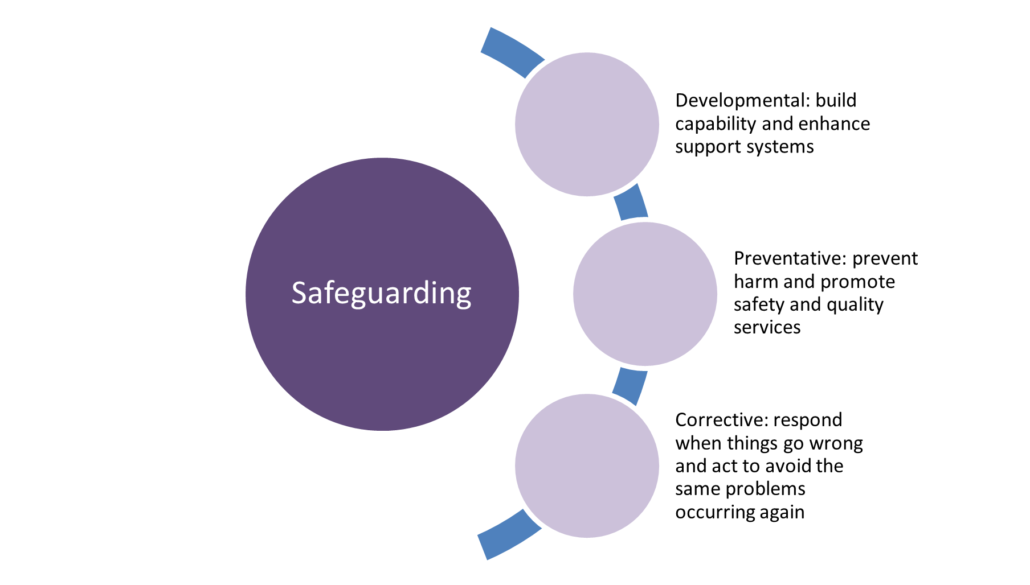

Contemporary safeguarding approaches address issues at multiple points. It includes actions across 3 domains. CIMS functions as part of a *corrective* safeguarding response. This means CIMS functions to respond to an incident and take action to prevent the incident from occurring again.

Working in a connected and collaborative way, CIMS promotes a just and continuous learning culture. Reflecting on and learning from an incident is a critical part of CIMS. Through analysing patterns and trends, a systems approach is undertaken. This promotes safe, effective, person-centred and connected services for everybody, every time.[5]

## 1.3 CIMS purpose, objectives and principles

#### Purpose

The primary purpose of CIMS is to safeguard clients. It does this by providing timely and effective responses to incidents that harm them during service delivery. This, in turn, enables service providers to enhance service delivery by learning from incidents.

#### Objectives

The objectives of CIMS are to:

* ensure timely and effective responses to incidents address client safety and wellbeing
* ensure effective and appropriate investigations of incidents
* ensure effective and appropriate reviews of incidents
* learn from individual incidents and patterns of incidents to reduce the risk of harm to clients and improve the quality of services and the service system
* ensure accountability of service providers to clients
* protect and maintain the personal and sensitive information of those involved in CIMS.

#### Principles

The principles listed in Table 1.1 underpin CIMS.

Table 1.1: CIMS principles

| Principle | Description |
| --- | --- |
| **Person-centred** | All people involved in an incident are respected and encouraged to contribute their values, beliefs and circumstances. CIMS responds to the clients’ preferences while promoting natural justice and a just culture. |
| **Outcome-focused** | The client’s safety and wellbeing are the primary focus of the incident response and management. |
| **Prioritising client-voice** | Clients are listened to, heard, understood and their views prioritised throughout CIMS. Clients know how their voice has been used and are supported to take part meaningfully in decision making. |
| **Aboriginal self-determination, voice and cultural safety** | Understanding, respect and support for Aboriginal culture, cultural diversity, customary lore, knowledge, perspectives and expertise across all stages of CIMS. |
| **Continuous improvement** | Issues are identified and changes are implemented to improve outcomes for client safety and wellbeing. |
| **Collaboration** | Service providers and the department work together to improve the safety and wellbeing of clients. |
| **Accountable** | Service providers and the department are accountable for their roles and responsibilities. |
| **Proportionate** | The nature of any investigation, review or other actions following an incident will align with the harm caused to the client and the risk of future harm. |

## 1.4 CIMS stages

This policy sets out the 5 stages of CIMS for incident management, review, analysis and system-wide learning (shown also in Figure 1.2).

Figure 1.2: Overview of CIMS stages

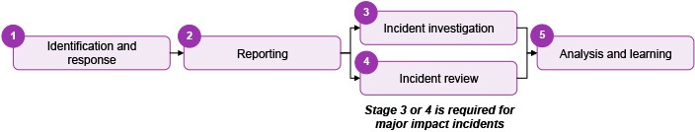

**Stage 1: Identification and response**

* Identification is when an incident is disclosed to, or observed by, a service provider. This can include disclosure by a client, family member or other professionals.
* Response covers the immediate activities undertaken to ensure the safety and wellbeing of clients, staff and visitors and notifying emergency services, family or other support people.

**Stage 2: Reporting**

* Submission of an incident report to the CIMS IT platform.
* Incident information is recorded accurately. Appropriate actions are being planned and undertaken to manage the incident.

**Stage 3: Incident investigation**

* Incident investigations are conducted for incidents of abuse, neglect or unexplained injury.

**Stage 4: Incident review**

* Incident reviews are conducted for all major impact incidents not subject to an incident investigation.

**Stage 5: Analysis and learning**

* Learnings from investigations and reviews are embedded in care and case planning, service and system improvement.
* Patterns and trends are found through analysing client incident information and are used to enhance the quality of services and supports provided to clients.

The following chapters of this policy are structured to align with each CIMS stage.

## 1.5 Roles and responsibilities

This policy identifies 5 specific functional roles in CIMS. People who participate or work in each of the 5 functional layers of CIMS have distinct and separate responsibilities (Table 1.2).[6]

Table 1.2: Functional roles in CIMS

| Role | Responsibilities |
| --- | --- |
| Client | * All actions and decision making in CIMS are client-centred and respond to the client’s views and wishes * The client has input into all areas of the reporting and management of CIMS |
| Service provider | * Service providers are both department-delivered and department-funded services * Service providers effectively respond to, report and manage incidents * Service providers learn from each incident to manage and improve the quality of their services |
| Operations Support | * Operations Support are departmental teams that manage the CIMS IT platform and conduct quality assurance on the application of CIMS policy * Operations Support rolls out the CIMS policy and provides training and guidance to support the implementation of CIMS * Operations Support reports on incident trends |
| Contract manager | * Contract managers are departmental teams that manage and track the service agreements with department-funded services * Contract managers analyse trends in incident reporting for department-funded services, to guide contract and performance discussions |
| System steward | * The system steward oversees and manages system policies, institutions, infrastructure, performance, policy and planning for services in scope of CIMS * The system steward uses incident trend data to inform the development and implementation of policy |

## 1.6 Policy context

CIMS is informed by legislation and other publications including:

* *Carer Recognition Act 2012*
* *Charter for children in out-of-home care 2007*
* *Charter of Human Rights 2006*
* *Children and Health Legislation Amendment (Statement of Recognition, Aboriginal Self-determination and Other Matters) Act 2023*
* Child Safe Standards
* *Child Wellbeing and Safety Act 2005*
* *Children, Youth and Families Act 2005*
* *Client voice framework for community services 2019*
* *Commission for Children and Young People Act 2012*
* *Community Services Quality Governance Framework 2018*
* *Disability Act 2006*
* *National Disability Insurance Scheme Act 2013*
* *Privacy and Data Protection Act 2014*
* Reportable Conduct Scheme
* *Social Services Regulation Act 2021*
* *Victorian charter supporting people in care relationships 2012.*

## 1.7 Scope

Services in scope for CIMS are department-delivered or -funded service providers. Service providers in scope of this policy must report in CIMS incidents that occur during service delivery and result in harm to a client or are reasonably likely to cause serious harm to a client.

The services in scope for this policy align with the prescribed social services of the Social Services Regulation Act(the Act). The list below is a high-level summary of the services in scope of the Social Services Regulator and CIMS policy:[7]

* child protection services[8],[9]
* community-based child and family services
* disability services[10]
* family violence services
* homelessness services
* out-of-home care services
* secure welfare services
* sexual assault services.

Please refer to the Social Services Regulator for detailed guidance on specific services or programs in scope of the Act.

The following services remain in scope of CIMS, even though they are outside the scope of the Social Services Regulator. Please note that services that report through the Victorian Health Incident Management System are not in scope for CIMS.

**Housing and community building services:**

* department-managed public housing.

**Health services:**

* aged care and carer’s support services
* alcohol and drug treatment services
* community palliative care services
* home and community care services for people aged under 65 or under 50 for Aboriginal people
* mental health community support services
* sexual health prevention services.

# Chapter 2: Responding to an incident

Identification and response is the first stage in the CIMS framework (Figure 2.1).

Figure 2.1: CIMS incident stages, focusing on identification and response

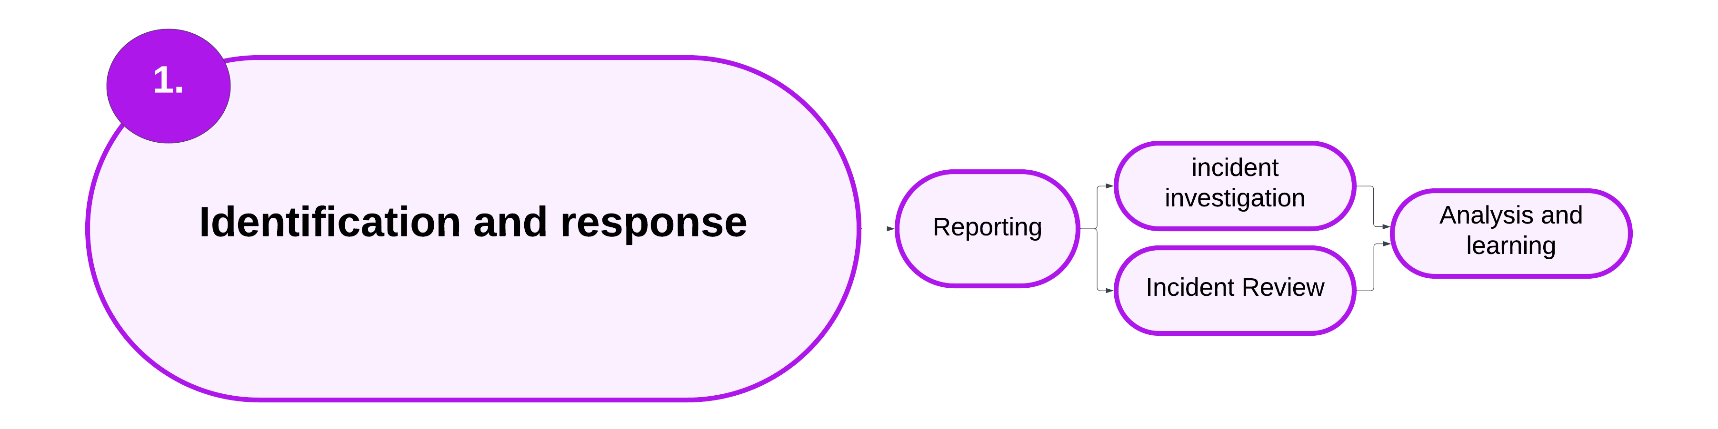

* Identification is when an incident is disclosed to, or observed by, a service provider. This can include disclosure by a client, family member or other professionals.
* Response covers the immediate activities undertaken to ensure the safety and wellbeing of clients, staff and visitors.

## 2.1 Responding to an incident – overview

A client incident is:

An event or circumstance that occurred during service delivery and resulted in harm to the client or is reasonably likely to cause serious harm to the client.

This chapter sets out the minimum requirements for responding to a client incident.

Policy and guidance in this chapter:

* 2.2 Immediate response
* 2.3 Service provider notifies the next of kin, guardian or key support person of the incident
* 2.4 Service provider reports the incident to Victoria Police
* 2.5 The subject of allegation is removed or relocated
* 2.6 Ongoing support
* 2.7 Supporting carers who are the subject of allegation
* 2.8 Staff members who are the subject of allegation
* 2.9 Responding to an incident – summary

## **2.2 Immediate response**

Once an incident has occurred, the priority is the health, safety and wellbeing of the client and others involved. This section sets out the minimum requirements for the immediate response stage of responding to an incident.

### Immediate response – policy

1. Service provider ensures client’s immediate safety.
2. Service provider arranges medical attention for the client (if needed).
3. Service provider establishes a basic understanding of what has occurred.
4. Service providers recognise and acknowledge the impact of the incident on the client.
5. Service providers assure the client that the incident will be taken seriously and dealt with in a fair and equitable manner.
6. When the client is involved with Child Protection, or if the client is authorised to an ACAC provider, the service provider must inform the client’s child protection or ACAC practitioner of the incident.
7. Service provider notifies the next of kin, guardian or key support person of the incident. Refer to section 2.3.
8. Service provider reports the incident to Victoria Police (if needed). Refer to section 2.4.
9. The subject of allegation is removed, relocated or stood down (if relevant). Refer to section 2.5 .
10. Service provider explains to the client what actions will be taken in response to the incident. This includes educating the client about their rights and taking their wishes into consideration.
11. Service provider puts in place a support plan for the carer when they are the subject of an allegation. Refer to section 2.7.
12. Service provider documents all actions undertaken on the client’s case file.

For Aboriginal clients receiving child protection services:

1. The service provider must consult with the relevant Aboriginal Child Specialist Advice and Support Service (ACSASS). Or, if the client is authorised to an ACAC provider, consult with the relevant Aboriginal agency.

### Immediate response – implementation guidance

#### ACSASS consultation

ACSASS is a specialised, child-focused service that has a critical role in enabling culturally appropriate and effective responses to protect Aboriginal children from harm and uphold their cultural rights.[11]

ACSASS offers specialist advice and support to Child Protection in relation to Aboriginal children. The service provides culturally attuned input into risk assessment and significant decisions. This includes responding to and managing major impact incidents such as allegations of abuse or neglect by a carer.

Aboriginal children and young people who are authorised to an Aboriginal agency under s 18 of the Children, Youth and Families Act(ACAC) are not in scope for ACSASS. In these cases, consultation must occur with the authorised Aboriginal agency.

Service providers must initiate the consultation with ACSASS. More information is in the [Child Protection Manual](https://www.cpmanual.vic.gov.au/sites/default/files/2019-11/2850%20ACSASS%20program%20requirements%20-%20revised%20February%202019.pdf) https://www.cpmanual.vic.gov.au.

#### Child Protection and ACAC clients

When the service provider responding to the incident is not Child Protection or an ACAC provider, the service provider must inform the relevant child protection practitioner or ACAC practitioner of the incident as soon as reasonably practicable.

Child Protection and ACAC providers must consider the immediate safety of the child, including the appropriateness of the placement while the incident is reported and follow-up actions are undertaken. The statutory responsibilities of the child protection or ACAC practitioner under the Children, Youth and Families Actare distinct and separate to CIMS requirements.

### Immediate response – roles and responsibilities

Table 2.1: Roles and responsibilities for responding to an incident

| Roles | Responsibilities |
| --- | --- |
| Client | * Have their views and wishes heard. * Have input into what follow-up actions should be taken. * Have input into what would make them feel safe. |
| Service provider | * Hear the views and wishes of the client. * Undertake all relevant actions listed in section 2.2 (Immediate response). |
| Operations Support | * Provide practice guidance and expert advice. |
| Contract manager | N/A |
| System steward | N/A |

## 2.3 Service provider notifies the next of kin, guardian or key support person of the incident

This section details the added requirements for notifying the next of kin, guardian or key support person.

### Service provider notifies the next of kin, guardian or key support person of the incident – policy

1. Service provider must explain to the next of kin, guardian or support person as soon as reasonably practicable about:
   * the nature of the incident
   * the standard procedure for reporting allegations to Victoria Police (if relevant)
   * that the client may choose to take part in the police investigation (if relevant)
   * any action that has been taken since reporting the incident.
2. Service provider must document the notification to the next of kin, guardian or support person on the client’s file.

### Service provider notifies the next of kin, guardian or key support person of the incident – implementation guidance

#### The departmental Secretary has parental responsibility for a client

The Children’s Court may grant parental responsibility of a client to the Secretary of the department or an authorised Aboriginal agency when they are in need or protection and cannot safely stay in their parents’ care. These orders include:

* family reunification order
* care by Secretary order
* long-term care order.

Where the service provider is not Child Protection or an ACAC provider, the service provider must notify the child protection practitioner or ACAC practitioner of the incident, as detailed in section 2.2. Child Protection/ACAC have statutory responsibilities that are distinct and separate from CIMS responsibilities. This includes decision-making responsibility for the client’s placement.

The child protection or ACAC practitioner informs the client’s parents, or next of kin, of the incident if appropriate to do so. Where possible, parents will be informed, consulted and appropriately involved in supporting the client.

When the incident requires forensic follow-up, such as a forensic medical examination, usual practice will involve seeking parental consent for forensic medical examinations regardless of whether the legislation requires consent or not.[12] Child protection or ACAC providers are responsible for undertaking these actions.

Detailed information and advice is available in the [Child Protection Manual](https://www.cpmanual.vic.gov.au/policies-and-procedures/health-medical-and-disability/medical-and-forensic-examinations) https://www.cpmanual.vic.gov.au/policies-and-procedures/health-medical-and-disability/medical-and-forensic-examinations.

#### A client receiving child protection or ACAC services does not wish for their next of kin to be contacted

If the client does not wish for their parents, or next of kin, to be notified of an incident, this should be discussed with the child protection director or ACAC manager. Clients have the right to make decisions on who is notified of an incident. A decision in relation to notification will need to consider factors including the client’s age and capacity, where they are living and their best interests. If necessary, legal advice should be sought. If the decision is made to not notify the parent or next of kin, this must be documented and placed on the client’s file.

#### The client is over 18 years

The client can decide whether to inform the next of kin of the allegations.

#### The client is under 18 years and receiving disability services

The service provider must ensure the next of kin or guardian is contacted.

For matters that must be reported to Victoria Police, the next of kin or guardian should be asked if they wish to be present while the client’s statement is being taken. Victoria Police will then decide whether the next of kin or guardian can take part in the interview.

#### The client is over 18 years and receiving disability services

The client can decide whether to inform the next of kin of the allegations. In the case of a client with a cognitive impairment, where the client decides not to advise their next of kin, service providers should document this. If the client chooses to notify the next of kin, the service provider should help the client to make contact.

Where the client has a guardian appointed by the Victorian Civil and Administrative Tribunal (VCAT), the guardian must be informed.

#### The client has a legal guardian

A legal guardian may be:

* the parents of a client under the age of 18
* the Secretary of the department for clients under the age of 18 subject to Children’s Court orders that grant the Secretary parental responsibility
* permanent care parents of a client under the age of 18
* a person granted a guardianship order by VCAT to make decisions on behalf of the client
* the Office of the Public Advocate, who have been nominated under a guardianship order by VCAT to make decisions on behalf of the client.

Service providers must notify the guardian of the incident.

For matters that must be reported to Victoria Police, the guardian should be asked if they wish to be present while the client’s statement is being taken. Victoria Police will decide whether the guardian can take part in the interview.

### Service provider notifies the next of kin, guardian or key support person of the incident – roles and responsibilities

Table 2.2: Roles and responsibilities for notifying the next of kin, guardian or key support person

| Roles | Responsibilities |
| --- | --- |
| Client | * Have their views and wishes heard. |
| Service provider | * Hear the views and wishes of the client. * Undertake all relevant actions listed in section 2.3. |
| Operations Support | * Provide practice guidance and expert advice. |
| Contract manager | N/A |
| System steward | N/A |

## 2.4 Service provider reports the incident to Victoria Police

Service providers must report alleged criminal acts including allegations of abuse to Victoria Police in specific cases. The term ‘client victim’ is used to distinguish actions required by service providers when the client is the victim of an alleged criminal act. This section details the added requirements for reporting the incident to Victoria Police (summarised in Figure 2.2).

Figure 2.2: Decision tree to report incidents to Victoria Police

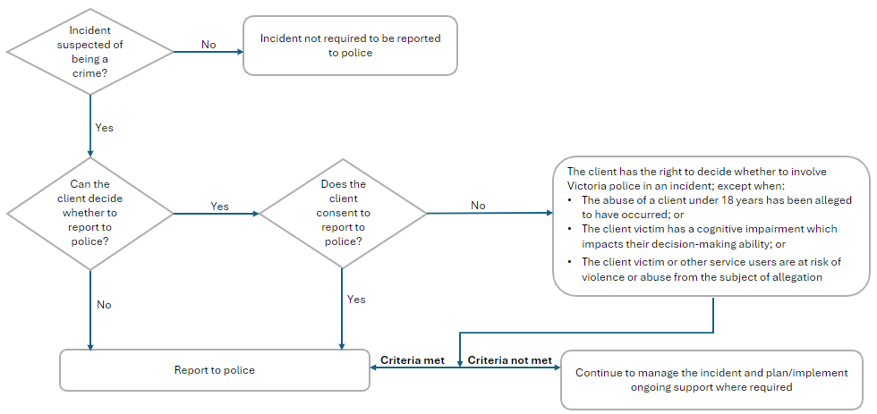

### Service provider reports the incident to Victoria Police – policy

1. Where an incident requires an emergency response from police, contact Triple Zero (000).

2. If a crime is suspected to have occurred, the most senior staff member present must report the incident to Victoria Police **if** the client victim consents to police involvement.

3. The client victim has the right to decide whether to involve Victoria Police in an incident except when:

* + the client victim is under 18 years of age and abuse has been alleged to have occurred
  + the client victim has a cognitive impairment that affect their decision-making ability, or
  + the client victim or other service users are at risk of violence or abuse from the subject of allegation.

If any of the above criteria are met, the service provider must report the incident to Victoria Police as soon as reasonably practicable. This is the case even if the client victim does not consent for Victoria Police to be notified.

4. When the client is the subject of allegation and Victoria Police has been notified, the service provider must consult with Victoria Police about whether the client should be told about the report and to collaborate on how to proceed.

### Service provider reports the incident to Victoria Police – implementation guidance

#### Informing the client victim of the actions that will be taken

When a report is made to Victoria Police, the service provider must inform the client victim. Service providers must provide the following information to the client victim to support them in making an informed decision about whether to take part in a Victoria Police investigation:

* whether the matter must be reported to Victoria Police regardless of the client’s consent
* that Victoria Police may, or may not, investigate the incident
* police officers may want to interview the client and take a statement
* the client can choose whether to take part in the police investigation
* Victoria Police will decide whether to charge the subject of allegation with an offence
* a parent, guardian, Independent Person or Independent Third Person can be present throughout contact with the police, to provide support to the client
* resources and help to seek support or legal advice.

#### Notifying Victoria Police

Client victims may initially decline involving Victoria Police and change their mind later. When the client victim is over 18 years of age, it is not necessary for the client victim to decide immediately about whether to report to Victoria Police.

When an emergency response is not needed and the client victim consents to contact with Victoria Police, speak with the general duties police unit. Some areas will be covered by Victoria Police’s Sexual Offences and Child Abuse Investigation Team. Victoria Police will advise of next steps.

If the client victim does not consent to the incident being reported to Victoria Police and has capacity to make this decision, this wish should be respected. The policy stipulates the times when Victoria Police must be notified of an incident, even if the client victim doesn’t wish for this to occur. In these cases, the service provider must explain to the client why they must report the incident to Victoria Police and plan to support the client to be involved in the CIMS report and follow-up process, as much as is reasonably possible.

#### Reducing the criminalisation of young people in residential care

The department, residential care service providers and Victoria Police have a joint responsibility to reduce the unnecessary and/or inappropriate contact of young people in residential care with police and the criminal justice system.

A police response in a non-crisis situation within a residential care home or the community should be the last resort and only considered after other de-escalation strategies have been attempted without success.[13] In these cases, the analysis and learning from the incident is critical, to ensure the client’s behaviour support plan and case management plan are modified to mitigate involvement of Victoria Police.

The *Framework to reduce criminalisation of young people in residential care* does not impact on mandatory reporting and/or the need to report crimes to police. However, the framework reduces unnecessary police involvement in matters that would normally be dealt with by parents in a traditional home environment.

More information on the framework is on the [department’s website](https://providers.dffh.vic.gov.au/framework-reduce-criminalisation-young-people-residential-care) https://providers.dffh.vic.gov.au/framework-reduce-criminalisation-young-people-residential-care.

### Service provider reports the incident to Victoria Police – roles and responsibilities

Table 2.3: Roles and responsibilities for reporting the incident to Victoria Police

| Roles | Responsibilities |
| --- | --- |
| Client | * Have their views and wishes heard. |
| Service provider | * Hear the views and wishes of the client. * Undertake all relevant actions listed in section 2.4. |
| Operations Support | * Provide practice guidance and expert advice. |
| Contract manager | N/A |
| System steward | N/A |

## 2.5 The subject of allegation is removed or relocated

When a service provider becomes aware of an allegation of abuse, the safety of the client is the primary concern. This includes preventing any more contact between the client and the subject of allegation. This section details the extra requirements for removing or relocating the subject of allegation.

### The subject of allegation is removed or relocated – policy

1. Service provider must put in place a plan to prevent any more contact between the client and the subject of allegation.
2. Service provider relocates the subject of allegation away from the client while the investigation is undertaken (preferred).

* When the subject of allegation is a child protection client in a residential care placement, the placement provider must consult with Child Protection about the placement. Child Protection is responsible for deciding the placement.

1. When the subject of allegation cannot be relocated, a safety plan must be put in place to ensure the safety of the client, other clients and staff. For clients receiving child protection or ACAC services, the child protection area director or ACAC area manager must endorse this plan.

For clients receiving disability services, the following requirements must be followed:

1. If a client of disability services is to be relocated, a consultation with senior department management must occur.
2. If the person subject to relocation lives in a residential accommodation service, any relevant requirements under the Disability Actand the *Strengthening rights in residential services policy 2010* must be followed.
3. The client or their guardian must consent to the relocation.

* When the consent of the client, guardian or next of kin is not provided or cannot be obtained and the relocation of the client is reasonably called for to prevent the foreseeable risk of serious harm, the person may be relocated provided:
  + the most senior staff member present has consulted with the Office of the Public Advocate
  + advice has been sought from the appropriate management within the service provider
  + where the client has a designated advocate, their advice has been obtained where possible.

1. When the person who is the subject of allegation cannot be relocated, such as when the subject of allegation is a co-client living in a residential treatment facility under the Disability Act, a safety plan must be put in place to ensure the safety of the client, other clients and staff.

**Where immediate action is needed to prevent serious harm in emergency situations, these requirements may be waived if, in the opinion of the most senior staff member present, a delay in acting would lead to serious harm.**

### The subject of allegation is removed or relocated – roles and responsibilities

Table 2.4: Roles and responsibilities for when the subject of allegation is removed or relocated

| Roles | Responsibilities |
| --- | --- |
| Client | * Have their views and wishes heard. |
| Service provider | * Hear the views and wishes of the client. * Undertake all relevant actions listed in section 2.5. |
| Operations Support | * Provide practice guidance and expert advice. |
| Contract manager | N/A |
| System steward | * Review and endorse the relocation of a person with disability. |

## 2.6 Ongoing support

After the immediate response to the incident has occurred, ongoing support should be provided to promote and assist the client’s recovery from the incident and to ensure the client’s ongoing wellbeing and safety. This section sets out the minimum requirements in the ongoing support stage of responding to an incident.

### Ongoing support – policy

1. Service provider must review the client’s care or support plan and include any modifications or ongoing risk management strategies.
2. Service provider ensures the client has access to support services to address their safety and wellbeing needs.
3. Service provider ensures the client has connection and access to culturally appropriate support, including connection to community (if relevant).
4. Service provider supports the client through any action the client takes to seek justice or redress, including making a report to Victoria Police or accessing legal counsel.
5. Service provider provides direct support to clients to discuss the incident and documents key actions in the client’s file.

For Aboriginal clients receiving child protection services:

1. Service provider documents consultation with ACSASS or ACAC provider.
2. Service provider implements recommendations from ACSASS or ACAC provider.

### Ongoing support – implementation guidance

#### Supporting the client through the justice process

Service providers should support both the client victim and client who is the subject of allegation through the justice process. This includes the police investigation, prosecution and crimes compensation processes as appropriate. This support may include the following:

* For matters that need the client victim’s consent to report to Victoria Police, supporting the client victim to decide, in their own time, what actions they would like taken.
* Supporting the client to seek specialist support, including independent legal advice, to support their decision making.
* Ensuring the client has access to appropriate communication support and tools to aid disclosures and provide evidence.
* Ensuring the client has access to a key support person of their choosing.
* Alerting the police to the need for an Independent Third Person and the client’s particular communication support needs.
* Facilitating arrangements with police for interviews and examination of evidence.

### Ongoing support – roles and responsibilities

Table 2.5: Roles and responsibilities for ongoing support roles

| Roles | Responsibilities |
| --- | --- |
| Client | * Have their views and wishes heard. * Lead ongoing support planning (if appropriate). |
| Service provider | * Hear the views and wishes of the client. * Ensure support planning is client-led. * Undertake all relevant actions listed in section 2.6. |
| Operations Support | * Provide practice guidance and expert advice. |
| Contract manager | N/A |
| System steward | N/A |

## 2.7 Supporting carers who are the subject of allegation

Foster and kinship carers who are the subject of allegation need support from the service provider throughout the CIMS stages. This section details the requirements for supporting carers who are the subject of allegation. This is in addition to section 4.2.

### Supporting carers who are the subject of allegation – policy

Service providers must undertake the following actions when a carer is subject of an allegation. These actions must be formally documented in a support plan. Where a kinship carer is not contracted to an agency, Child Protection or the ACAC provider are responsible for these actions.

1. Allocate a liaison person for the carer to contact.
2. Provide advice to the carer about procedures and timeframes for investigation/review.
3. Keep the carer up to date with the progress of the investigation.
4. Provide information to the carer on any parallel reporting requirements.
5. Provide information to the carer about services available.
6. Provide referral to appropriate support services.
7. Inform the carer about the process to seek a review, resolve disputes or make a complaint.

### Supporting carers who are the subject of allegation – implementation guidance

The Carers Recognition Actformally acknowledges the important contribution that people in care relationships make. The Act is supported by the *Victorian charter supporting people in care relationships* (the charter),which includes care provided by foster and kinship carers.

When managing an incident where the carer is the subject of an allegation, the service provider must act in a way that upholds thecharter.

Principles of the charter are that carers must:

* be respected and recognised:
  + as an individual with their own needs
  + as a carer
  + as someone with special knowledge of the person in their care
* be supported as an individual and as a carer, including during changes to the care relationship
* be recognised for their efforts and dedication as a carer
* have their views and cultural identity considered, together with the views, cultural identity, needs and best interests of the child or young people for whom they provide care
* have their social wellbeing and health recognised in matters relating to the care relationship.

Refer to the DFFH Providers website for more information on the Carers Recognition Act https://providers.dffh.vic.gov.au/carers-recognition-act-2012.

Refer to the DFFH Providers website for more information on the [Victorian charter supporting people in care relationships](https://providers.dffh.vic.gov.au/victorian-charter-supporting-people-care-relationships-word) https://providers.dffh.vic.gov.au/victorian-charter-support-people-care-relationships-word.

Refer to the DFFH Providers website for more information for kinship carers in the [Manual for Kinship Carers](https://services.dffh.vic.gov.au/manual-kinship-carers-word) https://services.dffh.vic.gov.au/manual-kinship-carers-word.

#### Aboriginal carers

Aboriginal people are disproportionately affected by traumatic and adverse events due to the experience of transgenerational trauma. Oppressive legislation and practices have an enduring impact on the social and emotional wellbeing of Aboriginal people.

Service providers must consider the history of Aboriginal carers and how the legacy of oppressive legislation and practices may impact the carer’s social and emotional wellbeing throughout CIMS stages. Support planning for Aboriginal carers must take a holistic view and be conducted with an Aboriginal self-determination and cultural safety lens.

#### Allocating a liaison person

Carers should be allocated a key liaison person to contact throughout the CIMS stages.

For carers whose case manager is conducting the CIMS investigation, it is not appropriate for this person to also be the liaison person. Service providers should consider whether there is an alternative staff member who can conduct the investigation or be the liaison person for the carer. Consideration should be given to the relationships the carer has with staff from the service provider. It is optimal for the liaison person to have an existing relationship with the carer, to enhance the effectiveness of support to the carer throughout CIMS processes.

#### How to seek a review or make a complaint

This section is specific to issues raised during the incident reporting and investigation process. For policy and guidance on challenging the outcome of an investigation or review, refer to section 4.8.

Carers should be given information about the service provider’s and the department’s review and complaint process to raise concerns during the incident reporting period. Service providers must provide the opportunity for carers to raise their views throughout the incident reporting and investigation. Ensuring the carer is heard can reduce the likelihood that a formal complaint will be raised.

Information for the feedback and complaints process for the department is at [Making a complaint](https://www.dffh.vic.gov.au/making-complaint) https://dffh.vic.gov.au/making-complaint.

A complaint can be raised with the Victorian Ombudsman. For more information, visit the [Victorian Ombudsman website](https://www.ombudsman.vic.gov.au/complaints/child-welfare/) www.ombudsman.vic.gov.au/complaints/child-welfare/.

### Supporting carers who are the subject of allegation – roles and responsibilities

Table 2.6: Roles and responsibilities for supporting carers who are the subject of allegation

| Roles | Responsibilities |
| --- | --- |
| Client | N/A |
| Service provider | * Hear the story, views and wishes of the carer. * Undertake all actions listed in section 2.7. |
| Operations Support | * Provide practice guidance and expert advice. |
| Contract manager | N/A |
| System steward | N/A |

## 2.8 Staff members who are the subject of allegation

This section outlines the response requirements where a staff member is the subject of an allegation of abuse against a client. This section is not relevant to staff members who are registered foster or kinship carers providing care to a client – refer to section 2.4.

### Staff members who are the subject of allegation – policy

1. Service provider notifies the subject of allegation’s line manager of the incident.
2. Line manager notifies the appropriate senior manager of the incident.
3. Service provider follows their disciplinary procedures and legal obligations in managing the subject of allegation.

### Staff members who are the subject of allegation – implementation guidance

Staff members who are the subject of allegation may need extra supports as an investigation or review takes place. It is best practice for the service provider to provide information on their employee assistance program to the staff member.

### Staff members who are the subject of allegation – roles and responsibilities

Table 2.7: Roles and responsibilities for staff members who are the subject of allegation

| Roles | Responsibilities |
| --- | --- |
| Client | N/A |
| Service provider | * Undertake all relevant actions listed in section 2.8. |
| Operations Support | N/A |
| Contract manager | N/A |
| System steward | N/A |

## 2.9 Responding to an incident – summary

Figure 2.3 overviews the process for responding to an incident.

Figure 2.3: High-level overview of responding to an incident process

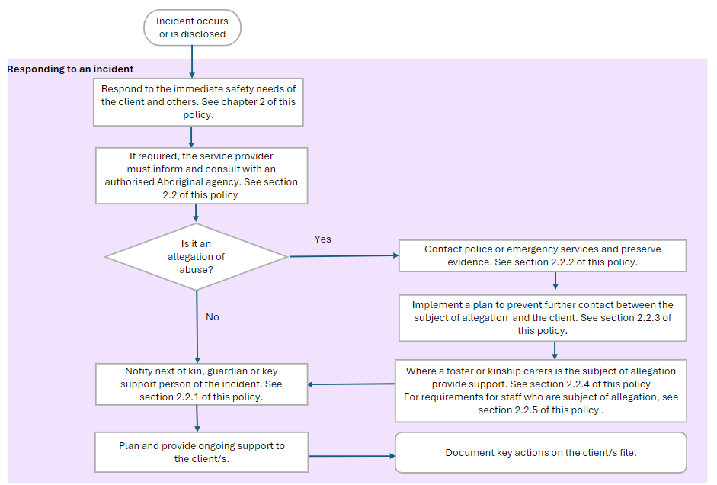

### Summary of responding to an incident roles and responsibilities

The below table presents a high-level overview of the roles and responsibilities for each layer in CIMS in the incident identification and response stage of CIMS.

Table 2.8: High-level roles and responsibilities for incident identification and response[14]

| Roles | Responsibilities |
| --- | --- |
| Client | * Have input into the follow-up actions undertaken by the service provider. |
| Service provider | * Hear the client’s story, views and wishes. * Ensure the client’s wishes are central to all decision making. In cases where the client’s wishes cannot be followed, the service provider must ensure this is explained to the client. * Assess and take all appropriate actions to ensure the safety and wellbeing of the client. |
| Operations Support | * Review the incident report for meeting CIMS minimum requirements. * Provide practice guidance and expert advice. |
| Contract manager | N/A |
| System steward | N/A |

# Chapter 3: Reporting an incident

Reporting is the second stage in the CIMS framework (Figure 3.1).

Figure 3.1: CIMS incident stages, focusing on reporting

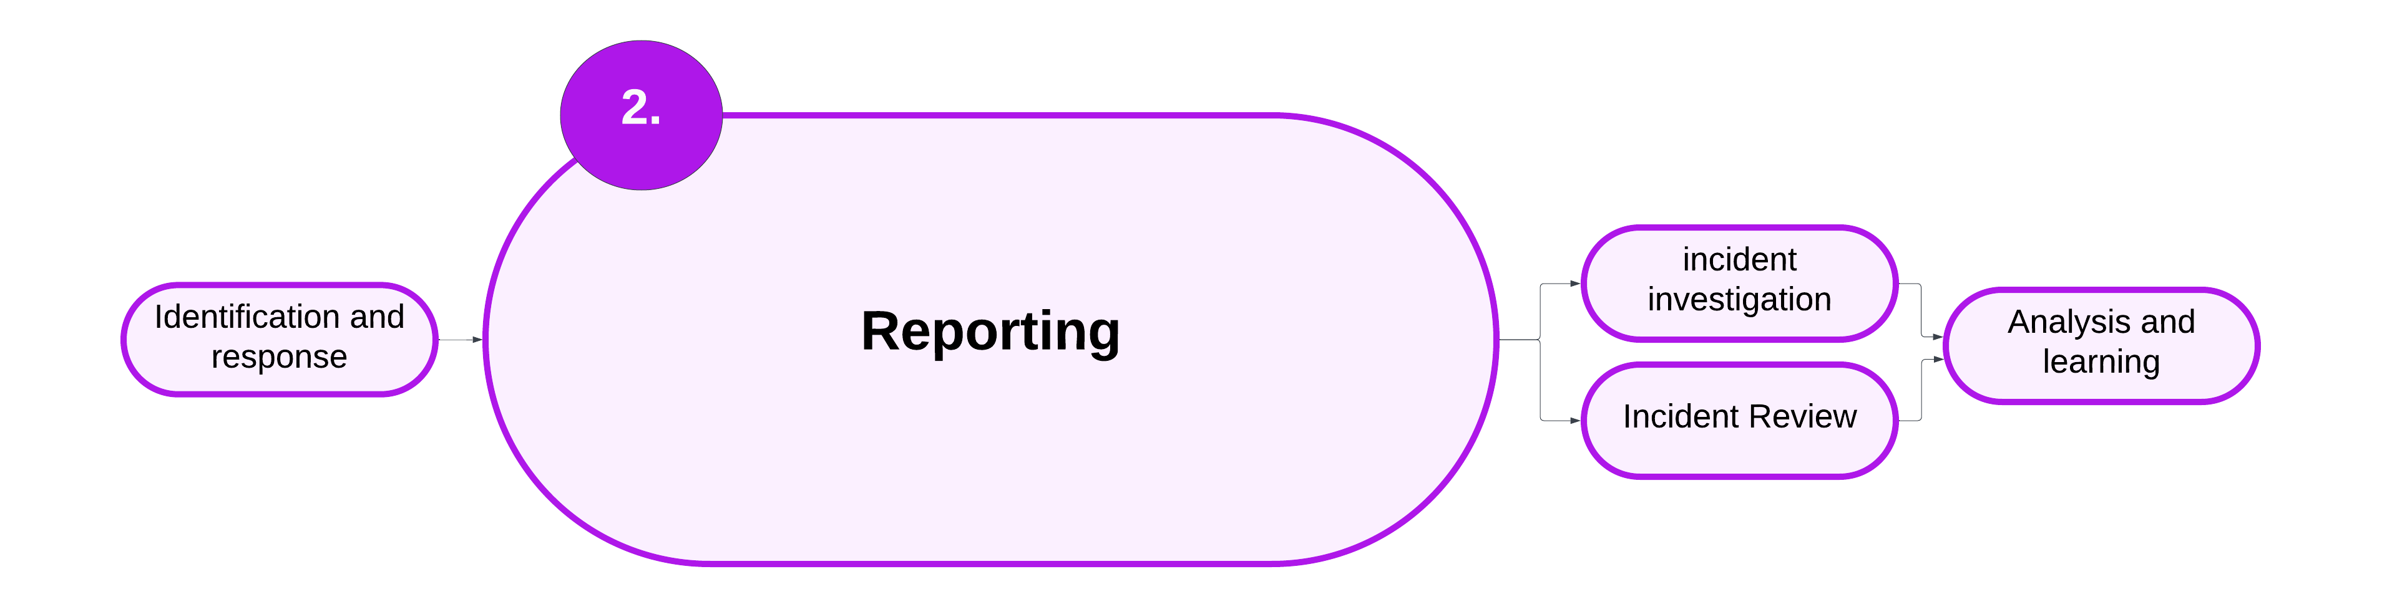

* The reporting stage involves submitting an incident report to the CIMS IT platform.
* Incident information is recorded accurately, and appropriate actions are being planned and undertaken to manage the incident.

## 3.1 Reporting an incident – overview

A client incident that meets the threshold of an incident type listed in Appendix 1 must be reported in CIMS.

Some client incidents may occur that don’t meet the threshold of reporting in CIMS. In these cases, service providers are entrusted to safely respond to and manage the incident. Service providers must record these incidents in their own systems.

This chapter sets out the minimum requirements for reporting an incident in CIMS.

Policy and guidance in this chapter:

* 3.2 Criteria for submitting an incident report
* 3.3 Reporting an incident
* 3.4 Common clients
* 3.5 Reporting historical incidents
* 3.6 Privacy requirements
* 3.7 Other reporting requirements
* 3.8 Summary

## 3.2 Criteria for submitting an incident report

This section sets out the minimum requirements for submitting an incident report.

### Criteria for submitting an incident report – policy

1. Service providers must report all incidents that meet the threshold of a CIMS incident type in CIMS, listed in Appendix 1.
2. An incident report must be submitted when the client experiences harm from an incident type during service delivery. CIMS defines during service delivery as:

An incident that has occurred ‘during service delivery’ is an incident that occurs during any of the following circumstances:

* + When the client is receiving a service (for example, when a staff member is with a client, when the client is on an outing where a staff member is present, or when the client is engaging with a service online or via telephone).
  + When the client attends a service provider’s premises including offices, residential services, respite facilities or day services. This includes the area within the boundaries of the premises, as well as the surrounding area within sight of the premises.
  + For clients under the care of 24-hour services (for example, out-of-home care, custodial services, supported accommodation or child protection), any incident is deemed to occur during service delivery.
  + For off-site/outreach services, this includes incidents that occur at the location of service delivery and the surrounding area within sight of that location. (For example, this includes when a staff member is providing in-home support or support in the community with the client, even if that support is minimal, such as an hour a month).
  + Where a client is receiving non-residential services (episodic open case, non-24-hour service) and an incident occurs that is related to providing the support or service. ‘Related to’ means the provider action or decision has harmed the client, or a direct link exists between the service provision and harm experienced by the client.

### Criteria for submitting an incident report – implementation guidance

#### Common clients

An incident may occur when a client is involved with multiple service providers, such as a client of Child Protection who receives adolescent support through a Targeted Care Package. Refer to section 3.4 for policy and implementation guidance.

#### The lawful use of force

When the use of force is lawful, authorised and duly used, a CIMS incident report is not needed. An incident report must always be submitted when the use of force was excessive or not lawful/authorised. When the lawful use of force was used to disrupt an incident, the incident is reported in CIMS under the appropriate incident type.

There are emergency cases that may call for force to be applied to the client, or for the client to be physically restrained.

* For details about when the use of restraint can be duly used in out-of-home care, refer to the [Guide to the emergency use of physical restraint in out-of-home-care](https://providers.dffh.vic.gov.au/guide-emergency-use-physical-restraint-out-home-care) https://providers.dffh.vic.gov.au/guide-emergency-use-physical-restraint-out-home-care
* For details about when restraint can be duly used in disability services, refer to the[*Physical restraint direction paper*](https://www.dffh.vic.gov.au/publications/physical-restraint-direction-paper-senior-practitioner)https://www.dffh.vic.gov.au/publications/physical-restraint-direction-paper-senior-practitioner.

When physical restraint has been used in keeping with the *Guide to the emergency use of physical restraint in out-of-home care* or the *Physical restraint direction paper* it is deemed authorised and so not reportable in CIMS.

Victoria Police may apply force, or physically restrain a client, in the lawful performance of their duties. Victoria Police may only use reasonable force in situations where they are authorised to do so, such as:

* to arrest a client
* to prevent the commission, continuance or completion of an indictable offence
* to prevent interference in the lawful arrest of a person committing or suspected of committing an offence.[15]

The lawful use of force must be recorded in the service provider’s case note system and any other required databases.

If the use of force or physical restraint was excessive, or not lawful, the incident must be reported in CIMS if it occurred during service delivery. In cases when a service provider believes that Victoria Police’s use of force was excessive, a complaint must also be made to the Police Conduct Unit.

Service providers can find more information on Victoria Police conduct by:

* visiting the [Police Conduct Unit webpage](https://www.police.vic.gov.au/complaints) https://www.police.vic.gov.au/complaints
* reading the [*Framework to reduce criminalisation of young people in residential care*](https://providers.dffh.vic.gov.au/framework-reduce-criminalisation-young-people-residential-care) https://providers.dffh.vic.gov.au/framework-reduce-criminalisation-young-people-residential-care.

### Criteria for submitting an incident report – roles and responsibilities

Table 3.1: Roles and responsibilities for submitting an incident report

| Roles | Responsibilities |
| --- | --- |
| Client | * Have their story heard. * Have input into the follow-up actions undertaken by the service provider. |
| Service provider | * Hear the client’s story, views and wishes. * Contact Operations Support for advice on whether to submit an incident report (if needed). * Submit the incident report. |
| Operations Support | * Provide practice guidance and expert advice on how and whether to submit an incident report. |
| Contract manager | N/A |
| System steward | N/A |

## 3.3 Reporting an incident

This section sets out the minimum requirements to complete an incident report. Figure 3.2 overviews the process for completing an incident report.

Figure 3.2: High-level overview of the process for completing an incident report

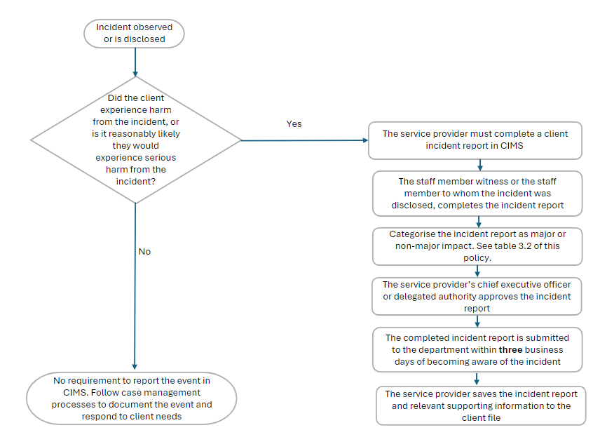

### Reporting an incident – policy

1. Service provider submits the incident report on the CIMS IT webform within **3 business days** of the incident occurring or of the service provider becoming aware of the incident.
2. Service providers follow the privacy provisions in their respective service agreements and/or the department’s privacy policy. More details are in section 3.6.

For Aboriginal clients receiving child protection services:

1. Service provider shares incident report with ACSASS, or if the client is authorised to an ACAC provider, the relevant Aboriginal agency.

#### Incident reporting process

1. The staff member witness to the incident, or the staff member to whom the incident was disclosed completes the incident report on the CIMS IT webform, or the service provider’s IT system.
2. The incident report is categorised as major or non-major impact, following the requirements of Table 3.2.
3. For major impact incidents, a follow-up action of investigation or review is selected.
4. The chief executive officer or delegated authority of the service provider reviews the incident report submitted by the staff member and:
   * completes a brief description of the incident (20 words or fewer)
   * confirms extra actions completed, such as notification to Victoria Police
   * quality checks the incident report, ensuring that appropriate incident type, category, client and location details are recorded.
5. The chief executive officer or delegated authority submits the completed incident report to the department within **3 business days** of the incident occurring or of the service provider becoming aware of the incident.
6. Operations Support reviews the submitted incident report for quality assurance.
7. Service provider saves the incident report and all relevant supporting information to the client’s file.

For child protection/ACAC clients only:

1. Incident report is uploaded to the client’s Client Relationship Information System (CRIS) file through an IT interface.

Table 3.2: Incident categorisation

| Always major impact | Assess impact | Always non-major impact |
| --- | --- | --- |
| * Attempted suicide * Death * Emotional and psychological abuse * Escape from a secure facility * Financial abuse * Neglect * Physical abuse * Sexual abuse * Sexual exploitation – grooming * Unexplained injury | * Absent client * Explained injury * Medication error * Self-harm | * Emotional and psychological harm * Inappropriate physical treatment * Inappropriate sexual behaviour * Serious risk * Sexual exploitation – suspected |

### Reporting an incident – implementation guidance

#### Selecting an incident type

An incident type is the descriptor of the key aspect of the incident. For each incident report, one primary incident type must be selected. For complex incidents where more than one type of harm was experienced, there is an option to add a secondary incident type. This option is not available when an incident of serious risk is being reported.

Please refer to Appendix 1 for the list of CIMS incident types and their definitions.

When choosing a primary incident type, service providers should choose the incident type that best describes the event that caused the greatest harm to the client (Figure 3.3).

#### Incident categorisation

Figure 3.3: Incident categorisation decision tree

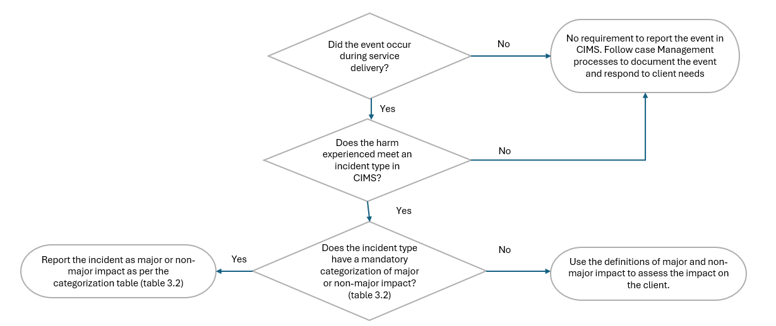

Most incident types have a mandatory incident categorisation, detailed in Table 3.2.

For incidents that require the service provider to assess impact, the service provider considers whether the harm experienced by the client meets the definition of major or non-major impact.

Major impact is defined in the following way.

Harm experienced by the client that:

* caused impairment, disfigurement or injury that is likely to be permanent or long-term or death; and/or
* is an accumulation of harms resulting in impairment, disfigurement or injury that is likely to be permanent or long-term or death; and/or
* requires an acute medical or mental health response; and/or
* requires significant extra resources or supports to respond to the needs of the client, such as long-term placement change, or extra staffing supports.

Non-major impact is defined in the following way:

* Client experiences harm from the incident at the time, but harm is not permanent or long-term. The incident does not need extra resources or supports beyond the client’s existing service, care arrangement or care planning to manage the response.
* The client was reasonably likely to experience serious harm from the incident.

It is important to consider the life experiences and characteristics of a client that may influence their experience of harm when assessing impact. Past experiences of harm can have a cumulative effect, increasing the impact of future experiences of harm.

For Aboriginal clients, cultural considerations of harm, including the ongoing impact of colonisation, are central to assessing impact. Aboriginal clients’ experiences of transgenerational trauma may express itself through behaviour and physical, emotional and psychological responses. Aboriginal people are disproportionately affected by traumatic and adverse events, which lead to a range of outcomes including the intergenerational transmission of trauma. Therefore, it is essential to consider how transgenerational trauma may contribute to the impact of an incident on a client.

#### Reporting an absent client incident

A CIMS incident report is required when a client’s whereabouts is unknown, or is known but their absence is not approved and is considered likely to result in harm.

Reporting of an absent client incident requires the service provider to understand the risk profile of the client to determine whether their absence is likely to result in harm. Understanding the client’s risk profile requires service providers to consider the client’s past experiences of harm and how this experience may have a cumulative effect for the current period of absence. When a safe custody warrant has been issued, a major impact CIMS incident report must be submitted. This is because the decision to issue a safe custody warrant indicates that the client’s absence has been determined likely to result in significant harm.

If a missing persons report has been made, service providers are to use professional judgement to assess whether the incident is categorised as a major or non-major impact incident.

Daily case notes should be used to record ongoing actions being undertaken throughout the client’s absence. A second incident report during the same incident of client absence should only be submitted when:

* the first incident report was categorised as non-major
* the client continues to be absent
* new information has become available to the service provider that has escalated the risk profile of the client to categorise the period of absence as a major impact incident.

### Reporting an incident – roles and responsibilities

Table 3.3: Roles and responsibilities for reporting an incident

| Roles | Responsibilities |
| --- | --- |
| Client | * Have their views and wishes heard. |
| Service provider | * Hear the client’s story, views and wishes. * Engage the client in constructing the narrative of the incident report (if appropriate). * Submit the incident report to the department within 3 business days of incident occurring/incident disclosure. |
| Operations Support | * Provide practice guidance and expert advice on the categorisation and classification of incidents. * Review the incident report for quality assurance. * Escalate significant and immediate concerns for the safety and wellbeing of a client to the attention of the responsible area director. * Oversee and support the IT interface between CIMS and CRIS. |
| Contract manager | N/A |
| System steward | N/A |

## 3.4 Common clients

An incident may occur when a client is involved with multiple service providers. This section sets out the minimum requirements for reporting an incident that relates to a common client.

### Common clients – policy

1. The service provider whose service delivery the incident occurred in must complete the CIMS incident report and all required follow-up tasks. This includes the investigation or review.

If the incident is disclosed to a different service provider:

1. The service provider to whom the disclosure is first made must submit an incident report; or
2. The service provider to whom the disclosure is first made informs the lead agency/relevant service provider of the incident (if known).
3. When the service provider who is responsible for incident reporting and follow-up actions is not known by the service provider to whom the disclosure was made, Operations Support will:
   * review the incident report submitted by the service provider to whom the disclosure was made
   * notify the relevant service provider of the incident and need to submit an incident report
   * withdraw the primary incident report with the notes *withdrawn as incident out of scope of service provider.*
4. The service provider to whom the disclosure is made conducts information sharing within the care team where appropriate.

### Common clients – implementation guidance

#### Notifying other service providers

When a client receives services from multiple service providers, incident information may need to be shared to promote the client’s health, safety or wellbeing.

When deciding whether it is appropriate for a client’s information to be shared, service providers should consider their legal obligations and privacy policies, as referred to in section 3.6. When a decision is made that information sharing is needed to promote the client’s health, safety or wellbeing, the service provider who is completing the incident report has responsibility for this function.

All information sharing activities should be documented on the client’s file by the service provider disclosing the client’s information.

Service providers must inform the child protection/ACAC provider of any incident that has occurred when the client is subject to involvement with these services, in keeping with legislative and service agreement requirements.

#### Child Protection case contracting arrangements

Child Protection/ACAC clients may be case contracted to a community service organisation (CSO) or Aboriginal Community Controlled Organisation (ACCO) for the day-to-day case management of the client. In cases where the case management of a client is contracted to a CSO or ACCO, it is the CSO/ACCO, not Child Protection, who are responsible for CIMS requirements. The CSO/ACCO must inform the child protection/ACAC practitioner of the incident as soon as is reasonably practicable.

In cases where the case is contracted to a CSO/ACCO, but the client lives in a placement provided by a second CSO/ACCO, it is the placement provider that is responsible for CIMS requirements, unless:

* the incident occurs while the client is 1:1 with a staff member from the case-contracted CSO/ACCO
* the incident occurs while the client is 1:1 with the child protection/ACAC practitioner.

When the placement provider is responsible for CIMS requirements, they must inform the contracted case manager and the child protection/ACAC practitioner of the incident as soon as is reasonably practicable.

More information on child protection case contracting is on the [Child Protection Manual](https://www.cpmanual.vic.gov.au/advice-and-protocols/advice/protection-order/case-contracting-advice) https://www.cpmanual.vic.gov.au/advice-and-protocols/advice/protection-order/case-contracting-advice.

#### Targeted Care Packages

Child Protection/ACAC clients may be supported by a Targeted Care Package (TCP). A TCP is a funding package, often supported by a key worker from a CSO/ACCO. The TCP provider is responsible for CIMS reporting and follow-up actions when the incident occurs during their service delivery.

If the TCP provider becomes aware of an incident that occurred outside of their service delivery, the worker must inform the relevant service provider. The service provider may be:

* a child protection/ACAC provider
* another CSO or ACCO.

The service provider whose service delivery the incident occurred in is responsible for submitting a CIMS incident report and conducting all required follow-up actions. For child protection/ACAC providers, they will need to work out whether the incident is in scope of CIMS, as described in section 1.7.

### Common clients – roles and responsibilities

Table 3.4: Roles and responsibilities for common clients

| Roles | Responsibilities |
| --- | --- |
| Client | * Have their views and wishes heard. |
| Service provider | * Undertake all relevant actions listed in section 3.4. |
| Operations Support | * Provide practice guidance and expert advice. |
| Contract manager | N/A |
| System steward | N/A |

## 3.5 Reporting historical incidents

During service delivery, a client may disclose an incident that occurred in this past. This section sets out the minimum requirements for reporting a historical incident.

### Reporting historical incidents – policy

1. A historical incident is an incident that occurred during a previous service period. The client may have been a service user of a different service provider or service stream.

2. If the disclosure is made by an adult, a historical incident is reported in CIMS if the incident:

* + occurred on or after 1 January 2018
  + occurred during a previous service period
  + involves a staff member as the subject of allegation.

3. If the disclosure is made by a child or young person under the age of 18, an incident is considered a historical incident if any of the following criteria are met:

* + the child is no longer a client of the service provider in relation to which the incident occurred, or
  + the subject of allegation is no longer employed or engaged with the service provider in relation to which the incident occurred.

1. If the incident occurred during the current service period, the incident is not considered to be historical and is reported as per section 3.3.
2. If the incident occurred while a child or young person was in the care of their parents, the incident is not within scope of CIMS. The service provider should report the incident to Child Protection if the child was subject to child protection involvement at the time of the incident; or is currently involved with Child Protection.

#### Historical incident reporting process

1. The service provider to whom the disclosure is made submits the incident report with all available information.

2. Operations Support reviews the incident report and contacts the previous service provider.

3. The previous service provider to whom the disclosure relates to submits an incident report and is responsible for all follow-up tasks, including the incident investigation.

4. Operations Support withdraws the incident report submitted by the service provider who received the disclosure with the notes *withdrawn as incident is out of scope of service provider.*

5. In cases where the previous service provider is not known, the following actions must be undertaken:

* Operations Support reviews all available information to work out which service provider the incident relates to. This may mean liaising with the Office of Professional Practice or operational areas to gather relevant information.
* Where the previous service provider cannot be identified, or is not in scope of CIMS reporting, Operations Support withdraws the incident report. Notes must be put in the withdrawal reason to explain why no incident report is being submitted for this incident.
* The service provider who submitted the incident report informs the client of the outcome. The client must be provided information on support services or other options available to them.

Figure 3.4 shows the process for reporting a historical incident.

Figure 3.4: Historical incident reporting process flowchart

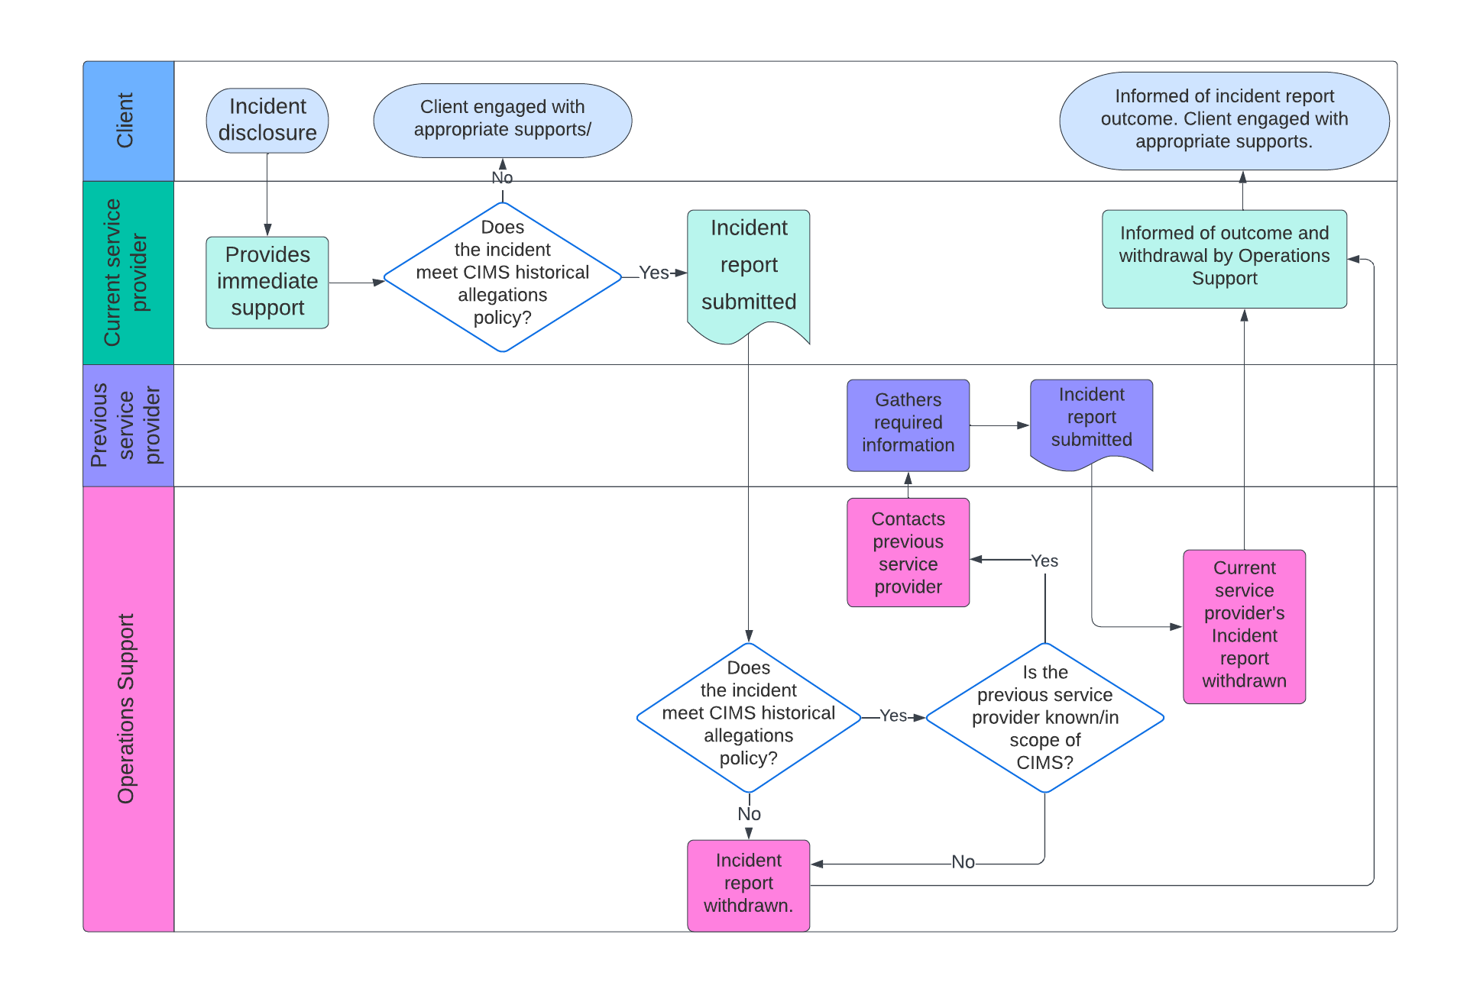

### Reporting historical incidents – implementation guidance

#### Incidents disclosed by a client under the age of 18

Children and young people who are subject to Child Protection involvement may be engaged with multiple service providers over their time in care. When the incident is disclosed, the service provider that manages the client’s current placement is responsible for CIMS when:

* the client is placed with the same carer, regardless of the time since the incident occurred
* both the child and the carer remain supported by the same service provider but the child is with a different carer.

These requirements apply to all placement types.

A disclosure relating to an incident that occurred while the client was in the care of their parents, or before the child or young person becomes a Child Protection client, should be referred to Child Protection. A CIMS report is not needed in this case.

Investigations of historical incidents are subject to the same CIMS incident investigation minimum requirements as all other incidents. Service providers must follow the policy and guidance in section 4.2.

#### Incidents disclosed by adults that occurred before 2018

Incidents disclosed by adults that occurred before 2018 are not within the scope of CIMS. This is because CIMS came into operation in 2018. This section details the alternative pathways and policies available for out-of-scope incidents.

If the disclosure is made by an adult client regarding an incident that occurred while they were a child in out-of-home care pre-1990, the client should be advised of the Victorian Redress Scheme.

Information on the redress scheme is on the department’s website via the [Pre 1980 Care Leavers webpage](https://services.dffh.vic.gov.au/people-institutional-settings-pre-1990) https://services.dffh.vic.gov.au/people-institutional-settings-pre-1990.

There are other guidelines for disclosures made by an adult client about an incident that occurred in out-of-home care between 1990 and 2018. Service providers should follow the *Historical abuse in care guidelines* in the [Child Protection Manual](https://www.cpmanual.vic.gov.au/advice-and-protocols/tools-and-checklists/historical-abuse-care-guidelines) https://www.cpmanual.vic.gov.au/advice-and-protocols/tools-and-checklists/historical-abuse-care-guidelines.

If the disclosure is made by an adult client and there isn’t an existing guideline for managing historical incidents before the introduction of CIMS, the service provider is to contact the system steward for their service. The system steward is to receive the report and take any necessary steps to record, investigate and review the incident. Where the program is no longer in operation, the relevant branch of the department is to undertake these actions.

### Reporting historical incidents – roles and responsibilities

Table 3.5: Roles and responsibilities for reporting historical incidents

| Roles | Responsibilities |
| --- | --- |
| Client | * Have their views and wishes heard. |
| Service provider | * Hear the client’s story, views and wishes. * Submit the incident report with all known information. |
| Operations Support | * Review the incident report. * Contact the previous service provider if the report relates to an incident that occurred during the service delivery of a different service provider. * Withdraw the incident report if submitted by a different service provider once the relevant service provider has submitted the report; or when it is confirmed that there is no service provider that can submit a report. * Support service providers to connect with the system steward when requested. |
| Contract manager | N/A |
| System steward | * Receive notification of a historical incident when it doesn’t meet the CIMS policy. * Conduct all required follow-up in line with departmental procedure when a historical incident is disclosed that doesn’t meet CIMS policy. |

## 3.6 Privacy requirements

Service providers have obligations for handling personal, health and sensitive information under the Privacy and Data Protection Actandthe Health Records Act. Thisisin addition to any other legislation that applies to their service stream or is included in their service agreement with the department. This section sets out the minimum privacy requirements for CIMS.

### Privacy requirements – policy

1. Incident, investigation and review reports must only contain factual and relevant information about the incident.
2. Incident, investigation and review reports must not have information that identifies a notifier to Child Protection under the Children, Youth and Families Act*.*
3. Service providers take reasonable steps to provide individuals with collection notices to inform them about how their personal, sensitive or health information may be used in an incident, investigation or review report.
4. Information sharing must only be conducted when there are clear benefits to the client, the sector and the broader community or is required by law.
5. Information sharing must only be conducted with approved third parties when it is lawful to do so.
6. Information sharing must be documented on the client’s file.

### Privacy requirements – implementation guidance

#### Collection notices

A collection notice is a statement that is provided to an individual at or before the time an organisation collects personal information from them.

Information on collection notices is on the [Office of the Victorian Information Commissioner’s website](https://ovic.vic.gov.au/privacy/resources-for-organisations/collection-noticeshttps:/ovic.vic.gov.au/privacy/resources-for-organisations/collection-notices/) https://ovic.vic.gov.au/privacy/resources-for-organisations/collection-notices/.

Service providers must take reasonable steps to issue collection notices to individuals when collecting personal information. This requirement is detailed in the service providers’ service agreement with the department.

Most information about clients will have been collected ahead of any incident in scope of CIMS. CIMS assumes this information has been collected in line with the privacy requirements.

When collecting personal information from non-clients for incident reports, such as witnesses or the subject of an allegation, the service provider should provide a collection notice to explain what information is being collected and how it is handled. This is required under the Information Privacy Principles in the Privacy and Data Protection Act.

The CIMS webpage has [template collection notices](https://providers.dffh.vic.gov.au/cims) https://providers.dffh.vic.gov.au/cims.

#### Information sharing

Respecting the privacy of people who are involved in incidents is an important consideration when conducting information sharing. Incident reports contain personal information and may include health and other sensitive information. Every decision to share information must be clearly documented on the client’s file and include the factors that informed decision making. It is important that the service provider’s obligations under privacy and other relevant legislation is spelled out in the decision-making process. This includes whether the service provider is a Risk Assessment Entity or Information Sharing Entity under the Family Violence Information Sharing Scheme or Child Information Sharing Scheme.

Information sharing can promote the safety and wellbeing of clients and reduces the burden on clients to re-tell their story to multiple service providers. However, information sharing must be conducted in a way that upholds the privacy of those involved in an incident. Information sharing must only occur when a clear benefit to the client can be identified, or when information sharing is required by law.

The Office of the Victorian Information Commissioner website has more about information sharing under the [Family Violence Information Sharing Scheme](https://ovic.vic.gov.au/privacy/resources-for-organisations/family-violence-information-sharing-scheme-and-privacy/) https://ovic.vic.gov.au/privacy/resources-for-organisations/family-violence-information-sharing-scheme-and-privacy/.

#### Protecting notifier details

This section does not apply to clients who are engaged with Child Protection and the service provider communicates the incident to Child Protection through an established case management channel.

Some incidents may need a notification to Child Protection. The service provider may make the notification or be aware that a person has made a notification to Child Protection in relation to the incident.

The identity of a notifier to Child Protection is protected under the Children, Youth and Families Act.

When a notification is made to Child Protection as part of following up an incident, this is deemed essential information for reviewing an incident. However, the service provider must not provide any information in the incident report that may help identify the notifier. It is recommended that a general statement, such as ‘the service provider is aware that Child Protection have been notified’, be included in the report.

#### Protecting personal and sensitive information

An incident report may be seen by different staff throughout the CIMS process. Only authorised staff can access incident reports. Some incident report information may be provided to independent oversight bodies as required by law. This includes the Commission for Children and Young People (CCYP) and the Social Services Regulator. Only relevant and authorised information under the Commission for Children and Young People Act, the Social Services Regulation Actand other relevant legislation is shared. Strict information sharing protocols are in place.

It is critical that service providers consider the audience of the incident report at the time of reporting.

Service providers must disclose certain relevant personal and sensitive information in incident reports. Client personal information must support the analysis and learning functions of CIMS. However, the relevance of health and sensitive information requires consideration from the service provider. Incident reports should only contain factual and relevant information, to support the description of the incident and the follow-up actions needed.

More information about Information Privacy Principles and Health Privacy Principles is available on the [Office of the Victorian Commissioner’s website](https://ovic.vic.gov.au/privacy/resources-for-organisations/information-privacy-principles-full-text/) https://ovic.vic.gov.au/privacy/resources-for-organisations/information-privacy-principles-full-text/.

#### Privacy complaints

Service providers must report breaches of privacy to the Office of the Victorian Information Commissioner. More information on this requirement is on the [Commissioner’s website](https://ovic.vic.gov.au) https://ovic.vic.gov.au.

A client or another participant in CIMS may raise a privacy concern with the service provider about the disclosure of their information throughout CIMS stages. The service provider should attempt to resolve the concern. The service provider should provide the complainant with information for the Office of the Victorian Information Commissioner to assist them to understand their rights and obligations.

### Privacy requirements – roles and responsibilities

Table 3.6: Roles and responsibilities for privacy requirements

| Roles | Responsibilities |
| --- | --- |
| Client | N/A |
| Service provider | * Seek the client’s consent for sharing their information (if relevant). * For information sharing that does not require client consent, to inform the client of what information has been shared and why (if relevant). * Undertake all relevant actions listed in section 3.6. |
| Operations Support | * Manage the IT system that enables incident reports to be shared with independent oversight bodies. * Respond to any privacy concerns or issues with independent oversight bodies’ access to CIMS information. |
| Contract manager | * Track service provider’s compliance with privacy requirements as part of ongoing contract management with providers. |
| System steward | N/A |

## 3.7 Other reporting requirements

This section details the other reporting requirements a service provider may need to undertake alongside CIMS reporting.

### Other reporting requirements – implementation guidance

#### Death of a current or former child protection client

The department must notify the CCYP about children who have died and were known to Child Protection in the 12 months before their death. The CCYP is responsible for conducting a child death inquiry to apply a systems lens on areas for improvement to promote the safety and wellbeing of children.

The unexpected or unanticipated death of a child protection client during service delivery is reported in CIMS. The department must provide a copy of the incident report to the CCYP to support the child death inquiry.

#### Notification to the minister

The minister has a responsibility to the Victorian Government and the public for the operation of the departments within their portfolio.

The department is responsible for escalating incidents to the minister to enable the minister to be briefed on an incident they may receive questions on, due to the incident posing a reputational risk to the department or likely to attract media attention.

#### Reportable Conduct Scheme

The Reportable Conduct Scheme (RCS) was established by the Child Wellbeing and Safety Actto improve organisations’ responses to allegations of child abuse and neglect by their employees. The CCYP administers the RCS.

Since 1 July 2017 the CCYP must be notified of allegations of reportable conduct by relevant in-scope organisations. The CCYP oversees investigations conducted under the RCS and may share information with regulators, Victoria Police and the Working with Children Check Unit in the Department of Justice and Community Safety.

Service providers in-scope for the RCS and CIMS must report through both systems for incidents when staff members, carers or volunteers are the subject of allegation.

Not all incidents that are reported in CIMS have to be reported under the RCS and vice versa. CIMS incident types that may be reportable conduct are listed in Table 3.7.

Table 3.7: CIMS incident types that may be reportable conduct

| CIMS incident type | Reportable Conduct Scheme category |
| --- | --- |
| Physical abuse | Physical violence |
| Inappropriate physical treatment | Physical violence |
| Sexual Abuse | Sexual misconduct or sexual offences |
| Sexual exploitation – grooming | Sexual misconduct or sexual offences |
| Neglect | Significant neglect |
| Emotional and psychological abuse | Significant emotional and psychological harm |

More information about the RCS, including the types of organisations to which the scheme applies, is on the [CCYP website](https://ccyp.vic.gov.au/reportable-conduct-scheme) https://ccyp.vic.gov.au/reportable-conduct-scheme.

#### Social Services Regulator

The Social Services Regulator began operating on 1 July 2024. CIMS is the framework for service providers who are in scope of CIMS and the Regulator to:

… as soon as is reasonably practicable, notify the Regulator of any serious incident that has occurred, or may pose a serious risk to service users, during the delivery of a social service (Social Services Regulation Act 2021, s 48(1)).

This means that the department shares CIMS information with the Social Services Regulator under a strict information sharing protocol. The Social Services Regulator has a tailored view-only access to the IT system that holds CIMS incident information. The Social Services Regulator can only view information within the scope of s 48(1) of the Social Services Regulation Act*.*

The Regulator has added notification requirements outside of CIMS. Service providers must be aware of their obligations to the Regulator, including any extra notification requirements under the Social Services Regulation Act*.*

More information is on the [Social Services Regulator’s website](https://www.vic.gov.au/social-services-regulator) https://www.vic.gov.au/social-services-regulator.

#### Worker and Carer Exclusion Scheme

The Worker and Carer Exclusion Scheme (WCES) began on 1 July 2024. The Social Services Regulator administers the WCES.

The WCES has replaced the Suitability Panel and the Victorian Carer Register. The WCES prevents workers and carers of children and young people in residential, foster or secure care from working in the out-of-home care sector if their behaviour points to an unjustifiable risk of harm to children and young people.

More information on the WCES is on the [Social Services Regulator’s website](https://www.vic.gov.au/social-services-regulator) https://www.vic.gov.au/social-services-regulator.

### Other reporting requirements – roles and responsibilities

Table 3.8: Roles and responsibilities for other reporting requirements

| Roles | Responsibilities |
| --- | --- |
| Client | * Have input into any reports made on their behalf. |
| Service provider | * Ensure their other reporting requirements are followed. * Inform the client on any subsequent reports made, why they are being made and seek client input into the process. |
| Operations Support | * Manage any IT issues impacting the Social Services Regulator’s view-only access to relevant CIMS incident information. |
| Contract manager | N/A |
| System steward | N/A |

## 3.8 Reporting an incident – summary

Figure 3.5 offers an overview of the incident reporting process.

Figure 3.5: High-level overview of incident reporting process

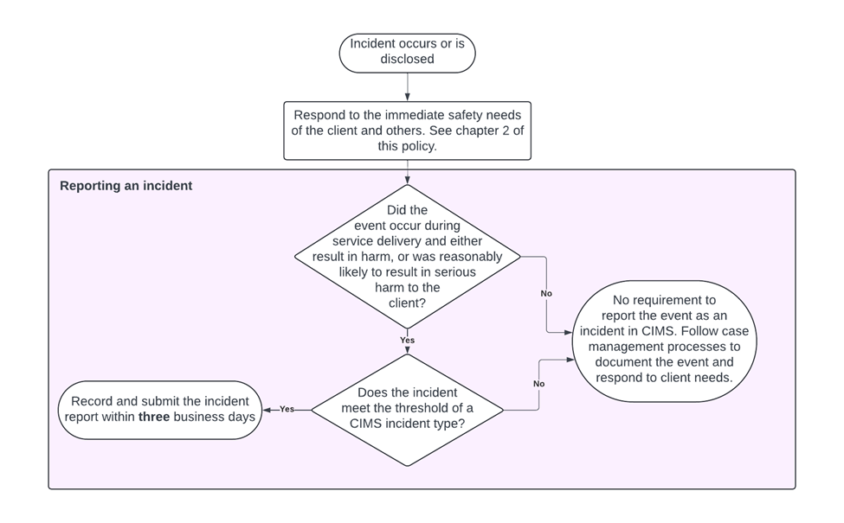

### Summary of reporting an incident roles and responsibilities

The below table presents a high-level overview of the roles and responsibilities for each layer in CIMS in the incident reporting stage of CIMS.

Table 3.9: High-level roles and responsibilities for reporting an incident[16]

| Roles | Responsibilities |
| --- | --- |
| Client | * Have input into the incident report and follow-up actions undertaken by the service provider. |
| Service provider | * Hear the client’s story, views and wishes. * Record and submit the incident report on the CIMS IT platform. * Notify the allocated child protection/ACAC practitioner of the incident report submission (if relevant). |
| Operations Support | * Data steward, custodian and CIMS IT administrator. * Receive the incident report via the CIMS IT platform and conduct quality assurance. * Respond to any queries from the service provider, including whether an incident report is called for. * Manage any IT system issues preventing the incident report being completed. |
| Contract manager | * Receive advice from Operations Support where there may be organisational issues with the quality or timeliness of incident reports. * Raise organisational quality issues as part of contract and performance management in line with the *Agency performance and monitoring framework*. |
| System steward | * Analyse, monitor and respond to incident trends using incident report data to inform policy and program development and improvement. |

# Chapter 4: Investigating an incident

Incident investigation is the third stage in the CIMS framework (Figure 4.1).

Figure 4.1: CIMS incident stages, focusing on incident investigation

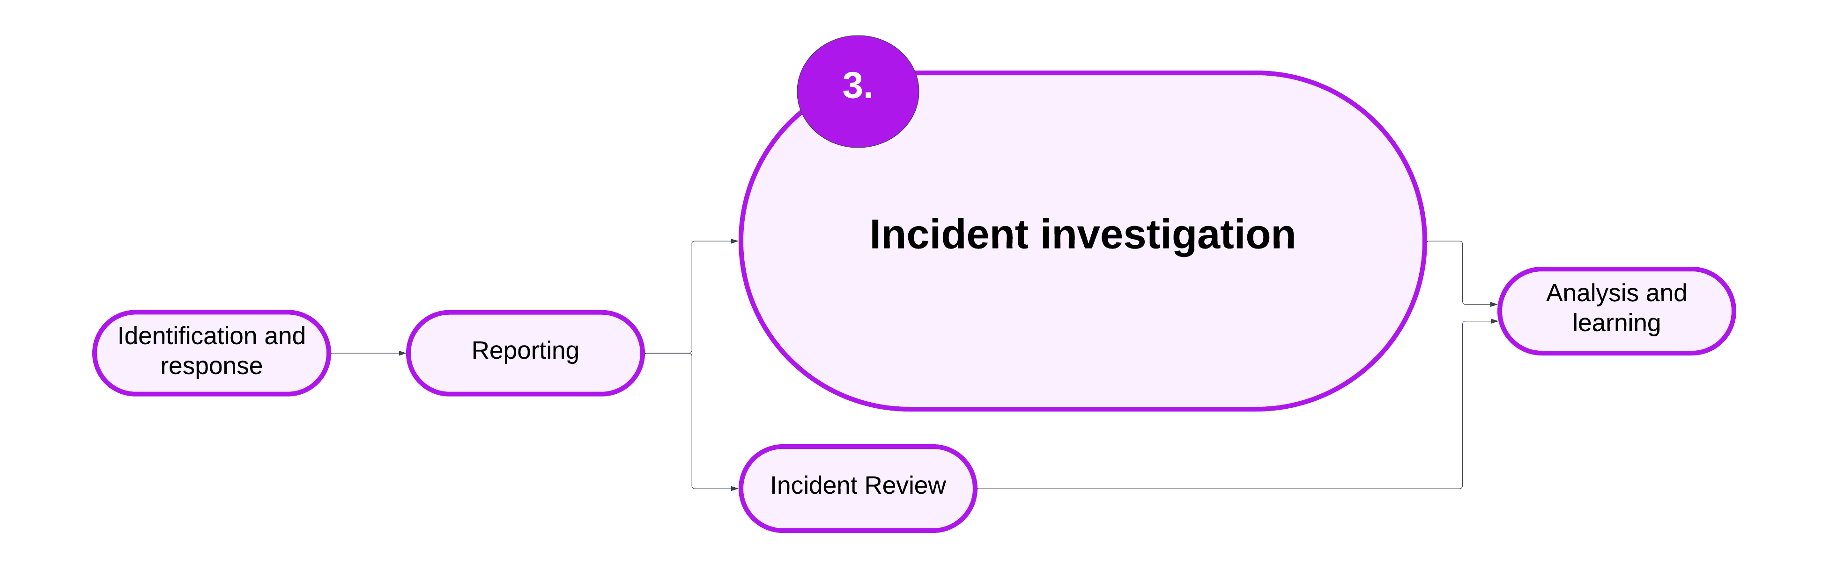

* Incident investigations are conducted for incidents of abuse, neglect or unexplained injury.

## 4.1 Reporting an incident – overview

An incident investigation determines whether the abuse or neglect of a client has occurred. An investigation must be completed for major impact incidents of the following incident types:

* any abuse, including sexual exploitation – grooming, when the subject of allegation is a staff member (staff-to-client incidents)
* any abuse, including sexual exploitation – grooming, that occurs between clients (client-to-client incidents)
* neglect, or
* unexplained injury.

This chapter sets out the minimum requirements for when and how an investigation into an incident is to be carried out by a service provider.

Policy and guidance in this chapter:

* 4.2 Incident investigation minimum requirements
* 4.3 Investigation plans
* 4.4 Reportable Conduct Scheme investigation
* 4.5 Additional considerations for investigations
* 4.6 Joint investigations
* 4.7 Investigation reports
* 4.8 Reviewing an investigation outcome
* 4.9 Summary

## 4.2 Incident investigation minimum requirements

An incident investigation determines whether the abuse or neglect of a client has occurred. This section sets out the minimum requirements for incident investigations.

### Incident investigation minimum requirements – policy

1. An incident investigation must be completed for all major impact incidents of:
   * abuse, including sexual exploitation – grooming, when the subject of allegation is a staff member (staff-to-client incidents)
   * abuse, including sexual exploitation – grooming, that occurs between clients (client-to-client incidents)
   * neglect, or
   * unexplained injury.
2. An investigation plan must be developed that outlines the information to be gathered and activities undertaken during the investigation. Refer to section 4.3 for more policy and guidance.
3. Investigations must be conducted with procedural fairness and outcomes based on the balance of probabilities.
4. An RCS investigation is accepted by the department in lieu of a CIMS investigation for any incident that meets the criteria for both CIMS and RCS. Refer to section 4.4 for more policy and guidance.
5. Individuals who are the subject of allegation must be informed of the details of the allegation in writing as soon as reasonably practicable. This must include potential impacts a substantiation decision may have on the subject of allegation.
6. The investigation report must be endorsed by the service provider’s chief executive officer (or delegate) and submitted to the department within 28 business days of incident report endorsement. Refer to section 4.7 for more policy and guidance.
7. The service provider must inform all relevant parties of the outcome of the investigation in writing and the opportunity to request a review of the decision. This includes:
   * the client
   * the subject of allegation.
8. Investigations and the investigation report must follow privacy requirements and relevant legislation. Refer to section 3.6 for more information.

For incidents reported to Victoria Police:

1. The service provider must consult with Victoria Police before undertaking point 5.
2. The investigation must not begin until Victoria Police have confirmed it may do so, to not impede on any criminal investigation.

### Incident investigation minimum requirements – roles and responsibilities

Table 4.1: Roles and responsibilities for incident investigation (minimum requirements)

| Roles | Responsibilities |
| --- | --- |
| Client | * Have their voice heard throughout the investigation. |
| Service provider | * Adhere to the investigation minimum requirements in conducting the investigation. * Ensure the investigation aligns with CIMS principles. |
| Operations Support | * Review the investigation report for quality assurance. |
| Contract manager | N/A |
| System steward | N/A |

## 4.3 Investigation plans

4.2 Incident investigation minimum requirements states:

An investigation plan must be developed that outlines the information to be gathered and activities undertaken during the investigation.

This section details the minimum requirements for an investigation plan.

### Investigation plans – policy

1. The investigation plan must:
   * identify who will be managing and undertaking the investigation.
   * detail what information needs to be gathered to enable decision making, including who will be responsible for these activities.
   * detail the other considerations needed to uphold CIMS principles. Refer to 4.5 Additional considerations for investigations for more guidance.
2. For incidents not in scope of the RCS, when there is significant, reliable and verifiable evidence available that enables a substantiation decision, the investigation report may be completed without undertaking more information-gathering activities.

For Aboriginal clients receiving Child Protection services:

1. Service provider must consult with ACSASS in developing the investigation plan, or if the client is authorised to an ACAC provider, the relevant Aboriginal Agency.
2. The investigation plan must include agreed review points with ACSASS, or if the client is authorised to an ACAC provider, the relevant Aboriginal agency, to be completed throughout the investigation.

For Child Protection/ACAC clients only:

1. In cases where Child Protection/ACAC has, or will be, assessing an incident as part of their core business to assess the immediate safety of a child in their care arrangement, this assessment may be used to satisfy information gathering activities.
2. The investigation plan must include agreed review points with Child Protection, or if the client is authorised to an ACAC provider, the relevant Aboriginal agency, to be completed throughout the investigation.
3. The investigation plan must be provided to the Child Protection/ACAC team manager for noting before undertaking the investigation.

### Investigation plans – implementation guidance

#### Appointing an investigation manager

Service providers should consider who is the most appropriate person to coordinate and maintain oversight of an investigation (investigation manager) and who will conduct the investigation (investigator). The service provider will decide if the person who conducts the investigation will also be the investigation manager, or if they will be separate roles.

The service providers should ensure the investigator/investigation manager:

* has no actual, potential or perceived conflict of interest, or risk of bias in the way an investigation will be conducted
* has the professional skills to conduct a balanced investigation using trauma informed practice.

Where an investigation uncovers conflicts of interest, these need to be immediately raised with the service providers’ senior delegate and appropriately addressed to ensure the investigation is conducted in a fair and impartial manner.

#### Engaging an external investigator

There may be situations where an external investigator may need to be engaged. This may be because:

* the seniority of staff involved means it is not possible for a service provider to conduct an investigation free from conflict of interest or bias, or
* the size of the organisation means that an investigator isn’t available who is sufficiently independent to conduct the investigation.

If a service provider decides that it is most appropriate to engage an external investigator, due diligence must be exercised in ensuring the external investigator is appropriately skilled to conduct the investigation that meets the minimum requirements set out in CIMS policy.

#### Making a substantiation decision without more information gathering

For incidents where there is reliable and verifiable evidence available that enables an outcome decision to be reached during investigation planning, service providers can complete an investigation report based on this information. The investigation report must:

* identify the investigation outcome (substantiated or not substantiated)
* provide a detailed rationale for not undertaking more information-gathering activities
* detail the evidence that supports the outcome
* provide recommendations to promote the safety and wellbeing of the client.

In deciding to not progress with more information-gathering activities, the service provider must provide a rationale stating how:

* the available evidence, on balance of probabilities, robustly enables a finding of abuse or neglect, without the need for more comprehensive information gathering
* procedural fairness is not compromised
* the information is objective and unlikely to be perceived to be biased, such as information provided by a co-worker or co-client.

Examples of evidence that may enable a substantiation decision being reached during investigation planning include:

* CCTV footage
* Child Protection assessment and interview notes.

#### Investigation plans

It is best practice to undertake a care team approach to investigation planning. Investigation plans should consider each of the following topics:

* details of the allegation
* how the investigation plan upholds the CIMS principles
* how the relevant parties to the investigation will be engaged and communicated with, including progress updates throughout the investigation
* privacy considerations – refer to 3.6 Privacy requirements for policy and guidance
* process for gathering information and evidence, including whether information can be gathered through information sharing to reduce the re-traumatisation of clients and others involved in an incident due to multiple interviews for the same matter.

## 4.4 Reportable Conduct Scheme investigation

4.2 Incident investigation minimum requirements states:

A Reportable Conduct Scheme (RCS) investigation is accepted by the department in lieu of a CIMS investigation for any incident that meets the criteria for both CIMS and RCS.

This section details the added requirements for conducting the RCS investigation in place of a CIMS investigation.

### Reportable Conduct Scheme investigation – policy

1. Service providers must follow all requirements of the RCS investigation, found on the [CCYP’s website](https://ccyp.vic.gov.au/reportable-conduct-scheme/) https://ccyp.vic.gov.au/reportable-conduct-scheme/.

### Reportable Conduct Scheme investigation – implementation guidance

To reduce duplication of effort, service providers have the option of conducting an RCS investigation in lieu of a CIMS investigation. Service providers may choose this option when the incident is in scope of both CIMS and the RCS. A CIMS incident would be considered in scope of RCS if there is information that leads a person to form a ‘reasonable belief’ that a staff member or volunteer has committed reportable conduct, or misconduct that may involve reportable conduct.[17]

When conducting an RCS investigation in lieu of the CIMS investigation, service providers follow all RCS investigation requirements and conduct the investigation according to the equivalent RCS type. It is acknowledged that RCS investigation requirements broadly align with CIMS investigation minimum requirements.

Following the investigation, the service provider must submit the RCS investigation outcome report in the CIMS IT platform to acquit their requirements in CIMS. Operations Support will review the investigation report for quality assurance.

The Child Wellbeing and Safety Actsets out 5 types of reportable conduct:

* sexual offences (against, with or in the presence of, a child)
* sexual misconduct (against, with or in the presence of, a child)
* physical violence (against, with or in the presence of, a child)
* behaviour that is likely to cause significant emotional or psychological harm
* significant neglect.

Table 4.2 lists the CIMS incident types that align with RCS categories for staff-to-client incidents. Service providers should refer to the CCYP’s website to ensure they follow current RCS requirements.

Table 4.2: CIMS incident type alignment with reportable conduct types

| CIMS incident type | Reportable Conduct Scheme |
| --- | --- |
| Physical abuse | Physical violence[18] |
| Sexual abuse | Sexual misconduct or sexual offences |
| Sexual exploitation – grooming | Sexual misconduct or sexual offences |
| Neglect | Significant neglect |
| Emotional and psychological abuse | Significant emotional and psychological harm |

More information is on the CCYP’s website https://ccyp.vic.gov.au/reportable-conduct-scheme/.

#### Submitting a Reportable Conduct Scheme investigation in CIMS

Service providers submit the RCS investigation report to the department. Service providers must also submit the high-level recommendations that address the findings of the investigation to improve client safety, wellbeing or service delivery to the department. Visit the CIMS webpage for a [template](https://providers.dffh.vic.gov.au/cims) https://providers.dffh.vic.gov.au/cims.

Reportable conduct investigations align with the CIMS investigation requirements to make a decision on the balance of probabilities. However, the substantiation options for RCS types are different from the options available in CIMS. Table 4.3 outlines the equivalent outcomes between CIMS and the RCS. When entering the outcome in the CIMS IT platform, the service provider will need to enter the CIMS equivalent to submit the RCS investigation outcome report.

Some incidents may lead to a substantiation in CIMS, but not under the RCS. In these cases, service providers complete a rationale on the recommendations template, submitted to the department with the RCS investigation report.

Table 4.3: Equivalent outcomes between the Reportable Conduct Scheme and CIMS

| CIMS | Reportable Conduct Scheme |
| --- | --- |
| Substantiated: emotional/psychological abuse | Substantiated: significant emotional and psychological harm |
| Substantiated: physical abuse | Substantiated: physical violence |
| Substantiated: sexual abuse or sexual exploitation – grooming | Substantiated: sexual misconduct or sexual offences |
| Substantiated: neglect | Substantiated: significant neglect |
| Not substantiated: further action required | Unsubstantiated – insufficient evidence  Unsubstantiated – lack of evidence of weight |
| Not substantiated: no further action required | Unsubstantiated – insufficient evidence  Unsubstantiated – lack of evidence of weight  Unfounded |

### Reportable Conduct Scheme investigation – roles and responsibilities

Table 4.4: Roles and responsibilities conducting a Reportable Conduct Scheme investigation

| **Roles** | **Responsibilities** |
| --- | --- |
| Client | * Have their voice heard throughout the investigation. |
| Service provider | * Follow the investigation requirements of the RCS. * Ensure the RCS investigation report upholds CIMS minimum requirements. |
| Operations Support | * Review the investigation report for quality assurance. |
| Contract manager | N/A |
| System steward | N/A |

## 4.5 Additional considerations for investigations

As detailed in section 4.3:

The investigation plan must detail the other considerations needed to uphold CIMS principles.

This section details the implementation guidance for other considerations for investigations.

### Additional considerations for investigations – implementation guidance

There are 3 categories of added considerations for a CIMS investigation:

* CIMS investigation – Aboriginal clients
* CIMS investigation – under 18s client-to-client
* CIMS investigation – kinship care.

#### CIMS investigation – Aboriginal clients

CIMS investigations may have a disproportionate impact on Aboriginal clients, carers and others involved in an incident because of oppressive legislation and practices that have had an enduring impact on the social and emotional wellbeing of Aboriginal people.

CIMS policy includes extra requirements for incidents and investigations involving Aboriginal people. These involve consultation with ACSASS or the ACAC provider in developing the investigation plan and at agreed points throughout the investigation.

The investigator and investigation manager must be appropriately skilled in ensuring an investigation is conducted in a culturally safe way. Aboriginal organisations are best placed to advise and inform on how to engage and support Aboriginal children, carers and families. Recommendations and advice from Aboriginal leaders should be prioritised throughout the investigation.

Visit the department’s website for information on [how to strengthen cultural safety in practice](https://www.dffh.vic.gov.au/publications/aboriginal-and-torres-strait-islander-cultural-safety-framework) https://www.dffh.vic.gov.au/publications/aboriginal-and-torres-strait-islander-cultural-safety-framework.

#### CIMS investigation – under 18s client-to-client

Client-to-client incident investigations for clients who are both under the age of 18 years differ from incidents where a staff member is alleged to have abused or neglected a client. Both clients may be children or young people living together, such as in a residential care home or foster care, where it is more appropriate for an investigation to focus on the harm experienced by both clients.

It is important when undertaking a client-to-client incident investigation when both clients are under the age of 18 years that the investigator is skilled in using a trauma-informed lens and compassionate language. The investigation should identify situational or systemic factors that have led to the incident. The investigation should include a risk and needs assessment for both clients to ensure their experiences are validated and identify appropriate strategies to meet their needs.

#### CIMS investigation – kinship care

As detailed in section 2.7, carers need specific consideration throughout the CIMS stages. During the investigation planning stage, consideration must include:

* the relationship with the client
* the length of the relationship
* the history of the carer.

All allegations of abuse and neglect must be investigated. The same thresholds and investigation requirements apply to investigations into allegations against kinship carers. However, to ensure the investigation upholds CIMS principles, extra considerations are needed for kinship carers. Kinship carers enter the care system through a different pathway from foster carers or residential care staff. Kinship carers may have different support and training and often hold existing relationships with a client.

Approaching a CIMS investigation into the conduct of a kinship carer should include specific consideration of:

* the history and life experiences of the carer
* how the carer entered the care relationship
* what system or support networks are in place to support the carer in the care relationship
* how the kinship relationship can be strengthened and preserved (if appropriate).

## 4.6 Joint investigations

In some cases an incident may occur that requires the service provider and department to jointly conduct the investigation. This section details the minimum requirements for a joint investigation.

### Joint investigations – policy

1. A service provider may request a joint investigation when it is not possible to undertake an independent investigation because of the seniority of the staff involved in the incident.
2. Operations Support may recommend a joint investigation to occur when:
   * there has been a demonstrated lack of capability by the service provider to conduct or commission an investigation that meets minimum requirements, or
   * it is not possible to undertake an independent investigation because of the seniority of the staff involved in the incident.
3. The executive director of Operations Support must endorse any decision to undertake a joint investigation.
4. Operations Support decides who will be the joint investigation manager.

### Joint investigations – implementation guidance

Joint investigations allow Operations Support to take a stronger role in the capability building of a service provider by being involved in each step of the investigation process. This ensures the investigation and investigation report meet CIMS minimum requirements.

#### Joint investigation manager

Operations Support advise who will be the joint investigation manager. The joint investigation manager must be appropriately skilled and knowledgeable in CIMS processes and the service being delivered to the client.

The joint investigation manager decides the level of involvement they will have in the investigation. This decision must be made using a risk-based approach. At minimum, the joint investigation manager must be involved in the investigation planning. The investigation plan must document which responsibilities are held by the joint investigation manager throughout this investigation. This may include:

* undertaking information gathering activities such as interviewing the client, subject of allegation or witnesses
* writing, or contributing to the writing of, the investigation report.

### Joint investigations – roles and responsibilities

Table 4.5: Roles and responsibilities for joint investigations

| **Roles** | **Responsibilities** |
| --- | --- |
| Client | * N/A |
| Service provider | * Requests a joint investigation. * Provides appropriate information and support to Operations Support to inform whether a joint investigation is to occur. |
| Operations Support | * Recommends whether a joint investigation is to be undertaken. * Assigns a joint investigation manager. * Notifies the contract manager of the joint investigation being undertaken and the rationale for why this is being conducted. |
| Contract manager | * Notes the rationale for why a joint investigation is undertaken. * Draws on joint investigation information to inform their work with the service provider. |
| System steward | N/A |

## 4.7 Investigation reports

Section 4.2 states:

The investigation report must be endorsed by the service provider’s chief executive officer (or delegate) and submitted to the department **within 28 business days** of incident report endorsement.

This section details the minimum requirements for investigation reports.

### Investigation reports – policy

1. An investigation report must include:
   * the investigation plan
   * the allegations made and investigated
   * the evidence gathering process including a summary of what was gathered and how the evidence was weighted
   * a rationale for why any relevant information may not have been gathered (such as the person is deceased or incapacitated)
   * interview notes or interview summaries
   * investigation findings based on the weighted evidence gathered throughout the investigation
   * an outcome decision based on the balance of probabilities and drawn from the findings made throughout the investigation
   * high-level recommendations to promote the safety and wellbeing of the client and to improve the quality of service delivery.

### Investigation reports – implementation guidance

#### Timeframe

The timeframe for submitting the investigation report excludes any time that the investigation is put on hold if directed by Victoria Police.

#### Investigation outcome

The service provider must register an outcome against the investigation of:

* substantiated
* not substantiated: further action required, or
* not substantiated: no further action required.

The investigation outcome is based on the balance of probabilities and informed by the findings made throughout the course of the investigation.

#### Investigation report

Investigation reports are submitted into the CIMS IT system and are a key mechanism for ensuring all incidents of reported abuse across the service system are carefully considered and addressed. Reports also ensure the process for doing so has been accurately documented.

Investigation reports include any relevant information that an independent reader may need to understand the purpose, context, process and evidence that decided the outcome of an investigation. In cases where an investigation minimum requirement has not been met, the investigation report must contain a detailed rationale for why this has occurred.

The content and analysis that is included in the investigation report is of greater priority than the format in which it is submitted. Templates are provided to assist service providers in approaching investigations consistently, noting there is also a need for flexibility in approaches to ensure proportionate responses are taken. Alternative templates may be used if it is deemed appropriate by the service provider and if all CIMS minimum requirements are addressed.

The investigation plan should be attached to, or included in, the investigation report to reduce administrative burden and the duplication of information across documents.

The CIMS webpage has [investigation report templates](https://providers.dffh.vic.gov.au/cims) https://providers.dffh.vic.gov.au/cims.

#### Investigation report recommendations

Investigation report recommendations are high-level practical suggestions that address the findings of an investigation. Some recommendations may address multiple findings. The investigation report recommendations may focus on:

* other actions to enhance client safety and wellbeing
* actions to meet the ongoing needs of the client following the incident
* actions to be undertaken by the service provider to enhance service delivery
* actions to prevent future harm at the organisation or system level to reduce the likelihood of a similar incident occurring; or minimise harm in the event of a reoccurrence.

Recommendations are actionable and used to inform response and support plans. Refer to section 6.2 for policy and guidance.

The report recommendations are informed by the evidence gathered throughout the investigation. Recommendations represent justifiable actions that can be taken to enhance client safety and wellbeing. Recommendations may be actions to meet the needs of the client, or actions to be undertaken by the service provider to enhance service delivery. Examples of recommendations are provided in Table 4.6.

Recommendations may be directed to the client, organisation or system. In cases where recommendations are made that are outside of the service provider’s decision-making responsibilities (such as Child Protection’s case planning responsibilities), the service provider who has made the recommendation must involve the other provider in response and support planning. Refer to section 6.2.

Table 4.6: Example of recommendations made in an investigation report

| Finding | Outcome | Recommendation |
| --- | --- | --- |
| * CCTV footage recorded the subject of allegation hitting the client with a closed fist on and around the face and torso * Client identified the subject of allegation as the person on the CCTV footage | Allegation of physical abuse is **substantiated** | * A family violence intervention order is obtained listing the client as the affected family member and the subject of allegation as the perpetrator |
| * Subject of allegation’s Working with Children Check and police check were expired | N/A | * Service provider to review carer monitoring processes |

## 4.8 Reviewing an investigation outcome

The client and the subject of allegation can request a review of an investigation outcome when concerns for the procedural fairness of an investigation, or its meeting the investigation minimum requirements, are raised. This section details the minimum requirements for an investigation outcome review.

### Reviewing an investigation outcome – policy

1. The client or subject of allegation can make a written request for a review of the investigation outcome **within 10 business days** of being notified of the outcome of the investigation.
   * When the client has a legal guardian, the guardian can make a written request on the client’s behalf.
2. The request for a review of an investigation outcome must identify how the investigation did not follow principles of procedural fairness or the investigation minimum requirements.
3. The service provider must notify Operations Support **within** **2 business days** of receiving the request to review the investigation outcome.
4. The service provider must nominate an investigation outcome review manager who is independent of the initial investigation.
5. The investigation outcome review manager:
   * considers any reasonable evidence provided by the person who has requested the review
   * reviews the investigation plan, investigation report and all evidence gathered during the investigation to assess the validity of the outcome decision
   * may gather more evidence to determine the validity of the outcome decision
   * confirms or reverses the investigation outcome decision.
6. The service provider’s chief executive officer (or delegate) must submit the endorsed investigation outcome review to the department **within** **28 business days** of the written request being made.
7. The service provider must inform all parties of the outcome of the investigation review **within 2 business days** of the endorsed investigation outcome review report being submitted to the department.

### Reviewing an investigation outcome – implementation guidance

#### Review of the investigation outcome

An investigation outcome may be reviewed when issues of procedural fairness and meeting the investigation minimum requirements are raised.

The service provider is responsible for leading the review of an investigation outcome and nominating the investigation outcome review manager.

The nominated investigation outcome review manager should:

* be of appropriate expertise (internal or external to the organisation) to conduct a comprehensive review of the investigation outcome and basis of the review request
* be independent of the person who conducted the investigation (investigator and/or investigation manager)
* be independent of the initial incident
* be of appropriate authority, skill and expertise to overturn an outcome decision if needed.

## 4.9 Investigating an incident – summary

Figure 4.2 summarises the CIMS investigation process.

Figure 4.2: High-level overview of the CIMS investigation process

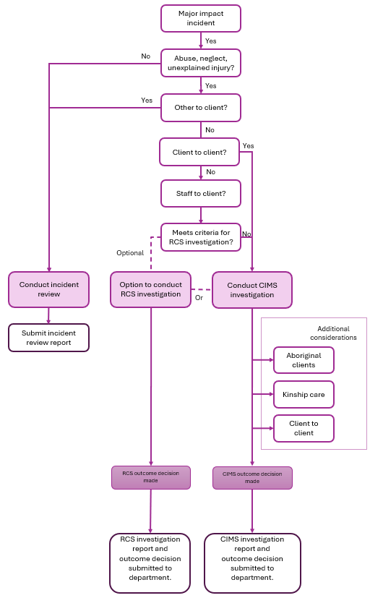

### Summary of investigating an incident roles and responsibilities

The below table presents a high-level overview of the roles and responsibilities for each layer in CIMS in the incident investigation stage of CIMS.

Table 4.7: High-level roles and responsibilities for incident investigation[19]

| **Roles** | **Responsibilities** |
| --- | --- |
| Client | * Have their story heard. * Have input into the follow-up actions undertaken by the service provider. |
| Service provider | * Hear the client’s story, views and wishes. * Lead/perform the investigation. * Complete and submit investigation report and outcome decision to the department. * Identify investigation recommendations that address the findings of the investigation. |
| Operations Support | * Provide quality assurance of the investigation report against the CIMS policy requirements. * Manage CIMS IT system issues preventing the investigation being completed. * Provide expert advice to the service provider. * Escalate significant performance issues with the contract manager. |
| Contract manager | * Receive advice from Operations Support where there may be organisational issues with the quality of investigation reports. * Raise organisational quality issues as part of contract and performance management in line with the *Agency performance and monitoring framework*. |
| System steward | * Analyse and monitor investigation outcomes and recommendations to inform policy and program development and improvement. |

# Chapter 5: Reviewing an incident

Incident review is the fourth stage in the CIMS framework (Figure 5.1).

Figure 5.1: CIMS incident stages, focusing on incident review

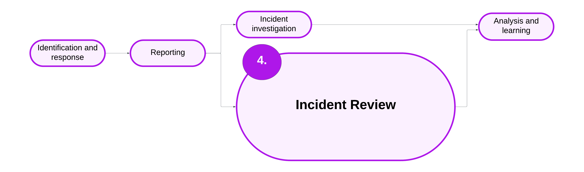

* Incident reviews are conducted for all major impact incidents that are not subject to an incident investigation.

## 5.1 Reviewing an incident – overview

Incident reviews analyse incidents to identify what happened, work out whether an incident was managed appropriately and to identify the contributing factors to the incident and subsequent learnings to apply to prevent recurrence of the incident or reduce the risk of harm if it were to reoccur.

This chapter sets out the minimum requirements for when and how an incident review is to be carried out by a service provider.

Policy and guidance in this chapter:

* 5.2 Incident review minimum requirements
* 5.3 Review report
* 5.4 Summary

## 5.2 Incident review minimum requirements

An incident review identifies what happened and any process or system issues that contributed to the incident. This section details the minimum requirements for an incident review.

### Incident review minimum requirements – policy

1. An incident review must be conducted for all major impact incidents that do not require an investigation. Refer to section 4.2.
2. Service provider completes the incident review. Refer to section 5.3 for more policy and guidance.
3. The chief executive officer (or delegate) of the service provider conducts quality assurance on the incident review report.
4. The chief executive officer (or delegate) of the service provider submits the incident review report to the department within 28 business days of the incident report submission.
5. The service provider communicates the findings of the incident review to the people involved in the incident. This includes:
   * the client
   * the carer (if relevant)
   * child protection/ACAC provider (if relevant).

For Aboriginal clients receiving child protection services:

1. Service provider must communicate the outcome of the incident review with ACSASS or the client’s authorised ACAC provider.

### Incident review minimum requirements – implementation guidance

#### Planning and conducting an incident review

An incident review plan should identify:

* what questions need to be answered
* what evidence is needed to answer those questions
* the best way to obtain that evidence.

This will include thinking about timing of a review and how the client will be engaged in the process to ensure a considered and holistic approach is taken.

Incident reviews are a methodical and professional way to analyse the circumstances surrounding an incident and evaluate opportunities to enhance client safety and service delivery. All incident reviews should be carried out in keeping with the CIMS principles.

There are many information sources that should be considered to obtain an understanding of what happened and why, including identifying contributing system factors to the incident. Table 5.1 has example information sources that may be used to ensure a considered review.

Table 5.1: Example of information sources to inform the review

| Systems layer | Example of information |
| --- | --- |
| Client | * Discussions with the client to understand what happened * Client’s case file |
| Staff | * Discussions with staff who were present to understand what happened * Consideration of staff physical and mental health factors * Training records to understand staff knowledge, skills, competency |
| Other relevant parties (carers, support workers) | * Discussions with other relevant parties to understand any other contextual factors related to the incident |
| Task and technology | * Availability and use of protocols or decision-making aids * CCTV |
| Environment | * Staffing and rosters at the time of the incident * Design and layout of the facility (photos, videos, floorplan) * Availability of equipment * Decision-making aids/checklists |
| Organisation and management | * Internal service policies and procedures * Staff safety culture surveys * Training and competency processes * Equipment and facilities maintenance process * Client and carer feedback (compliments and complaints) * Incident data |

## 5.3 Review report

This section details the minimum requirements for the review report.

### Review report – policy

1. The review report must contain:
   * the name and position of the person conducting the review
   * the date of the review
   * a summary of the incident
   * an assessment of the response and management of the incident
   * an assessment of the contributing factors or causes of the incident
   * key findings
   * high-level recommendations to promote the safety and wellbeing of the client and to reduce the risk of future harm.
2. One review report may be completed for multiple incidents when:
   * the same incident type is being reported
   * the response and management to the incident is consistent across incidents
   * the contributing factors or cause of the incident is consistent across incidents
   * the other incidents occurred within **28 days** of the first incident.

### Review report – implementation guidance

#### Incident review recommendations

Review report recommendations are high-level practical suggestions that address the findings of a review. Some recommendations may address multiple findings. The review report recommendations may focus on:

* other actions to enhance client safety and wellbeing
* actions to meet the ongoing needs of the client following the incident
* actions to be undertaken by the service provider to enhance service delivery
* actions to prevent future harm at the organisation or system level to reduce the likelihood of a similar incident occurring or to minimise harm in the event of a reoccurrence.

Recommendations are actionable and used to inform response and support plans. Refer to section 6.2 for policy and guidance.

The report recommendations are informed by the information gathered throughout the review. Recommendations represent justifiable actions that can be taken to enhance client safety and wellbeing. Recommendations may be actions to meet the needs of the client, or actions to be undertaken by the service provider to enhance service delivery. Examples of recommendations are provided in Table 5.2.

Recommendations may be directed to the client, organisation or system. In cases where recommendations are made that are outside of the service provider’s decision-making responsibilities (such as Child Protection’s case planning responsibilities), the service provider who has made the recommendation must involve the other provider in response and support planning. Refer to section 6.2.

Table 5.2: Example of recommendations made in an investigation report

| Finding | Recommendation |
| --- | --- |
| * Client’s injuries were caused by falling from trampoline * Trampoline was on an uneven surface, as noted in recent home visit case notes | * Review home assessment processes * Review process to formally notify carers of environment concerns |

## 5.4 Reviewing an incident – summary

Figure 5.2 overviews the incident review process.

Figure 5.2: High-level overview of incident review process

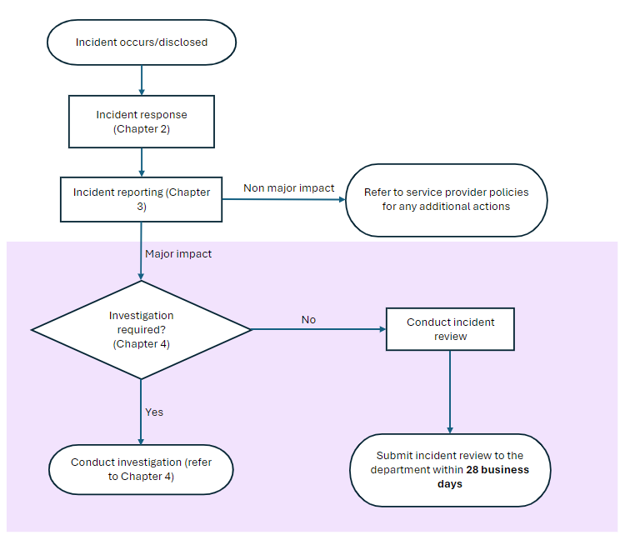

### Summary of reviewing an incident roles and responsibilities

The below table presents a high-level overview of the roles and responsibilities for each layer in CIMS in the incident review stage of CIMS.

Table 5.3: High-level roles and responsibilities for incident review[20]

| Roles | Responsibilities |
| --- | --- |
| Client | * Have input into the follow-up actions undertaken by the service provider. |
| Service provider | * Hear the client’s story, views and wishes. * Lead/perform the review. * Apply review recommendations. * Communicate the findings of the incident review to the people involved in the incident. |
| Operations Support | * Provides quality assurance of the incident review. * Manage CIMS IT system issues preventing the completion of the review. |
| Contract manager | * Use incident review information at the organisation level to inform contract management with the service provider. |
| System steward | * Use incident review outcomes and recommendations to inform service and system improvement. |

# Chapter 6: Analysis and learning from an incident

Analysis and learning is the final stage in the CIMS framework (Figure 6.1).

Figure 6.1: CIMS incident stages, focusing on analysis and learning

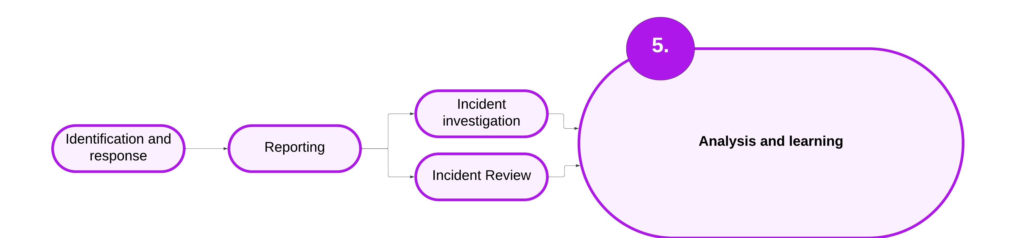

* Learnings from investigations and reviews are embedded in care planning and continuous improvement activities.
* Patterns and trends are identified through analysing client incident information.
* Quality of service is enhanced from incident analysis.

## 6.1 Analysis and learning – overview

Analysis and learning are conducted after each incident to:

* reflect on opportunities to enhance service delivery
* apply strategies to reduce the likelihood of future avoidable harm
* inform system learnings.

Each layer of CIMS has a responsibility to analyse and learn from incidents. All layers work together to foster a culture of continuous improvement and learning at all levels across the system.

This chapter sets out the minimum requirements for the analysis and learning from an incident.

Policy and guidance in this chapter:

* 6.2 Implementation of recommendations
* 6.3 Data analysis
* 6.4 System-wide sharing and learning
* 6.5 Mechanisms of monitoring and oversight
* 6.6 Summary

## 6.2 Implementation of recommendations

This section details the minimum requirements to embed investigation and review learning recommendations.

### Implementation of recommendations – policy

1. Service providers must develop a response and support plan informed by the client-focused recommendations of the incident investigation or review.
2. Service providers document the implementation of the response and support plan, including the progress through to completion of the actions being undertaken.
3. Service providers action organisation and system-level recommendations.

### Implementation of recommendations – implementation guidance

#### Implementing service provider continuous improvement recommendations

Investigation and review report recommendations may be specific to policy and program improvement opportunities for a service provider. These activities may not be appropriate to be documented within a client’s response and support plan because they are recommendations at the organisational level.

When recommendations have been made that are targeted at the organisation or system level, the service provider should consider how to leverage existing work already in progress that could be strengthened or complemented, or influence the development of new projects.

#### Response and support plans

Service providers must develop and roll out a response and support plan that is informed by the recommendations made in the investigation or review report. Response and support plans are held on the client’s case file. Response and support plans may be a standalone document or embedded in care team meetings notes as part of discussion and follow-up actions.

Response and support plans should be proportionate to the investigation or review outcome and consider:

* short- and long-term actions needed to reduce the likelihood of future harm or abuse
* therapeutic or extra supports to meet the needs of the client
* therapeutic or extra supports to meet the needs of the subject of allegation and others involved in the incident (if relevant)
* who will be responsible for completing the actions and in what timeframe
* strategies to roll out and monitor the response plan.

It is good practice to develop a care team approach to implementing recommendations, including leveraging existing care team meetings to decide the best response to the investigation or review recommendations. This includes developing plans in consultation with other areas of the service provider organisation or with child protection/ACAC practitioners when the client is subject to their involvement.

The CIMS webpage has [templates for a response and support plan](https://providers.dffh.vic.gov.au/cims) https://providers.dffh.vic.gov.au/cims. This template is optional and is provided to support service providers in meeting this requirement.

#### Carer development plans

A form of response and support plan is a carer development plan. A carer development plan is used to improve the quality of care the carer provides to the client.

Carer development plans address significant or repeated concerns about carers in out-of-home care. Carer development plans are a formal oversight strategy that focuses on promoting practice improvement by carers. Plans are developed in collaboration with carers to be action-oriented and help develop skills to address identified concerns.

Carer development plans may be in place for up to 6 months, with initial reviews within 28 business days and at 3 months from taking effect. The service provider leads these reviews in collaboration with the relevant carer.

The carer development plan does not replace existing processes to manage performance or alleged misconduct of staff or carers. Any allegation of misconduct will continue to be managed through existing service provider policies.

The CIMS webpage has [templates for the carer development plan](https://providers.dffh.vic.gov.au/cims) https://providers.dffh.vic.gov.au/cims.

### Implementing recommendations – roles and responsibilities

Table 6.1: Roles and responsibilities for implementing recommendations

| Roles | Responsibilities |
| --- | --- |
| Client | * To be involved in response and support planning. |
| Service provider | * To develop and roll out a response and support plan that actions the client-focused investigation or review recommendations. * Collaborate with the client to inform the response and support plan. * Make required changes to client care and case plans to action the response and support plan. * Monitor the completion of response and support plans. * Identify opportunities across the organisation for continuous improvement. * Use organisational or system-level investigation and review recommendations to leverage existing work in progress or to influence future project development. |
| Operations Support | N/A |
| Contract manager | * Discuss the implementation of recommendations with service providers as part of ongoing contract and performance management processes. |
| System steward | N/A |

## 6.3 Data analysis

Data analysis learns from patterns of client incidents to safeguard the safety and wellbeing of individual clients and improve quality of services. This section sets out the minimum requirements for data analysis across all layers of CIMS.

### Data analysis – policy

1. Service providers use CIMS incident data to inform continuous improvement activities.
2. The department uses CIMS data to:
   * monitor and report on incident trends
   * conduct trend analysis to identify capability gaps and inform regular training opportunities
   * inform contract and performance management activities in line with the *Agency performance and monitoring framework*
   * inform policy and program monitoring and development
   * inform CIMS policy enhancements and development.

### Data analysis – implementation guidance

#### Department-built client incident register data reports

The department-built client incident register is available to service providers that do not have an existing IT platform to record client incident details.

The department-built client incident register holds a suite of reports to assist service providers with analysis of client incident data. These reports include (but are not limited to) those listed in Table 6.2.

Table 6.2: Available client incident register reports

| Client incident register report type | Applicability |
| --- | --- |
| Count of incidents by impact by month | Incident level/client level |
| Count of incidents by division, by program, by month | Incident level/client level |
| Count of incidents by division, by area, by month | Incident level/client level |
| List of clients by impact category (top 10 incident counts only) | Client level |
| List of clients by incident type (top 10 incident counts only | Client level |
| Count of incidents by incident type, by impact and by area | Incident level |

Department-built reports only contain provider-specific information. Strict data control protocols are in place to ensure only provider-specific data is available.

### Data analysis – roles and responsibilities

Table 6.3: Roles and responsibilities for data analysis

| Roles | Responsibilities |
| --- | --- |
| Client | N/A |
| Service provider | * Analyse CIMS data to inform continuous improvement activities at the organisation level. |
| Operations Support | * Monitor and report on incident trends. * Prepare reporting to support statewide performance monitoring functions of the department. * Identify capability gaps in application of CIMS policy. * Put in place ongoing opportunities for service provider training, guidance and development. |
| Contract manager | * Use CIMS data to inform contract and performance management in line with the department’s *Agency performance and monitoring framework*. |
| System steward | * Monitor and respond to incident trends by using CIMS data to inform policy and program development. * Analyse CIMS data to inform CIMS policy enhancements. |

## 6.4 System-wide sharing and learning

### System-wide sharing and learning – implementation guidance

Sharing the lessons from an investigation or review promotes a continuous learning culture. Through system-wide sharing, learning opportunities can be implemented across the service system to reduce avoidable harm.

Sharing of lessons learnt should occur within service provider organisations as well as across the sector.

Consider the potential impact on staff who were involved in incidents. Outcomes and key facts may be redacted to uphold privacy considerations while engaging in system-wide learning.

Examples of ways to share review outcomes from incident investigations and reviews include:

* service provider team meetings
* communities of practice
* aggregated data on themes from findings and lessons learnt.

Table 6.4: Roles and responsibilities for system-wide sharing and learning

| Roles | Responsibilities |
| --- | --- |
| Client | N/A |
| Service provider | * Embed approaches to sharing learnings from investigations and reviews within the organisation to promote a continuous learning culture. * Engage in sector-wide sharing of learning opportunities. |
| Operations Support | * Promote and support sector sharing of learnings opportunities. * Prepare aggregated data on incident outcomes response themes. |
| Contract manager | * Use system learnings to inform contract and performance management in line with the department’s *Agency performance and monitoring framework*. |
| System steward | * Apply system learnings to inform policy and program development. * Apply system learnings to inform CIMS policy enhancements. |

## 6.5 Mechanisms of monitoring and oversight

### Mechanisms of monitoring and oversight – implementation guidance

There are 3 overarching analysis and learning mechanisms that draw on CIMS data.

1. CIMS specific mechanisms. These mechanisms include:

* + endorsement of incident reports as meeting CIMS policy
  + incident data analysis
  + quality assurance of incident investigations.

2. Broader department monitoring mechanisms. These mechanisms include:

* + *Agency performance and monitoring framework*
  + attestation
  + desktop reviews
  + live monitoring
  + service reviews.

3. Independent oversight mechanisms. These mechanisms include:

* + Commission for Children and Young People
  + Disability Services Commissioner
  + Mental Health Complaints Commissioner
  + Office of the Public Advocate
  + Social Services Regulator
  + Victims of Crime Commissioner
  + Victorian Ombudsman.

### CIMS-specific mechanisms

#### Endorsing incident reports as meeting CIMS policy

CIMS incident reports must be endorsed by the service provider’s chief executive officer (or delegate) before lodging the report with the department. In endorsing the incident report, the service provider’s chief executive officer (or delegate) is attesting that the report is a factual representation of the incident and follows CIMS policy.

Upon submission to the department, Operations Support reviews the report. When issues of quality are identified, Operations Support engages with the service provider to provide feedback. Refer to section 3.3 for detailed policy and guidance.

#### Incident data analysis

Incident data analysis includes the monitoring, interrogating and acting on trends found through the analysis of incident information. The purpose of analysing data is to learn from patterns of client incidents to safeguard the safety and wellbeing of individual clients, as well as improve the quality of services and the service system.

Incident data analysis is conducted by all layers in CIMS. Refer to section 6.3 for detailed policy and guidance.

#### Quality assurance of CIMS reports

CIMS incident, investigation and review reports undergo quality assurance from Operations Support to inform continuous improvement activities.

### Broader department monitoring mechanisms

#### Agency performance and monitoring framework

Contract managers use CIMS incident information at the organisation trend level to guide agency performance and monitoring discussions.

#### Attestation

Department-funded organisations must attest on an annual basis that they comply with their service agreement requirements related to financial and risk management. By attesting, the funded organisation is making a commitment to the department that they have the appropriate systems to comply with the relevant service agreement requirements.

#### Desktop reviews

Contract managers assess a funded organisation’s performance based on information collected throughout the financial year. This forms part of the department’s service agreement monitoring. CIMS data is used to identify any risks or trends that may be affecting the quality or sustainability of services. Desktop reviews are used to track the implementation of incident investigation and incident review recommendations.

#### Live monitoring

Contract managers use real-time information about funded organisations performance to meet service agreements. In keeping with the *Agency performance and monitoring framework*, issues with compliance with CIMS policy are recorded in live monitoring and supported with actions to focus on the remediation of the processes and management systems the funded organisation is accountable for.

#### Service reviews

Contract managers conduct service reviews when service agreement monitoring has found a high level of risk or issues of concern. Service reviews are an in-depth examination of the performance of an organisation. There are 2 types of service reviews:

* collaborative – undertaken in collaboration with the funded organisation that may involve a third party (such as an independent consultant)
* investigative – conducted by a third party and managed by the department. An investigative service review is undertaken when there is evidence or allegations of a significant breach of the service agreement, or when there is a service failure that will have an impact on service user safety or wellbeing or the ongoing provision of quality and sustainable services.

### Independent oversight mechanisms

#### Commission for Children and Young People

The CCYP is an independent oversight body responsible for promoting continuous improvement, innovation of policies and advocacy for vulnerable children and young people in Victoria. The CCYP administers the RCS.

Under s 60A of the Commission for Children and Young People Act*,* the Secretary must provide the CCYP with access to information about adverse events involving children in out-of-home care. The department shares adverse event information from CIMS to fulfill these legislative requirements.

More information on the CCYP is on [the Commisson’s website](https://ccyp.vic.gov.au) https://ccyp.vic.gov.au.

#### Disability Services Commissioner

The Disability Services Commissioner is an independent statutory oversight body for disability services in Victoria. They handle complaints about disability services delivered by registered disability service providers under the Disability Act*.*

The Commissioner oversees critical incidents and may conduct investigations into allegations of abuse, assault and neglect of people receiving disability supports. The department shares CIMS information with the Commissioner through a Ministerial Referral in keeping with ss 16(C) and 128I (2) of the Disability Act.

More information is on the [Disability Services Commissioner’s website](https://odsc.vic.gov.au) https://odsc.vic.gov.au.

#### Mental Health and Wellbeing Commission

The Mental Health and Wellbeing Commission is an independent statutory authority that holds government to account for the performance, quality and safety of Victoria’s mental health and wellbeing system.

More information is on the [Mental Health and Wellbeing Commission’s website](https://www.mhwc.vic.gov.au/) https://wwwmhwc.vic.gov.au.

#### Office of the Public Advocate

The Office of the Public Advocate is empowered by law to promote and safeguard the rights and interests of people with a disability. The Office of the Public Advocate provides advocacy to people who have no other advocacy options and may be appointed as a guardian by VCAT.

The Office of the Public Advocate manages the Community Visitors program. Community Visitors visit Victorian accommodation facilities for people with disability or mental illness. Community Visitors have significant powers of entry and inspection to report on the quality and care being provided to residents.

More information on the Community Visitors program is on the [Office of the Public Advocate website](https://www.publicadvocate.vic.gov.au/opa-volunteers/community-visitors) https://publicadvocate.vic.gov.au/opa-volunteers/community-visitors.

#### Social Services Regulator

The Social Services Regulation Actestablishes a framework for social services in Victoria. The Scheme began on 1 July 2024.

The initiatives in the Act will:

* support the safe delivery of social services
* ensure social service providers understand their role in protecting the rights of social service users
* define roles and responsibilities of social service providers
* give the new regulator monitoring and enforcement powers so they can respond to risks of harm
* improve information sharing between regulators so they can identify and respond to any risks of harm to service users.

The Social Services Regulator replaces the Human Services Regulator and is a co-regulator of the Child Safe Standards.

CIMS is the framework for department-delivered or -funded services to report serious incidents to the Regulator under s 48(1) of the Social Services Regulation Act. Section 36(2) of the Social Services Regulations 2023 details the prescribed information from CIMS that the department will share with the Regulator to fulfill the requirements under s 48(1) of the Act. The Regulator has other requirements that service providers must fulfill outside of CIMS.

More information is available on the [Social Services Regulator’s website](https://www.vic.gov.au/social-services-regulator) https://www.vic.gov.au/social-services-regulator.

#### Victims of Crime Commissioner

The Victims of Crime Commissioner is an independent statutory officer. The Commissioner advocates for victims to improve services and systems to better meet victims’ needs. The Commissioner is empowered to review complaints made to victim’s services agencies about their compliance with the Victims Charter, on request from a victim or person adversely affected by crime. The Commissioner can only review a complaint if the complaint has already been made to the department or an agency and has not been resolved. The complaint must also relate to a problem that has occurred within the previous 12 months of the review request.

More information is on the [Victims of Crime Commissioner’s website](https://www.victimsofcrimecommissioner.vic.gov.au/get-help/how-we-can-help.) https://www.victimsofcrimecommissioner.vic.gov.au/get-help/how-we-can-help.

#### Victorian Ombudsman

The Victorian Ombudsman investigates complaints about administrative actions taken by Victorian Government agencies. Any person can make a complaint to the Ombudsman, who may then independently investigate, review and resolve the complaint.

More information is on the [Victorian Ombudsman’s website](https://www.ombudsman.vic.gov.au) https://www.ombudsman.vic.gov.au.

## 6.6 Analysis and learning – summary

### Summary of analysis and learning roles and responsibilities

The below table presents a high-level overview of the roles and responsibilities for each layer in CIMS in the analysis and learning stage of CIMS.

Table 6.4: High-level roles and responsibilities for analysis and learning[21]

| Roles | Responsibilities |
| --- | --- |
| Client | * Participate in response and support planning |
| Service provider | * Inform the client how their views and experiences are being used to influence change. * Engage the client to take part in response and support planning. * Reflect and learn from an incident. * Develop and roll out a response and support plan that actions the investigation or review recommendations. * Embed investigation and review recommendations into service provider continuous improvement activities. * Analyse CIMS data to inform continuous improvement activities at the organisation level. |
| Operations Support | * Monitor and report on incident trends. * Preparate reporting to support statewide performance monitoring functions of the department. * Put in place ongoing opportunities for service provider training, guidance and development. * Undertake day-to-day quality assurance processes to identify and resolve any operational or system issues. |
| Contract manager | * Use CIMS information to inform contract and performance management in line with the department’s *Agency performance and monitoring framework*. |
| System steward | * Monitor and respond to incident trends by using CIMS data to inform policy and program development. |

# Appendix 1: Incident types

| Incident type | Definition | Categorisation |
| --- | --- | --- |
| **Absent client** | A client’s whereabouts is unknown, or is known but their absence is not approved, and is considered likely to result in harm. | Assess impact |
| **Attempted suicide** | Actions that intentionally cause harm or injury to self with the intention to end one’s own life. | Always major impact |
| **Death** | The death of a client during service delivery where the death is unanticipated or unexpected. This includes death due to the use or misuse of drugs, alcohol or other substances. | Always major impact |
| **Emotional/psychological abuse** | Intentional or reckless actions or behaviours that reject, isolate, intimidate or frighten by threats, or the exposure to family violence to the extent that the client’s behaviour is disturbed, or their emotional/psychological wellbeing has been seriously impaired.  *This definition aligns with significant emotional and psychological harm interpretation by the Commission for Children and Young People for the Reportable Conduct Scheme.* | Always major impact |
| **Emotional/psychological harm** | Client witnesses, hears or is otherwise exposed to an event, circumstance or action that causes an emotional or behavioural response such as anxiety, fear or helplessness, beyond what is usual and actively case managed. | Always non-major impact |
| **Escape from secure facility** | This incident type only applies to clients in custodial care and/or disability services, clients subject to compulsory treatment or judicial orders. This incident type includes:   * a client escaping a centre with defined boundaries * failure of a client to return from temporary leave. | Always major impact |
| **Financial abuse** | The misuse of a client’s assets, property, possessions or finances without their consent or through coercion. It includes but is not limited to:   * denying a client the use of their own assets, property, possessions and finances * theft, fraud, exploitation or pressure in relation to assets, property, possessions and finances * obtaining assets through deception. | Always major impact |
| **Inappropriate physical treatment** | Intentional or reckless actions that involve the inappropriate use, or threatened use, of physical contact or force against a person that does not meet abuse thresholds.  This includes but is not limited to threats of physical abuse made to a client by another person.  The lawful use of force, such as the lawful and duly authorised use of physical restraint, is not reportable in CIMS. | Always non-major impact |
| **Inappropriate sexual behaviour** | Actual or attempted unwanted actions of a sexual nature against, with or in the presence of a client that do not meet abuse or exploitation thresholds.  Consideration must be given to cumulative harm and whether this upgrades the incident to the abuse threshold.  *Staff-to-client incidents must not be reported under this category. Report under ‘Sexual abuse’ incident type and consider obligations under the Reportable Conduct Scheme.* | Always non-major impact |
| **Injury – explained** | Actions or behaviours that unintentionally cause harm to a client and require medical attention.  An explained injury is an injury sustained by a client that has an identifiable cause. | Assess impact |
| **Injury – unexplained** | Actions or behaviours that unintentionally cause harm to a client and require medical attention.  An unexplained injury is an injury sustained by a client that does not have a direct cause, or the explanation for the injury is inconsistent, vague or unlikely. | Always major impact |
| **Medication error** | Refers to any error in the administration of a client’s prescribed medication where the service provider is responsible for such administration. This includes:   * incorrect administration of medication * the incorrect or unauthorised administration of PRN restraint medication or psychotropic medications.   *Client refusal and missed due to absenteeism to be managed through case management processes.* | Assess impact |
| **Neglect** | Intentional or reckless actions or behaviours by caregivers or staff that fail to provide for the health, safety and wellbeing needs of a client and the client experiences major impactharm.  *This definition aligns with significant neglect interpretation by the Commission for Children and Young People for the Reportable Conduct Scheme.* | Always major impact |
| **Physical abuse** | The intentional or reckless use of physical force against a client or the intentional or reckless use of conduct or behaviour that causes a client to believe physical force will be used against them.  This includes but is not limited to:   * conduct or behaviour whereby contact is made with the client and causes major impact harm * conduct or behaviour that causes the client to believe physical force would be used that would seriously injure or harm the client * repeated conduct or behaviour where contact is made with the client but does not cause major impact harm (cumulative harm) * reckless behaviour by worker or volunteer that causes actual or threatened physical violence.   Staff-to-client specific:  Physical abuse does not include an act that constitutes a lawful exercise of force such as the lawful and duly authorised use of physical restraint.  *This definition aligns with physical violence interpretation by the Commission for Children and Young People for the Reportable Conduct Scheme.* | Always major impact |
| **Self-harm** | Actions that intentionally cause harm or injury to self without the intention to end one’s own life.  This includes the misuse of prescription or over-the-counter medications with the intention to harm self. | Assess impact |
| **Serious risk** | To align with the *Social Services Regulation Act 2021*, serious risk is:  An incident that is reasonably likely to cause serious harm to a service user (s 48(2)(b)).  Serious harm is defined in the Social Services Regulation Actas harm, whether a single instance of harm or a repeated and persistent instances of harm that resulted in one or more of the following:   * death/permanent or long-term serious impairment/permanent of long-term serious disfigurement/loss of fetus, or * permanent or long-term severe psychological injury or developmental delay. | Always non-major impact |
| **Sexual abuse** | Actual, attempted or alleged action of a sexual nature against, with or in the presence of a client without consent, or by force, intimidation and/or coercion.  This includes sexual exploitation where a person over the age of 18 engages a person under 18, or a person with a cognitive disability, in sexual activity through force, coercion or manipulation in exchange for goods, services, favours or promises. The client may seem to provide consent for the sexual activity, but due to the power imbalance in the relationship, the ability to provide informed consent is impacted or impaired.  Actions of a sexual nature include contact or non-contact activities, including but not limited to:   * engaging in a sex act * posting sexual images online or sending via phone.   Staff-to-client incidents must always be reported as sexual abuse.  *This definition has been informed by sexual misconduct and sexual offences interpretation by the Commission for Children and Young People for the Reportable Conduct Scheme.* | Always major impact |
| **Sexual exploitation – grooming** | * Conduct by a person over 18 years of age towards a client that includes non-sexual activities such as providing drugs, alcohol, money or mobile phones, affection or attention paid to the client, deliberately undertaken with the aim of befriending, and establishing an emotional connection with the client, to lower the client’s inhibitions in preparation for sexual activity. * There is confirmed knowledge of exploitative activity including dates, times and locations. This includes:   + the person of interest is known or currently being established   + client has received goods, services or favours with the promise of sexual activity.   Reporting under this incident type includes contact with a known person of interest or registered sex offender.  *The definition draws upon the Crimes Amendment (Grooming) Act 2014 and the Child Protection Manual sexual exploitation tier one response.* | Always major impact |
| **Sexual exploitation – suspected** | A client under the age of 18’s behaviour or actions suggest that they are being sexually exploited, but there is no confirmed knowledge of sexual exploitation.  Reporting under this incident type includes the client has in their possession money, material goods or has received services that have not been acquired through employment income or known source.  *This definition draws upon the Child Protection Manual sexual exploitation tier 2 response.* | Always non-major impact |

# Appendix 2: Descriptions of selected figures from this document

**Figure 1.1: Safeguarding and conceptual framework**

Figure displays there are 3 types of safeguarding. Developmental safeguarding builds capability and enhances support systems. Preventative safeguarding prevents harm and promotes safety and quality services. Corrective safeguarding responds when things go wrong and acts to avoid the same problems occurring again.

**Figure 1.2: Overview of CIMS stages**

Overview of the CIMS stages:

1. Identification and response

2. Reporting

3. Incident investigation

4. Incident review

(Stage 3 or 4 is required for major impact incidents)

5. Analysis and learning

**Figure 2.2: Decision tree to report incidents to Victoria Police**

Incident suspected of being a crime? If yes, can the client decide whether to report to police? If no, incident is not required to be reported to police.

Can the Client decide whether to report to police? If yes, does the client consent to a report to police? If no, Report to police.

Does the client consent to a report to police? If yes, report to police. If no, assess whether you must make a report to the police regardless of client consent.

**Figure 3.3: Incident categorisation decision tree**

Did the event occur during service delivery? If no, not required to report in CIMS.

If Yes, does the harm experienced by the client meet an incident type in CIMS? If no, not required to report in CIMS.

If yes, does the incident type have a mandatory incident categorisation of major or non-major impact? If yes, report according to this categorisation. If not, use the definitions of major or non-major impact to assess the impact on the client.

1. *Program requirements for the Aboriginal Child Specialist Advice and Support Service,* February 2019.
2. Adapted from the Federal Court of Australia, *Natural Justice or Procedural Fairness*, 2005.
3. Adapted from the Ombudsman of Western Australia, *Procedural Fairness Guidelines,* 2009.
4. Adapted from the NDIS *Quality and safeguarding framework*, 2016, p. 15.
5. *Community services quality governance framework*, 2018.
6. Child Protection/ACAC are a service provider when the incident occurs during their service delivery. For example, when they are one-on-one with a client or when the client is in a Child Protection/ACAC managed kinship care placement. When Child Protection are not the service provider, they have statutory responsibilities that are outside of CIMS.
7. Disability support services funded by the Transport Accident Commission or the Victorian WorkCover Authority and supported residential services are prescribed services under the Social Services Regulations but are not in scope of CIMS.
8. Aboriginal Children in Aboriginal Care providers are a child protection service.
9. Incidents harming children and young people while receiving child protection services are in scope for CIMS when they are with anyone other than the parent, approved by Child Protection/ACAC provider.
10. Only disability services funded or delivered by the department are in scope for CIMS.
11. Program requirements for the Aboriginal Child Specialist Advice and Support Service, 2019.
12. Medical and forensic examinations – advice from the [Child Protection Manual](https://www.cpmanual.vic.gov.au/advice-and-protocols/advice/health-medical/medical-and-forensic-examinations) https://www.cpmanual.vic.gov.au/advice-and-protocols/advice/health-medical/medical-and-forensic-examinations
13. Refer to [*A Framework to reduce criminalisation of young people in residential care*](https://providers.dffh.vic.gov.au/framework-reduce-criminalisation-young-people-residential-care) https://providers.dffh.vic.gov.au/framework-reduce-criminalisation-young-people-residential-care
14. When Child Protection is not the service provider, Child Protection undertakes its statutory functions. This includes:

    conducting immediate safety assessments

    case planning responsibilities for the placement of the client

    working with the service provider as part of the care team.
15. *Crimes Act 1958*, s 462A.
16. When Child Protection is not the service provider, Child Protection undertakes its statutory functions. This includes:

    working with the service provider as part of the care team

    sharing relevant information and advice to support the service provider in reporting the incident.
17. From the Commission of Children and Young People,[*‘What is reportable conduct under the Reportable Conduct Scheme?*](https://ccyp.vic.gov.au/assets/resources/RCSInfoSheetUpdates/Information-Sheet-1-About-RCS-21.03.18.docx)*’* https://ccyp.vic.gov.au/assets/resources/RCSInfoSheetUpdates/Information-Sheet-1-About-RCS-21.03.18.docx.
18. The CIMS non-major impact incident type of inappropriate physical treatment may meet the threshold for the RCS. While this incident type does not require an investigation in CIMS, service providers must refer to the CCYP for advice on whether an RCS notification and investigation is needed.
19. When Child Protection is not the service provider, Child Protection undertakes its statutory responsibilities. This includes:

    working with the service provider as part of the care team

    sharing relevant information and advice to support the service provider in conducting the investigation.
20. When Child Protection is not the service provider, Child Protection undertakes its statutory responsibilities. This includes:

    working with the service provider as part of the care team

    providing relevant information and advice to the service provider to support their completion of the incident review.
21. When Child Protection is not the service provider, Child Protection undertakes its statutory responsibilities. This includes:

    working with the care team to plan and roll out the response and support plan

    drawing on the learnings from the incident to inform case planning.