

|  |
| --- |
| Completing the Emergency Preparedness Attestation in the Service Agreement Module within the Funded Agency Channel |
|  |

# Contents

Introduction 2

What is an Emergency Preparedness Attestation? 2

Using this guide 4

Registration for My Agency 4

Completing your Emergency Preparedness Attestation 5

Navigate to SAM 5

Update your Agency’s Emergency Management Key Contact 8

Create an Additional Contact in SAM 9



**Please note:**

In this document, the terms ‘Organisation’ and Agency’ are used interchangeably to accurately reflect the terminology used in SAM / FAC and the policy.

# Introduction

## What is an Emergency Preparedness Attestation?

The Department of Families, Fairness and Housing (the department) *Social services sector emergency management policy* (the policy) protects Victorians’ health, safety, and wellbeing by outlining how social services plan and prepare for emergencies. It requires agencies that provide services that are funded or regulated by the department, as well as services delivered directly by the department, to:

* have an appropriate emergency management plan in place
* review this plan at least annually
* report (attest) to the department that they are prepared for a range of emergencies.

The policy also outlines the actions home-based carers and service providers located within areas of heightened bushfire risk must take once a Catastrophic fire danger rating day has been forecast by the Bureau of Meteorology (BOM) for the fire weather district in which they are located.

**PLEASE NOTE:**

Agencies (which includes all organisations providing services that are funded or regulated by the department):

1. only need to annually attest to their emergency preparedness once, for all services delivered by the agency (i.e., agencies are not required to attest for each individual service they are funded or regulated to deliver);
2. are not required to provide the department with a copy of their organisation’s emergency management plan (i.e., the attestation process only requires agencies to report back to the department to confirm that they are complying with the policy and have an appropriate emergency management plan in place, have reviewed it in the last 12 months, and are prepared for a range of emergencies).

### Emergency Preparedness Attestation form

From 2023 onwards, agency’s must complete their annual attestation process via an *online Emergency Preparedness Attestation* form, which can be found in the Service Agreement Module (SAM) within My Agency tab in the Funded Agency Channel (FAC) < <https://fac.dffh.vic.gov.au/>>.

The Emergency Preparedness Attestation form consists of a single check box indicating that your agency has an updated emergency management plan and has undertaken emergency preparedness activities as required under the policy and service agreement/contract with the department.

By submitting this online Emergency Preparedness Attestation, agencies are assuring the department that they have complied with the policy requirements.

The person submitting the agency’s Emergency Preparedness Attestation must be an Authorised Officer or approved delegate (i.e., an employee that is listed as the legal signatory in the service agreement the agency has with the department, or their nominated and approved delegate). Example of Authorised Officers include:

* Board of Management Chairs, Presidents and Treasurers
* Chief Executive Officers
* Executive Directors
* General Managers
* Principals
* other similarly authorised roles.

The Authorised Officer may delegate their responsibility to another agency officer, to enable them to attest on the Authorised Officer’s behalf for the agency. In such cases, this decision should be approved by the nominated Authorised Officer, and formally noted and recorded by the agency.

If an agency is unable to lodge its Emergency Preparedness Attestation online, it can request to complete a hard copy (PDF version) of the form, and then submit this as an attachment via email. However, this process can only occur:

* by agreement with the department; and
* in exceptional circumstances and (as determined by department key contact, who will then complete the form online in SAM / FAC on behalf of the service and attach the pdf version of the attestation form); and
* when an agency is not funded through the FAC / Service Agreement Management System (SAMS2) system (i.e., the agency may be funded through another system such as Oracle
* If you have any questions regarding the emergency preparedness attestation or have any queries regarding the information included in the agency’s online Emergency Preparedness Attestation form,

please contact your department key contact listed for your agency in SAM / FAC immediately.

**PLEASE NOTE:**

* Your agency is not required to upload or send your emergency management plans to the department as part of the annual Emergency Preparedness Attestation process.
* The Emergency Preparedness Attestation is an annual process, which can be completed anytime between 1 October to 30 November each year.
* Only agencies in scope of the policy, and required attest to compliance with the policy, will be able to access and complete the Emergency Preparedness Attestation Form in SAM / FAC.

# Using this guide

This document includes information on how to complete the online Emergency Preparedness Attestation Form in SAM / FAC. The document provides sequential steps and screenshots to outline the process of submitting the Emergency Preparedness Attestation.

Specifically, it provides guidance to assist with:

* completing and submitting your agency's Emergency Preparedness Attestation form
* navigating to the compliance tab to establish what action you need to take
* updating and/or adding your agency’s Emergency Management Key Contact (EM Key Contact) in SAM / FAC.

A red box outline in each screenshot of this guide will identify the area you need to select, action or note. In the example screenshot below, the agency name is being identified.

**Screenshot 1: Example screenshot**

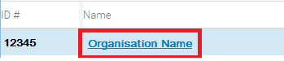

For additional information regarding the purpose of Emergency Preparedness Attestation, please reference the policy and supporting documents. These are available on the [Service Providers’ Emergency Management webpage](Service%20Providers’%20Emergency%20Management%20webpage) <https://providers.dffh.vic.gov.au/emergency-management> .

# Registration for My Agency

My Agency is the secure area of the FAC website, where registered users from funded services / agencies can access funding and payment information about their Service Agreement.

If you require access to My Agency and are not a registered user, please refer to [Funded Agency Channel](Funded%20Agency%20Channel) <<https://fac.dffh.vic.gov.au/my-agency-non-dffh-and-dh-staff> > under My Agency for non DFFH and DH staff page.

# Completing your Emergency Preparedness Attestation

## Navigate to SAM

1. Log into My Agency (via eBusiness). From the My Agency page, select ‘**Service Agreement Module [External Link]**’

**Screenshot 2: Navigating to the Service Agreement Module (SAM)**

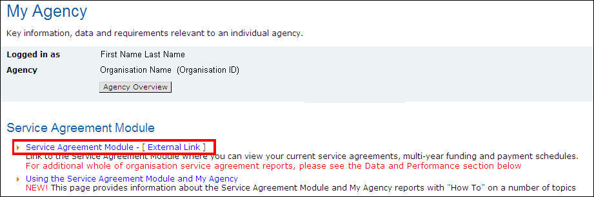

1. A new window will open, and the SAM main page will display. The Organisations tab at the top of the screen is selected by default. ***Select the hyperlink (blue text) with the name of your agency***.

Screenshot 3: SAM main page

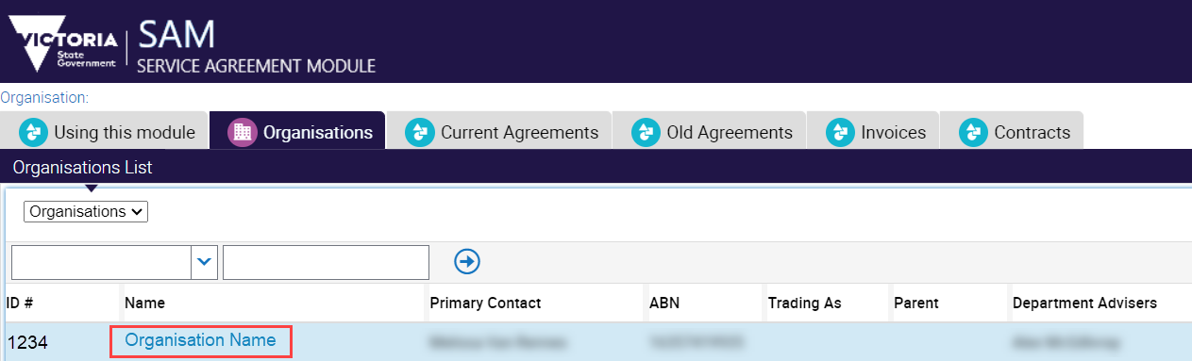

1. The Organisations screen will open with a series of lower-level tabs below the Organisation details section. The Contacts tab will load by default. ***Select the ‘Compliance’ tab.***

Screenshot 4: Compliance tab in Service Agreement Module

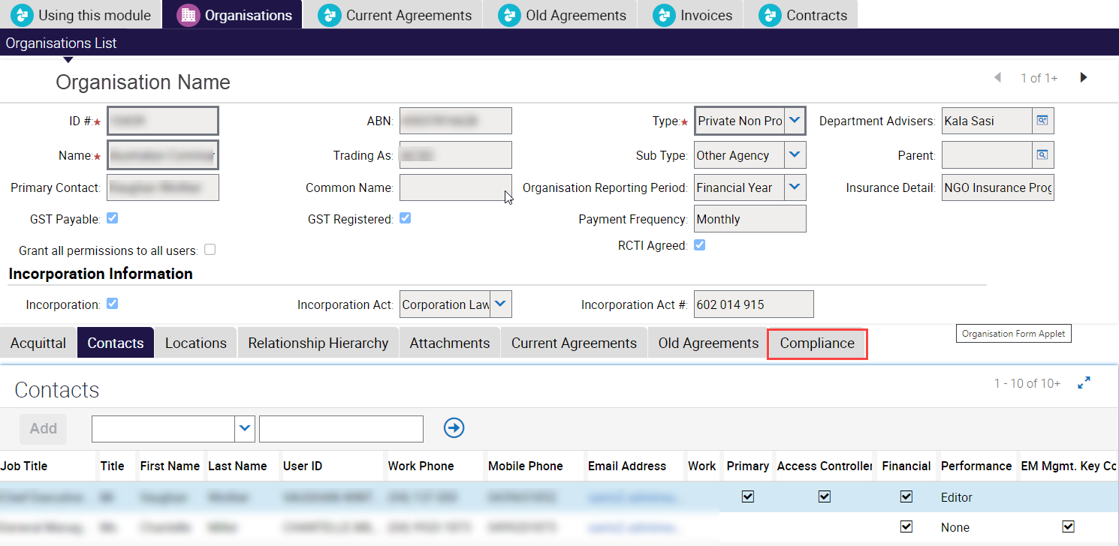

1. Select the Emergency Preparedness Attestation (EM Preparedness Attestation) record to be completed. Ensure the Emergency Preparedness Attestation record to be completed is highlighted, by selecting the ‘EM Preparedness Attestation’ on the far left of the record.
2. Ensure that the record you are working on has a status of ‘Open’. ***Select ‘Open Form’***

Screenshot 5: Select EM Preparedness Attestation record and ‘Open Form’

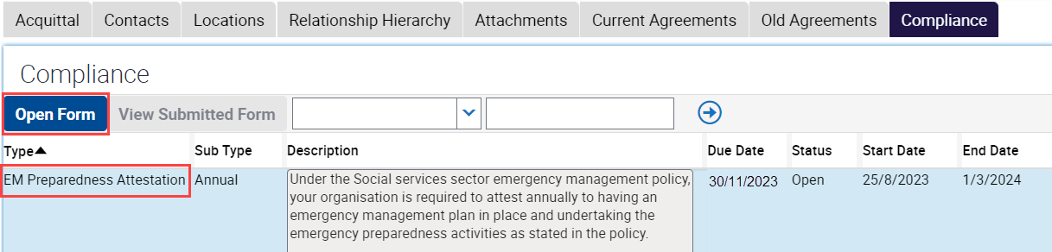

**Note:**

* The ‘Open’ Emergency Preparedness Attestation form will only become visible from the start of the reporting period (1 October). Until then, it will not be visible.
* Only agencies in scope of the policy will be able to access and complete the Emergency Preparedness Attestation in SAM.

1. The Emergency Preparedness Attestation form will display. Select the check box then ‘Submit’ to attest your agency’s emergency management preparedness.

Screenshot 6: An open Emergency Preparedness Attestation form

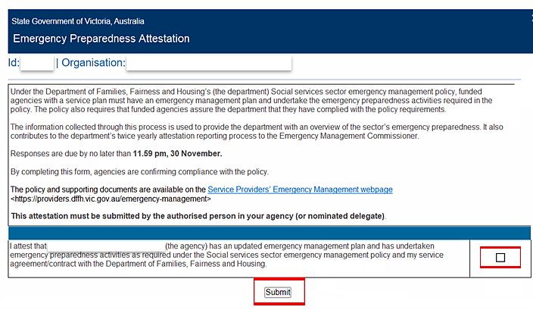

After submitting your Emergency Preparedness Attestation, the following message will display in the window: “*Thank you for completing your Emergency Preparedness Attestation*.”

Both you, and your agency's Primary and Secondary Contact/s listed in SAM (if separate) will also receive a system generated email confirming that the Emergency Preparedness Attestation has been submitted.

1. ***Select ‘Close’*** to exit the form.

# Update your Agency’s Emergency Management Key Contact

For effective communication purposes, an optional field is available to list an Emergency Management Key Contact (EM Key Contact). This has been introduced into the SAM system to provide in-scope agencies with the option of listing another staff member that is authorised to complete the agency’s annual Emergency Preparedness Attestation.

All EM Key Contact/s, as well as an agency’s Primary and Secondary Contacts (if separate) listed in SAM will receive communications related to the policy and attestation process. This includes information about key attestation dates and reminder emails. They will also have the functionality to complete the Emergency Preparedness Attestation process as outlined above.

Therefore, to be eligible for the role of EM Key Contact, individuals must hold positions such as director, chairperson, chief executive officer, president, principal, treasurer, or other similarly authorised roles. Alternatively, they can be delegated the responsibility to attest on behalf of your agency.

**Please note:**

* If no EM Key Contact/s is selected, the Primary Contact, as listed in SAM, will be responsible for completing the Emergency Preparedness Attestation.
* Only an Organisation’s Access Controller (SAM) or departmental SAMS2 users can update an organisation’s contacts. Please see the section below for information on how to add an additional contact in SAM.

1. Navigate to step your Organisation’s screen in SAM [See step 1, 2, and 3 in the *Completing your Emergency Preparedness Attestation* section above].
2. Select the ‘Contacts’ tab. The Contacts tab should load by default

**Screenshot 7: Contacts tab in Service Agreement Module (SAM)**

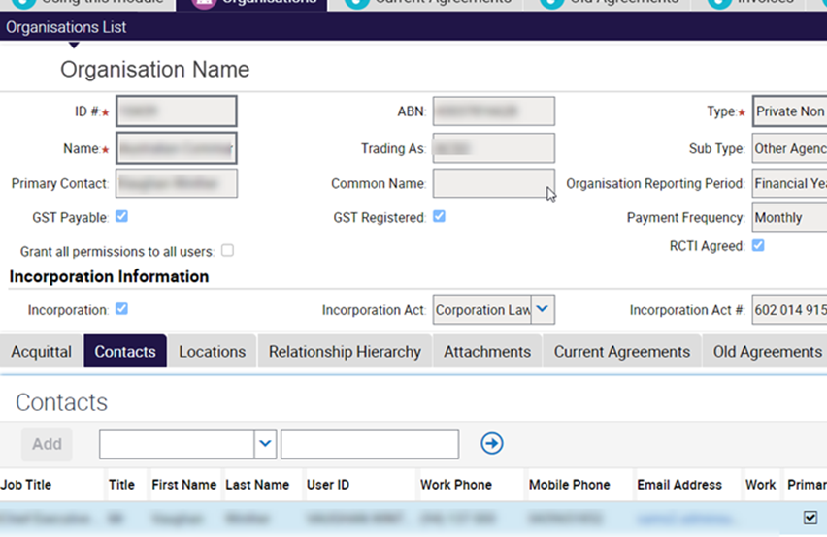

1. To select or update your agency’s preferred Emergency contact/s in SAM, select the ‘EM Key Contact’ check box for all relevant contact/s listed under the Contacts tab in SAM.

**Note**: To complete the attestation form, the 'Compliance' check box on the 'Contacts' tab also needs to be set to 'Editor'

**Screenshot 8: Select your agency’s Emergency Management Key Contact/s**

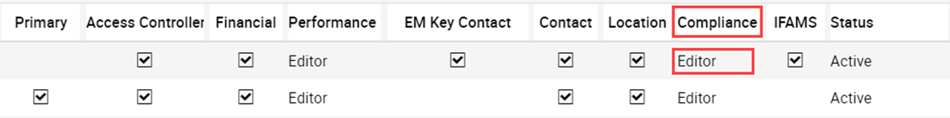

**Create an Additional Contact in SAM**

If you wish to create a new EM Key Contact that is not currently listed under your agency’s ‘Contacts’ in SAM, the new contact will need to register for My Agency access. Instructions on how to register a new user from your agency for FAC can be found in the document titled “How to register for My Agency” located in the [How to register for My Agency](How%20to%20register%20for%20My%20Agency) < <https://fac.dffh.vic.gov.au/how-register-my-agency> > page.

Your agency’s ‘Access Controller’ – as identified in SAM – can then add or nominate the new contact by following the below steps:

1. Log into My Agency (via eBusiness). From the My Agency page, select ‘***Service Agreement Module [External Link]***’

**Screenshot 9: Navigating to the Service Agreement Module (SAM)**



1. A new window will open, and SAM will display. The Organisations tab at the top of the screen is selected by default. Select the ***hyperlink (blue text) with the name of your agency***.

**Screenshot 10: Service Agreement Module main page**



1. The Organisations screen will open with a series of lower-level tabs below the Organisation Details section. The Contacts tab will load by default.
2. **Click on the '*Add*' button** to enter the new contact's details, including their name, job title, and email address.

**Screenshot 11: Contacts tab in Service Agreement Module**

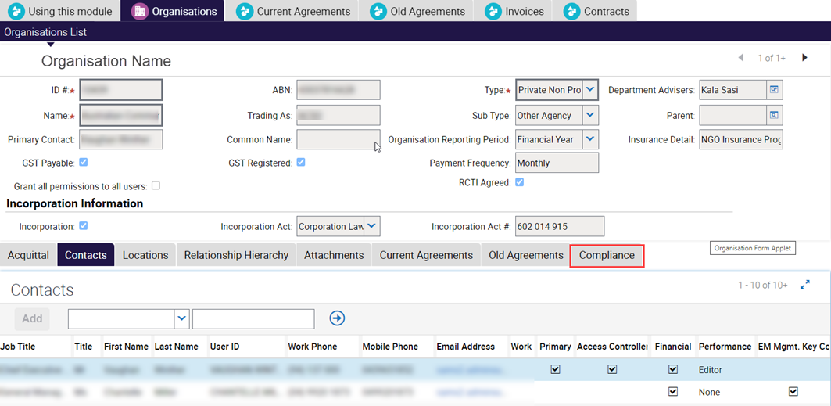

1. Select the relevant roles, including ‘**EM Key Contac**t’ and ‘**Editor**’ (under ‘***Compliance****’* role).

**Please note** that to complete the Emergency Preparedness Attestation form, the '***Compliance***' check box on the '***Contacts***' tab also needs to be set to 'Editor'.

**Screenshot 12: Select relevant roles under ‘Compliance’ check box**

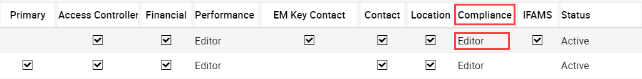

1. The new contact will then need to register for access to My Agency via the eBusiness portal. Instructions on how to do this can be found on the Funded Agency Channel website <<https://fac.dffh.vic.gov.au/how-register-my-agency>>
2. Once the registration request has been submitted, your nominated eBusiness organisation authority will receive an email notification and will be responsible for validating the new application access request.
3. After validation, the Funded Agency Channel Team will process the new access request. This usually takes up to 24 hours on business days (Monday – Friday).
4. The new contact will receive an email notification confirming their SAM account setup, granting them access to My Agency, SAM and the ability to complete the attestation.

If you encounter any difficulties or need additional assistance, you can also contact the Funded Agency Channel Help Desk at [FAC@dfh.vic.gov.au](mailto:FAC@dfh.vic.gov.au); or reach out to your local Agency Performance Support Services (APSS) team informing them that you wish to create an additional agency contact in SAM. They will be able to provide guidance and support in setting up the new contact in SAM.

For further information on how to register for My Agency please refer to: Funded Agency Channel <https://fac.dffh.vic.gov.au/my-agency-non-dffh-and-dh-staff> under [My Agency for non DFFH and DH staff](https://fac.dffh.vic.gov.au/my-agency-non-dffh-and-dh-staff) page.

|  |
| --- |
| To receive this document in another format email Emergency Management Branch <EMPolicy@dffh.vic.gov.au>.  Authorised and published by the Victorian Government, 1 Treasury Place, Melbourne.  © State of Victoria, Australia, Department of Families, Fairness and Housing, September 2024.  ISBN 978-1-76096-605-8 (pdf/online/MS word) |