

|  |
| --- |
| Vulnerable people in emergencies policy |
| Guideline 1 – Emergency Planning and Screening |

# Vulnerable People in Emergencies (VPE) Policy background

## 1.1 The VPE Policy

The VPE Policy Protocols have been developed to support the *Vulnerable People in Emergencies Policy* (the Policy), November 2012, by providing guidance for implementation and application of the Policy.

Figure 1. Vulnerable People in Emergencies Policy Scope (see section 4.1 of the Policy).

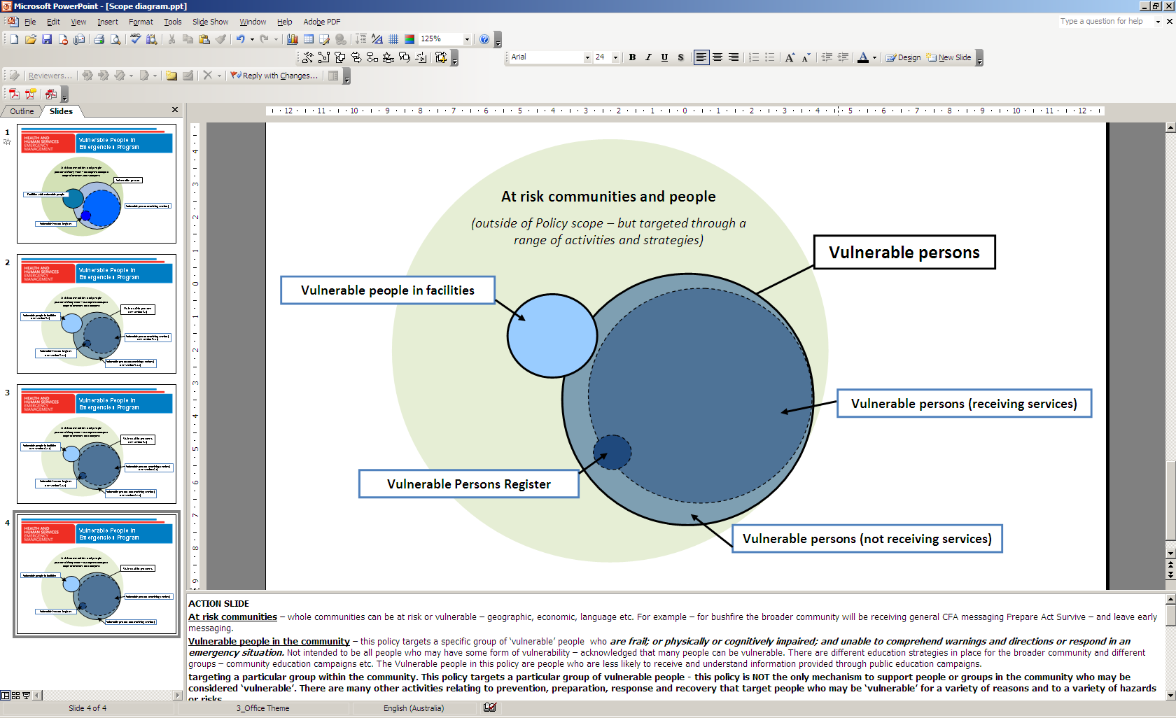

# Vulnerable people in facilities

Under the Policy, a **list of facilities** where vulnerable people are likely to be situated should be developed by municipal councils - to ensure they are effectively planned for at the local level. This requirement is in line with recommendation 3.2 of the 2009 Victorian Bushfires Royal Commission Final Report. Lists of facilities can be accessed by authorised Victoria Police representatives for the purposes of planning, exercising and in the event of an emergency.

## 2.1 Identifying facilities

|  |
| --- |
| For the purposes of the Policy, **facilities** refers to:  buildings where vulnerable people are likely to be situated, including aged care facilities, hospitals, schools, disability group homes and child care centres. This includes:  facilities funded or regulated by the Department of Health and Human Services and Department of Education and Early Childhood Development;  commonwealth funded residential aged care facilities; and  other locally identified facilities likely to have vulnerable people situated in them. |

### Funded facilities

To assist municipal councils to collate these lists, the Department of Health and Human Services will provide information about their relevant facilities and about Commonwealth residential funded aged care facilities.

Some facilities are sensitive locations and should not be widely circulated to the Municipal Emergency Management Planning Committee (MEMPC). While this information is important and must be available for consideration in emergencies, it should be limited to those who potentially require it (MEMPC Secretariat, Victoria Police and control agencies). The departments will advise which facilities this applies to.

### Locally identified facilities

Municipal councils are also encouraged to consider and identify other local facilities or amenities where vulnerable people are likely to be situated. This will differ dependent on location, but would include sites where vulnerable people:

* frequently meet or gather; and/or
* commonly reside.

Consideration may therefore be given to facilities or amenities such as Senior Citizens Centres, or retirement villages, rooming houses and caravan parks where there are long-term residents who are vulnerable (not a primarily tourism based caravan park). Informal, ad hoc or temporary gatherings of vulnerable people in the community are not required to be included.

## 2.2 Emergency planning - people in facilities

Funded facilities are expected to have emergency management plans in place for people residing, staying or situated within facilities – as such, under the Policy these vulnerable people would not require targeted individual emergency planning.

The role of an operator of a facility does not equal a requirement to undertake individual emergency planning activities or to screen people for Vulnerable Persons Registers.

Clients of funded agencies and people not receiving services who are residents of non-funded facilities may still require personal emergency planning support and may be considered for the Vulnerable Persons Register(in line with section 3.4).

## 2.3 Information requirements for the list of facilities

A **template** is available and should be used to compile the list of facilities (Appendix 1). This template has been developed to provide direction and consistent collection of information. Where municipal councils have already developed a list, it is requested they review their list to ensure consistent information is being collected.

Key elements are:

* **Facility identification information** – facility name, facility type (such as aged care, disability) and facility type sub-set (such as group homes, day programs), residential or non-residential.
* **Address information** – this is requested in a format that is able to be GIS mapped to support planning (with separate columns). Latitude and longitude can be included where known, but are not required. A local government field is included to assist sorting.
* **Contact information** – two contacts (name/position and contact phone number) are requested and an indication of availability (such as business hours, 24 hours). Where possible and relevant 24 hour contacts are requested.

## 2.4 How is the list of facilities accessed?

Facilities lists are to be included in, or available through, Municipal Emergency Management Plans (MEMPlans) and must be accessible to Victoria Police for the purposes of planning, exercising and in the event of an emergency.

Local emergency planning processes should clearly articulate how this information will be accessed in an emergency.

It is suggested the facilities list be included in the MEMPlans as per Emergency Management Manual Victoria Part 6, Appendix B - Special Plans and Arrangements. As per section 2.1, caution should be exercised about the treatment of information on some sensitive facilities.

# Vulnerable people in the community – emergency planning and screening

The Policy requires funded agencies to identify and support vulnerable people to undertake emergency planning, and screen for potential inclusion in a Vulnerable Persons Register.

Figure 2. Process for screening clients for the register

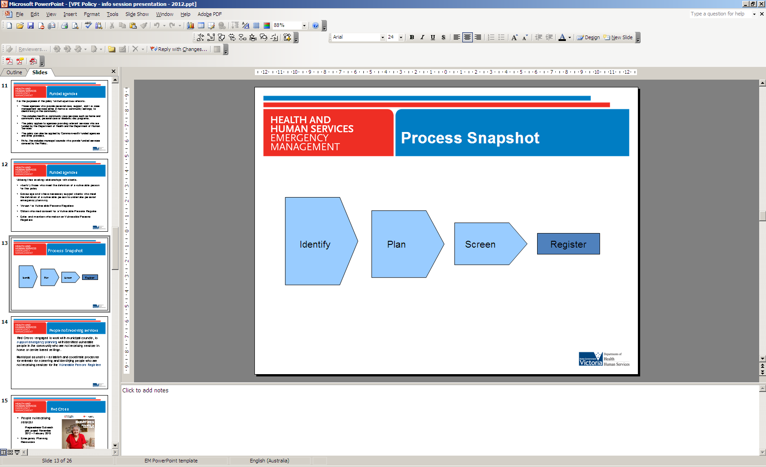

## 3.1 Identifying vulnerable people

### Applying the definition of a vulnerable person

|  |
| --- |
| For the purposes of the Policy a *vulnerable person[1]* is defined as someone living in the community who is:  frail, and/or physically or cognitively impaired; and  unable to comprehend warnings and directions and/or respond in an emergency situation. |

When identifying people who meet the definition of a vulnerable person for the purposes of the Policy, the following factors and indicators may be considered:

Frail, and/or physically or cognitively impaired

* level of frailty or physical impairment that would likely reduce their capacity to act during an emergency
* likely to require increased time and/or assistance to respond in an emergency
* inability to make an independent decision due to cognitive or other impairment.

Unable to comprehend warnings and directions and/or respond in an emergency situation

* inability to make an independent decision due to cognitive or other impairment
* unable to understand or respond to emergency warnings or directions – such as speech/hearing impediment and poor use and/or understanding of English
* does not drive or have access to a vehicle.

|  |
| --- |
| **Embedding into practice**  A desk top review of current clients can assist agencies to identify people who may meet the definition of a vulnerable person.  During initial assessment or case review processes funded agencies could consider potential vulnerability to emergencies and identify those who may need to be encouraged or supported to undertake emergency planning or potentially considered for a Vulnerable Persons Register. |

## 3.2 Emergency planning with vulnerable people

Encouraging and supporting emergency planning with vulnerable people is a key element of the Policy.

Under the Policy, agencies are asked to undertake these functions as part of their care and welfare activities with clients. Assessors or support staff are asked to use their professional skills and knowledge of clients to reasonably identify and support clients who may need additional help to complete a personal emergency plan.

In supporting clients to develop a personal emergency plan and identify potential support networks, funded agency staff are not expected to provide expert emergency or fire advice or to commit to being part of or responsible for a client’s emergency response or evacuation - where this is outside of current agency practices.

### Emergency planning support – with clients

Funded agencies are asked to:

* consider whether their clients, who would meet the definition of a vulnerable person, have a personal emergency plan; and
* encourage or, where necessary, support clients to develop a relevant plan.

It is preferable to encourage and promote emergency planning with personal or community support networks, such as family and friends or neighbours, where available.

Depending on the needs of the client, agencies may:

* provide direction about how to access planning guidance/materials
* distribute copies of planning guidance/materials to clients to fill out independently or with their personal support networks
* support clients to identify potential personal or community networks or support them to develop their own personal emergency plan.

### Emergency planning support – people not receiving services

Not all vulnerable persons in the community receive funded agency services (referred to as ‘people not receiving services’). To enable inclusion of these vulnerable persons, Red Cross has been funded by the Department of Human Services initially to work in partnership with municipal councils to develop and implement processes for identification and emergency planning with, and potential referral of, vulnerable people not receiving services. Department of Health is providing initial funding to municipal councils to facilitate and coordinate assessment related activities under the Policy, specifically including implementing these processes for people not receiving services.

Similar to the process outlined for funded agencies, Red Cross will encourage and support personal emergency planning, including initial discussions about whether personal or community support networks can be identified. Through this process, and with consideration of agreed criteria, Red Cross will be able to make referrals back to council for further consideration, including for Vulnerable Persons Registers.

This process will be further developed pending the outcome of trials occurring during late 2012 and early 2013.

## 3.3 Planning resources

Resources are available to assist people who may need additional support to prepare and plan for what they will do in an emergency. Where there is a recognised bushfire risk, more targeted bushfire emergency planning may be prompted.

### Emergency planning

The Red Cross REDiPlan is a resource that can be used to assist with general emergency planning for a range of hazards. There are a number of versions available that target different audiences, see [Red Cross](http://www.redcross.org.au/emergency-resources.aspx): <http://www.redcross.org.au/emergency-resources.aspx>.

### Bushfire specific

The *Red Cross Bushfires: Preparing to leave early* plan can be downloaded from the [CFA website](http://www.cfa.vic.gov.au/redcrossplan) <http://www.cfa.vic.gov.au/redcrossplan> or copies can be requested from the Victorian Bushfire Information Line on 1800 240 667.

### Additional planning materials or support

If clients require additional information relating to fire planning they can be directed to the Home Bushfire Advice Service provided by CFA by going to the [CFA website](http://www.cfa.vic.gov.au) <http://www.cfa.vic.gov.au> or calling the Victorian Bushfire Information Line on 1800 240 667.

Specific materials for storm and flood planning can be accessed through the Victoria State Emergency Services website at [VICSES](http://www.ses.vic.gov.au/prepare) <http://www.ses.vic.gov.au/prepare>.

## 3.4 Screening for Vulnerable Persons Registers

|  |
| --- |
| Funded agencies are asked to consider and screen clients**[2]** to identify people who should be listed on a Vulnerable Persons Register because they meet the definition of a *vulnerable person* and **additionally:**  cannot identify personal or community support networks to help them in an emergency. |

To identify someone for a Vulnerable Persons Register, funded agencies are asked to make a reasonable judgement based on their professional skills and understanding and knowledge of the client’s situation and personal needs.

In addition to meeting the definition of a vulnerable person, the following factors and indicators may assist when considering a person’s **personal or community support networks:**

Does the vulnerable person:

* live alone or live with someone with similar or greater degree of vulnerability?
* have no family, friend, carer or next of kin or social/community networks in the local area able to assist?
* have no near neighbours or no connection with neighbours or the local community?

## 3.5 What information do I need to collect for Vulnerable Persons Registers?

The process for registering identified vulnerable people on a Vulnerable Persons Register is outlined in the VPE Policy Protocol 2: Vulnerable Persons Registers, which will be circulated with the release of the register.

When screening people for a Vulnerable Persons Register, consider what information will be required in addition to informed consent (see section 3.6 below).

The information that is required includes:

* **Personal identification information** – client name, date of birth, gender and address (based on residence).
* **Contact information** – client and emergency contact details (where these are available). Even if emergency contacts are not located locally, they may be able to provide additional information in the event of an emergency.
* **Emergency considerations** – information about identified vulnerable people that would be relevant to emergency services officers, if they were to attempt to provide assistance to the client in an emergency; see Table 1.

Table 1. Emergency considerations for Vulnerable Persons Registers

|  |  |  |  |
| --- | --- | --- | --- |
| Mobility | Access and security | Equipment, critical medication and pets | Communication or cognitive |
| Wheelchair  Walking aids  Weight-related mobility aids  Stretcher required  Mobility aids | 4WD required  Side access  Rear access  Behaviour  Dangerous animals | Home ventilator  Oxygen  Dialysis  Parenteral nutrition  Ventricle assistance device  Critical medication  Service animal  Pets[3] | Hearing  Sight  Speech  Dementia  Mental health  Cognitive disability  Alcohol or other drugs  Non English speaking |

These considerations are required for Vulnerable Persons Registers and you will be requested to tick appropriate items when entering client records (additional information will be available in the VPE Policy Protocol 2: Vulnerable Persons Registers). Where they do not apply or if you do not know the answer to these questions, you will be asked to leave them blank.

Please note that Vulnerable Persons Registers include a small free text box where you can include additional details that you think would be crucial for emergency services officers to know. This may include:

* Will the client need special consideration before being approached by police or other emergency services personnel, should an evacuation be recommended?
* Is there a known strategy to deal with complex behaviour that could assist police in evacuation?
* Will specialist support be required to evacuate the client safely?
* Are there specific directions for accessing the property or a property name which could assist access to the property?

Note: clients will be able to request access to this information in line with privacy requirements.

## 3.6 Obtaining informed consent

Once identified, agencies require a vulnerable person’s informed consent before entering the person’s details on a Vulnerable Persons Register. Prior to obtaining consent, agencies should check the Vulnerable Persons Registers to confirm that the client has not already given consent and been entered onto the system; see VPE Policy Protocol 2: Vulnerable Persons Registers, which will be circulated with the release of the register.

A template consent form is provided (Appendix 2) to assist agencies gain informed consent. The form includes a range of methods to obtain consent, including written, verbal or consent via an authorised representative[4].

Being on the Vulnerable Persons Register is not compulsory – and identified people can choose not to consent and can remove themselves at any time. If consent is not obtained, this should be recorded internally within the agency as part of standard record keeping practices. Information must be collected and recorded in line with information privacy requirements.

|  |
| --- |
| **Sharing information in emergencies**  Whether someone is included on a register or not, agencies should note that special provisions are made for the sharing of information **in emergencies**. The Office of the Privacy Commissioner has developed Info Sheet 02.10: Emergencies and Privacy – January 2010[5], which states that:  public interest in safety will override the privacy requirements of the Act – even where emergency response was not the primary reason for collection. Privacy law does not stand in the way of responding to legitimate emergencies. |

## 3.7 What happens if someone wants to opt-in to Vulnerable Persons Registers?

Vulnerable Persons Registers are not being publicly promoted, however it is possible that someone may contact councils or funded agencies requesting to be put on a register or to have a member of their family or someone they know, put onto registers. Vulnerable Persons Registers are not opt-in and to enable a list that is manageable and potentially applicable for emergencies it is important to undertake the identification, planning and screening processes outlined above.

If council or agency staff receive requests for entry on Vulnerable Persons Registers, it is important to manage expectations about potential assistance from emergency services organisations. Undertaking emergency planning activities with personal and community networks, rather than focussing on being listed on a Vulnerable Persons Register should be encouraged.

If someone calls for themselves or a family member or friend, this is a good opportunity to provide someone with information about emergency planning resources and to encourage them to undertake some planning activities or to prompt the person they are calling about to connect with local community or personal networks.

Some key messages to support this conversation are:

* Being listed on the Vulnerable Persons Register does not guarantee assistance in an emergency.
* Emergency planning is important and it is an individual’s responsibility to have a plan and be prepared for an emergency.
* You need to think about your family and friends and know your neighbours; encourage them to plan for emergencies, and help them plan if they need assistance.

## 3.8 Who should I contact for more information?

Funded agencies are directed to regional contacts (or where this is not appropriate, the central office) in the first instance regarding any questions they may have about the Policy.

Queries relating to registration and entering client information on Vulnerable Persons Registers or local emergency planning should be directed to the identified primary council (who provided log in details) in the first instance.

|  |
| --- |
| To receive this publication in an accessible format phone 9096 8849, using the National Relay Service 13 36 77 if required, or [email Recovery](mailto:recovery@dhhs.vic.gov.au) <recovery@dhhs.vic.gov.au>  Authorised and published by the Victorian Government, 1 Treasury Place, Melbourne.  © State of Victoria, Department of Health and Human Services, February 2018.  Available at [Emergency preparedness](https://providers.dhhs.vic.gov.au/emergency-preparedness) <https://providers.dhhs.vic.gov.au/emergency-preparedness> |

**APPENDIX 1 – List of facilities**

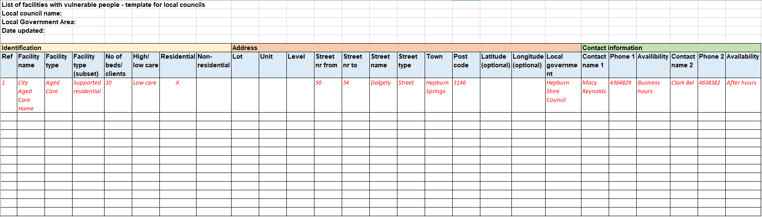

**APPENDIX 2 – Consent form (please remove before use)**

|  |  |  |  |  |
| --- | --- | --- | --- | --- |
| **Vulnerable Persons Register: Consent Form**  **Consent to sharing of personal information** | |  | | --- | | **<< Agency name>>** | | **<<Date entered on VPR>>** | | **<<Entered by (name/id)>>** | |

**Personal details**

|  |  |  |
| --- | --- | --- |
| **Name:** | | **Client ref #:** |
| **Date of birth:** | **Address:** | |

Your consent is requestedto enable your personal information to be provided by your service provider to be stored in a *Vulnerable Persons Register.*

This information will be available to Victoria Police, municipal councils, and the Department of Human Services due to their role in emergency management activities. Information will be accessed to support emergency planning and exercising and may be accessed and used for emergency response and recovery.

Through the *Vulnerable Persons Register*, your information may also be available to other health and community services providers and/or other emergency management organisations for database management or emergency planning and response.

Being listed on a *Vulnerable Persons Register* is voluntary and you can request to remove yourself at any time. Once provided, your consent will remain current until you request to remove consent.

The information collected on a *Vulnerable Persons Register*, which may be disclosed will include:

* **personal identification information -** including your name, date of birth and address information
* **contact information** – your personal and emergency contact information
* **personal care needs** – your health and mobility (such as life sustaining medications and equipment), security and access, communication and cognitive, or other needs that would be relevant to emergency services officers in considering the nature of assistance you may require.

Your information will be treated in accordance with the *Privacy and Data Protection Act 2014*.

**Section 1 - Please read the following:**

* Being listed on the Vulnerable Persons Register does not guarantee assistance in an emergency.
* Emergency planning is important, and it is an individual’s responsibility to have a plan and be prepared for an emergency.

Information to help me plan for an emergency has been provided and/or discussed with me **YES**

**Section 2 - Record of consent**

**Written consumer consent**

The worker/practitioner has discussed with me how and why certain information about me may be shared with other organisations, as set out above. I understand this and I give my consent for the information to be shared in the way set out in this form.

Sign: Dated (dd/mm/yyyy):

**Or**

**Verbal consumer consent**

I have discussed with the consumer how and why certain information may be shared with other organisations, as set out in this form. I am satisfied that this has been understood and that informed consent has been given for the information to be shared as set out in this form.

**Or**

**Consumer does not have the capacity to provide consent**

*(that is, they do not understand the nature of what they are consenting to, or the consequences)*

Consent given by authorised representative:

*Name (authorised representative)*

Sign*:* Date: (dd/mm/yyyy):

Relationship: Contact number:

To ensure that the consumer/ authorised representative can make an informed decision about consenting to the sharing of information as detailed above, the worker/practitioner should (tick when completed):

|  |  |
| --- | --- |
| 1. Discuss with the consumer/authorised representative the proposed sharing of information with other organisations as outlined in this form. |  |
| 2. Explain that the consumer’s information will only be shared with these services/agencies if the consumer/authorised representative has agreed. |  |
| 3. Provide the consumer/authorised representative with information about privacy, such as the brochure *Your Information – It’s Private.* |  |
| 4. Provide the consumer/authorised representative with a copy of this form once completed. |  |

|  |  |
| --- | --- |
| **Consent obtained/witnessed by:** |  |
| Name: | Agency: |
| Position:­­­ | Contact number: |
| Sign: | Date: |

1. This can apply to clients of funded agencies and people not receiving services.
2. Vulnerable people who are not receiving services and have been referred to council may also require screening for a Vulnerable Persons Register.
3. While pets may be listed, it is important not to raise expectations about emergency response capacity to assist in the relocation or evacuation of pets.
4. Further information about who constitutes an authorised representative is provided in the Information Privacy Act 2000, section 64 - part 6.
5. Info Sheet 02.10: Emergencies and Privacy – January 2010 is available at: https://www.cpdp.vic.gov.au/images/content/pdf/CPDP_Information_Sheet_-_Emergencies_and_Privacy_V1.0.pdf