

|  |
| --- |
| Child and Family Alliance planning and oversight environmental scan |
| OFFICIAL |

# Environmental scan

#### Client experience and outcomes in Family Services[1]

| Alliance planning framework | State-wide objectives | Scan Guidance  Minimum Data Instructions Compare Local Data to State-wide | Data Analysis/Comments | Alliance Goal or Initiative Yes/No |
| --- | --- | --- | --- | --- |
| Client Experience   * Journey of the client * Quality and Safety | * Implement processes to capture client voice and understand factors that contribute to family engagement | * Consider data that reflects the client experience in the local service system including the ‘journey of the client’ through (but not limited to);   + allocation times (dependant on Orange Door data)   + any local client voice information or data collected for example client satisfaction surveys or lived experience. * Consider other information available to your Alliance. | Free text | Free text |
| Client Outcomes   * Child safety, stability & wellbeing * Parenting & family functioning * Mental health, Alcohol and Drugs, Family Violence * Housing, health, connection, financial stability | * Data integrity – in particular CRIS IDs recorded for children engaged in Child protection, kinder and school engagement and case closure outcome reflects outcomes in data directory. * Outcome measurement:   + Children attending Kindergarten – 100% of 4-year olds, and 100% of 3-year olds known to Child Protection are attending kindergarten.   + Increasing the number of school aged children from families supported by family services engaged with education. | * Consider the Family Services IRIS data for all children’s, and Aboriginal children’s enrolment and attendance at Kindergarten and schools. * Become familiar with the top 15 issues in your area as identified in IRIS   + what is their prevalence   + do practitioners think this is accurate   + do practitioners have the tools or partnerships they need to support families in these area * Consider data and other sources of information around outcomes in cumulative harm, Best Interest Framework, culturally safe engagement with Aboriginal and Torres Strait Islander families. * Consider other information available to your Alliance. | Free text | Free text |

#### Family Services frontline workforce capability

| Alliance planning framework | State-wide objectives | Scan Guidance  Minimum Data Instructions Compare Local Data to State-wide | Data Analysis/Comments | Alliance Goal or Initiative Yes/No |
| --- | --- | --- | --- | --- |
| Workforce capability   * Confidence in client outcome areas * Confident in Family Services practice elements and service models * Training needs met * Thriving teams * Supportive policies and procedures * The right networks & partnerships | * Continue to develop a baseline understanding of workforce satisfaction in key domains, and identify strategic workforce development objectives * Take an evidence based approach to developing strategies. * Consider processes to ensure effective implementation of evidence-based practice. * Consider workforce attraction and retention strategies (as relevant). * Use of Program Development funding for workforce support is guided by Alliance priorities. | * Consider processes in place to measure and understand workforce capabilities and satisfaction:   + Survey/Anecdotal evidence   + Measure Staff Confidence against top 15 IRIS issues   + Measure staff confidence in best interest framework   + Measure staff confidence in cumulative harm   + Measure staff confidence in working with children under two   + Measure staff confidence in working in a culturally safe way with Aboriginal and Torres Strait Islander families   + Measure staff satisfaction of important elements of the Alliance functioning * Consider workforce challenges across the Area. * Take an evidence based approach to developing strategies * Other relevant comments. | Free text | Free text |

#### Models of service delivery

| Alliance planning framework | State-wide objectives | Scan Guidance  Minimum Data Instructions Compare Local Data to State-wide | Data Analysis/Comments | Alliance Goal or Initiative Yes/No |
| --- | --- | --- | --- | --- |
| Models of Service Delivery   * Community activation * Early Help * Targeted and Specialist Support (including CP working earlier and in more connected ways with family services) * Continuing care * Theories of change, evidence-based practice elements | * Models of service delivery for priority groups as identified by the Alliance, including consideration of the groups outlined in Roadmap for Reform: Priority Setting Plan including:   + vulnerable children and families pre-birth and in the first three years of life, with a focus on Aboriginal children and parents   + children and young people experiencing cumulative harm   + children and young people at risk of entering care, particularly Aboriginal children and young people. | * Consider data to identify gaps in relation to responses in responses to identified priority groups. For example for unborn reports or children aged 0-3 consideration may be given to:   + Numbers of this cohort in Child Protection   + Numbers in The Orange Door (dependant on data availability)   + Allocation outcomes in The Orange Door (dependent on data availability)   + Numbers in Family Services   + Outcomes in Family Services * Consider how cumulative harm is assessed and managed across the system. * Other relevant comments. | Free text | Free text |

#### Priority cohorts and access to Family Services

| Alliance planning framework | State-wide objectives | Scan Guidance  Minimum Data Instructions Compare Local Data to State-wide | Data Analysis/Comments | Alliance Goal or Initiative Yes/No |
| --- | --- | --- | --- | --- |
| Access & Priority Groups   * Identify vulnerable families earlier and wrap evidence-based support around them. * Access & outcomes for priority groups are actively managed * Partnership approach to demand management (Demand Management Advice a separate policy) | * Improved access for priority groups identified by the Alliance, including consideration of the priority groups outlined in the Roadmap for Reform Priority Setting Plan. | * Consider data to identify gaps in relation to priority groups. * Consider data to understand who is accessing services. * Identify in data major referral sources (including aboriginal) e.g. MCHN, Police, Education and consider (dependant on available data):   + How many reports to Child Protection?   + How many referrals The Orange Door?   + Allocation Rates   + Outcomes * Consider referrals to The Orange Door and Family Services from Child Protection seeking to understand (dependant on available data):   + Which Cohorts   + What phase of Child Protection (Intake, Substantiation, Family Preservation, Family Reunification)   + Outcomes * Other relevant comments | Free text | Free text |

#### Partnerships, networks & governance

| Alliance planning framework | State-wide objectives | Scan Guidance  Minimum Data Instructions Compare Local Data to State-wide | Data Analysis/Comments | Alliance Goal or Initiative Yes/No |
| --- | --- | --- | --- | --- |
| Partnerships, Networks and Governance   * Core members (Orange Door, CP Intake and Post Intake, Integrated Family Services and Preservation and Reunification Services) * Universal (MCH, education) and early help (parenting) and secondary service partners (MH, AOD, FV) and OoHC * Understand the business of others, trust, shared purpose and responsibility * Sharing knowledge and a learning network | * Incorporate Family Preservation and Reunification Services into Local Area governance at all levels, including ensuring that MOUs and other local governance arrangements are up to date and consider operational, allocation and prioritisation for family preservation and reunification services, including the role of the CP Navigator * Ensure local area governance arrangements recognise the Orange Door * Ensure that the Alliances have mechanisms in place to support business continuity in emergencies. | * Review membership, vision and structures to include the members required to wrap support around families, especially priority groups. * Review partnership health;   + Review the DFFH Community services quality governance framework policy document.   + Alliances may continue to use the VicHealth Partnership Analysis tool to identify areas for focus. * Review mechanisms to support Aboriginal self-determination and self-management. * Other relevant comments | Free text | Free text |

#### SWOT analysis

| SWOT Area | Data Analysis/Comments | Alliance Goal or Initiative Yes/No |
| --- | --- | --- |
| Strengths | Free text | Free text |
| Weaknesses | Free text | Free text |
| Opportunities (Initiatives) | Free text | Free text |
| Threats (Risks) | Free text | Free text |

# Instructions for use

* Please refer to the Child and Family Alliance planning and oversight policy for full details of how to use this document. This can be found on the [Family Services Providers webpage](https://providers.dhhs.vic.gov.au/family-services) <https://providers.dffh.vic.gov.au/family-services>
* ‘Free text’ indicates where Alliance’s should enter text. ‘Free text’ should be deleted prior to Alliances adding their own text.
* Additional lines can be added to each table to reflect Alliance initiated goals.
* No lines should be deleted, and each area should be commented on.

# Appendix 1: Alliance Planning Framework

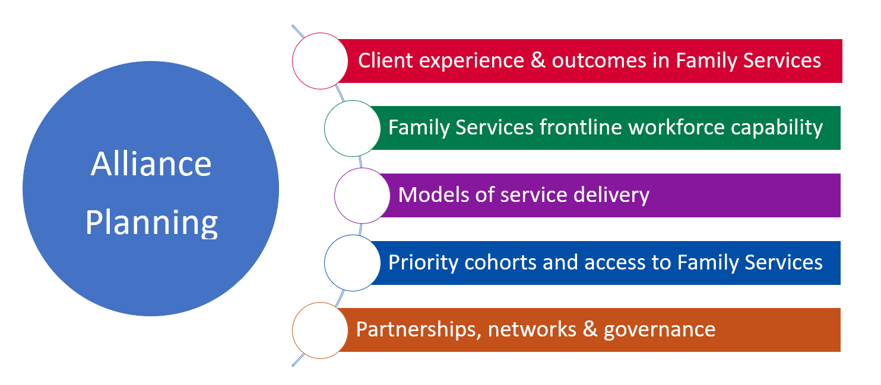

|  |
| --- |
| To receive this publication in an accessible format email [Children, Youth and Families](mailto:ChildrenYouthFamilies@dhhs.vic.gov.au) <ChildrenYouthFamilies@dffh.vic.gov.au>  Authorised and published by the Victorian Government, 1 Treasury Place, Melbourne.  © State of Victoria, Department of Families, Fairness and Housing August 2022.  Where the term ‘Aboriginal’ is used it refers to both Aboriginal and Torres Strait Islander people. Indigenous is retained when it is part of the title of a report, program or quotation.  ISBN 978-1-76069-115-8  Available at [DFFH Family Services webpage](https://providers.dffh.vic.gov.au/family-services)  <https://providers.dffh.vic.gov.au/family-services> |

1. Includes any services funded under Individual Child and Family Support, Specialised Interventions and System Enablers