

|  |
| --- |
| Child and Family Alliance planning action and oversight plan and review |
|  |

|  |  |
| --- | --- |
| Year of Plan: | Alliance Name: |
| Date Plan/Review: | Plan/Review 1/Review2 (Highlight Appropriate) |

# Action plan

#### Client experience and outcomes in Family Services

| Alliance planning framework | Goal guidance | Alliance goals | State-wide objectives  tracking | Indicators | Actions | Who Responsible | Date Due | Report – progress to goals-success/risks/barriers  (To be completed at review points only) | Completed |
| --- | --- | --- | --- | --- | --- | --- | --- | --- | --- |
| Client Outcomes | Implement strategies to promote client voice | Free text | Free text | Free text | Free text |  |  |  |  |
| Client Outcomes | Data integrity. | Free text | Improvements in data integrity - CRIS IDs recorded for children engaged in Child Protection, kinder and school engagement, goals and case closure outcome are recorded as defined in data directory | Free text | Free text | Free text | Free text | Free text |  |
| Client Outcomes | Kindergarten goal | Free text | (IRIS) currently  X% of 4-year olds enrolled & attending  X% of 3-year olds referred by Child Protection enrolled and attending | 100% of 4-year olds, and of 3-year olds referred by Child Protection are enrolled and attending Kindergarten at the end of a family service | Free text | Free text | Free text | Free text | Yes/No |
| Client Outcomes | School engagement | Free text | (IRIS)  X% of school aged children from families supported by family services engaged with school/education | N/A. | Free text | Free text | Free text | Free text | Yes/No |

#### Family Services frontline workforce capability

| Alliance Planning Framework | Goal guidance | Alliance goals | State-wide objectives  Tracking | Indicators | Actions | Who Responsible | Date Due | Report – progress to goals-success/risks/barriers  (To be completed at review points only) | Completed |
| --- | --- | --- | --- | --- | --- | --- | --- | --- | --- |
| Workforce  Capability | Workforce uplift goal | Free text | Free text | Free text | Free text | Free text | Free text | Free text | Yes/No |

#### Models of service delivery

| Alliance Planning Framework | Goal guidance | Alliance goals | State-wide objectives  tracking | Indicators | Actions | Who Responsible | Date Due | Report – progress to goals-success/risks/barriers  (To be completed at review points only) | Completed |
| --- | --- | --- | --- | --- | --- | --- | --- | --- | --- |
| Models of Service Delivery | Models of service delivery for priority groups as identified by the Alliance in consideration of those outlined in Roadmap for Reform: Priority Setting Plan. | Free text | Free text | Free text | Free text | Free text | Free text | Free text | Yes/No |
| Models of Service delivery | Models of service delivery for priority groups as identified by Alliance in consideration of those outlined in Roadmap for Reform: Priority Setting Plan. | Free text | Free text | Free text | Free text | Free text | Free text | Free text |  |

#### Priority cohorts and access to Family Services

| Alliance Planning Framework | Goal guidance | Alliance goals | State-wide objectives  Tracking | Indicators | Actions | Who Responsible | Date Due | Report – progress to goals-success/risks/barriers  (To be completed at review points only) | Completed |
| --- | --- | --- | --- | --- | --- | --- | --- | --- | --- |
| Access & Priority Groups | Improved access for priority groups as identified by Alliance in consideration of priority groups identified in the Priority Setting Plan. | Free text | Free text | Free text | Free text | Free text | Free text | Free text | Yes/No |

#### Partnerships, networks and governance

| Alliance Planning Framework | Goal guidance | Alliance goals | State-wide objectives  tracking | Indicators | Actions | Who Responsible | Date Due | Report – progress to goals-success/risks/barriers  (To be completed at review points only) | Completed |
| --- | --- | --- | --- | --- | --- | --- | --- | --- | --- |
| Governance & Networks | Incorporate Family Preservation and Reunification Services into Local Area governance at all levels, including ensuring that MOUs and other local governance arrangement are updated and that consider operational, prioritisation and allocation processes for family preservation and reunification services and the role of Child Protection Navigators | Free text | Free text | Free text | Free text | Free text | Free text | Free text | Yes/No |
|  | Recognise and incorporate the Orange Door in Local area governance arrangements | Free text | Free text | Free text | Free text | Free text | Free text |  |  |
|  | Ensure that the Alliances have mechanisms in place to support business continuity in emergencies. | Free text | Free text | Free text | Free text | Free text | Free text |  |  |

# Alliance business

|  |  |
| --- | --- |
| Risks | Free text |
| Risk mitigation strategies | Free text |
| Barriers to priority areas | Free text |
| Barrier mitigation strategies | Free text |
| Other Business/initiatives | Free text |
| Feedback on Alliance Planning  (Process, templates, etc.) | Free text |

# Governance and oversight meeting

## Attendance

|  |
| --- |
| Please list attendees, role and agency. |

# Endorsement

|  |  |  |  |
| --- | --- | --- | --- |
| Area Director | Signed: | Name: | Date: |
| Alliance Chair | Signed: | Name: | Date: |

# Instructions for use

* Please refer to the Child and Family Alliance planning and oversight policy for full details of how to use this document. This can be found on the [Family Services Providers webpage](https://providers.dhhs.vic.gov.au/family-services) <https://providers.dffh.vic.gov.au/family-services>
* ‘Free text’ indicates where Alliance’s should enter text. ‘Free text’ should be deleted prior to Alliances adding their own text.
* Additional lines can be added to each table to reflect Alliance initiated goals.
* No lines should be deleted, and each area should be commented on.
* Same document to be used for Action Plan and 2 oversight reviews. ‘Grey’ Shaded Areas may be left blank until reviews.
* ‘Save As’ to capture different points of process without having to rewrite action plan.

# Appendix 1: Alliance Planning Framework

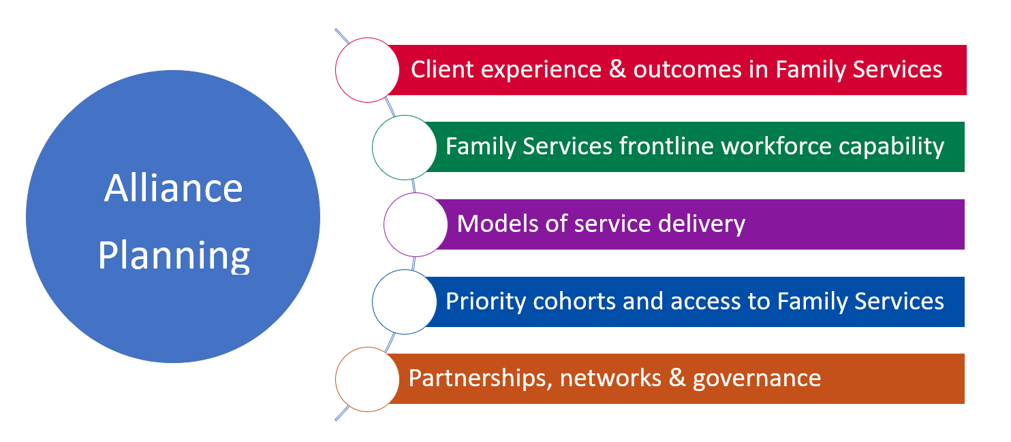

|  |
| --- |
| To receive this publication in an accessible format email [Children, Youth and Families](mailto:ChildrenYouthFamilies@dhhs.vic.gov.au) <ChildrenYouthFamilies@dffh.vic.gov.au>  Authorised and published by the Victorian Government, 1 Treasury Place, Melbourne.  © State of Victoria, Department of Families, Fairness and Housing – September 2022.  Where the term ‘Aboriginal’ is used it refers to both Aboriginal and Torres Strait Islander people. Indigenous is retained when it is part of the title of a report, program or quotation.  ISBN 978-1-76069-114-1  Available at [DFFH Family Services webpage](https://providers.dffh.vic.gov.au/family-services) <https://providers.dffh.vic.gov.au/family-services> |