

|  |
| --- |
| Human Services Regulator Newsletter |
| Information for supported residential services  December 2022 |
|  |

### Contents

Human Services Regulator update

The HSR’s regulatory approach

Providing a safe environment for SRS residents and staff

What SRS can expect from Authorised Officers

Social Services Regulation

Enforcement actions

SRS staffing requirements

Newsletter suggestions

Upcoming SRS staff training

# Human Services Regulator update

Welcome to the Human Services Regulator (HSR) spring newsletter for the Supported Residential Services (SRS) sector. We are returning after a year’s hiatus.

These regulator newsletters focus on providing information to help proprietors of SRS to understand and meet their responsibilities under the *Supported Residential Services (Private Proprietors) Act 2010* (SRS Act) and the *Supported Residential Services (Private Proprietors) Regulations 2012* (SRS regulations).

You can find previous editions of the HSR’s newsletters for SRS on the [Operating an SRS webpage](https://providers.dffh.vic.gov.au/operating-supported-residential-service) <https://go.vic.gov.au/uUWQR9>.

You recently received *SectorConnect*, Homes Victoria’s publication providing information about programs, resources, and government activities relevant to proprietors and residents of SRS.

**Richard Marks**

Director, Compliance, Human Services Regulator

# The HSR’s regulatory approach

The HSR uses a risk-based, intelligence-led approach to regulate SRS. Risk-based regulation seeks to minimise harm by focussing on the potential risks of non-compliance with SRS legal obligations.

It is important that we collectively strive for the delivery of high-quality services and work to avoid the risk of harm to people. Most service providers and carers do the right thing. Where this is not the case, it is important that safeguards are in place to enable a timely and effective response.

The HSR *Regulatory Strategy* outlines our guiding principles and regulatory approach for ensuring that regulated service providers meet their obligations and that the safety and rights of service users are upheld.

The HSR *Compliance and Enforcement Policy* explains our compliance and enforcement approach and expectations to external stakeholders, duty holders and client group representatives.

You can find both the HSR *Regulatory Strategy* and the *Compliance and Enforcement Policy* on the [Human Services Regulator webpage](https://www.dffh.vic.gov.au/human-services-regulator) <https://go.vic.gov.au/NhUnbw>

# Providing a safe environment for SRS residents and staff

Schedule 9 of the [SRS regulations](https://www.legislation.vic.gov.au/in-force/statutory-rules/supported-residential-services-private-proprietors-regulations-2012/003) <https://go.vic.gov.au/LXqVzu> set out the minimum accommodation and personal support standards required under the [SRS Act](https://www.legislation.vic.gov.au/in-force/acts/supported-residential-services-private-proprietors-act-2010/010) <https://go.vic.gov.au/i14OEb>. Standard 13 ensures residents live in a safe and stable environment, setting out the minimum requirements which identify the reasonable steps expected of proprietors to meet the requirements under the Act.

The minimum requirements identify requirements such as call bells, grab rails, sufficient lighting, power outlets, hot and cold water, and having appropriate processes to identify and manage risks and hazards to residents.

We have identified that non-compliance in SRS often relates to:

* call bell systems that are not functional or regularly tested
* processes not in place and maintained to identify and manage risks and hazards to residents.



You can find guidance around standard 13 in section 8 of [Operating a supported residential service: A guide for proprietors](https://providers.dffh.vic.gov.au/operating-supported-residential-service-guide-proprietors) <https://go.vic.gov.au/rCctIX>.

# What SRS can expect from Authorised Officers

The SRS Act empowers authorised officers to enter a supported residential service unannounced, to monitor compliance and investigate possible contraventions of the Act or Regulations. An authorised officer may also enter, with the consent of the occupier or a search warrant, any premises that the authorised officer has a reasonable suspicion is operating as an unregistered supported residential service.

If there are areas where an SRS does not meet requirements of the Act or Regulations, the authorised officer may take a range of actions to ensure the SRS meets those requirements. Authorised officers will discuss the findings of their inspection with you on the spot or notify you in writing.

SRS staff can contact their local authorised officer via the following emails:

South: [regulation.south@dffh.vic.gov.au](mailto:regulation.south@dffh.vic.gov.au)

East:  [regulation.east@dffh.vic.gov.au](mailto:regulation.east@dffh.vic.gov.au)

West: [regulation.west@dffh.vic.gov.au](mailto:regulation.west@dffh.vic.gov.au)

North: [regulation.north@dffh.vic.gov.au](mailto:regulation.north@dffh.vic.gov.au)

SRS can expect authorised officers to act professionally and to treat SRS staff and residents with respect. However, they will be direct about non-compliances to ensure there is no miscommunication, and the obligation for compliance is always with the proprietor.

We welcome feedback about authorised officers via [email](mailto:humanservicesregulator@dffh.vic.gov.au) <humanservicesregulator@dffh.vic.gov.au>.

# Social Services Regulation

On 16 September 2021 new legislation (*Social Services Regulation Act 2021*) was passed by the Victorian Parliament. The Act establishes a new regulatory framework for social services. It will help keep Victorians who use social services, including SRS residents, safe from harms such as abuse and neglect.

The new scheme also establishes an independent Social Services Regulator, which will replace the current Human Services Regulator. The Regulator will be appointed in mid 2023, and will commence monitoring compliance with the new scheme when it begins on 1 July 2024.

The new *Social Services Regulation Act 2021* will regulate SRS and broader social services together under one regulatory framework.

The Department of Families, Fairness and Housing (department) has provided three information sessions on the reforms specifically targeting proprietors of SRS, with the most recent session held on 27 October 2022.

You can find more information about the reforms on the [Social Services Regulation Reform webpage](https://www.dffh.vic.gov.au/social-services-regulation-reform) <https://go.vic.gov.au/Cq2uSG>. If you have any further queries about the reforms please [email](mailto:regulationreform@dffh.vic.gov.au) <regulationreform@dffh.vic.gov.au>.

# Enforcement actions

The HSR emphasises preventative measures (such as education and guidance) as its starting point for engaging with duty holders. However, it will use compliance and enforcement action where the risk is greater or where duty holders are uncooperative or repeatedly non-compliant.

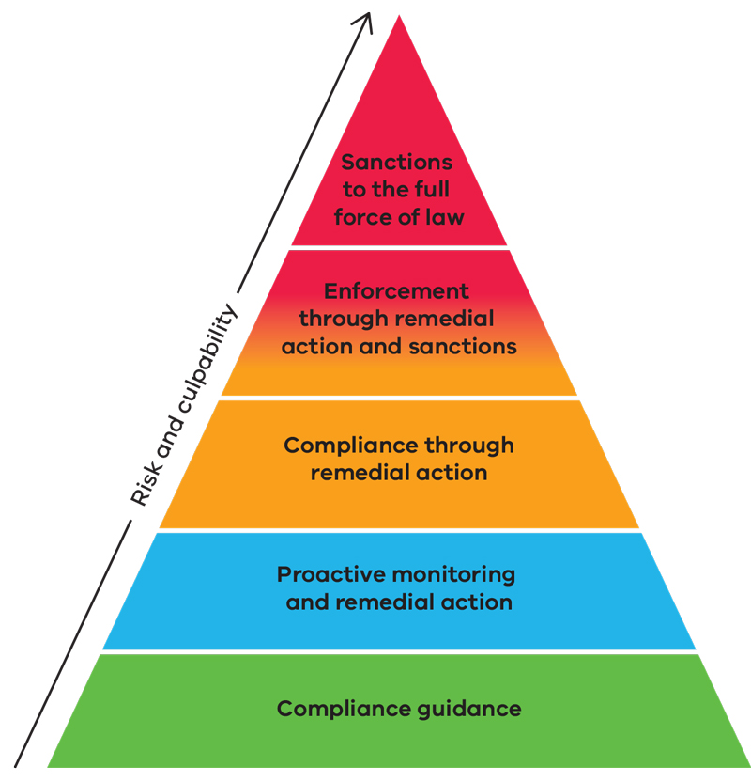

The pyramid of compliance and enforcement activities shows the most used and least severe non compliances (level 5) at the base of the pyramid and escalates to the most severe and less frequently used (level 1) at the top.

* Level 5: Compliance guidance, including direction to education resources and advice during registration
* Level 4: Proactive monitoring and remedial action, including inspections, investigations, remedial letters and referrals to peer regulators
* Level 3: Compliance through remedial action, including through remedial letters, undertakings, registration conditions and remedial notices
* Level 2: Enforcement through remedial action and sanctions, including remedial notices, registration restrictions and imposition of sanctions
* Level 1: Sanctions to the full force of the law, including prosecutions and registration revocations

The department registers all SRS and monitors compliance with the Act and the Regulations. You are responsible for each of your SRS complying with the Act and Regulations.

Authorised Officers may issue infringement notices (fines) for certain offences under the Act and Regulations. The provisions of the Act and Regulations considered to be infringement offences are outlined in Schedule 11 of the Regulations.

# SRS staffing requirements

Regulation 34 of the SRS regulations require an SRS to ensure they have an adequate number of staff members on duty at all times in the SRS. If there are absences due to a staff member being ill or other leave, you still need to ensure each of your SRS has an adequate number of suitable staff on duty.

You can find guidance around SRS staffing requirements in section 7 of [Operating a supported residential service: A guide for proprietors](https://providers.dffh.vic.gov.au/operating-supported-residential-service-guide-proprietors) <https://go.vic.gov.au/rCctIX>.

## Prosecution Outcome

An SRS proprietor plead guilty after the HSR charged them with failure to ensure that an adequate number of appropriately trained staff were employed at the facility between the hours of 7 PM-7 AM, who can respond to first aid or emergency issues.

The proprietor received an individual fine of $750.00 and a company fine of $1500.00, with no conviction recorded.

We will continue to monitor SRS to ensure they meet their requirements under regulation 34.

# Newsletter suggestions

The HSR uses data obtained from our staff, SRS, and other stakeholders to identify what information would be of most use to SRS. If you have any content suggestions or queries, please send us an [email](mailto:srs@dffh.vic.gov.au) <srs@dffh.vic.gov.au> and we will look to include in future editions of the newsletter. We look forward to hearing from you.

# Upcoming SRS staff training

You can find dates and registration details on the [Aged & Community Care Providers Association[’s website](’s%20website)](https://www.accpa.asn.au/srs-training) <https://www.accpa.asn.au/srs-training/>.

#### SRS Emergency Management

6 December 2022

This online workshop consists of two 90-minute (1.5-hour) online meetings with a 1-hour lunch break in between. This course is suitable for all SRS staff.

#### Residents and Mental Health

30 January 2023

This online workshop consists of two 120 minute meetings with a 1-hour lunch break in between. This workshop is suitable for all staff who have contact with residents.

#### Obligations of Running an SRS

31 January 2023

This online workshop consists of two 120 minute meetings with a 1-hour lunch break in between. This workshop is suitable for all SRS proprietors, managers and personal support coordinators.

#### Medication Administration and Management in SRS

9 February 2023

This online workshop consists of two 90 minute meetings with a 1-hour lunch break in between. This workshop is suitable for all SRS proprietors, managers, personal support coordinators and any staff responsible for medication administration.

#### Support Planning, Legislation and Ongoing Support of SRS Residents

16 February 2023

This online workshop consists of two 120 minute meetings with a 1-hour lunch break in between. This workshop is suitable for all SRS proprietors, managers and personal support coordinators.



|  |
| --- |
| To receive this document in another format, email Standards and Regulation <srs@dffh.vic.gov.au>.  Authorised and published by the Victorian Government, 1 Treasury Place, Melbourne.  © State of Victoria, Australia, Department of Families, Fairness and Housing, December 2022.  Except where otherwise indicated, the images in this document show models and illustrative settings only, and do not necessarily depict actual services, facilities or recipients of services. Images in this newsletter were designed by [FreePik](http://www.freepik.com)  Available at the department’s [Supported residential services webpage](https://providers.dffh.vic.gov.au/operating-supported-residential-service) <https://providers.dffh.vic.gov.au/operating-supported-residential-service> |