

|  |
| --- |
| SHIP Guidance  for local family violence After-hours services |

|  |  |
| --- | --- |
| Project owner | Toni Buck |
| Version | 4 |

Contents

Key Referral functionality and areas 3

Referral mailbox 3

Person’s referral repository 3

How to Send a Referral 4

Sections of the Referral Form 5

Section 1: Status and Restrictions 5

Section 2: From 5

Section 3: To 5

Section 4: For 6

Section 5: Associated Persons 6

Section 6: Details 7

Section 7: Attachments 8

Acknowledging, accepting and declining a referral 12

Acknowledging 12

Accepting 13

Declining 15

Comments 16

Referral Outcome 17

Alternate referrals sources 17

Referral questions and answers 18

1. Can I recall a Referral sent to the wrong organisation? 18

2. I recalled a referral, how do I re-send it with correct information? 18

3. Can I copy a referral and re-send to the same or a different organisation? 19

Support Periods 20

Process map for support periods and After-hours profiles 20

Creating an After-hours profile 21

Sections of the After-hours response profile 21

Referral details 21

Children present 22

Client information 23

Notes and payments 24

Notes 24

Payments 24

Response 26

Recording children who receive an after-hours response 27

Capturing referrals that don’t result in an After-hours response 27

Recording a New Unassisted Person 27

Helpful tips for capturing data 29

After-hours acquittals (list reports) 29

How to download your list report 30

# Key Referral functionality and areas

There are two areas where the Referral functionality is **accessed within the Specialist Homelessness Information Platform (SHIP),** and these are described below.

## Referral mailbox

Each workgroup has a Referral repository, like a mailbox that shows the Received, Accepted, Declined, Sent and Draft Referrals. The Referral repository is located on the Home page in the Referral tab.

This section of the workgroup allows the users to collectively see the list and status of all Referrals that are being managed throughout the workgroup. In this document we call this area the Referral mailbox. From the Referral mailbox, practitioners can click on the person icon to go directly to the person record. They can also click on the pen icon to see inside of the referral, accessing any client files and seeing comments and outcomes.

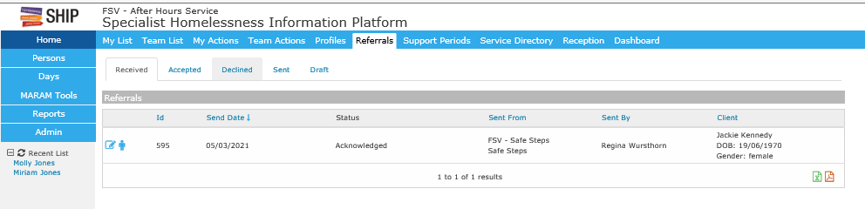

## Person’s referral repository

Inside of a Person’s record there is a Referral repository that houses referrals sent and received for that person as well as any recalled and declined referrals for that person. This area is where new referrals and copied referrals are generated for that person. In this document we call this area the Person’s referral repository.

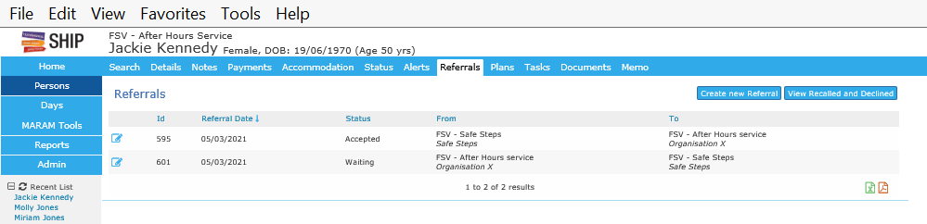

# How to Send a Referral

After creating a person record go to the Person’s referral repository and click Create a new referral.

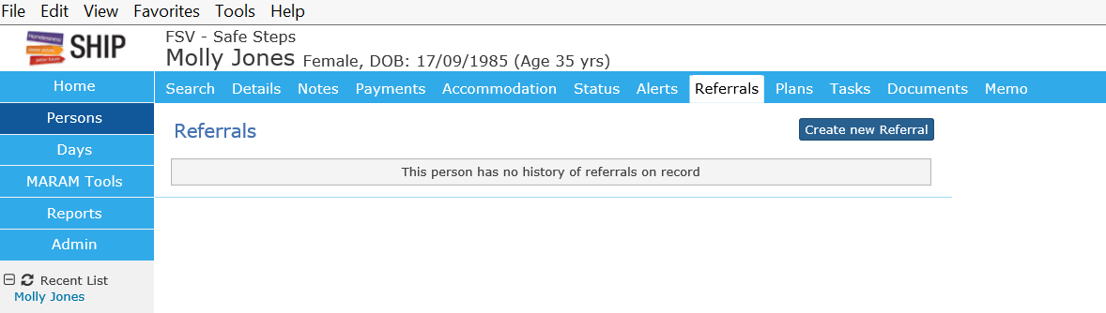Click on SRS external to search for the workgroup that you want to send the referral to.

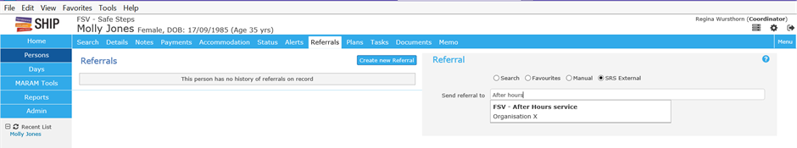

**Submit** to create a referral form.

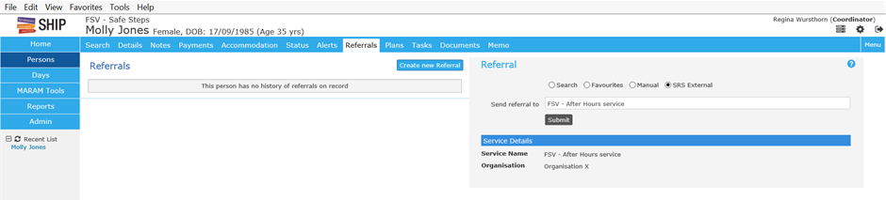By default the form will appear with some sections collapsed and some areas expanded. 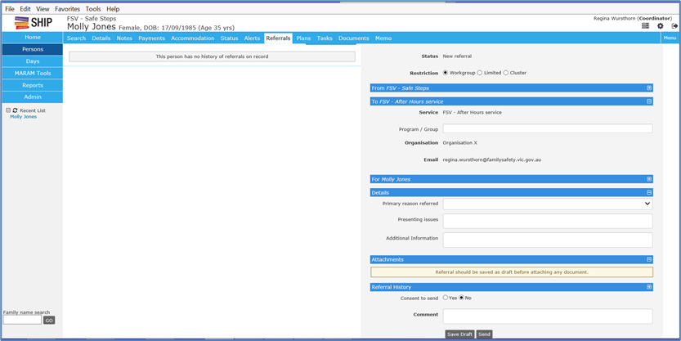

# Sections of the Referral Form

## Section 1: Status and Restrictions

The status section of the form identifies where the referral is up to and who will be able to view the referral. The status will update automatically as the referral progresses however the referrer needs to mark the restriction as ‘workgroup’, ‘limited’ or ‘cluster’. This can be changed by the receiving organisation.

If checked as workgroup, only the receiving workgroup will be able to review the referral. If checked as ‘cluster’, the entire cluster will be able to review the referral. If checked as limited, the cluster will have read-only view.

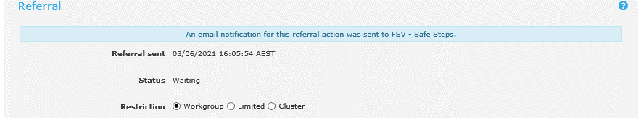

## Section 2: From

The **from** section provides details of which service, organisation and worker is sending the Referral. This section is automatically generated based on the practitioner’s credentials.

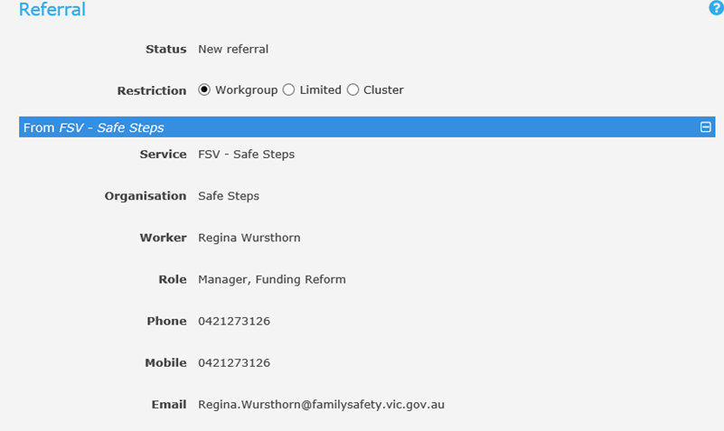

## Section 3: To

This **to** section provides the details of which service and organisation the Referral is being sent to. It also allows a program/group type to be included. This is a free text area and ‘**After-hours**’ can be included here which may be important if the Referrals functionality starts to be used by other services (e.g. business hours intake services). Practitioners should always ensure that this section is checked for accuracy.

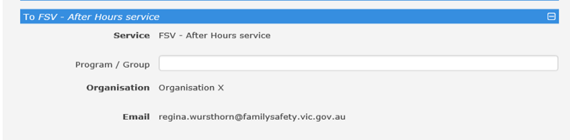

## Section 4: For

The **for** section states who the Referral is for. This is automatically generated from the client record attached to the person’s referral repository that the referral was created from. Practitioners must always check that these details are accurate.

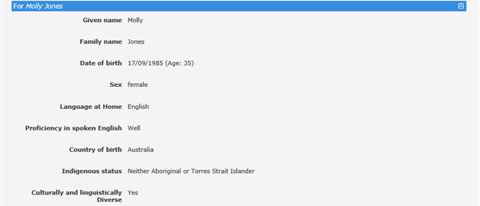

## Section 5: Associated Persons

The **Associated Persons** section allows the sender to include details of people associated to the primary person being referred such as children or other victims within the household. To be able to add an associated person you must first click **Save Draft.**

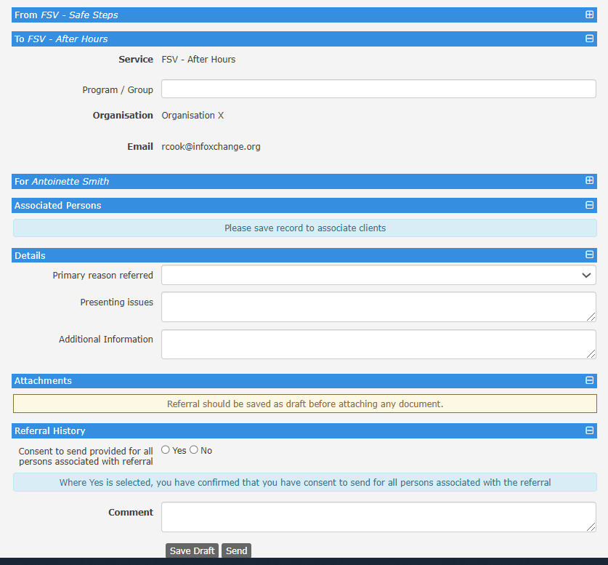

The **plus sign** will appear for you to select.



Select the **radio button** for the type of search you want to undertake to find the associated person. Recent and related searches may find the associated person quickly or select the search button if undertaking a broad search of the database. Type the surname in the search box and select either one or multiple associated persons. Click Save.

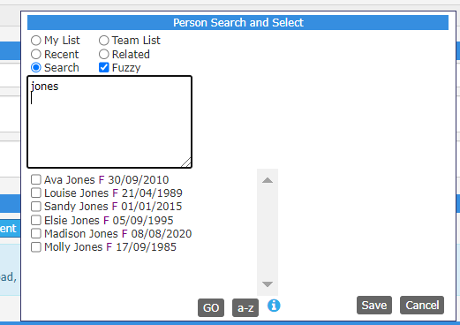

The associated person(s) record will be attached to the referral. You can remove an associated person by selecting the red pen icon.

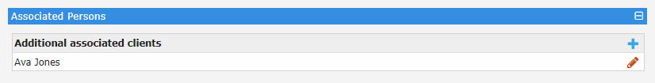

## Section 6: Details

The details section contains reasons for referral. There are three non-mandatory fields under ‘Details’ as highlighted below:

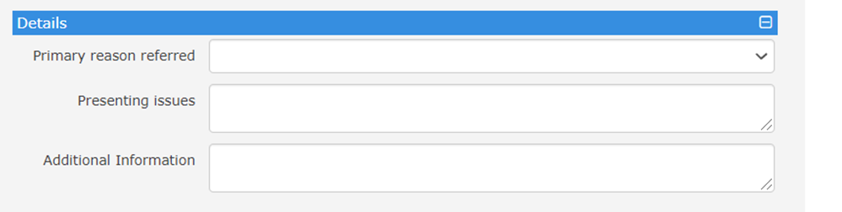

**Primary reason referred** has a drop-down list from which Family/Domestic violence support can be chosen.

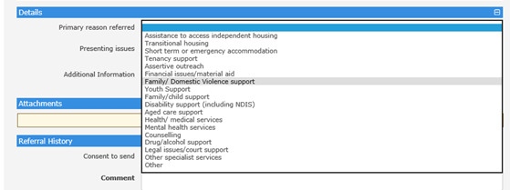

Presenting issues and Additional information should also be completed.

*Presenting issues* – This field should be used to briefly describe any immediate safety needs for practitioners and any significant presenting issues of the victim that you may wish to highlight to the referee without duplicating what is in the MARAM assessment.

*Additional information* – This field should include information that is being requested in response to the victim’s needs assessment and information on the victim’s location including how to access/call/meet her at that location. This section could also describe any minor changes since the MARAM assessment was completed.

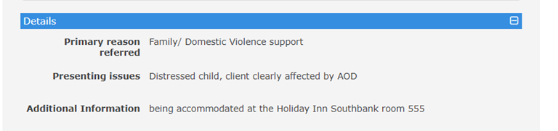

After this section, the Referral must be **saved** as draft, prior to attaching the client file and sending.

## Section 7: Attachments

The **Attachments** section allows information from the **client file** including MARAM tools and any other accompanying information to be included inside of the Referral. Documents that are not inside of the client file can be uploaded if this is appropriate by pressing **Select & Upload**.

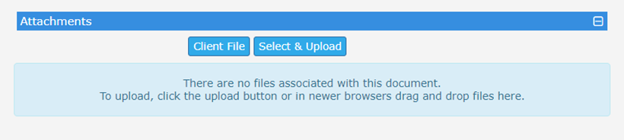

When Client file is clicked, information from the Person’s Information record including MARAM tools are ticked for inclusion for both the victim and children by default. This can be altered noting addresses, contacts and MARAM tools for both the victim and children are critical to tick. If there is information in the case note that is useful, practitioners may also choose to the send case notes. There may also be relevant documents in the ‘documents’ tab that should be ticked and uploaded.

**Please Note:** Safe steps undertake safety planning as part of the MARAM assessment rather than in the case note or separate safety plan. Including a safety plan or MARAM assessment is critical so make sure you check the correct box to send this information.

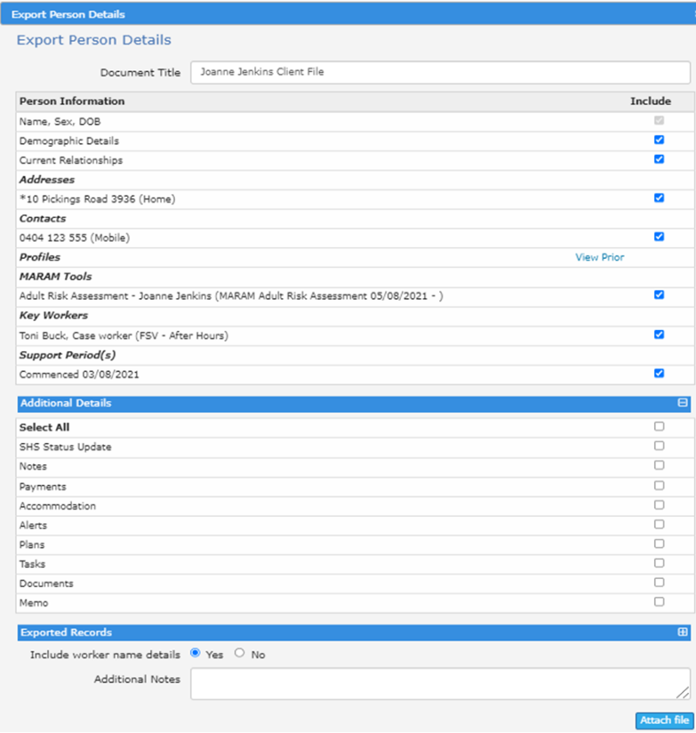

Further criteria including, **page control, order of records, export period** and inclusion of the **worker’s name** as well as **additional notes** can be managed and inserted. The page control break and order being ‘most recent at top’ is helpful for easy viewing information. The inclusion of the export history timeframe and worker name are at the practitioner’s discretion.

Once all relevant files have been ticked and the criteria managed, click ‘**attach file’** to attach these records.

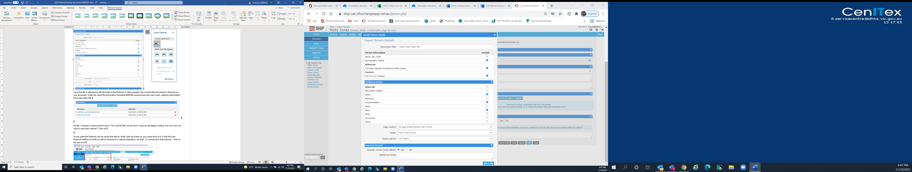

Once the file is attached it will sit inside of the Referral. In this example, the consent file document is attached as one document, while the client file information including MARAM assessment, case notes and address information sits in the client file.

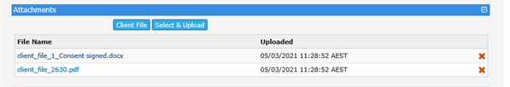

Finally, **consent to send for all persons** associated with the referral must be set to ‘Yes’. By checking this radio button, you are confirming that you have consent to send the referral for all persons including the associated person. A pop up will appear asking ‘Are you sure you wish to send this referral?’ Click ok.

At any point the Referral can be saved and left as ‘draft’ until such time as you come back to it. It will sit in the Referral mailbox as draft as well as the person’s referral repository, as draft. To re-enter the draft referral – click on the pen icon.

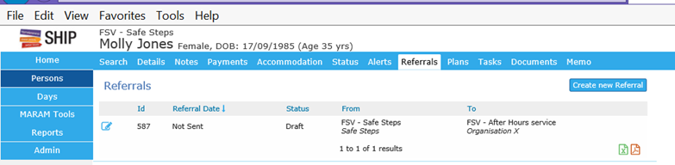

Once a referral is sent, it will appear in the **Referral Mailbox** as **waiting** until action is taken by the receiver. Other key information including the organisation **sent to**, the **send date**, **sent by** and **client information** also appear here. Each Referral also has a unique ID.



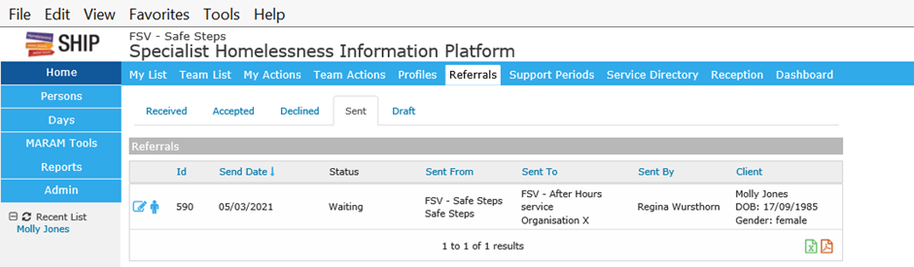

Once the receiver of the Referral has received it, it will appear in their ‘received’ inbox in their **Referral Mailbox**. The receiver may choose to acknowledge, accept or decline the referral. In any of these circumstances they will be expected to make **comments** which can be seen by the referrer.

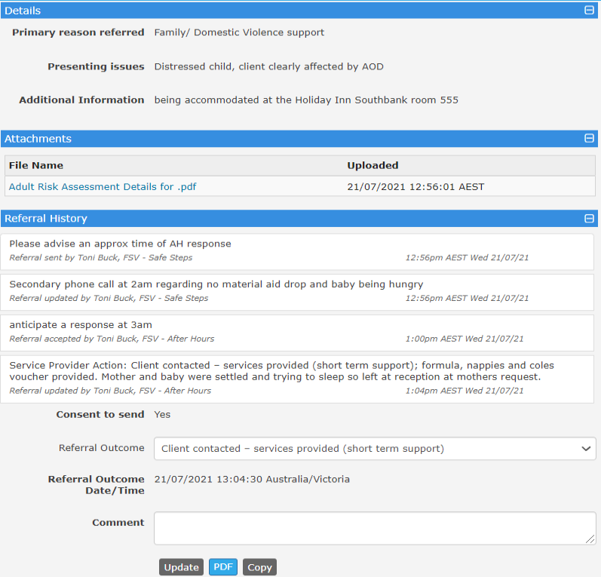

# Acknowledging, accepting and declining a referral

Practitioners can go into the **Referral mailbox** and see that a new referral has been received and is marked as ‘waiting’. An email notification will notify that a Referral has been received.

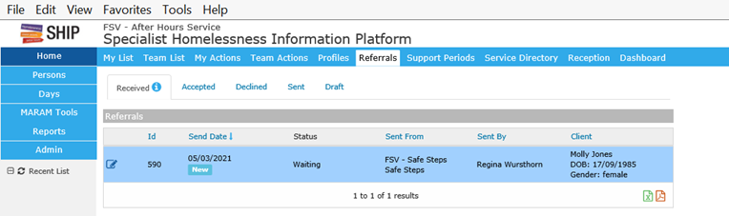

By clicking on the pen icon, the referral appears with all the information including person record and client files. The receiving organisation can review the documentation including the client files to make sure that the referral is appropriate. Once the worker has reviewed the referral and confirmed it is suitable, they can acknowledge the Referral.

Acknowledging

Practitioners should **always acknowledge** a referral even if they are not ready to accept the referral immediately.

Acknowledging the Referral lets the sender know that the Referral has been received and is being reviewed, make sure to include comments with information of when you believe you will be able to attend to the Referral.

Both the sending and receiving practitioner will stay informed by utilising the comments section to provide updates on the status of the referral which supports the referrer in the event that the client calls back.

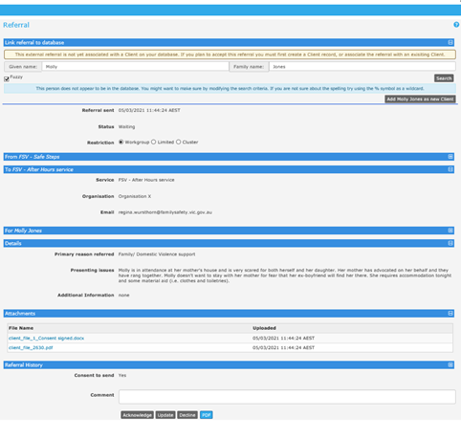

## Accepting

When a practitioner is ready to **action** a referral, they can notify the referrer by clicking on the ‘accept’ button.

The referral advises whether the person is already a client on your database, and whether you wish to modify the search to find this person including using a wildcard symbol ‘%’, and ticking fuzzy to expand the search. The referral cannot be accepted until the referral has been linked to an existing person in your workgroup or a new person has been created.

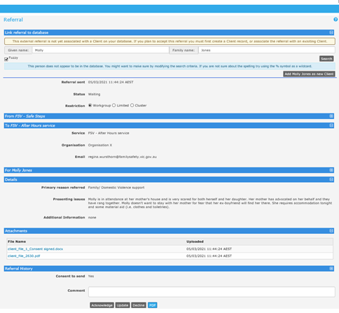

In the below example, I searched only on Jones to see if any other names came up. I was able to see that two Molly Jones’ and a Miriam Jones existed, with different dates of birth (DOB). There are two blue icons attached to the search. The arrow icon allows me to enter into the searched person record, while the chain link icon allows me to link any searched person’s record with the referred person, to recognise them as the same record. If you wish to do neither or these things, you can simply ‘**add Molly Jones as a new Client**’.

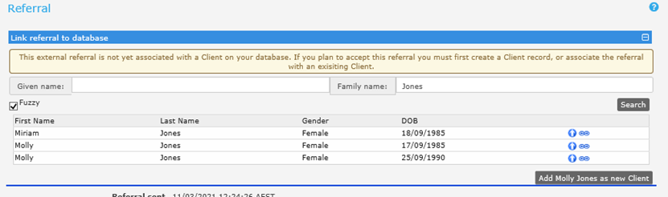

In a separate example, I widened the search by searching Jon% and ticked fuzzy, which returned all people with Jon in their name. In this view I could also see their DOB**.**

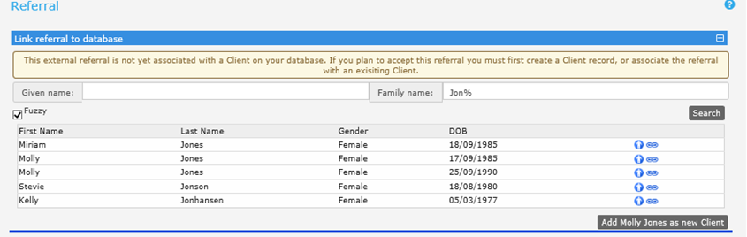

Lastly, if you wish to do a wide search on the Address, DOB, phone number or identifier, press CTRL followed by the **Persons** tab. A second window browser will appear allowing expanded search functionality without losing the original Referral window. If the person is found, for example under a different name, they can then be searched for under that name in the Referral window and linked.

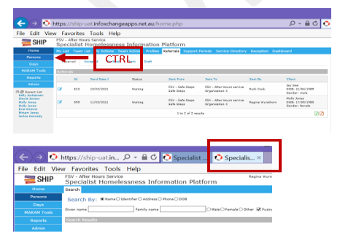

Once the person is imported or linked, there is now the ability to **accept** the referral, or to decline or update with a comment if the situation changes.

Once the Referral is accepted, the referral will move into the **accepted** **inbox**. The client record can be quickly accessed by clicking the person icon on the Referral tab.

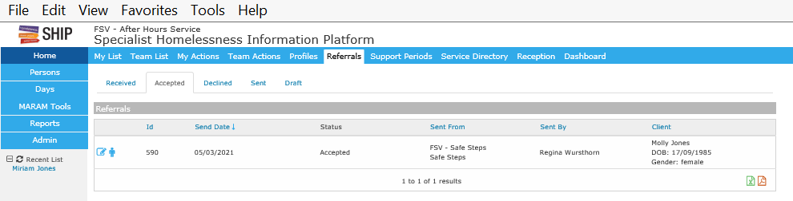

Inside of the client record, phone and address information is transferred via the Referral to the person record.

The client file information including MARAM tools, support period information, case notes and any other documents that came with the Referral will continue to be housed in the **person’s referral repository** (they will not appear in any other place on the Peron’s record).

Below you can see that Molly Jones referral is now sitting in the After-hours Service workgroup in her **Person Referral Repository**. The referral is accepted and practitioners can proceed to undertake Molly’s case work.

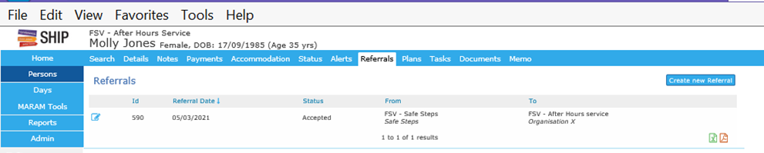

## Declining

A Referral can be immediately declined or declined after it is acknowledged and/or after adding the person’s details. The Referral cannot be declined once it is accepted.

**Prior to declining the referral**, it is best practice to enter a comment with additional details as to why the Referral is being declined. Press update to post the comment.

To decline a referral, press **decline**, and a message will appear asking for a reason for the decline.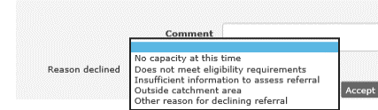

There are **four reasons** an After-hours service would **decline** a referral which include:

1. insufficient information e.g. missing contact details or needs identified

2. outside of catchment area and not a neighbouring area

3. does not meet eligibility criteria / an inappropriate referral eg child sighting and

4. the service doesn’t have capacity to provide a response.

Where a victim survivor declines the service following contact or can’t be reached, this should be noted in the ‘Referral Outcome’ section (described below) after the referral has been accepted.

Use the correct drop down, don’t use ‘other reason for declining referral’.

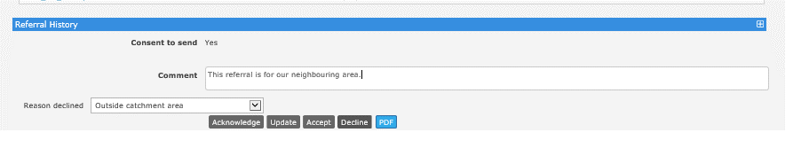

The status and reason of the declined referral will now appear as declined to the sender in their sent items. The sender can also enter the referral and see the comments.

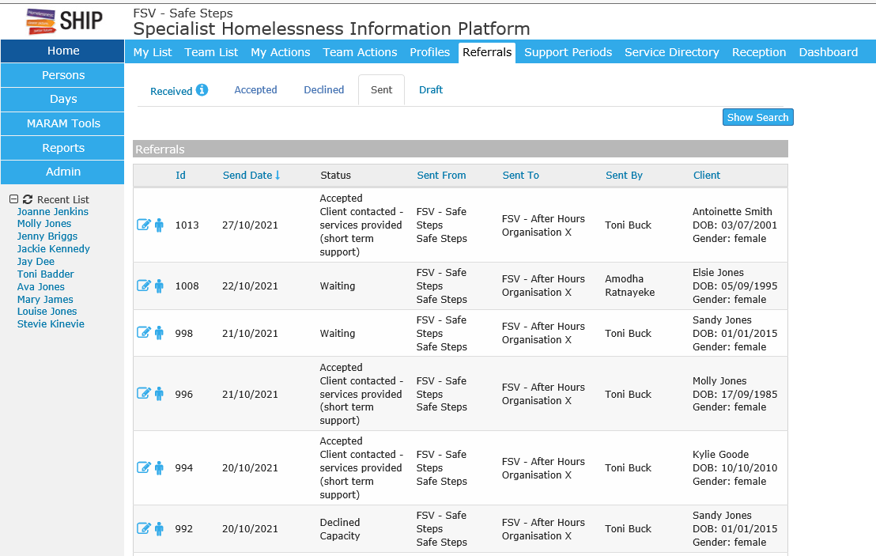

## Comments

There is also the ability to **update** the **comments** section of the referral, to communicate between the sender and receiver, including to provide details about the Referral outcome. Updating the progress throughout the response keeps Safe steps informed which is helpful if the victim calls back to get an update. The conversation can be viewed in the Referral history.

* 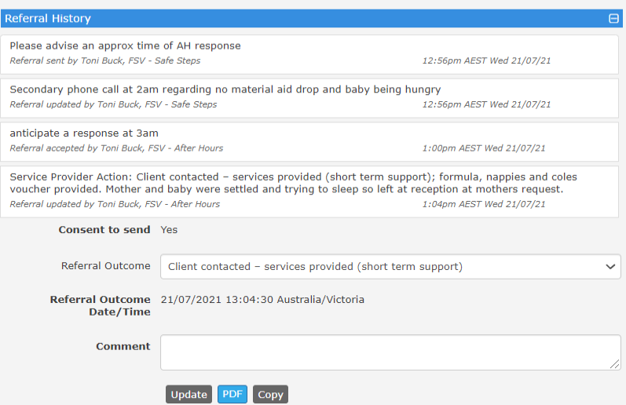

## Referral Outcome

All responses, including where a victim can’t be reached, or no longer wants service, should include a Referral Outcome comment, so that Safe steps know when a referral is complete from the After-hours service providers perspective. Select the most appropriate drop down. The Services accepted (longer term support), is only intended to be used where the client becomes a longer-term client – for example is referred to intake or case management within the After-Hours service.

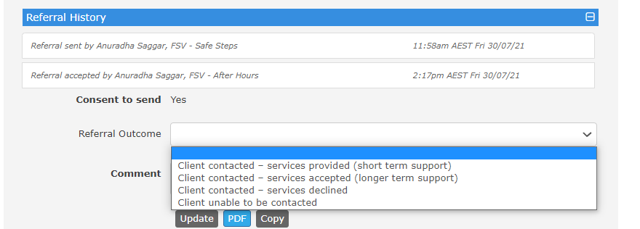

In the **Comment box**, include the following information:

1. Whether the service was declined or unable to contact; **or**
2. Confirm that the service was provided; **and**
3. Detail presenting issues or observations at time of after-hours response; and
4. Include details of brokerage used in the provision of the response.

## Alternate referrals sources

After-hours referrals are only received electronically from Safe Steps. All referrals received from other referral sources, such as hospitals, police, and a service’s own agency will require a manual entry into SHIP. Practitioners will need to search for a person’s record and add a new person record for new clients to the workgroup database.

# Referral questions and answers

## Can I recall a Referral sent to the wrong organisation?

The sender can recall the referral if it was incorrectly sent while the Referral has a status of ‘**waiting’.** If a referral is **recalled**, it will sit in the **draft** area of the **Referral mailbox**.

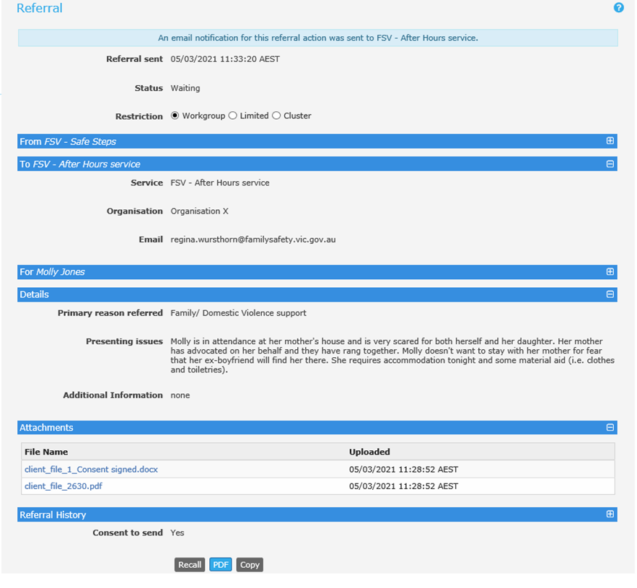

If the referral is acknowledged or accepted by the receiving organisation, it will be too late to recall. The sending organisation can **update the comments** section of the referral to provide an update or alternatively call the organisation. The organisation who received the ‘wrong’ referral can decline the Referral, or if too late to **decline** (because they already accepted), they can also **update a comment** in the referral history that it was incorrect.

## I recalled a referral, how do I re-send it with correct information?

If the referral was recalled, it will be sitting in the ‘draft’ inbox of the Referral Mailbox with a status of ‘recalled’. By clicking the pen icon, you can re-enter the recalled referral and amend sections 5 and 6; details and attachments. You can’t amend who the referral is from and to and the referral history will remain.

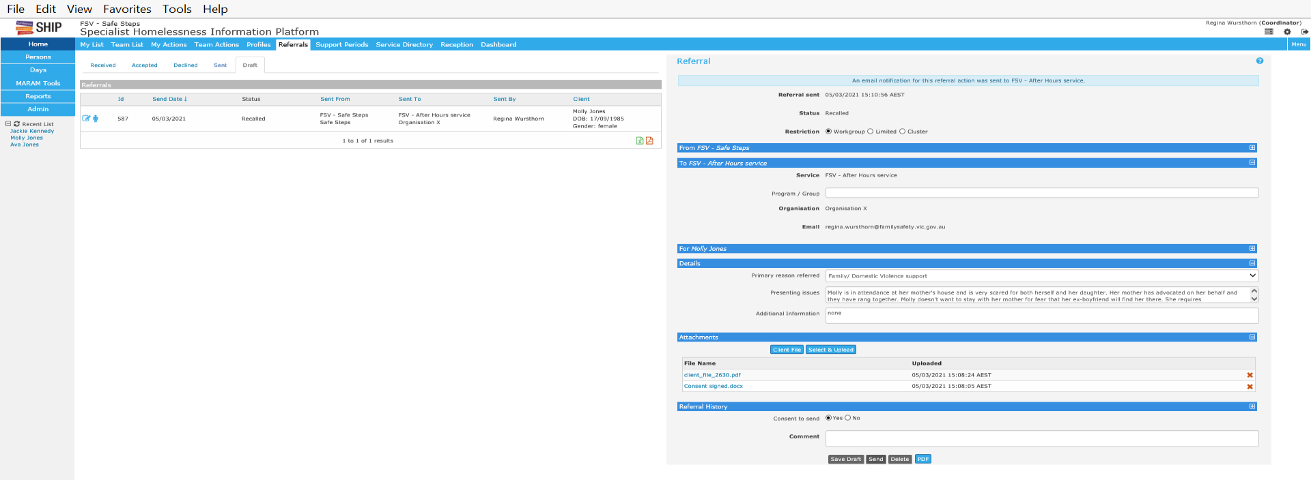

## Can I copy a referral and re-send to the same or a different organisation?

This is a particularly helpful function in the event you send a referral to the wrong organisation and are unable to recall it as its status is acknowledged, declined or accepted, where a Referral needs to be sent to a different organisation or where a file was accidentally left off the original referral.

**However, where Referral information and files need to be amended substantially, it is advisable to create an entirely new referral.**

To copy a referral, go into the **person referral repository**. Referrals can be copied by clicking on the pen icon to open the referral and pressing copy.

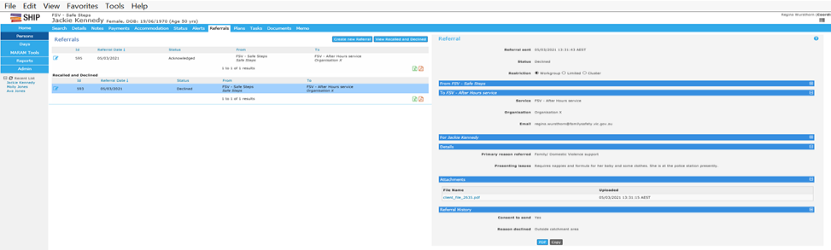

The copied referral will return to the beginning of the process and ask who you want to send the referral to. Click on SRS External and choose the correct organisation and submit.

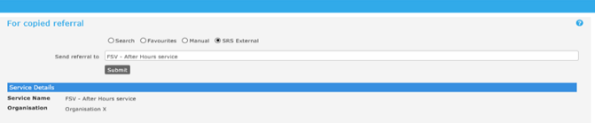

Initially the details section will copy across and the draft needs to be saved. Thereafter, the client file information will also show up as it did on the initial referral. Both the details and attachments sections can be changed, and the referral can be re-sent.

# Support Periods

A support period is defined by the Australian Institute for Health and Welfare (AIHW) as the length of time a client receives services from your agency. A support period commences on the day a person becomes a client by receiving a direct service from your agency and it ends on the last day on which services are provided. If a person is uncontactable or does not accept a service, they will not have a support period opened for them.

A client is any person who receives a service from a SHS agency. A client can be of any age, as long as they receive a direct service from a SHS agency.

For more information, refer to the Specialist Homelessness Services Collection <https://www.aihw.gov.au/getmedia/328cf07f-cb94-4d5f-94a5-9149984bfdf9/SHS-collection-manual-2017.pdf.aspx>.

Generally, all after-hours support periods will be **closed** on the after-hour shift that they are opened, however some may remain open if the relationship continues during business day support or over subsequent days / nights. If a client’s support period has been closed and the client soon after presents again to that agency, with the purpose of continuing the relationship, the support period can be re-opened, and further details included.

## Process map for support periods and After-hours profiles

The following diagram identifies the process for opening support periods and After-hours profiles.

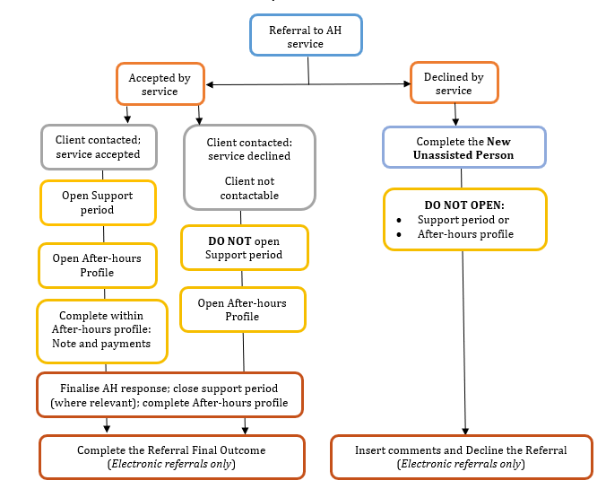The After-hours profile

The After-hours profile captures data relating to the After-hours Crisis Response Service and is how services acquit their targets. From the 1 July 2021 the After-hours Profile has replaced manual data collection and reporting processes. An After-hours profile should be created for every after-hours response including those where victims were not contactable or did not accept the service. The After-hours Profile is **not** used where a referral is declined by the service.

## Creating an After-hours profile

From the person record, workers can create the after-hours profile form to start capturing information about the after-hours response. Click on **Create new profile.**

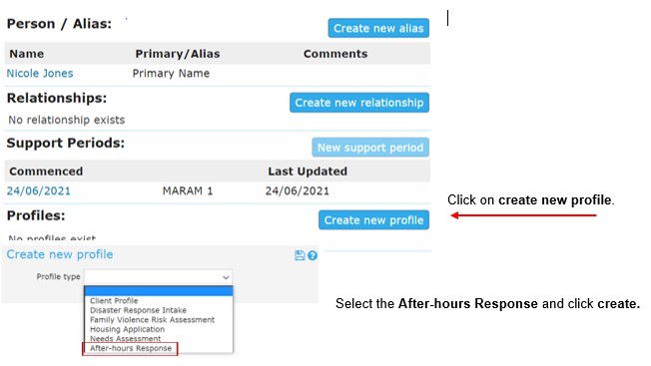

A pop up notice will appear to confirm that *if you are providing SHS services and report to AIHW, a SHS Support period and SHS note will need to be completed*. **Note:** further instructions are provided on page 24 on completing SHS notes.

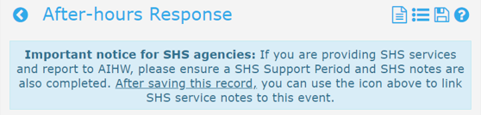

# Sections of the After-hours response profile

## Referral details

Complete the **Referral** section of the After-hours Response profile with the date, time in hours and minutes e.g. 8.30pm will be Referral received hour: 20, Referral received minutes: 30, Referral source and the DFFH area of your after-hours service.

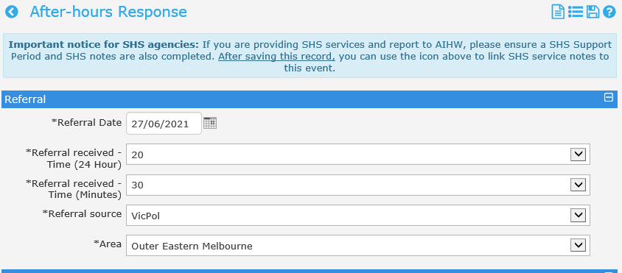

## Children present

**Where a child is provided with a response in their own right e.g. a child assessment, safety plan or response, a separate after-hours profile should be completed, in addition to including them in the following section.**

Any children present at the time of the after-hours response will need to be added to the After-hours profile by clicking on the **blue plus sign** (see diagram next page).

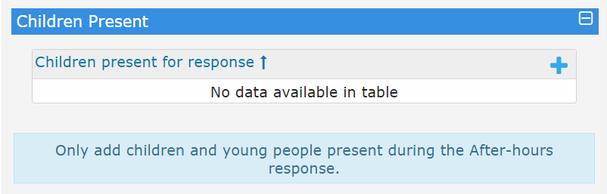

The person search field will display and defaults to the **recent search** list. If the child is not in the recent list tick, use the **search** radio button and enter the child’s full name or last name in the **search box**.

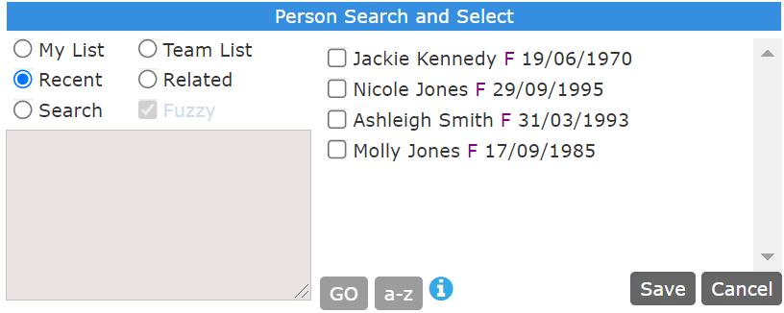

Select the correct person by ticking the check box and click **Save**.

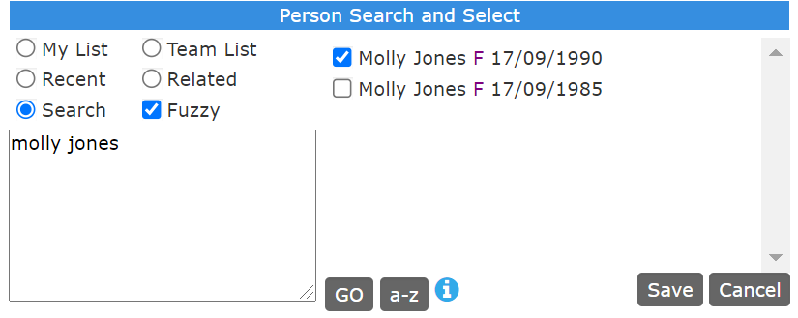

Additional children present during an after-hours response may be added by clicking on the **blue plus symbol**. Alternatively if you add the wrong person they can be removed by clicking on the **red pen**.

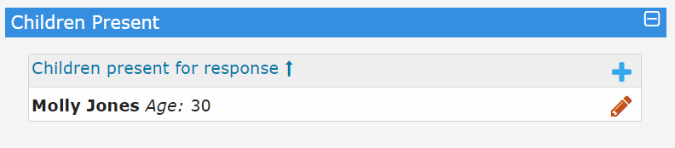

## Client information

This section includes information relating the client’s risks and identifies potential opportunities for secondary consultations or referrals to other crisis support services.

The risk category drop down list is aligned to the MARAM framework and includes: At risk, Elevated risk and Serious risk. Select the appropriate drop down.

A single selection radio button is available for all relevant fields, for example a question about accessing interpreter services will only appear for client who have been identified as from a CALD background. Select all relevant fields.

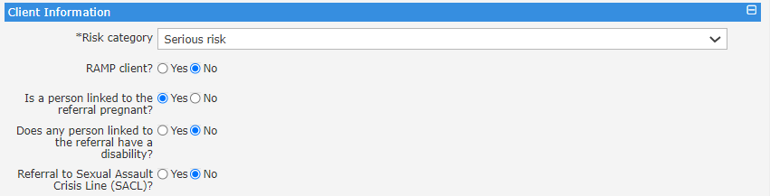

At this point you should **save** your work to avoid losing data when navigating away from this page. The next step in this process is to complete the notes and payments.

## Notes and payments

**All notes and payments relating to the After-hours response must be created from *within* the After-hours profile, otherwise the relevant data will not be captured in the after-hours reports and lists.** To enter a note or payment from *within* the After-hours profile, click on the file button at the top of the After-hours profile.

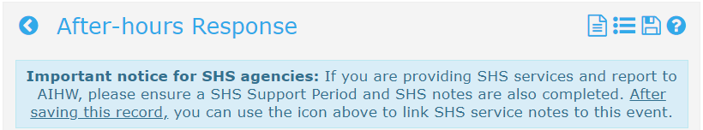

### Notes

All after-hours responses must contain a note which is created from within the After-hours profile. The **note** will include details of the After-hours response, children associated or present during the response and the contact length or duration of the response in minutes, as well as services needed, provided, or referred.

**For agencies on a limited licence, only the contact type and contact length of the response in minutes should be captured. All other information will be completed in their own client management system.**

The **Contact length** within the note is where time spent on an after-hours response is entered. This is recorded across three fields; contact (time spent with the client), case work (noting etc.) and travel. Contact length is recorded in **minutes.** For example, a 2-hour outreach response would be recorded as 120 minutes and may include additional case work and travel time.

**Save the note.** If you select ‘Save Final’ no further editing will be possible except by contacting the InfoXchange support line. The note will automatically be closed for editing 7 days after it has been saved.

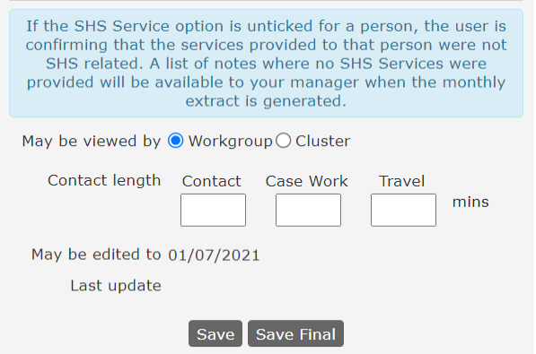

### Payments

Details of **crisis brokerage** used to support an after-hours response should be captured *within* the After-hours profile. Select **Family Violence Crisis Brokerage (FVCB)** as the payment type from the drop-down, details can then be added into the amount and other details. Save the payment.

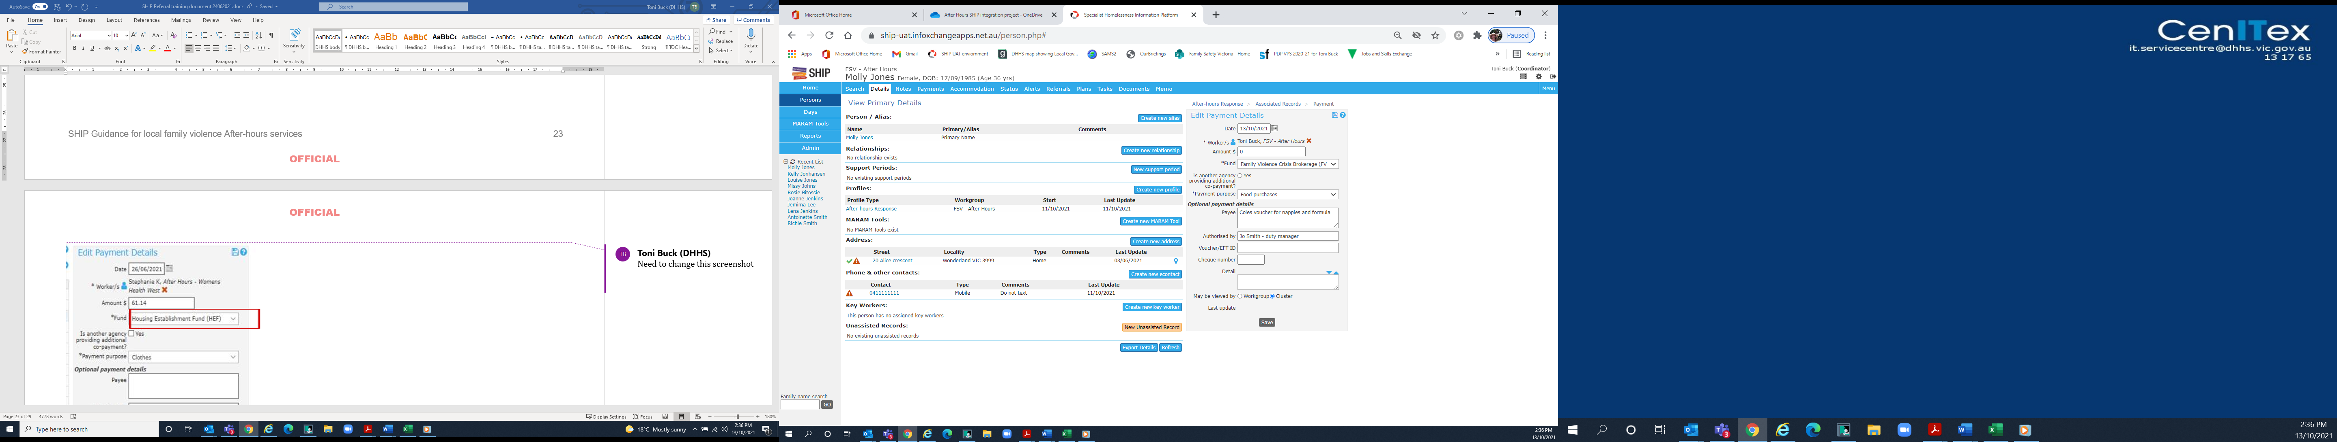

You can **edit** payment after it has been saved by clicking on the record list icon.



And then clicking on the **hyperlink date** for prior payments. Alternatively, you can create a new payment by clicking on **create new**.



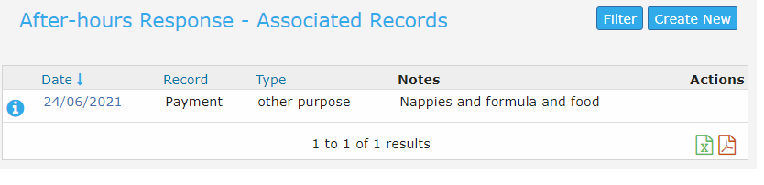

Payment details can be added at a later date by going to the view prior button within the persons primary details and selecting the After-hours profile which the payment relates to and backdating to within the date stamp period.

* 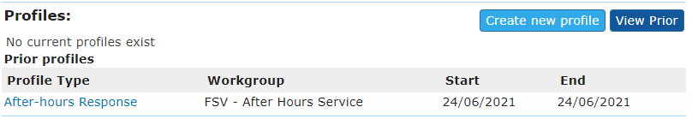

## Response

After you have completed the **notes and payments** complete the **response** section of the After-hours profile.

This section identifies the type of response provided, the location of the victim survivor at the time of the response, the referral outcome and date the response was completed. The after-hours **response** should be completed at the conclusion of the after-hours shift (on the same night or day as the referral).

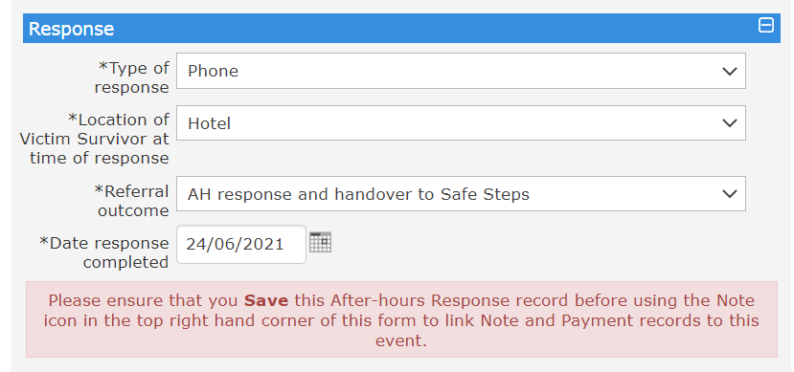

Drop down options under **Type of response** include phone, face-to-face, contactless material aid drop and unable to contact. Where material aid is dropped to reception without providing any additional response to the client this should be considered contactless material aid drop.

Select the **location** of the victim survivor at the time of the response. If you select ‘Other’ a free text box will appear ‘Other location’. Enter the location details of the response.

The **Referral outcome** identifies who is holding the client at the conclusion of the after-hours response. This is likely to be ‘AH response and hand over to Safe Steps’ unless there is an agreed alternate referral pathway such as into own agency intake for Case Management.

***Please note: this must also be clearly articulated in the Referral Outcome section within the referral from Safe Steps. Safe Steps only see outcome details in the Referral, they cannot see the data in the After-hours profile.***

By clicking save, this **completes** the after-hours response. The after-hours profile will now be contained in the **View Prior** section of the client profiles and can be opened, edited, and resaved by clicking on the blue hyperlink.

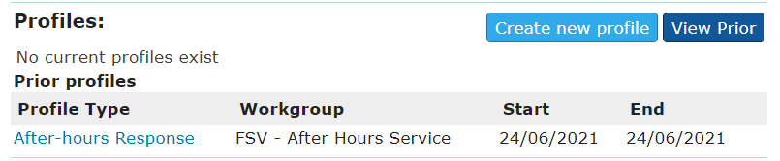

Once an After-hours profile has been created it may only be **deleted** by a Coordinator.

# Recording children who receive an after-hours response

**If a worker undertakes a child risk assessment or provides a response to a child as a victim survivor in their own right a separate after-hours response should be recorded.** It is also recommended that you open a support period within the presenting mother’s person record, unless the child is presenting alone.

Navigate to the child’s person details by clicking on their hyperlinked name in the Relationship field.

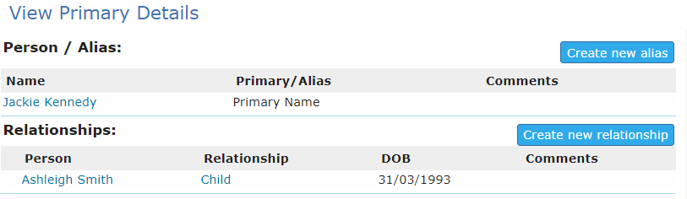

And then create any relevant notes or payments associated with the child’s After-hours response as per the instructions on page 24 of this guide.

# Capturing referrals that don’t result in an After-hours response

The **New Unassisted Person** allows services to capture external contacts to the organisation that do not result in a service being delivered and cannot be acquitted as an After-hours response. Noting that the amount of data available from requests where a service is not required is limited, this section therefore only collects:

* Given and Family Name
* Sex
* Date of Birth or Year estimated
* Was this the first request for services at any agency on this date?
* What service requested?
* When had the service been requested?
* Why the service had not been provided?

## Recording a New Unassisted Person

The **New Unassisted Person** is located on the Home tab under Reception. This is the default screen when opening SHIP. See the diagram below

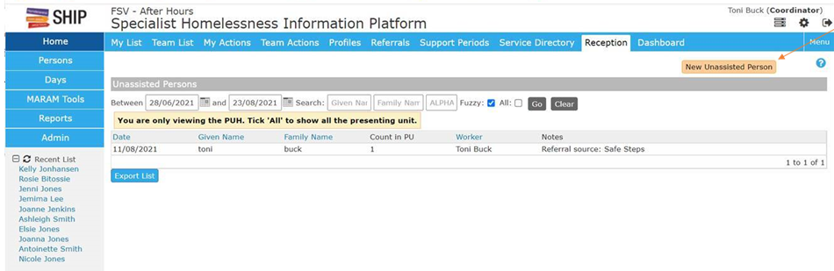

The form below will open for completion. The Name, sex and reason for contact are compulsory fields. Where a date of birth is not available an approximate year can be entered in the date of birth to provide an estimate age.

The Notes section is a free text field. We would like to capture the Referral source in this section

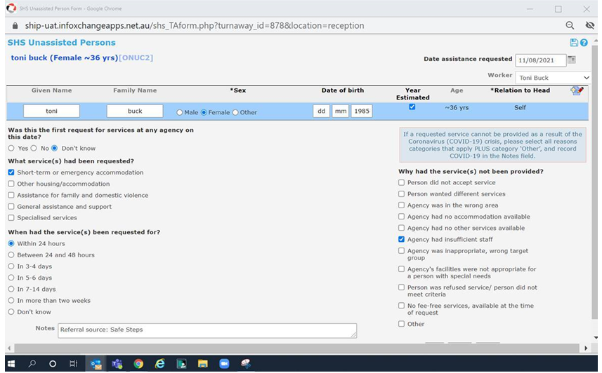

As data is entered a list will appear on the opening page. Agencies will be able to export this data according to a date range to report on activations that did not result or require an After-hours response.

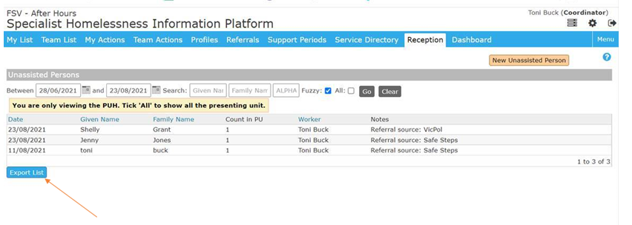

# Helpful tips for capturing data

1. An After-hours profile should be created for every after-hours response including those where victim survivors were not contactable or did not accept the service. The After-hours Profile is not created where a service declines a referral.
2. Be sure to include contact length in minutes not hours under the notes. You don’t want to record 5 minutes instead of 5 hours. To avoid under-reporting of contact time Coordinators should run a weekly report and check for contact length under 30 minutes.
3. Case notes should be raised at the time of the after-hours response and within the after-hours response date stamp (start and finish) periods.
4. Payment dates should relate to the specific after-hours response. If making a payment at a later date, ensure you backdate the payment date to withing the after-hours response date stamp (start and finish) periods.
5. To avoid multiple notifications about support periods ensure you create your support period (when required) prior to creating your notes and payments in the After-hours profile. If a support period isn’t required, i.e. the victim didn’t accept a service, ensure that the SHS box is unchecked in the case note. ***Note:*** *does not apply to agencies on a limited licence.*
6. Be sure to save your After-hours profile prior to entering notes and payments to avoid losing data in the After-hours profile.
7. By clicking save (rather than save final) within a note you will have 7 days to amend the details before it is automatically locked for editing.
8. A date response completed within the After-hours profile completes the After-hours response. The After-hours profile will now be contained in the View Prior section of the client profiles and can be opened, edited, and resaved by clicking on the blue hyperlink.
9. Only a Coordinator will be able to delete erroneous After-hours profiles once created.

# After-hours acquittals (list reports)

Under the funding agreement, local family violence After-hours services are required to submit a quarterly acquittal. As of the 1st July 2021, local family violence After-hours services commenced capturing data relating to After-hours responses and outcomes via the After-hours profile in SHIP.

The following information will provide you with instructions to download a list report which will be how services acquit their After-hours responses. List reports can be run in real time and can also be used to support local management of the After-hours service. It will be important to download list reports regularly to review data in the list report and ensure it has been appropriately validated prior to submission to FSV.

**Acquittals (list reports) will continue to be emailed to the Program and Service Development inbox at** [**programservicedevelopment@familysafety.vic.gov.au**](mailto:programservicedevelopment@familysafety.vic.gov.au) **and should include the relevant DFFH APPS Manager.**

## How to download your list report

1. Navigate to the Reports Page > Lists Tab

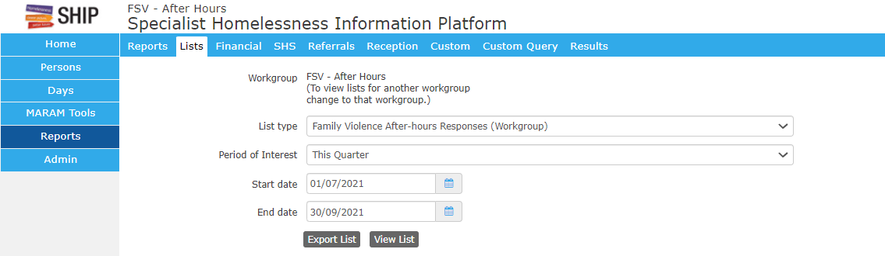

1. Select the List Type: Family Violence After-hors Responses (Workgroup) as seen above
2. Select your Period of Interest
3. Enter the Start date and End date
4. Click View List
5. To view the List results, navigate to the Results Tab, scroll to the bottom to find the list and click View List.



1. You can now export the list to Excel by clicking on the Excel icon



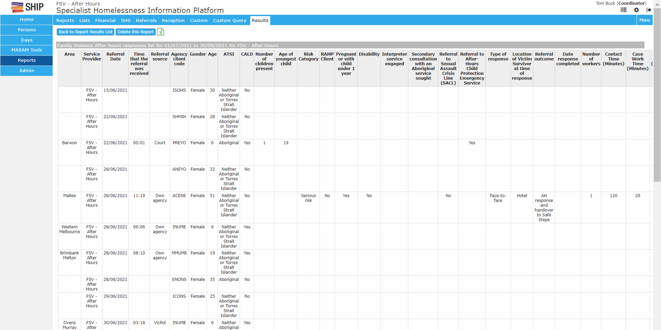

1. You can export straight to excel without viewing first by clicking Export list in diagram 1 and finding the export list in the Results Tab.

|  |
| --- |
| To receive this document in another format, [Program and Service Development](mailto:programservicedevelopment@familysafety.vic.gov.au) <programservicedevelopment@familysafety.vic.gov.au>.  Authorised and published by the Victorian Government, 1 Treasury Place, Melbourne.  © State of Victoria, Australia, Family Safety Victoria, June 2021.  Except where otherwise indicated, the images in this document show models and illustrative settings only, and do not necessarily depict actual services, facilities or recipients of services.  Available at [Family Violence Services Training](https://providers.dffh.vic.gov.au/family-violence-services-training) <https://providers.dffh.vic.gov.au/family-violence-services-training> |