

|  |
| --- |
| DWES Portal  User guide for service providers v2 |
|  |

|  |
| --- |
| To receive this publication in an accessible format phone (03) 9096 3203, using the National Relay Service 13 36 77 if required, or [email the DWES Unit](mailto:DWESU@dhhs.vic.gov.au) <DWESU@dhhs.vic.gov.au>.  Authorised and published by the Victorian Government, 1 Treasury Place, Melbourne.  © State of Victoria, Department of Health and Human Services, October 2019.  Available at the [DWES page on the department’s website](https://providers.dhhs.vic.gov.au/disability-worker-exclusion-scheme) <https://providers.dhhs.vic.gov.au/disability-worker-exclusion-scheme>. |

Contents

Introduction 4

Terms of use 4

Computer requirements 4

Accessing the DWES Portal 5

Authorised persons 5

Getting started 5

Logging in to the DWES Portal 7

Logging out of the DWES Portal 7

Resetting your password 8

Check requests 10

Raising check requests 10

Bulk checking mechanism 16

Viewing checks 17

Viewing check results 18

Notifications 19

Submitting notifications 19

Viewing notifications 25

Updating notifications 26

Adding notes or attachments to notifications 28

DWES Portal security 36

Support 37

Support contacts 37

Frequently Asked Questions 37

# Introduction

This guide will assist users in getting started with the Disability Worker Exclusion Scheme (DWES) Portal. The guide provides instructions on accessing the portal, how to perform the functions available in the portal and how to troubleshoot issues and seek assistance if required.

## Terms of use

The Department of Health and Human Services’ systems are provided for the conduct of the business of the department. Access to the department’s systems via the internet is granted on the basis that:

* Only registered and authorised persons access any system
* Users only access computer systems, applications, databases or files for which they are authorised
* Use of the systems is not for any purpose that breaches any law or infringes the civil rights of any person
* The systems are not used to store or distribute material that is defamatory, obscene, indecent, offensive, discriminatory or harassing
* Users do not damage these computer services, including knowingly uploading, distributing or opening a virus, spam or other malicious code
* Private or confidential information is not shared with unauthorised people
* Private or confidential information is not copied, unless the information is subsequently protected in a manner appropriate to the sensitivity of the information
* Users abide by the Department’s Confidentiality Undertaking, where applicable
* Passwords and other authentication devices issued to provide access are kept secure to prevent unauthorised access
* Passwords are not written down where they may be accessible to an unauthorised user
  + Breaches of security are reported at the earliest opportunity.

## Computer requirements

The DWES Portal can be accessed through your computer’s web browser. The following web browsers are supported:

* Google Chrome (preferred)
* Mozilla Firefox
  + Internet Explorer 9 or greater

If you do not have access to one of these browsers, please speak to your IT support for assistance in getting one of these web browsers installed on your computer.

# Accessing the DWES Portal

## Authorised persons

Access to the DWES Portal is limited to authorised persons nominated by each service provider.

To appoint a new authorised person, please complete an Authorised Person Nomination Form, available at the [DWES page on the department’s website](https://providers.dhhs.vic.gov.au/disability-worker-exclusion-scheme-worker-review-form-word) <https://providers.dhhs.vic.gov.au/disability-worker-exclusion-scheme>.

When nominating a new Authorised Person, please select the level of access to the DWES Portal that person requires. You may select from either “Standard User (Request checks and see results)” or “Power User (Request checks and see results, lodge and update notifications/investigations)” access.

The form must be signed by a senior person within the organisation (at CEO or director level) and sent to the DWES Unit to action. If you would like to remove an authorised person, please contact the DWES Unit.

## Getting started

The department will send all authorised persons an email containing your user name as well as instructions on how to set your password. The email will be sent to the email address you have associated with your organisation. The email you receive will look similar to the example at Figure 1.

Figure 1 – Invitation to DWES portal

|  |
| --- |
| From: Department of Health and Human Services <noreply@salesforce.com> To: Joe.Smith@cso.org.dhhs  Subject: Welcome to the Department of Health and Human Services online portal  Hi Joe,  You have been invited to connect to the Department of Health and Human Services online portal.  To get started, go to:  https://dhhs-victoria.force.com/partners/login?c=CyUdoirSCNJyjSNP7wjBEQQ%2FuCqCCny9J4 ij4FeQPmxb9kPlsLw  Username: joe.smith@cso.org.dhhs  Thanks,  Department of Health and Human Services |

You will receive the email from ‘noreply@salesforce.com’. If you are encountering issues with receiving the invitation email, you may need to add that email address to your contacts, mark it as a non-spam email or have your organisation’s IT support ‘whitelist’ the email address. If you continue to encounter issues, please contact your IT provider for additional support.

Click on the link within the email and your default web browser should open and present you with a screen similar to the one shown in Figure 2. You must enter a password that:

* is at least ten characters long
* contains at least one letter
* contains at least one number
  + contains at least one special character. The special characters are ! # $ % - _ = + < >

Figure 2 – Change password screen

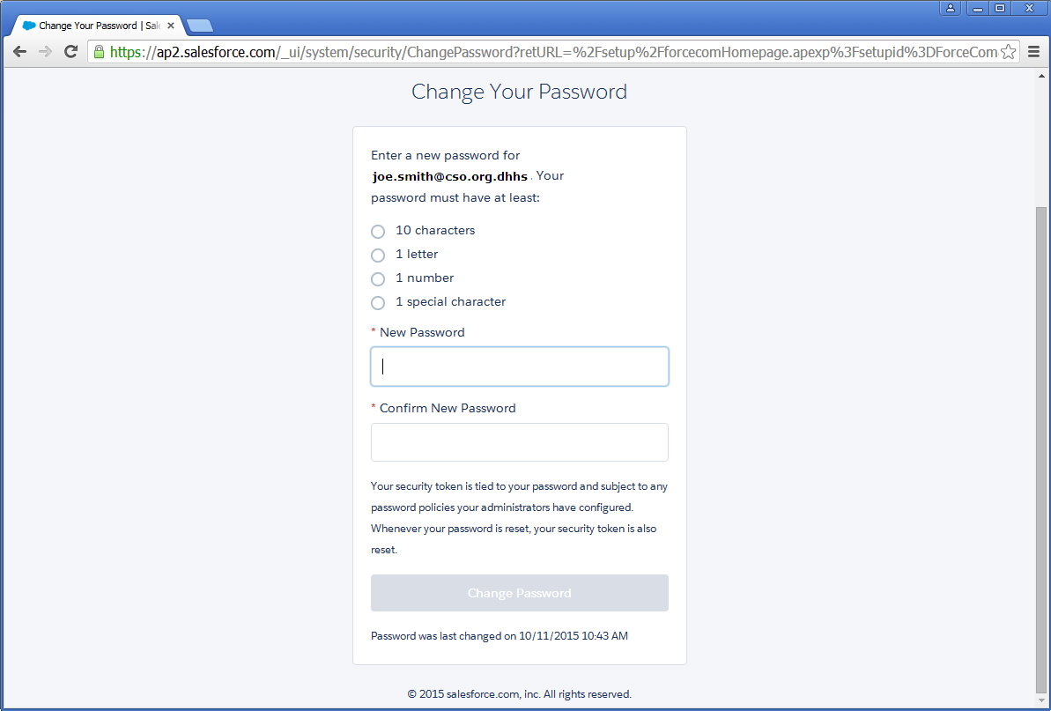

Once you have entered a suitable password and re-entered the password in the ‘Confirm New Password’ field, click the ‘Change Password’ button to proceed.

## Logging in to the DWES Portal

The Disability Worker Exclusion Scheme (DWES) Portal can be accessed via the [login web address](https://dhhs-victoria.force.com/partners/login)

<https://dhhs-victoria.force.com/partners/login>.

Enter the web address in your browser and you will be presented with a login screen as shown in Figure 3. Enter your user name and password and click the **‘Log In’** button to enter the DWES Portal.

Your user name will be included in the original set up email sent to you by the DWES Unit. It will usually be the email address assigned to you by your organisation.

Figure 3 – Login screen

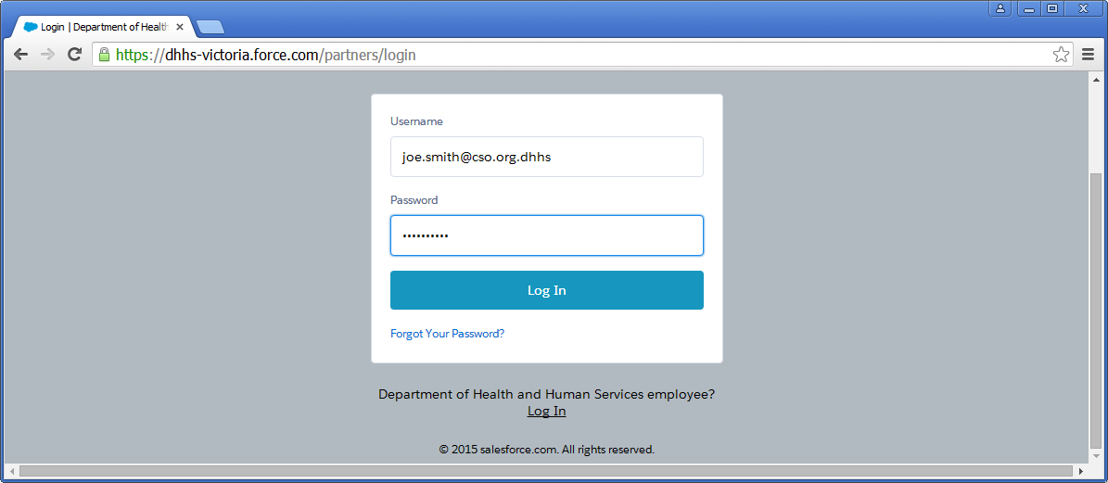

## Logging out of the DWES Portal

If you wish to log out of the DWES Portal, click on ‘Logout’ at the top right of the screen as shown in Figure 4.

If you are inactive for a period longer than 15 minutes whilst logged in to the DWES Portal, you will be logged out automatically.

Figure 4 – How to log out

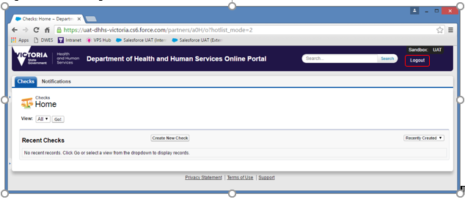

## Resetting your password

If you forget your password, you can request a reset of your password by clicking on the ‘Forgot Your Password?’ link on the DWES Portal login screen, as shown in Figure 5.

Figure 5 – Forgot your password link

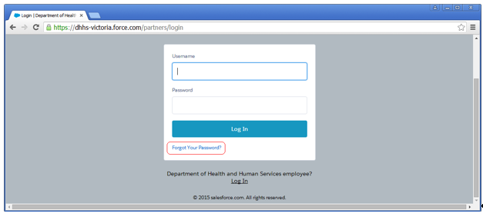Enter your user name as shown in Figure 6 and click the ‘Continue’ button to reset your password.

Remember, your user name will be included in the original set up email sent to you by the DWES Unit. It will usually be the email address assigned to you by your organisation.

Figure 6 – Forgot your password screen

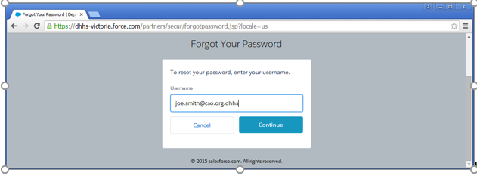

After clicking the ‘Continue’ button, you will be presented with a screen confirming that a password reset request has been sent to your email address (Figure 7). Please check your email and follow the instructions in the email to reset your password.

Figure 7 – Password reset request

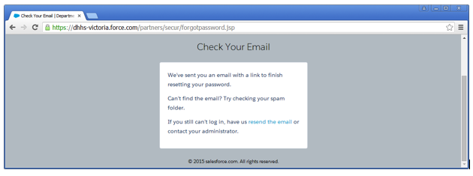

# Check requests

## Raising check requests

To raise a new check, first log in to the DWES Portal using your user name and password.

Click on the ‘Checks’ tab located near the top left of the screen (circled in red in Figure 8).

Next, click on the ‘Create New Check’ button located near the centre of your screen (circled in blue in Figure 8).

Figure 8 – Navigate to Create Check

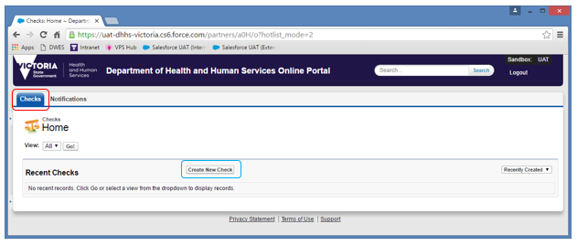

The ‘New Check’ screen will appear (Figure 9). Enter the job applicant’s details. Any field marked with a red line must be completed (example circled in red in Figure 9).

Read the conditions listed towards the bottom of the check form. You must agree to all the conditions by clicking the checkbox next to their description before proceeding.

Raise the check by clicking the ‘Raise Check’ button at the end of the form (circled in blue in Figure 9).

Please note that once a check has been raised, the check form becomes read-only and you will no longer be able to edit any of the details on the form.

Figure 9 – Create Check screen

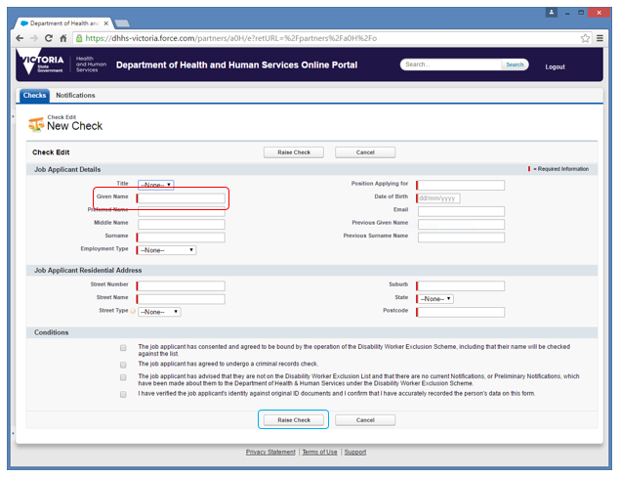

Note: If the address includes a street type that is not available in the ‘Street Type’ drop-down menu, please include the full street name and street type in the ‘Street Name’ field. Figure 10 provides an example of this.

Figure 10 – Street type not available

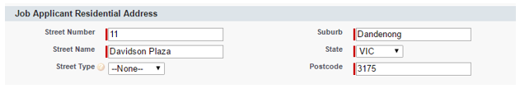

Once you have clicked on ‘Raise Check’, you will be shown the completed version of the form. Scroll down to the bottom of the form where you will see a ‘Notes and Attachments’ section.

To attach the person’s Consent and Acknowledgement Form to the check request, click on the ‘Attach **File’** button (circled in red in Figure 11).

Figure 11 – New Check form Notes & Attachments

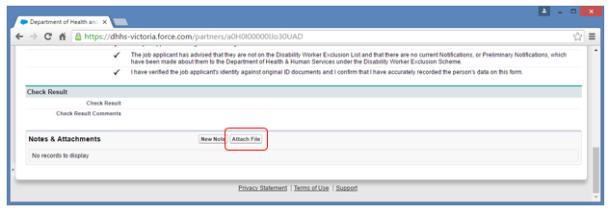

The ‘Attach File’ screen will appear. Select the file you want to attach by clicking the ‘Choose File’ button (circled in red in Figure 12).

Figure 12 – Choose file to attach

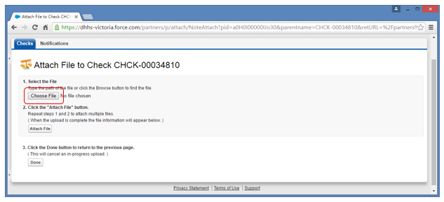

An ‘Open’ dialog will appear (Figure 13). Navigate to the location where the file you want to attach is located and select the file.

Click the **‘Open’** button (circled in red in Figure 13).

Figure 13 – Open Dialog

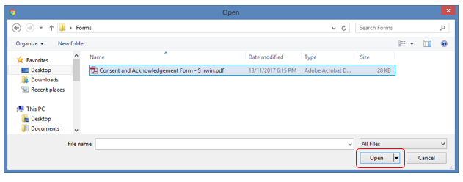

The dialog will close and your file will be displayed next to the ‘Choose File’ button (circled in red in Figure 14).

Click the ‘Attach File’ button to attach the file to the notification (circled in blue in Figure 14).

Figure 14 – File attached to Check

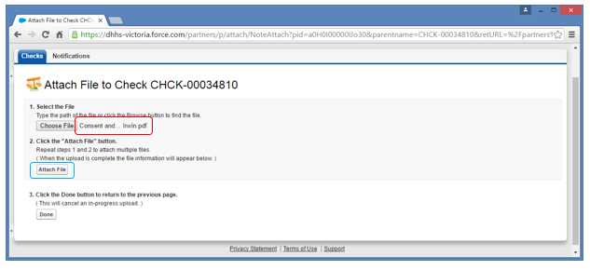

Once the upload has completed, details of the file you just attached will be displayed at the bottom of the screen (circled in red in Figure 15).

Click the ‘Done’ button to return to the completed check form (circled in blue in Figure 15).

Figure 15 – File uploaded

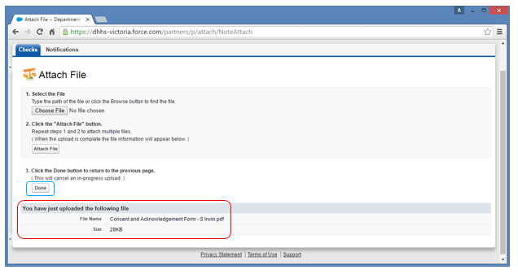

Your screen will then return to the completed check form, showing the file added in the ‘Notes & Attachments’ section. You can open and view the attachment by clicking on the title (circled in red in Figure 16).

Figure 16 – File added confirmation

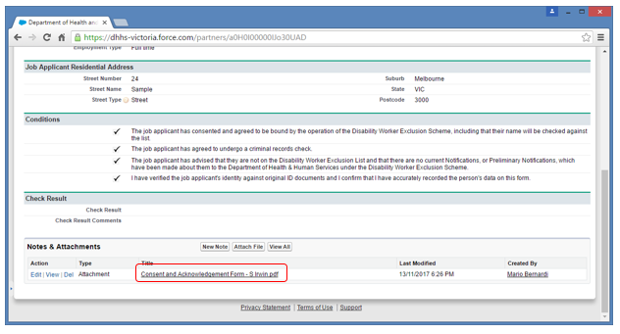

Once you have submitted a check request, and the check has been conducted by the DWES Unit, you should receive an email similar to the one shown at Figure 17.

Figure 17 – Check result email

|  |
| --- |
| From: Joan.Citizen@dhhs.vic.gov.au To: Joe.Smith@cso.org.dhhs  Subject: *Confidential – DWES check result (auto reply)  Dear Joe Smith,  Your DWES check request for Scarlett Irwin has been processed, with a DWEL result of Clear.  Please log on to the DWES portal here to view all checks and notifications submitted by your organisation.  Further information relating to DWES is available at www.dhs.vic.gov.au/disability-worker-exclusion-scheme.  If you have any other queries, please contact us by email to DWESU@dhhs.vic.gov.au or by phone on (03) 9096 3203.  Yours sincerely, Disability Worker Exclusion Scheme Department of Health and Human Services. |

If you require a printed copy of the check result for your personnel records, you can choose to print either the check result email or the full check result directly out of the DWES Portal (refer to *Viewing checks*).

## Bulk checking mechanism

A bulk checking spreadsheet is available for transition purposes only. The spreadsheet can be made available by the DWES Unit on request. An example of the spreadsheet is shown at Figure 18.

Figure 18 – Bulk checking spreadsheet

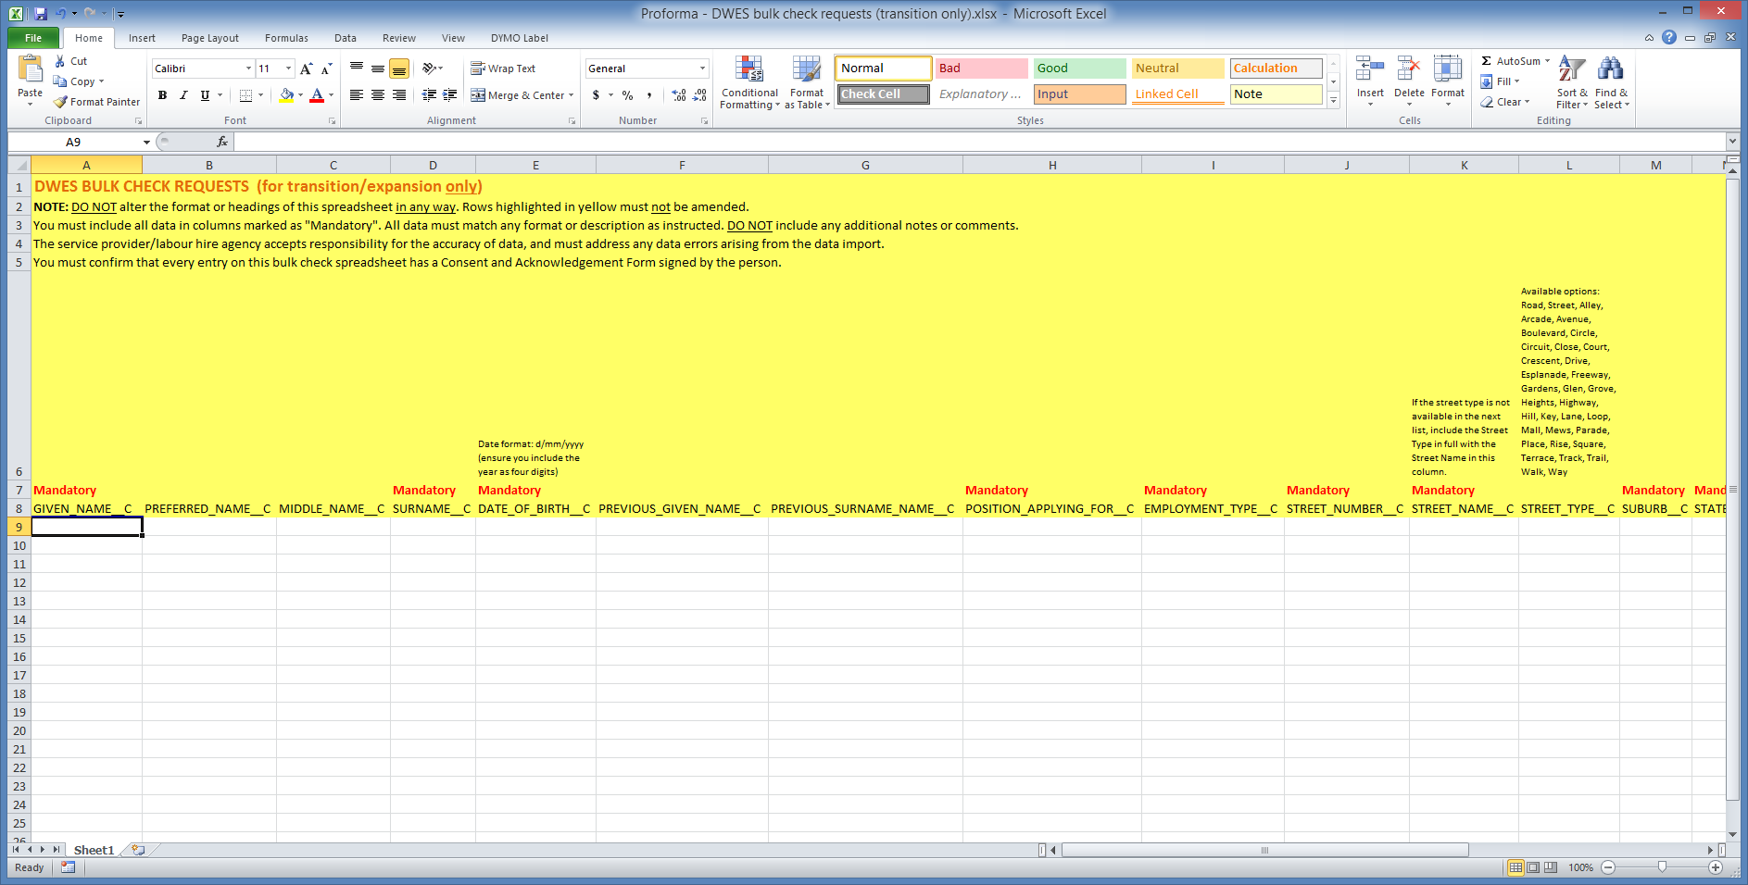

Any worker details that are exported from a database can be copied into this spreadsheet. You are responsible for ensuring that the data matches the format or description as instructed above each column.

Where possible, you should avoid any cell/content formatting. For example, dates or numbers may be formatted in a particular way in Microsoft Excel that may cause errors during upload.

Mandatory fields are indicated with the word “Mandatory” above the column. Columns that are marked “Mandatory as “True”” must have a value of ‘True’ entered in that column for each record.

The following requirements must also be observed when using the bulk checking spreadsheet:

* The spreadsheet allows for the uploading of check form data only. It does not allow *Consent and Acknowledgement Forms* to be uploaded in bulk. These forms must be attached by the organisation to each check request once they are available in the DWES Portal (see *Raising check requests* for instructions on attaching the forms).
* Do not alter the layout, format or content of the spreadsheet in any way. Rows highlighted in yellow must not be amended.
* The organisation accepts responsibility for the accuracy of data, and must rectify any errors in the data that may cause the bulk upload to fail. Check requests will not be processed unless correct data is provided and has been successfully uploaded.
  + The bulk checking process is a system-based upload, meaning that the data is imported directly into the DWES Portal from the spreadsheet. Do not include any notes or comments that do not strictly meet the formatting requirements, as these may cause the bulk upload to fail.

Once you have completed the bulk spreadsheet, you can return it by [email to the DWES Unit](mailto:DWESSalesforceSupport@dhhs.vic.gov.au) <DWESSalesforceSupport@dhhs.vic.gov.au>.

## Viewing checks

Log in to the DWES Portal using your user name and password and click on the ‘Checks’ tab located near the top left of the screen.

The default view displays any recent checks. These can be filtered using the drop down menu on the right of the screen to display ‘Recently Created’, ‘Recently Modified’ or ‘Recently Viewed’ records (circled in red in Figure 10).

Click the ‘Go’ button located near the top left of the screen to view all records (circled in blue in Figure 19).

Figure 19 – Navigate to view Checks

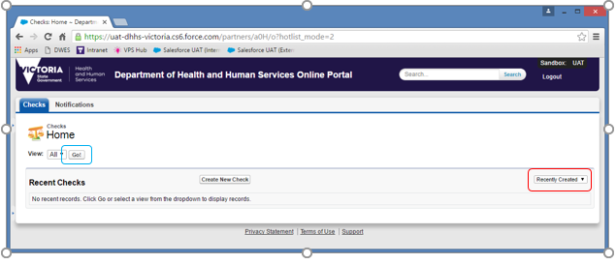

A list of checks raised by you or other staff within your organisation will appear in the list (Figure 20).

You can view any of these checks by clicking the corresponding Check ID for the check (circled in red in Figure 20).

You can return to the default view of recent checks by clicking on the ‘Checks’ tab at the top left of the screen.

Figure 20 – List of Checks

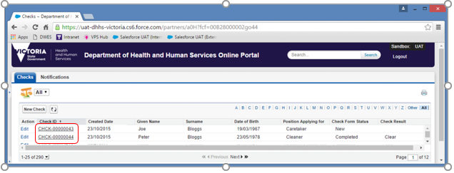

## Viewing check results

When accessing the list of checks (see *Viewing checks*), you can see the status of any checks raised by your organisation, as well as any available results (circled in red in Figure 21).

The Check Form Status column indicates the current status of the check, which could be:

* New: A check that has been raised but not yet actioned by the DWES Unit;
* In Progress: A check that is currently being processed by the DWES Unit; or
  + Completed**:** A check that has been processed by the DWES Unit, with a result available to view.

The Check Result column shows the outcome of the check. This column will only show a result when the check is completed. There are four possible values:

* Clear: The person’s name is not on the Disability Worker Exclusion List (the List). This is the only result indicating that a check of the worker’s name has been returned as clear. A worker in any other category is not clear to be employed.
* Excluded: The person’s name is on the List.
* Subject of Investigation: There is a current notification relating to the person but no decision has been made with respect to their placement on the List.
  + Current Appeal/Review: The person has sought a review of a decision to place their name on the List.

Figure 21 – Check results

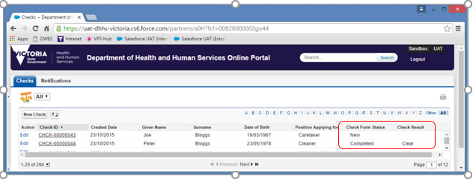

# Notifications

## Submitting notifications

Log in to the DWES Portal using your user name and password and click on the ‘Notifications’ tab located near the top left of the screen (circled in red in Figure 22).

Next, click on the ‘Create New Notification’ button located near the centre of your screen (circled in blue in Figure 22).

Figure 22 – Navigate to Create Notification

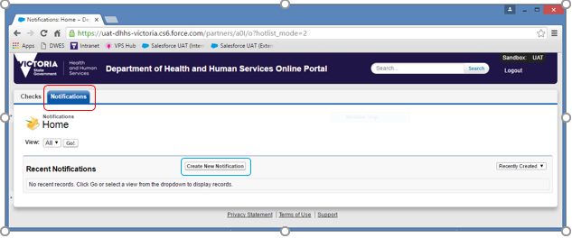

The New Notification screen will appear (Figure 23).

Figure 23 – New Notification screen

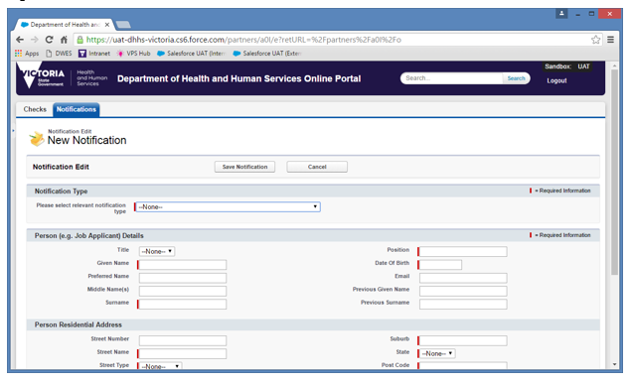

Choose a Notification Type from the drop down list. There are several notification types to choose from:

* Preliminary notification that investigation has commenced
* Unable to complete investigation
* Job applicant may qualify for inclusion on the list
* Retrospective – Open and concluded investigation
  + Retrospective – Open and unable to complete investigation

Depending on the Notification Type chosen, the information that needs to be entered will differ. Complete as many details as possible about the person and the circumstances of the notification. Any field marked with a red line must be completed.

Click the **‘Save Notification’** button to complete the creation of the Notification.

A sample of each notification form is shown in Figures 15, 16, 17, 18 and 19.

Figure 24 – Job applicant may qualify for inclusion on the list

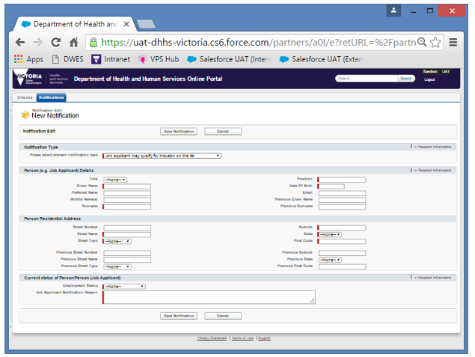

Figure 25 – Preliminary notification that investigation has commenced

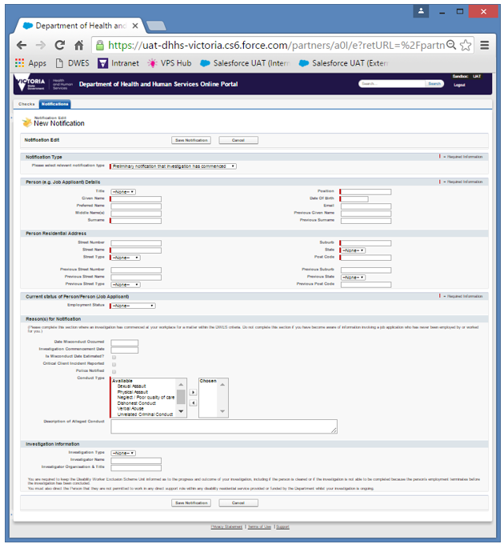

Figure 26 – Unable to complete investigation

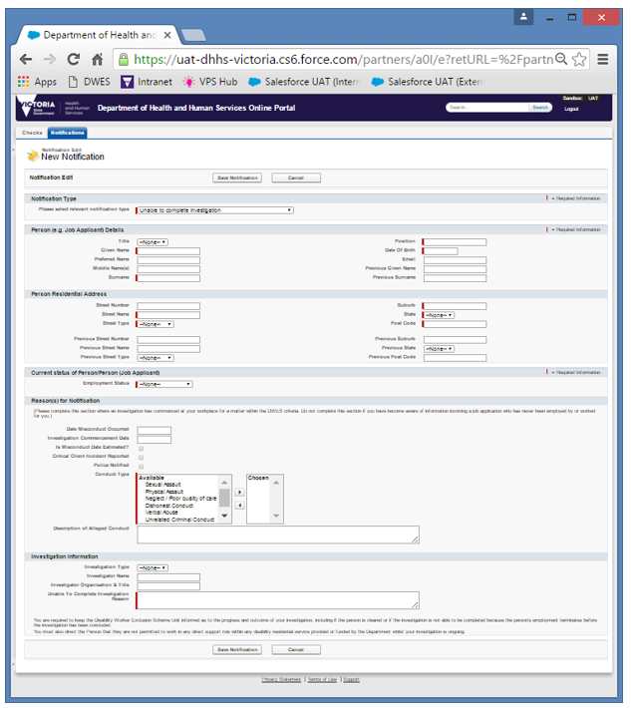

Figure 27 – Retrospective – Open and concluded investigation

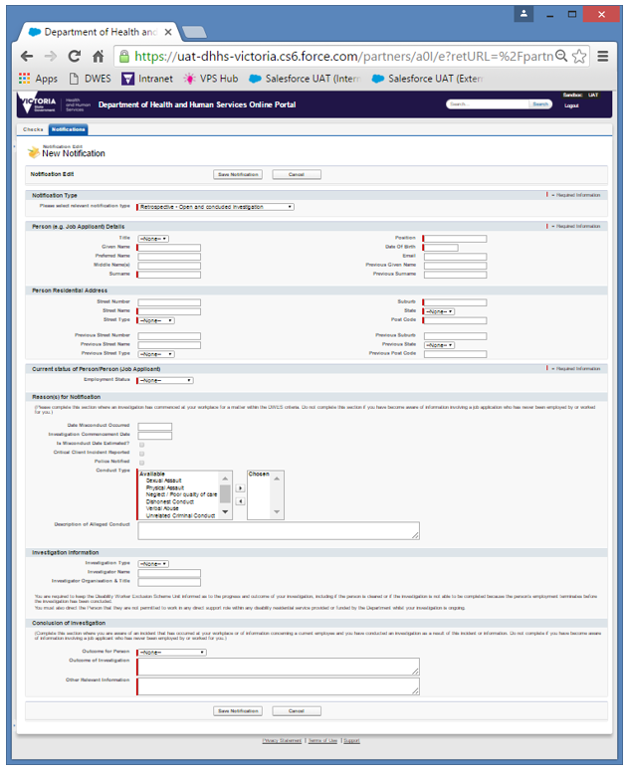

Figure 28 – Retrospective – Open and unable to complete investigation

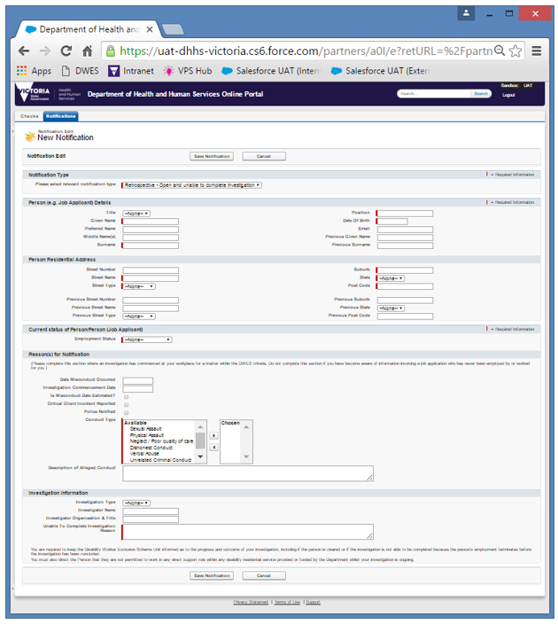

**Note:** If the address associated with the check request is a PO box, or includes a street type that is not available in the ‘Street Type’ drop-down menu, please include the PO box details or the full street name and street type in the ‘Street Name’ field. Include the street number (if applicable) and the suburb, state and postcode details in the relevant fields as normal. Please see *Raising check requests* for examples of how this information should be entered.

## Viewing notifications

Log in to the DWES Portal using your user name and password and click on the ‘Notifications’ tab located near the top left of the screen.

The default view displays any recent notifications. These can be filtered using the drop down menu on the right of the screen to display ‘Recently Created’, ‘Recently Modified’ or ‘Recently Viewed’ records (circled in red in Figure 29).

Click the **‘Go’** button located near the top left of the screen (circled in blue in Figure 29).

Figure 29 – Navigate to view Notifications

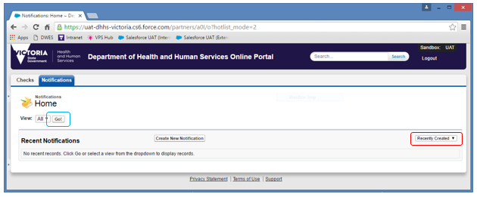

A list of notifications submitted by you or other staff within your organisation will appear in the list (Figure 30).

You can view any of these notifications by clicking the corresponding Notification ID for the notification (circled in red in Figure 30). You can also quickly edit a notification by clicking the ‘Edit’ link that corresponds to the notification (circled in blue in Figure 30; see *Updating notifications*).

You can return to the default view of recent notifications by clicking on the ‘Notifications’ tab at the top left of the screen.

Figure 30 – List of Notifications

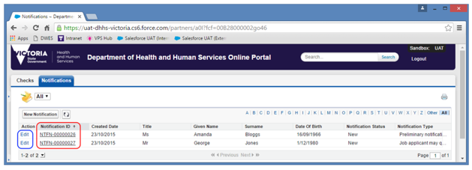

## Updating notifications

When a notification progresses from a preliminary to completed investigation, or if further information becomes available, you can update the notification with additional information.

Log in to the DWES Portal with your username and password.

Open the notification you want to update (See *Viewing notifications*).

Click the ‘Edit Notification’ button to edit the notification (highlighted in red in Figure 31).

Figure 31 – Update Notification

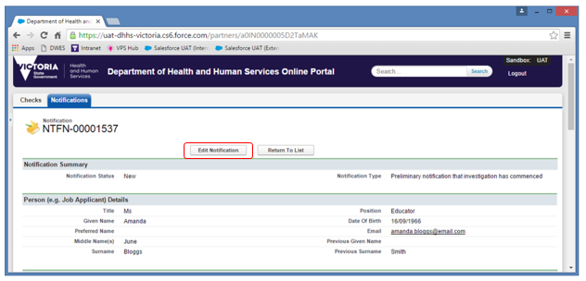

If the notification has a Notification Type of ‘Preliminary notification that investigation has commenced’, you will have the option to progress the notification by changing the Notification Type to:

* Notification where an investigation has been completed, or
  + Unable to complete investigation.

If the notification has a Notification Type other than ‘Preliminary notification that an investigation has commenced’, you will not be able to edit the Notification Type.

Update any other details of the notification that need to be changed. All fields marked with a red line must be completed.

Click the ‘Save Notification’ button to save the changes to the notification (circled in red in Figure 32).

Figure 32 – Update Notification

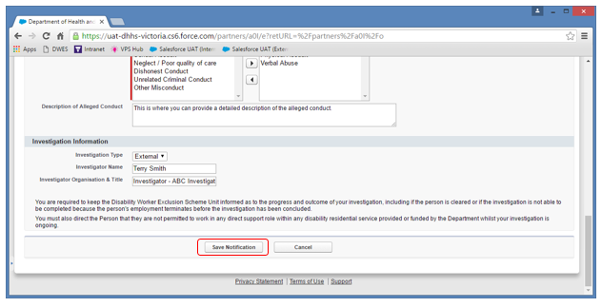

Note: Notifications are not editable if the status of the notification is ‘Received’, as this indicates the DWES Unit is currently assessing the notification. Some fields may no longer be editable if the Notification Status is ‘Recorded’ or ‘Updated’. If you require a change to any read-only fields, please contact DWES Portal support by phone on 03 9096 3200 or by [email to the DWES Unit](mailto:DWESSalesforceSupport@dhhs.vic.gov.au) <DWESSalesforceSupport@dhhs.vic.gov.au>.

## Adding notes or attachments to notifications

Log in to the DWES Portal with your username and password. Navigate to the notification you would like to add a note or attachment to (see *Viewing notifications*).

Scroll down to the bottom of the notification. You will see a section labelled ‘Organisation Notes & Attachments’ as shown in Figure 33.

Click the ‘New Organisation Notes & Attachments’ button (circled in red in Figure 33).

Figure 33 – Organisation Notes & Attachments section

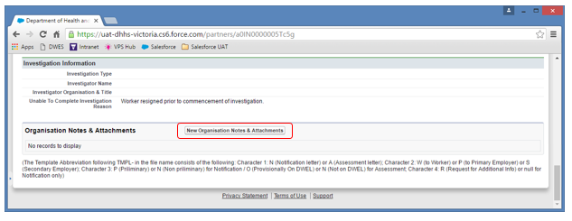

This will create a new Organisation Notes & Attachments group, allowing you to then save any related notes or attachments together. Please provide a description, such as “Investigation documents” or “Disciplinary hearing process”, as shown in Figure 34.

Click the **‘Save’** button to create the group (circled in red in Figure 34).

Figure 34 – New Organisation Notes & Attachments record

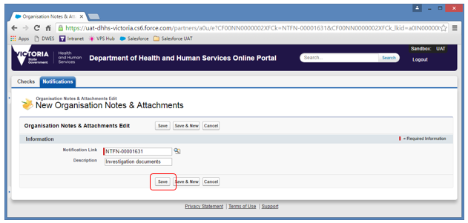

A message will appear, confirming that the Organisation Notes & Attachments record has been created (Figure 35).

You can choose to attach a note or a file by clicking on either the ‘New Note’ or the ‘Attach File’ button (both circled in red in Figure 35).

Figure 35 – Organisation Notes & Attachments saved

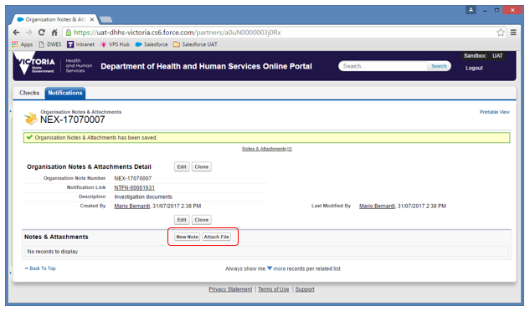

If you wish to create a new note, click on the ‘New Note’ button. The screen shown at Figure 36 will appear.

Insert a title for the note and any further detail in the ‘Body’ field.

Ensure the ‘Private’ check box is not ticked. A Private note will only be visible to you, and not to any other person in your organisation or to the DWES Unit.

Click the ‘Save’ button to save the note (circled in red in Figure 36).

Figure 36 – New Note Screen

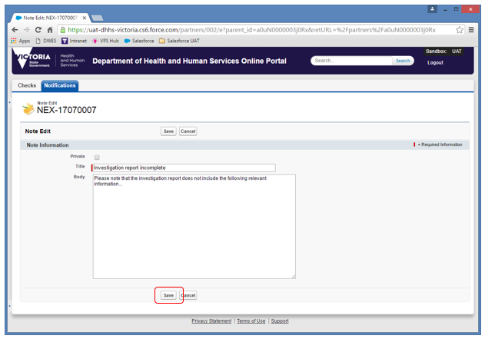

The screen shown at Figure 37 will appear, confirming that the note has been saved.

You can continue attaching related notes and files to this same record by using the ‘New Note’ and ‘Attach File’ buttons (circled in red in Figure 37).

Figure 37 – Note saved confirmation

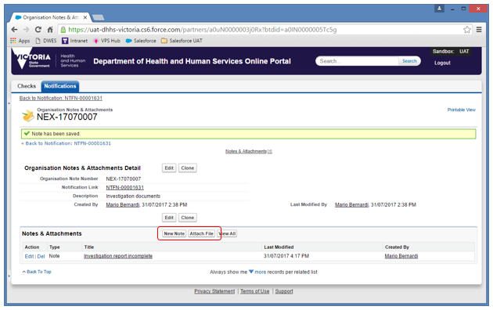

To attach a file to an Organisation Notes & Attachments group, click on the **‘Attach File’** button. The screen shown at Figure 38 will appear. Select the file you want to attach by clicking the **‘Choose File’** button (circled in red in Figure 38).

Figure 38 – Choose file to Attach

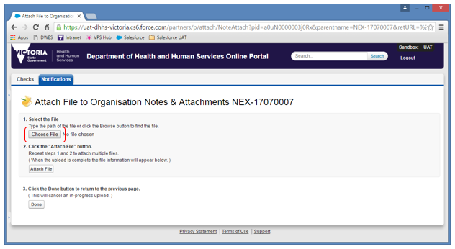

An ‘Open’ dialog will appear (Figure 39). Navigate to the location where the file you want to attach is located and select the file.

Click the ‘Open’ button (circled in red in Figure 39).

Figure 39 – Open Dialog

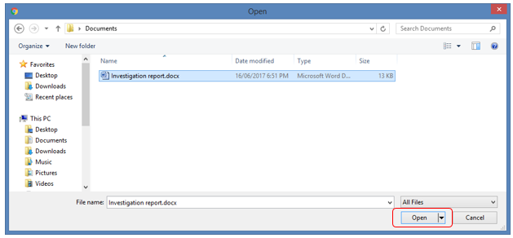

The dialog will close and your file will be displayed next to the ‘Choose File’ button (circled in red in Figure 40).

Click the ‘Attach File’ button to attach the file to the notification (circled in blue in Figure 40).

Figure 40 – File Attached to Notification

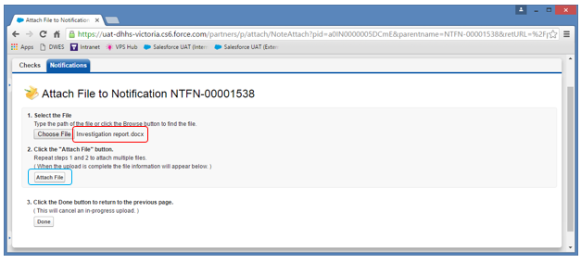

Once the upload has completed, details of the file you just attached will be displayed at the bottom of the screen (circled in red in Figure 41).

If you need to add additional attachments to the same Organisation Notes & Attachments group, you can repeat this process without needing to exit this screen. Click the ‘Choose File’ button to select your next file to upload.

Click the ‘Done’ button to return to the Organisation Notes & Attachments Detail screen (circled in blue in Figure 41).

Figure 41 – File Uploaded

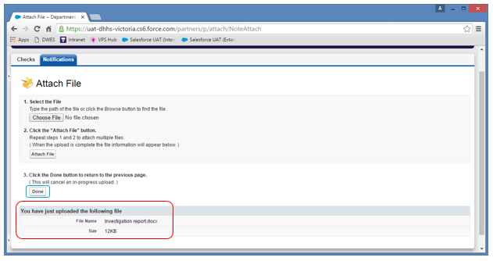

The screen shown at Figure 42 will appear, confirming that the attachment has been added.

Figure 42 – Attachment added confirmation

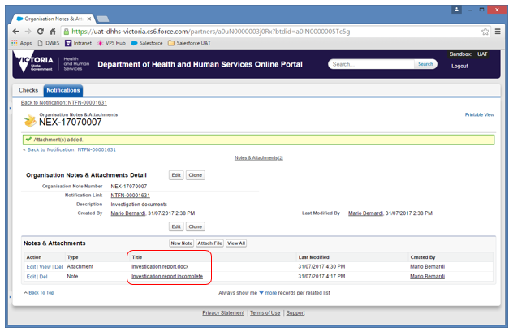

You can open and view any note or attachment by clicking on the title (circled in red in Figure 42).

# DWES Portal security

The DWES Portal is built on a software platform that has been hardened against unauthorised access and malicious attacks. Regular security reviews are conducted on the DWES Portal to ensure it remains a secure and safe environment for our clients’ data.

As a result of these security measures, certain policies are in place with respect to your access to the DWES Portal.

* All login attempts are monitored.
* Passwords expire every 30 days.
* Passwords must meet minimum security requirements as outlined in *Accessing the DWES Portal*.
  + Users are automatically logged out of the DWES portal after 15 minutes of inactivity.

In addition, data stored within the DWES Portal is secured at an individual record level. This means that any check requests or notifications created by you are only visible to you and other members within your organisation (provided they also have access to the DWES Portal). Access within the Department of Health and Human Services is restricted to key personnel only.

If you have any security related questions or concerns relating to the DWES Portal, please contact DWES Portal support by phone on 03 9096 3200 or by [email to the DWES Unit](mailto:DWESSalesforceSupport@dhhs.vic.gov.au) <DWESSalesforceSupport@dhhs.vic.gov.au>.

# Support

## Support contacts

If you encounter any issues or require any assistance with the DWES Portal, please contact DWES Portal support via:

Phone: 03 9096 3200

Email: DWESSalesforceSupport@dhhs.vic.gov.au

Certain support calls may also be escalated through to the department’s technical support teams.

## Frequently Asked Questions

### Q. I cannot log in to the DWES Portal. Help!

A. Ensure you are using the correct user name. Your user name is located in the initial email you received from the department welcoming you to the DWES Portal. It is typically your email address.

### Q. I have forgotten my DWES Portal password.

A. You can request a reset of your password by clicking the **‘Forgot your password?’** link on the login screen. See *Resetting your password* for more details.

### Q. The DWES Portal is not displaying correctly.

A. Ensure you are using a compatible web browser and it has been updated to the latest version. Google Chrome is the preferred browser for the DWES Portal, but Mozilla Firefox and Internet Explorer (9 or greater) are also supported.

### Q. I receive an error when raising a check request.

A. Ensure you have completed all mandatory fields (marked with a red line) and accepted the conditions by clicking the checkboxes next to their description. If you are still having trouble, please contact DWES Portal support.

### Q. The check request I have raised has no result. What is going on?

A. After raising a check request, the DWES Unit will process the check typically within 2 business days. A result will only be displayed (in the **Check Result** column) once the check has been completed, as noted in the **Check Form Status** column.

### Q. I can’t see the Notifications tab or submit any notifications.

A. Not all DWES Portal users are granted access to create notifications. Some users are provided with ‘Checks only’ access. The relevant level of access required for new Authorised Persons should be indicated on the *Authorised Person Nomination Form*. If you believe you have not been provided with the correct level of access, please contact DWES Portal support.

### Q. I receive an error when submitting a notification.

A. Ensure you have completed all mandatory fields (marked with a red line) including any fields further down the web page that may not be immediately visible. Note also that some fields are dynamic and only appear when a related field elsewhere in the form is changed or completed. If you are still having trouble, please contact DWES Portal support.

### Q. Why are only some fields mandatory for checks and notifications? Why do you ask for information that is not mandatory?

A. The fields in checks and notifications indicated as mandatory relate to the absolute minimum amount of information the DWES Unit requires to process the relevant matter. All organisations are encouraged to provide as much information as they can (including non-mandatory information) to assist the DWES Unit with progressing each matter. However, each matter is different and must be dealt with individually. The non-mandatory fields allow organisations to provide varying amounts and types of information to reflect the details available to them at the time.

### Q. When I try to create a check or notification, details for previous checks and notifications appear in a list or predict what I will type when I click on each field. Why does this happen?

A. This is a feature of your internet browser, commonly called “Autofill” or “AutoComplete”. This is not a function of the DWES Portal. To switch off this functionality, you should refer to the ‘Settings’ or ‘Options’ menu of your internet browser.

### Q. I can’t change the person’s details in a notification after creating the notification. Why?

A. Once a notification has been created; most fields remain editable until the notification is processed by the DWES Unit. Once this occurs, the person’s details will be locked and unable to be changed. If you have made a mistake with one or more of the person’s details and are unable to make the change yourself, please contact DWES Portal support with details of the required changes.

### Q. I have a friend who works at another organisation. They also have access to the DWES portal. Why can’t they see the checks or notifications I have created?

A. Checks and notifications created by a person in your organisation are only visible to other staff of **your** organisation with access to the DWES Portal. This is one part of the strict security measures in place to protect the privacy of data contained in the DWES Portal.

### Q. My question is different to any of the other questions listed here. How do I get help?

A. If you have any other queries or encounter any issues when using the DWES Portal, please contact DWES Portal Support (contact details are provided above). Depending on the nature of your query, the DWES Unit may be able to assist you immediately, or may need to escalate your issue through to the department’s technical support teams. The DWES Unit will endeavour to assist you as a matter of priority and escalate your issue, if required, as soon as possible.