

|  |
| --- |
| Good Practice Bulletin |
| SAFER Children Risk Assessment Framework  Office of Professional Practice, Issue 2, March 2019 |

A message from the Chief Practitioner, Office of Professional Practice

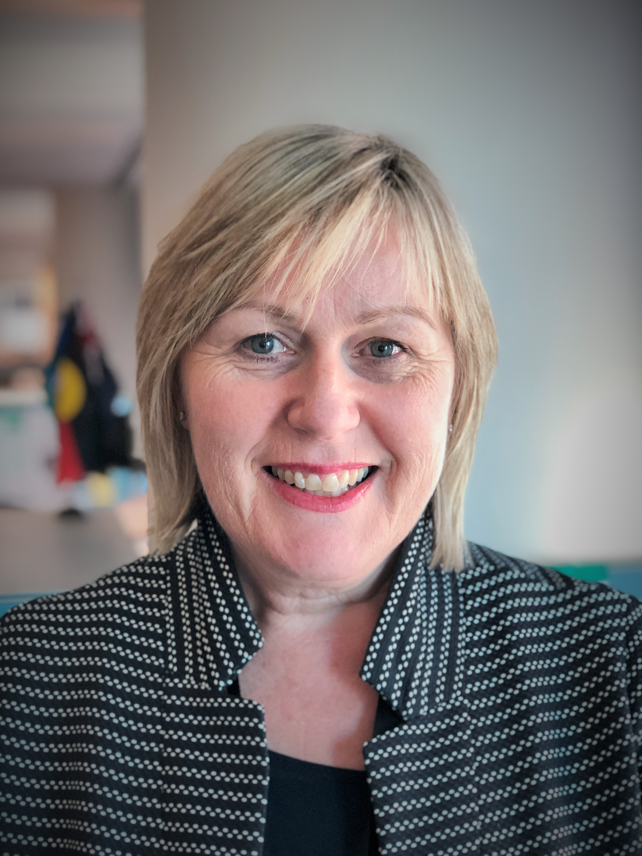

#### Tracy Beaton

Welcome to the second edition of the SAFER Children Good Practice Bulletin. This edition is part of a series of periodic bulletins updating you on the development and implementation of the SAFER Children Risk Assessment Framework (SAFER).

The SAFER acronym summarises the following key practice activities:

* Seek and share information
* Analyse the information gathered to determine risk of harm
* Formulate a plan of action to address those risks and the child’s needs
* Enact the plan; and
* Review changes and reassess the risks.

### SAFER Implementation – Go live in September 2019

I am very pleased to let you know that SAFER will go live in early September 2019 with the official launch at the Child Protection Symposium on 2 September 2019 at the MCG.

We have also developed a new Engage DHHS - SAFER page which will act as a hub for the SAFER project. Engage DHHS - SAFER will provide a platform to update child protection staff about the project. It also provides an interactive space to “Ask Emma”, Principal Project Officer, questions about the development and the rollout of SAFER. For more information, see to the [Engage DHHS - SAFER page](https://engagedhhs.vic.gov.au/safer-children-risk-assessment-framework) (internal DHHS staff only) <https://engagedhhs.vic.gov.au/safer-children-risk-assessment-framework>.

I would like to take this opportunity to thank the practitioners who participated in the Barwon pilot and our Practice Leaders and Principal Practitioners for sharing your time, ideas and valuable feedback during a workshop in January 2019. Your contributions have assisted immensely in the continued refinement and development of the tools and overall framework which ultimately aims to strengthen our service provision to vulnerable children and young people.

## SAFER Risk Assessment – Pilots

### Barwon Pilot Phase 1

A pilot of the SAFER draft CRIS templates was undertaken in Barwon which commenced in September 2018 and concluded in December 2018. The pilot consisted of a series of information sessions, focus groups and testing of the CRIS templates by child protection managers and staff. The staff in Barwon were supported on-site by Emma Wicks, Principal Project Officer, who is part of the CP Risk Assessment Project Team.

Six information sessions were held on-site at the Geelong office with forty practitioners attending these sessions to provide feedback on risk assessment, CRIS enhancements and the development of the risk assessment framework. The overall feedback received was positive with practitioners eager to participate in the co-design process and share their ideas in the development of the tools. Following the information sessions, a series of focus groups were facilitated to continue working with practitioners to understand risk assessment in their everyday practice and to give practitioners and managers an opportunity to co-design the SAFER tools.

Undertaking this pilot has helped gain an understanding of the practical use of the tools and has successfully provided clarity and direction for the further refinement of the draft CRIS templates. The pilot also informed the learning and development strategy and implementation considerations.

Hear from the Barwon child protection staff as they talk about their participation in the pilot and their initial thoughts on the tools:

[SAFER Children Barwon Pilot Video](https://intranet.dhhs.vic.gov.au/child-protection-risk-assessment) (internal DHHS staff only) <https://intranet.dhhs.vic.gov.au/child-protection-risk-assessment>

### Pilot Phase 2 Workshops

Following the first pilot, the draft CRIS templates have been refined with these now ready for a second pilot. A number of workshops will be held across the North and West divisions in March 2019 with child protection practitioners encouraged to participate and to provide their feedback on the enhanced templates. This will assist in consolidating final refinement of the draft CRIS templates prior to the CRIS build and rolled out in September. The workshops will run for 3 hours and be limited to 6-8 practitioners.

**Evaluation of Barwon Pilot**

The department’s Centre for Evaluation and Research (CER) is undertaking an evaluation at every phase of the development and implementation of SAFER. The CER team was out in Barwon talking to the workforce about their participation in the pilot, satisfaction with the templates and early perceptions on how the templates might enhance practice. Three focus groups were conducted in December 2018 and January 2019 together with an on-line survey, open from the end of December 2018 until 25 January 2019.

The review found that:

* overall, the draft templates are perceived as providing the right amount of structure to support guidance which, in turn, promotes comprehensive risk assessments. Importantly, the inclusion of strengths and protective factors are welcomed.
* findings revealed that the templates are regarded as easy to use, relevant and useful. Streamlining the risk protection templates was recommended with this work now complete.

CER will continue the evaluation as we embark on our workshops examining the templates in the North and West Divisions.

**Principal Practitioners and Practice Leaders Forum**

On Wednesday 9 January 2019, a combined workshop was held with child protection Principal Practitioners and Practice Leader representatives from each division. The workshop focused on the review of the Best Interests Case Practice Model (BICPM) and SAFER.

## Adopting a world café approach, participants responded to a range of questions relating to the implementation and rollout of SAFER, including the development of practice resources, learning and development strategies, training, change management, and measuring the success and outcomes for our workforce and our clients. Participant feedback suggested further work to refine the risk assessment and analysis templates that will be embedded into CRIS and the development of a practice resource guide and critical practice transformation considerations.

## Thank you to all who participated!

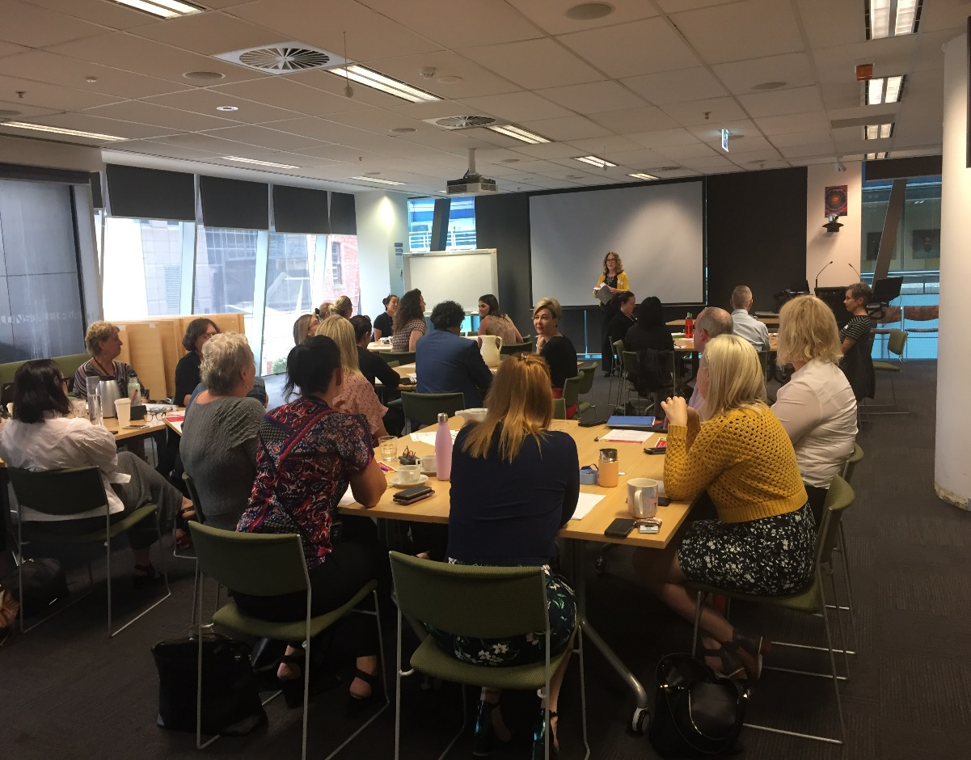

#### *Above: Beth Parker, Assistant Director, Office of Professional Practice, opens the state-wide workshop*

**Finally…**

Work is progressing in the learning and development space. Procurement has commenced to work with an instructional designer on the development of training modules, as well as an e-learning approach.

## Further Information

For further information visit our intranet page, Engage DHHS – SAFER page or contact:

[Email Georgia Crilis](mailto:Georgia.Crilis@dhhs.vic.gov.au) <Georgia.Crilis@dhhs.vic.gov.au>, Project Implementation Manager

[Email Emma Wicks](mailto:Emma.Wicks@dhhs.vic.gov.au) <Emma.Wicks@dhhs.vic.gov.au>, Principal Project Officer

On behalf of the Office of Professional Practice, we hope you have found this issue of the Good Practice Bulletin useful. If you have any feedback or ideas about what you would find useful to include, please email [Safer Children Risk Assessment](mailto:saferchildren.riskassessment@dhhs.vic.gov.au) <saferchildren.riskassessment@dhhs.vic.gov.au> or “Ask Emma” via the [Engage DHHS - SAFER page](https://engagedhhs.vic.gov.au/safer-children-risk-assessment-framework) (internal DHHS staff only) <https://engagedhhs.vic.gov.au/safer-children-risk-assessment-framework>..

|  |
| --- |
| To receive this publication in an accessible format phone 03 9096 9999, using the National Relay Service 13 36 77 if required, or email Office of Professional Practice <officeofprofessionalpractice@dhhs.vic.gov.au>  Authorised and published by the Victorian Government, 1 Treasury Place, Melbourne.  © State of Victoria, Department of Health and Human Services November 2018.  Available at the Good Practice Bulletin page of the DHHS Providers website http://providers.dhhs.vic.gov.au/good-practice-bulletin |