Family violence referral protocol
Between the Department of Health and Human Services, Family Safety Victoria, Department of Justice and Regulation and Victoria Police
2018

To receive this publication in an accessible format phone 03 9194 3100, using the National Relay Service 13 36 77 if required, or email Family Safety Victoria <reception@familysafety.vic.gov.au>
Authorised and published by the Victorian Government, 1 Treasury Place, Melbourne.
© State of Victoria, Family Safety Victoria March 2018
In this document, ‘Aboriginal’ refers to both Aboriginal and Torres Strait Islander people. ‘Indigenous’ or ‘Koori/Koorie’ is retained when part of the title of a report, program or quotation.

Foreword

Family violence is a serious problem that has profound effects on victims, children, families and communities. Family violence is primarily perpetrated by men against women and children and it is known to be a cyclical problem. Children who are exposed to family violence can experience trauma that may affect their development and wellbeing. Victims can fear for their safety and may become homeless. Effective strategies must account for this, with systems for monitoring, feedback, prevention and timely intervention. Providing integrated, effective responses to cease family violence is a key priority for the Department of Health and Human Services, Family Safety Victoria, the Department of Justice and Regulation and for Victoria Police.
This document – the Family violence referral protocol between the Department of Health and Human Services, Family Safety Victoria, the Department of Justice and Regulation and Victoria Police 2018 (the Family violence referral protocol) – provides guidance on how Victoria Police, the Department of Health and Human Services, Family Safety Victoria and the Department of Justice and Regulation (collectively, the “Parties”) and the service agencies they fund can work together to strengthen the collective response to family violence.
The Family violence referral protocol is an important part of the overall, state-wide effort to build an integrated system to respond to family violence and it will strengthen existing agreements in this area. Importantly, it requires collaborative arrangements between the Parties and service agencies at the front line to cease family violence, to protect those affected by it, and to bring greater accountability and service options to men who use violence.
The establishment of Support and Safety Hubs (Hubs) was a central recommendation made by the Royal Commission into Family Violence (Royal Commission) to integrate and strengthen the current response to family violence. The Hubs will bring together the access points for specialist family violence services, child and family services and perpetrator services through a shared, area-based intake, making it easier for people who experience family violence and child and family vulnerability to get the help they need.
The Family violence referral protocol sets out clear and consistent referral pathways for Victoria Police to Hubs, family violence services, Child FIRST, Child Protection and victims of crime support services. It also specifies procedures for service agencies to notify Victoria Police of safety concerns and to provide feedback on the outcomes of referrals.
This version of the protocol has been updated to reflect statewide changes to the service system recommended by the Royal Commission, Roadmap for Reform: strong families, safe children and Ending Family Violence: Victoria’s Plan for Change, such as the establishment of Family Safety Victoria and the introduction of the Family Violence Information Sharing Scheme.

The Family violence referral protocol has been endorsed (and executed at Section 10) by:

Terry Symonds, Acting Secretary, Department of Health and Human Services

Sue Clifford, Chief Executive Officer, Family Safety Victoria

Greg Wilson, Secretary, Department of Justice and Regulation

Dean McWhirter, Assistant Commissioner, Family Violence Command, Victoria Police

Contents
Foreword 3
Contents 4
1. Introduction 5
1.1. Objectives of the protocol 5
1.2. Risk and threats assessment 5
2. Definitions 6
3. Procedures for referrals by police, DHHS, FSV and DJR funded services to each other 7
3.1. Police L17 referrals and the L17 Portal 7
3.2. Support and Safety Hubs 8
3.3. Disclosure, use, protection and disposal of information 8
4. Referral pathways 9
4.1. Referrals by police for female victims of family violence 9
4.2. Referrals by police for male victims of family violence 11
4.3. Referrals by police for children (including unborn) and young people 13
4.4. Referrals by police for male perpetrators of family violence 15
4.5. Referrals from Hubs and family violence services to police for assistance and ongoing involvement 17
5. Review, variation and termination 18
6. Contacts 18
7. Dispute resolution 18
8. Disclaimer 19
9. Internal guidelines 19
10. Execution of this protocol 20
Appendix 1 – L17 Portal Routing Rules 25

Introduction
The following protocol has been developed to support the legislative context and reform agenda of police, justice and human services working together to build an integrated system to respond to family violence.
This protocol is to be read in conjunction with, and performed in accordance with, formal arrangements between the parties on the subject or related matters, including the L17 Portal Letter of Understanding. The protocol is also strengthened when read in conjunction with the Victoria Police Code of Practice for the Investigation of Family Violence.
The Family Violence Protection Act 2008, as amended by the Family Violence Protection Act 2017 and the Family Violence Protection Amendment (Information Sharing) Act 2017 to create a Family Violence Information Sharing Scheme (FVISS), is the main legislative instrument covering family violence in Victoria. The FVISS commenced on 26 February 2018.
In addition, related Victorian Acts are the Children, Youth and Families Act 2005 and the Child Wellbeing and Safety Act 2005.
In regard to the Children, Youth and Families Act 2005, section 10 provides a unifying set of best interest principles and the concept of ‘cumulative harm’, which recognises the trauma and impact on the development and safety of children who witness family violence over time.

Objectives of the protocol
The aim of this protocol is to document effective referral pathways between Victoria Police, family violence services funded by the Department of Health and Human Services (DHHS) and Family Safety Victoria (FSV) and victims of crime support services funded by the Department of Justice and Regulation (DJR), so that victims are better protected and family violence is reduced over time.
This protocol outlines the approaches for:
- formal and informal referrals by police for victims of family violence to family violence and other services;
- assessing the risk to any child or young person who is present, has witnessed or is affected by a family violence incident, and referring that child or young person to appropriate support services;
- formal and informal referrals by police for perpetrators of family violence to services; and
- referral by family violence services for police assistance.

Risk and threats assessment
In Victoria, specialist family violence services funded by FSV, and victim support services funded by DJR, undertake risk assessments using the Family Violence Risk Assessment and Risk Management Framework (otherwise known as the Common Risk Assessment Framework or CRAF).
The Victoria Police Code of Practice for the Investigation of Family Violence states that police will respond to and take action on any family violence incident reported to them. The action taken is based on an assessment of the risks and threats, regardless of whether the victim makes a verbal complaint or written statement. Victoria Police assess risk using a CRAF-compatible form.
The Royal Commission recommended that the CRAF be reviewed and strengthened. Redevelopment of the CRAF is underway and will be completed in late 2018.
As Support and Safety Hubs are being established in five launch site areas in early 2018, an interim approach was required to support risk assessment and management prior to the CRAF redevelopment being completed.
Interim findings from the CRAF redevelopment have informed the development of an Interim Comprehensive Risk Assessment Tool (ICRAT). At commencement, Support and Safety Hubs will use the ICRAT.

Definitions

Family violence
Family violence is defined under Section 5 of the Family Violence Protection Act 2008 as:
    - Behaviour by a person towards a family member of that person if that behaviour:
(i) is physically or sexually abusive; or
(ii) is emotionally or psychologically abusive; or
(iii) is economically abusive; or
(iv) is threatening; or
(v) is coercive; or
(vi) in any other way controls or dominates the family member and causes that family member to feel fear for the safety or wellbeing of that family member or another person; or
    - Behaviour by a person that causes a child to hear or witness, or otherwise be exposed to the effects of, behaviour referred to above.

After-hours
After-hours refers to the period outside of the traditional business hours of 9am to 5pm Monday to Friday, noting that normal operating hours for some agencies may extend beyond these hours. After-hours includes the period between 5pm and 9am on weekdays, all hours on weekends (between 5pm Friday and 9am Monday) and public holidays.

Business hours
Business hours refers to the period between 9am and 5pm Monday to Friday (excluding public holidays).

Child
The definition of child is consistent with the definition as outlined in the Children, Youth and Families Act 2005 s. 3(1)

Party and parties
Refers to the parties to this protocol, which collectively are: Victoria Police, the Department of Health and Human Services, Family Safety Victoria and the Department of Justice and Regulation and the service agencies they fund.

Victims and alleged perpetrators or perpetrators
For the purpose of this protocol it is recognised that in the majority of cases victims of family violence are women and children, and that those who perpetrate violence against victims are men. This language is consistent with the Victoria Police Code of Practice for the Investigation of Family Violence. This will not preclude other local and statewide services using alternative language to represent this gender difference (for example, men who use violence).
For the purposes of this protocol, the referral pathways for victims and perpetrators apply to individuals aged 17 and over. Victims aged 16 and under can be referred to either Child FIRST or Child Protection, according to the police assessment. Perpetrators aged 16 and under are referred to Child Protection.
For the purposes of information sharing under the Family Violence Information Sharing Scheme, the following definitions apply:
    - Victim survivor: is a person (adult or child) that an Information Sharing Entity reasonably believes is at risk of being subjected to family violence.
    - Alleged perpetrator: is a person who is alleged to pose a risk of committing family violence. Information about alleged perpetrators can only be shared with Risk Assessment Entities for a family violence Assessment Purpose. Reasonable belief is not required to share for an Assessment Purpose.
    - Perpetrator: is a person that an Information Sharing Entity reasonably believes may commit family violence.
Reasonable belief will have been identified through undertaking a CRAF-based family violence risk assessment.

Procedures for referrals by police, DHHS, FSV and DJR funded services to each other

Police L17 referrals and the L17 Portal
Victoria Police members who attend a family violence incident can make formal referrals to community agencies and/or reports to Child Protection by completing and forwarding a Victoria Police Risk Assessment and Risk Management Report (L17 referral/report). Police are able to generate an L17 referral electronically, indicating on it the need for referral(s) for an affected family member (victim), respondent (perpetrator) and/or children.
The web-based L17 Family Violence Portal (L17 Portal), implemented in December 2016, identifies the appropriate service/s to receive the referral (based on automated referral pathways, as set out in Appendix 1) and forwards the L17 referral electronically to the service/s that is provided in the area where the incident occurred.
The L17 Portal Letter of Understanding outlines the responsibilities, functions and manner by which the L17 Portal will operate and be used by the parties to this protocol.
In the current system, one family violence incident can result in multiple referrals. The L17 Portal can send an L17 referral to a specialist family violence service for a female victim, to the Victims of Crime (VoC) Helpline for a male victim, to a men’s family violence service or the Men’s Referral Service for a male perpetrator, to Child Protection where police have a reasonable belief that a child or young person is in need of protection, and to Child FIRST where neither a formal referral for a victim or a report to Child Protection is made, but significant concerns for the wellbeing of a child or young person remain.

Informal referrals
In some circumstances (i.e. if there are no immediate concerns for the victim or children’s safety and welfare) police do not make formal referrals. Instead, they provide the individuals involved in a family violence incident with the contact details of appropriate support services (an informal referral). From mid-2018, the L17 Portal will be able to capture and keep a record of all family violence incidents recorded by police, including informal referrals.

Support and Safety Hubs
In future, Hubs will receive almost all police L17 family violence referrals (except those for male victims, reports to child protection where police have a reasonable belief that a child is in need of protection, or referrals made to Aboriginal services where agreed as part of local Koori Family Violence protocols). This means that in most cases one incident will result in one referral (for the victim, perpetrator and child) to a Hub via the L17 Portal.
As such, the routing rules for the L17 Portal will be changed (initially in the Hub launch areas and eventually across the State) to ensure that the system diverts L17 referrals to the Hubs.
Hubs will also receive referrals for children and families in need of support (intended for Child FIRST intake which may or not be related to family violence), self-referrals and referrals from other professionals. This will effectively replace the current intake points for specialist family violence services, men’s behaviour change programs and Child FIRST (family services).
Hub workers will have access to the L17 Portal to be able to view, track and redirect referrals, update client information and share information with other services. The L17 Portal will be integrated with the Hubs Client Relationship Management System (CRM), a purpose-built information system that will capture, store and record case information, so that information flow and record keeping is seamless and efficient. The roll-out of this infrastructure will form part of the phased implementation of the Hubs so that by 2021 there is a statewide Hubs CRM system. Individual Hubs workers will be required to abide by the requirements set out in the CRM Terms of Use, and services as a whole must adhere to the requirements of the CRM Use and Access Agreement.
The first five Hubs will be established in Bayside Peninsula, Inner Gippsland, Barwon, Mallee and North-East Melbourne areas from April 2018. The phased establishment of the Hubs will allow learnings from the initial five sites to inform the consideration of future investment and rollout of the Hubs in each of the 17 DHHS areas across the State by 2021.

Disclosure, use, protection and disposal of information
Victoria Police information shared under this Protocol must be handled as 'Sensitive: Personal' or as otherwise indicated by Victoria Police.
DHHS, FSV and DJR will handle information shared under this Protocol in accordance with the requirements of the Victorian Protective Data Security Standards, including by not releasing, disclosing or allowing access to that information to any other party or individual unless authorised by the other Party, the Victorian Protective Data Security Standards or by law.
The Family Violence Information Sharing Scheme and associated Family Violence Information Sharing Guidelines 2017 set out the consent requirements for adult victims, alleged perpetrators or perpetrators, children and third parties, as applicable.

Referral pathways
The following section of the protocol sets out the following referral procedures and pathways:
- Flowchart one – Referrals by Police for female victims of family violence
- Flowchart two – Referrals by Police for male victims of family violence
- Flowchart three – Referrals by police where a child (including unborn) or young person is present, has witnessed or has been affected by an incident of family violence
- Flowchart four – Referrals by Police for male perpetrators of family violence
- Flowchart five – Referrals from Hubs and family violence services to police for assistance and ongoing involvement
For the purposes of this protocol, the referral pathways for victims and perpetrators apply to individuals aged 17 and over. Victims aged 16 and under can be referred to either Child FIRST or Child Protection, according to the Police assessment.
The parties acknowledge that further work is required to clarify and set out referral pathways for victims and perpetrators who are not adequately captured by the processes described in this protocol, such as female perpetrators, adolescents who use violence, and transgender and non-binary victims.

Referrals by police for female victims of family violence
For female victims of family violence, referral by police to Hubs or specialist family violence services for necessary support and assistance will follow in all cases. Options of criminal charges or civil complaint will be made against perpetrators of family violence where warranted.
Flow chart one indicates the assessment criteria and pathways for female victims including:
- formal referral for immediate assistance to Hubs or specialist family violence services (after-hours and business hours)
- formal referral for non-immediate assistance to Hubs or specialist family violence services
  - informal referral to Hubs or specialist family violence services (where the client is provided with contact details and encouraged to seek support from services).
When making a referral for a female victim, Police must provide details of any children or young people who were present, witnessed or were affected by the incident and identify whether a referral to Child Protection or a Hub / Child FIRST has been made.

Flow chart one: Referrals by police for female victims of family violence
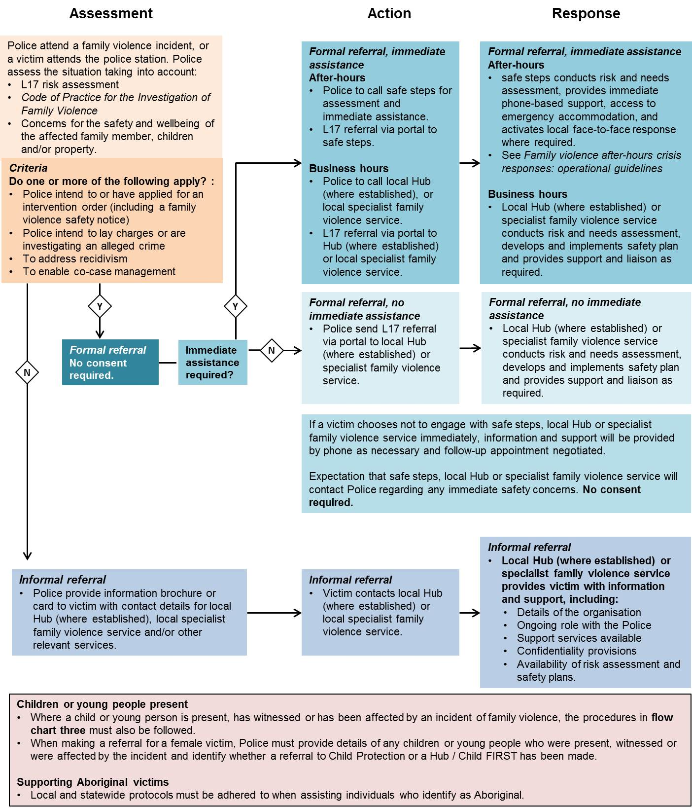

Referrals by police for male victims of family violence
For male victims of family violence, a different referral process is in place.
DJR funds a suite of services across Victoria to support victims of violent crime. The DJR operated Victims of Crime (VoC) Helpline is the ‘gateway’ to victim services across Victoria and also receives referrals from police for adult male victims. The VoC Helpline can be contacted on 1800 819 817, 8am-11pm, seven days a week. Men assessed as victims of family violence by the VoC Helpline are referred to the DJR funded Victims Assistance Program (VAP) for support.
The VAP provides case management services comprising practical support, criminal justice advocacy and therapeutic interventions to victims of crime throughout Victoria. The services are provided through a network of regionally based providers from over 45 locations and 28 Police Stations.
Options of criminal charges or civil complaint will be made against perpetrators of family violence where warranted.
Flow chart two indicates the assessment criteria and pathways for male victims including:
- formal referral to VoC Helpline
  - informal referral to VoC Helpline and other relevant services (where the client is provided with contact details and encouraged to seek support from services).
When making a referral for a male victim, Police must provide details of any children or young people who were present, witnessed or were affected by the incident and identify whether a referral to Child Protection or a Hub / Child FIRST has been made.
Where the VoC Helpline identify that a male victim has been miscategorised and is reassessed as a perpetrator, they will on-refer the L17 referral with case notes to either the local Hub (where established), Men’s Referral Service, or men’s family violence service via secure email.

Flow chart two: Referrals by police for male victims of family violence
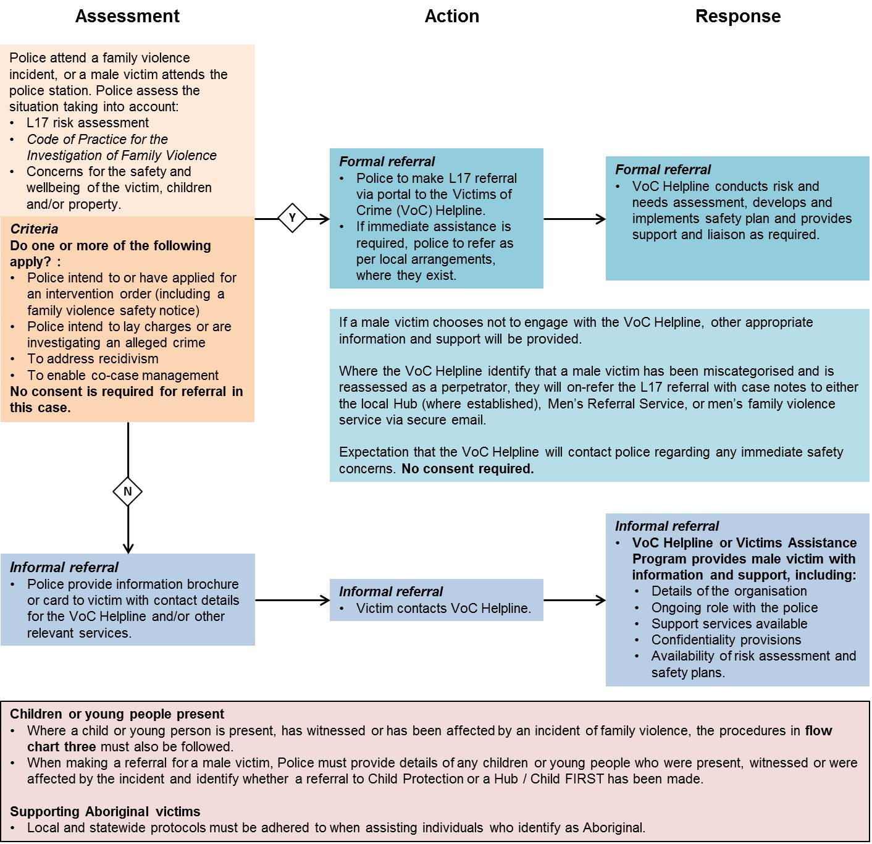

Referrals by police for children (including unborn) and young people
Police members must make an independent (from the affected family member and perpetrator) assessment of risk for any child or young person who is present, has witnessed or has been affected by an incident of family violence. A child or young person is defined in the context of the Children, Youth and Families Act 2005. This legislation also applies to unborn children. Action taken may include a combination of applying for an intervention order, laying criminal charges, reports to Child Protection or formal referrals to other service providers.
Flow chart three outlines the referral and contact pathways where a child or young person is present including:
- report to Child Protection if police believe that a child or young person is in need of protection due to actual or likely sexual or physical abuse, or concerns of harm or neglect (as mandated professionals Police must report these concerns to Child Protection, as soon as possible; always before the end of a shift);
- where police make a formal L17 referral for a female or male victim, they must provide details of any children or young people who were present, witnessed or were affected by the incident with the referral. Specialist family violence services and the VoC Helpline will consider the need for any children or young people involved to be referred to a Hub / Child FIRST and make a referral if appropriate;
- where police do not make a formal L17 referral for a female or male victim, or a report to Child Protection, but significant concerns for the wellbeing of a child or young person remain, police will make a referral to a Hub (where established) or Child FIRST.

Any individuals’ information that is relevant to the assessment or management of family violence risk to a child may be shared without consent. This protocol should be read in conjunction with existing protocols between Victoria Police and DHHS Child Protection, including Protecting Children: Protocol between the Department of Human Services - Child Protection and Victoria Police 2012.

Flow chart three: Referrals by police where a child (including unborn) or young person is present, has witnessed or has been affected by an incident of family violence

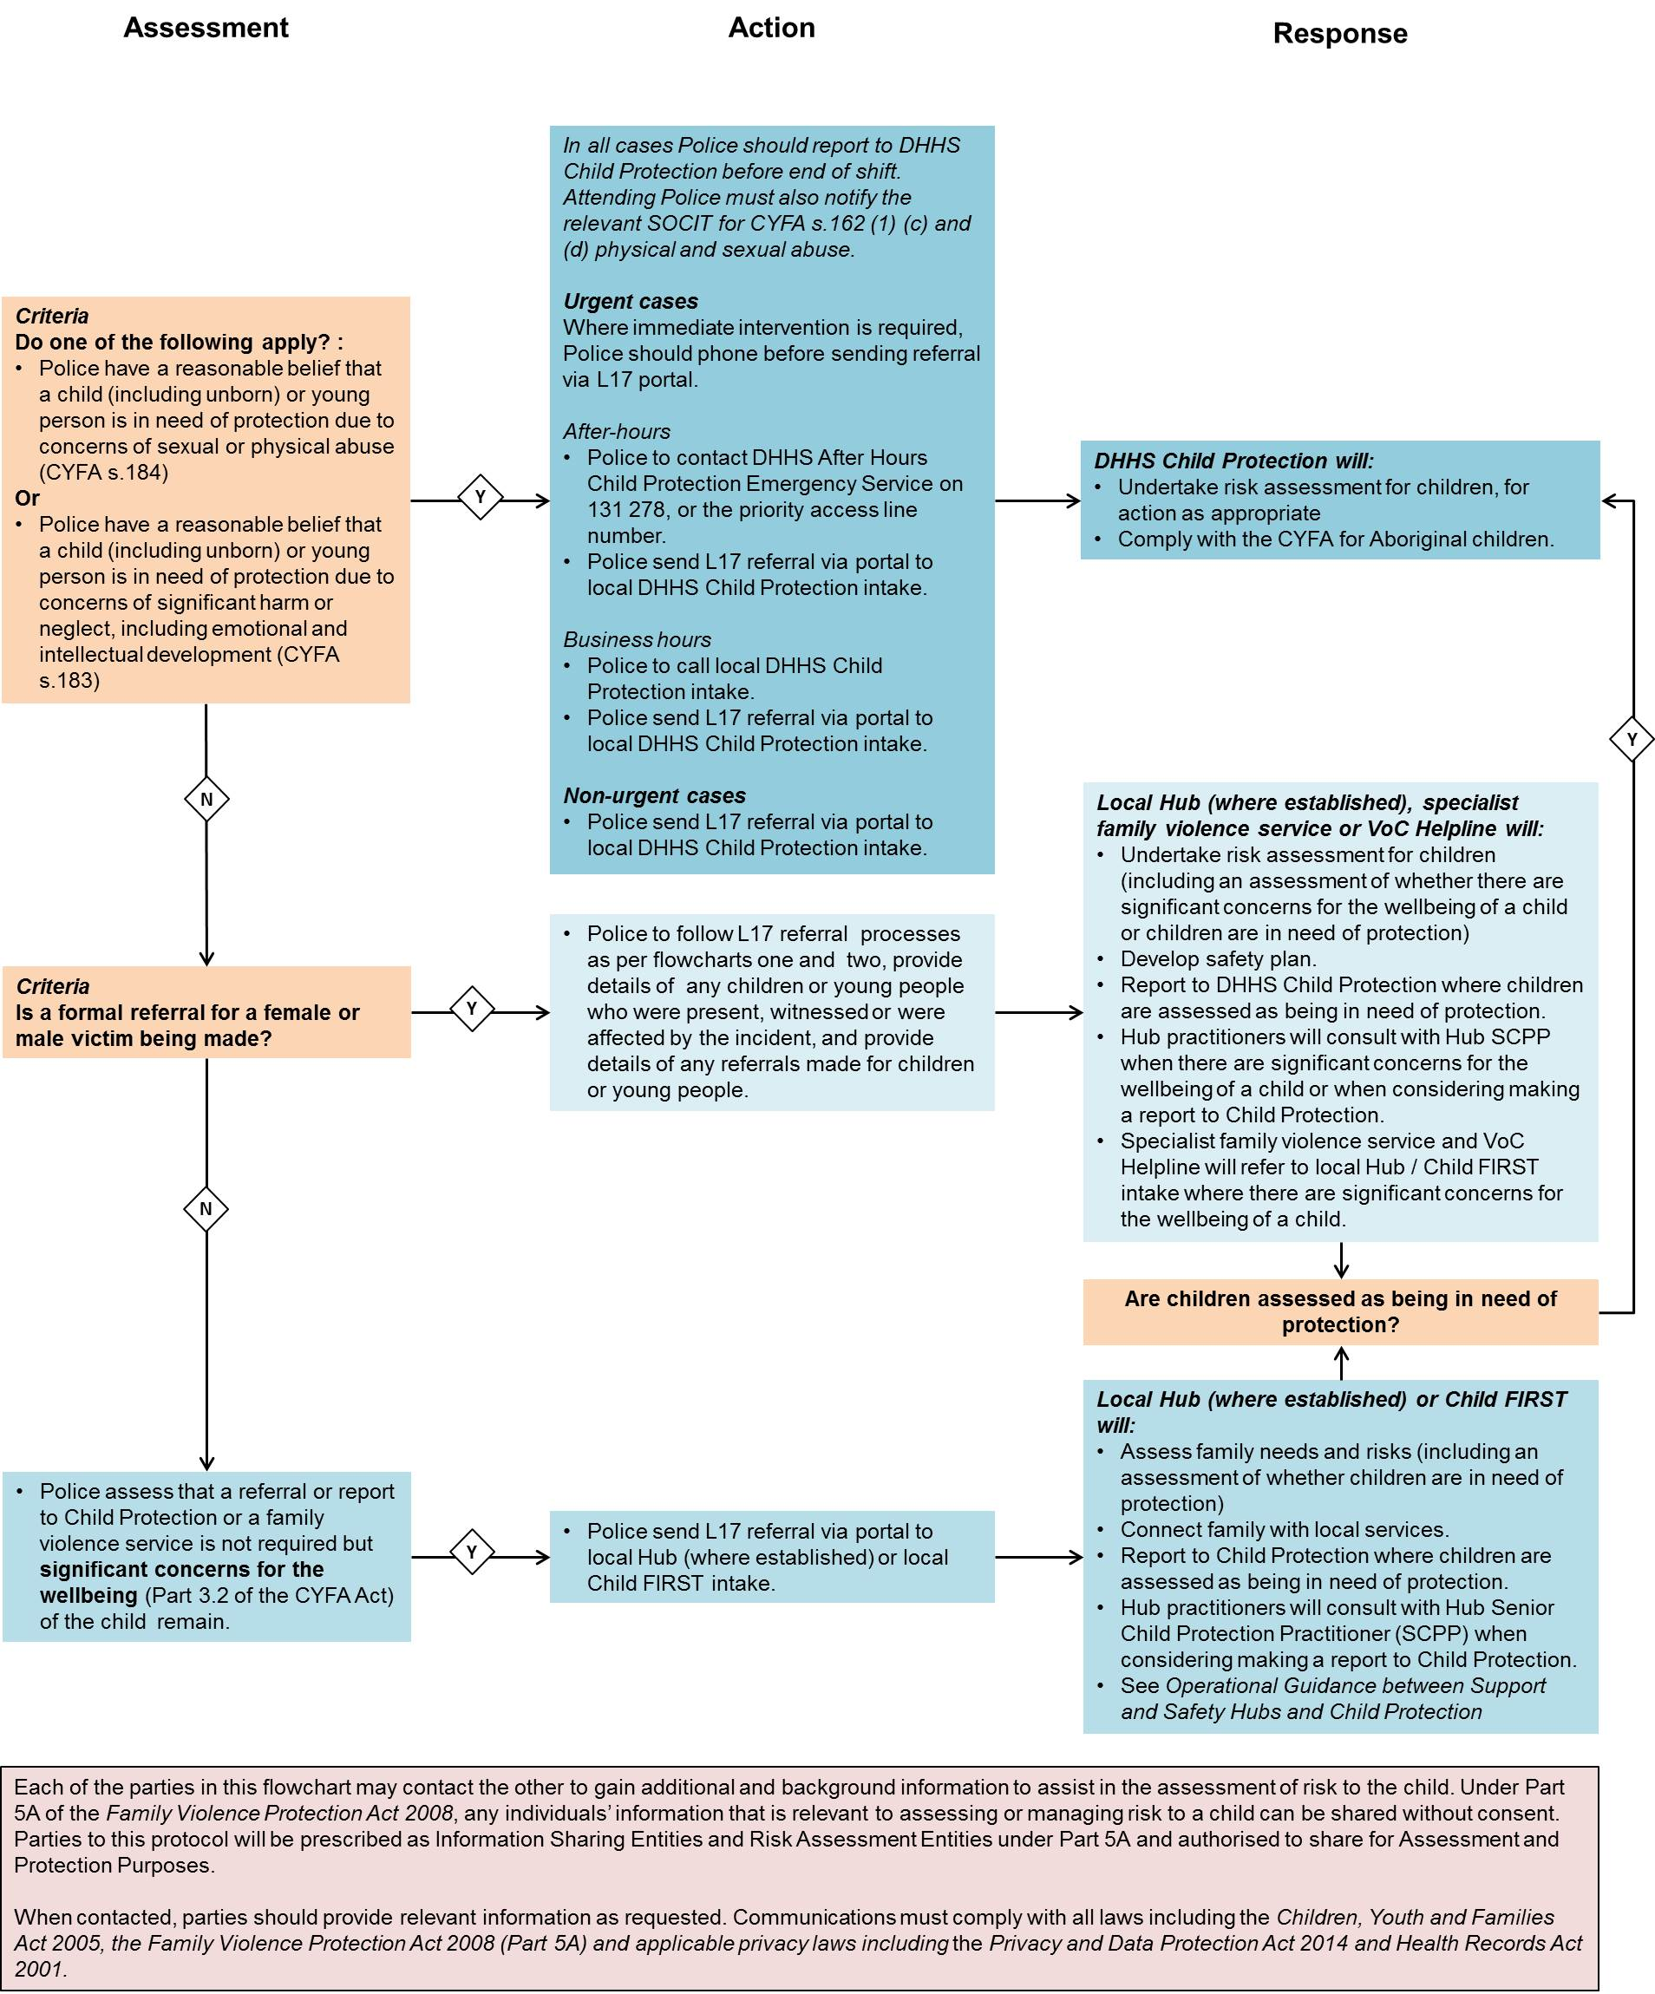

Referrals by police for male perpetrators of family violence
Police will lay criminal charges or seek civil compliance against perpetrators of family violence where warranted. This is consistent with the Victoria Police Code of Practice for the Investigation of Family Violence.
Flow chart four outlines the criteria for referral and contact pathways for male perpetrators of family violence including:
- formal referral to a Hub, Men’s Referral Service (MRS) or men’s family violence service
- informal referral to a Hub, MRS or men’s family violence service (where the perpetrator is provided with contact details and encouraged to seek support from services).
Where police initiate a formal referral for a male perpetrator, they must provide details of any children or young people who were present, witnessed or were affected by the incident and identify whether a referral to Child Protection or a Hub / Child FIRST should be made.
Where MRS, a Hub (where established) or men’s family violence service identify that a male perpetrator has been miscategorised and is reassessed as a victim, they will on-refer the L17 referral with case notes to the VoC Helpline via secure e-mail.
Where established, Hubs will receive formal L17 referrals for female perpetrators.
Flow chart four: Referrals by police for male perpetrators of family violence
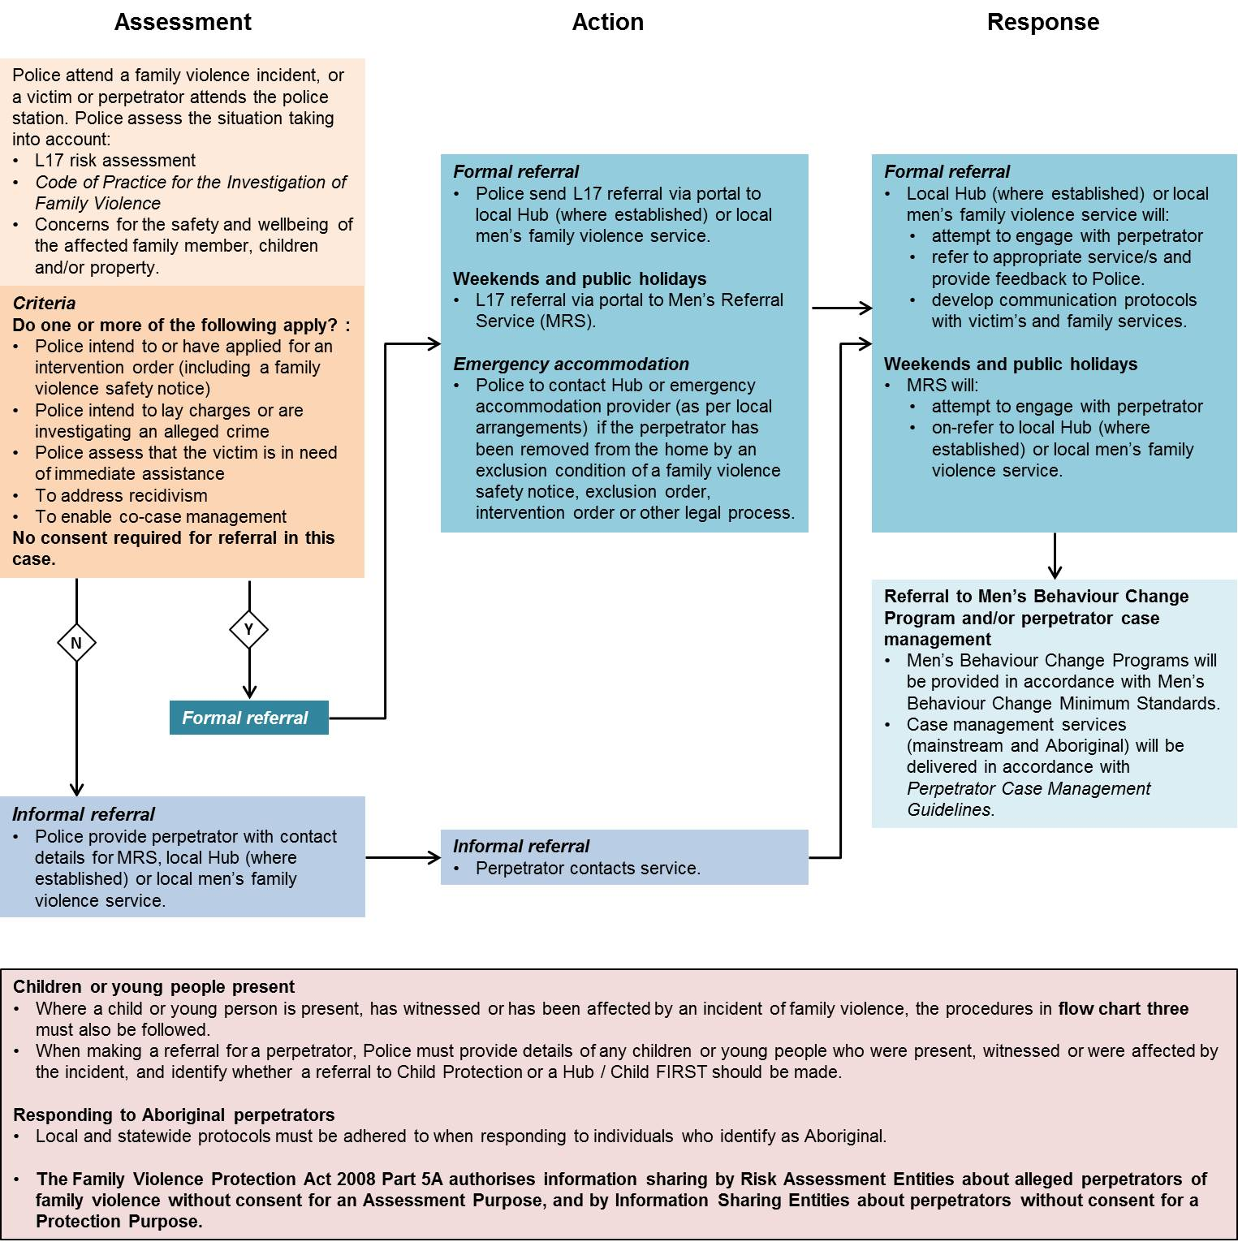

Referrals from Hubs and family violence services to police for assistance and ongoing involvement
Hubs (where established) and family violence services (including specialist family violence services, MRS, men’s family violence services and the VoC Helpline) will refer to police for immediate assistance where a person is at immediate risk of violence or further violence.

Flow chart five: Referrals from Hubs and family violence services to police for assistance

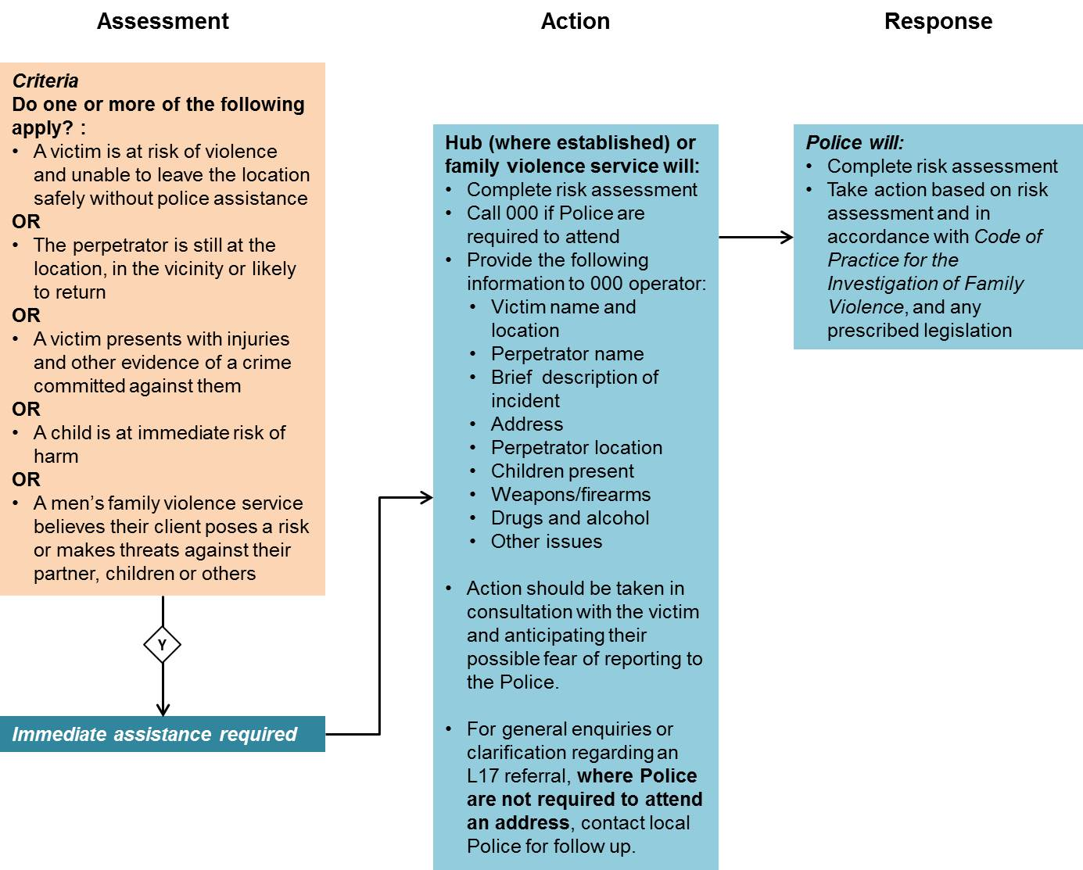

Review, variation and termination
This protocol may be reviewed, varied or extended at any time as agreed in writing by all parties.
Any party may terminate this protocol by giving 30 (thirty) days’ written notice to the other party.
The next review of this document will be conducted by July 2019.
Requests for amendment should be directed to, and will be coordinated by:
- Director, Service Implementation and Support, Department of Health and Human Services;
- Director, Family Violence Policy and Programs, Family Safety Victoria;
- Manager, Policy, Projects and Regional Engagement, Family Violence Command, Victoria Police; and
  - Director, Community Operations and Victims Support Agency, Department of Justice and Regulation.

Contacts
Local issues should initially be raised with:
- Local Support and Safety Hubs Leadership Groups;
- Managers of the Department of Health and Human Services-funded family violence services;
- Officer in Charge, Family Violence Investigation Units, Victoria Police;
- Department of Health and Human Services Agency Performance Officers/Agency Performance Manager/Area Director; and
  - Operations Manager, Victims of Crime Helpline.

Statewide issues should be raised with:
- Family Violence Policy and Programs, Family Safety Victoria;
- Child Protection, and Early Pathways Unit, Department of Health and Human Services;
- Community Operations and Victims Support Agency, Department of Justice and Regulation; and
- Family Violence Command, Victoria Police.

Dispute resolution
A party to this protocol claiming that a dispute has arisen under this protocol will immediately inform the other parties. Upon being informed of a dispute, the parties will enter good faith discussions and use all reasonable endeavours to resolve the dispute through negotiations. The relevant persons to notify of a dispute are:
- Director, Service Implementation and Support, Department of Health and Human Services;
- Director, Family Violence Policy and Programs, Family Safety Victoria;
- Manager, Policy, Projects and Regional Engagement, Family Violence Command, Victoria Police; and
- Director, Community Operations and Victims Support Agency, Department of Justice and Regulation.

If the parties are unable to resolve the dispute within a reasonable time then the dispute shall be referred for resolution to the:
- Deputy Secretary, Children, Families, Disability and Operations, Department of Health and Human Services;
- Executive Director, System Policy and Reform, Family Safety Victoria;
- Assistant Commissioner, Family Violence Command, Victoria Police; and
- Deputy Secretary, Criminal Justice Law Policy and Operations Division, Department of Justice and Regulation.

Disclaimer
This protocol is neither intended to represent a comprehensive analysis of the law nor replace the exercise of professional judgment on a case-by-case basis.
Nothing in this protocol should replace the seeking of appropriate legal advice by the parties where it is considered appropriate.
Nothing in this protocol creates, nor is intended to create, any legally binding obligation on any party.

Internal guidelines
Family Violence Risk Assessment and Risk Management Framework, 2012
Family Violence Information Sharing Guidelines, 2017
Code of practice for specialist family violence services for women and children, 2006
Human Services Standards (gazetted as Department of Health and Human Services Standards)
Men’s behaviour change group work: minimum standards and quality practice 2005 (current until 30 June 2018)
Men’s behaviour change program minimum standards, 2018 (effective as of 1 July 2018)
Victoria Police Code of Practice for the Investigation of Family Violence, Third Edition 2017
Protecting Children: Protocol between the Department of Human Services - Child Protection and Victoria Police 2012
Assessing children and young people experiencing family violence practice guide, 2013
Family violence after-hours crisis responses – operational guidelines
Victorian Protective Data Security Standards, 2016
Hubs Integrated Practice Framework, 2017 (including the Interim Comprehensive Risk Assessment Tool Operational Practice Guidance)
Victims of Crime Helpline Practice Manual, 2017
L17 Portal Letter of Understanding between the Department of Health and Human Services, Victoria Police and Department of Justice and Regulation
Perpetrator case management guidelines, 2018

Execution of this protocol
This protocol may be executed in any number of counterparts. All counterparts together will be taken to constitute one instrument.

Family violence referral protocol: Between the Department of Health and Human Services, Family Safety Victoria, Department of Justice and Regulation and Victoria Police, 2018

Signed for and on behalf of the Department of Health and Human Services by:

………………………………………………………………….
Terry Symonds
Acting Secretary, Department of Health and Human Services

Date: ……………………………….

Family violence referral protocol: Between the Department of Health and Human Services, Family Safety Victoria, Department of Justice and Regulation and Victoria Police, 2018

Signed for and on behalf of Family Safety Victoria by:

………………………………………………………………….
Sue Clifford
Chief Executive Officer, Family Safety Victoria

Date: ……………………………….

Family violence referral protocol: Between the Department of Health and Human Services, Family Safety Victoria, Department of Justice and Regulation and Victoria Police, 2018

Signed for and on behalf of the Department of Justice and Regulation by:

………………………………………………………………….
Greg Wilson
Secretary, Department of Justice and Regulation

Date: ……………………………….

Family violence referral protocol: Between the Department of Health and Human Services, Family Safety Victoria, Department of Justice and Regulation and Victoria Police, 2018

Signed for and on behalf of Victoria Police by:

………………………………………………………………….
Dean McWhirter
Assistant Commissioner, Family Violence Command, Victoria Police

Date: ……………………………….

Appendix 1 – L17 Portal Routing Rules
 | Practice: | Non-Hub areas | Hub areas
Typical Scenario | Police attend a family violence incident, complete an L17 Risk Assessment and Risk Management Report and indicate that a formal referral for a victim and perpetrator is required.  Police then make an independent assessment of risk for any child or young person who is present, has witnessed or is affected by the incident.  Police send a formal L17 referral for the child or young person where a formal referral for a victim has not been made but significant concerns for the wellbeing of the child or young person remain. | L17 Portal sends L17 referral to a local specialist family violence service, men’s family violence service and Child FIRST based in the location of the incident. Each service can only view the L17 information as is relevant to their client (i.e. victim, perpetrator, child) | L17 Portal sends L17 referral (for victim, perpetrator and child) to local Hub.
 | Exceptions:
1 | Police assess risk for a child or young person and believe that they are in need of protection (i.e. where there are concerns of sexual or physical abuse or significant harm or neglect). | L17 Portal sends L17 referral to Child Protection
2 | Police indicate a referral for a male victim. | L17 Portal sends L17 referral to the Victims of Crime Helpline.
3 | Police indicate a referral for a male perpetrator from 12pm Friday to 5pm Sunday. | L17 Portal sends L17 referral to Men’s Referral Service (MRS).
4 | Police indicate a referral for a female victim for immediate assistance outside the hours of 8am to 4pm Monday to Friday. | L17 Portal sends L17 referral to safe steps.
5 | Police indicate a referral for a female victim for immediate assistance between the hours of 8am and 4pm Monday to Friday. | L17 Portal sends L17 referral to local family violence service. | L17 Portal sends L17 referral to local Hub.
6 | Police indicate the need for a formal referral for a victim, child and/or perpetrator that identifies as Aboriginal. | L17 Portal sends L17 referral to local Aboriginal service – currently only for referrals in Mallee and Goulburn.

