Background

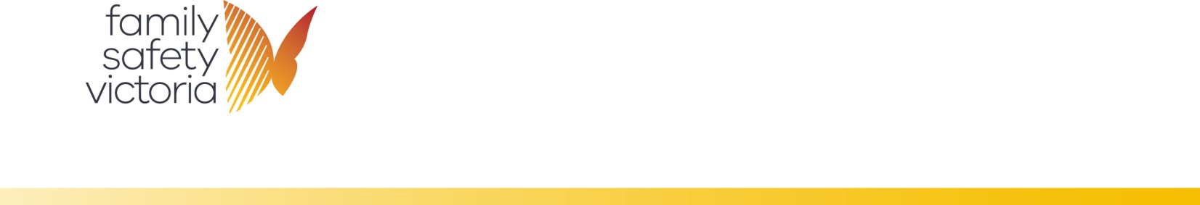

**Specialist Homelessness Information Platform (SHIP)**

Training program to support accurate data capture

The National Agreement on Social Housing and Homelessness (NASHH) requires funded homelessness providers in Australia to make monthly client data submissions to the Australian Institute of Health and Welfare (AIHW) for the national minimum data set, by participating in the Specialist Homelessness Services Collection (SHSC). The Family Violence sector in Victoria receives funding under the NASHH and is required to provide the SHSC monthly data submissions under this agreement.

# Program Overview

The purpose of this training program is to provide practitioners with the essential knowledge and skills needed to record Specialist Homelessness Services Collection (SHSC) data in Specialist Homelessness Information Platform (SHIP), while ensuring compliance with contractual obligations in Victoria.

**Program and target audience**

The program will consist of key e-learning modules, designed to provide practitioners with theoretical knowledge, a demonstration of SHIP data entry and the use of additional SHIP functionalities to assist with case management. This program is self-paced and designed for:

* new practitioners working in family violence agencies and
* existing family violence practitioners seeking to embed prior knowledge.

**e-learning training program**

1. Overview of the SHS collection
   * **Objective:** Practitioners will be able to gain insight into the SHSC.
     + [Elements of the SHS collection](https://youtu.be/TP8nkO6Vk3U)
2. Adding people into SHIP
   * **Objective**: Practitioners will be able to decipher the appropriate collection (client/unassisted persons) to record individuals in SHIP.
     + [Overview of SHIP](https://youtu.be/Q00FUOhMWQw)
     + [Creating a person in SHIP](https://youtu.be/u9X-tw5N6Ik)
3. Opening a support period

* [Adding relationships](https://youtu.be/XiTYPyB48cg)
* [Unassisted persons](https://youtu.be/NpRuavk6M58)
  + **Objective:** Practitioners will be able to create support periods, collect SHSC data and relevant client information in SHIP.
    - [Support periods in SHS collection](https://youtu.be/3FawoqeUAm4)
    - [Admin and reasons tab](https://youtu.be/e1xUHu2A-08)
    - [History and situation tabs](https://youtu.be/DUau-RgdwOE)
    - [Week before and presenting tabs](https://youtu.be/Rp7ay0YJt5E)
    - [Support periods for family members](https://youtu.be/RSDzY-3aHTw)

1. Recording services
   * **Objective:** Practitioners will be able to identify SHS services, document relevant case notes, including payments and accommodation details. They will also be able to distinguish between a direct service recipient and an indirect beneficiary of an SHS service provided to a client.
     + [SHS services and how to record them](https://youtu.be/d_HDzaXh1_4)
     + [Recording case notes](https://youtu.be/L_BWXN-o5mY)
2. Closing a support period

* [Payments and accommodation](https://youtu.be/2utXGOUphz8)
* Data quality enhancement
  + **Objective:** Practitioners will be able to determine when to close a support period and carry out the required steps to complete the process.
    - [How to close a support period](https://youtu.be/qg5yjqkPLNA)
    - [Status update](https://youtu.be/hrnsgkPyoMY)

# SHS training and resources

Further training and information about the SHSC data collection and SHIP functionality is available on the AIHW website including:

* [SHSC manual](https://www.aihw.gov.au/getmedia/43f4e03d-d229-46ae-938a-b508aff89e26/SHS-collection-manual-2023.pdf.aspx)
* [Additional training materials](https://www.aihw.gov.au/about-our-data/our-data-collections/specialist-homelessness-services-collection/training-resources)
* [SHIP reports e-learning module](https://youtu.be/BpFHYhs7KYw)

# DFFH training and resources

* [SHIP custom fields e-learning module](https://youtu.be/QgKRpiliJQQ)
* [SHS data definitions](https://www.aihw.gov.au/about-our-data/our-data-collections/specialist-homelessness-services-collection/shs-data-definitions)
* [SHIP how to identify and report on specific agency programs](https://www.aihw.gov.au/getmedia/5ae293c1-c3c2-4f9f-b26b-dd1b76e7ed7f/SHIP-how-to-identify-and-report-on-specific-agency-programs.pdf.aspx)

Further training and information specific to the Victorian data collection and practices including MARAM, support periods and referrals is available at the following websites:

* MARAM practice guide and resources
* [Case management program requirements and the Family violence crisis response model](https://providers.dffh.vic.gov.au/working-victim-survivors-family-violence)
* [MARAM training](https://safeandequal.org.au/training-events/maram-courses/)
* [Family violence services training (Additional data extract, referrals, after-](https://providers.dffh.vic.gov.au/family-violence-services-training) [hours services and service hours)](https://providers.dffh.vic.gov.au/family-violence-services-training)

To receive this document in another format, phone 03 9085 0900, using the National Relay Service 13 36 77 if required, or [email Family Safety Victoria](mailto:reception@familysafety.vic.gov.au)

<[reception@familysafety.vic.gov.au](mailto:reception@familysafety.vic.gov.au)>.

Authorised and published by the Victorian Government, 1 Treasury Place, Melbourne.

© State of Victoria, Australia, Family Safety Victoria, July 2025.

**ISBN** 978-1-76130-858-1 **(pdf/online/MS word)**

Available at <https://providers.dffh.vic.gov.au/service-hours-training-sheet> <https://providers.dffh.vic.gov.au/service-hours-training-sheet>