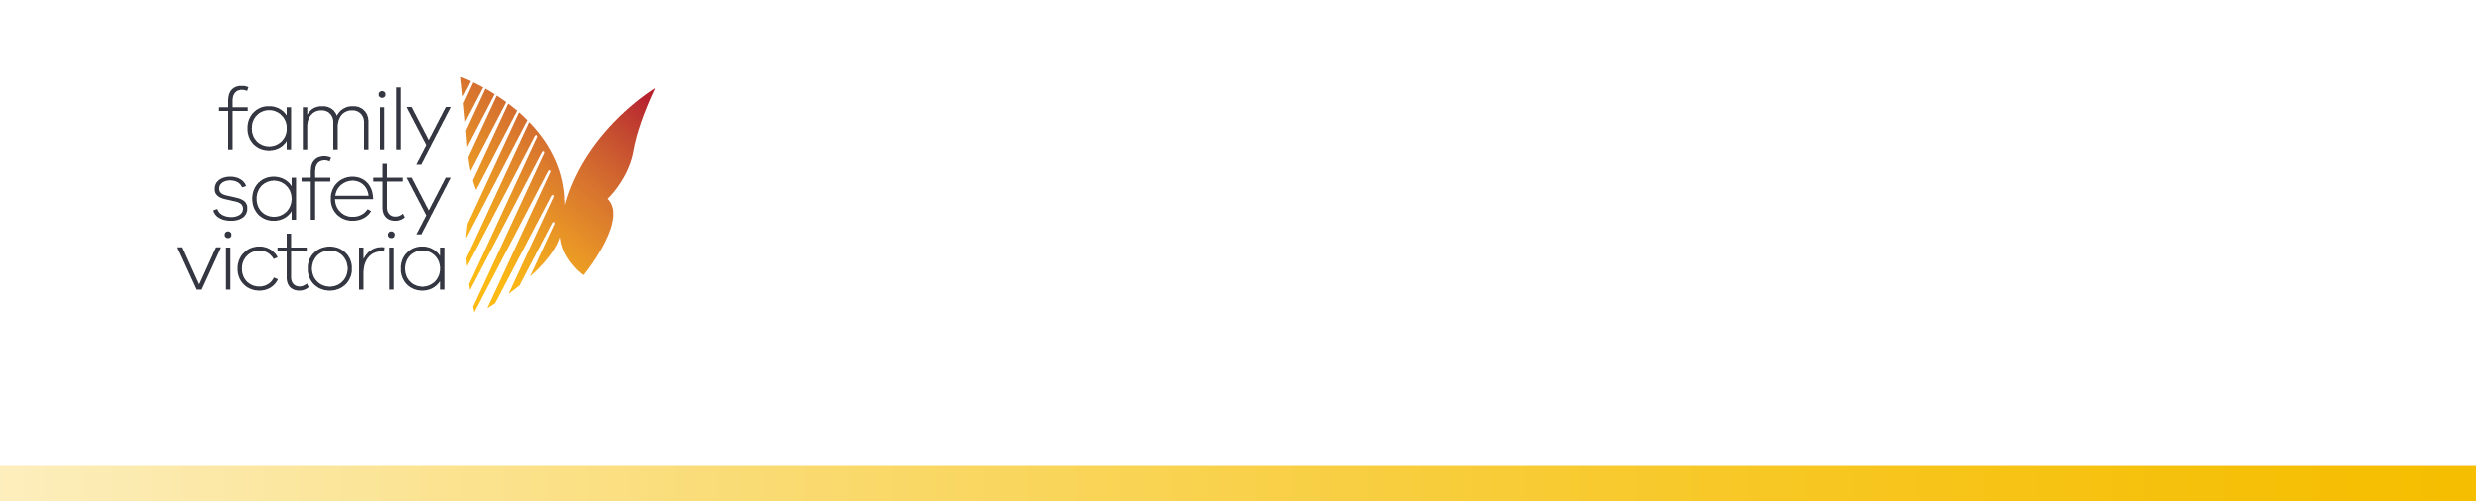

|  |
| --- |
| Service Hours Training Sheet  for Client Support and Holistic Aboriginal Family Violence |

# Key performance measures

Services funded under the Client Support and Holistic Aboriginal Family Violence (excluding RAMP and after-hours) activities are contracted using two key performance measures:

* **Service hours** are unit priced at the Integrated Family Services (IFS) unit price and reported in Service Delivery Tracking.
* **Support periods** are maintained as a measure of support to victim survivors and reported to the SHS collection and in Service Delivery Tracking (SDT) as per current practice.

# Service hours

Service hours are described in the activity descriptor as **time relating to a client**, including direct client facing time, case work related to the client, travel time related to the client, secondary consultations related to a client, information sharing about your client with other services and consultation with a client where the client prefers to remain unidentified. The total of all case workers’ time related only to client service delivery is an organisation’s service hours under the funding model.

Service hours is the **time spent by case workers**, not the time your clients receive. As an example, if a case worker provides one hour of time to two clients, only count one hour of time.

Service hours do **not include non-client** case worker time, such as attending supervision, attending training, undertaking administrative functions and organizational planning.

## Service hours in SHIP

Service hours are input into SHIP in the **case note** and in the **Support Actions** repositories and these are outlined below. The service hours report calculates the sum of the service hours into a report for each workgroup. FSV understand that organisations are at different stages of implementation to reliably capture their service hours and accurately undertake service hours reporting.

## Service Hours in the SHIP case note

Where client consent has been obtained, a support period should be opened and

all client interactions should be captured in a case note. Information on support

A range of detailed information including information about locked notes and filtering notes is available by clicking the ? icon. For support, including to unlock notes, call Infoxchange Support on 1800 627 191.

periods is available at page 6 and 7. The following image provides key information

for recording service hours accurately within a case note.

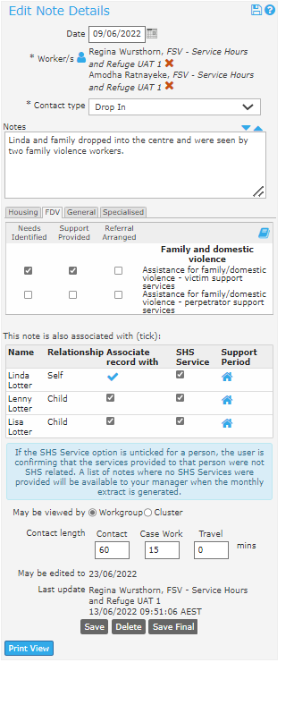

If multiple case workers worked with, or on behalf of the client, multiple workers can be added to the case note by clicking the blue person icon. However, the time will **duplicate** for the secondary case worker(s). As such, only add additional workers to the case note when time is expected to be duplicated, and the secondary case worker doesn’t add their own time to another case note.

The case note has a section for recording **minutes** by each of the work types: Contact, Case work and Travel.

Case notes, and associated time, are attached to client records, regardless of whether the person has a support period open or not.

The note can be associated with multiple people in the presenting unit and the record will appear on each person’s client record.

Alternatively, a case note that is relevant only to a child or young person, may be created and attached only to their client record.

Time associated in the notes is not duplicated for the performance measure – e.g., 1 worker providing an hour to 3 clients is counted as 1 hour for the performance measure.

Only check the box for ‘Assistance for family/domestic violence – perpetrator support services’ if providing perpetrator services such as Men’s Behaviour Change and Perpetrator case management.

If the person does not have an open support period, or if the service is not SHS related, untick the *SHS service* tick-box on the case note. The minutes will still be recorded towards the total sum of service hours.

## Service Hours in the Support Actions repository

Support Actions is a repository for recording any information where there is **no client record.** If consent can be obtained, it is best practice to capture information about a person attached to their client record in a case note. Remember, they do not need a support period opened to still attach time to the case note. See the e-learning instructional and the interactive pdf guide in the set of resources, to help understand when to use Support Actions.

Support Actions currently has the drop-down consultation types to include Secondary Consultations and Direct Person Consultations.

Secondary consultations

Secondary Consultations includes a consultation with a third party, or professional about a client where consent to obtain a client record is not provided. In these instances, record details about the consultation, the sector and the consultation length in this form.

The following image identifies the support actions drop down menu for consultation type and consultation length.

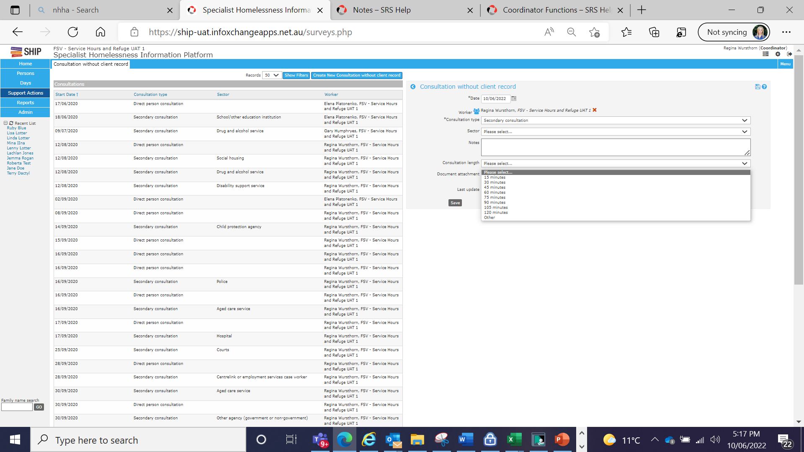

Direct person consultations

Direct person consultations include a consultation with a client or group of clients, where consent to obtain the client(s) record is not provided. In these instances, record details about the consultation and the consultation length in this form.

Time can be entered in intervals – or by clicking other and entering a specific amount of time in minutes or hours – e.g., 23 minutes

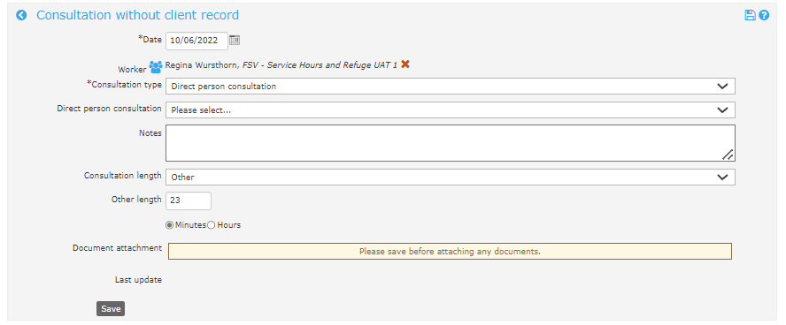

## Service hours report in SHIP

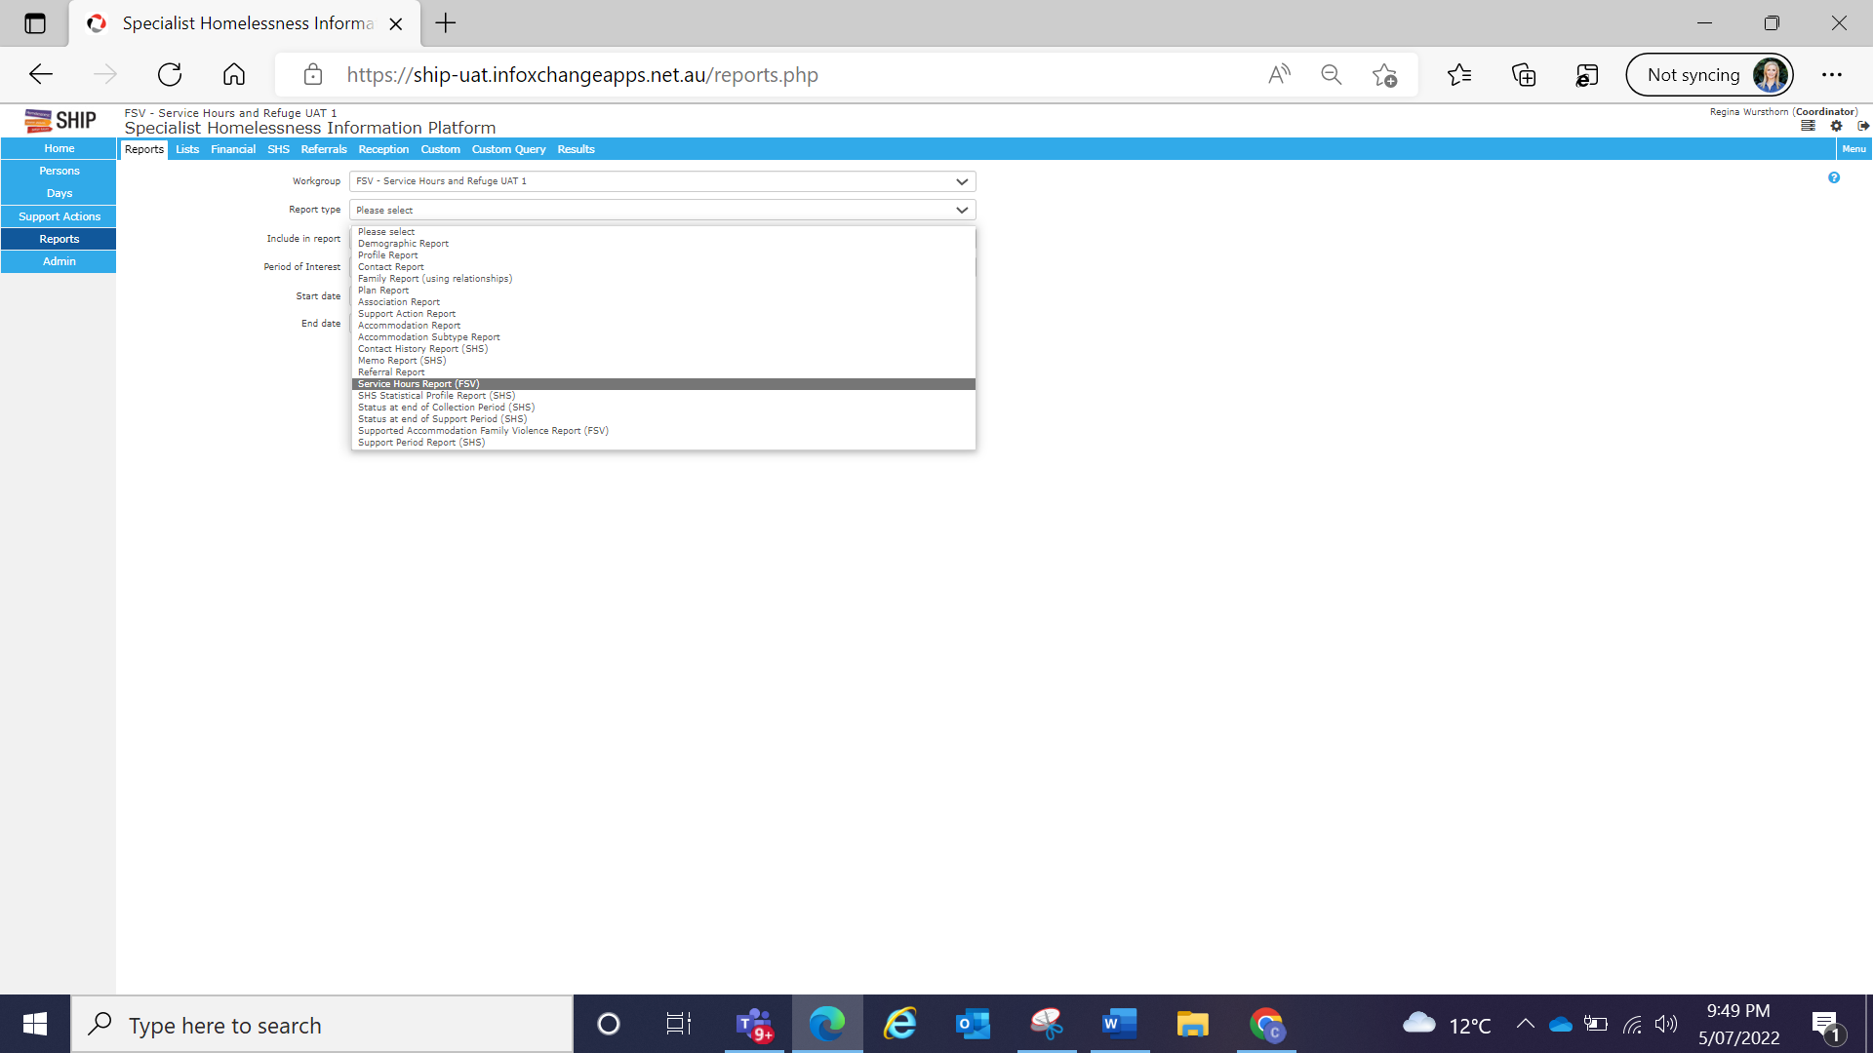A new service hours report is available in SHIP. The report sums the time in the case note and the support actions repositories. The following image identifies where to access the new service hours report; go to ‘Reports’ in the left-hand menu. From the ‘Reports’ tab in the ribbon, choose report type ‘Service Hours Report (FSV)’

Select a time period from the ‘Period of Interest’ drop-down or enter start and end dates. The image below identifies the period of interest drop downs. Press ‘Generate Report’ and the report will run and appear in the ‘Results’ tab in the ribbon.

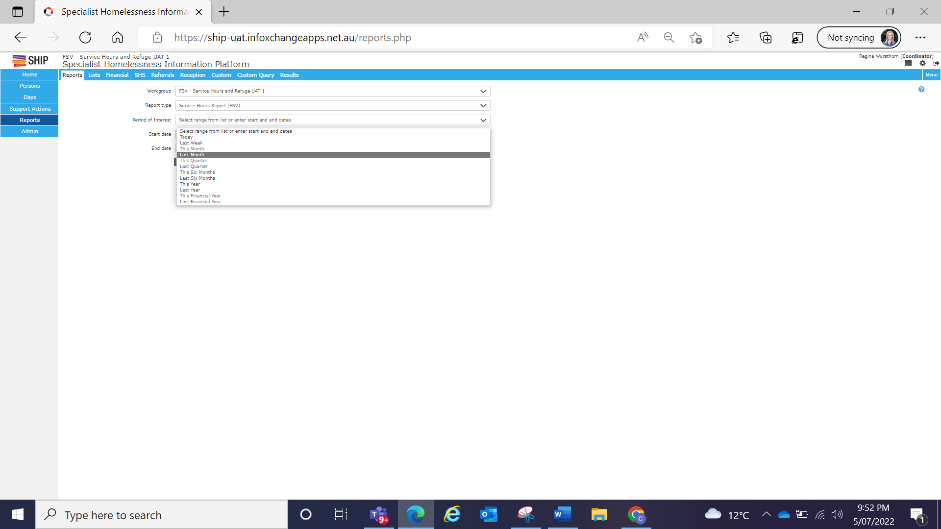

Press ‘view report’ to view the auto-calculated tables as described overleaf. The image below identifies the view report hyperlink within SHIP results tab.

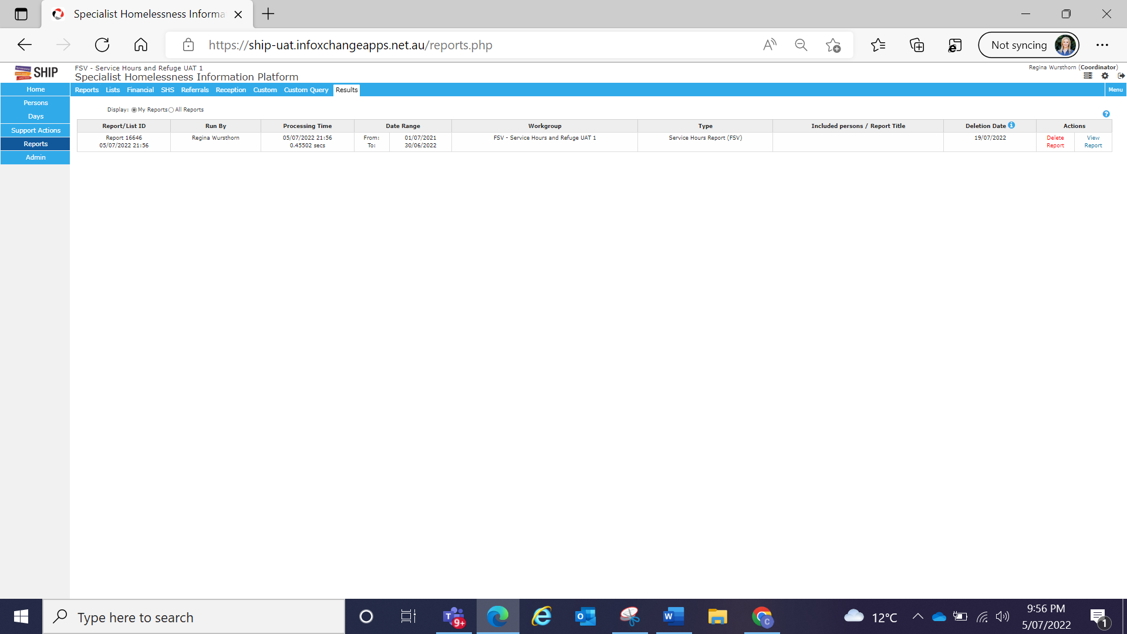

The tables in the report ‘**Total Service Hours**’ and ‘**Support Periods**’ are the only tables organisations will require to acquit on each of the performance measures.

All other tables – *‘Service hours by work type’*, *‘Service Hours inside and outside of support periods’*, *‘Service hours for Support Actions’*, *‘Service hours by case worker’* and *‘Hours per closed support period in the reporting period’* are provided only to assist organisations to understand the drivers behind their time and activities.

The following image provides clarification of the Service

Hours report and the ‘count’ being generated.

**Total Service hours** are the total of the organisation’s recorded service hours as required by the performance measure: service hours. This sums all time in the case note and the support actions repositories. It excludes associated notes and notes opened from the after-hours profile repository.

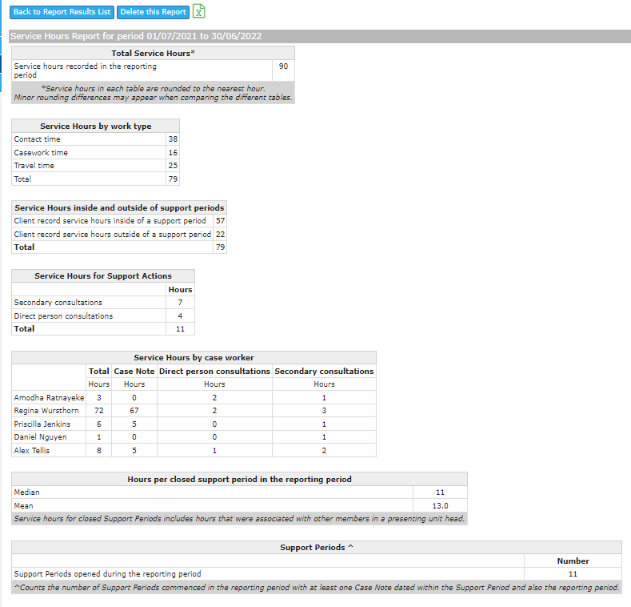

**Hours per closed support period** provides an average of the time provided to each person for all closed support periods in the period. This includes associated time (i.e., from associated records), and is a measure of the time your clients receive. For more information – see appendix 1.

**Service hours by case worker** provides a breakdown of the service hours for each worker, by the unique time they recorded in the case note (not counting associations), and from each type of support action consultation.

**Service hours for Support Actions** provides a breakdown of the service hours for secondary consultations and direct person consultations. It includes time captured in support actions only – i.e., consultations without a client record, and does not include time from the case note.

**Service hours inside and outside of support periods** provides a breakdown of the service hours from the case note that were recorded inside and outside of support periods. This helps organisations to understand how much time is spent on activities for a client that occur outside of a support period. It excludes associated notes and notes opened from the after-hours profile repository and does not include time from the support actions repository.

**Service hours by work type**, provides a breakdown of the service hours by type in the case note, helping organisations to understand how much time is dedicated to each of contact, casework and travel. It excludes associated notes and notes opened from the after-hours profile repository.

**Support periods** provides a count of support periods opened in the reporting period if they had at least one case note (including associated notes) raised for those support periods in the reporting period. This provides a count to acquit the 2nd performance measure – **support periods.** This count will exclude notes raised in the after-hours profile repository (i.e., exclude after hours support periods).

# Support Periods

Support periods are described in the activity descriptor as an **episode of support** provided to a client from your agency.

One support period is counted for **each individual, including children and young people**, who receive client support. A client is a person who receives **a direct service** from your agency. Services are defined as any work an agency undertakes to **support or advocate for a client** including administrative tasks directly related to the support of a client and travel incurred by the case worker to assist clients.

Members of your organisation who have access to Funded Agency Channel will see that service hours and support periods are connected, and funding is provided by support period tiers of brief (10 hours), intermediate to longer-term (24 hours) and intensive (98 hours). The [strategic funding model overview](https://providers.dffh.vic.gov.au/strategic-funding-model-overview) <https://providers.dffh.vic.gov.au/strategic-funding-model-overview> provides more information about the support period tiers.

Importantly, **the tiers are averages**, and organisations are not expected to package support to victim survivors based on the tiers. Instead, organisations are expected to implement a service hours approach that supports flexible, holistic, and appropriate service delivery to victim survivors’ safety and support needs. The activity descriptor requires that organisations count total new support periods and *not* count support periods by tiers.

## Support periods in SHIP

## Creating relationships and opening support periods

Where persons present together and relationships are established in SHIP, the support periods and notes functions will be interrelated for that presenting unit, making documentation as streamlined as possible. More information on presenting units can be found in the Specialist Homelessness Services Collection manual at [Specialist Homelessness Services Collection Manual August 2023](https://www.aihw.gov.au/getmedia/43f4e03d-d229-46ae-938a-b508aff89e26/shs-collection-manual-2023.pdf.aspx) <https://www.aihw.gov.au/getmedia/43f4e03d-d229-46ae-938a-b508aff89e26/shs-collection-manual-2023.pdf.aspx>.

A range of training and e-learning information including on how to set up relationships, copy over functions for families, and how to add or remove presenting unit members can be found at [Training & resources - Australian Institute of Health and Welfare (aihw.gov.au)](https://www.aihw.gov.au/about-our-data/our-data-collections/specialist-homelessness-services-collection/training-resources) < https://www.aihw.gov.au/about-our-data/our-data-collections/specialist-homelessness-services-collection/training-resources>.

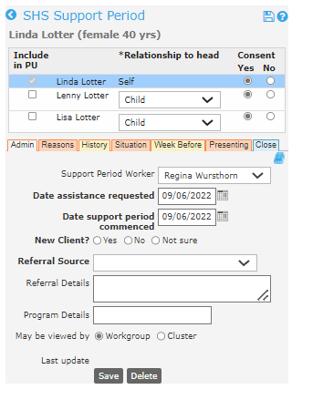This image demonstrates how support periods can be opened at the same time for each member of the presenting unit, from the unit head’s record.

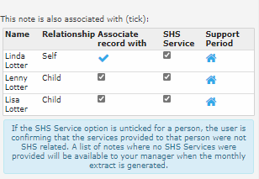Importantly, where a support period has already been opened, **at least one case note** must be associated with members in the unit (as demonstrated in the image to the below), or a note entered individually for members of the unit, in order for each support period to be counted in the ‘**Support periods**’ table in the service hours report.

Remember that if any person or member of a unit presented to your service, but was not provided with any service, or did not want a service, do not open a support period for them.

## Appendix 1 – Hours per closed support period

Hours per closed support period was included as a table in the Service Hours report to help agencies understand how many hours their clients are receiving. The table counts all service hours including associated service hours provided to a group of clients. For example, if a case worker provides 1 hour of time to a mother and four children at the same time in the support period, one hour will be counted towards the service hours performance measure. However, the *service hours per closed support period* table will count an hour for each of the five closed support periods. This table can help organisations understand how much time they are providing to their clients, and to monitor this over time.

In the table, the mean calculates the average of total time received by your clients divided by the total number of closed support periods in the month. Closed support periods will include any support period closed in the month including those that were opened in previous reporting periods. The median returns the midpoint of hours received of all closed support periods.

Where the mean exceeds the median, it can be understood that there are more records with a lower number of service hours, than the average sum of the records. The number of hours per support period is typically closer to the median.

Where the median exceeds the mean, it can be understood that there are more records with a higher number of service hours than the average sum of the records. The number of hours per support period is typically closer to the median.

To receive this document in another format, phone 03 9085 0900, using the  National Relay Service 13 36 77 if required, or [email Family Safety Victoria](mailto:reception@familysafety.vic.gov.au) <reception@familysafety.vic.gov.au>.

Authorised and published by the Victorian Government, 1 Treasury Place, Melbourne.

© State of Victoria, Australia, Family Safety Victoria, July 2025.

**ISBN** 978-1-76130-859-8 **(pdf/online/MS word)**

Available at <https://providers.dffh.vic.gov.au/service-hours-training-sheet> <https://providers.dffh.vic.gov.au/service-hours-training-sheet>