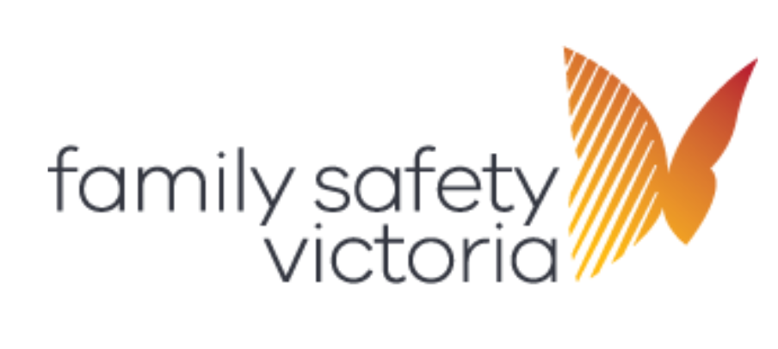

Family violence crisis responses

Roles and responsibilities after hours flow chart



The diagram below is a representation of the workflow described in Family violence crisis responses: Roles and responsibilities after hours.



|  |
| --- |
| To receive this document in another format, phone 1300 758 554, using the National Relay Service 13 36 77 if required, or [email Family Safety Victoria](mailto:reception@familysafety.vic.gov.au) <reception@familysafety.vic.gov.au>.  Authorised and published by the Victorian Government, 1 Treasury Place, Melbourne.  © State of Victoria, Australia, Family Safety Victoria, month year.  In this document, ‘Aboriginal’ refers to both Aboriginal and Torres Strait Islander people. ‘Indigenous’ or ‘Koori/Koorie’ is retained when part of the title of a report, program or quotation.  Available at [https://providers.dffh.vic.gov.au/roles-and-responsibilities-after-hours-flow-chart-family-violence-crisis-responses](https://providers.dffh.vic.gov.au/roles-and-responsibilities-after-hours-flow-chart-family-violence-crisis-responses%20) < https://providers.dffh.vic.gov.au/roles-and-responsibilities-after-hours-flow-chart-family-violence-crisis-responses > |