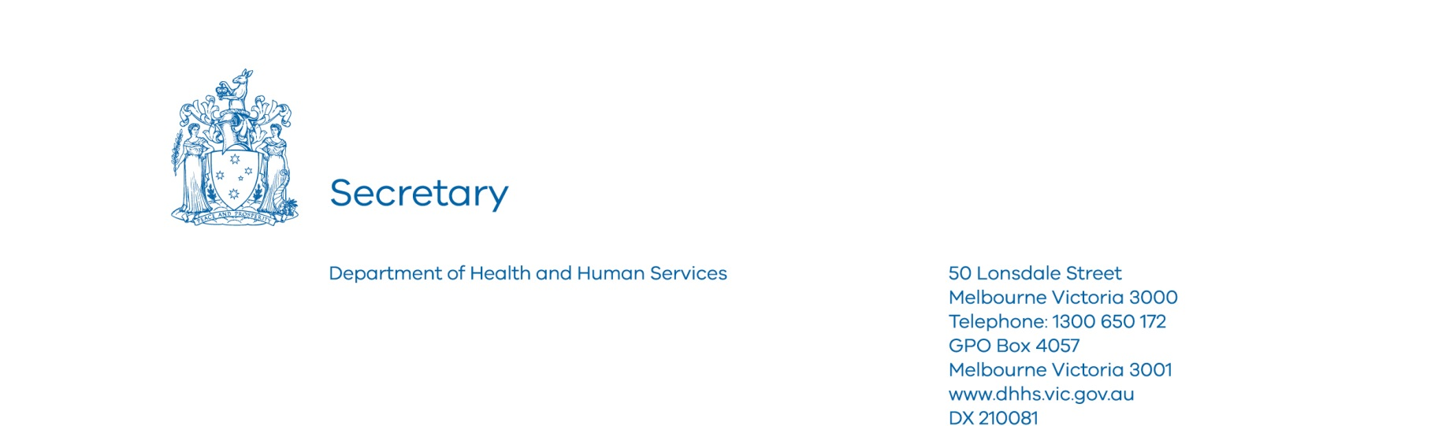

E4276257

Hon Jenny Mikakos MP
Minister for Families and Children
Minister for Youth Affairs
Level 22, 50 Lonsdale Street
MELBOURNE VIC 3000

Dear Minister

2016-17 Ministerial Statement of Expectations: Standards and Regulation Unit

Thank you for your Ministerial Statement of Expectations letter for the Standards and Regulation Unit, for the period 1 July 2016 to 30 June 2017. I am pleased to provide you with the attached department action plan outlining actions the department will undertake to give effect to your expectations.

Your Ministerial Statement highlights the importance of broader organisational design and regulatory reform work that is being carried out across the department. This work is significant in driving ongoing departmental changes arising from the Royal Commission into Family Violence and Roadmap for Reform: Strong Families, Safe Children.

In this context, I have established an organisational design team within the department to provide advice on the department's future operating model and structure to help us realise our vision of improving the health and wellbeing of Victorians. I have also tasked the department’s Regulation, Health Protection and Emergency Management Division to develop a strengthened regulatory governance framework across the department’s regulators, with the aim of improving regulatory oversight and coordination.

The Standards and Regulation Unit’s action plan includes a commitment that the unit’s regulatory policy will clearly articulate when it is appropriate to use regulatory action, or when it is appropriate to use departmental funding or stewardship measures.

Your Ministerial Statement and the department’s action plan will form part of the Standards and Regulation Unit’s work plan and will also be published on the department’s website. The department’s progress in undertaking the actions outlined in the action plan will be publically reported on shortly after the conclusion of the 2016-17 financial year.

I look forward to working with you to continue to further improve the performance of the department’s regulators.

Yours sincerely

Kym Peake
Secretary

Encl. 2016-17 Ministerial Statement of Expectations: Standards and Regulation Unit’s action plan

Ministerial Statement of Expectations: regulator action plan 2016-17
Standards and Regulation Unit

Standards and Regulation Unit
The table below details the Department of Health and Human Services’ Standards and Regulation Unit's plan to meet the performance improvement expectations outlined in the Standards and Regulation Unit’s Ministerial Statement of Expectations 2016-17.
Performance Improvement | Actions | Performance Targets
Increasing stakeholder engagement by providing and seeking feedback from funded and registered homelessness, children, youth and families and disability services, in relation to regulation activities, such as through sector meetings and forums. | In addition to the existing annual quality forum, develop an online survey for feedback.  Consult with the sectors, via the existing quality reference group, on the format for the next quality forum.  Produce a public report pertaining to the themes identified from the first round of independent reviews.  Request feedback on the Standards and Regulation Unit's email updates and action accordingly. | Online survey to be completed by 30 June 2017.  Consultation and quality forum to be completed by 31 December 2016.  Public report to be completed by 31 December 2016.  Requested feedback to be completed by 31 December 2016 and ongoing.
Providing additional assistance, such as through information and training, to support smaller organisations funded under a prescribed threshold to encourage regulatory compliance. | Develop and deliver at least one facilitated workshop on the self-assessment requirements, for organisations exempt from independent review due to the level of funding. | Facilitated workshop to be completed by 31 December 2016.
Reducing regulatory burden by ensuring processes or systems in place make it as easy as possible for organisations to access and submit information. This should include investigating, in consultation with the funded agency sector, the use of online forms and surveys. | Explore online mechanisms for processes such as:  - registration renewal applications  - changes to registration details  - changes to site locations.  Review webpage for accessibility and ease of use, ensuring dates are added when information is updated. | Investigation of online mechanisms to be completed by 30 June 2017.  Review of webpage to be completed by 31 December 2016.
Identifying and collecting data available to the Standards and Regulation Unit, such as information that relates to risks to client safety and wellbeing, to inform a risk-based approach to regulation. | Clearly identify and document the data used to inform decision making regarding renewal of registration, including desktop reviews, live monitoring, unannounced audit outcomes and risk tiering data. | Documentation of data to inform renewal of registration to be completed by 31 December 2016.
Ensuring formal instruments, such as information sharing protocols and working arrangements, are updated or developed. These should clarify the roles of the Standards and Regulation Unit and other regulators, such as the Housing Registrar, and agencies, such as the National Disability Insurance Agency, where there are shared accountabilities. | Establish transition working arrangements with the National Disability Insurance Agency, which continue to improve on the processes put in place for the trial period 2013-2016, and allow information sharing and reduce the regulatory reporting burden for jointly funded organisations. The protocol with the National Disability Insurance Agency allows the use of Victoria’s quality and safeguards during the transition to full scheme.  Work with other regulatory bodies to develop information sharing protocols to reduce the regulatory reporting burden.  Where formal instruments exist, the Standards and Regulation Unit should meet with the other regulators to identify good practice and share lessons. | Transition working arrangements to be implemented on 1 July 2016.  Information sharing protocols to be completed by 30 June 2017.  Meeting with other regulators to be completed by 30 June 2017.
Improving internal business processes of the Standards and Regulation Unit through documenting its activities, such as documenting how the Standards and Regulation Unit responds to breaches of the Service Agreement or Act. | Document process maps for the decision making process regarding registration, registration revocation and Service Agreement termination or breaches to build on existing policies and documentation.  Review and update, where necessary, the existing processes for self-assessment reports and quality improvement plans.  Document the Standards and Regulation Unit's standard operating procedures to ensure consistency in its approach to monitoring and regulation. | Document process maps to be completed by 30 June 2017.  Review process for self-assessment reports and quality improvement plans to be completed by 30 June 2017.  Documentation of operating procedures to be completed by 30 June 2017.
Ensuring the Standards and Regulation Unit’s regulatory policy provides clarity in relation to when the Unit should take regulatory action, or when it should prompt an alternative response using the department’s funding or stewardship measures. | Update the Standards and Regulation Unit’s regulatory policy to clarify the circumstances in which regulatory action should be taken and when alternative responses are required. This will be included when improving and documenting the Standards and Regulation Unit’s processes as noted in other performance improvements and actions above. | Update of regulatory policy to be completed by 31 December 2016.

All organisations within scope of the Human Services Standards are required to be independently reviewed. In some cases, where an organisation receives less than the prescribed funding threshold – less than $100,000 indexed annually – it may be exempt from the requirement to be independently reviewed and instead required to complete a self-assessment.

