

Responding to allegations of abuse involving people with disabilities
Process summary for reporting abuse to police

Summary of actions for reporting abuse to police and after a report has been made

At the time staff become aware of the alleged abuse

Ensure immediate safety and report to senior management
- Ongoing danger – contact police and emergency services (000)
- Medical attention required – call for an ambulance (000) or go to the nearest hospital emergency department or doctor
- If the alleged perpetrator is a staff member – ensure the staff member is removed from client contact
  - If the alleged perpetrator is a person with disability – see page 26 in the Responding to allegations of abuse involving people with disabilities: Guidelines for disability service providers and Victoria Police on the department’s website <https://providers.dhhs.vic.gov.au/responding-allegations-abuse-involving-people-disabilities>.

Reassure the victim and gather more information, if required
- Assure the victim that allegations will be taken seriously, and ask them how they would like to be supported
  - Gather only enough information to be able to make a report to Victoria Police. This may include some discussion, using open ended questions, to establish a basic understanding of what has occurred and to be able to support the person – see page 19 in the Responding to allegations of abuse involving people with disabilities: Guidelines for disability service providers and Victoria Police on the department’s website <https://providers.dhhs.vic.gov.au/responding-allegations-abuse-involving-people-disabilities>
    - Do not formally interview the victim, any witnesses or alleged perpetrator about the alleged abuse – the is the role of the police.

Reporting to police

Incidents that must be reported to police
  - The person has a cognitive impairment
  - There is evidence aside from the person’s statement of a crime being committed
  - The person suffered serious harm
  - The person’s decision not to report the incident to police was made under duress
  - The person or other service users are still at risk of violence and abuse
  - The person is under 18 years of age
  - The incident falls within the Reportable Conduct Scheme.

Gaining consent to report other incidents
- Unless the incident meets the criteria above, consent to report an allegation of abuse to police should always be sought from the victim or victim’s guardian (if applicable) unless the guardian is alleged to have committed the abuse.
- For assistance in deciding whether a person with disability can decide not to report the matter to police, contact the Office of the Public Advocate Advice Service on 1300 309 337.

How to report to police
- Urgent action: immediate danger – call ‘000’ and request police attendance and intervention
    - Less urgent matters: report to your local police station <www.police.vic.gov.au> by phone or in person.

Preserve evidence
- Ensure the immediate area around the scene is not touched, disturbed or cleaned. If possible, take photographs of the scene
- Note any disturbances to the area around the scene, such as if another client walks through the area
- If multiple people witnessed the alleged abuse, separate them until they have been interviewed
- In the case of an alleged sexual assault, where possible, wait for police to arrive and encourage the victim not to shower or change so that evidence is not destroyed. If the person wants to change their clothes, ask them to put the clothing they were wearing at the time of the assault in unused paper bags, one item per bag, which should be sealed, labelled and secured. If other people need to handle these items, they must wear gloves.

In consultation with police, engaging a support person and notifying next of kin

Engaging support person
- Where it is indicated that the person with disability may need support and consents (or does not have the capacity to consent), engage a key support person.

Notifying next of kin
- Where the person is under 18 years old, the next of kin or guardian (parent or other legal guardian) must be contacted, unless they are an alleged perpetrator
  - Where the person is over 18 years of age, it is the person’s decision whether or not to inform the next of kin.

After a report has been made to police

Service provider investigation to be placed on hold
- Do not make any form of public comment during the course of a criminal investigation
- Internal reporting to line or senior management should occur in accordance with the disability service provider’s policy and processes. Only high level reports should be provided. Specific details should not be provided without advice from Victoria Police, as this may compromise the investigation
- Cease service provider investigation unless police approval has been obtained
- Take action to ensure the safety of the victim and other service users and to manage future risks. Engage supports as appropriate.

Commence/continue service provider investigation
- An investigation of the incident should occur as soon as possible following consultation with Victoria Police and in accordance with chapter 4 of the Client Incident Management Guide November 2017
- Disability service providers should refer to chapters four and five about ‘Incident Investigation’ and ‘Incident Review’ of the Client Incident Management Guide November 2017
- Input should be sought from all service users involved, disability support staff and management, guardians, families and/or other supporters and relevant professionals
- When police do not pursue a matter, finding should still be made as to whether a service user has experienced abuse. If there are lingering concerns that abuse may have occurred, other protective action should be taken
- Consider ongoing responses being incorporated into the person’s support plan
- Seek feedback from the person (and their family or significant others) on the outcomes of responses to the allegations and incidents and inform them of the services of the Disability Services Commissioner and if children are involved the Commission for Children and Young People.
Figure 1 Summary of actions for reporting abuse to police and after a report has been made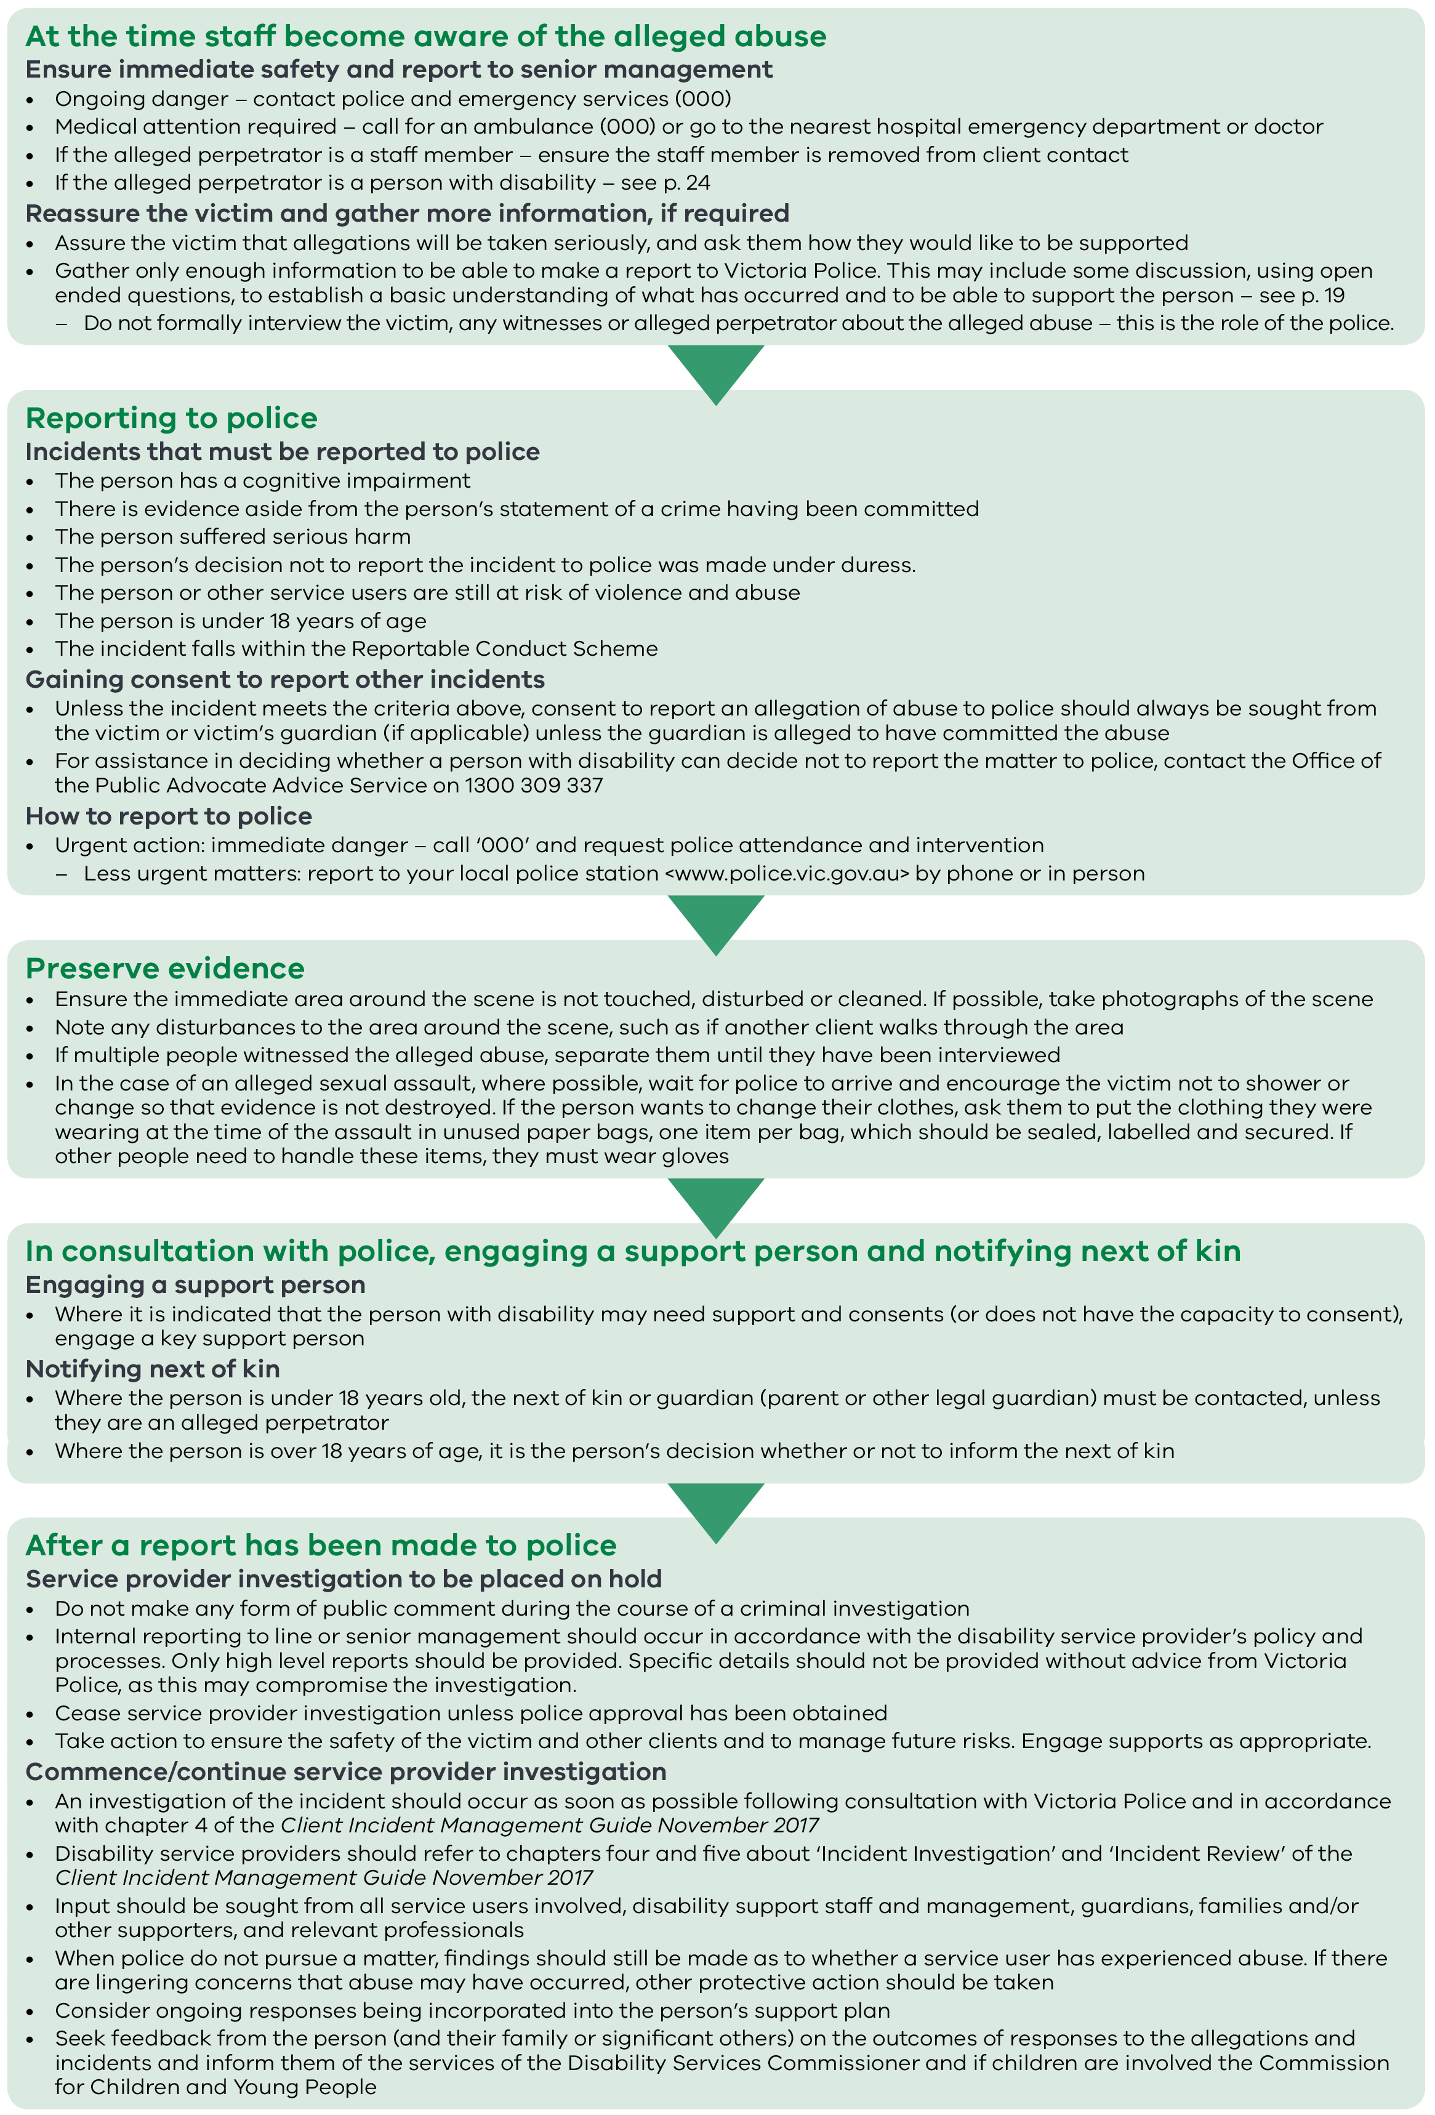

More information
For more information read the Responding to allegations of abuse involving people with disabilities: Guidelines for disability service providers and Victoria Police on the department’s website <https://providers.dhhs.vic.gov.au/responding-allegations-abuse-involving-people-disabilities>.
These guidelines have been developed to support disability service providers and Victoria Police to more effectively respond to people with disabilities who have been victims, witnesses or alleged perpetrators of abuse.
To receive this publication in an accessible format phone State Wide Disability Information and Support on 1800 783 783, using the National Relay Service 13 36 77 if required, or email disability services <disability.services@dhhs.vic.gov.au>. TTY users phone: (03) 133 677 then ask for 1300 650 172.
Authorised and published by the Victorian Government, 1 Treasury Place, Melbourne.
© State of Victoria, Department of Health and Human Services, June 2018.
Available at <https://providers.dhhs.vic.gov.au/responding-allegations-abuse-involving-people-disabilities>

