

|  |
| --- |
| Procedural requirements for referral and consultation  Child Protection and Child FIRST / Integrated Family Services |
|  |

Department of Health

|  |
| --- |
| Procedural requirements for referral and consultation  Child Protection and Child FIRST / Integrated Family Services  Version 2.2  December 2019 |
|  |

|  |
| --- |
|  |
| To receive this publication in an accessible format phone 9096 0621 using the National Relay Service 13 36 77 if required, or [email Children Youth and Families](mailto:ChildrenYouthFamilies@dhhs.vic.gov.au) <ChildrenYouthFamilies@dhhs.vic.gov.au>  Authorised and published by the Victorian Government, 1 Treasury Place, Melbourne.  © State of Victoria, Department of Health and Human Services, December 2019.  Except where otherwise indicated, the images in this publication show models and illustrative settings only, and do not necessarily depict actual services, facilities or recipients of services. This publication may contain images of deceased Aboriginal and Torres Strait Islander peoples.  Where the term ‘Aboriginal’ is used it refers to both Aboriginal and Torres Strait Islander people. Indigenous is retained when it is part of the title of a report, program or quotation.  ISBN <978-1-76069-062-5 (pdf/online)>  Available at [Family Services on the Providers website](https://providers.dhhs.vic.gov.au/family-services) <https://providers.dhhs.vic.gov.au/family-services> |
|  |

# Contents

Contents 5

Introduction 6

Scope 6

Overarching Legislative and Practice Principles 7

Legislative requirements of Child FIRST and IFS 7

The Child Wellbeing and Safety Act 2005 8

The Children Youth and Families Act 2005 8

Information sharing schemes and family violence Multi Agency Risk Assessment and Management Framework (MARAM) 9

Information sharing and privacy 10

Operational principles 11

Roles and responsibilities of Child Protection, Child FIRST and IFS 13

Roles and responsibilities of statutory Child Protection 14

Roles and responsibilities of Agency Performance and System Support 15

Roles and responsibilities of Child FIRST/IFS 15

Joint ways of working: best outcomes for children, young people and families 17

Intake liaison meetings 17

Local consultative panels 18

Joint practice approaches 18

Operational procedures between Child Protection and Child FIRST/IFS 19

Referrals from Child Protection Intake to Child FIRST 21

Referrals from Child Protection to Child FIRST (all other phases) 25

Consultations and reports from Child FIRST/IFS to Child Protection 28

Section 38 consultation 28

Outcomes of s. 38 consultation 28

Relationship management 29

Key considerations 30

Review 31

Endorsement 31

# 

# Introduction

Child and Family Information, Referral and Support Teams (Child FIRST) and Integrated Family Services (IFS) are part of the broader Victorian child and family service system.

Together with Child Protection, Child FIRST and IFS deliver services to children and families.

Child FIRST and IFS are part of the secondary tier of child and family services, and they link to universal, tertiary and statutory services.

These *Procedural requirements for referral and consultation* (the requirements) provide a consistent statewide approach to the referral pathways and interface between Child FIRST and IFS, and Child Protection.[1]

This approach supports an integrated service system that responds to vulnerable children and families within the practice requirements of the *Children Youth and Families Act 2005* and the *Child Wellbeing and Safety Act 2005*.

The requirements are part of a commitment between Child FIRST/IFS and Child Protection to deliver collaborative services, with clear and consistent processes and practice standards that apply no matter where in Victoria children and families become involved with the service system.

The requirements emphasise and promote productive working relationships to manage service performance and demand pressures between Child FIRST/IFS and Child Protection.

The requirements:

* establish consistent operational processes and proceduresbetween services, including referrals and reporting, consultation, information sharing, collaborative practice approaches and the proactive resolution of differences
  + promote high level principles and mechanisms that emphasise a common approach to working together to achieve better outcomes for children, young people and their families.

Workers can access the requirements via the *Child Protection practice manual*. The requirements should also be referenced in local Child FIRST/ IFS procedural requirements.

For further guidance about when it may be appropriate to refer to Child FIRST/IFS or guidance relating to unborn child referrals please refer to the relevant fact sheets available from the *Child Protection practice manual*.

The requirements will be subject to regular review and updates.

# Scope

The requirements support the operational relationship between Child FIRST, IFS and Child Protection.

The requirements also include the delivery of Cradle to Kinder, Stronger Families programs and the evidence-based program trials.

Maintaining effective partnerships requires the ongoing commitment and engagement of all key partners, the requirements alone will not guarantee successful working relationships between sectors.

Child Protection, Child FIRST and IFS interface with many other sectors including:

* alcohol and drugs
* mental health
* housing
  + early childhood and education.
  + National Disability Insurance Scheme (NDIS)

There are existing protocols with these and other partners and these requirements should be used in the context of other existing protocols and agreements.

Implementing these requirements effectively will rely on maintaining partnerships and the ongoing commitment and engagement of all key partners.

### The Orange Door

These requirements apply to catchments that are yet to transition to The Orange Door.

The Orange Door is the access point for women, children and young people who are experiencing family violence and/or families who need assistance with the care and wellbeing of children to access the services they need to be safe and supported.

Commencing in Mary 2018 The Orange Door is being progressively rolled out across Victoria.

Separate Procedural requirements for referral and consultation have been developed for The Orange Door sites. Refer to the Operational Guidance between The Orange Door, Child Protection and Integrated Family Services for further details.

# Overarching Legislative and Practice Principles

## Legislative requirements of Child FIRST and IFS

The requirements are underpinned by the legislative requirements of the Children, Youth and Families Act.

Section 61 of the Act describes the key responsibilities of community-based child and family services, which must:

1. provide its services in relation to a child in a manner that is in the best interests of the child; and
2. ensure that the services provided by the service are accessible to and made widely known to the public, recognising that prioritisation of provision of services will occur based on need; and
3. participate collaboratively with local service networks to promote the best interests of children.

The requirements are also supported by a set of operational principles. These are aligned with the legislative, policy and practice context to ensure the safety, wellbeing and development of children, and young people.

The operational principles emphasise the shared commitment andjoint responsibilities of Child FIRST and IFS, and Child Protection to deliver quality services to vulnerable children, young people and their families.

## The Child Wellbeing and Safety Act 2005

The Child Wellbeing and Safety Act is the overarching legislative framework that supports a shared commitment from all services working with children and families.

The Child Wellbeing and Safety Act is available from the [Victorian Legislation and Parliamentary documents website](http://www.legislation.vic.gov.au/) <http://www.legislation.vic.gov.au>

## The Children Youth and Families Act 2005

The Children, Youth and Families Act describes the legislative requirements that apply to Child FIRST and Integrated Family Services, including:

* the purpose of community-based child and family services (s. 22)
* child wellbeing including reports made to Child Protection and referrals made to a community based child and family service under Part 3.2 (ss. 27–34)
* Information exchange and consultation arrangements between the Secretary and a community based child and family service (s. 38)

The Children, Youth and Families Act requires that Family Services, Child Protection and placement services work in ways that reflect the Best Interests Principles and associated provisions of the Act.

The Best Interests Principles guide professionals who work with local communities and other services to meet the needs of vulnerable children and their families. They encourage a consistent focus on the child’s safety, wellbeing and development.

Sections 10-12 of the Act reiterates that the best interests of a child must always be paramount when making a decision or taking action. These decisions should be made in the context of the need to protect the child from harm, the need to protect the child’s rights, and the need to promote the child’s development.

The Act also recognises the principle of Aboriginal self-management and self-determination when making decisions or taking actions in relation to an Aboriginal child.

These principles establish the platform for the Best Interests Case Practice Model, which provides a consistent foundation for working with children, including unborn children, young people and families.

The model informs and supports professional practice and decision making.

For further information the [Best Interests Framework and Best Interests Principles](http://www.cpmanual.vic.gov.au/our-approach/best-interests-case-practice-model/best-interests-case-practice-summary-guide) can be found on the Child Protection Manual website <http://www.cpmanual.vic.gov.au/our-approach/best-interests-case-practice-model/best-interests-case-practice-summary-guide>.

In addition to the Best Interests Principles, as outlined in *A strategic framework for Family Services*,[2]<http://providers.dhhs.vic.gov.au/family-services>Child FIRST and IFS are also guided by a set of nine principles that focus on outcomes and solutions:

1. Children’s wellbeing and safety is everybody’s responsibility.
2. The service system will intervene earlier to protect children and young people and improve family functioning.
3. All services will strengthen their focus on children’s developmental needs.
4. Services will focus on building the capacity of parents, carers and families.
5. Children’s and family services will be integrated and coordinated.
6. Flexible, timely and solution-focused services will be provided to improve family functioning.
7. Culturally competent service responses will be available for Aboriginal children and families.
8. Culturally sensitive service responses will be available for children and families from culturally and linguistically diverse groups.
9. Family Services will be outcomes focused in their service delivery and practice approaches.

The principles prioritise:

* the needs of children
* actively engaging with children and young people and their families
* cultural sensitivity
* integrated services that strengthen a child’s development needs
  + building the capacity of parents, carers and families to care for their children.

*A* *strategic framework for Family Services* also requires practitioners to understand issues affecting Aboriginal children, young people, families and communities, and their interactions with broader society and mainstream services. The framework recognises the need to support Aboriginal families and communities to access culturally competent mainstream and Aboriginal-specific services.

In addition, the [*National framework for protecting Australia’s children 2009–2020*](https://www.dss.gov.au/our-responsibilities/families-and-children/programs-services/protecting-australias-children) *<https://www.dss.gov.au/our-responsibilities/families-and-children/programs-services/protecting-australias-children>*  outlines the ways that commonwealth, state and territory governments and non-government organisations will work together. The national framework outlines six key outcomes and how they will be achieved.[3]

More information on the national framework is available at the [Department of Social Services website](http://www.dss.gov.au) <http://www.dss.gov.au>

## Information sharing schemes and family violence Multi Agency Risk Assessment and Management Framework (MARAM)

In 2018 the following significant information sharing and risk management reforms were introduced:

* the Child Wellbeing and Safety Information Sharing Scheme, authorised by Part 6A of the *Child Wellbeing and Safety Act 2005*
* the Family Violence Information Sharing Scheme, authorised by Part 5A of the *Family Violence Protection Act 2008*, and
* the family violence Multi Agency Risk Assessment and Management Framework (MARAM), authorised by Part 11 of the *Family Violence Protection Act 2008*.

The Child and Family Violence Information Sharing Schemes assist professionals and organisations that are ‘prescribed’ in Regulations to better perform their roles and responsibilities by expanding the circumstances in which they can share information to:

* promote the wellbeing or safety of a child or group of children; and/or
* assess and manage the risk of family violence to adults and children (including holding perpetrators to account).

The Child and Family Violence Information Sharing Schemes complement each other, and build on information sharing already permitted under the Children, Youth and Families Act and privacy legislation.

Child FIRST and IFS and Child Protection are prescribed under the information sharing schemes, along with a range of other services. Further organisations and services will be included in 2020, including education and health entities.

Family service organisations are also included as ‘MARAM Framework Organisations’, which means they should work towards alignment with MARAM over time according to their role in the service system, including updating their policies and practice guidance.

Information sharing should be guided by MARAM and other relevant professional frameworks (such as the Best Interests Framework and Case Practice Model), and appropriate records are required to be kept.

Together, these reforms are intended to facilitate practitioners and services working together to identify needs and risks, promote earlier and more effective intervention and integrated service provision, and improve outcomes for children and families.

More information:

* [Child Information Sharing Scheme Ministerial Guidelines](https://www.vic.gov.au/system/user_files/Documents/cis/Child%20Information%20Sharing%20Scheme%20Ministerial%20Guidlines_FINAL_130918.pdf) <https://www.vic.gov.au/system/user_files/Documents/cis/Child%20Information%20Sharing%20Scheme%20Ministerial%20Guidlines_FINAL_130918.pdf>
* [Family Violence Information Sharing Scheme Ministerial Guidelines](https://w.www.vic.gov.au/system/user_files/Documents/fv/Ministerial_Guidelines_-_Family_Violence_Information_Sharing_Scheme_-_October_2018.pdf) [https://www.vic.gov.au/system/user_files/Documents/fv/Ministerial_Guidelines_-_Family_Violence_Information_Sharing_Scheme_-_October_2018.pdf](https://w.www.vic.gov.au/system/user_files/Documents/fv/Ministerial_Guidelines_-_Family_Violence_Information_Sharing_Scheme_-_October_2018.pdf)
* MARAM resources and practice guidance - <https://www.vic.gov.au/maram-practice-guides-and-resources>
* [Child Protection Manual section on the Child Information Sharing Scheme](https://www.cpmanual.vic.gov.au/our-approach/information-sharing/child-information-sharing-scheme-and-child-protection) <http://www.cpmanual.vic.gov.au/our-approach/information-sharing/child-information-sharing-scheme-and-child-protection>
* [Child Protection Manual section on the Family Violence Information Sharing Scheme](https://www.cpmanual.vic.gov.au/our-approach/information-sharing/family-violence-information-sharing-scheme-and-child-protection) <https://www.cpmanual.vic.gov.au/our-approach/information-sharing/family-violence-information-sharing-scheme-and-child-protection>

## Information sharing and privacy

### Specific consultation provisions for Community Based Child and Family Services (CBCFS) under the Children, Youth and Families Act

When Child FIRST, or IFS receive a referral relating to significant concerns about the wellbeing of a child the Act provides specific consultation provisions. Child FIRST or IFS may consult with the Secretary (generally represented by community based child protection) in relation to any matter relating to the purpose of the CBCFS as set out in s. 22

* All CBCFS consults with the Secretary (generally represented by community based child protection) occurs under s. 38 of the Act.
* If the consultation is for the purpose of risk assessment or to help determine appropriate service provision; this is specifically allowed for under s.193. Typically, this is used in the assessment phase following a referral being received.
* s.193 also allows a CBCFS to consult with, for the same purpose, Information Holders, Service Agencies or Community Services.
* s.192 allows the Secretary to receive information from or disclose information to a CBCFS

### Reporter confidentiality

The reporter details may be included in the referral from Child Protection to a CBCFS (including Child FIRST) (s.41 Children, Youth and Families Act). The CBCFS must ensure that the reporter details, or any other information that leads to the identity of the reporter, must not be disclosed to anyone outside of that CBCFS.

Service providers will have information sharing policies in place that comply with the Children, Youth and Families Act, *Information Privacy Act 2000,* Health Records Act, *Health Services Act 1988* and relevant departmental guidelines.

Service providers will maintain accurate and comprehensive client records.

Service providers will share information appropriately with other services that work with children, youth and families.

The first phase of implementation of Family Violence and Child Wellbeing Information Sharing Schemes occurred in 2018. Child Protection, Child FIRST and CBCFS’s are all prescribed entities under the Scheme.

### The Central Information Point (CIP)

The Royal Commission into Family Violence recommended developing the CIP to provide timely

information to support effective risk assessment and management, in particular for medium and high risk cases.

Initially, the CIP will be a team of representatives from key government agencies, Victoria Police,

corrections, courts and the department working together to share critical information about a family

violence perpetrator from their respective databases. The collective information will be gathered and

recorded on a CIP report.

Initially CIP reports may only be requested by the five Orange Door sites.

## Operational principles

### Respectful and collaborative relationships

Respectful, timely and transparent communication drives productive relationships.

### Timeliness and quality

Provide quality information to ensure effective and timely decision making for families across the service system. Each referral pathway is underpinned by the expectation that responsibility for good communication processes is shared between all practitioners and managers.

### Active engagement

Child FIRST/IFS, and Child Protection will be proactive in their attempts to engage families and promote their involvement in decision making, while protecting the needs and rights of children and young people, at every phase of their involvement with Child FIRST/IFS.

Child FIRST/IFS will make all reasonable attempts to actively engage families if there are concerns about the safety, development or overall wellbeing of children, including when families are unwilling or unable to acknowledge the need for, or to seek, assistance.

The Child Protection case manager or Senior Child Protection Practitioner Community Based (SCPPCB) will support engagement, where required, through joint practice approaches outlined on p. 17.

These approaches are particularly relevant when families who have been subject to an investigation or substantiation, or who are placed on an order, are referred to Child FIRST, or for families who have a history or pattern of being reported to Child Protection or involvement with Child FIRST/IFS.

Where risk factors are above the threshold for family services, that is, where there are reasonable grounds for believing a child has suffered or is suffering significant harm, Child FIRST/IFS is required to consult with SCPPCB to determine whether a report into Child Protection is required. Generally, SCPPCB will only record a report that warrants Child Protection investigation.

### Prioritisation for our most vulnerable families.

Child Protection and Child FIRST/IFS will work in partnership to implement effective systems and strategies that provide timely and responsive support for children, young people and families.

Case allocation will occur in partnership across the catchment through the Child and Family Services Alliance service coordination functions.

This will ensure that the case is allocated to the organisation that is in the best position to undertake it from both a caseload and service delivery perspective. This will allow casework to start at the earliest possible time after the case is allocated to an IFS agency, or as agreed in articulated catchment processes.

The most appropriate service (Child FIRST or IFS) within the catchment will be identified for the active holding response.

The Child and Family Services Alliance in each catchment is required to have an active holding and demand management strategy in accordance with *A strategic framework for Family Services*.

### A commitment to collaborative demand management approaches

Child FIRST/IFS and Child Protection will work together within the Child and Family Services Alliance to understand and manage current and changing demand.

From time to time, Child Protection and Child FIRST/IFS may need to implement demand management strategies in response to significant demand pressures.

To be effective, these strategies will require actions from both Child FIRST/IFS, and Child Protection. Strategies will need to be negotiated respectfully and in partnership. If agreement cannot be reached, use the relationship management mechanisms described on p. 31.

Demand management strategies should be developed in advance, as part of a shared response, in line with *A strategic framework for Family Services.*

Alliances should have local demand management strategies in place that are monitored by all alliance members, as part of a shared responsibility for responding during times of peak demand across the sector.

Restricted intake in Child FIRST and Family Services is *strongly discouraged* and should only be implemented if there is no other option and all resources are used. Department representatives should understand how long restriction is expected, which referrals will be accepted during restriction and what referrers will be advised. A clear communications strategy to relevant stakeholders must support any restricted intake.

In the event of any restricted intake, Agency Performance and System Support should facilitate sign off by the Area Director and notify the [Children and Families Policy branch](mailto:ChildrenYouthFamilies@dhhs.vic.gov) <ChildrenYouthFamilies@dhhs.vic.gov.au as soon as possible>.

### Responding to the needs and safety of Aboriginal children, young people and their families

As stated in the Best Interests Case Practice Model, the maintenance of and connection to culture for Aboriginal families is central to the health and development of Aboriginal children and young people.

These requirements will be implemented to:

* support cultural connection
* uphold the Aboriginal decision-making principles outlined in the Children, Youth and Families Act
* support the *Aboriginal cultural competence framework* developed by the Victorian Aboriginal Child Care Agency and the Department of Health and Human Services.

# Roles and responsibilities of Child Protection, Child FIRST and IFS

The Department of Health and Human Services’ divisional operations are organised into 17 local areas based on geographic catchments that reflect trends in population growth and service demand across the state.

The 17 areas manage service delivery with government and non-government organisations in an integrated way, along functional rather than program lines.

The areas have greater decision-making responsibility over local services, and the ability to allocate resources depending on the needs of that area.

The local areas drive coordinated services at the local level, integrated across Child Protection, Youth Justice, housing, disability and IFS.

Child FIRST teams are established in designated subdivisional catchments across Victoria. Subdivisional catchments are aligned across the 17 Department of Health and Human Services local areas to deliver integrated and more coordinated services for vulnerable children, young people and families.

A Child and Family Services Alliance is in place in each of the catchments (including within The Orange Door sites). These include IFS, area Child Protection and area Agency Performance and System Support teams, Cradle to Kinder and, where capacity exists, an Aboriginal community-controlled family service organisation. Other sector representatives and professional groups may be invited to participate, as agreed by the core Alliance partners.

At the catchment level, all members of Alliances fulfil three key functions:

* undertaking Alliance planning for their catchment
* providing operational management
  + coordinating service delivery.

Areas aim to achieve lasting outcomes for families through early intervention and building opportunities for social, educational and economic participation.

Child FIRST/IFS and Child Protection have key roles in each catchment.

## Roles and responsibilities of statutory Child Protection

As prescribed by the Children, Youth and Families Act, Child Protection has statutory responsibility for protecting children.

Child protection practitioners are delegates of the Secretary of the Department of Health and Human Services. Their responsibilities as protective interveners are not transferable to external agencies, except for those Aboriginal family and community services delegated under ss. 18 and 19 of the Children, Youth and Families Act.

Child Protection intervenes to the degree necessary to promote the protection of children from significant harm resulting from abuse and neglect within the family unit, including cumulative harm. It also facilitates access to support and treatment services to address the impact of harm.

Child Protection intervention processes include:

* intake, investigation and assessment of reports of child abuse and neglect
* case management activities associated with protective intervention, following substantiation of significant harm (or likely harm)
  + preparing and making a protection application through the Children’s Court, as well as the management of Children’s Court orders.

Child Protection supervises and manages children and young people on protection orders, who may be residing at home on Family Reunification orders or placed in alternative care, where Child Protection may have shared or full parental responsibility. When separation has been necessary, Child Protection prioritise reunification of children with their families where possible.

Child Protection may also work with the child and family in a voluntary capacity within prescribed timelines.

The target group for Child Protection is children aged 0 to 16 years inclusive (or 17 years if a protection order is in force), including unborn wellbeing reports.

### Community-based Child Protection

Community-based child protection is the term used to describe the roles and functions in Child Protection local areas that support partnerships between Child FIRST/IFS, and Child Protection. Community-based child protection also supports the delivery of services.

There are a number of positions within Child Protection local areas that are responsible for these relationships.

The four child protection divisional intake sites are managed by a **Deputy Area Operations Manager**, who has a leadership role across the local area, including local service planning. They play a role in the interface between Child Protection and Child FIRST/IFS.

The **SCPPCB**, supervised by the **area-based Practice Leader**, divides their time between Child FIRST/IFS sites and the divisional Child Protection office.

The SCPPCB works collaboratively both within the Area’s Child Protection program and across the IFS sector to support earlier and more effective intervention for vulnerable children, young people and their families.

The key roles and responsibilities of SCPPCB include:

* managing unborn cases and cases that are transitioning to Child FIRST/IFS
* providing consultation, advice and community education for agencies regarding statutory processes and responsibilities
  + providing consultation and advice to Child FIRST/IFS on specific cases, including assistance with risk management and safety planning. This includes chairing and attending case conferences, attending home visits with Child FIRST/IFS agencies if required, and working collaboratively with the practice leader to strengthen partnerships with Child FIRST/IFS.

This position also provides consultation with Child Protection teams in relation to referrals to Child FIRST/IFS.

Under s. 17 of the Children, Youth and Families Act, the Secretary of the department has delegated some powers and functions. As such, the SCPPCB is authorised to receive and respond to reports, and they can perform functions as protective interveners when a report is made.

SCPPCB has a significant role in fostering positive working relationships and supporting the service delivery of IFS in subdivisional catchments. It is important that community-based child protection builds a strong profile and has a firm presence in the catchment, and that it is accessible to both Child Protection and Integrated Family Services.

SCPPCB will actively participate in Child FIRST, IFS, Alliance and service coordination activities. They will work collaboratively with IFS to support their work with vulnerable children, young people and their families.

Child Protection will actively support the role and function of the SCPPCB. As the SCPPCB is a critical role with legislative obligations, withdrawal of the SCPPCB role to address demand pressures should not occur unless it is assessed as critical for the functioning of the Child Protection program.

If it is required to withdraw the SCPPCB role:

* every effort will be made for this to be a short-term arrangement
* Child Protection will work in partnership with Child FIRST and IFS to develop a contingency plan to meet the legislative obligations of the SCPPCB role
* Child Protection will inform the Alliance executive of the arrangements that will be in place in the absence of the SCPPCB role.

## Roles and responsibilities of Agency Performance and System Support

Agency Performance and System Support, formerly Local Connections and health program advisers, are area-based teams in the department's operational divisions.

APSS have responsibility for contract managing organisations funded to deliver services on behalf of the department against their Service Agreement requirements. APSS drive good client outcomes by ensuring funded organisations meet their performance targets, and that contractual obligations, and client safety and wellbeing needs are met.

## Roles and responsibilities of Child FIRST/IFS

The primary client group for Child FIRST and IFS is vulnerable children and young people aged 0 to 17 years (including unborn children) and their families who are:

* likely to experience greater challenges because the child or young person’s development has been affected by risk factors and cumulative harm
* at risk of concerns escalating and becoming involved with Child Protection if problems are not addressed.

### Role of Child FIRST

Child FIRST provides a central, community-based referral point for IFS, and it connects vulnerable children, young people and families to other supports. Local agencies may provide intake and initial assessment where agreed by individual Alliances.

Child FIRST aims to provide an identifiable and easily accessible entry point in a designated subdivisional catchment to ensure that vulnerable children and their families are allocated to IFS, or effectively linked with other relevant services based on assessed need and risk.

Child FIRST also focuses on establishing collaborative relationships with key local services and professionals (s.22 Children, Youth and Families Act).

Broadly, the key functions of Child FIRST in the catchment are to:

* provide information and advice
* undertake initial needs identification and assessment of underlying risks to the child or young person, in consultation with Child Protection and other services
* undertake risk management and develop appropriate plans
* identify the Aboriginal status of children and families, and consult with an Aboriginal Liaison Worker (or Aboriginal community-controlled organisation)
* identify differentiated service responses for families related to the initial assessment of needs and underlying risks
* actively engage with the child and their family to complete an initial assessment, and support them with parenting issues
* determine the priority of a response, and allocate families to IFS, in consultation with IFS and Child Protection (where required)
* participate in local professional and community education initiatives, as identified by the Alliance.

### Role of IFS

The Family Services casework component of IFS engages families by using a range of skills and approaches that build on family strengths and address past trauma and other issues that may impact on parenting.

This is underpinned by a partnership approach between families and professionals.

Family Services casework includes:

* providing services, in-home intervention, casework and counselling interventions tailored to meet the needs of the child or young person and their family
* providing earlier intervention services to minimise the need for statutory involvement if there are risk factors and neglect or cumulative harm indicators
* taking a child and youth-centred, family-sensitive approach to ensure services are provided in the best interests of the child, and working collaboratively with Child Protection to develop effective responses to improve outcomes for children
* providing additional information from ongoing family services assessment and casework to Child Protection to ensure appropriate statutory intervention, as required.

### Role of Child and Family Services Alliances

In each catchment, the Child and Family Services Alliance is responsible for Alliance planning for their catchment, operational management and coordinated service delivery.

Child FIRST is a key component of the catchment service delivery model, and also contributes to:

* implementing timely and effective referral pathways between all services
* providing advice about the interface with Child Protection, including protocols and procedures for decision making and day-to-day relationships with community-based child protection
* providing advice about information management and capacity to share information, as specified in legislative provisions
* establishing and maintaining strong linkages with area Child Protection and Integrated Family Services programs within the catchment.

# Joint ways of working: best outcomes for children, young people and families

Child Protection and IFS share responsibility in their roles for delivering services to vulnerable families. Outcomes for individuals and families improve when services work in partnership to deliver services that are integrated and coordinated.

For this purpose, there are a number of joint approaches and governance arrangements that will be established in the delivery of IFS services.

## Intake liaison meetings

Planned, regular and formal interface between Child Protection Intake Managers and Child First Managers, their teams and the SCPPCB is a key strategy to:

develop transparent and effective communication, manage critical decisions, and provide an opportunity to deal with operational day-to-day systems focussed, theme-based issues and data sharing in a timely way.

Interface meetings must occur regularly (at a minimum quarterly). The Child Protection Team Manager, Child FIRST Team Leader and Deputy Area Operations Manager must attend these meetings as a priority to ensure an effective, collaborative partnership between the two systems. Child Protection is responsible for ensuring these meetings occur. A ‘portfolio holder’ should be identified on the membership list as a ‘go to’ contact for these meetings.

Intake liaison meetings provide a forum to discuss:

* case-related themes or patterns of referrals
* systemic issues impacting on service delivery
* staffing updates
* demand updates
  + quality issues around referrals or reports between Child Protection Intake and Child FIRST.

Intake liaison meetings are intended to focus on strategic issues, not individual cases. Case discussions should occur at Team Manager (Child Protection) and Team Leader (Child FIRST) level.

The Child Protection Intake and Child FIRST interface can occur in many forms, including by phone, in person and by video conferencing.[4]

## Local consultative panels

Local consultative panels provide a local mechanism to consult on complex case-related matters and operational issues related to families engaged with Child FIRST and IFS.

Panels provide:

* the opportunity for consultation on complex case-related matters, including clinical practice advice
* the opportunity to achieve better outcomes for families
* identification of themes and emerging trends relating to complex families engaged with Child FIRST and family services to inform service system learning

Local consultative panels are chaired by the Child Protection Practice Leader. Membership of panels is drawn from across Child Protection, Child FIRST and IFS, as well as considering other professionals from mental health, disability, alcohol and drugs, family violence, early years or education, as needed.

Child FIRST/ Integrated Family Services Team Leaders should consider referring cases to Consultative panels where they are experiencing challenges or are unsure about how to provide case direction and could benefit from clinical practice advice offered by the panel.

Potential cases to be referred to the Consultative panel should be a standing agenda item at Child FIRST/ Integrated Family Services Team meetings. The potential for the panel to achieve positive outcomes for families should be reinforced within teams.

Each panel should ensure it provides opportunities for Alliance members to come together for the purposes described above.

In some instances, an Alliance will meet this obligation through a range of strategic activities.

## Joint practice approaches

Joint practice approaches provide a system of proactive engagement that ensures best outcomes for vulnerable families as outlined in the Children, Youth and Families Act.

This includes information sharing, shared assessments, joint intervention and involvement of the family.

Regular and positive communication is crucial to this process. Child Protection, Child FIRST and IFS will deliver the following practice approaches.

#### Care teams

Care teams are groups of people who jointly provide care and support for a child while they are involved with the Child Protection system and placed in out of home care.

Members of the care team are jointly responsible for determining and ensuring the child’s best interests.

Membership of care teams will vary depending on the nature of involvement and long-term goals for the child and their family.

#### Joint visits

Joint visits can help to engage clients and are an important part of collaborative practice between Child Protection and Child FIRST/IFS.

Joint visits can also achieve outcomes for individuals and families when used for first contact, engagement, handover, and as part of risk assessment to help determine case direction.

They can allow honest, open conversations with parents about the risks and concerns held for their children, including concerns practitioners have if the family declines to engage with Child FIRST/IFS.

Joint visits are also an opportunity to clarify with families the different roles and responsibilities of Child Protection and Child FIRST/IFS.

Decisions about conducting a joint visit should be made collaboratively and determined on a case-by-case basis.

#### Unannounced visits

Child Protection and Child FIRST/IFS may undertake unannounced visits, where appropriate.

This practice is used to assess the safety and wellbeing of families where significant concerns have been identified. It usually occurs when other attempts to engage, such as telephone calls, letters or announced visits, have been unsuccessful, or where risk of disengagement is identified.

Decisions about an unannounced home visit should also be made collaboratively and determined on a case-by-case basis.

#### Case conference

Case conferences are a useful tool for:

* sharing information and understanding the risks and needs of the family
* defining professional roles and responsibilities
  + developing and reviewing action plans
  + establish a care team approach around children and families

Where Child Protection holds case management responsibility for a family, they may invite Child FIRST or IFS (where the family is already involved with family services) to a case conference or case plan meeting concerning an open case and prior to a referral to Child FIRST.

This allows services to clarify roles and responsibilities, promote engagement with the family, and set family goals.

Where IFS hold case management, they can ask the SCPPCB to attend a case conference or care team meeting to provide recommendations and advice.

The SCPPCB may also recommend that a case conference occur as a result of a consultation under s.38.

The family should be informed of the role of the SCPPCB, and consent to their attendance at a case conference.

# Operational procedures between Child Protection and Child FIRST/IFS

The focus of this document is on ensuring that children and families do not fall through gap as they are referred between the two systems of Child Protection and Child FIRST/IFS. Monitoring and tracking of referrals is essential to not lose line of sight of families.

The referral and consultation processes between ChildFIRST/IFS and Child Protection have three high-level operational pathways.[5]

These pathways are:

* referrals from Child Protection to Child FIRST – from Child Protection Intake
* referrals from Child Protection to Child FIRST– after Child Protection Intake (all other phases)
  + consultations and reports from Child FIRST/IFS to Child Protection.

The first two pathways recognise that a referral to Child FIRST/IFS can be made at any point during Child Protection involvement, from intake through to closure phase, after a protective investigation, long-term case management involvement or other statutory intervention.

Child Protection should target families who they assess as suitable and most likely to engage with and benefit from Family Services.

Referral from Child Protection Intake to Child FIRST should occur where there is significant concern for child wellbeing, but does not meet threshold for Child Protection. That is, there are reasonable grounds for believing a child has suffered or is suffering significant harm.

This decision for Child Protection to refer to Child FIRST is ordinarily reached when:

* there is significant concern for the wellbeing of the child; and
* there may be concerns about harm or likely harm to the child's safety, stability and development is significant; but
* the involvement of community supports is assessed as the most appropriate action to address the concerns and prevent further involvement by Child Protection; and
* an assessment has been made that it is likely the family is willing and has capacity to engage with services.

A senior child protection practitioner (community based) needs to be consulted in instances where referrals are to be made to Child FIRST and family services.

Further direction on [Child Protection Intake Outcomes](https://www.cpmanual.vic.gov.au/advice-and-protocols/advice/intake/intake-outcomes) can be found in the Child Protection Manual <https://www.cpmanual.vic.gov.au/advice-and-protocols/advice/intake/intake-outcomes>.

Referrals from Child Protection where Child Protection will remain involved should occur when a joint response is required to improve outcomes for vulnerable children, young people and families.

If a child or young person is subject to a Children’s Court order, this will not preclude a referral being made to Child FIRST/IFS*.*

Each referral pathway is underpinned by the expectation that responsibility for good communication processes is shared between all practitioners and managers.

The elements include:

* key decision-making points, and providing clarity about which service holds case management at points on the referral/report pathway
* the community-based child protection role to strengthen an integrated response for families who are difficult to engage with
* standard and consistent referral and consultation documents
  + standard mechanisms to collectively respond to work flow, peaks in demand and complex cases.

Each referral pathway has a flow chart, with a description of the procedures for:

* before referral
* referral
* acceptance and transition of the referral
  + closure.

Note that while Child FIRST is the primary central community intake, IFS may also provide a local intake. This is primarily for self-referrals or intra-agency referrals.

Child FIRST should have or develop a mechanism at the local level to ensure the allocation of families to IFS is based on priority of need and vulnerability of children and young people.

## Referrals from Child Protection Intake to Child FIRST

Figure 1 shows the flow chart for referrals from Child Protection intake to Child FIRST.

#### This referral pathway requires an assessment from the Intake Team Manager as to whether the referral will be:

#### Standard Referral

These are referrals direct from Child Protection Intake to Child FIRST, with no requirement for SCPPCB involvement. These cases are overseen by Intake Team Managers and Practice Leader (Divisional Services).

#### Enhanced Referral

Enhanced referrals will typically be made in instances where:

* there is a pattern and history of reports and referrals to both Child Protection and Child FIRST or IFS, and/or
* there are previous investigations and substantiations, particularly where previous attempts at engagement by either service has been largely or completely unsuccessful resulting in limited or no engagement, and
* Child Protection has assessed that due to the risk, history and/or family’s previous engagement, a differential response (i.e. SCPPCB involvement) is deemed necessary to support Child FIRST and IFS engagement to address the concerns.

Enhanced referrals from Child Protection Intake to Child FIRST require Child Protection to consult with the SCPPCB who will confirm that the referral meets criteria as an enhanced referral. Child Protection Intake will then refer to Child FIRST, with advice that the SCPPCB has been consulted. Upon Child FIRST accepting the referral, Child Protection Intake will close the case.

Enhanced referrals are more likely to need SCPPCB involvement. Child FIRST practitioners can decide if they require early consultation with a SCPPCB via a section 38 consult under the Children, Youth and Families Act regarding how to best engage a family and whether SCPPCB should play an active part, alongside the Child FIRST practitioner. At a minimum, the SCPPCB must be consulted if Child FIRST is unable to engage the family.

If consulted, the SCPPCB will open a section 38 consult on CRIS (Child Protection’s client record and information system). No enhanced referral can be closed due to non-engagement without prior consultation with the SCPPCB please refer to closure of referrals from either Child FIRST or IFS section on page 28 for further details regarding this process.

### Before referral

* Referrals from Child Protection to Child FIRST should be targeted and purposeful, as this makes successful engagement and improved outcomes much more likely. If there is a more appropriate or specialist service (i.e. an adolescent specific program or Drug and Alcohol program), strong consideration should be given to referring to that service.
* Before a referral to Child FIRST is made, Child Protection Intake Team Managers or the Child Protection Intake Senior Child Protection Practitioner will determine if this is a standard referral from intake or an enhanced referral with the SCPPCB.
* Child Protection may consult with Child FIRST / IFS to obtain relevant information of past or current interventions with the family to assist with decision making.
* If the referral is an enhanced referral, then consultation with the SCPPCB will occur prior to referral being sent to Child FIRST.
* Criteria for an enhanced referral will include a pattern of reports, previous investigations, substantiations or previous referrals to Child FIRST, which have resulted in limited or no engagement.
* The assessment of the safety, wellbeing and development of the child will be the basis for any referral to Child FIRST.
* Child Protection will provide a clear assessment to assist Child FIRST to actively engage the family in the referral process.
* Child Protection will determine with Child FIRST/IFS if the case is already open, before making a referral.
* The referral is completed by the Child Protection intake worker (for an intake referral) and endorsed by the Child Protection Team Manager as a minimum.
* Child Protection should inform Child FIRST when another report is received soon after referral to Child FIRST and to pass on any relevant information regarding the intake outcome.

### Referral Tool

#### Standardised referral tool: Child Protection Intake report

All referrals from Child Protection Intake will be made using the Child Protection Intake report as the standard state-wide referral document. The report will include:

* a summary of Child Protection history (where relevant)
* the reported concerns and follow up conducted
* the outcome of the Child Protection Intake assessment
* whether or not the family has been informed of the referral
* the rationale for a Child FIRST referral
* whether Child Protection would have concerns if the family does not engage with Child FIRST and if so – what actions Child Protection recommends are taken in these instances.

The intake report will be sent by email as a protected file from the Child Protection Intake Team Manager to Child FIRST. As a minimum the SCPPCB will be copied into emails for referrals assessed as an enhanced referral.

Excerpts and relevant information from the intake report can be used by Child FIRST to support and inform any onward referral to IFS. The intake report in its entirety should not be on-shared.

#### Acceptance and transition

* For a standard referral to Child FIRST, as soon as Child FIRST receives the referral they must notify Child Protection of the referral being received (either by email received receipt, return email or phone call). Child Protection will close the intake report once they have confirmation that the referral has been received.
* Child Protection will inform the family of the referral to Child FIRST by letter (at a minimum), keeping in mind that families are less likely to engage and benefit from family services when they are unaware of the referral. This letter will state that Child FIRST maymake contact with the family and parents are encouraged to make contact with Child FIRST.
* As Child Protection has closed the report after receipt of referral from Child FIRST, if Child FIRST do not accept a standard referral then Child FIRST should provide a rationale of this decision to Child Protection via email so that it can be recorded on the child’s CRIS file.
* If there is crucial information missing from a standard referral which Child FIRST requires in order to deliver a service to a family, Child Protection must speak to Child FIRST and where possible, provide the required information in a timely manner.

***Enhanced referrals***

* For an enhanced referral, **and only once Child FIRST accepts the referral**, (unless by agreement), Child Protection will send (as a minimum) a letter to the family informing them that a referral to Child FIRST has been made.
* After acceptance of an enhanced referral, Child FIRST will initiate attempts to engage the family. If Child FIRST is unable to engage the family sufficiently for the intervention to proceed, a s.38 consultation must be initiated with the SCPPCB to explore potential additional engagement strategies, including the direct use of the SCPPCB role.
* If an enhanced referral is not accepted, Child FIRST will provide a rationale in writing within two working days to the allocated Child Protection practitioner and SCPPCB where relevant.
* When Child FIRST does not accept an enhanced referral, Child Protection will plan an appropriate response for the family, considering the child’s safety and developmental needs.
* Child FIRST should not contact intake to dispute threshold or decision making. If the referral is accepted, any discussion regarding how to manage risk to children should occur via a consultation with the Senior Child Protection Practitioner Community Based under s.38 of the Children Youth and Families Act.
* Relationship management processes (see p. 27) should be used if at any point there is disagreement between the two services. Intake liaison meetings between Senior staff should be used to resolve differences and to discuss any issues related to referrals being received.

### Child Protection Closure

* Child Protection **will not close** the case until Child FIRST receives the referral (either by email received receipt, return email or phone call). If Child FIRST does not accept the referral, a rationale will be provided to Child Protection and the SCPPCB via email within two working days so that it can be recorded on the child’s CRIS file.
* For a standard referral, at a minimum Child Protection will inform the family of the referral to Child FIRST by letter (using the standard Child Protection letter: Child Protection has referred to Child FIRST), bearing in mind that families are less likely to engage and benefit from family services when they are unaware of the referral. This letter will state that Child FIRST maymake contact with the family, and parents are encouraged to make contact and engage with Child FIRST.

### Child FIRST/IFS closure of referrals

As Child Protection are likely to have closed the case upon making a standard referral to Child FIRST, the decision for closure of a standard referral has no specific requirements regarding consultation with SCPPCB, unless Child FIRST or IFS identify risk issues prior to closure. In this circumstance a consultation may occur with SCPPCB.

In relation to Enhanced Referrals where Child FIRST or IFS have not successfully engaged the family, leading to consideration of closure, consultation with SCPPCB should occur prior to the referral being closed.

SCPPCB will assist in considering whether:

* There are any other strategies that could be deployed, including the use of the SCPPCB role, to engage the family, or
* The outstanding risks for the child/ren meet the threshold for a Child Protection investigation. In the event that the risks do not meet that threshold, consideration will be given to closure/safety planning for Child FIRST/IFS, including onward referrals as required.

SCPPCB could also participate in a case conference or Consultative Panel organised by the family services agency.

**Figure 1. Referral pathways from Child Protection Intake to Child FIRST**

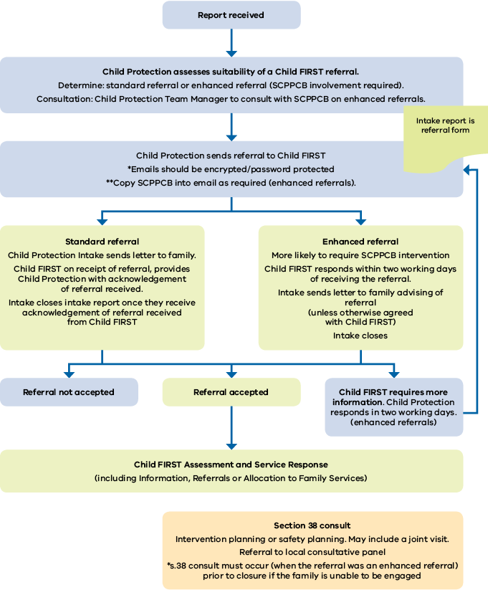

## Referrals from Child Protection to Child FIRST (all other phases)

Figure 2 shows the flow chart for referrals from Child Protection to Child FIRST (all other phases).

A referral to Child FIRST can be made at any point during Child Protection involvement.

The SCPPCB is involved in all referrals in this pathway. The Child Protection practitioner also plays an active role in referral, transition and ongoing case management and planning.

The consultative panel responds to complex practice issues and ensures a joint service platform to engage and respond to vulnerable families.

### Before a referral is made

* In all cases the referral process after intake must be part of an overall case planning process, in accordance with the Best Interests Case Practice Model and where cases have been substantiated in line with the Children, Youth and Families Act.
* The allocated Child Protection worker must seek consent for the referral from the family, and ensure the family know the goals of the referral.
* For all referrals after intake, the SCPPCB will be consulted. This consultation will inform the referral and planned transition to Child FIRST, and the respective family service agency if allocated.
  + For complex cases the SCPPCB, the Senior Child Protection Practitioner, Child Protection Team Manager or Child FIRST Team Leader may request a case conference before the referral is made or accepted. The case conference may also include partner agencies, family services or delegates.

### Referral

* The allocated Child Protection practitioner will complete the referral. If the case is unallocated, the contact person for the referral is the relevant Team Manager.
* A standardised referral tool will be used for all referrals from Child Protection (post intake) to Child FIRST.
* The referral will include:
  + - An assessment that highlights areas of risk and need, the actions that have been attempted to reduce risk, and the current plan in relation to the child and family for both substantiated and non-substantiated reports
    - the child’s case plan (if this exists) attached to the referral document
    - indication of the need for a joint home visit with the relevant Child Protection practitioner, SCPPCB (if appropriate) and Child FIRST or IFS. If the referral is accepted and allocated, the relevant IFS worker will conduct the joint visit with the allocated Child Protection practitioner or the SCPPCB
      * evidence that the family has been involved in a discussion about acceptance of the referral.
* If Child Protection determines the family require support from a service that IFS does not directly offer, Child Protection should refer the family directly to that service. If a referral is made to Child FIRST/Family Services and, within that intervention the need for other services is identified, Child FIRST/Family Services will make further referrals as appropriate.

**Use the standardised referral tool: Child Protection (post-intake) to Child FIRST and IFS**

Acceptance and case transition

* Child FIRST should respond to a Child Protection referral within two working days. This response will be to accept the referral, provide a rationale for not accepting the referral, or to seek further information.
* CP will maintain case management responsibility while the child protection case remains opens. After CP closure, case management responsibility will be held by IFS. This should be well communicated between the two services.
* If Child FIRST asks for further information, Child Protection will provide this information within two working days. This is to ensure active engagement and timely intervention.
* If a referral is not accepted by Child FIRST, this should be communicated directly with Child Protection and a rationale then provided in writing to the allocated child protection practitioner and team manager within two working days.
* Child FIRST will present all referred cases to the IFS allocations meeting, with the SCPPCB available to answer any questions and support the referral process. For open Child Protection cases, the SCPPCB communicates the outcomes of the allocation meeting to the allocated child protection practitioner and/or their supervisor.
* The scope of cases discussed at allocation meetings and in the presence of Community-Based Child Protection will be limited to cases that have been referred from Child Protection, may be reported to Child Protection, or require a specific consultation.
* For accepted referrals (and as an outcome of allocation meetings), a handover meeting or case conference will occur. This is to be led by Child Protection. Consider including the family in the handover meeting or case conference. The case conference or transition arrangements will articulate and respond to:
  + - case management responsibilities
    - timing of Child Protection closure
    - joint visits
    - ongoing communication between Child Protection and Child FIRST/IFS if the case remains open with Child Protection
    - sharing of information
      * factors that would trigger future consultation to the SCPPCB or referrals to the local consultative panels.

The allocated Child Protection practitioner will:

* make contact with the allocated IFS worker to lead and organise joint handover processes
* acknowledge all communication from IFS relating to the client
* work with the IFS worker to clarify roles and responsibilities, and identify strategies to engage and work effectively with the family
* share information about risk assessment and casework activities that informs the joint assessment, planning, decision making and intervention
* inform the IFS worker of the outcome of an investigation, if undertaken
* attend joint home visits, as negotiated and required, with the allocated Child FIRST/IFS practitioner
  + discuss with the IFS worker the level of involvement for IFS during the investigation phase.

The allocated Family Support worker will:

* attend the transition meeting with the allocated Child Protection practitioner (or if case is unallocated, the Child Protection team manager) to discuss the case, clarify roles and responsibilities, and discuss strategies to engage and work effectively with the client
* work with the Child Protection practitioner to clarify roles and responsibilities, and identify strategies to engage and work effectively with the family
* attend joint home visits, as negotiated and as required, with the allocated Child Protection practitioner
  + share information about risk assessment and casework activities that informs the joint assessment, planning, decision making and intervention.

Timely transition is crucial to support the successful engagement of IFS and the family. Child Protection & IFS should prioritise engagement with the family including if the case is on active hold in IFS. In some cases, by agreement, IFS may engage a family prior to a meeting, especially if there is a delay to the handover.

**Closure**

* Closure is a planned and negotiated process between Child Protection, IFS and the family.
* The key requirement is that Child Protection and Child FIRST/IFS inform each other of the timing of closure. Agreement must be reached on who will hold case management responsibility.
* Robust handover processes and local consultative panels (for complex cases) can strengthen closure planning in this phase.

Figure 2. Referral pathways from Child Protection to Child FIRST (all other phases)

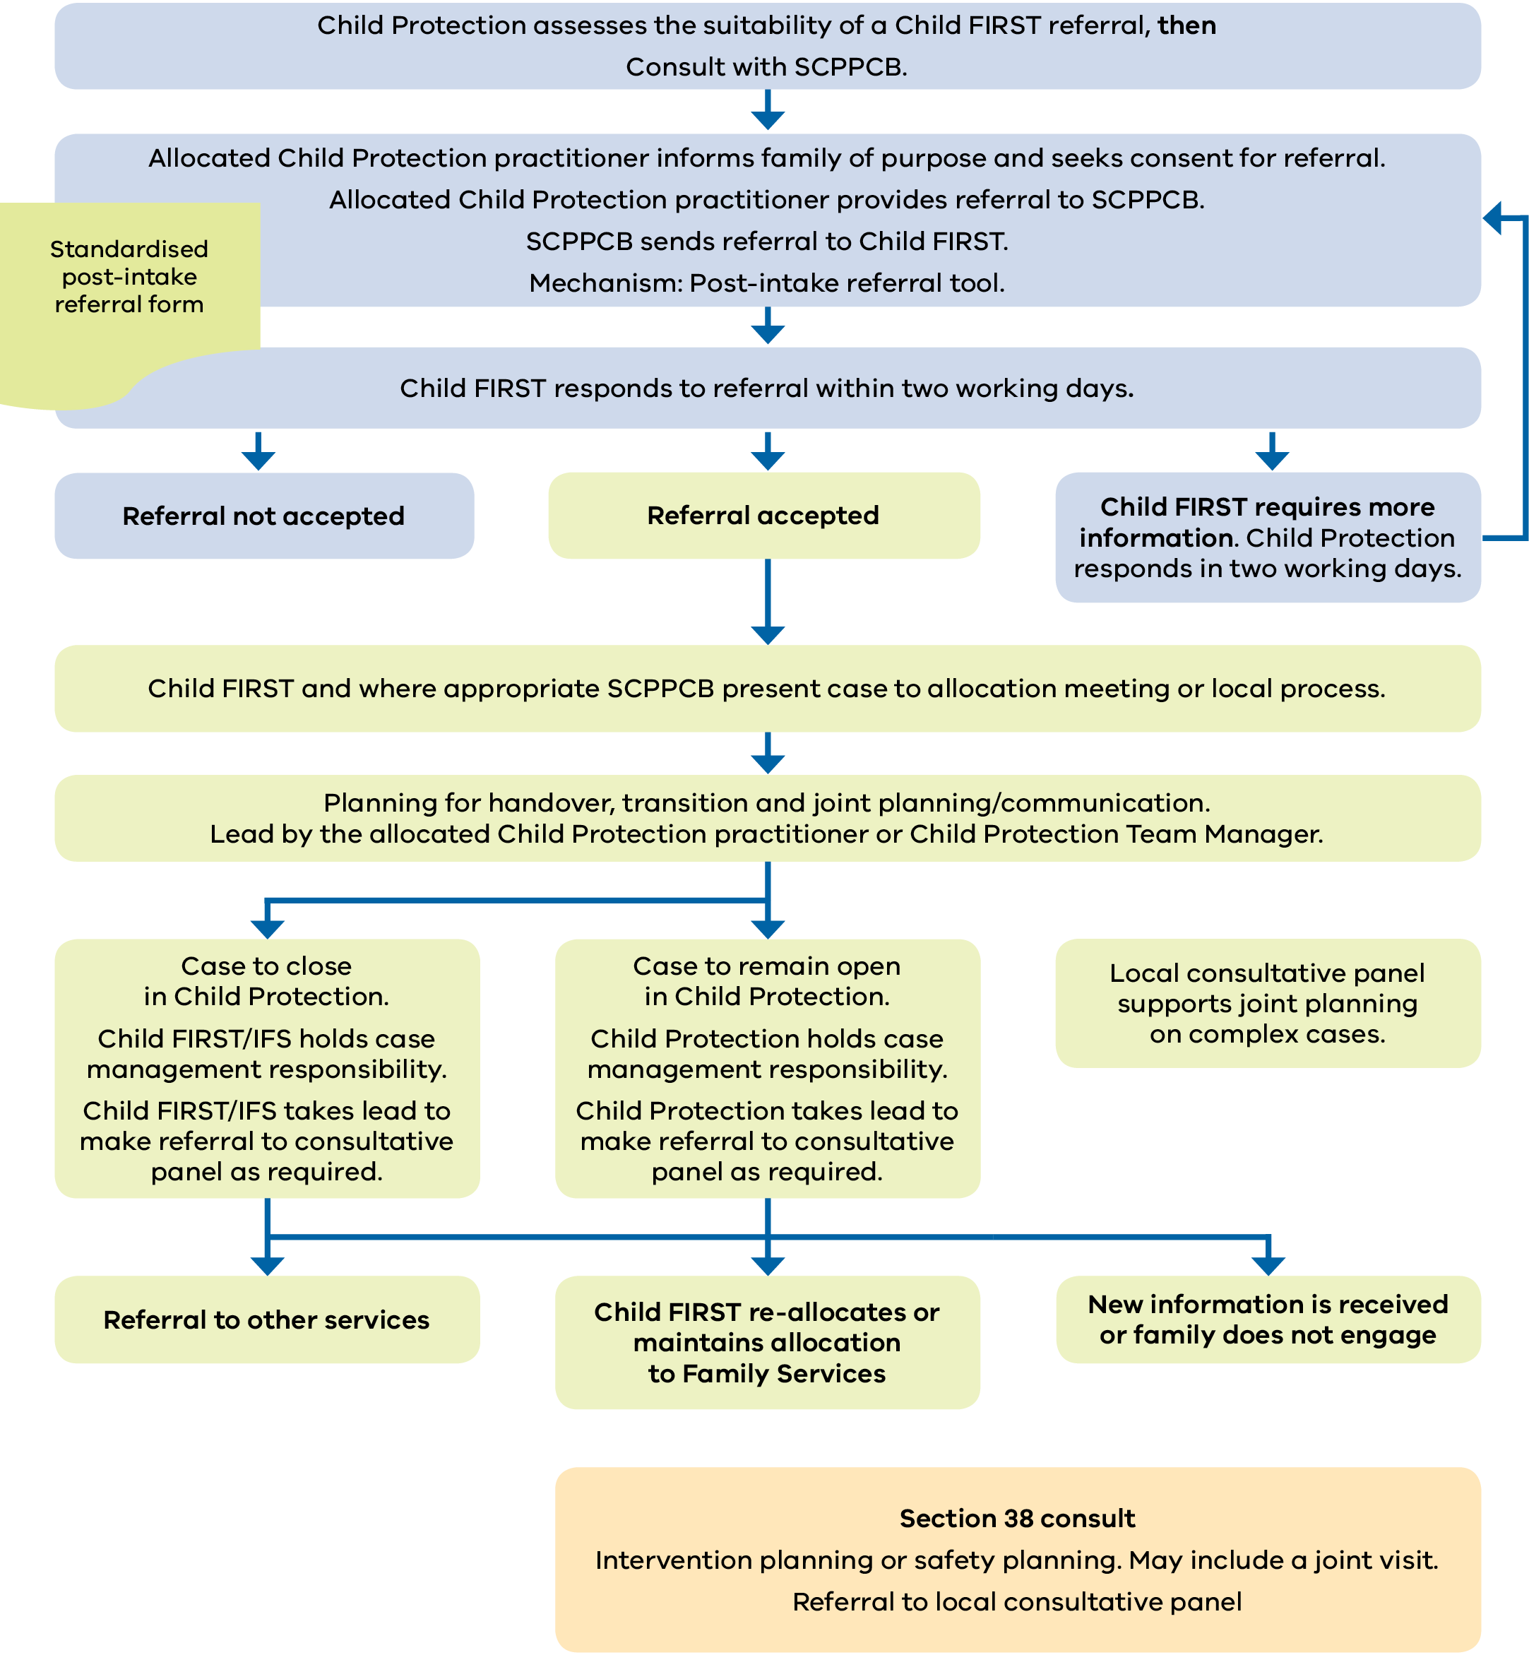

## Consultations and reports from Child FIRST/IFS to Child Protection

## Section 38 consultation

**Use a standard s. 38 consultation template: for Child FIRST and IFS to consult with the SCPPCB**

* Consultation with SCPPCB can occur at any time there are concerns for the safety and wellbeing of a child for advice, information, for the purposes of joint risk assessment, safety planning and strategies to manage risk. Obtaining parental consent is best practice, but this consent is not required to ensure a planned response to the safety and wellbeing of children and young people.
* Child FIRST and IFS workers will seek endorsement and support from their supervisor before requesting a s. 38 consultation with the SCPPCB.
* Before the consultation, Child FIRST and IFS workers should email the s. 38 template to the SCPPCB, together with the completed risks and needs assessment section. This needs to occur before the consultation if possible.
* Section 38 consultations can occur by phone. The consultation record will be completed as soon as possible. Child FIRST and IFS will send the consultation form to the SCPPCB in a password-protected email.
* The s. 38 consultation form is a record of the consultation process, and only includes information that was discussed or agreed upon in the consultation.
* The SCPPCB will record the consultation as a s. 38 (as per the Children, Youth and Families Act), unless the decision is to make a report.
* If a report is made, the SCPPCB will close any open s. 38 consultation, and will include the consultation in the report.
* The SCPPCB will communicate a rationale for the decision. Child FIRST/IFS will record this rationale as a case note.
* If the SCPPCB is not available and the matter is urgent, make a request for consultation to the Child Protection Practice Leader. If they are unavailable, make a request to the Child Protection Deputy Area Operations Manager to decide who will undertake the consultation. If it is after hours, and the matter is urgent, contact the After Hours Emergency Child Protection Service.

## Outcomes of s. 38 consultation

* A s. 38 consultation can result in a number of outcomes:
  + - The development of a joint risk assessment
    - Where required, the provision of advice and expert child risk assessment by SCPPCB
    - Recommendations by SCPPCB to Child FIRST/IFS to support child/family engagement, as well as child safety and wellbeing. Recommendations/agreed actions may include (but is not limited to):
      * SCPPCB conducting a joint visit to the family with Child FIRST/IFS
      * A case conference or professionals meeting, which may or may not require the involvement of SCPPCB
      * Contact by Child FIRST/IFS with professionals that may be able to provide information to support risk assessment, or directly impact on child safety and wellbeing.
    - A report to Child Protection.
    - Referral to the local consultative panel
* Relationship management processes should be used if at any point there is disagreement between the two services.
* Note that if agreement cannot be reached, Child FIRST/IFS can still make a report to Child Protection.
* Reports from Child FIRST and IFS to Child Protection can be made at any time. If there are immediate safety concerns, Child FIRST/IFS can contact Child Protection Intake directly.
* Wherever possible, however, it is preferred that Child FIRST/IFS consult with the SCPPCB before reporting to Child Protection. If the case is open in Child Protection, Child FIRST/IFS will directly consult the Child Protection practitioner assigned to the case.
* Following a s. 38 consultation, if there is a decision to make a report, the SCPPCB will register the Intake report on CRIS.
* The SCPPCB will facilitate the direct transfer of the report to the Investigation and Assessment Team.
* As a general rule, a Child Protection report will only be recorded if the SCPPCB assesses there is sufficient risk to warrant a Child Protection investigation.
* Note that if agreement cannot be reached, Child FIRST/IFS can still make a report to Child Protection, noting that the decision as to whether the report meets the threshold for investigation will then sit with the divisional Child Protection intake service.
* Relationship management processes should be used if at any point there is disagreement between the two services.

Figure 3: Consultations and reports from Child FIRST/IFS to Child Protection

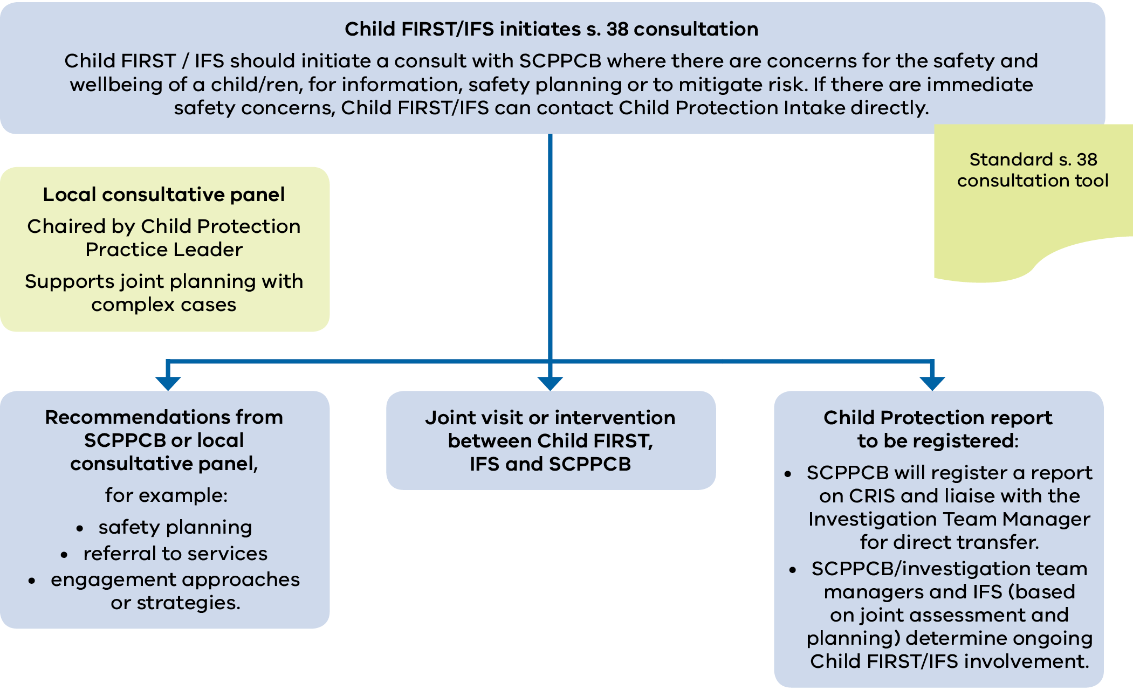

# Relationship management

In a highly integrated system comprising both statutory and non-statutory services, robust advocacy and dialogue about a child’s best interests are necessary and encouraged.

The key to building trust and relationships is a commitment to managing differences and resolving any conflict that arises through client focus, cooperation, collaboration, mutual respect, transparency, accountability, effective communication and timely responses.

The child’s best interest, as specified in the Children, Youth and Families Act, is the paramount consideration in any mediation, dispute resolution or relationship management process or mechanism.

Issues that could delay or otherwise influence service delivery must be resolved quickly, with a focus on the needs and rights of children and families to receive timely support.

Every attempt will be made to deal with issues or points of difference between services at the local level, with the aim of resolving the matter at this level. If the matter cannot be resolved, issues will be referred to the appropriate line manager to consider holding a case meeting.

Additional information or further joint work may be required if there are different views about acceptance of a report for an investigation, a referral for allocation to IFS, or in relation to case direction or case management issues.

The Best Interest Case Practice Model is a useful mechanism to resolve issues using a framework to assess, plan and act in the child’s best interests.

## Key considerations

Clearly define roles and responsibilities in relation to the child and family during formal mediation and dispute processes.

The allocated worker with primary case management responsibility (whether Child Protection or Child FIRST and IFS) will retain case responsibility until the dispute is resolved, unless the service–client relationship has broken down or risk is at a level that necessitates Child Protection taking this role.

The dispute resolution process should follow the table below, **with an emphasis placed on resolving disputes at operational level** and between the operational management group.

Use a tiered approach to resolving disagreements and addressing issues at the point of practice. If patterns of issues or intractable issues arise, collaborative senior management oversight will ensure issues are resolved according to standard mechanisms.

| Issue/s | Responsibility/mechanism | Roles |
| --- | --- | --- |
| **Day to day:**  Day-by-day communication | Child FIRST Team Leader, Child Protection Intake Team Manager, SCPPCB, IFS Team Manager | Communicating with each other to resolve issues at practice level. |
| **Operational**  Patterns or series of issues, and demand and referral trends | Child FIRST and Child Protection intake interface meetings (including IFS where relevant)  Program Manager level | Resolve issues, or refer to Alliance operations meeting or consultative panel. |
| Issues associated with complex cases | Practice Leader, Child Protection Case Manager, SCPPCB and consultative panel. | Advise and lead responses and strategies with complex cases and cohorts. |
| **Strategic**  Intractable or system-related issues | Alliance operations meeting (including Child Protection intake representative).  If unresolved, then referred to Alliance executive (inclusive of Department of Health and Human Services Divisional Services Manager). | Respond to and develop joint options for tackling problem.  Consider appropriate response and action and communicate decisions to all levels within both services. |

If the matter cannot be resolved through these processes, services may choose to undertake a formal review process between the relevant Alliance members and the department.

Child Protection area management plays a key role and will be involved in any formal mediation and dispute resolution process.

Mechanisms for systematically reviewing issues related to the relationships and transactions between Child Protection and IFS will also occur though regular reviews of joint memorandums of understanding, Alliance operations manuals, interface or liaison meetings, and so on.

# Review

These requirements were developed through a review process guided by a state-wide Reference group aimed at improving state-wide consistency and streamlining decision making across catchments.

These requirements (Version 2.2) replace the previous version released in September 2017.

These requirements will be subject to review in September 2021 or earlier if required.

# Endorsement

|  |  |
| --- | --- |
| Beth Allen  A/Director, Children and Families Policy  Department of Health and Human Services  Date: 2 January 2020 | Deb Tsorbaris  Chief Executive Officer  Centre for Excellence in Child and Family Welfare  Date: 13 Jan 2020 |

1. Throughout these requirements, references to Child FIRST and Integrated Family Services also includes Cradle to Kinder and Stronger Families in catchments in which these programs operate.
2. Department of Human Services 2007, *A strategic framework for Family Services* *-* <http://providers.dhhs.vic.gov.au/family-services>
3. Council of Australian Governments 2009, [*Protecting children is everyone’s business: national framework for protecting Australia’s children 2009–2020*](https://www.dss.gov.au/our-responsibilities/families-and-children/publications-articles/protecting-children-is-everyones-business)*.* <https://www.dss.gov.au/our-responsibilities/families-and-children/publications-articles/protecting-children-is-everyones-business>
4. It is the Department of Health and Human Services’ responsibility to arrange video conferencing facilities if these are not available in the agency.
5. In addition to these referral pathways Child Protection, Child FIRST and IFS also receive referrals or reports from community services and professionals.