+-

Prescribing psychotropic medication to people with an intellectual disability

Final report and recommendations

To receive this publication in an accessible format, please contact the Office of the Senior Practitioner, Department of Human Services on 9096 8427.

Background
The prevalence of intellectual disability (ID) in the Australian community is estimated at between one and three per cent (Australian Bureau of Statistics 2007; Australian Institute of Health and Welfare 2008). Approximately 30–40per cent of people with an ID will experience some kind of mental illness, psychiatric disorder or emotional difficulty that requires treatment (Thomas et al. 2011). This equates to a higher risk than the general population. Unfortunately, people with an ID are often misdiagnosed with mental illness. This is due partly to the difficulty in diagnosing mental illness and emotional problems in people who have severe communication difficulties.
It is estimated that 7–15per cent of people with an ID will show behaviours of concern that may be dangerous to themselves or others (Webber, Donley & Tsanakis 2008). Behaviours of concern have a range of presentations, including self-injury, verbal and physical assault, and absconding. However, it is important to note that while people with an ID who have a psychiatric condition often display behaviours of concern, the exact link between the two is undetermined. Therefore, behaviours of concern alone do not indicate mental illness. Such behaviours could be reactions to environments of concern or other medical reasons.
Despite the difficulty in assessing mental illness and the myriad de-escalation options for behaviours of concern, medication remains a common response (Thomas et al. 2011). It is estimated that 44–80 per cent of people who show behaviours of concern are prescribed chemical restraint, most commonly a psychotropic.
The Victorian Government Office of the Senior Practitioner (OSP) has initiated a series of activities to explore and address the issue of inappropriate use of psychotropics for those with an ID. These include commissioning the report Disability, mental health and medication: Implications for practice and policy, (Thomas et al. 2011). The project outlined in this report had three broad aims:
- to explore the prevalence of mental illness and/or psychotropic use within a random sample of people with an ID
- to examine the need for independent psychiatric review (IPR) of those with an ID who are on psychotropics
- to develop recommendations for practice regarding the use of psychotropic medications for people with an ID.
The results of this project clearly identify the trend between ID and psychotropic use, but also highlight that the majority of these cases (88 per cent) required IPR. This emphasises the importance of a robust IPR process; however, IPR should be employed as an exception. People with an ID should be assessed, managed and – if required – medicated in an appropriate way to provide best practice care and minimise the need for IPR. This highlights the need to adopt guidelines for the efficacy of care and treatment of people affected.
In order to begin the conversation about standardisation of care for this group, the OSP engaged the Royal Australian and New Zealand College of Psychiatrists (RANZCP) to conduct a round table with relevant stakeholders. The RANZCP has a comprehensive policy on minimising the use of seclusion and restraint in people with mental illness, and understands the many issues and challenges of identifying and adopting alternative practices.
In March 2011 the RANZCP hosted a round table to discuss the issues of prescribing psychotropics to those with an ID. The list of stakeholders invited and in attendance can be seen in Appendix 1. Issues raised during this round table are outlined in the following sections.

Available guidelines
The roundtable discussion identified three key guidelines on assessing and managing people with an ID, and/or using pharmacological interventions. These are:
- the University of Birmingham guideline Using medication to manage behaviour problems among adults with a learning disability (Deb, Clarke & Unwin 2006)
- the World Psychiatric Association (WPA) Section of Psychiatry of Intellectual Disability (SPID) guideline Problem behaviours in adults with intellectual disabilities (Deb et al. 2006)
- the Therapeutic Guidelines Limited (TGL) Developmental disability (2005).
In November 2006 the University of Birmingham published the guideline Using medication to manage behaviour problems among adults with a learning disability in conjunction with the Royal College of Psychiatrists and Mencap, a disability advocacy group. The guideline included:
- a quick reference guide (for clinicians)
- a technical document (full clinician guide)
- an easy-read guide (for consumers and carers, available in print or audio)
- 35 easy-read medicine information leaflets (for consumers and carers, available in print or audio)
- a screening instrument for dementia in people with intellectual disabilities.
In 2009 the WPA SPID developed an international guideline for prescribing psychotropic medication for people with an ID entitled Problem behaviours in adults with intellectual disabilities. It was adapted from the University of Birmingham guideline for an international audience.
In 2005 the Australian organisation TGL released the second edition of their guideline Developmental disability. It covers a wide range of topics on managing people with a developmental disability, and includes specific sections on:
- assessing psychiatric disorders
- managing psychiatric disorders
- challenging behaviour
- medication and challenging behaviour.

Endorsing the guidelines
A key assumption of the roundtable participants was that an appropriate option could be readily identified from the available guidelines outlined above. They agreed that it is important for the RANZCP and other medical colleges to endorse an appropriate guideline for this issue. However, there was considerable concern around the table that action to address the problems of this group would not include adequate resourcing for implementation. The roundtable participants identified a set of criteria to consider when assessing and recommending an appropriate guideline, and agreed that the endorsement of the recommended guideline should be reported along with a set of implementation recommendations.
The roundtable participants identified the following criteria for selecting an appropriate guideline:
- Does the guideline cover assessment and treatment?
- Does the guideline cover the patient lifespan?
- Does the guideline address a range of audiences (for example, craft groups and non-prescribers)?
- Does the guideline outline the flow of care?
- Is the guideline freely available and widely accessible?

Each of the available guidelines has been assessed against these selection criteria, and the results are recorded in the tables below. Where appropriate, comments from the round table have been included.
Table 1: Assessment of the University of Birmingham guideline
Guideline | University of Birmingham guideline Using medication to manage behaviour problems among adults with a learning disability
Year of publication | 2006
Country | United Kingdom (UK)
Does the guideline cover assessment and treatment? | - While the guideline identifies appropriate assessment and review as key components of good implementation, the guideline itself does not address these.  - It does not tease out the issues of challenging behaviour versus mental health.  - Page 8 points users to other guidelines on the assessment of challenging behaviour.  - Page 34 outlines principles of assessment, but is not instructive as to process.
Does the guideline cover the patient lifespan? | No. Adult guideline.
Does the guideline address a range of audiences (for example, craft groups and non-prescribers)? | Yes. While it is intended as a prescribing guideline for daily use by a range of craft groups, it has also been framed through a series of consumer and carer guidelines to ensure there is broad access to the information.
Does the guideline outline the flow of care? | Yes. However, this flow is specific to the UK National Health Service, which means it is not as relevant to the Australian context.
Is the guideline freely available/widely accessible? | Yes, at <www.ld-medication.bham.ac.uk/downloads.shtml>.

Table 2: Assessment of the WPA SPID guideline
Guideline | WPA SPID guideline Problem behaviours in adults with intellectual disabilities
Year of publication | 2009
Country | International
Does the guideline cover assessment and treatment? | - While the guideline outlines appropriate assessment and review as key components of good implementation, the guideline itself does not address these.  - It outlines that there are considerations surrounding the indication of challenging behaviour and/or mental health.  - Page 17 outlines principles of assessment, but is not instructive as to process.
Does the guideline cover the patient lifespan? | No. Adult guideline.
Does the guideline address a range of audiences (for example, craft groups and non-prescribers)? | This guideline is aimed at prescribers of various craft groups. There are no consumer or non-prescriber supplements.
Does the guideline outline the flow of care? | The guideline does cover the flow of care as it concerns a prescribing health professional. It does not cover care as delivered in a multidisciplinary setting. As an international guideline, it is also quite general.
Is the guideline freely available/widely accessible? | Yes, at <www.wpanet.org/uploads/Sections/Psychiatry_Intellectual/problem-behaviours-in-adults-with-intellectual.doc>.

Table 3: Assessment of the TGL guideline
Guideline | TGL guideline Developmental disability
Year of publication | 2005
Country | Australia
Does the guideline cover assessment and treatment? | - The guideline is not limited to the medical management of challenging behaviour but covers the gamut of developmental disability issues.  - It includes chapters on assessing/managing challenging behaviour.  - It includes chapters on assessing/managing psychiatric conditions.  - The TGL guideline is intended to promote the quality use of medicines, which may imply a stronger focus on medication management.  - The guideline is focused on care as it pertains to the Australian context, which is highly relevant and useful.
Does the guideline cover the patient lifespan? | Yes. The guideline outlines a range of considerations for child, adolescent, adult and aged care.
Does the guideline address a range of audiences (for example, craft groups and non-prescribers)? | This guideline is intended for general practitioners (GPs). There are no other versions available for other craft groups or consumers.
Does the guideline outline the flow of care? | The guideline outlines other resources and options for multidisciplinary care that may be available but does not map the flow of care.
Is the guideline freely available/widely accessible? | No. The hard copy is $39 plus $7.50 in postage; the soft copy is available only in a complete set of guidelines through a $315 per annum subscription.  An outline of the guideline is available at <www.tg.org.au/index.php?sectionid=93#mozTocId88163>.

From the review of the three guidelines the RANZCP notes the following:
- The TGL guideline Developmental disability is the most directly relevant to assessing and managing psychotropic prescription to those with an ID. This guideline should be considered carefully as limitations include its cost restrictions and focus on GPs.
- In the absence of the TGL guideline, the WPA guideline Problem behaviours in adults with intellectual disabilities is also considered appropriate because the alternative guideline is considered too UK specific. Limitations of the WPA guideline include the lack of assessment guidelines and its generality.

Implementing the guidelines
Stakeholders at the round table specifically noted that the selection of an appropriate guideline is the first step in ensuring that best practice care is delivered. However, the dissemination of this information – and more importantly the implementation of its recommended practices – is the key to clinician and other change. The roundtable discussion identified a number of barriers to implementation including the following.
Clinical barriers
- There is a lack of psychiatrists and GPs with the specific competence to assess and manage people with an ID.
- Assessment is of particular importance when considering pharmacological management of those with an ID; incorrect assessment leads to incorrect management.
- Guidelines tend to approach issues from a prescriber’s perspective, whereas assessment and management of those with an ID may be carried out by non-prescribers (for example, a speech pathologist).
- People with an ID are a specific and unique cohort; there are considerations as to how competence building best fits into medical and other training.
- Health professionals (including prescribers) and disability support staff do not understand the various dimensions of the issue (for example, challenging behaviour and/or mental health, and alternative strategies to managing challenging behaviour).
- There is no framework for utilising the knowledge and input of all those supporting the individual, and there is a need for prescribers to shift to a more holistic and collaborative approach to assessment and care, taking into account all relevant information.
Administrative and resourcing barriers
- There is difficulty in sharing information between care settings (for example, GP to pharmacist to client/carer).
- Administrative systems may not be providing appropriate monitoring and care, for example the suggestion that the Restrictive Intervention Data System (RIDS) should be used regardless of mental health diagnosis.
- There is a lack of appropriate human resourcing to implement alternative management strategies (either pharmacological or non-pharmacological) for those with challenging behaviours.
- Administrative systems (for example, audit) have to complement best practice guidelines, as opposed to simply policing them.
Other barriers
- There is a lack of consumer/carer/family information about the expected levels and activities of care.
- Information is required for a wide range of sectors, professional groups and support groups (for example, supportive housing, general practice, community assessment and pharmacy); however, aligning these messages and strategies is difficult.
The roundtable participants noted that there are a number of mechanisms and implementation channels by which to effect change in healthcare. Identifying appropriate activities is vital in driving clinician change. In reflecting on these change drivers, the RANZCP would like to highlight two relevant models: the Royal Australian College of General Practitioners’ (RACGP) quality framework for Australian general practice (2005), as can be seen in Appendix 2, and the Grol model (2007), as can be seen in Appendix 3. These tools approach change from different foci; however, both tools recognise that it is a range of different yet linked and simultaneous approaches that effect change.
The RACGP model provides a useful framework for identifying possible solutions to the implementation barriers noted above. It identifies the domains of quality and the settings of care. When applying these domains to the issue of standardisation of clinical care for those with an ID, a number of issues and possible solutions become clear. For example:
- competence – clinician education (undergraduate education, training, continuing professional development), curriculum development requirements, disability support training, accreditation (for example, in housing), referral bases with appropriate skills
- capacity – disability support workforce, standards (for example, in housing or clinical care) to drive infrastructure resourcing, clinicians with appropriate training
- financing – appropriate billing mechanisms commensurate with time (both clinician and support staff), Medicare Benefits Schedule (MBS) item numbers that appropriately represent care
- patient focus – consumer/carer/family information about expected best practice care, appropriate assessment of those with an ID, accessibility of services, consumer advocacy at all levels, appropriate complaints and review mechanisms
- professionalism – ethical standards represented in continuing professional development programs and highlighted in clinical risk management procedures
- knowledge and information management – endorsed clinical guidelines, adequate IT/IM systems to ensure recalls and reminders, decision support tools, administrative systems that identify anomalies in care (for example, RIDS), best practice indicators and clinical communication tools (for example, secure messaging and referral forms).
The RANZCP notes that once a clinical guideline is selected and endorsed by peak bodies, a detailed implementation strategy will be required. The RANZCP would be pleased to work with the Victorian Government in developing this strategy.

Recommendations
A number of principles for action became apparent from the round table.
- The prescription of psychotropic medication to those with an ID is a serious issue that requires the review, identification and endorsement of appropriate guidelines and implementation activities.
- The standardisation of processes for prescribing psychotropic medication for people with an ID is best achieved via the adoption and implementation of a clinical practice guideline that outlines the following:
- considerations for comprehensive assessment, leading to more accurate diagnosis of co morbid ID and mental illness
- comprehensive management planning of interventions targeting behaviours of concern in people with an ID, including the use of evidence-based non-pharmacological treatment whenever possible
- appropriate monitoring of the efficacy and toxicity of any pharmacological intervention.
- It was acknowledged that no single guideline dealt with all the issues outlined above. The WPA guideline Problem behaviours in adults with intellectual disabilities is considered the most appropriate, since it is freely available to clinicians in Australia and New Zealand. The TGL guideline Developmental disability is more relevant and useful but due to its cost should be used additionally if available.
- It was agreed that, prior to a future review of guidelines, funding should be made available to map the current usage by GPs, other health groups and non-prescribers of the TGL guideline.
- Implementing standardised care is a complex issue with many challenges including but not limited to: the competence of clinicians and other staff; the management and review of client information; and human resource capacity to implement change.
- Prescription should be based on best practice in clinical assessment. Effective use of psychotropic medication in a person with an ID involves all members of the person’s care. Each component of the care system needs adequate training and appropriate processes to meet this need.
- Appropriate funding for implementation should be made available. This funding should focus on appropriate mechanisms to ensure that people on psychotropics are appropriately monitored but should also focus on up skilling health professionals to engage in alternative methods of understanding and managing behaviours of concern.

Appendix 1: Round table attendees and apologies
The following is a list of attendees and apologies for the RANZCP roundtable discussion on prescribing psychotropics to those with an ID.
No. | Attendance | Organisation | Position/unit | Name
1 | Present | Australian Psychological Society | Senior Manager, Strategic Policy and Liaison | Mr Harry Lovelock
2 | Present | Centre for Developmental Disability Health | Proxy for Dr Jane Tracy | Dr Bob Davis
3 | Present | Department of Human Services | Proxy for Ms Kathryn Lamb | Mr Michael Gibbs
4 | Present | Department of Human Services | Office of the Senior Practitioner | Ms Mandy Donley
5 | Present | Department of Human Services | Acting Senior Practitioner, Office of the Senior Practitioner | Mr Rod Carracher
6 | Present | Department of Human Services | Proxy for Ms Christine Owen | Mr Geoff Anderson
7 | Present | General Practice Victoria | Proxy for Board chairperson | Dr Lenora Lippman
8 | Present | Office of the Disability Services Commissioner | Deputy Commissioner | Ms Lynne Coulson-Barr
9 | Present | Professional Association of Nurses in Developmental Disability Areas | President | Mr John Ryan
10 | Apology | Pharmacy Guild | Proxy for Mr Dipak Sanghvi | Mr Paul Karrassis
11 | Present | Royal Australian and New Zealand College of Psychiatrists | Fellow | Dr Yitzchak Hollander
12 | Present | Royal Australian and New Zealand College of Psychiatrists | Fellow | Professor Bruce Tonge
13 | Present | Royal Australian and New Zealand College of Psychiatrists  The Centre for Developmental Disability Health Victoria | Fellow | Dr Jennifer Torr
14 | Present | Royal Australian and New Zealand College of Psychiatrists | Chairperson, Victorian Branch | Associate Professor Mal Hopwood

No. | Attendance | Organisation | Position/Unit | Name
15 | Present | Royal Australian and New Zealand College of Psychiatrists | Manager, Projects | Ms Jane London
16 | Present | Yooralla | Manager, Positive Behaviour Support Services | Mr Shanker Pragnaratne
17 | Present | Royal Australasian College of Physicians | Fellow (Paediatrics) | Dr Catherine Marraffra
18 | Apology | Victorian Advocacy League for Individuals with Disability | Proxy for Mr Kevin Stone | Mr Seth Howell
19 | Apology | Australian College of Mental Health Nurses | Member | Not provided
20 | Apology | Australian College of Mental Health Nurses | Chief Executive Officer | Ms Kim Ryan
21 | Apology | La Trobe University | Director of Postgraduate Programs | Professor Christine Bigby
22 | Apology | Office of the Chief Psychiatrist | Chief Psychiatrist | Dr Ruth Vine
23 | Apology | Professional Association of Nurses in Developmental Disability Areas | Member | Not provided
24 | Apology | Pharmacy Guild | Policy Unit | Mr Maurice Sheehan
25 | Apology | Royal Australasian College of Physicians | Policy staff (Neurology) | Dr Andrew Churchyard
26 | Apology | Royal Australasian College of Physicians | Fellow (Neurology) | Not provided
27 | Apology | Royal Australian and New Zealand College of Psychiatrists | Chairperson, Special Interest Group on ID Mental Health | Associate Professor Julian Troller
28 | Apology | Royal Australian College of General Practitioners | Fellow | Not provided
29 | Apology | Royal Australian College of General Practitioners | General Manager, Practice Innovation and Policy | Ms Josephine Raw

Appendix 2: RACGP quality framework for Australian general practice
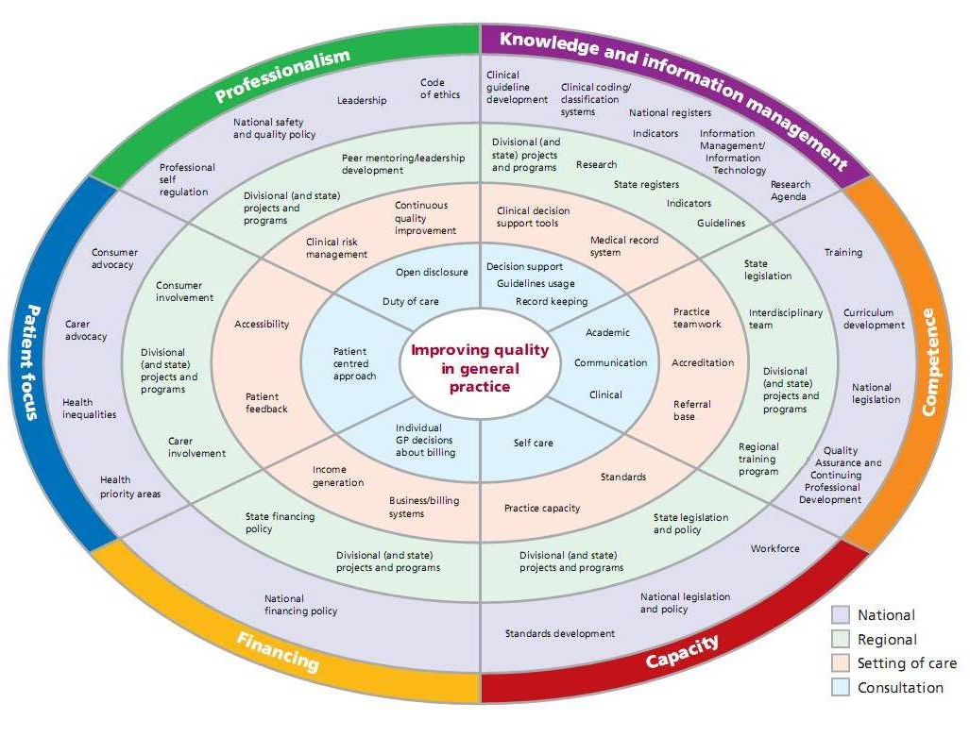

Appendix 3: The Grol framework
Approach | Theories | Focus | Example interventions, strategy
Focus on internal processes
Education | Adult learning theories | Intrinsic motivation of professionals | - Bottom up, local consensus development  - Small-group interactive learning  - Problem-based learning
Epidemiology | Cognitive theories | Rational information seeking and decision making | - Evidence-based guideline development  - Dissemination of research findings through courses, mail-outs, journals
Marketing | Health promotion, innovation and social marketing theories | Attractive product adapted to needs of target audience | - Needs assessment, change proposals adapted to local needs  - Stepwise approach  - Various channels for dissemination (mass media and personal)
Focus on external influences
Behaviour | Learning theory | Control of performance through external stimuli | - Audit and feedback  - Reminder systems  - Economic incentives, sanctions
Social interaction | Social learning and innovation theories, social influence/ power theories | Social influence of significant peers or role models | - Peer review in local networks  - Outreach visits, individual instruction  - Opinion leaders  - Influence over key people in social networks  - Patient-mediated interventions
Organisation | Management theories, system theories | The right structural and organisational conditions to improve care | - Re-engineered care process  - Total quality management/ continuous quality improvement approaches  - Team building  - Enhanced leadership  - Improved structures, practices
Coersion | Economic power and learning theories | Control and pressure, external motivation | - Regulations, legislation  - Budgets, contracts  - Licensing, accreditation  - Complaints, legal procedures
Source: Grol 1997

References
Australian Bureau of Statistics 2007, National survey of mental health and wellbeing: Summary of results, cat. no. 4326.0, Canberra.
Australian Institute of Health and Welfare 2008, Disability in Australia: intellectual disability, AIHW bulletin no. 67, cat. no. AUS 110, Canberra.
Deb S, Clarke D, Unwin G 2006, Using medication to manage behaviour problems among adults with a learning disability: Quick reference guide, University of Birmingham, Birmingham, viewed 11 March 2011, <www.ld-medication.bham.ac.uk/1qrg.pdf>.
Deb S, Salvador-Carulla L, Barnhill J, Torr J, Bradley E, Kwok H, Bertelli M, Bouras N (eds) 2006, Problem behaviours in adults with intellectual disabilities: International guide for using medication, The World Psychiatric Association, University of Birmingham, Birmingham, viewed 11 March 2011, <www.wpanet.org/uploads/Sections/Psychiatry_Intellectual/problem-behaviours-in-adults-with-intellectual.doc>.
Grol R 1997, ‘Beliefs and evidence in changing clinical practice’, British Medical Journal, vol. 315, pp. 418–421.
Royal Australian and New Zealand College of Psychiatrists 2010, Position statement 61: Minimising the use of seclusion and restraint in people with a mental illness, viewed 1 April 2011, <www.ranzcp.org/images/stories/ranzcp-attachments/Resources/College_Statements/Position_Statements/ps61.pdf>.
Royal Australian College of General Practitioners 2005, A quality framework for Australian general practice, Melbourne, viewed 16 March 2011, <www.racgp.org.au/qualityframework>.
Therapeutic Guidelines Limited 2005, Development disability version 2, TGL, Melbourne.
Thomas S, Corkery-Lavender K, Daffern M, Sullivan D, Lau P 2011, Disability, mental health and medication: Implications for practice and policy, State Government of Victoria, Melbourne.
Webber L, Donley M, Tzanakis H 2008, Chemical restraint: What every disability support worker needs to know, State Government of Victoria, Melbourne.

