

2026 Neighbourhood House Coordination Program
Service Delivery Tracking – Frequently Asked Questions (FAQ)
OFFICIAL

Overview
In line with the Neighbourhood House Coordination Program (NHCP) guidelines, neighbourhood houses are required to report on activity hours and open hours each month using the Service Delivery Tracking (SDT) acquittal tool to meet program and funding requirements.
The monthly reporting requirement aligns with standard departmental requirements for other funded organisations and allows the department to monitor service delivery against program targets across the sector in a timely manner.
SDT must accurately reflect neighbourhood houses open hours and activity hours. Neighbourhood houses are required to be open for at least 88.85% of their funded coordination hours and deliver twice as many activity hours as their funded coordination hours.
Contents
When is my SDT acquittal due? 2
How do I complete an SDT acquittal in the Service Agreement Module? 2
Navigating to the acquittal tab in the Service Agreement Module 2
Manually completing the acquittal tab 3
What are activity hours and what can be counted towards activity hours? 4
Should I report preparation time even if a class or activity doesn’t run? 5
Why can’t I see an option to record my organisation’s open hours? 5
Is the target number in the SDT acquittal template for my organisation’s activity hours? 5
I am unable to see SDT acquittal or enter information into the acquittal template. How do I get the right access? 5
I am reporting for an organisation that operates multiple funded neighbourhood houses. How should I report this? 6
How can I amend or change my SDT data once submitted? 6

When is my SDT acquittal due?
The SDT acquittal is due on the 10th of each month, except for January, where reporting will be due by 31 January. This extension is to recognise that many neighbourhood houses are closed in early-to-mid January and will allow more time for reporting.
SDT will remain open after the 10th of each month, so entries can be submitted late if required. The department will follow up with neighbourhood houses that routinely fail to meet reporting deadlines without any reasonable justification.

How do I complete an SDT acquittal in the Service Agreement Module?

Navigating to the acquittal tab in the Service Agreement Module
Log in to My Agency and select the ‘Service Agreement Model’ (SAM) link.
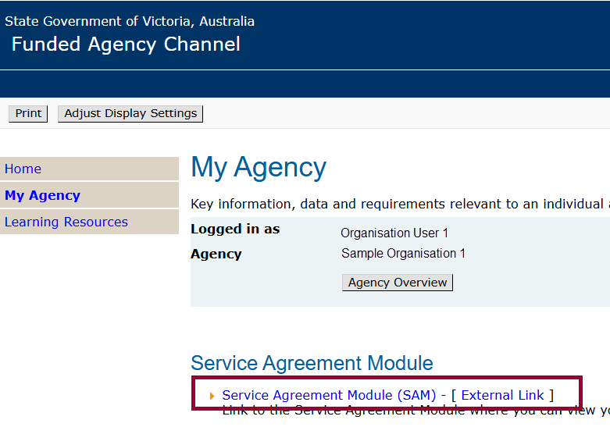

Manually completing the acquittal tab
The acquittal template can be completed manually by entering the data directly in SAM.
- Once logged in, select the ‘Acquittal’ tab.
- Under the ‘Actual Responses’ section in the ‘Acquittal’ tab, select the month that your neighbourhood house or organisation is submitting data for.
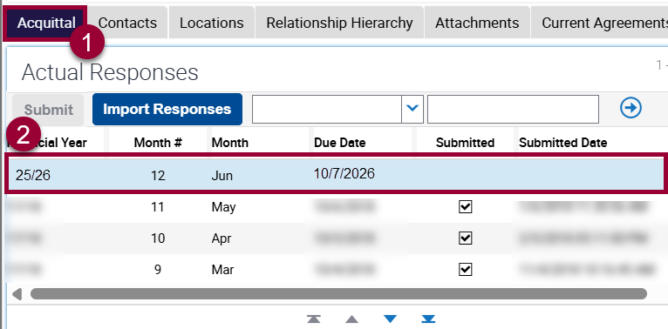
- Scroll down to the ‘Actual Response Details’ section.
- Navigate across to the ‘Actual Units’ and ‘Comment’ fields on the right.
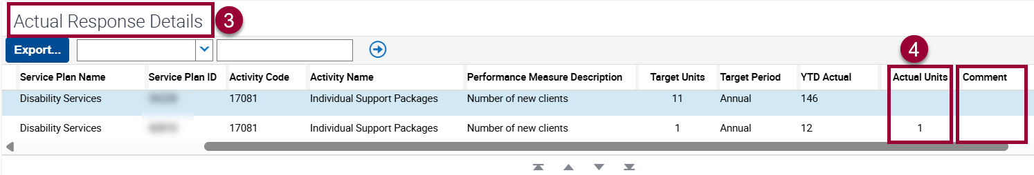
    - For each activity, enter the actual number of units delivered for the month in the ‘Actual Units’ field. If services are provided across multiple divisions and areas, enter the data relevant to the Division/ Group/ Region and Service Plan Area specified in the Service Plan Division/ Group/ Region and ‘Service Plan Area’ fields.
    - While comments are not mandatory, an explanation must be provided for any targets that were not achieved. Up to 1,000 characters can be entered in the ‘Comment’ field. However, it is advised to enter only summarised information in this field and limit the number of characters to 255.
    - Save data at any time by pressing and holding the ‘ctrl’ and then ‘S’ keys.
    - Once the ‘Actual Units’ field has been completed, the ‘Submit’ button will appear at the top of the ‘Actual Responses’ section. Select the submit button.
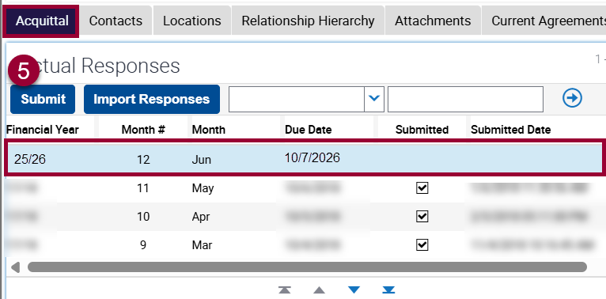
- The ‘Submit’ button and ‘Import Responses’ fields will become disabled once data has been submitted. The ‘Submitted’ checkbox, ‘Submitted Date’ and ‘Submitted By’ fields will automatically appear as completed.
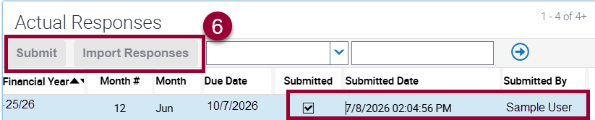

What are activity hours and what can be counted towards activity hours?
Under the NHCP guidelines on page 12, activity hours encompass any activities, programs and services that neighbourhood houses deliver in line with the community strengthening aims of the NHCP, including those supported by other funding streams and program areas.
Activities, programs or services must meet at least one of these aims to be counted:
- build community capacity
- contribute to community development and resilience
- create and foster social connections, diversity and wellbeing
- provide training and employment opportunities.
Some activities a neighbourhood house may deliver, such as client services programs funded by another area of government, may not be considered activities that meet the aims of the NHCP. If you are unsure about these activities, please reach out to your contact for that program.
Neighbourhood houses are encouraged to use the NHVic Activity Hours Calculator Tool to assist with tracking monthly reporting and understanding the types of activities that can be reported.
For queries or support, please contact the Social Inclusion team at NHCP@dffh.vic.gov.au.

Should I report preparation time even if a class or activity doesn’t run?
Yes, preparation for classes count towards activity hours. Neighbourhood houses must ensure that they add any preparation hours completed to their SDT acquittal template.

Why can’t I see an option to record my organisation’s open hours?
The open hours reporting function is currently unavailable. We ask that neighbourhood houses continue reporting their activity hours monthly and await further notice from the NHCP team regarding open hours reporting.
The NHCP team is working with the SAM/My Agency team to address this issue as quickly as possible and will notify neighbourhood houses once this function becomes available.
Once available, neighbourhood houses will be expected to report their hours in line with the open hours requirement in the Guidelines on page 11. The Guidelines state that houses must be open for at least 88.85% of their funded coordination hours.

Is the target number in the SDT acquittal template for my organisation’s activity hours?
The listed target number in the acquittal is the neighbourhood house’s annual coordination hours (for most houses, this is 1300). Annual activity hours reported are expected to be double this number.

I am unable to see SDT acquittal or enter information into the acquittal template. How do I get the right access?
To access and edit the SDT acquittal, a nominated staff member within a neighbourhood house or organisation needs to have ‘Editor’ permissions under the ‘Performance’ tab selected in the SAM module. The neighbourhood house’s Access Controller can update user permissions to support this process.
Please see Managing contacts in the Service Agreement Module (SAM) for guidance. If this does not resolve the issue, please contact the My Agency team by email at fac@dffh.vic.gov.au.

I am reporting for an organisation that operates multiple funded neighbourhood houses. How should I report this?
For organisations reporting on behalf of neighbourhood houses, please input the total number of activity hours that your organisation operates in the ‘Response Details Actual Units’ box. In the ‘Response Details Comments’ box, please provide a breakdown by house, for example:
- NH1 – 108
- NH2 – 97.

How can I amend or change my SDT data once submitted?
To amend or un-submit SDT data for the current financial year, neighbourhood houses must contact the department for assistance.
Departmental staff can initiate the un-submission process for two reasons:
- If the neighbourhood house used an incorrect counting method
- If the commentary field contains confidential or sensitive information. Please refer to the ‘Manually completing the acquittal tab’ section on page 3 for details on the type of information that should be entered.
For support, please contact the NHCP team by email at NHCP@dffh.vic.gov.au.

Contact us to receive this document in another format. Please email Social Inclusion NHCP@dffh.vic.gov.au.
Authorised and published by the Victorian Government, 1 Treasury Place, Melbourne.
© State of Victoria, Australia, Department of Families, Fairness and Housing, August 2026.
ISBN 978-1-76171-228-9 (online)
Available at DFFH Service Providers' Neighbourhood House Coordination program web page:

https//providers.dffh.vic.gov.au/neighbourhood-hours-coordination-program
https://www.nhvic.org.au/sector-specific-resources
https://fac.dffh.vic.gov.au/managing-contacts-service-agreement-module-sam
https://providers.dffh.vic.gov.au/neighbourhood-house-coordination-program

