
Client incident management system (CIMS)
Self-paced learning module
Module 2: Responding to and reporting client incidents
March 2020

To receive this publication in an accessible format phone 1300 024 863, using the National Relay Service 13 36 77 if required, or email the client incident management system team <CIMS@dhhs.vic.gov.au>
Authorised and published by the Victorian Government, 1 Treasury Place, Melbourne.
© State of Victoria, Department of Health and Human Services March 2020.
Available at client incident management system <https://providers.dhhs.vic.gov.au/cims>
Department of Health
Contents
Module 2: Responding to and reporting client incidents 4
Learning objectives 4
Introduction to the client incident management system 6
Learning 2.1: Responding to a client incident 7
Learning 2.2: Client incident reporting 13
Learning 2.3: Working with ‘shared clients’ 21
Learning 2.4: Completing the report 22
Sector application 24
Case study 1: Homeless sector 24
Case study 2: Child protection sector 25
Case study 3: Community mental health 26
Case study 4: Disability sector 27
Summary 28
Module 2: Responding to and reporting client incidents 28
Self-check 31
Tasks – expected responses 31
Case studies – expected responses 34
Appendix A: Definitions of incident types 38
Evaluation form 46

Module 2: Responding to and reporting client incidents

Learning objectives
Module 2: Responding to and reporting client incidents will focus on the Department of Health and Human Services (the department) client incident management system (CIMS) stage 1, identification and response, and stage 2, reporting.
This module will describe how to respond to a client incident and what information is required to complete an incident report. A client incident in the CIMS is an event or circumstance that occurs during service delivery and results in harm to a client. Incidents that affect staff or members of the public but do not have an impact on a client should be reported through other appropriate channels, as outlined in your organisation's policies and procedures.
When participants complete this module, they will have an understanding of:
- expectations in the CIMS for responding to a client incident, both the immediate response and provision of ongoing support
- definitions of the two incident types – major impact and non-major impact
- the different reporting requirements for major impact and non-major impact incidents
- incident classifications
- response and reporting requirements for client incidents involving ‘shared clients’, and how to work with other organisations who support these clients
- the information required to complete and submit an incident report.
This is the second of four self-paced learning modules to support participants’ understanding of the CIMS, as outlined in detail in the CIMS policy document, the Client incident management guide. It is not necessary for participants to read the Client incident management guide in order to complete the learning modules. The first two self-paced learning modules are relevant to any staff member working for an in-scope service provider to gain an overview of the CIMS and the requirements for responding to and reporting client incidents.
Classroom-based training programs will also be available. The classroom-based training, along with learning modules 3 and 4, is targeted at people who will be required to undertake investigation and review of client incidents in their organisation. It is recommended that all those who are attending the classroom-based training should first complete the self-paced learning modules.
Table 2.1 outlines the four self-paced learning modules and the classroom-based training programs, and what they cover.

Self-paced learning Module 1  The CIMS end-to-end model | Module 1 is a self-paced module that introduces the aims, objectives and principles of the CIMS, along with the five stages of the CIMS, as outlined in the Client incident management guide.
Self-paced learning Module 2  Responding to and reporting client incidents | Module 2 is a self-paced learning module that focuses in more detail on CIMS stages 1 and 2, responding to and reporting client incidents. This module describes how to respond to a client incident and what information is required to complete an incident report.
Self-paced learning Module 3  Introduction to investigating client incidents | Module 3 is a self-paced learning module on CIMS incident investigations. It describes what incident types require an investigation to be undertaken and the requirements for conducting an incident investigation.
Self-paced learning Module 4  Introduction to reviewing client incidents | Module 4 is a self-paced learning module on CIMS incident reviews. It provides an overall picture of what incident reviews are and how they are undertaken.
Classroom-based training program  Investigating client incidents | ‘Investigating client incidents’ is a classroom-based training program that focuses on CIMS stage 3, incident investigations. This workshop will build participants’ capability to undertake and report on a client incident investigation as required under the CIMS.
Classroom-based training program  Reviewing client incidents | ‘Reviewing client incidents’ is a classroom-based training program that focuses on CIMS stage 4, incident reviews. This workshop will explore the two types of incident reviews and build participants’ capability to conduct them.
Table 1: CIMS self-paced modules and classroom-based training programs
The four CIMS self-paced learning modules will be on the Client incident management page on the Service Providers website <https://providers.dhhs.vic.gov.au/cims>.
Participants will have a better understanding of the requirements of the CIMS once the four self-paced learning modules are completed.
The other modules are one-day classroom-based training programs which are relevant for people who are required to complete client incident reviews and client incident investigations.
Each of the self-paced modules (1–4) will take one to two hours to complete. The modules do not have to be completed in one sitting.

Introduction to the client incident management system
Welcome to the Department of Health and Human Services (the department) client incident management system (CIMS) self-paced learning module.
The CIMS has clear requirements for responding to, reporting and managing client incidents. The main aim of the CIMS is to support the safety and wellbeing of clients. The objectives of the CIMS are to ensure:
- timely and effective responses to client incidents
- effective and appropriate investigations of client incidents
- effective and appropriate review of client incidents
- learnings are used to reduce the risk of harm to clients and improve the quality of the service system
- accountability of service providers to clients.
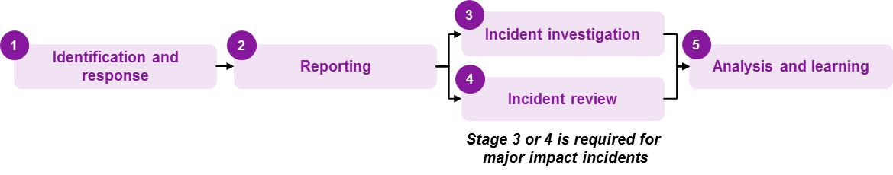
The CIMS includes the five stages outlined in Figure 2.1.

Figure 1: The five stages of CIMS

Learning 2.1: Responding to a client incident
What is the first priority when responding to a client incident?
When responding to an incident, the first and main priority is always the safety, health and wellbeing of clients. Staff also need to consider their own safety and wellbeing and that of any others involved.
What is a client incident?
A client incident is defined as an event or circumstance that occurs during service delivery and results in harm to a client.
Responding to a client incident is covered in depth in Section 2 of the Client incident management guide. There are actions that need to be taken immediately and actions that need to be planned for to ensure adequate follow-up to the incident and appropriate ongoing support to the client.

The immediate response
Depending on the nature of the incident, actions that might need to be taken immediately when responding to a client incident include:
- ensuring the clients, staff and anyone else in the area are safe from harm
- calling for help or asking a colleague for assistance
- getting medical assistance if needed – telephoning 000 for an ambulance, contacting the client’s medical practitioner, or taking the person to hospital
- notifying Victoria Police or other emergency services as required
- if necessary, ensuring that no-one goes into the area where the incident has occurred in case evidence needs to be preserved
- keeping any potential evidence safe, but avoiding touching or moving anything if possible
- making sure a supervisor or line manager is made aware of the incident.
Additional information
Incidents that involve allegations of physical abuse, sexual abuse, emotional abuse, financial abuse, sexual exploitation or poor quality of care have specific response requirements. Please refer to the Client incident management guide, Appendix B: Responding to allegations of abuse, for more information.
How to respond to major impact incidents will be discussed in Module 3: Investigating client incidents and Module 4: Reviewing client incidents.

Reporting to Victoria Police
What incidents need to be reported to Victoria Police?
All suspected crimes must be reported to Victoria Police. This includes any allegations of sexual, physical or financial abuse, sexual exploitation or significant quality of care concerns that allege neglect of the client.
Who should contact the police will depend on a number of factors, including the seriousness, immediacy and nature of the event. For example, in a situation unfolding immediately, such as an attack or an accident where emergency services are required straight away, the police should be contacted urgently by whoever at the scene is able to do so quickly. On other occasions, staff will follow organisational policies and procedures and report concerns to a manager who will follow up with the police at a later time (for example, in a suspected case of financial abuse).
The process to contact Victoria Police, including how to consider the consent and wishes of the client, is provided in Figure 2.
What if the client does not want an incident reported to police – should I respect their wishes?
While it is important to respect the wishes of clients, sometimes there is no option but to make a report to police. If the client does not wish to report the incident to Victoria Police and they have the capacity to make this decision, this wish should be respected where possible. However, if the incident meets any of the six criteria outlined below, it must be reported to police.
The incident must be reported to Victoria Police if it meets one or more of the following criteria:
- the client
- is under 18 years old. If the child is a client of child protection, child protection should be immediately informed
- has a cognitive impairment
- has suffered serious harm
- has made the decision under duress
- the client or other service users are still at risk of violence or abuse
- there is evidence aside from the client’s statements of a crime having been committed.
If the client has the capacity to make the decision not to report the incident to police (and it does not meet any of the criteria listed above), it is important to follow up with the client after an incident has happened. They might need additional advice or more time to process what has happened before deciding whether to refer the matter to police.
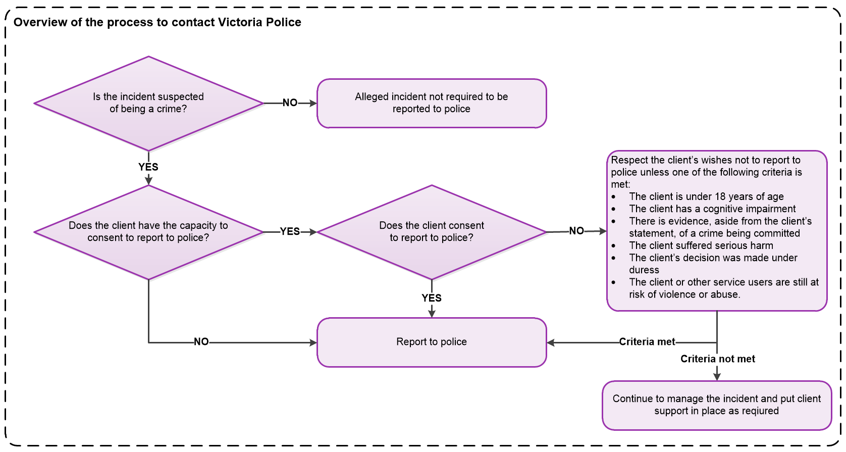
Figure 2: Overview of the process to contact Victoria Police

Ongoing support
Support isn’t just at the time of the incident – what happens next is just as important
An important part of client incident management is providing ongoing support. This should consider any others who should be involved in the process, while always ensuring you respect the client’s right to privacy.
To help make informed choices and decisions, clients should get the support they need at the time of the incident and following the incident. This might mean involving a person they know well and trust, a family member or an independent advocate. It may mean involving a person who speaks their language (including sign language). In some situations, it might mean seeking advice from a professional, such as a medical practitioner, psychologist or social worker. The client might need support to engage a lawyer.
Keeping in mind the client’s right to privacy, consider who else needs to know about the incident, and who needs to be involved in the follow-up. Do any of the following need to be involved?
- the client’s guardian, next of kin or a family member
- the client’s doctor, psychologist or other professionals already involved with the client
- other services involved in providing support to the client.
It is important that ongoing support:
- recognises and acknowledges the impact the incident has had on the client
- reassures the client that the incident will be taken seriously and dealt with in a fair way
- keeps the client informed of what is happening throughout the process
- provides the client with information about their rights, and listens to and takes their wishes into consideration
- identifies and supports the involvement of a guardian, advocate or support person if appropriate, and that this person is kept informed throughout the follow-up process
- involves the client in the process of reviewing or investigating the incident, including the opportunity to provide their account of what happened, with communication support if required
- ensures the client can provide feedback on the response to the incident
- ensures that personal and sensitive client information is appropriately managed and secured to mitigate the risk of privacy breaches.
For some clients, such as children and people with a disability, it will be particularly important to keep them up to date with what is happening in a way that is meaningful to them.
It is important to check in on the client’s support needs as time passes. In the hours, days and weeks following an incident, the client might require increasing levels of support, a modification to their support plan or routine, and more specialised support (for example, referral to a psychologist).

Privacy requirements when responding to and reporting a client incident
Issues of privacy and consent need to be considered before disclosing information to anyone other than those directly involved in managing the incident. Each organisation should have policies and guidelines on privacy. If in any doubt about where to find these, ask a supervisor or line manager.
When can a client’s personal and health information be shared?
A client’s personal and health information should only be disclosed or shared among service providers as is allowed by law and always considering the client’s safety, wishes and best interests.
There are times when a service provider is legally obliged to share information. Legislation related to how information can and cannot be handled includes the:
- Privacy and Data Protection Act 2014
- Health Records Act 2001.
Other Acts, such as the Disability Act 2006 and the Children, Youth and Families Act 2005, regulate certain types of service provision and contain additional privacy provisions. Departmental staff must comply with the Department of Health and Human Services privacy policy. Information relating to privacy is available on the department’s website at <https://dhhs.vic.gov.au/publications/privacy-policy>.
There are times when it is clearly in the client’s best interests that information is shared. This includes situations where there are opportunities to improve client safety and wellbeing. However, wherever possible, it is good practice to ask the client (or their guardian) for permission before sharing information.
Privacy considerations are further discussed in Learning 2.3, particularly in regard to situations where clients are supported by multiple service providers or a consortium of service providers.

Roles and responsibilities for response
Service provider staff have various roles and responsibilities in responding to incidents, including ensuring the appropriate immediate response to an incident, ensuring client safety, and reporting the incident to the department. As already identified, the immediate priority is ensuring the safety, health and wellbeing of clients and anyone else involved. For further information, the range of responsibilities for service providers and divisional office staff are outlined in the Client incident management guide, Section 2.4.
When responding to an incident, how long are staff required to be involved?
Staff are responsible for ensuring a client’s safety from the moment they identify an incident until they have ensured that the client is out of harm’s way. Once the client’s safety has been ensured, staff are also responsible for ensuring that the appropriate next step is undertaken as per the CIMS requirements. That is, they are responsible for notifying a manager of the incident and reporting the incident.

Summary of response process
Figure 3 summarises the process for responding to client incidents.
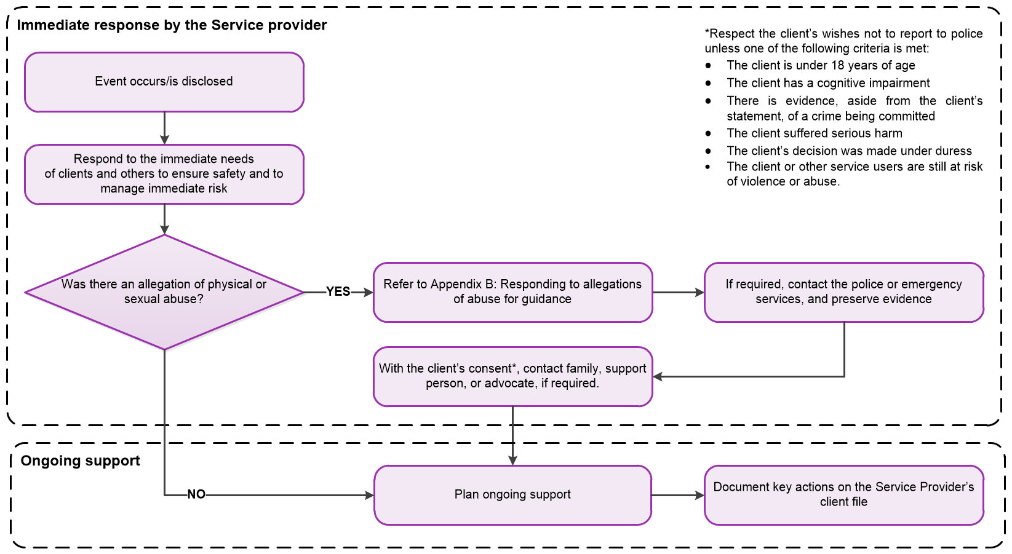
Figure 3: Immediate response process

Task 2.1.1: Putting yourself in the client’s shoes
Now that you’ve read about the roles and responsibilities in responding to client incidents under CIMS, let’s put the client and their experience of an incident at the very centre of your thinking.
By thinking more about the client’s perceptions following an incident (the column on the left side), we can clearly identify how to adapt our behaviour and approach (the column on the right side) in our immediate response to an incident, and in providing ongoing support.
Put yourself in the client’s shoes and think about a client incident you have just witnessed, reported or been a part of to complete the exercise below. You might like to complete this activity with a colleague or your manager.

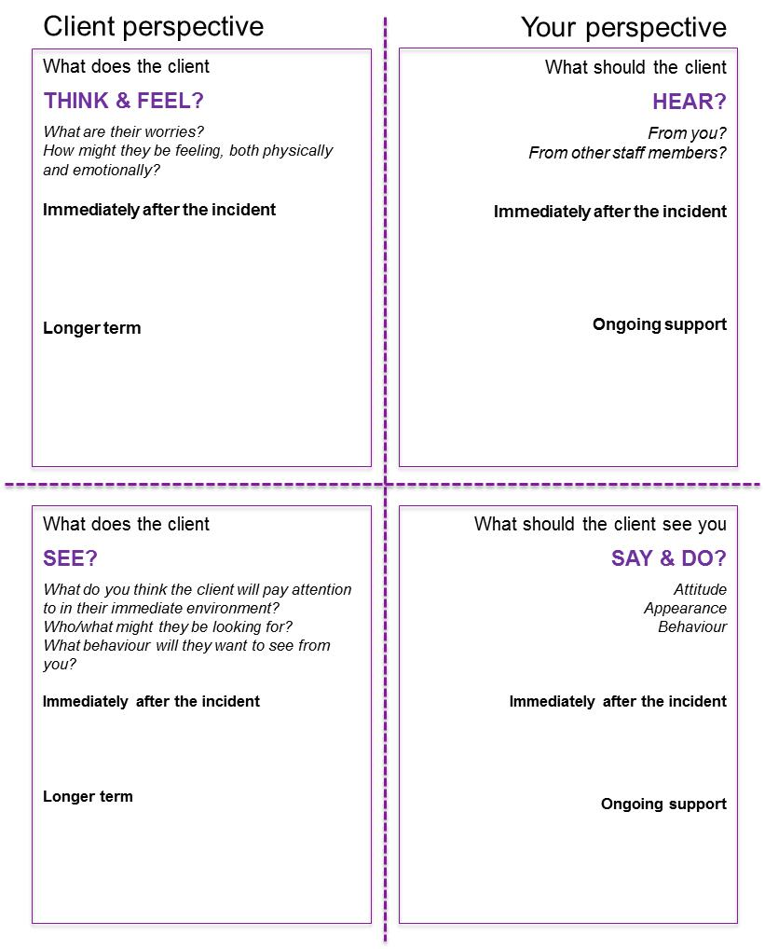

Learning 2.2: Client incident reporting

Reporting and classifying incidents
Incidents that must be reported through the CIMS are events that occur during service delivery and result in harm to the client.
There are two classifications of incidents for reporting purposes – major impact and non-major impact incidents.
Figure 4 shows the distinction between events that do not need to be reported in the CIMS, and non-major impact and major impact incidents (both of which must be reported in the CIMS).
Figure 4: Events, non-major impact incidents and major impact incidents

Task 2.2.1: Understanding incidents that should be reported in the CIMS
For each of the situations described below, indicate whether or not it would be classified as an incident and therefore need to be reported through CIMS.
Event | Yes / No
    - Mustafa is an employee for a service provider. While at work, a client accidentally closes the door forcefully on Mustafa’s foot and he suffers a broken toe as a result. The client is not injured.
    - Sahjee, a client, says she has been hit by a care worker at the residential share home where she lives.
    - A person with cancer, who has been attending a community palliative care day program, suddenly becomes very ill when at home over the weekend and is taken to hospital.
    - Staff notice that some belongings of a homeless man, including his cash card, have been stolen while he is staying at department-funded accommodation.
Refer to Self-check at the back of the module for answers.

Recap of definitions of client incident categories
Module 1 introduced the classification of major impact and non-major impact incidents and defined these categories. A reminder of this information is included below.
What determines whether an event is a major impact or non-major impact incident?
The service provider’s assessment of the level of harm to the client (the impact) determines whether it is reported as a major impact or non-major impact incident. The most senior staff member present must use their professional judgement to determine the impact an incident has had on a client. However, there are some incidents that must be reported and managed as major impact incidents .

Major impact | Non-major impact
- The unanticipated or unexpected deaths of clients, including suicides  - Severe physical, emotional or psychological injury or suffering that is likely to cause ongoing trauma  - A pattern of incidents related to one client that, when taken together, meet the level of harm to a client defined above. This may be the case even if each incident is a non-major impact incident | - Incidents that involve a client but result in minimal harm  - Incidents that cause physical, emotional or psychological injury or suffering, without resulting in a major impact  - Impacts to the client that do not require significant changes to care requirements, other than short-term interventions (for example, first aid, observation, talking interventions or short-term medical treatment)  - Incidents that do not otherwise meet the criteria for ‘major impact’
Table 2: Definitions of the client incident categories
Factors to consider when deciding whether harm to the client has resulted in a major impact or a non-major impact include specific client characteristics that might influence their experience of that incident. This is largely a matter of professional judgement. The decision should be made by a senior and experienced staff member.
Some questions to think about when assessing the impact of the incident include:
- Was the client physically, emotionally or psychologically harmed in the incident? If so, to what extent?
- What level of treatment or care did the client require because of the incident and what follow-up support is needed?
- Is the client still at risk of further harm from this incident; is it likely to happen again?
In addition, the characteristics and circumstances of the individual client need to be considered:
- Does the client’s age or intellectual and emotional development increase the likely severity of suffering and trauma experienced?
- Might issues associated with the client’s gender, culture or personal history increase the likely severity of suffering and trauma experienced?
- Does the balance of power or position or the relationship between the subject of an allegation and the victim affect the impact of the incident on the client; has there been a breach of a trusted relationship?
- Does the client’s individual intellectual and physical capacity, understanding of potential risks or communication skills affect how the incident impacts them?
- Does the client have a history of abuse, trauma or other factors that increases the impact of the incident? For example, abuse, poverty, homelessness, social isolation, history of discrimination or health status?

Incident types
Once an incident has been assessed as one of the two categories (major or non-major impact) it will also require determination of appropriate incident type. An incident type is a label used to signify the key aspect of how the incident affected the client.
There are 16 incident types. Of these, five must always be classified as a major impact incident, and a sixth will most often be classified as major impact. The other 10 can be classified as either major impact or non-major impact, depending on the level of harm to the client. See Appendix A: Definitions of incident types, for detailed definitions of these types of incidents.

Incident types that MUST be reported as major impact | Incident types that could be EITHER major impact or non-major impact
- Death (unexpected)  - Escape from a secure facility  - Physical abuse  - Sexual abuse  - Sexual exploitation | - Absent  - Dangerous actions – client  - Emotional/psychological abuse  - Inappropriate physical treatment  - Medication error  - Financial abuse  - Poor quality of care  - Injury  - Emotional/psychological trauma  - Inappropriate sexual behaviour  - Self-harm/attempted suicide
Table 3: Classification of incident types
For each incident report, one primary incident type must be selected. There is an option to add a secondary incident type (if required). For example, this might be relevant to record associated events that occurred as part of the incident.
Incident types must be classified for each client (if more than one is involved in an incident), reflecting the specific impact of the event on them.
When choosing a primary incident type, staff should choose the incident type that best describes the circumstance that caused the most impact on the client.
Each incident will require consideration of the client(s) iinvolved and the context to determine the right classification. Staff will need to draw on the content from this module and their professional judgement in determining the appropriate categorisation and classification of client incidents. If in any doubt, discuss with a supervisor or manager.

Reoccurring incidents and cumulative impacts that may meet the definition of a major impact incident
There may be a pattern of incidents related to one client that, taken together, are sufficient to meet the definition of a major impact incident. In these cases, the incident should be reported as a major impact incident. In making this determination, staff will need to rely on their professional judgement, their knowledge of the client and the context of the services being delivered. If in doubt, seek advice from a supervisor or manager.
Some clients may have a history of dangerous actions or behaviours that are well known and well documented. They are understood by the service provider and are being actively and effectively managed (for example, there is a current behaviour management or behaviour support plan in place). In such cases, the service provider may categorise further client incidents of such behaviour as non-major impact incidents unless the incident is linked to either of the following:
- an escalation in the severity or frequency of dangerous actions
- abnormal actions outside the known behavioural patterns of that client.

Task 2.2.2: Differentiating between major impact and non-major impact categorisations
Classify the following client incidents as either major impact or non-major impact by marking correct in the appropriate column.
Client incident | Major  impact | Non-major  impact
    - Harry lives in a department-funded residential home and is making offensive comments at the dinner table one evening to another client about their physical appearance, mocking them and laughing at them. A staff member brings it to Harry’s attention that his behaviour is unacceptable and asks him politely to modify his behaviour. Harry becomes very upset and subsequently goes to a supervisor, saying he believes he has been bullied by the staff member.
    - Talia is a client of a disability day program and breaks her thumb when she trips over while walking through a doorway of her service provider.
    - Farhad is a client at a drug and alcohol treatment centre. While at the centre, he spills some hot coffee on his hand, causing some immediate redness and pain. The staff treat the area immediately by holding it under cold water, and there does not appear to be any ongoing pain or other issues.
    - Edward, who is 92 years old, has been a client of an aged care facility for many years and has been in good health throughout the time he has been a client there. One afternoon, a staff member finds Edward deceased in his room.
    - Jessica is a client of a youth service. She walks into a room and sees another client attempting to commit suicide. She screams and alerts staff members nearby. They successfully intervene in the suicide attempt and the client is not physically harmed. Jessica, however, is trembling, crying and appears to be very traumatised by what she has seen.
Refer to Self-check at the back of the module for answers.

CIMS client incident register
All client incidents, both major impact and non-major impact, must be recorded in the service provider’s client incident register. Further information and e-learning modules about the client incident register can be found on the CIMS funded agency page <https://providers.dhhs.vic.gov.au/cims>.

Major impact incident reporting
The timelines and reporting requirements for major impact and non-major impact are different.
Service providers must report all major impact incidents to the department within three business days of the incident occurring or the service provider becoming aware of the incident.
Who completes the CIMS report for a major impact incident?
The most senior witness to the incident or, if there are no witnesses, the staff member to whom the incident has been disclosed, must complete the CIMS report as soon as possible after the incident (or disclosure).
Occasionally, there are impacts on more than one client from a single incident. In such cases, impacts must be recorded for all clients impacted under a single incident.
Figure 5 sets out the process for reporting major impact incidents in the CIMS.
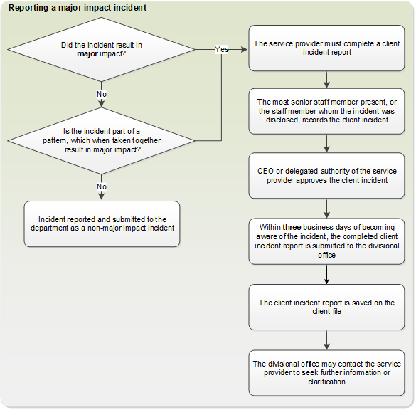
Figure 5: Reporting requirements for major impact incidents

Non-major impact incident reporting
Like major impact incidents, non-major impact incidents need to be reported to the department within three business days of occurring or being disclosed to the service provider.
How are non-major impact incidents reported?
Service providers must electronically report all non-major impact incidents to the department within three business of the incident occurring or the service provider becoming aware of the incident, submitting the incident report either using the department’s CIMS webform or via the service provider’s CIMS API-linked reporting system.
Staff should consult their supervisor or a manager if they are unclear on what their organisation uses for client management and record-keeping systems, or if they need more information about their organisation’s client incident register and associated processes.

Who signs the service provider’s non-major incident reports?
Non-major incident reports must be endorsed by the service provider’s chief executive officer (or senior delegate) before submission to the department’s divisional office. In endorsing, the service provider’s senior delegate is responsible for ensuring client incidents have been appropriately categorised as non-major impact, and that any patterns of non-major impact incidents that meet the cumulative harm threshold have been appropriately escalated.
If the service provider is part of the department, the relevant divisional child protection or area director must sign off the incident report.
Impacts on all clients should be recorded under a single incident (as per major impact incidents).
Figure 6 outlines the process for reporting non-major impact incidents.
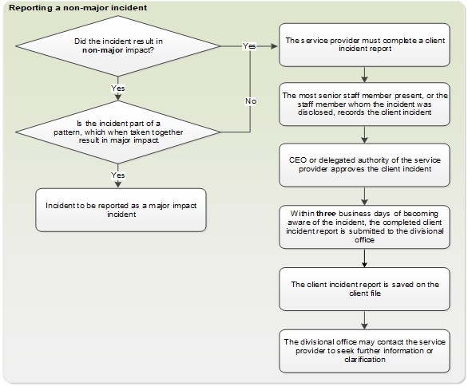
Figure 6: Process for reporting non-major impact incidents

Task 2.2.3: Case study – multiple incident types
Use the information provided in the following case study to classify the primary incident type for each client and then the category (major or non-major impact). You may also want to add a secondary incident type and category.

Case study
A bus is transporting nine children from the Refugee Minor Program on a field trip organised by a department-funded service provider. During the return journey there is an accident. The bus brakes were applied suddenly, as it hit the back of a stationary van at the traffic lights. One child is injured in the accident and is taken to the hospital to be treated for a broken arm. Another child requires basic first aid. All the children are somewhat shaken and upset by the accident and concerned for the child who has been injured. Some children appear more upset than others.
For guidance, refer to Appendix A: Definitions of incident types.
Client and description | Primary incident type | Major impact /  non-major impact | Secondary incident type  (optional) | Major impact /  non-major impact
Esra, 12, broken arm, in significant pain, crying and shaking
Peter, 11, swollen thumb and fingers from impact of crash, receives minor first aid, seems to be in good spirits otherwise
Evaku, 9, shaken and very concerned for Esra
Pierre, 11, very upset, crying for 20 minutes as staff and children console him
Sarah, 13, shaken but does not seem to be too upset, reports to be OK
Adfa, 10, reports to be OK, consoling Pierre
Burim, 9, reports to be OK, consoling Pierre
Vado, 11, shaken but does not seem to be too upset, reports to be OK

Learning 2.3: Working with ‘shared clients’
A shared client is someone who is supported by multiple services simultaneously.
The service provider who delivers the most support (has the most responsibility) for the client is called the lead provider. However, all services are equally accountable for ensuring the safety, health and wellbeing of any client they are involved with, whether shared or not.
For a shared client, which service provider is responsible for managing and reporting incidents involving a shared client?
The service provider who first becomes aware of the incident is responsible for ensuring the client’s immediate safety and for completing the incident report. However, a more appropriate service provider might take on this role by mutual agreement.
Where a shared client is involved, the following questions might help inform decisions about which service provider should take the responsibility for preparing and submitting a CIMS incident report:
- Does the client incident have a direct and obvious relationship to, and impact on, the delivery of one service?
- Is each service provider involved required to report the incident? For example, are all service providers subject to CIMS reporting requirements? If not, an agency with responsibility for the client and a requirement to report under the CIMS must take responsibility for the report.
If the service provider that first becomes aware of an incident is not sure who the lead service provider is, they should contact their divisional office for guidance.
In the majority of cases, the service provider responsible for completing the CIMS incident report is also responsible for discharging the other CIMS obligations regarding incident investigation, review and data analysis. Where a client has disclosed an incident that occurred during the service delivered by another provider, the reporting provider should contact the divisional office for guidance.

Notifying other service providers
Client privacy and confidentiality is important. However, there are situations where personal or health information relating to a client incident needs to be shared between service providers, to respond effectively to an incident and manage an incident.
When should information about a client be shared with other service providers?
Information should be disclosed when necessary to prevent or lessen a serious risk to the safety and wellbeing of a client or clients. It should also be disclosed where either of the following apply:
- There are multiple service providers and clients involved in an incident.
- An incident occurs involving a client who is using services offered through a consortium of service providers, and other service providers within the consortium need to know.
Another example is where a contractor or external organisation is participating in, or leading, an incident investigation or review and they need information disclosed to properly investigate or review the incident.
Only information specific to the management of the incident and the client’s ongoing safety and support should be shared. When sharing information, service providers need to consider the best interests of the client and their obligations with regard to privacy.

Learning 2.4: Completing the report
For any event that occurs during service delivery and results in harm to a client, an incident must be reported using the CIMS IT incident report webform. Details on using the incident report webform are available in the CIMS e learning modules.
The report must be filled out by the most senior witness to the incident, or if there were no witnesses, the staff member who was first told about the incident.

Writing effective incident reports
The quality of the response to the incident ensures that information is captured in a way that it can be used for the future safety of the client and others involved.
A good report will be:
- well-organised – for example, use subheadings or a timeline
- factual – you can include your observations, but be clear about what you saw, or were told. If you do not know about a part of the incident, say so; do not try and fill in the gaps
- complete – do not leave out any details
- respectful – write it as if the client or a family member was going to read about the incident
- concise – keep to the point
- objective – state what happened; be careful not to use emotive words or phrases
- accurate and specific.

Information required for incident reports
The information needed in an incident report is similar across all client incident types. However, the amount of detail submitted to the divisional office will vary depending on whether the incident is a major impact or non-major impact incident.
All incident reports, for major or non-major impact incidents, must contain the necessary factual details including but not limited to:
- description of the incident
- client(s) identification number (must be provided if applicable)
- client(s) name
- client(s) gender
- client(s) Aboriginal or Torres Strait Islander status
- client(s) date of birth
- how each client is involved (for example, participant, witness or victim)
- staff/carer(s) involved name (if applicable)
- how each staff/carer is involved (for example, participant, witness, victim or subject of the allegation)
- date and time of incident
- date and time incident disclosed
- primary incident type (and secondary incident type if applicable)
- incident classification (major impact/non-major impact) for each client impacted
- address/location of incident
- immediate action taken in response to the incident
- planned follow-up actions in response to the incident
- immediate safety needs of the client met? (yes, no, not applicable)
- medical attention required? (yes, no, not applicable)
- police contacted? (yes, no, not applicable).
For the full list of data fields, please refer to the Client incident management guide, Appendix E: Client incident register data fields.
What information is required in the report summary?
Both non-major impact and major impact incidents must include the following:
- a detailed description of the incident
- details of the immediate action taken in response to the incident
- plans for follow-up actions in response to the incident.

Is any additional information required for incidents?
A senior management representative of the service provider must complete the incident report with:
- a brief description of the incident
- a quality check of the client incident report – ensuring that appropriate incident type, category, client and location details are recorded.

Sector application
The aim of this section is to apply learnings to the relevant sectors. A selection of case studies is provided. Responses may be reviewed against the self-check section at the end of Module 2.

Case study 1: Homeless sector

Introducing Zeb
You will remember Zeb from Module 1.
Brookfield is an outreach program that provides assertive outreach to people who are sleeping rough in Melbourne. Zeb is a 40-year-old client who has been difficult to contact over the past week. Two staff members, Josephine and Bill, decide to visit him in in the park where he normally sleeps.

The incident
Josephine and Bill find Zeb in the park at 6.00 am. He appears to be intoxicated, with two empty casks of wine nearby. He is shaking uncontrollably and says that he has considerable pain in his abdomen. Josephine calls an ambulance while Bill reassures Zeb and monitors his condition.
The ambulance arrives and the paramedics assess Zeb and suggest that he needs to go to hospital. Zeb refuses initially, but after some discussion with Josephine and Bill, agrees to go. An hour later, Bill rings the hospital and is told that Zeb has been admitted to a ward for observation.
Zeb is offered short-term accommodation following his discharge from hospital. Zeb refuses this offer, but agrees to accept a daily visit from the Brookfield outreach workers in the park while the service continues to try to find him appropriate long-term accommodation.

Questions
Read through the questions below, which refer to Case study 1. Using your knowledge of the CIMS, complete the boxes. If you are not sure, talk with a colleague or your line manager.
Would you report this incident as a major impact or non-major impact incident? | Yes/No
Major impact
Non-major impact

What is your rationale for deciding to report this incident as a major impact or non-major impact incident?

What incident type would you report this under (noting you can list up to two incident types)?

Case study 2: Child protection sector

Introducing Katie
You will remember Katie from Module 1.
Katie is 13 years old and lives in a four-bedroom residential care unit run by a community service organisation. It is recorded on Katie’s file that six months prior to coming under the care of this organisation, she was a victim of sexual abuse and had trouble settling into multiple foster care arrangements. It is also noted that Katie is very vulnerable to sexual exploitation.

The incident
On Monday night Katie tells Li, the residential care worker, that an older man in his forties had been chatting with her at the bus stop. He asked her some personal questions about where she lived and whether she had tried smoking marijuana before. Just before her bus arrived, Katie stated, she had given her mobile phone number to him.
Katie told Li that the man had been sending her text messages all afternoon. Li was immediately concerned about the appropriateness of the man contacting Katie and the nature of their interactions. Li asked Katie if he could view the text messages they had exchanged, which Katie allowed him to do. The text messages were sexually suggestive in nature and the man had asked Katie to tell him about her sexual experience. He had also shared some of his sexual fantasies with her.
Katie leaves the placement with another client later that afternoon, advising they are going to the shops. Katie returns that evening and she informs Li that she met the man at the local train station and that he sexually assaulted her.
Li contacts the local police, his organisation’s on-call service and child protection after hours. The police come to the facility and interview Katie. They take her to receive medical treatment and take her mobile phone so they can follow up any leads.

Questions
Read through the questions below, which refer to Case study 2. Using your knowledge of the CIMS, complete the boxes. If you are not sure, talk with a colleague or your line manager.
Would you report this incident as a major impact or non-major impact incident? | Yes/No
Major impact
Non-major impact

What is your rationale for deciding to report this incident as a major impact or non-major impact incident?

What incident type would you report this under (noting you can list up to two incident types)?

Case study 3: Community mental health

Introducing Tina
You will remember Tina from Module 1.
Tina is a young woman in her early twenties; her parents died when she was 14 and she now lives with her grandfather. Tina was diagnosed with an anxiety disorder when she was 18 and has recently started experiencing panic attacks. Her grandfather and her close friend Ping Wang, whom she has known since her early school days, are her main supports.
Tina’s grandfather came with her to the Chapman Community Mental Health Service because Tina’s anxiety had reached a point where her life was really impacted, and she has taken a leave of absence from her part-time job. Tina has stopped going anywhere that’s crowded or enclosed, including places she used to enjoy like shopping centres and cinemas, and she finds using public transport really hard.
Tina was allocated a counsellor from the service – Fabio Santamaria. Fabio is a practicing psychologist who works with people experiencing anxiety and depression. Fabio’s treatment plan has included accompanying Tina and her grandfather to a cafe and the supermarket. At these outings, he has helped Tina to implement the strategies they have worked on, including identifying triggers for her anxiety and responding with actions like regulating her breathing and thinking processes. Tina is making progress and has gone back to her part-time job. Tina’s really pleased with the improvements she’s making and continues to attend regular sessions with Fabio.

The incident
Ping Wang, Tina’s friend, contacted the Chapman Community Mental Health Service Director, Chris Rogers, to raise concerns about Fabio’s relationship with Tina. She alleges that Fabio has been offering support that is outside his role, including taking Tina to a cafe and to the movies.
Ping advises that Tina has told her that Fabio is always very friendly and that she thought he was very handsome. Ping is aware that Fabio has also invited Tina to the football this weekend. Ping had asked if she could come with them but Tina told her that Fabio said, ‘it would be better if it was just the two of them’. Ping is worried that Fabio might be exploiting her friend and that his approach isn’t professional.

Questions
Read through the questions below, which refer to Case study 3. Using your knowledge of the CIMS, complete the boxes. If you are not sure, talk with a colleague or your line manager.
Would you report this incident as a major impact or non-major impact incident? | Yes/No
Major impact
Non-major impact

What is your rationale for deciding to report this as a major or non-major impact incident?

What incident type would you report this under (noting you can list up to two incident types)?

Case study 4: Disability sector

Introducing Frank
You will remember Frank from Module 1.
Frank is a 45-year-old man with Down syndrome. Frank lives with four other people in a five-bedroom group home located in the community.

The incident
On Monday, while Frank was attending a day service outing run by the local activity centre, he was required to walk down a flight of stairs. Frank was very hesitant about taking the stairs as he finds stairs hard to navigate. A new staff member, Maurizio, held Frank’s hand encouraging him to take care with the steps. Despite Maurizio’s assistance, Frank lost his balance and fell down the stairs. Frank was in significant pain and it appeared he had broken his leg.
Maurizio called an ambulance while another staff member comforted Frank and monitored his condition. The ambulance arrived, and the paramedics took Frank to the local hospital where it was confirmed that he had broken his leg. Frank was treated at the hospital and was able to return to the group home that evening. It is expected he will make a full recovery.

Questions
Read through the questions below, which refer to Case study 4. Using your knowledge of the CIMS, complete the boxes. If you are not sure, talk with a colleague or your line manager.
Would you report this incident as a major impact or non-major impact incident? | Yes/No
Major impact
Non-major impact

What is your rationale for deciding to report this incident as a major impact or non-major impact incident?

What incident type would you report this under (noting you can list up to two incident types)?

Summary

Module 2: Responding to and reporting client incidents
- Responding to a client incident
      - What is a client incident?
An event or circumstance that occurs during service delivery and results in harm to a client.
      - What is the immediate response to a client incident?
The first priority is ensuring the safety, health and wellbeing of the client(s) involved. Staff also need to consider their own safety and wellbeing and that of any others involved.
      - Which incidents need to be reported to Victoria Police?
Under the CIMS, all suspected crimes must be reported to Victoria Police, including any allegations of sexual, physical or financial abuse, sexual exploitation or significant quality of care concerns that allege neglect of the client.
      - Who has to make the report to Victoria Police?
Who should contact the police will depend on a number of factors, including the seriousness, immediacy and nature of the event. For example, in a situation unfolding immediately, such as an attack or an accident where emergency services are required straight away, the police should be contacted urgently by whoever at the scene is able to do so quickly. On other occasions, staff will follow organisational policies and procedures and report concerns to a manager who will follow up with the police at a later time (for example, in a suspected case of financial abuse).
      - What if the client does not want a matter reported to police?
While it is important to respect the wishes of clients, sometimes there is no option but to make a report to police. If the client does not wish to report the matter to Victoria Police, and they have the capacity to make this decision, this wish should be respected where possible. However, if the incident meets certain criteria, it must be reported to the police.
      - What about support after the incident?
An important part of client incident management is providing ongoing support. This should take into account any others who should be involved in the process, while always ensuring you respect the client’s right to privacy.
      - When can a client’s personal and health information be shared?
A client’s personal and health information should only be disclosed or shared among service providers as is allowed by law and considering the client’s safety, wishes and best interests. If in doubt, check with your line manager.
      - When responding to an incident, how long are staff required to be involved?
Service provider staff are responsible for maintaining a safe environment for the client(s) from the moment they identify and respond to an incident until they have ensured that the client is out of harm’s way. Once the client’s safety has been ensured, staff are also responsible for ensuring that the appropriate next step is undertaken as per the CIMS requirements. That is, they are responsible for notifying a manager of the incident and reporting the incident.

- Client incident reporting
      - What determines whether an event is a major impact or non-major impact incident?
It is the level of harm to the client (the impact) that determines whether it is a major impact or non-major impact incident. The most senior staff member present must use their professional judgement to determine the impact an incident has on a client. However, there are some incidents which must be reported as a major impact incident, for example, an allegation of sexual abuse.
      - How do reporting timeframes differ between major impact and non-major impact incidents?
There is no difference. Major and non-major impact incidents both need to be reported to the department within 3 business days of the incident occurring or the service provider becoming aware of the incident.
      - Who completes the CIMS report for a major impact incident?
The most senior witness to the incident or, if there are no witnesses, the staff member to whom the incident has been disclosed, must complete the CIMS report as soon as possible after the incident (or disclosure).
- Working with shared clients
      - Which service provider is responsible for managing and reporting incidents involving a shared client?
The service provider who first becomes aware of the incident is responsible for ensuring the client’s immediate safety and for completing the incident report. However, a more appropriate service provider might take on this role by mutual agreement.
      - When should information about a client be shared with other service providers?
Information should be disclosed when necessary to prevent or lessen a serious risk to the safety and wellbeing of a client or clients. It should also be disclosed where either of the following apply:
- There are multiple service providers and clients involved in an incident.
- An incident occurs involving a client who is engaging with services offered through a consortium of service providers, and other service providers within the consortium need to know.
Another example is where a contractor or external organisation is participating in, or leading, an incident investigation or review and they need information disclosed to properly investigate or review the incident.
Please refer to your organisation’s policies regarding the sharing of client information.
      - What client personal and health information should be shared?
Only information specific to the management of the incident and the client’s ongoing safety and support should be shared.

- Completing the incident report
      - What information is required in the report summary?
Both major impact and non-major impact incidents must include a summary containing the following:
- a detailed description of the incident
- details of the immediate action taken in response to the incident
- plans for follow-up actions in response to the incident.
      - Is any additional information required for major impact incidents?
A senior management representative of the service provider must complete the major impact incident report with:
- a brief description of the incident
- a quality check of the client incident report – ensuring that appropriate incident type, category, client and location details are recorded.

Self-check

Tasks – expected responses
Check your understanding of the tasks given during the module against the expected responses below.

Task 2.2.1: Understanding incidents that should be reported in the CIMS
Event | Yes / No
- Mustafa is an employee for a service provider. While at work, a client accidentally closes the door forcefully on Mustafa’s foot and he suffers a broken toe as a result. The client is not injured. | No
- Sahjee says she has been hit by a care worker at the residential share home where she lives. | Yes
- A person with cancer, who has been attending a community palliative care day program, suddenly becomes very ill when at home over the weekend and is taken to hospital. | No
- Staff notice that some belongings of a homeless man, including his cash card, have been stolen while he is staying at department-funded accommodation. | Yes
See Appendix A: Definitions of incident types, and the Client incident management guide, Section 3.3.

Task 2.2.2: Differentiating between major impact and non-major impact categorisations
To determine the appropriate reporting of each of these incidents, the service provider must assess the individual impact on the clients involved. Responses below are indicative only.
Client incident | Major  impact | Non-major  impact
- Harry lives in a department-funded residential home and is making offensive comments at the dinner table one evening to another client about their physical appearance, mocking them and laughing at them. A staff member brings it to Harry’s attention that his behaviour is unacceptable and asks him politely to modify his behaviour. Harry becomes very upset and subsequently goes to a supervisor, saying he believes he has been bullied by the staff member. |  | Non-major  impact
- Talia is a client of a disability day program and breaks her thumb when she trips over while walking through a doorway of her service provider. |  | Non-major  impact
- Farhad is a client at a drug and alcohol treatment centre. While at the centre, he spills some hot coffee on his hand, causing some immediate redness and pain. The staff treat the area immediately by holding it under cold water, and there does not appear to be any ongoing pain or other issues. |  | Non-major  impact
- Edward, who is 92 years old, has been a client of an aged care facility for many years and has been in good health throughout the time he has been a client there. One afternoon, a staff member finds Edward dead in his room. | Major impact
- Jessica is a client of a youth service. She walks into a room and sees another client attempting to commit suicide. She screams and alerts staff members nearby. They successfully intervene in the suicide attempt and the client is not physically harmed. Jessica however, is trembling, crying and appears to be very traumatised by what she has seen. | Major impact
See Appendix A: Definitions of incident types, and the Client incident management guide, Section 3.3.

Task 2.2.3: Case study – multiple incident types
To determine the appropriate reporting of each of these incidents, the service provider must assess the individual impact on the clients involved. Responses below are indicative only.
Client and description | Primary incident type | Major impact /  non-major impact | Secondary incident type  (optional) | Major impact /  non-major impact
Esra, 12, broken arm, in significant pain, crying and shaking | Injury | Major | Emotional/ psychological trauma | Major
Ari, 11, swollen thumb and fingers from impact of crash, receives minor first aid, seems to be in good spirits otherwise | Injury | Non-major
Evaku, 9, shaken and very concerned for Esra | Emotional/ psychological trauma | Non-major
Pierre, 11, very upset, crying for 20 minutes as staff and children console him | Emotional/ psychological trauma | Major
Zarah, 13, shaken but does not seem to be too upset, reports to be OK | Emotional/ psychological trauma | Non-major
Adfa, 10, reports to be OK, consoling Pierre | Not classified as an incident as the incident has not had any significant impact on Adfa
Burim, 9, reports to be OK, consoling Pierre | Not classified as an incident as the incident has not had any significant impact on Burim
Vado, 11, shaken but does not seem to be too upset, reports to be OK | Not classified as an incident as the incident has not had any significant impact on Vado
See Appendix A: Definitions of incident types, and the Client incident management guide, Section 3.3.

Case studies – expected responses
Check your understanding of the case study selected against the expected responses below.

Case study 1: Homeless sector

The incident
Josephine and Bill find Zeb in the park at 6.00 am. He appears to be intoxicated, with two empty casks of wine nearby. He is shaking uncontrollably and says that he has considerable pain in his abdomen. Josephine calls an ambulance while Bill reassures Zeb and monitors his condition.
The ambulance arrives and the paramedics assess Zeb and suggest that he needs to go to hospital. Zeb refuses initially, but after some discussion with Josephine and Bill, agrees to go. An hour later, Bill rings the hospital and is told that Zeb has been admitted to a ward for observation.
Zeb is offered short-term accommodation following his discharge from hospital. Zeb refuses this offer, but agrees to accept a daily visit from the Brookfield outreach workers in the park while the service continues to try to find him appropriate long-term accommodation.

Questions/answers
Would you report this incident as a major impact or non-major impact incident? | Yes/No
Major impact | No
Non-major impact | Yes

What is your rationale for deciding to report this incident as a major impact or non-major impact incident?
Although Zeb was admitted to hospital, this was for observation only, and upon discharge it appears that this incident has not caused major harm to him.

What incident type would you report this under (noting you can list up to two incident types)?
Dangerous actions – client

Case study 2: Child protection sector

The incident
On Monday night Katie tells Li, the residential care worker, that an older man in his forties had been chatting with her at the bus stop. He asked her some personal questions about where she lived and whether she had tried smoking marijuana before. Just before her bus arrived, Katie stated, she had given her mobile phone number to him.
Katie told Li that the man had been sending her text messages all afternoon. Li was immediately concerned about the appropriateness of the man contacting Katie and the nature of their interactions. Li asked Katie if he could view the text messages they had exchanged, which Katie allowed him to do. The text messages were sexually suggestive in nature and the man had asked Katie to tell him about her sexual experience. He had also shared some of his sexual fantasies with her.
Katie leaves the placement with another client later that afternoon, advising they are going to the shops. Katie returns that evening and she informs Li that she met the man at the local train station and that he sexually assaulted her.
Li contacts the local police, his organisation’s on-call service and child protection after hours. The police come to the facility and interview Katie. They take her to receive medical treatment and take her mobile phone so they can follow up any leads.

Questions/answers
Would you report this incident as a major impact or non-major impact incident? | Yes/No
Major impact | Yes
Non-major impact | No

What is your rationale for deciding to report this incident as a major impact or non-major impact incident?
Allegation of sexual abuse – mandatory major impact incident

What incident type would you report this under (noting you can list up to two incident types)?
Sexual abuse
Emotional/psychological trauma

Case study 3: Community mental health

The incident
Ping Wang, Tina’s friend, contacted the Chapman Community Mental Health Service Director, Chris Rogers, to raise concerns about Fabio’s relationship with Tina. She alleges that Fabio has been offering support that is outside his role, including taking Tina to a cafe and to the movies.
Ping advises that Tina has told her that Fabio is always very friendly and that she thought he was very handsome. Ping is aware that Fabio has also invited Tina to the football this weekend. Ping had asked if she could come with them but Tina told her that Fabio said, ‘it would be better if it was just the two of them’. Ping is worried that Fabio might be exploiting her friend and that his approach isn’t professional.

Questions/answers
Would you report this incident as a major or non-major impact incident? | Yes/No
Major impact | No
Non-major impact | Yes

What is your rationale for deciding to report this incident as a major or non-major impact incident?
Inappropriate sexual behaviour – always non-major impact. The concern about Fabio’s relationship with Tina relates an allegation that the intimacy of the relationship has extended beyond appropriate and acceptable professional boundaries. There is no allegation of sexual abuse at this time.

What incident type would you report this under (noting you can list up to two incident types)?
Inappropriate sexual behaviour.

Case study 4: Disability sector

The incident
On Monday, while Frank was attending a day service outing run by the local activity centre, he was required to walk down a flight of stairs. Frank was very hesitant about taking the stairs as he find stairs hard to navigate. A new staff member, Maurizio, held Frank’s hand encouraging him to take care with the steps. Despite Maurizio’s assistance, Frank lost his balance and fell down the stairs. Frank was in significant pain and it appeared he had broken his leg.
Maurizio called an ambulance while another staff member comforted Frank and monitored his condition. The ambulance arrived and the paramedics took Frank to the local hospital where it was confirmed that he had broken his leg. Frank was treated at the hospital and was able to return to the group home that evening. It is expected he will make a full recovery.

Questions/answers
Would you report this incident as a major or non-major impact incident? | Yes/No
Major impact | Yes
Non-major impact | No

What is your rationale for deciding to report this incident as a major or non-major impact incident?
The fall resulted in Frank breaking his leg.

What incident type would you report this incident under (noting you can list up to two incident types)?
Injury

Appendix A: Definitions of incident types
The table below, Definitions of incident types, is taken from Appendix A of the Client incident management guide.
Table A1: Definitions of incident types
Incident type | Definition | Always major impact  (Incidents that must always be categorised as major impact) | Generally non-major impact  (Any additional guidance on incident types that should generally be classified as  non-major impact)
Absent client | A client is unexpectedly absent from the service or absent without authorisation and there are concerns for their safety. | Use categorisation processes as per section 3.3. | Use categorisation processes as per section 3.3.
Escape from a secure facility | This type only applies to clients in custodial care and/or disability services clients subject to compulsory treatment or judicial orders. This incident type includes:  - a client escaping a centre with defined boundaries  - failure of a client to return from temporary leave. | Successful escape by clients in disability services. Clients subject to compulsory treatment or judicial orders must be reported as a major impact incident. | Use categorisation processes as per section 3.3.
Dangerous actions – client | Dangerous actions that cause client harm or place the client at risk of harm. This includes:  - dangerous actions as a result of the misuse of drugs, alcohol or other substances  - high-risk activities such as arson or train surfing  - sexually oriented actions by a client in circumstances that place their safety at risk. | Use categorisation processes as per section 3.3. | - Dangerous actions by vulnerable clients that are understood and being actively case-managed by the service provider are not major impact incidents. This does not apply to dangerous actions which are:  - an escalation in the severity or frequency of dangerous actions; or  - abnormal actions outside the known behavioural patterns of that client.  - Legal, consensual, sexually oriented actions that do not impact on client safety or put client safety at risk do not meet the definition of an incident.
Death | The death of a client during service delivery where the death is unanticipated or unexpected. This includes death as a result of the use or misuse of drugs, alcohol or other substances. | All deaths of clients in unexpected or unanticipated circumstances, including suicides, must be reported as major impact. | Client deaths as the consequence of the progression of a diagnosed condition or illness are not reportable as a client incident unless the death occurred in a disability residential service.
Emotional/ psychological abuse | Actions or behaviours that reject, isolate, intimidate, or frighten by threats, or the witnessing of family violence, to the extent that the client’s behaviour is disturbed or their emotional/ psychological wellbeing has been, or is at risk of being, seriously impaired. This includes:  - rejecting, isolating, terrorising and ignoring behaviours  - denying cultural or religious needs and preferences  - emotional abuse perpetrated by other clients.  You should consider any potential power imbalance between the client and the person engaging in the behaviour. | Allegations of emotional/psychological abuse of a client by a staff member, volunteer carer or member of the carer’s household are usually classified as major impact. However, there may be circumstances of a minor nature which are not major impact – use of professional judgement is required based on the categorisation process outlined in section 3.3. | There may be circumstances which meet the adjacent definition but are of a minor nature which are not major impact – use of professional judgement is required based on the categorisation process outlined in section 3.3.
Emotional/ psychological trauma | A reaction or set of reactions that develop in a client because they have witnessed, heard, or otherwise been exposed to, a traumatic event which has threatened the client’s life or safety, or that of others around them. As a result, the person experiences feelings of intense anxiety, fear or helplessness. This includes (but is not limited to) the witnessing of catastrophic events such as the severe injury or death of a close family member or friend or the diagnosis of a life-threatening condition. | Use categorisation process outlined in section 3.3. | Use categorisation process outlined in section 3.3.
Financial abuse | The misuse of a client’s assets, property, possessions and finances without their consent. It includes:  - denying a client the use of their own assets, property, possessions and finances  - theft, fraud, exploitation and pressure in relation to assets, property, possessions and finances  - obtaining assets through deception.  This also includes financial abuse perpetrated by other clients. | Allegations of financial abuse of a client by a staff member, volunteer carer or member of the carer’s household are usually classified as major impact. However, there may be circumstances of a minor nature which are not major impact – use of professional judgement is required based on the categorisation process outlined in section 3.3. | There may be circumstances which meet the adjacent definition but are of a minor nature which are not major impact – use of professional judgement is required based on the categorisation process outlined in section 3.3.
Inappropriate physical treatment | Actions that involve the inappropriate use of physical contact or force against a person that result in non-major impact harm to the client. This includes impact resulting from:  - threats of physical abuse made to a client by another person  - excessive use of physical force or restraint by a staff member.  Inappropriate physical treatment does not include an act or omission that constitutes a lawful exercise of force, such as the lawful and duly authorised use of physical restraint. | All incidents which meet this definition should be classified as ‘non-major impact’ unless the incident is linked to:  - an escalation in the severity or frequency of dangerous actions; or  - abnormal actions outside the known behavioural patterns of that client.  Where the level of harm to the client is a major impact, the incident must be reported instead as physical abuse – see below for definition. Use of professional judgement is required based on the categorisation process outlined in section 3.3. | All incidents which meet this definition should be classified as ‘non-major impact’ unless the incident is linked to:  - an escalation in the severity or frequency of dangerous actions; or  - abnormal actions outside the known behavioural patterns of that client.
Inappropriate sexual behaviour | Actual or attempted unwanted sexual actions (or allegations of such actions) that result in non-major impact harm to the client, unless the relevant behaviour meets the definition of sexual abuse, in which case it must always be reported as major impact (see definition below). | All incidents which meet this definition should be classified as ‘non-major impact’ unless the incident is linked to:  - an escalation in the severity or frequency of dangerous actions; or  - abnormal actions outside the known behavioural patterns of that client.  Where the level of harm to the client has a major impact nature, the incident must be reported instead as sexual abuse – see below for definition. Use of professional judgement is required based on the categorisation process outlined in section 3.3. | All incidents which meet this definition should be classified as ‘non-major impact’ unless the incident is linked to:  - an escalation in the severity or frequency of dangerous actions; or  - abnormal actions outside the known behavioural patterns of that client.
Injury | Actions or behaviours that unintentionally cause harm which requires first aid or medical attention. Includes both explained and unexplained injuries. | Use categorisation process outlined in section 3.3. | Use categorisation process outlined in section 3.3.
Medication error | Refers to any error in the administration of a client’s prescribed medication, where the service provider is responsible for such administration. Includes:  - the administration of incorrect medication  - missed medication  - the incorrect or unauthorised administration of PRN (from the Latin ‘pro re nata’) restraint medication  - psychotropic medicines misuse  - client refusal of prescribed or authorised medication  - pharmacy error (an error in the dispensing of medication). | Misuse of psychotropic medicines administered by a staff member must be reported as major impact. | Use categorisation process outlined in section 3.3.
Physical abuse | Actions that involve the inappropriate use of physical contact or force against a person that result in major impact harm to the client. This includes impact resulting from:  - threats of physical abuse made to a client by another person  - excessive use of physical force or restraint by a staff member  - physical abuse perpetrated by other clients, as well as by caregiver or staff.  Physical abuse does not include an act or omission that constitutes a lawful exercise of force, such as the lawful and duly authorised use of physical restraint. | All incidents of physical abuse must be reported as major impact.  - Where the level of harm to the client has a non-major impact to the client, the incident must be reported instead as inappropriate physical treatment – see above for definition.  - Use of professional judgement is required based on the categorisation process outlined in section 3.3. | All incidents of physical abuse must be reported as major impact.  - Where the level of harm to the client has a non-major impact to the client, the incident must be reported instead as inappropriate physical treatment – see above for definition.  - Use of professional judgement is required based on the categorisation process outlined in section 3.3.
Poor quality of care | Inappropriate or inadequate care by caregivers or staff in the context of service delivery.  Note: Abuse by a caregiver or staff member should be categorised under the sexual abuse, physical abuse, emotional/psychological abuse or financial abuse types. | Neglect of a client must be reported as a major impact incident. Neglect is the failure to care adequately for a client to the extent that the health, wellbeing and development of the client is significantly impaired or at risk. | Use the categorisation process outlined in section 3.3.
Self-harm / attempted suicide | - Actions that intentionally cause harm or injury to self  - Actions to attempt suicide (the intention to end one’s own life). | Attempted suicide must be reported as a major impact incident. | Use the categorisation process outlined in section 3.3.
Sexual abuse | Actual or attempted unwanted sexual actions (or allegations of such actions) that result in major impact harm to the client or which are otherwise forced upon a client against their will or without their consent, through the use of physical force, intimidation and/or coercion. | All incidents of sexual abuse must be reported as major impact.  Examples may include (regardless of level of harm or perceived harm to client):  - all allegations of rape, which is the actual or attempted penetration or attempted penetration (anal, oral, vaginal) through the use of physical force, intimidation and/or coercion without that person’s consent  - sexual abuse of a child by another child. | All incidents of sexual abuse must be reported as major impact.
Sexual exploitation | Sexual exploitation, defined as the abuse of a person under 18 or a person with a cognitive disability, which may include:  - the exchange of sex or sexual acts for money, goods, substance or favours  - involving a child in creating pornography  - contact with known sex offender. | All incidents of sexual exploitation must be reported as major impact. | All incidents of sexual exploitation must be reported as major impact.

Evaluation form
Module 2: Responding to and reporting client outcomes
Please help us improve this self-paced learning module by responding candidly to the following statements, using a five-point scale where:
1 = Strongly disagree; 2 = Disagree; 3 = Neither agree nor disagree; 4 = Agree; 5 = Strongly agree
By the end of this self-paced learning module, I had a good understanding of the requirements for responding to and reporting client incidents in the CIMS | 1 | 2 | 3 | 4 | 5
The content was easy to understand, and the activities useful and easy to follow | 1 | 2 | 3 | 4 | 5
There was enough information about where I could find out more about the CIMS | 1 | 2 | 3 | 4 | 5
Overall, the self-paced learning module was informative and provided a sufficient overview of the CIMS | 1 | 2 | 3 | 4 | 5
What did you like most about this self-paced learning module?
How can we improve this self-paced learning module?
Any other comments:
Please provide your contact details if you would like to discuss your response:
Name | Email | Telephone number
Please send this form to CIMS Learning <CIMS.Learning@dhhs.vic.gov.au>.

