

|  |
| --- |
| Acknowledgment and publicity guidelines for Victorian Government funding support |
| For organisations funded under the Service Agreement by the Department of Health and Human Services, the Department of Education and Training (Early Childhood area and the Adult and Community Further Education Board) and the Department of Justice and Regulation. |

Contents

Introduction 1

Keeping the funding confidential 2

Format of acknowledgement 2

Written acknowledgement statement of Victorian Government funding 2

Brand Victoria logo 3

Events/conferences/launches 5

Further information 5

Department of Health and Human Services 5

Department of Education and Training 5

# Introduction

Under clause 4.17 of the Service Agreement or under a short form agreement, organisations must acknowledge the funding support provided by the Victorian Government for the services funded.

This acknowledgement must be made in:

* publications and publicity related to services funded – for example, websites, media releases, print and electronic documents and speeches/launches
  + an organisation’s annual report.

**Please note:** No acknowledgement is required for general administrative notices or messages such as weekly newsletters relating to operational aspects of the business. These guidelines are focused on publications that directly relate to services funded by the Victorian Government.

By acknowledging this support, organisations are informing the community about how public funding is spent.

This change is not retrospective. Only publications or publicity developed, revised or updated after 18 March 2013 need to include this funding acknowledgement. Existing publications or publicity does not need to be revised to include this acknowledgment, until the content of the document is updated for other purposes.[1]

Unless otherwise specified in any other applicable departmental policy or schedules to an organisation’s Service Agreement, the acknowledgment requirements listed in this document are required to be followed.

Some services have program specific acknowledgement requirements described in other applicable departmental policies or schedules to an organisation’s Service Agreement (including, youth programs, men’s sheds and the Home and Community Care (HACC) program). This is often the case where service funding is provided jointly from the State and Commonwealth Government, such as the HACC program.

These specific program requirements will continue to apply, and to the extent that there is a conflict between program specific acknowledgment requirements and the acknowledgement requirements described in this document, specific program requirements will prevail.

Organisations should ensure that they are aware of their specific acknowledgement requirements. If an organisation has any questions about the funding acknowledgement requirements that apply to the services they deliver, it should contact its Service Agreement department contact (department contact).

# Keeping the funding confidential

Organisations may be required to keep the funding confidential until a public announcement is made.

Once funding has been approved for the delivery of services by an organisation, it may remain highly confidential until the relevant minister or their representative has publicly announced that funding has been approved. An organisation will be advised in writing if this is the case at the time it is notified that funding has been approved.

# Format of acknowledgement

Organisations must acknowledge the Victorian Government’s funding support for services funded under the Service Agreement in published or printed materials, speeches, or other forms of presentations.

The funding acknowledgment format required in publications and publicity related to funded services is as follows:

* annual report – logo and written acknowledgment statement to be included in the report, for example on an acknowledgment or supporter page rather than on the front page
* videos – logo and written acknowledgment in credits, end slides or another appropriate part of the production.
* print and electronic documents, reports, brochures and the like – logo and written acknowledgement statement placed where appropriate
* posters – logo and written acknowledgement
* websites – written acknowledgment statement and logo (as relevant). The acknowledgement only needs to occur on relevant pages describing the funded services. Websites developed with the Victorian Government’s funding support should also include a link to the department’s website. An organisation can contact its department contact for the relevant URL
* media releases – written acknowledgement statement
  + speeches/launches/conferences – verbal acknowledgment, display of banners (where practical) and signs and logo acknowledgment in programs/invitations/websites.

In limited circumstances, an organisation may be exempt from using the Brand Victoria logo in particular publicity and publications related to services funded. Please contact your department contact for further advice if there is a publication which you believe should be exempt.

## Written acknowledgement statement of Victorian Government funding

Any written acknowledgement statement in published or printed materials associated with the funded service should include one of the statements below:

The [name of program/s/projects/s/ service/s] was/were supported by the Victorian Government.

The [name of program/s/projects/s/ service/s] are/is supported by the Victorian Government.

[Name of organisation] acknowledges the support of the Victorian Government.

**Please note:** The Victorian Government is to be acknowledged, not the individual department.

## Brand Victoria logo

The Brand Victoria logo replaced the previous Victorian Government logo on 12 August 2015 and should be used for all new acknowledgements.



Where a logo acknowledgement by a funded organisation is required, the guidelines outlined below for using the Brand Victoria logo must be followed.

Under no circumstances should funded organisations alter these logos or copy and paste the logo from this or any other Victorian Government publication or website. The downloadable logos available in conjunction with this document on the Funded Agency Channel must be used.

There are variations on how the logo is to be used depending on what an organisation is publishing or printing.

### Official colours and correct logo usage

Black is the official colour of the logo. The web-safe equivalent is RGB (R = 0, G = 0, B =0).

The area surrounding the text and triangle should reveal the underlying background colour and should not default to white on a coloured background. It should never appear with a white box around it.

For reasons of clarity and impact, consideration should be given to the appropriate contrast between the background and the logo.

Where the background is a solid dark colour, use a white logo.

Logos cannot be stretched or distorted in any way – the ratio between width and height measurements should always be kept the same.

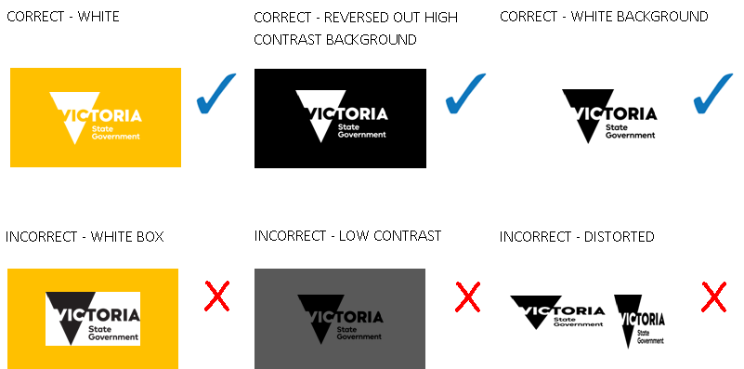

### Logo usage and placement

The visual style of the organisation receiving the funding should be the primary brand of the publication or website. The Brand Victoria logo can be placed on either side or above or below the organisation’s own logo.

Clear space must be maintained around the Brand Victoria logo.

#### Clear space

To maintain the clarity and integrity of all logos, a minimum ‘clear space’ must be observed in all applications. Clear space creates an invisible frame that is a minimum area surrounding the logo that must remain free of any conflicting visual element.

Wherever possible, apply additional clear space beyond the minimum requirement.

**Print applications**

The clear space for print applications is at least 50 per cent of the height of the triangle in the logo.

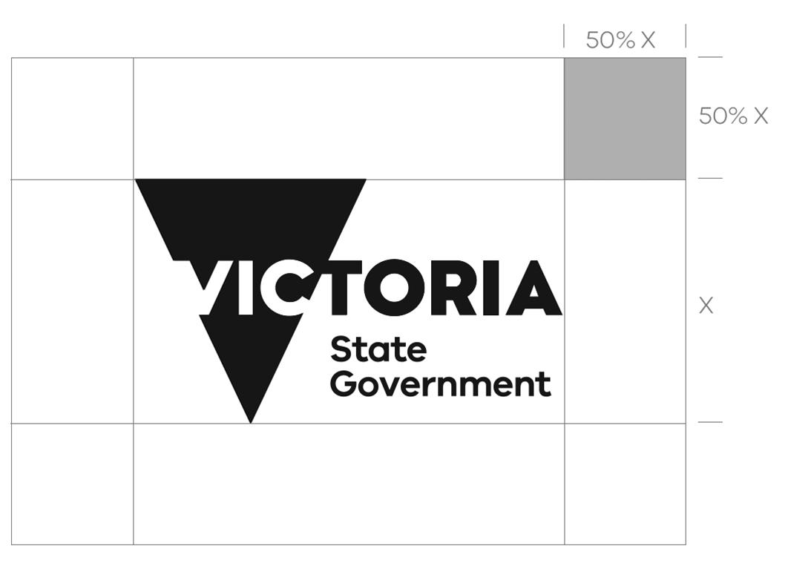

**Screen applications**

The clear space for screen applications is at least 20 per cent of the height of the triangle in the logo.

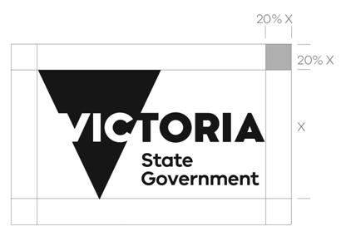

#### Minimum size

The minimum size for **print applications** is 10 mm from the top to the bottom of the triangle in the Brand Victoria logo.



The minimum size for **screen applications** is 60 pixels from the top to the bottom of the triangle in the Brand Victoria logo.



Where there is a question of the quality of reproduction, the logo must be used at a size larger than the minimum size.

### How to access the logo

The Brand Victoria logo can be downloaded from [My Agency](https://hns.dhs.vic.gov.au/facadmin/home.aspx) : <https://hns.dhs.vic.gov.au/facadmin/home.aspx>.

The logos are located under the heading ‘Resources’ on the front screen when entering My Agency. The page is titled Victorian Government insignia – logo for acknowledgment of funding support.

My Agency is a secure website. To access My Agency, staff members of organisations are required to be registered for eBusiness. Further information about registering for eBusiness is on [My Agency for non-DHHS staff](https://fac.dhhs.vic.gov.au/my-agency-non-dhhs-staff) <https://fac.dhhs.vic.gov.au/my-agency-non-dhhs-staff>.

If an organisation is unsure about when and how the logo should be used, an organisation should contact its department contact.

## Events/conferences/launches

Where a conference supported by the Victorian Government or an event/launch has been organised in relation to a service funded by the Victorian Government:

* programs/invitations/websites should display the Brand Victoria logo (as relevant)
* any speeches and presentations should include a verbal acknowledgement of Victorian Government support. Where appropriate the relevant Minister should be acknowledged together with the relevant program/service name.

Departmental or Victorian Government signs and banners may be available for use by organisations to display at relevant events/launches and conferences and can be used where practical. When organising an event or conference, an organisation can contact its department contact to discuss the use of these signs and banners. If organisations have their own banners developed related to the service or initiative funded which includes the Brand Victoria logo a department/Government banner may not be required in some cases.

If the minister/other government representative has agreed to launch the service/project/conference, the department will coordinate participation by the minister or representative and work with organisations on the details of the event, including ensuring that appropriate banners and signs are available for the event.

# Further information

## Department of Health and Human Services

An organisation can contact its department contact if they require further information on the funding acknowledgement requirements above. The department contact may consult with the Communications and Media branch by [emailing Creative Services](mailto:publishing.studio@dhhs.vic.gov.au) <publishing.studio@dhhs.vic.gov.au>.

## Department of Education and Training

An organisation can contact its department contact if they require further information on the funding acknowledgement requirements above. The department contact may [email the Communications division](mailto:sponsorship@edumail.vic.gov.au) <sponsorship@edumail.vic.gov.au>.

|  |
| --- |
| To receive this publication in an accessible format, [email Service Agreement Communications Team](mailto:sacomms@dhhs.vic.gov.au) <sacomms@dhhs.vic.gov.au>  Authorised and published by the Victorian Government, 1 Treasury Place, Melbourne.  © State of Victoria, Department of Health and Human Services, updated July 2018. This document is available on [Acknowledgement and publicity guidelines for Victorian Government funding support: Acknowledgement and publicity guidelines for Victorian Government funding support](https://fac.dhhs.vic.gov.au/acknowledgement-and-publicity-guidelines-victorian-government-funding-support) <https://fac.dhhs.vic.gov.au/acknowledgement-and-publicity-guidelines-victorian-government-funding-support> |

1. For websites, this does not include HTML or automatic updates of pages. The funding acknowledgement only needs to be included where there is additional content or a new page is being added about an initiative, program or service funded by the Victorian Government under the Service Agreement.