

Maintenance Manual

Chapter 7
Programmed Works
October 2012

Programmed Works
October 2012

Published by the Victorian Government, Department of Human Services, Melbourne, Victoria, Australia.
Copyright State of Victoria, Department of Human Services, 2012.
This publication is copyright. You may make limited copies of this document in accordance with the Copyright Act 1968 (Cth), including copies for research, study, criticism, review or news reporting. Apart from this, you may not publish, reproduce, adapt, modify, communicate or otherwise use any part of this document (in particular for commercial purposes).
Authorised by the State Government of Victoria, 50 Lonsdale Street, Melbourne.
Table of Contents

7.1 Programmed Works Policy 4
7.1.1 Introduction 4
7.1.2 Contractor Performance 4
7.1.3 Types of Programmed Works 5
7.1.4 ULI Ratings 6
7.1.5 Reletting Restrictions 7
7.1.6 Business Rules 7
7.1.7 Assessing Programmed Works 8
7.1.8 Contractor Communication 9
7.1.9 Ancillary Programs 10
7.1.10 Programmed Works Responsibility 12
7.2 Programmed Works Procedures 14
7.2.1 Property Inspections 14
7.2.2 Assign Reletting Restrictions 14
7.2.3 Preparing a Business Case 15
7.2.4 The tender and approval process 16
7.2.5 Tenant Communication 16
7.2.6 Variations to the Scope of Works 17
7.2.7 Ancillary Programs 18
7.2.8 Contractor Non-compliance 19
7.2.9 Tenant Damage 20
7.2.10 Dispute Resolution 22
7.2.11 The works are completed 22
7.2.12 Programmed works for Aboriginal and Torres Strait Islander tenants 22
7.2.13 Programmed works for community-managed properties 23
7.2.14 Contractor Payment 23
7.3 Appendices 24
7.3.1 Reletting Restriction Codes 24
7.3.2 Project Brief 25
7.3.3 24-hour Notice to enter Rented Premises 26
7.3.4 Certificate of Practical Completion 27
7.3.5 Request for Disability Modifications (including Aids and Adaptations) form 28
7.3.6 Property Condition Report 29
7.3.7 Low-rise Villa works Approval Process 30
7.3.8 Variation Quotation Request 31
7.3.9 MCAT procedure for vacant properties on program 32
7.3.10 MCAT procedure for tenanted properties not on program 33
7.3.11 MCAT procedure for vacant properties on program 34
7.3.12 MCAT procedure for vacant properties not on program 35
7.3.13 Report of Fire Incident Form 36

Programmed Works Policy

Introduction
Programmed works are capital improvement works that improve or extend the life of a property or amenity owned by the Director of Housing (the Director). The Department of Human Services (the Department), undertakes improvement works on Director owned properties annually under its Physical Improvements Program, including rental general, community and Aboriginal Housing Victoria (AHV) managed stock.
The Property Portfolio Branch invites contractors to submit tenders for such capital works. The works on properties may be tendered individually or assembled into bulk lots. The scheduling of works is undertaken in a planned and systematic manner, and the works are scheduled for completion over a contracted period.
This chapter covers the Department’s policy and procedures for:
- determining the nature and extent of programmed restoration, improvement and upgrade works
- planning and arranging for programmed works to be carried out
- the roles of the Superintendent and superintendent’s representatives in carrying out the Department’s works program.
The Department’s programmed works policy has been formulated to meet the following objectives:
- to extend the life of existing properties and amenities
- to maintain properties and amenities in good repair
- to improve and sustain energy efficiency performance
- to provide for disability modification requirements of clients
- to improve the safety and security of residents in public and community/AHV managed housing.

Contractor Performance
 Property Condition Assessments Chapter
 Australian Standards AS4000 – 1997 General Conditions of contract
The contract
The contract is the agreement between the Principal, that is, the Director and the contractor that carries out the programmed works, as described in the contract documents and governed by current Victorian legislation.
The Department of Human Services uses both selected tendering and public tendering processes to secure contractors for the works programs. The tenders are assessed by the project manager and consultant, and a recommendation is made by the Principal or the principal’s representative.
The Department uses the central contract procurement method of securing contractual services in programmed works to achieve optimum benefits, and to ensure that the contractor’s output is according to the delivery specification. Contractors are required to tender for works programs according to agreed conventions. The tendering process is managed by the Department’s Property Management Group, Property Portfolio Branch.
The Superintendent
The Department’s Superintendent represents the Principal, that is, the Director, in the contract to carry out programmed works.
The Principal ensures that there is a Superintendent at all times. In carrying out the functions of the Superintendent under the terms of the contract, the Superintendent:
- acts honestly and fairly
- acts within the time prescribed under the contract or where no time is prescribed, within a reasonable time
- arrives at a reasonable measure or value of work, quantities or time.
In accordance with the provisions of the contract, the Superintendent gives direction to the contractor verbally and in writing. The term ‘direction’ includes agreement, approval, authorisation, certificate, decision, demand, determination, explanation, instruction, notice, order, permission, rejection, request or requirement.
The superintendent’s representative
The Superintendent may from time to time appoint individuals to exercise any functions of the Superintendent under the contract. When this occurs, the Superintendent notifies the contractor in writing of:
- the appointment and the name of the superintendent’s representative and the functions delegated to the superintendent’s representative
- the termination of the appointment of the superintendent’s representative.
In accordance with the contract between the Director and the contractor, the superintendent’s representative is responsible for:
- coordinating and approving variations and additions to the scope of works
- ensuring that work is undertaken in compliance with the Department’s environmental or workplace health and safety obligations
- confirming whether the scoped works are completed satisfactorily
- issuing directions for non-performance and rectification of unsatisfactory works.

Types of Programmed Works
 Property Condition Assessments Chapter
Programmed works may typically include the following:
- internal or external painting
- full or part replacement of floor coverings
- major window, fencing and other carpentry works
- re-stumping
- re-roofing
- installation of security doors
- upgrades to kitchens or bathrooms
- aids, adaptations and disability modifications
- upgrades to public areas and community rooms.
 An assessment of a property’s existing condition is made by the local Housing Office in conjunction with Property Portfolio Branch, to develop and prioritise the programs for improvements and upgrades, as detailed in the Property Condition Assessments Chapter of this manual.
Immediate improvements
Improvement works may be required on a property where the health, safety or security of tenants may be affected if these works were not undertaken. For example, tree branches overhanging a property need to be trimmed back and away from the roof line or electrical wiring, or electrical works are necessary for the installation of lights in corridors and communal areas.
Preventative works
Preventative works should form the basis of a programmed works contract. As far as possible, the Department will repair or replace existing attributes within a property to maintain the property in good repair. For example, in planning the scope of structural programmed works, consideration is to be given to trees or shrubs which may cause or contribute to structural damage of the property in the future.
Improvements and upgrade works
The Department of Human Services undertakes improvement works on two to three thousand properties annually under its Physical Improvements Program. In preparing the scope of works, the Department aims to maximise the value and effectiveness of the funding provided for capital improvements. In doing so, the Department’s objective is to improve the general condition of properties and client satisfaction with their homes.

ULI Ratings
The Department’s Useful Life Indicator (ULI) Rating on a property is a basic indicator of how long the Department intends to keep a Director owned property. The rating reflects the property’s long term viability, given the relevant factors at the time. The local Housing Office and Asset Planners make recommendations to Property Portfolio Branch to change a ULI rating.
In determining the ULI rating on a property, the following factors are considered:
- the current and expected demand for the property
- the estimated costs of bringing the property to a state of ‘good repair’
- the age of the property, the property type (for example, villa or flat) and property construction (for example, concrete panel or brick veneer).
The ULI ratings are listed in Table 6.1 below:
Table 6.1: ULI Ratings
ULI Rating | Property status
0 | Has been approved by Property Portfolio Branch for sale or demolition
5 | Identified by the regional office for disposal within five years. Only responsive maintenance is carried out.
10 | Identified for disposal within 10 years. Limited maintenance is carried out, and for health and safety reasons.
20 | To be retained indefinitely and can be upgraded.

Note: The ULI rating on a property is not an absolute measure or a final commitment to take action, and is subject to change.

Reletting Restrictions
 The Department of Human Services assigns Reletting Restriction (RLR) Codes on properties which are placed on an upgrade or demolition/sale program or are required for relocation purposes for tenants in a property marked for upgrade, demolition or sale. RLR codes provide an indication of the reletting status of a property when programmed maintenance is to be carried out on that property. For example, a RLR code of ‘RAM’ (Refer to Asset Management) indicates that there has been a request from the local Housing Office /Community Managed Accommodation Unit (COMAC) to Portfolio Management, Property Portfolio Branch, to have a property placed on a maintenance, disposal or relocation program.

Business Rules
 Property Condition Assessments Chapter
 Australian Standards AS4000 – 1997 General Conditions of contract
The purpose of setting business rules in programmed works is to provide a framework for the way in which a scope of works for public and community/AHV managed housing properties is developed in order to maximise the value and effectiveness of funding for physical improvements.
Business rules are set by the Department based on the following asset management objectives:
- Extend the life of existing properties
- Maintain properties in good repair
- Provide for disability modification requirements of clients
- Improve energy efficiency performance
- Improve the safety and security of residents in Director owned properties.
Business rules are applied by the Department in developing a works program for:
- low-rise properties, for example, houses, villas, walk-up blocks and stand-alone units
- high-rise estates, for example, high-rise towers.
Low-rise upgrade program
 As part of its planned physical improvement program, the Department undertakes improvement works on low-rise properties to meet the Department’s objectives. The Department’s low-rise redevelopment and upgrade program is targeted at houses, stand-alone units and low-rise blocks which have been identified through the Department’s assessment process, as detailed in the Property Condition Assessments Chapter of this manual.
It is critical that all the attributes of a property are considered, to ensure that program formulation and costs are specific and accurate so that an informed decision can be made on the overall viability of the project.
Note: Depending on the existing condition of the property or its amenities, repair of the item is considered before replacement.
High-rise estates
Programmed upgrade works in a high-rise estate are planned and carried out on targeted units or floors of towers, community facilities and communal areas inside and outside a building, for example, car park, laundry or foyer. Such works are described in a standard scope of works for a block or tower, with variations based on bedroom size and disability modification needs. They are planned and developed in accordance with the Australian Standards.

Assessing Programmed Works
 Property Condition Assessments Chapter
 Australian Standards AS4000 – 1997 General Conditions of contract
 Guide to the role of the Field Services Officer
 Relocation Manual
 Information and Consultation Chapter – Relocation Manual
 Interpreting and Translating Services Chapter - Business Practice Manual
The Department regularly inspects the condition of Director-owned properties to assist in formulating and planning programmed works. Properties which may require upgrades are identified by the following:
- the property’s ULI rating
- the three-yearly property condition audits undertaken by the local Housing Office /COMAC
- recommendations by the responsive maintenance head contractor or external consultants.
Property Condition Audits (PCAs)
 The Department carries out Property Condition Audits (PCAs) on selected properties every three years to determine if they may be in need of repair, improvements or demolition, and the nature and extent of the works required. A Property Condition Report (PCR) is completed on each property to provide a detailed description of its internal and external physical condition, as detailed in the Property Condition Assessments Chapter of this manual.
Scope of works for low-rise properties
The scope of works is a list of necessary, internal and external property-related works, which are drawn up for houses within the framework of the Department’s business rules on upgrade works, and within the Australian Standards AS4000.
 Scopes of works are established for selected properties by consultants who conduct physical inspections of the properties under the direction of Property Portfolio Branch. The preparation of the scope of works is guided by the Department’s business rule on physical improvements for low-rise villa and estate works to enable the Department to carry out its capital works program most effectively, detailed in the Guide to the role of the Field Services Officer (FSO).
The Property Management project manager is responsible for ensuring that the scopes of works prepared by the consultant comply with the Department’s business rules on improvement works.
High-rise estate project brief
 The Project Brief is a record of what works need to be carried out on the properties in a high-rise building or estate, as determined on-site by Property Portfolio Branch and the local Housing Office /COMAC.
The types of work identified in project briefs can include:
- Internal/external repairs and upgrades
- Service upgrades
- Security improvements
- Landscaping.
Property Management uses the information in the project brief in communication with engaged consultants who then confirm all works required, and to determine the extent and costs of works following a more detailed inspection of the property.
Tenant communication
 The Department informs tenants who are residing in properties or blocks that have been targeted for development or upgrades of the works program in accordance with the Department’s Relocation Policy. Tenant and tenant groups are consulted on and advised at various stages of the project. In relocating tenants, the Department gives consideration to tenants’ special requirements and preferences.
Tenants are notified in writing as soon as possible after the decision to proceed with the capital works has been made, and during the redevelopment or upgrade process. All written information is accompanied with the community languages information sheet promoting contact with the local Housing Office or community housing provider.
Access to inspect the premises
The Residential Tenancies Act 1997 (RTA) (s.86(1)) provides for rights of entry by a landlord or the landlord’s agent, that is, the Department’s housing staff, along with any persons who are necessary to achieve the purpose of entry. Entry can be made with the consent of the tenant.
 Entry can also be made without the expressed consent of the tenant, provided at least 24 hour Notice to Enter Rented Premises written notice has been given to the tenant.

Contractor Communication
 Schedule of Rates
 Australian Standards AS4000 – 1997 General Conditions of contract
The aim of communication between the Department of Human Services and the contractor is to give instruction on the scope of works and to resolve any contractual issues in the tender contract.
Contractor communication is used to ensure that the provisions in the contract are adhered to, particularly in the following areas:
- issuing instructions or variations to the scope of works
- ensuring the satisfactory completion of scoped works
- ensuring the contractor’s compliance of legislative and statutory requirements
- determining and making timely and accurate payments to the contractor.
Communication between the Department and the contractor covers the following areas within the scope of works:
- variations to the original scope of works
- defects liability.
Variations to the scope of works
Variations to the original scope of works may be initiated by the Superintendent or the contractor. All variations to works requested by the contractor are to be authorised in writing by the Superintendent prior to the works being carried out.
Where contractors are unable to complete a contract on time they must apply to the Superintendent for an extension of time. If the reason for the extension of time is legitimate, for example, delays due to wet weather, the Superintendent will grant the extension and set a new completion date.
Defects liability
  During the contracted defects liability period, the contractor is required, at their own expense, to rectify all defects and repair all damage caused by defective materials or workmanship, see Schedule of Rates. The defects liability period commences after:
- The Certificate of Practical Completion (CPC) is issued by the Department and signed by the consultant as the Superintendent
Compliance
The contractor is required to comply with the requirements of all authorities which have legal jurisdiction over any matter affecting the scoped works. For example, the contractor must immediately notify the Department of any environmental or workplace health and safety incidents that occur during the works.
In some circumstances, the contractor may be required to remedy non-compliance of safety or environmental standards. Non-compliance occurs in the following circumstances:
- the contractor does not carry out the work in compliance with their environmental or workplace health and safety obligations
- the contractor carries out the work in a manner which may endanger the environment, or the health or safety of any person.
The Department requires the contractor to remedy that non-compliance or take action to prevent endangering the environment or people.

Ancillary Programs
 Responsive Maintenance Chapter
 Tenant Property Damage Chapter
In addition to the upgrade internal and external works programs, the Department has four ancillary works programs aimed at maintaining Director owned properties in good repair or to extend the life of specific property attributes or amenities.
The four ancillary programs are:
- Aids, adaptations and disability modifications
- Fire restoration works
- Structural rectification program
- Additional bedroom program.
Aids, adaptations and disability modifications
 Generally, the Department assesses the complexity and cost of modification works, based on the occupational therapist’s report that is submitted with the Request for Disability Modifications Form. If the request is approved, these works may be undertaken by the local Housing Office, or they may be included in the Department’s current works program.
Major and full modifications are referred to Property Portfolio Branch if the works cannot be carried out locally, for one of the following reasons:
- structural changes may be required on the property
- the works are of a complex nature
- council certification approval is required.
 For more information on aids, adaptations and disability modifications, refer to the Responsive Maintenance Chapter in this manual.
Fire restoration works
Fire restoration works are necessary after a fire in a Director owned property has resulted in substantial damage to the property or its amenities. Generally, the household also needs to be relocated as a result.
The Department determines if the damage should be repaired and the property retained, or if the property should be disposed of. If significant repairs are needed to ‘make good’ the property and they are of a capital nature, the property may be referred to the Portfolio Management Group of Property Portfolio Branch for upgrade or disposal consideration.
 Note: The Department takes action to recover costs where repairs to a property are necessary as a result of damage or neglect caused during a current or previous tenancy, as detailed in the Tenant Property Damage Chapter of this manual.
Structural rectification program
If building movement damage is detected in a Director owned property, the Department conducts a structural investigation of the property to assess the extent of the damage and to determine whether to include it in the structural rectification program or to dispose of it.
There are three types of building damage:
- ‘Severe’ building movement damage means that major structural damage has occurred to the building’s foundations and superstructure. Extensive structural repairs are required urgently.
- ‘Moderate’ building movement damage means that significant damage has occurred to the building’s foundations and superstructure. Some structural repairs are required in the short-term (up to 12 months) to prevent the structural damage worsening and to stabilise the structure.
- ‘Slight’ damage means that minor structural damage has occurred to the building. Minor works are only required at that stage.
Additional bedroom program
The additional bedroom program provides an opportunity for eligible applicants who require larger accommodation to have their existing property extended to meet their needs.
The following guidelines are considered when assessing a request for an additional bedroom:
- generally, the household meets the Department’s early housing guidelines for severe overcrowding
- applications made on medical grounds are considered
- properties should be of brick construction
- the property must be in an area of medium to high demand.
The properties and requests are assessed to determine if these capital works comply with Department’s asset management principles. The works may be undertaken as part of the works program or the properties may be returned to the regional office if the works are not approved.

Programmed Works Responsibility
All programmed upgrade and major capital works are planned, formulated and managed by the Property Portfolio Branch of the Division of Housing & Community Building, Department of Human Services in consultation with the regional offices/COMAC.
The Property Portfolio Branch business units that are responsible for developing and managing works programs and contracts are:
- Portfolio Management Group
- Property Delivery & Management Group.
Portfolio Management
In the works program process, Portfolio Management perform the following functions:
- establish the planning methodology and cycle for the annual program, in line with budgetary parameters and the Department’s priorities
- determine target numbers of properties for programmed maintenance and upgrades
- deliver finalised project briefs annual programs to the Property Delivery and Property Management Groups for implementation
- develop the business rules which govern works programs.
Portfolio Management is located on Level 26, 50 Lonsdale Street, Melbourne 3001.
Property Management Group
Property Management are responsible for the preparation and management of the contracts and the tender process for programmed works.
Property Management commence the tendering process by identifying and ‘bundling’ properties and works for each capital works project. Detailed scopes of works, the conditions of contract and other legal documentation are developed and included in the tender documents. Contractors are invited to submit works tenders for projects in the program.
Property Management manage the works program after the contract between the Director and the construction contractor is signed.
The Property Management project manager liaises with Housing Office, COMAC and the Housing Call Centre (HCC) on the special needs of the tenants and community regarding the scheduled works. The Property Management project manager’s role also includes providing updates to tenants on the progress of the works, and addressing any tenancy or property issues which may arise during the works.
The Property Management Group is located on Levels 25 and 26, 50 Lonsdale Street, Melbourne 3001.
Engineering Services, Property Management Group
Engineering Services in Property Management are responsible for providing specialist services to public housing properties. These are often essential services that have a legislative compliance component, and can necessitate a demand-driven response in some instances.
Examples of cyclical specialist services include routine servicing of sprinkler and portable fire services equipment, boilers and plant rooms, lifts, emergency lighting, public lighting and electrical services. Engineering Services also manage other specialist services, including fabric repairs, spalling works and underpinning.
The planning of upgrades to specialist services is included in the Department’s annual works program. Engineering Services are responsible for managing the upgrade works and the contract management process for such works.
Engineering Services, Property Management Group is located on Level 25, 50 Lonsdale Street, Melbourne 3001.
Community Managed Accommodation Unit (COMAC), Property Management Group
COMAC is responsible for managing the Department’s annual capital upgrades and programmed maintenance for works community program.
COMAC properties are owned by the Director and either managed or leased for tenancy management by non-profit community groups, such as the Salvation Army or Rural Housing Network. COMAC undertakes the planning and formulation of upgrades and improvement works to community and AHV managed properties in conjunction with the Portfolio Management Group in three-year cycles.
The Centre of Excellence (COE)
The Centre of Excellence in the local Housing Office is the Department’s regional liaison for asset issues. In managing upgrade and improvement works, the COE is on-site to liaise with the project manager from Property Portfolio, FSO and COMAC to:
- coordinate building, upgrade and programmed works
- liaise with the local housing office or community housing provider in coordinating special tenant requirements and resolving tenant issues
- provide local advice to Property Portfolio in planning and formulating works programs.
The consultant
The external consultant is engaged by the Director to produce the required options and cost estimates of programmed works to be undertaken in a block or estate. The consultant, as the Superintendent works with the Property Management project manager in preparing tender documents and managing the tendering process.
The consultant’s role includes communication with the tenant on the progress of the works, and with the Property Management project manager on works or tenancy issues.

Programmed Works Procedures

Property Inspections
 Guide to the role of the Field Services Officer
 Responsive Maintenance Chapter
 Contractor Code of Conduct
 Access to Property Chapter – Tenancy Management Manual
Complete the property condition report (PCR)
 The Field Services Officer (FSO) in the local Housing Office /COMAC conducts property condition audits (PCAs) on selected public or community managed housing properties every three years. The details of the internal and external condition of the properties are recorded in property condition reports (PCRs) in the HiiP system. Any costs entered in the PCR reflect the current condition of the property or block, and include consultancy costs and allowances. The Portfolio Management Group assesses the condition of the property using information recorded in the PCR, the property’s ULI rating and reletting restriction to determine what works may be required on the property.
Consultants’ inspections
The Property Management Group, Property Portfolio Branch engage external consultants to establish the scopes of works for properties identified for the annual works program through physical inspections of the properties. Any disability modifications required are taken into account in determining the extent and scope of works in the program.
The consultant liaises with the FSO in the local Housing Office to assess and coordinate special tenant requirements in affected properties.
Tenant’s duty to permit entry
The tenant has a duty to permit entry under the RTA (s.89) provided the Department has served a notice to inspect in accordance with the provisions of the RTA. Should the tenant refuse to permit entry upon being served with the correct notice, they are in breach of the RTA.
 Where a notice of inspection has been served, the FSO/consultant confirms with the tenant if they will be present at the premises on the date and time specified in the notice. If the tenant will not be present to permit access on the date and at the time documented in the notice, an alternative date is arranged for the inspection, as detailed in the Responsive Maintenance Chapter of this manual.
 Reasonable care must be taken to avoid damage during entry and housing staff must not stay or permit others to stay in the premises longer than is necessary for the purpose of the inspection, as detailed in the Contractor Code of Conduct.
 Refer to the Access to Director Owned and Managed Properties Chapter in the Tenancy Management manual and to the Responsive Maintenance Chapter in this manual for more information on access to a property.

Assign Reletting Restrictions
Housing staff are responsible for updating the property’s reletting restriction codes when a property is referred to Portfolio Planning to be included in a works program. An RLR code ‘RAM’ shows that the region has requested Portfolio Management to apply an RLR on a property to signify that the property should not be relet to another tenant for a variety of reasons. If Portfolio Management accepts the RAM, the RLR will then show whether the property is to be sold, upgraded, demolished or used for relocation purposes.

 Refer to the list of Reletting Restriction Codes for a description of the status for each code.

Preparing a Business Case
 Guide to the role of the Field Services Officer
A business case for low-rise villa or estate works must include the following:
- a detailed report comparing repair to the item or property against its replacement, including the current condition of the property, and the costs of replacement and any additional costs
- a summary of the works required, and where replacement is recommended, the reasons against repairs.
Note: Based on the existing condition of the property’s attributes, repair is to be considered before replacement.
Preparing the project brief and scope of works
  Property information from the completed Property Condition Reports (PCRs) is used to develop the project brief for each block/estate. The lists of properties, programmed works and timelines are jointly determined by regional and Property Portfolio Branch staff, see Guide to the role of the Field Services Officer.
 The Property Management Project Manager arranges for inspections and the preparation of scopes of works and cost estimates for each low-rise property in accordance with the Department’s business rules. The scopes of works are reviewed by the local Housing Office, see Project Brief.
Additional items
 When additional items are identified during the property inspection, the consultant includes these items in the 'Additional items for review’ section of the business case. The inclusion of these additional items enables the consultant to communicate with the regional office about works outside the business rules that would otherwise not be undertaken, see Guide to the role of the Field Services Officer.
Scope of works review
 The local Housing Office can make recommendations for additions and subtractions to individual scopes of works in accordance with the Department’s business rules. Portfolio Management is then able to make an informed decision on the final scope of works for items outside the business rules, or whether to maintain or to dispose a property, see Guide to the role of the Field Services Officer.
Additional works may be needed on items such as:
- Sleepouts or additional bedrooms
- Movable units
- Party fencing
- Tenant damage repairs
- Disability modifications.

The tender and approval process
 Australian Standards AS4000 – 1997 General Conditions of contract
 Schedule of Rates
 Responsive Maintenance Chapter
 Public Liability Insurance Policy
Contractors are selected to tender by a selection panel.
The Property Management Group call tenders for programmed maintenance and upgrade works in accordance with their Quality Management system. Tenders are closed in the Tender Box at 50 Lonsdale Street and opened by a formal Tender Opening Committee.
The contract is awarded to the successful tenderer.
  As part of the tender documents submitted by a contractor in the tendering process to carry out programmed maintenance and upgrade works, the contractor must produce evidence of a current and appropriate insurance policy in accordance with and to the amounts stated in the General Conditions of Contract, see Low-rise Villa works approval process and SOR.
 The bidding contractor’s insurance policy is checked by Property Management to ensure that the provision for the minimum public liability insurance cover of $10 million per claim is included, as detailed in the Responsive Maintenance Chapter of this manual.
The period of cover includes the defects liability period.
The bidding contractor is also required to give an undertaking to confirm that they have in place an acceptable industrial relations management system, including the management of sub-contractors, and compliance with employment and legal obligations.
 The contractor is to provide the Department with the following documents prior to the commencement of work on the site:
- proof of current registration as building practitioner
- proof of current WorkCover insurance for all individuals working on each site
- proof of current public liability insurance for $10 million
- an appropriate Occupational Health & Safety Management system.

Tenant Communication
Property Portfolio Branch develops and prioritises the Department’s annual program for programmed works and upgrades in conjunction with the local Housing Office /COMAC. Once the works are approved and included in the current program by Portfolio Management, the list is sent to Property Management Group, COMAC and the local Housing Offices. The Property Management project manager determines a framework for delivering the program with the regional Centre of Excellence (COE), COMAC and Service Delivery Group, Client Services & Programs Branch, including assessing the requirements for tenants with special needs.
Tenant communication is the essential responsibility of housing staff at the local Housing Office. The local Housing Office or community housing provider is responsible for advising tenants that their property has been included on the annual program. The project manager will arrange notification to the tenants prior to the inspection of the property for programmed works.
The Property Management project manager liaises with the local Housing Office or community housing provider in coordinating special tenant requirements and resolving tenant issues. These issues may arise from tenant queries or complaints to the Department about their public housing properties.
 Refer to the Information and Consultation Chapter in the Relocation Manual for more information on the communication and consultation process in a redevelopment or upgrade project, and to the Interpreting and Translating Services Chapter in the Business Practice Manual for interpreting services.
The consultant
Prior to the commencement of programmed and upgrade works, the consultant provides initial advice to the tenants on the type of programmed works to be carried out, the timeframes required to complete the work and various aspects of the scoped works, for example, the tenant has special requirements, such as wheelchair access.
While the works are being undertaken, the purpose of tenant communication is to advise the tenant of the status of the project. Such advice may be required where the contractor is not able to meet the timelines in the scoped works, or a variation to the works is necessary.
As the Superintendent, the consultant is also responsible for managing site supervision. Negotiations with the contractor may be required to negotiate a timeline if the contractor is not able to meet the original timeline. Variations to the scoped works may also need to be discussed and agreed upon between the contractor and the consultant.
The Property Management Group project manager
The Property Management Group project manager communicates with the local Housing Office on the scheduled maintenance works. If there are special needs requirements that need to be incorporated into the programmed works, the Property Management Group project manager coordinates the additional works with the local Housing Office. The Property Management Group project manager works with the consultant who is on-site to supervise the completion of the works and to advise the local Housing Office of the work status.
Any queries or complaints received by the local Housing Office /COMAC from the tenants about the contractor or the works are forwarded to the Property Management Group project manager for resolution.
Note: The contractor and his staff are required to conduct themselves in accordance with the Code of Practice as specified in the contract.

Variations to the Scope of Works
 Australian Standards AS4000 – 1997 General Conditions of contract
The contractor submits a written request to the Superintendent to carry out variations to the original scope of works together with evidence of all material and labour costs associated with the variations.
Property Portfolio Branch takes into consideration the cost to the contractor in determining whether to authorise the variations to the works. The actual value of the variation works is determined by mutual agreement between the Superintendent and the contractor.
The Superintendent, on behalf or the Director, gives approval or notice, for example, for rectification of works, in writing in accordance with the General Conditions of Contract AS4000 - 1997.
Variations to the scope of works
During the course of works, additional items may arise that require a variation to the contract. These may include unforeseen problems or additional client requests, for example, termite damage or a stepless shower. The project manager is responsible for obtaining quotations for additional items from the contractor and to issue instructions for the additional work to be undertaken.
Variations or additions to the scope of works may be required if there is insufficient documentation for the works to proceed, for example, there are termites in the property which were overlooked in the original scope of works. Variations may also be required to meet a tenant’s special needs, such as a stepless shower.
 All variations to scoped works are documented by the consultant in a Variation Quotation Request (VQR). The VQR contains a detailed description of the works variations, the reasons for the changes and their costs. It is sent to the Property Management Group project manager for assessment and approval. Approval of the VQR may also be given by the senior project manager and Portfolio Management.
The Property Management project manager sends approval for the works to the consultant who formally notifies the contractor of the decision. The contractor undertakes the works variations as part of the original scoped works. If the variations are not approved, the Property Management project manager advises the consultant of the outcome and the reasons in writing. The contractor completes the works according to the initial scoped works.
Property becomes vacant during the programmed works
 If a property that has been placed on a program becomes vacant prior to the commencement of the programmed works, Portfolio Management and Property Management determine whether the property is to be returned to the local Housing Office for minimum vacant maintenance and reletting, see MCAT Procedures Flowcharts.

Ancillary Programs
 Housing Standards Policy Manual
 Tenant Property Damage Chapter
Aids, adaptations and disability modifications
 When making a referral to Property Portfolio Branch for aids, adaptations or disability modifications, the local Housing Office determines whether:
- the scope of the work is in accordance with the Department’s Modified Housing Standards
- alternative housing options have been considered
- the client’s long-term needs have been met by the modification and the property
- works require building or planning permits
- works require structural changes to the building
- the extent of works requires a formalised tender process
- all relevant documentation has been submitted with the request, including an occupational therapist’s assessment and the FSO’s report.
 The tenant completes a ‘Request for Disability Modifications (including Aids and Adaptations) Form which may include an FSO’s report to confirm that the building is able to accommodate the modification works requested. A cost estimate may also be provided by the FSO.
After Portfolio Management has assessed the request, it is either returned to the local housing office for action as minor works, or the works are undertaken by Property Management Group in consultation with the occupational therapist and the client.
 Note: All disability modification works are undertaken in compliance with the Department’s Modified Housing Standards Policy.
Fire restoration works
 Following a fire which has resulted in substantial damage, a Report of Fire Incident Form must be completed by the local Housing Office /COMAC.
The Fire incident form must be completed and sent immediately to the Emergency Unit, Tel: (03) 9096 5376 or email emergencybranch.housing@dhs.vic.gov.au.
The FSO undertakes a technical inspection of the fire damage, and arranges for ‘make-safe’ works unless Portfolio Management and the local Housing Office determine that the property should be demolished. The local Housing Office /COMAC sends a request to Portfolio Management for a property to be given a Reletting Restriction code Upgrade or Demolition, as appropriate.
Portfolio Management requests a feasibility report to determine if the property is to be retained or disposed. If Portfolio Management gives approval for the property to be repaired, the property is referred to Property Management for a feasibility study and cost estimates.
If rectification works are to be undertaken on the property, the Property Management project manager is responsible for:
- managing the tender process
- getting the necessary permits, if required
- overseeing the works carried out by the construction manager
- providing handback of the property back to the local Housing Office on completion of the works
- updating the property condition details.
 Note: The Department takes action to recover costs where repairs to a property are necessary as a result of damage or neglect caused during a current or previous tenancy, as detailed in the Tenant Property Damage Chapter of this manual.
Structural rectification works
If building damage in a property is detected at a property inspection or is reported by the tenant, the local Housing Office makes referrals to Property Portfolio Branch so that a structural investigation is carried out on the building movement damage.
If the building damage is considered moderate to severe, the Property Management project manager arranges for a structural report to be provided to Property Portfolio Branch (with a copy to the local Housing Office /COMAC) detailing the full scope of works, including repair or replacement costs and the local Housing Office /COMAC of the action to be taken.
Additional bedroom works
The regional office sends referrals for the additional bedroom program to Portfolio Management, and provides specific information that is relevant to the property/tenancy to support the application.
Portfolio Management reviews the properties and requests to ensure that they comply with Department’s asset management principles. Once approved, the final list of properties is sent to Property Management and the regional office for a feasibility study to be carried out. Works may be undertaken or advice is sent to the regional office as a result of the findings in the study.

Contractor Non-compliance
 Australian Standards AS4000 – 1997 General Conditions of Contract
Where the contractor is not able complete the works according to the scoped works specified in the contract, the contractor is to have written consent from the Superintendent for variations to the scoped works.
 The Department monitors the contractor’s performance by measuring the completed works against the provisions in the Victorian Industry Participation Policy (VIPP) to ensure compliance with the VIPP statement which forms part of the tender documents.
Extension of time
Where a contractor is unable to complete a contract on time they must apply to the Superintendent for an extension of time. If the reason for the extension of time is legitimate, for example, delays due to wet weather, the Superintendent will grant the extension and set a new completion date.
Defects liability
 Once the works have reached the Practical completion stage of the process, Property Management issues a Certificate of Practical Completion and makes an assessment of any outstanding works or defects. A Defects List is then issued to the contractor. This list of works and any others which may occur must be completed by the time of Final Completion.
On a typical upgrade contact, there is a six-month period between Practical Completion and Final Completion. If any works on the Defects List are deemed to be urgent, the contractor is instructed to carry them out immediately.
Defects may be detected in one of the following ways:
- the consultant notices defects or omissions at Practical completion
- the tenant contacts the consultant
- the tenant advises housing staff who then notify the consultant
- housing staff notify the Property Management project manager.
The standard of the completed work is assessed against the scope of works and the Australian Standards.
Note: The Property Management project manager works with the consultant and the local Housing Office in managing defects liability to ensure that tenant concerns are addressed early and with minimal intrusion to the household.

Tenant Damage
 Tenant Property Damage Chapter
 Responsive Maintenance Chapter
 Housing Standards Policy Manual
Where the Department carries out repairs on a property resulting from damage or neglect during a current or previous tenancy, a Maintenance Claim Against the Tenant (MCAT) is raised. The Department takes action to recover costs on such repair works needed in a property that is on an upgrade program, as per the RTA.
 In assessing maintenance works required to bring a damaged public housing property to a state of good repair, the local Housing Office or consultant identifies the damage and categorises the repair works as minor works (costing up to $1,000) or works extensive (costing over $1,000), as detailed in the Tenant property Damage Chapter of this manual.
Tenant damage as works extensive
If major works are required, for example, to repair structural damage to the property, and the cost of repairing the damage is expected to exceed $1,000 and the property cannot be relet, the local Housing Office may refer the property to Portfolio Planning to determine whether:
- the repair works are to be undertaken by Property Portfolio Branch or the Housing Office
- the works can be commenced within three months of the request
- the property requiring the repair works is to be included in Property Portfolio’s works program.
 See MCAT Procedures Flowcharts;
MCAT procedure for tenanted properties on program
MCAT procedure for tenanted properties not on program
MCAT procedure for vacant properties on program
MCAT procedure for vacant properties not on program
Properties not on a program
Once tenant responsibility damage has been itemised and determined as Works Extensive, the Housing Office refers the property to Portfolio Management by completing a Program Amendment Form, see MCAT procedure for tenanted properties not on program The Housing Office submits a detailed list of repair works required and a request for the property to be included in the Department’s current works program, see MCAT procedure for vacant properties not on program.
Portfolio Management consults with Property Management to determine a works commencement date. If Property Management is able to carry out the works and commence within a three-month period, Portfolio Management adds the works to the works program and refers the property to Property Management.
The Property Management project manager manages the repair works as part of the property’s scoped programmed works. After the works are completed and certified by the contractor, the Property Management project manager sends a list of the MCAT items and their actual costs to the local Housing Office.
 If Property Portfolio Branch is not able to commence the repair works within the three-month period, Portfolio Management may return the property to the local Housing Office. The local Housing Office completes the necessary urgent repair works to restore the property to a make-safe condition, such as lock changes or the removal of non-standard fittings. Vacant Unit Maintenance is also completed for vacant properties in accordance with the Department’s Reletting Standards.
The local Housing Office carries out investigations to establish whether or not and to what extent the current or previous tenant is responsible for the cost of the works. Local housing staff reconcile the MCAT jobs in HiiP with the list of MCAT items sent by the Property Management project manager.
Where there is evidence to support a case for the Department to claim against damage caused by the tenant or a household member, the Department applies to VCAT to recover damage costs pursuant to the RTA (s.210).
After the VCAT hearing, the HSO records the Compensation Outcome, and scans and stores a copy of the VCAT Order in HiiP.
Note: The application to VCAT is a non-automated works procedure. The application form is available on the VCAT website.
 For more information on debt recovery policy and procedures, refer to the Tenant Property Damage Chapter of this manual.

Dispute Resolution
Contractors who are employed by the Department are required to understand and abide by the Department’s Code of Conduct and the conditions of contract in accordance with the Domestic Building Contracts & Tribunal Act 1995. The Code of Conduct sets out rules advising contractors, their employees, sub-contractors and suppliers on how to behave while carrying out work for the Department.
Any complaints made against the contractor are investigated by the Property Management project manager or consultant, in their role as the Superintendent, and generally resolved at the first level. If the matter is not resolved at the first level, it may be escalated to the Principal’s representative.

The works are completed
The consultant advises the Property Management Group project manager that the contracted works are complete at the Practical completion stage of the works process. The property is now habitable, and is ready for the tenant to move back into it or for reletting.
To verify the completion of the upgrade works, the contractor submits to the Department the following documents:
- copies of building permits and final inspection notices, where required
- copies of certified drawings, where required
- copies of Certificates of Compliance for gas, plumbing and electrical trades
- all certificates and documentation from asbestos removalists, as applicable.
 See MCAT procedure for tenanted properties not on program
MCAT procedure for vacant properties not on program
In addition to the above, the contractor provides evidence that all final testing and inspections of works have been carried out in compliance with an appropriate quality assurance system.
 Property Management Group completes the process by updating the Property Condition Management (PCM) and the Property Condition databases, and by advising the regional offices that the works are completed. A system-generated Certificate of Practical Completion (CPC) is issued to the contractor to confirm the completion of the works in the contract. This document describes the scoped works that have been undertaken and their completion date, and any outstanding works to date. The RLR on the property is automatically removed by the system.
The local Housing Office liaises with the Property Management Group project manager in returning the property back to the local Housing Office for reletting or for the tenant to move back into.

Programmed works for Aboriginal and Torres Strait Islander tenants
For Aboriginal and Torres Strait Islander tenants residing in Director-owned housing (RGS) properties, programmed works are planned and carried out in accordance with the Department’s policy and procedures for such capital and upgrade works. These works are managed by the Portfolio Management and Property Management Groups.
The works program for Aboriginal Housing Victoria (AHV) properties is developed and undertaken by Property Portfolio Branch in conjunction with AHV.

Programmed works for community-managed properties
 Responsive Maintenance Chapter
Community managed properties are owned by the Director and leased to or managed by community agencies. These properties are managed by COMAC, Property Portfolio Branch. Programmed works for community-managed properties are planned and carried out by Portfolio Management, COMAC and Property Management.
The COMAC project manager is responsible for providing the consultant with a list of properties to develop scopes of works and cost estimates. They review the scopes of works to ensure that the scoped works adhere to the Department’s business rules for low-rise property works. Following the region’s review of the scoped works, COMAC may refer properties to Portfolio Management for maintenance or disposal considerations.
 Refer to the Responsive Maintenance Chapter of this manual for more information on COMAC.
Programmed works for properties managed by registered housing agencies
The Department of Human Services is not responsible for the planning and maintenance of properties that are managed by registered housing agencies. Tenants residing in Housing Association managed properties are to report their maintenance issues to their managing agent/landlord.

Contractor Payment
 Responsive Maintenance Chapter
The conditions and method of payment to the contractor are detailed in the tender documents, and included in the General Conditions of Contract, in accordance with the Building and Construction Industry Security of Payment Act 2002.
The Superintendent acts as the agent of the Director in receiving payment claims or issuing payments. They also have the authority to suspend payment if the works have not been completed within the provisions of the contract.
A claim for payment must include the following:
- a current and valid tax invoice
- the contractor’s Australian Business Number (ABN)
- the amount claimed
- the amount of any GST paid or payable
- the contractor’s address for payment.
The Superintendent makes progress payments to the contractor during the course of the works. The final payment is made when all the contractor’s obligations under the contract have been met and a Final Certificate issued.
Liquidated damages
 Where a works defect has been detected by the Superintendent, an instruction is issued to the contractor instructing them to attend to and rectify the omission or defect. It may be issued at any time prior to the expiration of the defects liability period, as detailed in the Responsive Maintenance Chapter of this manual.

Appendices

Reletting Restriction Codes
Reletting Restriction Code | Description
EW | Extensive works
SAD | Awaiting statutory authority
UR | Under review
HTL | Hard to let
MRO | Multiple refused offers
NEA | No eligible applicants
RAM | Refer Assets Management
AC | Awaiting bedsit conversion
AD | Awaiting demolition
AR | Awaiting redevelopment
AS | Awaiting sale of property on the market
ATS | Awaiting sale of property to the tenant
GU | General update
LHB | Lease handback
HI | Handover incomplete
DS | Disposal strategy
DSR | Disposal strategy relocation
VEMP | The Victorian Emergency Management Procedures enacted after a major disaster

Project Brief
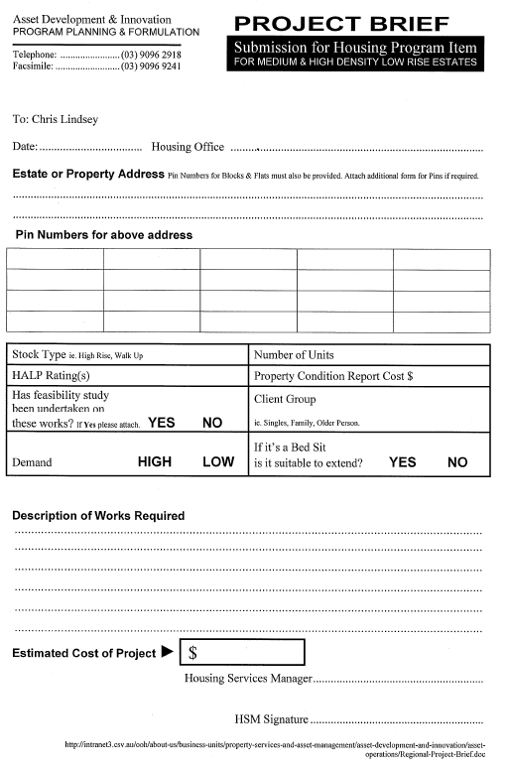

24-hour Notice to enter Rented Premises

Section 85(b) Residential Tenancies Act 1997
NOTICE TO ENTER RENTED PREMISES
To: …………………………………………………………………………………… (‘the tenant(s)’)
Of: ……………………………………………………………………………. (‘the rented premises’)
From: The Director of Housing of 50 LONSDALE STREET, MELBOURNE (‘the Landlord’)
TAKE NOTICE that:
1. Pursuant to Section 85(b) of the Residential Tenancies Act 1997 (RTA), the Director of Housing, 50 Lonsdale Street, Melbourne, as Landlord, requires you to permit entry to the rented premises on the basis that:
- entry is required to enable the Landlord to carry out a duty under the Residential Tenancies Act 1997, the tenancy agreement or any other Act – s.86(1)(c) RTA
- the Landlord has reasonable grounds to believe the tenant(s) has failed to comply with his/her duties under the Act or the tenancy agreement – s.86(1)(e) RTA
- entry is required to enable inspection of the premises & entry for that purpose has not been made within the last 6 months – s.86(1)(f) RTA
(strike out non applicable sections)

Brief description of reasons(s) for entry: .....................................................................
.....................................................................................................................................
.....................................................................................................................................
2. The Director of Housing requires you to permit officers of the Department of Human Services, together with any persons who are necessary to achieve the purpose of the entry, to enter the rented premises between the hours of.............. and................. on the......................... (day) of.......................................... (month) 20.…
3. If you do not permit entry to the rented premises at the time and date specified above, the Landlord may issue a Breach of Duty Notice to you and if necessary, apply to the Victorian Civil and Administrative Tribunal for a compliance order requiring you to permit entry.

Signed........................................ Date.................................
For and on behalf of the Director of Housing

Certificate of Practical Completion
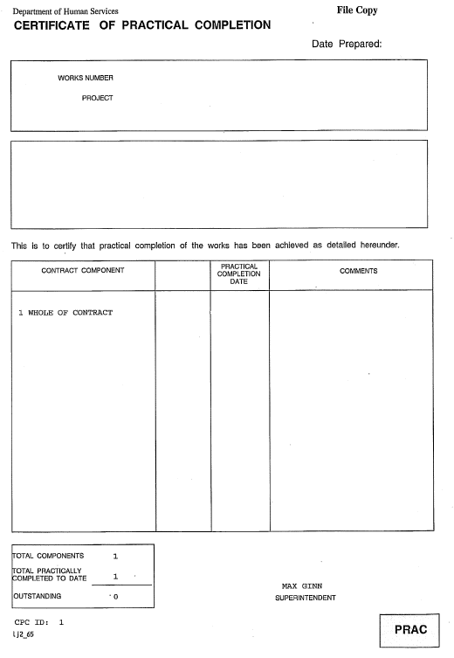

Request for Disability Modifications (including Aids and Adaptations) form
DEPARTMENT OF HUMAN SERVICES
REQUEST for DISABILITY MODIFICATIONS (including AIDS or ADAPTATIONS)

Date | Housing Office | Contact Name

Estate or Property Address | PIN

The property is: | HALP rating
Vacant ◻ Tenanted ◻

Please ensure that all Occupational Therapists are provided with a copy of the Modified Housing Standards before their submissions are received.
Please complete the following checklist:
Is the Occupational Therapist’s report attached? | ◻ YES | ◻ NO
Is the FSO report attached?  (This should indicate any potential issues in undertaking the OT’s proposed modifications) | ◻ YES | ◻ NO
Have the longer-term modification requirements of the client been discussed with the OT, and are they reflected in the proposed modifications? | ◻ YES | ◻ NO
Are the proposed OT modifications aligned with the Modified Housing Standards? | ◻ YES | ◻ NO
If not, please detail what/why these particular works are supported:

Is this property suitable for the long-term needs of the client?  (Consider the HALP rating, cost of works, PCR $, property profile, location to services, stock plan, etc.) | ◻ YES | ◻ NO
Is a more suitable or more easily-modified property available or likely to be available within the next 1 –3 months? | ◻ YES | ◻ NO
If YES, please give details:
If the client requiring modifications is not currently residing in the property, are there any specific timeframes relating to the client’s return to the property that Property Portfolio need to be made aware of? | ◻ YES | ◻ NO
If YES, please give details:

Estimated Cost of Request | $
Property Condition Details Costs | $

Have the Property Condition Details been updated?  Date of the last inspection: | ◻ ◻ YES ◻ NO  / / 20

HSM Name &  Signature: |  | Send to: Portfolio Management  Property Portfolio  26th floor, 50 Lonsdale Street, Melbourne 3000.  Tel: (03) 9096 2918 Fax: (03) 9096 9241

Property Condition Report
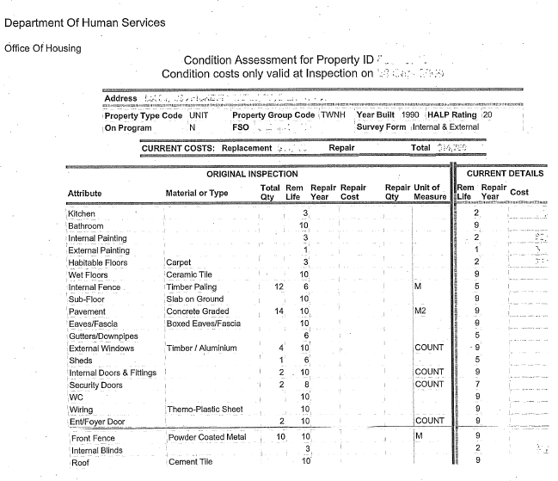

Low-rise Villa works Approval Process
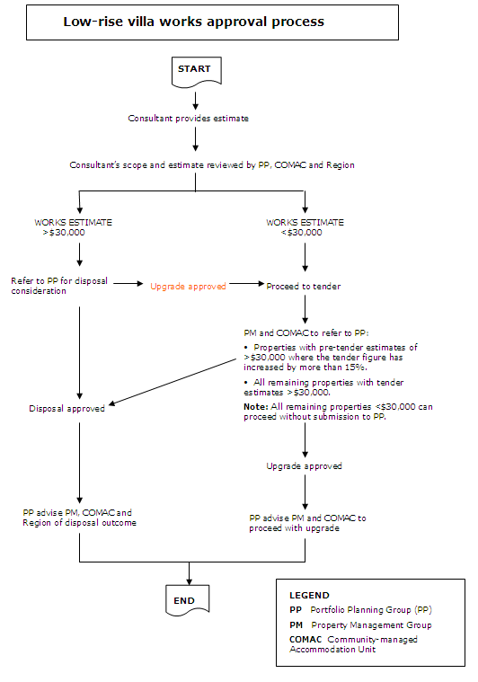

Variation Quotation Request
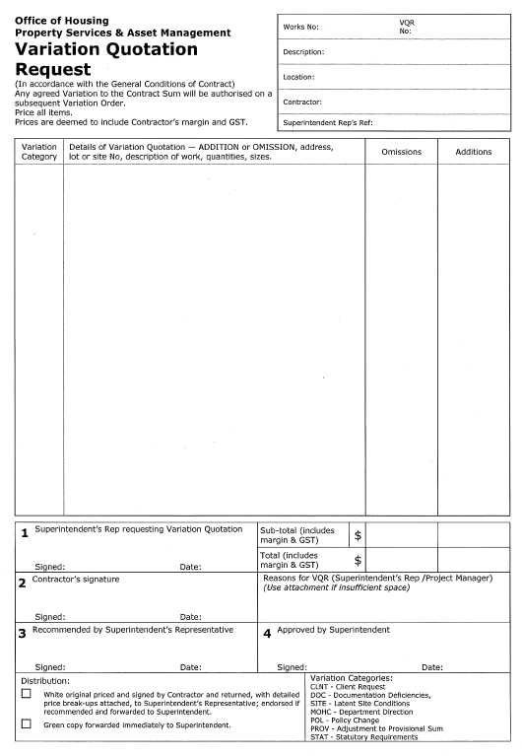

MCAT procedure for vacant properties on program
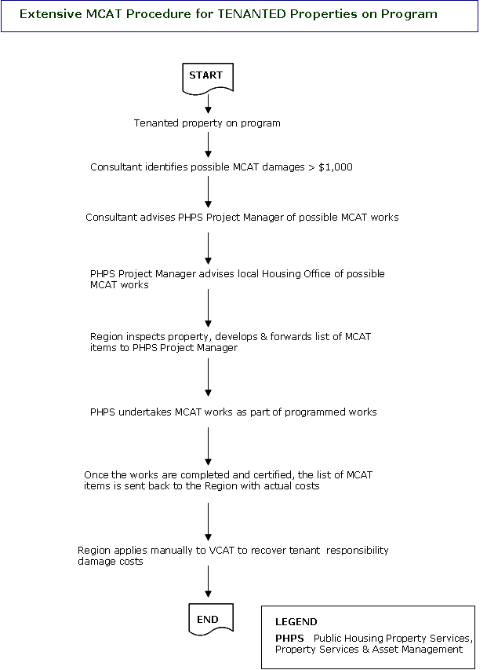

MCAT procedure for tenanted properties not on program
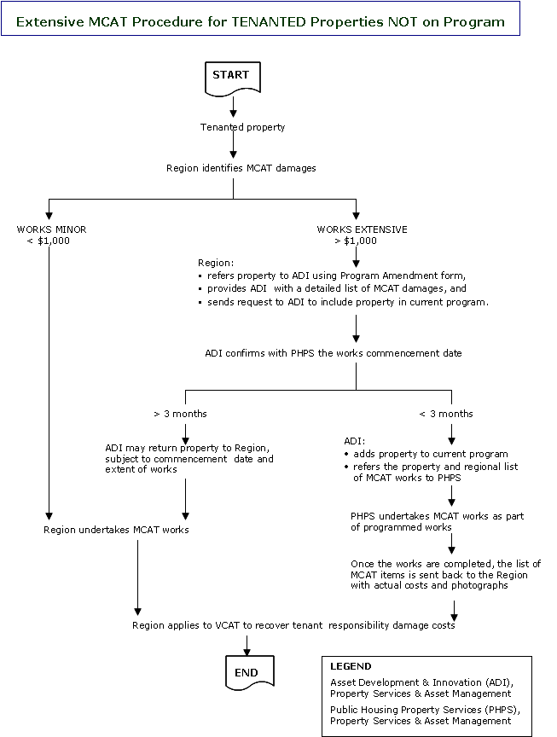

MCAT procedure for vacant properties on program
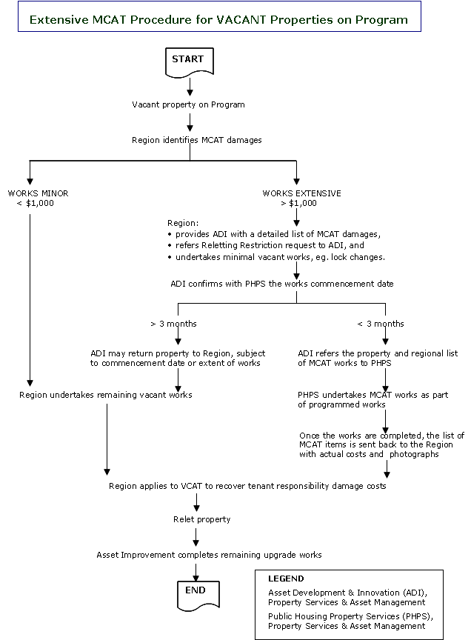

MCAT procedure for vacant properties not on program
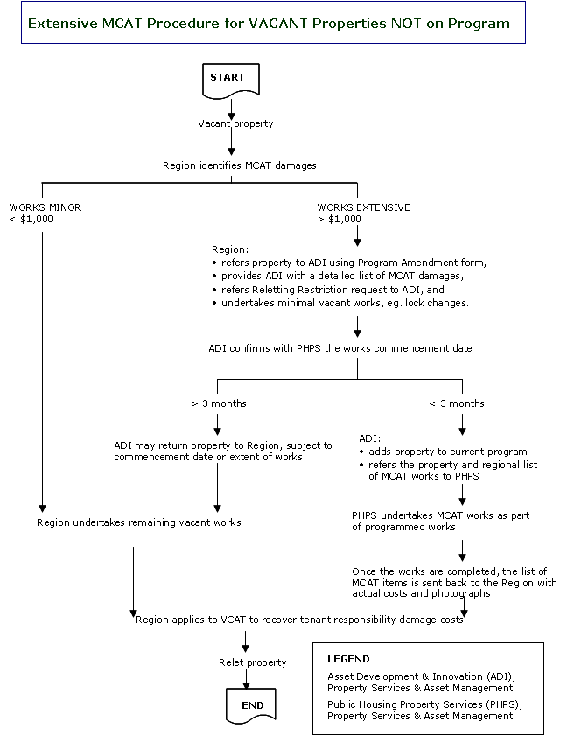

Report of Fire Incident Form
DEPARTMENT OF HUMAN SERVICES
REPORT OF FIRE INCIDENT
This report should be prepared by the responding officer of the Department of Human Services, as soon as possible after the fire.
This document does not supersede or form part of a Ministerial Briefing Paper.
The information is confidential and must not be released to other agencies, organisations or municipalities without the authority of the Director of Housing or a delegated representative.

GENERAL INFORMATION
1 | Address of Property
2 | Property Identification Number |  | 3 | Property Type | RGS RABG  Other:
4 | Name of Tenant |  | 5 | Client ID number of Tenant
6 | Tenancy Account Number |  | 7 | Number of persons in property
8 | Date of Fire | / /20 | 9 | Was Smoke Alarm activated? |  | YES NO
10 | Fire Discovered by:  Date:  Time: | Tenant Neighbour  Other:  / /20  : AM/PM | 11 | Fire reported to Housing Office by:  Date:  Time: |  | Tenant Neighbour  Other:  / /20  : AM/PM
12 | Fire Brigade Called by:  Date:  Time: | Tenant Neighbour  Other:  / /20  : AM/PM | 13 | Time Fire Brigade Arrived: |  | : AM/PM
14 | Estimated Cost of Damage | $ . | 15 | Was Property Services & Asset Management notified? |  | YES NO

SUPPORT INFORMATION
Answer the following questions by ticking one, or more if relevant, of the options provided.
Take time to read the selections. Comment only where applicable.

16 | BUILDING TYPE
A | Multi Storey |  | B | Flat |  | C | Floor No. |  | D | Other
E | Single Dwelling |  | F | Detached |  | G | Town House |  | H | Housing Office
I | Number of Rooms |  |  |  |  | J | Age of Property |  | years months
COMMENTS :

