

|  |
| --- |
| Keep Embracing Your Success |
| Tools, Assessments and Supplementary Guidance |
| OFFICIAL |

To receive this publication in an accessible format email [Care Services](mailto:careservices@dffh.vic.gov.au) <mailto:careservices@dffh.vic.gov.au>.

Authorised and published by the Victorian Government, 1 Treasury Place, Melbourne.

© State of Victoria, Australia, Department of Families, Fairness and Housing November 2021.

In this document, ‘Aboriginal’ refers to both Aboriginal and Torres Strait Islander people. ‘Indigenous’ or ‘Koori/Koorie’ is retained when part of the title of a report, program or quotation.

**ISBN** 978-1-76096-652-2

Contents

KEYS Assessment 6

KEYS Plan 26

KEYS Transition Plan (Can be used for transition in or Transition out) 28

Young Person Goal Setting tools 29

Care Team Goal Setting Tool (Spidergram) 33

ERIC Resources / wallet cards adapted for KEYS 37

Behaviour Support Plan 42

Safety and Stability Support Plan 47

Cyber Safety – General Tips 54

# KEYS Assessment

|  |
| --- |
| INSTRUCTIONS AND BACKGROUND |

The intent of this document is to be a working document that centralises assessment information and provides clarity in regards to the strengths and focus areas of the young person and their family during their time in KEYS. This document is to be used in line with the guiding principles of the Best Interests Case Practice Model (information gathering- analysis and planning- action- reviewing outcomes). Specifically, it is reviewed and interpreted in accordance with the KEYS Plan, and should be regularly updated based on discussions and interactions with the young person, and their family.

The expectations for the completion and sharing of this document are:

* All care team members should have a copy
* All professionals within the KEYS team have equal responsibility to update this document, however it will be the case manager who coordinates the completion
* The document is intended to be a ‘working’ document, and therefore regularly updated, it is to be formally reviewed in line with the Monash Health assessments (initial completion at 6 weeks, then 3 monthly reviews)
* As a guide it is envisaged that:
  + The Background will be completed by the Case Manager
  + The Safety assessment section will be completed by the Case Manager and Mental Health Clinician
  + The Mental Health section will be completed by the Mental Health Clinician
  + The Education and Employment section will be completed by the education and Community Engagement Worker
  + The Life Skills section will be completed by the Key Worker and Community Engagement worker
  + The Family section will be completed by the Family Engagement Worker

**Interpretation**

This document provides a brief snapshot of the young person across a number of domains, and should be interpreted via discussion with the specialist worker about each assessment. Care team members who are unfamiliar with an assessment measure or tool should seek to speak with the worker who undertook the assessment for clarity.

|  |  |  |  |  |  |
| --- | --- | --- | --- | --- | --- |
| BACKGROUND | | | | | |
| **Name:** | | **DOB:** | | | |
| **Type of care services placement:** KEYS initiative | | **Is the young person Aboriginal or Torres Strait Islander:** | | | |
| **Date of entry into KEYS:** | | **CALD:** | | | |
| **Date of first entry into OOHC:** | | **Disability:** | | | |
| **Total number of placements in past 12 months:** | | **Alerts/ allergies:** | | | |
| **Total number of placements in care:** | | **Current medication:** | | | |
| **Current court order:** | | **Other alert:** | | | |
| **Case planning direction:** | | **Assessment Date:** | | | |
| **Critical information regarding case planning:** | | | | | |
|  | | | | | |
|  | | | | | |
| SAFETY ASSESSMENT | | | | | |
| COMPLETED BY: | | FULL ASSESSMENT LOCATION: | | | |
|  | Not at all | | Occasionally | Often | Frequency/ Comments |
| Does this young person engage in criminal offending |  | |  |  |  |
| Are there concerns about this young person’s risk of sexual exploitation |  | |  |  |  |
| Risk of suicide or serious self- harm |  | |  |  |  |
| Risk of aggression, violence, or harm to others |  | |  |  |  |
| Risk of absconding or AWOL |  | |  |  |  |
| Risk of physical illness |  | |  |  |  |
| Risk of cognitive/ developmental related harm |  | |  |  |  |
| Vulnerability to harm from others |  | |  |  |  |
| Difficulties with engagement |  | |  |  |  |
| Social/ environmental related harm |  | |  |  |  |
| Does this young person engage in criminal offending |  | |  |  |  |

Substance USe

**List current and past substances used:** (*e.g. cannabis, alcohol and inhalants)*

**In the past 3 months, how often has the young person used each of the above substances?**

|  |  |  |  |  |  |  |  |
| --- | --- | --- | --- | --- | --- | --- | --- |
| **Type of Substance** | **Never** | **Once or twice** | **Monthly** | **Weekly** | **Daily/ almost daily** | **Do not know** | **Comments** |
| Alcohol |  |  |  |  |  |  |  |
| Tobacco |  |  |  |  |  |  |  |
| Cannabis |  |  |  |  |  |  |  |
| Cocaine |  |  |  |  |  |  |  |
| Amphetamines |  |  |  |  |  |  |  |
| Inhalants |  |  |  |  |  |  |  |
| Sedatives |  |  |  |  |  |  |  |
| Opioids |  |  |  |  |  |  |  |
| Other |  |  |  |  |  |  |  |

|  |
| --- |
| SAFETY ASSESSMENT COMMENTS |

|  |  |
| --- | --- |
| MENTAL HEALTH ASSESSMENT | |
| COMPLETED BY: | FULL ASSESSMENT LOCATION: |
|  |  |

### HoNOSCA (Measure of general health and social function)

|  |  |  |  |  |  |
| --- | --- | --- | --- | --- | --- |
|  | Current (Date) | Previous (Date) | Previous (Date) | Previous (Date) | Previous (Date) |
| Behavioural problems (score range 0-16) |  |  |  |  |  |
| Impairment (score range 0-8) |  |  |  |  |  |
| Symptomatic problems (score range 0-12) |  |  |  |  |  |
| Social problems (score range 0-16) |  |  |  |  |  |
| Total (score range 0-52) |  |  |  |  |  |

* Higher score equates to more significant problems, 0= no problems, 52= severe problems on all items

### CGAS (Measure of emotional and behavioural functioning)

|  |  |  |  |  |  |
| --- | --- | --- | --- | --- | --- |
|  | Current (Date) | Previous (Date) | Previous (Date) | Previous (Date) | Previous (Date) |
| Total score (score range 0-100) |  |  |  |  |  |

**\*** Higher score equates to higher functioning, 0= extremely impaired, 50= variable functioning, 100= superior functioning

### SDQ (Measure of behaviours)

|  |  |  |  |  |  |
| --- | --- | --- | --- | --- | --- |
|  | Current (Date) | Previous (Date) | Previous (Date) | Previous (Date) | Previous (Date) |
| Emotional problems (score range 0-10) |  |  |  |  |  |
| Conduct problems (score range 0-10) |  |  |  |  |  |
| Hyperactivity and inattention (score range 0-10) |  |  |  |  |  |
| Peer relationships (score range 0-10) |  |  |  |  |  |
| Prosocial behaviors (score range 0-10) |  |  |  |  |  |
| Total difficulties (score range 0-40) |  |  |  |  |  |

* Higher score equates to more difficulties

|  |
| --- |
| MENTAL HEALTH ASSESSMENT  TREATMENT SUMMARY |

|  |  |
| --- | --- |
| EDUCATION AND EMPLOYMENT ASSESSMENT | |
| COMPLETED BY: | FULL ASSESSMENT LOCATION: |

Current education setting:

When was this young person last attending mainstream education:

### ATTENDANCE

|  |  |  |  |  |  |  |
| --- | --- | --- | --- | --- | --- | --- |
|  | Entry (Date) | 6 Weeks (Date) | 18 Weeks (Date | 30 Weeks (Date) | 42 Weeks (Date) | 54 Weeks (Date) |
| Expected days |  |  |  |  |  |  |
| Actual days |  |  |  |  |  |  |

|  |  |  |  |  |
| --- | --- | --- | --- | --- |
|  | Term 1 | Term 2 | Term 3 | Term 4 |
| Percentage % |  |  |  |  |

### ENGLISH

|  |  |  |  |  |  |
| --- | --- | --- | --- | --- | --- |
|  | Test Type | Test Administered | Raw Score | Scale Score | ACSF Level |
| Baseline  (Date) |  |  |  |  |  |
| 6 Months  (Date) |  |  |  |  |  |
| 12 Months  (Date) |  |  |  |  |  |

### MATHS

|  |  |  |  |  |  |
| --- | --- | --- | --- | --- | --- |
|  | Test Type | Test Administered | Raw Score | Scale Score | ACSF Level |
| Baseline  (Date) |  |  |  |  |  |
| 6 Months  (Date) |  |  |  |  |  |
| 12 Months  (Date) |  |  |  |  |  |

*Raw scores: number of correct answers a student gives

*Scale score & ACFS level: higher score/level equates to higher functioning and increased capabilities

### GOALS AND ACHIEVEMENTS

|  |  |  |  |
| --- | --- | --- | --- |
|  | Entry Skills | Outcome Target | Rating of Progress |
| English |  |  |  |
| Math’s |  |  |  |
| School participation & Motivation/Engagement |  |  |  |
| SAAS-R: |

**\***Ratings for progress towards achievement:  1. No progress. 2. Little progress. 3. Satisfactory progress. 4. Reached the goal. 5. Slightly exceeded the goal. 6. Exceeded the goal.

*SAAS-R (Student attitude to school survey score)

*Refer to Personalised Education Plan for a detailed breakdown and review of goals.

### EMPLOYMENT

Has this young person undertaken any paid or unpaid work? (list details)

Has this you person attending any interviews or training days? (list details)

What steps has this young person undertaken towards their career goals?

|  |
| --- |
| EDUCATION AND EMPLOYMENT ASSESSMENT SUMMARY  *(please include academic strengths and difficulties within each of the strands in Math’s and English)* |

|  |  |
| --- | --- |
| LIFE SKILLS ASSESSMENT | |
| COMPLETED BY: | FULL ASSESSMENT LOCATION: |

### YOUNG PERSONS GOALS

|  |  |  |  |  |  |
| --- | --- | --- | --- | --- | --- |
| (1) STARTING OUT | (2) ON MY WAY | (3) MAKING PROGRESS | (4) ALMOST THERE | (5) MADE IT | LAST STEP ACHIEVED? |
|  |  |  |  |  |  |
|  |  |  |  |  |  |

### LIFE SKILLS ASSESSMENT

|  |  |  |  |  |
| --- | --- | --- | --- | --- |
|  | Current (date) | Previous (date) | Previous (date) | Previous (date) |
| Personal care skills |  |  |  |  |
| Domestic skills |  |  |  |  |
| Housing related knowledge |  |  |  |  |
| Financial skills |  |  |  |  |
| Service related knowledge |  |  |  |  |
| Time management |  |  |  |  |
| Education and employment |  |  |  |  |
| Relationships |  |  |  |  |
| Post care |  |  |  |  |

* Higher score equates to more developed skills, 0= Minimal or not yet developed, 1 = Developing, 2= Capable, 3 = Strong, N/A = Item inappropriate for age or development

Please list any items scored 0 (focus areas)

Please list any items scored 3 (strengths)

### ECOMAP (please attach)

|  |
| --- |
| YOUNG PERSONS GOALS SUMMARY  *(Progress towards goal? What’s going well? What got in the way? Next steps?)*  LIVING SKILLS AND COMMUNITY ENGAGEMENT SUMMARY |

|  |  |
| --- | --- |
| FAMILY ASSESSMENT | |
| COMPLETED BY: | FULL ASSESSMENT LOCATION: |

Brief description of current family situation:

### NCFAS (Maternal)

|  |  |  |  |  |  |
| --- | --- | --- | --- | --- | --- |
| Skill rating: (+2 Clear strength, +1 Mild strength, 0 Adequate, -1 Mild problem. -2 Moderate problem, -3 Serious problem) | | | | | |
|  | Family Interactions (section C) | | | | Child Wellbeing (section E) |
|  | Bonding with children | Communication with children | Expectations of children | Mutual support within family | Children’s relationship with siblings |
| Intake |  |  |  |  |  |
| 3 months |  |  |  |  |  |
| 6 months |  |  |  |  |  |
| 12 months |  |  |  |  |  |
| Closure |  |  |  |  |  |

* Please refer to NCFAS subscale definitions

Please list any items scored – 2 or -3 (moderate/ serious problem):

Please list any items scored 2 (clear strength):

Please list any significant notes from NCFAS here:

### NCFAS (Paternal)

|  |  |  |  |  |  |
| --- | --- | --- | --- | --- | --- |
| Skill rating: (+2 Clear strength, +1 Mild strength, 0 Adequate, -1 Mild problem. -2 Moderate problem, -3 Serious problem) | | | | | |
|  | Family Interactions (section C) | | | | Child Wellbeing (section E) |
|  | Bonding with children | Communication with children | Expectations of children | Mutual support within family | Children’s relationship with siblings |
| Intake |  |  |  |  |  |
| 3 months |  |  |  |  |  |
| 6 months |  |  |  |  |  |
| 12 months |  |  |  |  |  |
| Closure |  |  |  |  |  |

* Please refer to NCFAS subscale definitions

Please list any items scored – 2 or -3 (moderate/ serious problem):

Please list any items scored 2 (clear strength):

Please list any significant notes from NCFAS here:

### FAMILY CONTACT

|  |  |  |  |  |  |  |  |  |  |  |
| --- | --- | --- | --- | --- | --- | --- | --- | --- | --- | --- |
|  | N/A (e.g. not alive) | None | Occasionally | Monthly | Fortnightly | Weekly | Several times a week | Daily | Quality of Contact | Comments |
| Mother |  |  |  |  |  |  |  |  |  |  |
| Father |  |  |  |  |  |  |  |  |  |  |
| Sibling |  |  |  |  |  |  |  |  |  |  |
| Extended Family |  |  |  |  |  |  |  |  |  |  |

* No differentiation between supervised/unsupervised, with permission/without permission, face-to-face/phone

* Quality of contact: (+2 Clear strength, +1 Mild strength, 0 Adequate, -1 Mild problem. -2 Moderate problem, -3 Serious problem)

### GENOGRAM (please attach)

|  |
| --- |
| FAMILY ASSESSMENT SUMMARY |

|  |  |
| --- | --- |
| SPIDERGRAM ASSESSMENT | |
| COMPLETED BY: Care Team | FULL ASSESSMENT LOCATION: Dandenong |

### SPIDERGRAM (please attach)

|  |
| --- |
| Series 1 = Care team scores, Series 2 = Young person scores |
| 1 = Strongly disagree, 2 = Disagree, 3 = Neither agree or Disagree, 4 = Agree, 5 = Strongly agree |

# KEYS Plan

| **Safety** |
| --- |

|  |  |  |  |
| --- | --- | --- | --- |
| GOAL | ACTIONS TO ACHIEVE GOAL | PERSON RESPONSIBLE | BY WHEN |
| *What needs to happen?*  *(SMART goal)* |  |  |  |
|  |  |  |  |

| **Managing Emotions** |
| --- |

|  |  |  |  |
| --- | --- | --- | --- |
| GOAL | ACTIONS TO ACHIEVE GOAL | PERSON RESPONSIBLE | BY WHEN |
|  |  |  |  |
|  |  |  |  |

| **Life Skills** |
| --- |

|  |  |  |  |
| --- | --- | --- | --- |
| GOAL | ACTIONS TO ACHIEVE GOAL | PERSON RESPONSIBLE | BY WHEN |
|  |  |  |  |
|  |  |  |  |

| **Education & Employment** |
| --- |

|  |  |  |  |
| --- | --- | --- | --- |
| GOAL | ACTIONS TO ACHIEVE GOAL | PERSON RESPONSIBLE | BY WHEN |
|  |  |  |  |
|  |  |  |  |

| **Identity & Connection** |
| --- |

|  |  |  |  |
| --- | --- | --- | --- |
| GOAL | ACTIONS TO ACHIEVE GOAL | PERSON RESPONSIBLE | BY WHEN |
|  |  |  |  |
|  |  |  |  |

## 

# KEYS Transition Plan

# (Can be used for transition in or Transition out)

|  |  |  |  |
| --- | --- | --- | --- |
| GOAL | ACTIONS TO ACHIEVE GOAL | PERSON RESPONSIBLE | BY WHEN |
| *Transition Readiness*  *What needs to happen?*  *(SMART goal)* |  |  |  |
|  |  |  |  |

# Young Person Goal Setting tools

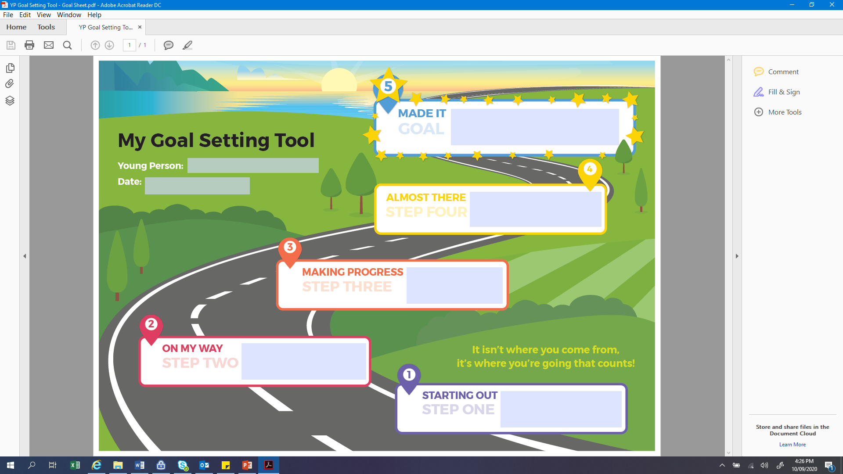

### My Goal Setting Tool

**Young Person:** Insert details here

**Domain*:** Insert details here

**It isn’t where you come from,**

**It’s where you’re going that counts!**

**Goal:** Insert details here

|  |  |  |  |  |  |
| --- | --- | --- | --- | --- | --- |
| Date | Step | What’s working well? | What got in the way? | Next steps? | By when? |
|  |  |  |  |  |  |
|  |  |  |  |  |  |
|  |  |  |  |  |  |
|  |  |  |  |  |  |

*Domains: safety, managing emotions, life skills, education & employment, identity & connection

### KEYS – Spidergram Scaling Tool (Young Person)

**Young Person:** Insert details here

**Date:** Insert details here

**Completed by:** Insert details here

|  |  |  |  |  |  |
| --- | --- | --- | --- | --- | --- |
|  | **1** | **2** | **3** | **4** | **5** |
| **STRONGLY DISAGREE** | **DISAGREE** | **NEITHER AGREE OR DISAGREE** | **AGREE** | **STRONGLY AGREE** |
| **SAFETY**  I am able to keep myself safe (with support). |  |  |  |  |  |
| **MANAGING EMOTIONS**  I am developing the ability to manage difficult emotions. |  |  |  |  |  |
| **LIFE SKILLS**  I am developing life skills for my future. |  |  |  |  |  |
| **EDUCATION & EMPLOYMENT**  I am consistently participating in a day program. |  |  |  |  |  |
| **IDENTITY**  I have a good understanding of my life story (including cultural). |  |  |  |  |  |
| **CONNECTION**  I have a positive connection to my family, friends and community. |  |  |  |  |  |

# Care Team Goal Setting Tool (Spidergram)

### KEYS – Spidergram Scaling Tool (Care Team)

**Young Person:** Insert details here

**Date:** Insert details here

**Completed by:** Insert details here

|  |  |  |  |  |  |
| --- | --- | --- | --- | --- | --- |
|  | **1** | **2** | **3** | **4** | **5** |
| **STRONGLY DISAGREE** | **DISAGREE** | **NEITHER AGREE OR DISAGREE** | **AGREE** | **STRONGLY AGREE** |
| **SAFETY**  The young person is able to keep themselves safe (with support). |  |  |  |  |  |
| **MANAGING EMOTIONS**  The young person is developing the ability to manage difficult emotions. |  |  |  |  |  |
| **LIFE SKILLS**  The young person is developing life skills for the future. |  |  |  |  |  |
| **EDUCATION & EMPLOYMENT**  The young person is consistently participating in a day program. |  |  |  |  |  |
| **IDENTITY**  The young person has a coherent life story (including cultural). |  |  |  |  |  |
| **CONNECTION**  The young person has a positive connection to family, friends and community. |  |  |  |  |  |

**KEYS - Spidergram Scaling Tool**

**Young Person:**

**Date:**

|  |
| --- |
| **Score the young person in each of the areas below using the following scale:**  **1 = Strongly Disagree**  **2 = Disagree**  **3 = Neither Agree or Disagree**  **4 = Agree**  **5 = Strongly Agree** |

|  |  |  |
| --- | --- | --- |
|  | Care Team | Young Person |
| **Safety:** The young person is able to keep themselves safe (with support). |  |  |
| **Managing Emotions:** The young person is developing the ability to manage difficult emotions. |  |  |
| **Life Skills:** The young person is developing life skills for the future. |  |  |
| **Education & Employment:** The young person is consistently participating in a day program. |  |  |
| **Identity:** The young person has a coherent life story (including cultural). |  |  |
| **Connection:** The young person has a positive connection to family, friends and community. |  |  |

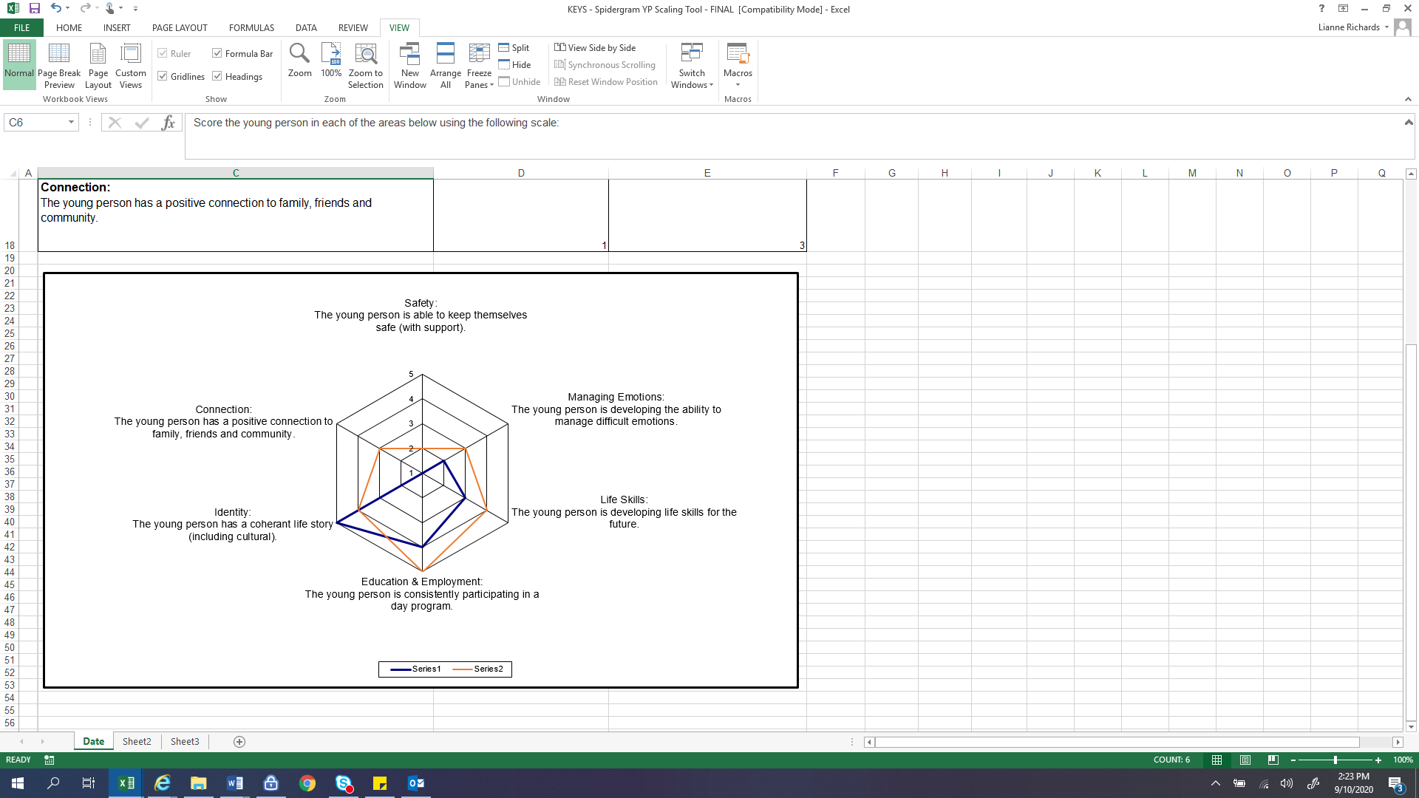

# ERIC Resources / wallet cards adapted for KEYS

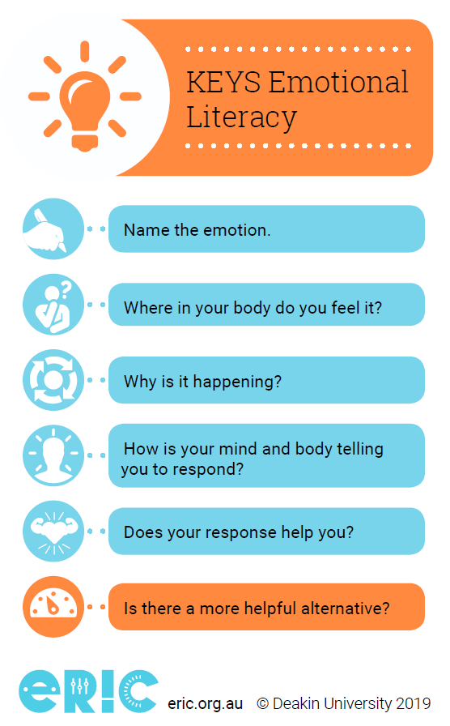

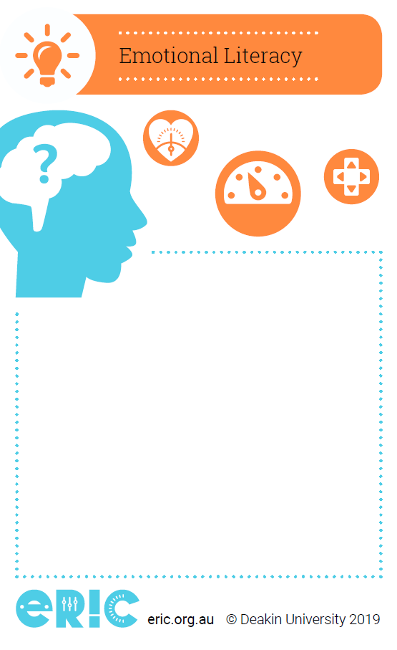

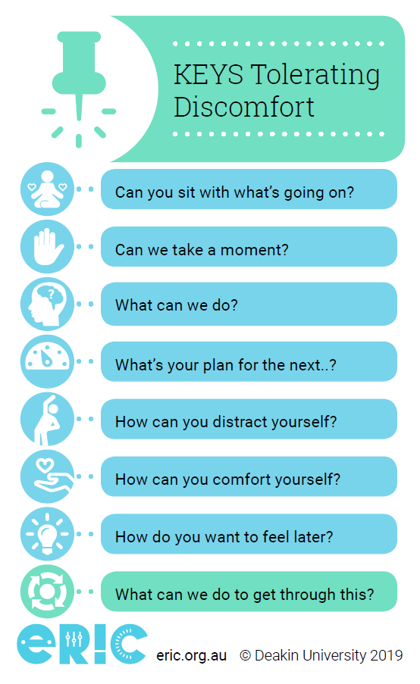

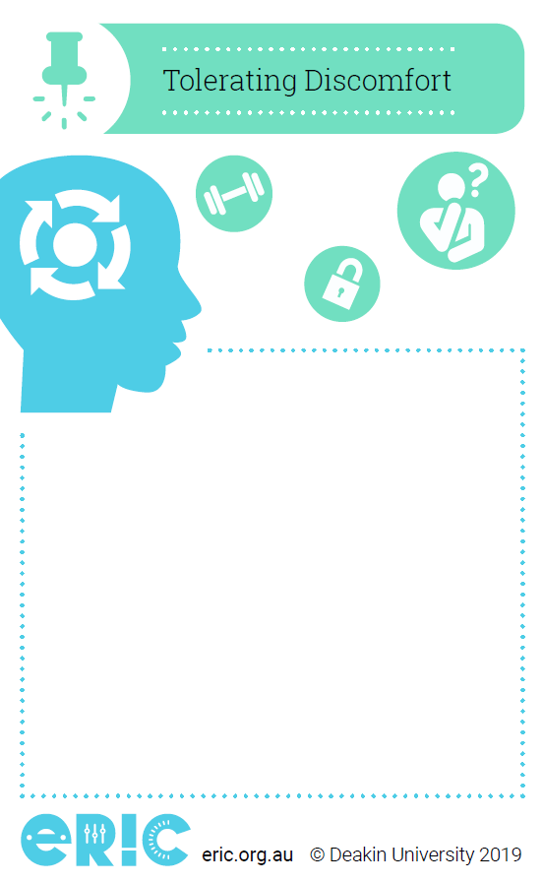

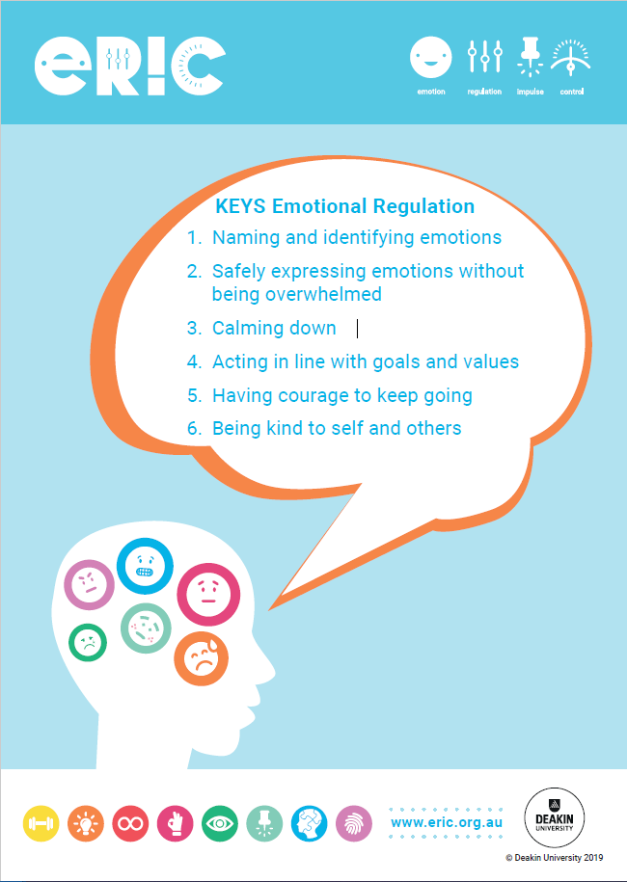

# Behaviour Support Plan

### Client Details

|  |  |  |  |
| --- | --- | --- | --- |
| **Name:** |  | | |
| **D.O.B:** |  | **Gender:** |  |

|  |  |
| --- | --- |
| **Goals for this Plan:** |  |

### Personal Preferences

|  |  |
| --- | --- |
| **Likes:** |  |
| **Dislikes:** |  |

### Care needs (in relation to behaviours of concern)

|  |  |
| --- | --- |
| **Communication:** |  |
| **Health Alerts:** |  |
| **Support Needs:** |  |

### Behaviours of concern

|  |  |
| --- | --- |
| **Behaviour** | **Reasons for the Behaviour** |
|  |  |
|  |  |
|  |  |

### Where and when these behaviours may occur?

|  |  |
| --- | --- |
| **Place:** |  |
| **Activity:** |  |
| **Time:** |  |
| **People:** |  |
| **Other:** |  |

### What can staff/carers do to help to reduce behaviours of concern?

|  |  |
| --- | --- |
| **Changes to environment:** |  |
| **Replacement skills to teach:** |  |
| **Rewards:** |  |

### Main Contact for this person

|  |  |
| --- | --- |
| **Name:** |  |
| **Role/Responsibility:** |  |
| **Contact Number:** |  |

### Behaviour Response Plan

|  |  |  |  |  |  |
| --- | --- | --- | --- | --- | --- |
|  | **Early warning signs** | **Low level behaviour** | **Severe behaviour** | **Calming Down** | **Recovery** |
| ***What does this look like?*** |  |  |  |  |  |
| ***How to support person/***  ***intervention strategies?*** |  |  |  |  |  |
| ***What do staff need to know/do?*** |  |  |  |  |  |

### Action plan – Who will do what and by when to make this behaviour support plan happen?

|  |  |  |
| --- | --- | --- |
| **Care team member name** | **Tasks** | **By date below** |
|  |  |  |
|  |  |  |
|  |  |  |
|  |  |  |
|  |  |  |
|  |  |  |
|  |  |  |

### Review and Communication – When will the plan be reviewed? Who is responsible? What information will they receive?

|  |  |  |
| --- | --- | --- |
| **When (dates)** | **Care team members responsible** | **Information provided** |
|  |  |  |
|  |  |  |
|  |  |  |
|  |  |  |

### Plan Details

|  |  |  |  |
| --- | --- | --- | --- |
| **Plan prepared by:**  *(name & position)* |  | **Date:** |  |

# Safety and Stability Support Plan

### Crisis Management Plan

A crisis is when the adolescent puts him/herself or others at ***significant*** risk and when the strategies on the young person’s behaviour management plan are not effective. Based on the young person’s past behaviour, it is possible to predict the type of behaviour that may escalate into a ‘CRISIS’ and have a crisis plan in place to assist staff and carers at that time.

The Crisis plan should not change the fundamental long term goals the adolescent is working towards, but can set them aside for the period of the crisis.

### Client Details

|  |  |  |  |
| --- | --- | --- | --- |
| **Name** |  | | |
| **D.O.B** |  | **Gender:** |  |
| **Child Protection Status** | Please detail any conditions relating to the Child Protection Order | | |
| **CRIS No** |  | | |
| **Case Management Responsibility** |  | | |
| **Contract Case Manager** |  | | |
| **Type of Placement** |  | | |
| **Address** |  | | |
| **Phone No** |  | | |
| **Carer Details** |  | | |
| **Legal Status** |  | | |
| **Health Alerts** |  | | |
| **Medicare No** |  | | |

### Plan Details

|  |  |
| --- | --- |
| **Plan prepared by:**  *(name & position)* |  |
| **Date:** |  |
| **Review Date:** |  |

### Background Information

|  |
| --- |
|  |

### Current Situation:

|  |
| --- |
|  |

### Current Concerns / High Risk Behaviours:

|  |
| --- |
|  |

IN THE FOLLOWING ACTIONS TABLE: Please delete any behaviours that have not been identified or make it clear that these concerns HAVE NOT been observed in the young person.

FAMILY STRUCTURE: Advise of any family or friends that CAN and CANNOT have contact with young person.

*Please note any Youth Justice orders or bail condition*

| IDENTIFIED BEHAVIOUR | TRIGGERS FOR WORKERS TO NOTE | **ACTION REQUIRED****(Include how to recognise crisis phase is over)** |
| --- | --- | --- |
| ABSCONDING |  | ***If the young person has been missing for a period of ……….. then they are considered to be at risk, the following steps need to be followed:*** |
|  |  |  |
| SUBSTANCE USE |  | ***In the event that the YP is substance affected or has returned substance affected:*** |
|  |  |  |
| SUICIDAL IDEATION, THREAT OR ATTEMPT |  | ***If YP presents with depressive symptoms and is verbalising thoughts of suicide:*** |
|  |  |  |
| SELF HARM, THREAT OR ATTEMPT |  | ***If YP presents as threatening to self-harm:*** |
|  |  |  |
| VERBALLY OR PHYSICALLY ABUSIVE |  | *If the YP becomes physically and verbally abusive:* |
|  |  |  |
| SPARE |  |  |
|  |  |  |

**SUPPORT SERVICES**

|  |  |  |
| --- | --- | --- |
| **SERVICE** | **CONTACT NAME** | **CONTACT NUMBER** |
|  |  |  |
|  |  |  |
|  |  |  |
|  |  |  |
|  |  |  |

**FAMILY STRUCTURE**

|  |  |  |  |
| --- | --- | --- | --- |
| **NAME** | **RELATIONSHIP** | **ADDRESS** | **PHONE NO** |
|  |  |  |  |
|  |  |  |  |
|  |  |  |  |
|  |  |  |  |
|  |  |  |  |
|  |  |  |  |
|  |  |  |  |

# Cyber Safety – General Tips

General cyber safety tips, if required:

* Install security and parental controls on all devices in the home to filter what content young people can access and see online, and to help set time limitations regarding what times a young person can use the internet.
* Put a password on the internet connection, especially if it is a home wifi connection. Carers can change the password regularly. Alternatively, carers can disconnect the young person’s device by asking the device to ‘forget’ the wifi connection and password when disconnected. This means the password needs to be input by the carer every time the young person wishes to connect to the internet.
* Have regular and open conversations with young people about appropriate internet use. This may include:
  + Not posting personal information such as address, phone number and DOB.
  + Not befriending everyone who sends them a friend request.
  + Not giving their password to anyone (however it is suitable for young people to provide carers with their password as part of a social media agreement).
  + Not sending pictures of themselves or others that show nudity or sexual acts, bullying, racism, sexism or other derogatory imagery.
  + Not feeling pressured to disclose their details to a stranger online.
  + Being aware that what they post on the internet is there permanently, even if they think they have deleted it.
  + Being aware that people online are not always who they say they are.
  + Being aware of online scams.
  + Being kind online, and not bullying others.
* Establish and explain house rules regarding internet/device use to the young person on day one of the placement. This may include:
  + That a written agreement must be made before the wifi password is provided.
  + Times of the day the internet/device can be used.
  + Time limits for internet/device use.
  + In what rooms devices can be used.
  + What websites, Apps, and content are allowed and not allowed to be accessed.
  + Not to give out personal information online (such as address).
  + Not to meet a stranger they met online in person.
  + Who has access to the password for their social media accounts and why this needs to be shared.
  + Who in the home they should inform if their family contacts them online.
  + Who in the home is available to help at any time if they come across inappropriate content, experience online bullying and predatory behaviour, or are unsure how to approach a social situation online.