

|  |
| --- |
| Independent review themes report  October 2018 to March 2019 |
|  |

# Introduction

The Human Services Standards (Standards) (gazetted as the Department of Health and Human Services Standards) consist of the four service delivery standards as well as the governance and management standards of a service provider’s chosen department-endorsed independent review body.

This report relates to audits/surveys/reviews (reviews) undertaken by the Department of Health and Human Services (department) endorsed IRBs against the department’s Human Services Standards.[1]

The purpose of the independent review bodies (IRB) themes report is to capture a high level overview of key themes arising from independent reviews.

Data for this report was collated from a survey completed by each of the eight department endorsed IRBs and focuses on themes rather than specific incidences.

A certification/accreditation review is undertaken every three years and a surveillance/mid cycle review is undertaken every 12 or 18 months, depending on the governance and management standards chosen.

Survey data is collected and published twice a year. This fourth IRB themes report is for the period 1 October 2018 to 31 March 2019.

The report will be published on the department’s website and a copy of the previous report is available on the [Human Services Standards page](https://providers.dhhs.vic.gov.au/human-services-standards) <https://providers.dhhs.vic.gov.au/human-services-standards> on the Providers website.

Notifiable issues reported and the categories

Independent review bodies are required to immediately notify the department if it suspects, has evidence of, or receives a complaint or allegation about any of the following:

* the health, safety, abuse or risk to a person who receives services from a service provider
* the governance, financial accountability or criminal activity of the service provider
* a service provider fails or may fail to meet basic client needs or puts a client at risk of significant harm
* a service provider is experiencing significant disruption and executive mismanagement
* the independent review body has serious concerns about the ongoing financial viability of the service provider
* a service provider engages in conduct which is fraudulent or potentially fraudulent or is engaged in other criminal activities
* a service provider has missing safety screening checks (for example Working with Children Checks and National/International Police Checks)
* there is medication mismanagement within a service provider
* a service provider has a lack of reporting on Restrictive Intervention Data System (RIDS) and or Restrictive Interventions.

During the period, October 2018 to March 2019, IRBs reported a total of 31 notifiable issues out of the 261 service providers reviewed (twelve per cent). During the same period Standards and Regulation received a total of 46 notifiable issues from various sources such as IRBs, service providers, other regulators and department staff. The following table indicates the number of notifiable issues reported against each of the relevant categories. Note, some notifiable issues reported covered a number of categories.

**Table listing number of notifiable issues reported against each notifiable issues category**

| **Notifiable issue category** | **Number reported by IRBs** | **Number reported from other sources** |
| --- | --- | --- |
| Health, safety, abuse or risk to a person who receives services from a service provider. | 2 | 0 |
| Governance, financial accountability or criminal activity of the service provider. | 1 | 0 |
| Service provider fails to or may fail to meet basic client needs or puts the client at risk of significant harm. | 0 | 3 |
| Service provider experiences significant disruption and executive mismanagement. | 0 | 0 |
| IRB has serious concerns about the ongoing financial viability of the service provider. | 0 | 0 |
| Service provider engages in conduct which is fraudulent or potentially fraudulent or is engaged in other criminal activities. | 0 | 0 |
| Service provider has missing safety screening checks (for example, Working with Children Checks and National/International Police Checks). | 26 | 43 |
| There is medication mismanagement within the service provider. | 0 | 0 |
| There is a lack of reporting on Restrictive Intervention Data System (RIDS) and or Restrictive Interventions. | 2 | 0 |
| **Total** | **31** | **46** |

# Total number of audits undertaken during the period

The total number of service providers reviewed during the period (01 October 2018 to 31 March 2019) was 256.

254 reviews undertaken were against the four service delivery standards, of these 125 (49 per cent) were for certification/accreditation, 92 (36 per cent) were surveillance/mid-cycle and 37 (15 per cent) were follow up reviews.

235 reviews were undertaken against the governance and management standards, of these 127 (54 per cent) were certification/accreditation, 81 (34 per cent) were surveillance/mid-cycle and 27 (12 per cent) were follow up reviews.

It should be noted that a service provider may have had more than one type of review within this period and the reviews may have been undertaken against the four service delivery standards and/or governance and management standards.

The following graph details the breakup of the types of reviews against the four service delivery standards and the governance and management standards.

Further information regarding the Human Services Standards and a description of the endorsed governance and management standards are found in Appendix 1.

**Figure 1 - Graph representation of total number of reviews undertaken against the Human Services Standards**

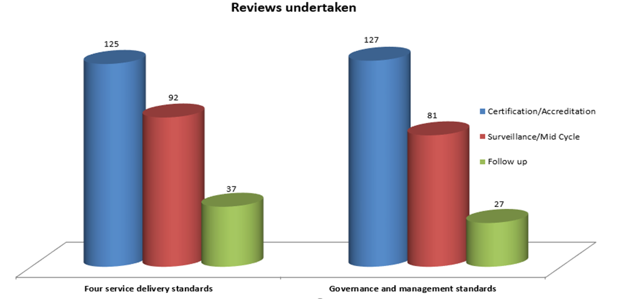

The following table and graph detail the breakup of the types of reviews against each of the governance and management standards.

**Table listing the breakup of reviews undertaken against the governance and management standards**

| **Standard** | **Certification/Accreditation** | **Surveillance/Mid Cycle** | **Follow up** |
| --- | --- | --- | --- |
| ASES | 3 | 2 |  |
| NSDS | 73 | 40 | 19 |
| EQuIP | 0 | 0 | 0 |
| ISO 9001:2008 and ISO 9001:2015 | 27 | 21 | 8 |
| NSQHSS | 3 | 1 | 0 |
| QIC | 21 | 17 | 0 |
| **Total** | **127** | **81** | **27** |

**Figures 2 and 3 - Graph representation of governance and management standards undertaken**

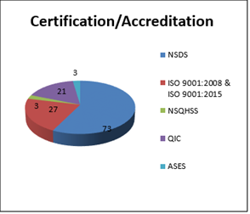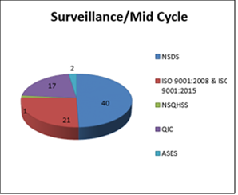

Number of organisations registering a non-conformance against the Standards

To achieve and maintain accreditation service providers need to be assessed as meeting the Standards. Non-compliance is where a Standard was not met at the time of the review.

Where a service provider does not meet a standard there is a requirement to immediately resolve any non-compliance with standards that place a client at significant risk; or resolve any other non-compliance within a period up to six months.

During the period, there was a total of 176 non-conformances against the four service delivery standards. The following graph shows a break up against each of the Standards’ criterion.

**Figure 4 - Graph representation of organisations registering non-conformances against each Standard criterion**

*Number of non-conformances reported against each Standard criterion:
1.1 - 19
1.2 - 10
2.1 - 5
2.2 - 8
2.3 - 8
3.1 - 9
3.2 - 10
3.3 - 22
3.4 - 14
3.5 - 50
4.1 - 4
4.2 - 3
4.3 - 2
4.4 - 7
4.5 - 2
4.6 - 3
*

Number of organisations registering a non-conformance against the governance and management standards

There was a total of 76 non-conformances against the governance and management standards. The following graph shows a break up against each of the standards.

**Figure 5 - Graph representation of organisations registering non-conformances against the governance and management standards**

Number of non-conformances reported against each Standard criterion:
ASES - 0
NSDS - 50
EQuIP - 0
ISO 9001:2008 and ISO 9001:2015 - 22
NSQHSS - 0
QIC - 4



Common themes of non-conformances against the Standards

IRBs identified the following two key areas where service providers were not meeting or having difficulty meeting the Human Services Standards:

* Safety Screening (for example Disability Worker Exclusion Scheme, National and International Police Checks, Working with children Checks).
* Newly registered service providers.

The following information is provided to support service providers to meet their legislative and/or service agreement requirements.

**Safety screening requirements.** Further information regarding the department’s Safety Screening policy can be found in section 4.5 of the department’s Service Agreement Information Kit, on the department’s website at: <http://fac.dhhs.vic.gov.au/service-agreement-information-kit-0> and information on Out-of-home-care requirements, such as the Carers register and disqualified carers checks can be found on the department’s website at: <https://providers.dhhs.vic.gov.au/registration-out-home-carers>.

**Human Services Standards evidence guide (guide).** The guide provides information about Standards and supports service providers to undertake an independent review against the Standards and meet requirements. Further information regarding the guide can be found on the department’s website at: https://providers.dhhs.vic.gov.au/human-services-standards-evidence-guide-word.

Certification/accreditation suspended (put on hold), revoked (cancelled) or failed to achieve certification/accreditation.

One service provider failed to achieve certification/accreditation due to high number of non-conformances.

Summary comments

Standards and Regulation will consider the findings of this report in its future work.

# Appendix 1

# Information regarding Human Services Standards

Table listing the four service delivery standards criterion and the governance and management standard

| Standard | | Criterion |
| --- | --- | --- |
| 1 | **Empowerment**  People’s rights are promoted and upheld. | 1.1 People understand their rights and responsibilities.  1.2 People exercise their rights and responsibilities. |
| 2 | **Access and engagement**  People’s right to access transparent, equitable and integrated services is promoted and upheld. | 2.1 Services have a clear and accessible point of contact.  2.2 Services are delivered in a fair, equitable and transparent manner.  2.3 People access services most appropriate to their needs through timely, responsive service integration and referral. |
| 3 | **Wellbeing**  People’s right to wellbeing and safety is promoted and upheld. | 3.1 Services adopt a strengths-based and early intervention approach to service delivery that enhances people’s wellbeing.  3.2 People actively participate in an assessment of their strengths, risks, wants and needs.  3.3 All people have a goal-oriented plan documented and implemented (this plan includes strategies to achieve stated goals).  3.4 Each person’s assessments and plans are regularly reviewed, evaluated and updated. Exit/transition planning occurs as appropriate.  3.5 Services are provided in a safe environment for all people, free from abuse, neglect, violence and/or preventable injury. |
| 4 | **Participation**  People’s right to choice, decision making and to actively participate as a valued member of their chosen community is promoted and upheld. | 4.1 People exercise choice and control in service delivery and life decisions.  4.2 People actively participate in their community by identifying goals and pursuing opportunities including those related to health, education, training and employment.  4.3 People maintain connections with family and friends, as appropriate.  4.4 People maintain and strengthen connection to their Aboriginal or Torres Strait Islander culture and community.  4.5 People maintain and strengthen their cultural, spiritual and language connections.  4.6 People develop, sustain and strengthen independent life skills. |
| 5 | **Governance and management**  Organisations must be effectively governed and managed at all times. | 5.1 The organisation must be able to demonstrate that it is able to meet governance and management standards, as established by an independent review body approved by the Secretary to the Department of Health and Human Services. |

The endorsed governance and management standards are listed in the following table.

**Table listing the endorsed governance and management standards and their description**

| **Standard (Acronym)** | **Description** |
| --- | --- |
| ASES | Australian Service Excellence Standards |
| NSDS | National Standards for Disability Services |
| EQuIP | Evaluation and Quality Improvement Program Standards |
| ISO 9001:2008 and ISO 9001:2015 | International Organisation for Standardisation (ISO) 9001:2008 Quality Management Systems - Requirements  ISO 9001:2015 Quality Management Systems - Requirements |
| NSQHSS | National Safety and Quality in Health Services Standards |
| QIC | Quality Improvement Council Health and Community Services Standards |

The governance and management standards cover the following areas:

* governance
* leadership and management
* financial management
* human resources - including pre-employment checks, training and development, supervision and workforce
* continuous quality improvement and feedback processes
* information and knowledge management including confidentiality
* occupational health and safety
  + partnerships/service coordination.

|  |
| --- |
| To receive this publication in an accessible format phone 9096 2745 using the National Relay Service 13 36 77 if required, or email hsstandards@dhhs.vic.gov.au  Authorised and published by the Victorian Government, 1 Treasury Place, Melbourne.  © State of Victoria, Department of Health and Human Services, September 2019.  Available from the [Human Services Standards page](https://providers.dhhs.vic.gov.au/human-services-standards) <https://providers.dhhs.vic.gov.au/human-services-standards> on the Providers website |

1. Information on Human Services Standards can be found on the department’s website at: https://providers.dhhs.vic.gov.au/human-services-standards