

|  |
| --- |
| Independent review bodies themes report  October 2016 to March 2017 |
| June 2017 |

# Introduction

The purpose of the independent review bodies (IRB) themes report is to capture a high level overview of key themes arising from independent reviews.

There are approximately 500 organisations that are required to undertake an independent review. A certification/accreditation review is undertaken every three years and a surveillance/mid cycle review is undertaken every 12 or 18 months, depending on the IRB.

Data for this report was collated from a survey comprising 11 questions completed by each of the ten department endorsed IRBs.

The report will be published on the Department of Health and Human Services’ (department) website and shared with program areas.

Survey data will be collected and published twice a year. This first IRB themes report is for the period  
1 October 2016 to 31 March 2017.

# Human Services Standards

The Human Services Standards (Standards) (gazetted as the Department of Health and Human Services Standards) comprise four service delivery standards set by the department and the governance and management standards used by the individual IRB.

The survey replies provided data against each of the Standards (including the Standards criterion) as well as the governance and management standards in use.

List of the four services delivery standards and criterion and the governance and management standard

| Standard | | Criterion |
| --- | --- | --- |
| 1 | **Empowerment**  People’s rights are promoted and upheld. | 1.1 People understand their rights and responsibilities.  1.2 People exercise their rights and responsibilities. |
| 2 | **Access and engagement**  People’s right to access transparent, equitable and integrated services is promoted and upheld. | 2.1 Services have a clear and accessible point of contact.  2.2 Services are delivered in a fair, equitable and transparent manner.  2.3 People access services most appropriate to their needs through timely, responsive service integration and referral. |
| 3 | **Wellbeing**  People’s right to wellbeing and safety is promoted and upheld. | 3.1 Services adopt a strengths-based and early intervention approach to service delivery that enhances people’s wellbeing.  3.2 People actively participate in an assessment of their strengths, risks, wants and needs.  3.3 All people have a goal-oriented plan documented and implemented (this plan includes strategies to achieve stated goals).  3.4 Each person’s assessments and plans are regularly reviewed, evaluated and updated. Exit/transition planning occurs as appropriate.  3.5 Services are provided in a safe environment for all people, free from abuse, neglect, violence and/or preventable injury. |
| 4 | **Participation**  People’s right to choice, decision making and to actively participate as a valued member of their chosen community is promoted and upheld. | 4.1 People exercise choice and control in service delivery and life decisions.  4.2 People actively participate in their community by identifying goals and pursuing opportunities including those related to health, education, training and employment.  4.3 People maintain connections with family and friends, as appropriate.  4.4 People maintain and strengthen connection to their Aboriginal or Torres Strait Islander culture and community.  4.5 People maintain and strengthen their cultural, spiritual and language connections.  4.6 People develop, sustain and strengthen independent life skills. |
| 5 | **Governance and Management**  Organisations must be effectively governed and managed at all times. | 5.1 The organisation must be able to demonstrate that it is able to meet governance and management standards, as established by an independent review body approved by the Secretary to the Department of Health and Human Services. |

The endorsed governance and management standards are listed in the following table.

List of endorsed governance and management standards

| Standard (Acronym) | Description |
| --- | --- |
| ASES | Australian Service Excellence Standards |
| NSDS | National Standards for Disability Services |
| EQuIP | Evaluation and Quality Improvement Program Standards |
| ISO 9001:2008 and ISO 9001:2015 | International Organisation for Standardisation (9001:2008 and 9001:2015) |
| NSQHSS | National Safety and Quality in Health Services Standards |
| QIC | Quality Improvement Council Health and Community Services Standards |
| CQL Quality Measure | Quality Measures including Basic Assurances and Responsive Services |

The governance and management standards cover the following areas:

* governance
* leadership and management
* financial management
* human resources - including pre-employment checks, training and development, supervision and workforce
* continuous quality improvement and feedback processes
* information and knowledge management including confidentiality
* occupational health and safety
  + partnerships/service coordination.

# Total number of audits undertaken during the period

There were a total of 243 audits undertaken during the period (01 October 2016 to 31 March 2017).

This was made up of 128 (53 per cent) audits against the four service delivery standards and 115 (47 per cent) against the governance and management standards.

Of the 128 audits undertaken against the four service delivery standards, 44 (34 per cent) were certification/accreditation audits and 84 (66 per cent) were surveillance/mid cycle audits.

Graph representation of total number of audits undertaken against the four service delivery standards

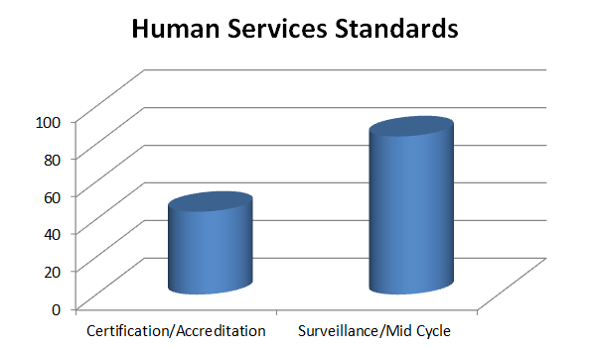

There were 115 audits undertaken against the governance and management standards, of these 40 (35 per cent) were certification/accreditation and 75 (65 per cent) were surveillance/mid-cycle. The following table details the breakup of the types of audits against each of the governance and management standards.

Breakup of audits undertaken against the governance and management standards

| Standard | Certification/Accreditation | Surveillance/Mid Cycle |
| --- | --- | --- |
| ASES | 0 | 0 |
| NSDS | 13 | 25 |
| EQuIP | 0 | 4 |
| ISO 9001:2008 and ISO 9001:2015 | 14 | 29 |
| NSQHSS | 3 | 1 |
| QIC | 10 | 16 |
| CQL Quality Measure | 0 | 0 |

Graph representation of governance and management standards undertaken

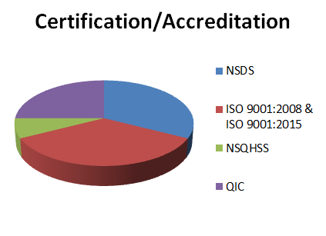 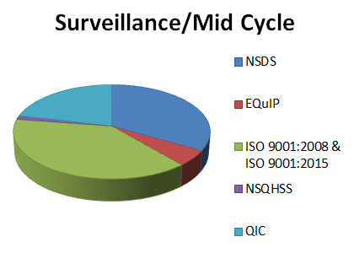

# Number of organisations registering a non-conformance against the Standards

To achieve and maintain accreditation service providers need to be assessed as meeting the Standards. Non-compliance is where a Standard was not met at the time of the review.

Where a service provider does not meet a standard there is a requirement to:

* immediately resolve any non-compliance with standards that place a client at significant risk; or
  + resolve any other non-compliance within six months.

During the period, there was a total of 56 organisations that had a non-conformance against the four service delivery standards. The following graph shows a break up against each of the Standards’ criterion.

Graph representation of organisations with a non-conformances against the four service delivery standards’ criterion

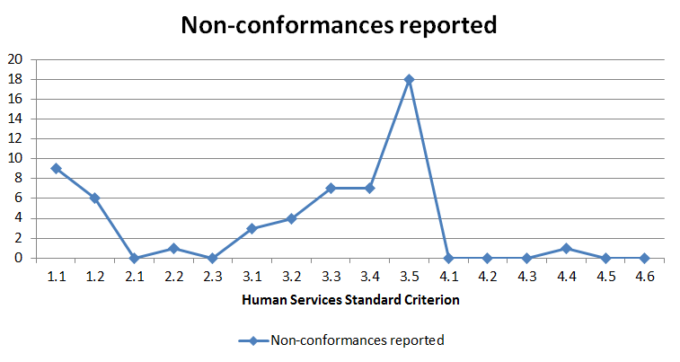

# Number of organisations registering a non-conformance against the governance and management standards

There was a total of 39 organisations that had a non-conformance against the governance and management standards. The following table shows a break up against each of the standards.

No. of organisations registering non-conformances against the governance and management standards

| Standard | Non-conformance reported |
| --- | --- |
| ASES | 0 |
| NSDS | 14 |
| EQuIP | 0 |
| ISO 9001:2008 and ISO 9001:2015 | 20 |
| NSQHSS | 1 |
| QIC | 4 |
| CQL Quality Measure | 0 |

# Common themes of non-conformances against the Standards

The IRBs provided responses which are listed below against each of the Standards (four service delivery standards and the governance and management standards).

No non-conformances were identified against standards two and four.

## Common themes of non-conformances: Standard 1 Empowerment

* Privacy and storage of client information.
* Clients not understanding their rights and/or no evidence of provision of information on rights.

## Common themes of non-conformances: Standard 3 Wellbeing

* No evidence available to demonstrate shift handover is occurring.
* Lack of up to date individual support plans and limited evidence of actions taken to meet the goals of the individual.

## Common themes of non-conformances: Governance and management standards

* Lack of monitoring/management of staff and volunteer safety screening requirements, including no evidence of national police checks (for non-direct client contact) or procedures for recognition of international police checks.
* Lack of self-assessment/internal audit/monitoring/reflective processes.
* Procedures not reflecting current practices.
* Lack of processes to ensure compliance with legal and other obligations.
* No recent management reviews.
* No corrective action indicated when investigating complaints.

# Key strengths against the Standards

In this initial survey the IRBs identified the following key strengths listed against each of the Standards (four service delivery standards and the governance and management standards).

Note, a number of key strengths conflicted with key opportunities for improvement and as such, these have not been included. The key strengths listed below are predominately made up of good practices observed by the IRBs.

No key strengths were identified against standard three.

## Key strengths: Standard 1 Empowerment

* Information to clients, families and significant others via a range of mechanisms including accessible information packs, websites and verbal information.
* Clients exercise their rights through consent, feedback/complaints processes, completion of surveys and the planning processes.
* Innovative programs implemented to empower clients.

## Key strengths: Standard 2 Access and engagement

* Site arrangement tailored to clients’ needs.
* Strong collaboration with other organisations to provide appropriate service to client.
* Use of mobile technology provides improved client access to staff.
* Entry and exit processes well defined and procedures followed.

## Key strengths: Standard 4 Participation

* Use of Aboriginal and Torres Strait Islander client support processes, including links with Aboriginal and Torres Strait Islander community groups.
* Excellent cultural responsiveness, integration of activities and processes within the community.
* Cultural reflection and improvement processes.

## Key strengths: Governance and management standards

* Staff orientation program and resources and professional development opportunities, including e-learning modules.
* Staff communication and feedback processes, including continuous quality improvement processes and initiatives.
* Client feedback and program evaluation processes.
* Strong needs analysis and trending processes.
* Organisational benchmarking processes.
* Project/program evidence-based, values-directed planning and evaluation processes.

# Key opportunities for improvement against the Standards

The key opportunities for improvement provided by the IRBs are listed below against each of the Standards (four service delivery standards and the governance and management standards).

## Key opportunities for improvement: Standard 1 Empowerment

* Ensuring evidence is available to demonstrate all required information has been provided to staff at induction.
* Provision of information and reminders to help clients’ understanding of rights and complaint processes for example, reissuing of information packs to long term clients when the packs are updated.
* Ensuring all client plans are reviewed in the required timeframe.
* Systematic feedback processes.
* Client consent information on documents.
* Service information, including service expectations, provided to clients.
* Culturally-sensitive delivery of information.
* Information on the traditional owners of the land included in organisation literature and materials.
* Increase client information in languages other than English.
* Better alignment of program principles and parameters to the overarching health service principles and parameters framework.

## Key opportunities for improvement: Standard 2 Access and engagement

* Enhancing communication between ‘the office’ and clients, including communicating outcomes.
* The opportunity to update service documentation to reflect organisational changes.
* Some organisation procedures do not include the organisation’s approach to establishing networks.

## Key opportunities for improvement: Standard 3 Wellbeing

* Ensuring clients are involved in planning and, where an opportunity exists, significant others.
* Improve exit planning processes.
* Ensuring material safety data sheet registers are maintained along with contents of first aid kits.
* Development of extreme weather policies/procedures.
* Consideration of home visit risks and enhance security at an after-hours site.
* Review processes for longer term cases.
* Updating processes for documents relating to legislation and service delivery.
* Improvement to documentation used for client goal reviews.
* Increased emphasis on information about dignity of risk.

## Key opportunities for improvement: Standard 4 Participation

* Systemic approach to program development based on consumer goals.
* Access and equity processes.
* Diversity plan and data collection processes.
* Increase cultural diversity training.
* Provision of privacy requirements for clients not engaging in direct services.
* Monitoring the uptake when referred to external providers.

## Key opportunities for improvement: Governance and management standard

### Governance

* Compliance monitoring processes.
* Risk management concerning mergers.
* Business continuity plan development.
* Updating service documentation to reflect organisational changes.

### Leadership and management

* Managers need to review and update all quality management system documentation to reflect changes in organisational structure.
* Communication processes.
* Strategic plan development.
* Delegation and succession planning processes.

### Financial management

* Review of suppliers.
* Asset register development.
* Financial record management processes and planning.

### Human resources - including pre-employment checks, training and development, supervision and workforce

* Ensuring consistent staff performance appraisals.
* Training provision on alternative forms of communication, bullying/harassment and legislative compliance.
* Staff training records processes and requirements.
* Processes involving safety screening checks.
* Governance performance review, training, succession and mentoring processes.
* HR files for long term staff employed (> 10 years) lack documentation that is accepted as best practice.
* Staff performance/employment information not current.

### Continuous quality improvement and feedback processes

* Opportunities for services to increase feedback from clients.
* Evaluation processes of client needs.
* Enhancement of quality improvement resources.

### Information and knowledge management including confidentiality

* Update service documentation to reflect organisational changes.
* Improve document control.
* Inconsistency in files - layout, order, content.
* Ensure hyperlinks in documents are current.

### Occupational health and safety

* Development of disaster recovery policies/procedures.
* Improve safety inspection processes, including testing and tagging, emergency responses, infection prevention and control guidelines.

### Partnerships/service coordination

* Document how client information is collected and recorded including referral pathways.
* Evidence-based client service delivery and improvement.
* Document partnership/collaboration recording processes.

# Notifiable issues reported and the categories

Notifiable issues are a result of a complaint or allegation about any of the following:

* the health, safety, abuse or risk to a person who receives services from a service provider
* the governance, financial accountability or criminal activity of the service provider
* a service provider fails or may fail to meet basic client needs or puts a client at risk of significant harm
* a service provider is experiencing significant disruption and executive mismanagement
* the independent review body has serious concerns about the ongoing financial viability of the service provider
  + a service provider engages in conduct which is fraudulent or potentially fraudulent or is engaged in other criminal activities.

During the period, there was a total of 17 notifiable issues reported out of the 243 audits undertaken (7 per cent). The following table indicates the number of notifiable issues reported against each of the relevant categories.

Number of notifiable issues reported against each notifiable issues category

| Notifiable issue category | Number reported |
| --- | --- |
| Health, safety, abuse or risk to a person who receives services from a service provider. | 1 |
| Governance, financial accountability or criminal activity of the service provider. | 2 |
| Service provider fails to or may fail to meet basic client needs or puts the client at risk of significant harm. | 2 |
| Service provider experiences significant disruption and executive mismanagement. | 2 |
| IRB has serious concerns about the ongoing financial viability of the service provider. | 2 |
| Service provider engages in conduct which is fraudulent or potentially fraudulent or is engaged in other criminal activities. | 0 |
| Service provider has missing safety Screening checks (Working with Children Checks and National/International Police Checks). | 5 |
| There is medication mismanagement within the service provider. | 2 |
| There is a lack of reporting on Restrictive Intervention Data System (RIDS) and or Restrictive Interventions. | 1 |

# Certification suspension (put on hold) and revocations (cancelled)

One organisation had their accreditation suspended due to a Notifiable Issue, which has since been lifted.

# Sectors that struggled to meet the Standards

In order to improve service delivery, the department continues to seek opportunities to identify knowledge gaps and learning and development needs of its service delivery providers.

While specific sectors were not identified, there were two particular areas where all sectors struggled to meet the Standards. These were:

1. Keeping up to date with changing legislative and regulatory obligations for example, international police check requirements.
2. Lack of self-assessment/internal audit/monitoring processes - which can lead to procedures being out of date or staff not following procedures, then resulting in non-conformances.

# Summary comments

The data collected from this first survey has proven to be a very useful exercise in identifying specific areas relating to common themes of non-conformances against the Standards. It has also identified key strengths and opportunities for improvement. However, the data provided was not specific enough to determine what makes one practice better than another.

In an effort to make the data collected more user friendly, duplication and inconsistencies (as noted between key strengths and opportunities for improvement) have been removed.

In consultation with the IRBs and sector (via the Quality Reference Group), it was decided that future survey questions would be amended to better reflect and describe best practice and innovation being used in the sector.

The Standards and Regulation Unit (SRU) will share the findings of survey results with the Quality Reference Group and department program areas. SRU will also take the findings into account when updating policies and guidelines.

|  |
| --- |
| To receive this publication in an accessible format phone (03) 9096 2745, using the National Relay Service 13 36 77 if required, or email hsstandards@dhhs.vic.gov.au.  Authorised and published by the Victorian Government, 1 Treasury Place, Melbourne.  © State of Victoria, Department of Health and Human Services June, 2017. |