

|  |
| --- |
| Human Services Standards Regulation Survey feedback |
| Summary of feedback - 2018 |

# Human Services Standards Regulation Survey feedback

## Contents

Introduction 1

Presentations 2

Feedback from survey 2

1.Registration status 2

2.Reasons to choose an independent review body 2

3.Changing independent review bodies 3

4.Locating department funded activity numbers and NDIA registration groups 4

5.Tools and resources 5

6.Processes: notifiable issues and non-conformances 5

7.Review reports 7

8.Multiple accreditation 8

9.Costs associated with reviews 8

10.Department reporting requirements 9

11.Communication 9

12.Innovation/sharing ideas/systems and practice 10

## Introduction

The Department of Health and Human Services (department) Standards and Regulation team (S&R) facilitated a regulation forum on 2 October 2018 to provide organisations, which were in-scope of an independent review against the Human Services Standards (Standards) (gazetted as the Department of Health and Human Services Standards), with the opportunity to provide feedback on the process and share ideas for embedding quality and innovation.

A survey was sent out to participants prior to the forum. Below is a summary of key feedback from the survey. It is noted that in all areas there were mixed opinions given the range of people’s experiences and expectations.

Notes in this document have been provided by S&R to respond to the queries raised in the survey and to provide further information to organisations. These notes are available under the heading ‘S&R response’. S&R will continue to consider and provide feedback to relevant stakeholders for their consideration.

S&R would like to thank participants for completing the survey and attending the forum.

## Presentations

The following presentations were provided by Department of Health and Human Services:

* Andrea Grant, Child Safeguarding and Regulation
* Kate Spink, Disability and National Disability Insurance Scheme
* Mario Bernardi, Disability Worker Exclusion Scheme
* Brigid Clarke, Community Services and Safety Office.

Following on from presentations, S&R provided an overview of the survey results, focussing on the key results.

## Feedback from survey

This is the third year a survey was sent prior to the forum. Twenty-six respondents completed the survey compared to 30 who completed the survey in 2017. The survey was sent to approximately 650 organisations which means four per cent (26) of the total number of organisations responded. The department notes the response rate does not provide a statistically significant sample size to draw conclusions. In order to gain a clearer overview of themes, the department is investigating other sources of data and intelligence to provide feedback.

The survey and forum invitations were sent to the key contacts on the Service Agreement Management System (SAMS) and disseminated through the Human Services Standards Regulation Reference Group and local departmental offices to send onto relevant key contacts in organisations.

The survey comprised key questions regarding:

* registration status of organisation
* reasons organisations choose an independent review body (IRB)
* locating department funded activity numbers and National Disability Insurance Agency (NDIA) registration groups
* tools and resources
* notifiable issues and non-conformances
* review reports
* multiple accreditation
* costs of reviews
* department reporting requirements
* communication
  + innovation.

### 1. Registration status

Most (seven) organisations were registered under both the *Children, Youth and Families Act 2005* (CYF Act) and *Disability Act 2006* (Disability Act)

Eight organisations were registered under the Disability Act and five organisations were registered under the CYF Act only.

Two organisations were unregistered, and one organisation was unsure.

### 2.Reasons to choose an independent review body

Overall having a previous relationship with the IRB and governance and management standards offered was a factor for organisations when choosing an independent review body (IRB).

#### S&R response

There is information on the department’s website relating to IRBs including a fact sheet, contact information, selecting an IRB fact sheet and content of IRB review reports. This information is located under the section: Human Services Standards independent review bodies at the [Human Services Standards page](https://providers.dhhs.vic.gov.au/human-services-standards) <https://providers.dhhs.vic.gov.au/human-services-standards> on the Providers website.

Figure 1 - Graph representation of factors contributing to the selection of an independent review body.

Factors contributing to the selection of an independent review body:
Cost: Yes - 15, No - 11, No response - 0
Business relationship: Yes - 18, No - 8, No response - 0
Standards offered: Yes - 20, No - 6, No response - 0
Recommendation: Yes - 14, No - 12, No response - 0

### 3.Changing independent review bodies

* The majority of respondents have not changed their IRBs (53 per cent).
  + Eight per cent are considering changing their IRB.

Figure 2 - Graph representation of organisations considering changing their independent review body.

**Organisations considering changing their independent review body:
Yes - 9
No - 14
Considering changing - 2
Not aware it's an option - 1**

#### S&R response

Organisations considering changing their IRB or needing more information should contact S&R via email at hsstandards@dhhs.vic.gov.au or refer to the website (as noted above) which has information on choosing an IRB.

Organisations need to ensure their organisation maintains certification during the ‘transfer’ when changing IRBs.

### 4.Locating department funded activity numbers and NDIA registration groups

* The majority of respondents (95 per cent) stated they **could** locate their department funded activity numbers.
* The majority of respondents (94 per cent) stated they **could** locate their NDIA registration groups.

Figure 3 - Graph representation of organisation ability to find department funded activity numbers and NDIA registration groups.

Organisation ability to find department funded activity numbers and NDIA registration groups.
Department funded activity numbers:
Yes - 22
No - 1
Not applicable - 3
NDIA registration groups
Yes - 18
No - 7
Not applicable - 1

#### S&R response

S&R notes review reports are missing in-scope department funded activity numbers and/or NDIA registration groups or have incorrect department funded activity numbers and/or NDIA registration groups listed in the reports.

If organisations are having problems navigating the Funded Agency Channel (FAC) to find their department funded activities they can contact FAC directly on 1300 799 470 or discuss with their Agency Performance and System Support Officer.

Organisations are also encouraged to contact the person in their organisation responsible for managing their Service Agreement for details regarding department funded activity numbers and/or NDIA registration groups.

Department funded activities and NDIA registration groups in scope of the Human Services Standards are subject to change. Organisations are encouraged to check the *Human Services Standards policy* on which activities and NDIA registration groups are in scope at the time of review. The Human Services Standards policy can be found on the [Human Services Standards Policy page](https://providers.dhhs.vic.gov.au/human-services-standards-policyhttps:/providers.dhhs.vic.gov.au/human-services-standards-policy) <<https://providers.dhhs.vic.gov.au/human-services-standards-policy-word>> on the Providers website.

### 5.Tools and resources

The majority of respondents had a good awareness of the following tools and over 60 per cent found the tools useful:

* Evidence guide including the Aboriginal culturally informed addendum
* Aboriginal culturally informed resource tool
* Client file audit tool
* Staff, volunteer, carer file audit tool
  + Self-assessment report and quality improvement plan.

Only 34 percent were aware of Standards and Regulation statement of expectations and 38 percent were aware of the Regulator Plan.

#### S&R response

All tools, except the self-assessment report and quality improvement plan can be found on the [Human Services Standards page](https://providers.dhhs.vic.gov.au/human-services-standards) <https://providers.dhhs.vic.gov.au/human-services-standards> on the Providers website.

Standards and Regulation’s Ministerial statement of expectations can be found on the [Human Services Standards page](https://providers.dhhs.vic.gov.au/human-services-standards) <https://providers.dhhs.vic.gov.au/human-services-standards> on the Providers website.

Standards and Regulation’s regulator plan can be found on the [Better regulatory practice framework page](https://www.dhhs.vic.gov.au/publications/better-regulatory-practice-framework) <https://www.dhhs.vic.gov.au/publications/better-regulatory-practice-framework> on the department’s website.

### 6.Processes: notifiable issues and non-conformances

The majority of survey respondents said the processes relating to notifiable issues and non-conformances were easy to understand and complete.

Figure 4 - Graph representation of understanding the processes for notifiable issues and non-conformances.

**Are processes for notifiable issues and non-conformances easy to understand and complete?
Notifiable issues:
Yes - 14
No - 1
Not applicable - 11
Non-conformances:
Yes - 16
No - 1
Not applicable - 9**

#### S&R response

Information on notifiable issues is in the Human Services Standards policy document on the [Human Services Standards Policy page](https://providers.dhhs.vic.gov.au/human-services-standards-policy) <https://providers.dhhs.vic.gov.au/human-services-standards-policy-word> on the Providers website.

IRBs are required to submit a themes survey to S&R every six months. The April 2018 to September 2018 report highlighted the following in relation to notifiable issues:

* Most notifiable issues related to safety screening checks, such as National Police Checks and Working with Children Checks. Further information regarding the department’s Safety Screening policy can be found in section 4.6 of the department’s Service Agreement Information Kit, on the [Service Agreement Information Kit page](https://fac.dhhs.vic.gov.au/service-agreement-information-kit-0) <https://fac.dhhs.vic.gov.au/service-agreement-information-kit-0> on the Funded Agency Channel website.
* Other notifiable issues related to the Restrictive Intervention Data System (RIDS) for disability service organisations. Further information on RIDS can be found on the [Restrictive interventions page](https://providers.dhhs.vic.gov.au/restrictive-interventions) <https://providers.dhhs.vic.gov.au/restrictive-interventions> on the department’s website.
* Notifiable issues were also raised in relation to Out of Home Care requirements, such as the Carers Register and disqualified carers checks. Further information can be found on the [Victorian Carer Register](https://providers.dhhs.vic.gov.au/carer-register) page <https://providers.dhhs.vic.gov.au/carer-register> on the Providers website.
* Organisations are encouraged to understand what program requirements relate to their organisation and can find further information from their Agency Performance and System Support Officer.

#### Non-conformances

The majority of respondents (61 per cent) said they were able to follow the process and 34 per cent said non-conformances were not applicable to them.

#### S&R Response

To achieve and maintain accreditation, organisations need to be assessed as meeting the Standards. A non-conformance is where a Standard was not met at the time of the review. Where an organisation does not meet a Standard there is a requirement to immediately resolve any non-conformances that poses a serious risk and other non-conformances must be closed out within six months.

### 7.Review reports

Most respondents (80 per cent) said review reports met their expectations. Twenty per cent said the review reports did not meet expectations.

Figure 5 - Graph representation of review reports - do they meet expectations?

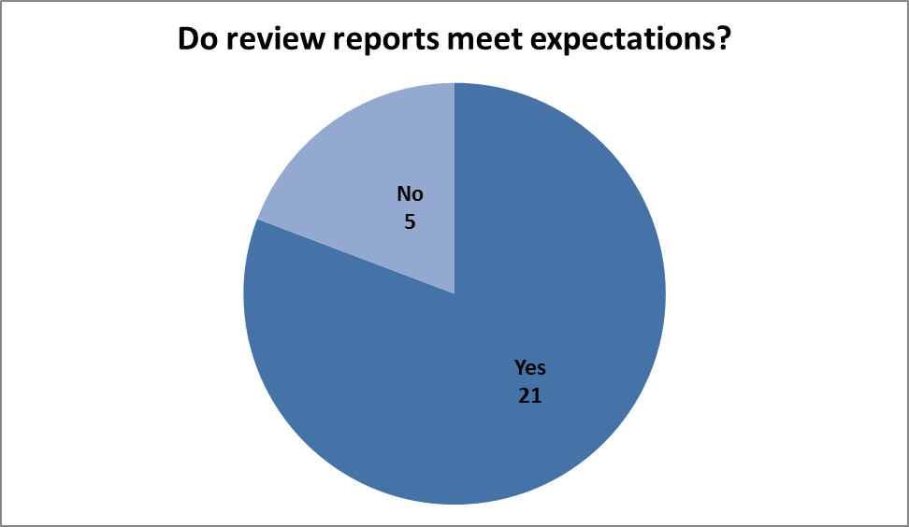

#### S&R Response

A fact sheet on the Content of IRB’s review reports is available on the [Content of independent review body review reports (word) page](https://providers.dhhs.vic.gov.au/content-independent-review-body-review-reports-word) <http://providers.dhhs.vic.gov.au/content-independent-review-body-review-reports-word> on the Providers website.

Organisations are also encouraged to discuss any issues with their IRB and S&R as required.

### 8.Multiple accreditation

The majority of respondents (73 per cent) said their organisation is required to meet other accreditation/certification, of these:

* the majority (42 per cent) had two to three other reviews
* thirty-one per cent had one other review
  + twenty-one per cent had four to five other reviews.

Figure 6 - Graph representation of organisations undertaking more than one accreditation/certification review.

#### Number of organisations undertaking more than one review: 1 other review - 6 2 or 3 other reviews - 8 4 to 5 other reviews - 1 More than 5 reviews - 4

#### S&R Response

S&R recommends that organisations choose a department appointed IRB that can, where possible, meet requirements of other reviews required.

A list of the eight department appointed IRBs and the standards they can assess is available on the [Human Services Standards page](http://providers.dhhs.vic.gov.au/human-services-standards) <http://providers.dhhs.vic.gov.au/human-services-standards> on the Providers website.

The document is located under the section: Human Services Standards independent review bodies titled ‘IRB fact sheet’.

### 9.Costs associated with reviews

#### S&R response

This was the second year a question was included in the survey on costs associated with the reviews. The questions were included to ascertain resources required to complete reviews and maintain accreditation. Overall the estimated costs of the accreditation for organisations within a three-year cycle were:

* Total fee charged by an independent review body ranged from under $10,000 up to $100,000 plus.
* Estimated cost (wages) ranged from $2,000 to $400,000.
  + Estimated cost (consultancy fees) ranged from $3,000 to $70,000.

These variations are to be expected due to the different types of organisations which are in scope of independent review. For example, organisations range in size, complexity, funding streams, program areas and geographic coverage.

### 10.Department reporting requirements

This was the first year a question regarding department reporting requirements was included. The majority (84 per cent) of organisations are required to submit Critical incidents Management System (CIMS). Only a minority is required to submit reporting on the following: 46 per cent report on Restrictive Intervention Data System, 26 per cent must undertake spot audits for out of home care and 26 per cent report on the Carers Register.

42 per cent are required to submit other department reporting which includes the following: annual reports, quality improvement plans, complaints, Home and Community Care Data collection, Disability Worker Exclusion Scheme, financial reporting, privacy breaches, Quarterly Data Collection, Service Delivery Tracking, liaison reports and Service Agreement Compliance Certification

### 11.Communication

Overall, organisations stated they were satisfied with the communication from their IRB, S&R and local department office.

Figure 7 - Graph representation of level of satisfaction with communication and service provided by the Independent Review Body, Standards and Regulation Unit and Department Local Office.

Level of satisfaction with communication and service provided:
Independent Review Body:
Poor - 2
Fair - 1
Average - 7
Good - 11
Excellent - 5
Not applicable - 0
Standards and Regulation Unit:
Poor - 0
Fair - 2
Average - 0
Good - 8
Excellent - 14
Not applicable - 2
Department Local Office:
Poor - 3
Fair - 3
Average - 7
Good - 11
Excellent - 2
Not applicable - 0

#### S&R response

The S&R communicates with stakeholders in the following ways and encourages feedback on communication methods:

* IRB workshop (Preparing to audit against the Human Services Standards).
* IRBs meet quarterly for moderation forums.
* the Human Services Standards Regulation Reference Group members meet quarterly. This group is made up of key peak bodies and organisations. Copies of minutes are on the [Human Services Standards page](http://providers.dhhs.vic.gov.au/human-services-standards) <http://providers.dhhs.vic.gov.au/human-services-standards> on the Providers website under the section: Human Services Standards Quality Reference Group.
* Quality Enhancement Officers meet every six weeks and information is disseminated via this group to local department offices.
* S&R facilitated workshops for organisations in-scope of an independent review and self-assessment.

### 12.Innovation/sharing ideas/systems and practice

#### Survey responses

Organisations shared the following ideas to improve systems and practice:

* ensure quality is embedded across the whole organisation.
* Have a quality framework in place and have regular quality committee meetings.

**Further information, feedback and suggestions**

For further information, feedback or suggestions for future forums, contact Standards and Regulation, Human Services Regulator, Health and Human Services Regulation and Reform Branch on:

Telephone: (03) 9096 2745

Email: hsstandards@dhhs.vic.gov.au

|  |
| --- |
| To receive this publication in an accessible format telephone (03) 9096 2745, using the National Relay Service 13 36 77 if required, or email hsstandards@dhhs.vic.gov.au  Authorised and published by the Victorian Government, 1 Treasury Place, Melbourne.  © State of Victoria, Department of Health and Human Services March 2019.  Available on the [Human Services Standards page](http://providers.dhhs.vic.gov.au/human-services-standards) <http://providers.dhhs.vic.gov.au/human-services-standards> under Standards and Regulation updates on the Providers website. |