

Housing First for Young People Leaving Care

Operations Manual

Version 2.0 June 2025

To receive this document in another format, email the Transitions from Care team at [betterfuturescentral@dffh.vic.gov.au](mailto:betterfuturescentral@dffh.vic.gov.au)

Authorised and published by the Victorian Government, 1 Treasury Place, Melbourne.

© State of Victoria, Australia, Department of Families, Fairness and Housing, June 2025

In this document, ‘Aboriginal’ refers to both Aboriginal and Torres Strait Islander people. ‘Indigenous’ or ‘Koori/Koorie’ is retained when part of the title of a report, program or quotation.

ISBN: 978-1-76130-829-1 **(pdf/online/MS word)**

Available at the [department website](https://providers.dffh.vic.gov.au/housing-first)

(2502285)

Contents

1. Introduction 5

1.1. Program description 5

1.2. Program principles 6

1.3. Program objectives 7

1.4. Eligibility 7

1.5. Program roles and responsibilities 9

2. Program supports 11

2.1. Case work 12

2.1.1 Housing First Support Plan 13

2.2. Tenancy support 15

2.2.1. Annual Tenancy Support Directions Plan 15

2.2.2. Annual Tenancy Support Outcomes Report 15

2.3. Housing 16

2.4. Brokerage for Aboriginal young people 16

2.5. Accommodation management 16

2.6. Complementary supports 16

3. Nomination and referral 18

3.1. Stage One 18

3.2. Stage Two 18

4. Service delivery 23

4.1. In-reach period 23

4.2. Housing period 25

4.3. Post-reach period 27

4.4. Feedback and complaints 27

5. Program participation 28

5.1. Mandatory forms 28

5.2. Rent contribution 29

5.3. Participant attrition 29

5.3.1 Participant attrition during in-reach period 30

5.3.2 Participant attrition during housing period 30

5.4 Young people disengaged from Housing First 33

5.5. Eviction from the Housing First property 34

5.6. Pets 34

5.7. House rules 35

6. Funding and evaluation 36

6.1 Funding 36

6.2 Evaluation 36

6.2.1 Early Intervention Investment Framework reporting 36

6.2.2 Payment by Results for Community Services Organisations 37

6.2.3 Aboriginal Community Controlled Organisations incentive payment 38

7. Mechanisms of oversight 39

7.1. Service agreements 39

7.2. Client Relationship Information System for Service Providers (CRISSP) 39

7.3. Service Delivery Tracking 40

7.4. Client Incident Management System (CIMS) 40

8. Legislation, frameworks and standards 41

8.1. Children, Youth and Families Act 2005 41

8.2. Social Services Regulation Scheme 41

8.3. Child Wellbeing and Safety Act 2005 41

8.5. Privacy and Data Protection Act 2014 41

8.6. Charter of Human Rights and Responsibilities 41

8.7. Care and transition planning for leaving care framework 41

8.8. Aboriginal and Torres Strait Islander cultural safety framework 42

8.9. Multi Agency Risk Assessment and Management Framework (MARAM) and Information Sharing Schemes 42

9. Department contacts 43

Appendix - version history 44

# 1. Introduction

Each year in Victoria, approximately 1,000 young people aged 16 to 18 years have their child protection order end for the final time and leave care.

Young care leavers are significantly more likely to experience a range of adverse life outcomes. This includes:

* homelessness
* poor mental health
* involvement with Child Protection (as a parent)
* interactions with the justice system.

Access to stable housing continues to be a challenge and a key driver of these outcomes.

Young people do best when they experience a gradual and supported transition from care to independence through the establishment of safe, stable, and secure housing and support.

Through the 2023-24 Victorian State Budget, the Government has funded the Housing First for Young People Leaving Residential Care initiative (Housing First). Housing First will support 225 young people leaving residential care and other care settings with at least:

* 2 years of housing, and
* 3 years of wrap-around support.

Housing First:

* provides guaranteed housing and support to young people leaving care
* adds to existing supports like Better Futures and Home Stretch
* assists a gradual and supported transition from care
* supports young people to thrive in adulthood.

## 1.1. Program description

Each young person participating in Housing First is provided with housing to support their transition from care. Housing arrangements vary depending on the needs of young people. Young people may live on their own or share with another young person participating in the program.

Housing will be provided for at least two years; and 30% of participants may receive a 6-month housing extension. The program includes dedicated places for Aboriginal care leavers due to their over-representation within the leaving care population.

There are 5 components of the Housing First program:

* case work
* tenancy support
* housing
* brokerage for Aboriginal young people; and
* accommodation management.

Housing First is being implemented in two stages:

* **Stage 1** is an interim model delivered from the second half of 2024. Stage 1 was available for young people leaving residential care settings
* **Stage 2** is the full model delivered from February 2025. The model will support young people from all 3 eligible cohorts.

## 1.2. Program principles

The Housing First for Young People Leaving Care initiative has been informed by [Housing First principles](https://homelessnessaustralia.org.au/homelessness-resources/housing-first/)[1]. Housing First for Young People Leaving Care is a bespoke initiative tailored for the unique needs of this client cohort. The principles listed in table 1 underpin the Housing First for Young People Leaving Care initiative.

Table 1: Housing First principles

| Principle | Description |
| --- | --- |
| Advantaged Thinking[2] | Housing First case work support is delivered via the Advantaged Thinking practice approach. Advantaged Thinking is a strength-based approach towards planning and engaging with young people that recognises and builds on their individual talents and aspirations, as well as assisting them to overcome challenges. |
| Aboriginal voice and cultural safety | Young people’s familial, social, community and cultural connections are promoted and inform all planning and actions. |
| Collaboration | Young people and Housing First case workers work together to achieve the young person’s goals for the program. |
| Person-centred | Young people are respected and encouraged to contribute their values, beliefs and goals. |
| Self-determination | Young people are empowered to make and be responsible for their informed life choices. Young people participate in planning and exercise agency over the decisions that impact them. |
| Sustained housing focus | Support contributes to the young person’s ability to access and maintain housing. Young people are supported to transition into safe and secure alternative housing arrangements when their Housing First tenancy ends. |
| Tailored support | Support is tailored to each young person’s needs and incorporates trauma-informed practice to set up young people for success in adulthood. |
| Trauma-informed | Support is grounded in trauma-informed practice approaches which do not give up on young people. Engagement with young people is assertive, repeated, creative, innovative, adaptive, and endures for the duration of the young person’s time in the program. |

## 1.3. Program objectives

The objectives of Housing First are to:

* provide housing stability that enables young people leaving care to achieve their transition goals
* strengthen social, community, cultural and where appropriate, family connections for young people
* improve health outcomes for young people
* increase educational attainment and employment participation rates
* reduce the risk of homelessness and contact with the justice system for young people leaving care

## 1.4. Eligibility

Housing First supports 3 cohorts of young people aged between 16 years and 6 months to 17 years and 6 months[3] who are, or were on an eligible care order after their 16th birthday and are:

* transitioning from residential care
* exiting a custodial facility
* transitioning from kinship, foster or permanent care, and who are at immediate risk of homelessness within six months of leaving care.

For the purposes of the above:

* eligible order includes:
  + Long Term Care Order
  + Care by Secretary Order
  + Permanent Care Order, and
  + Family Reunification Order.
* residential care includes lead tenant arrangements
* exiting a custodial facility means finishing a sentenced period of custody
* immediate risk of homelessness means young people who are, or will be, in accommodation classified as ‘unstable’ within 6 months of leaving care, such as:
  + crisis accommodation
  + caravan parks or rooming houses
  + sleeping rough
  + couch surfing.

Figure 1: Eligibility Model  
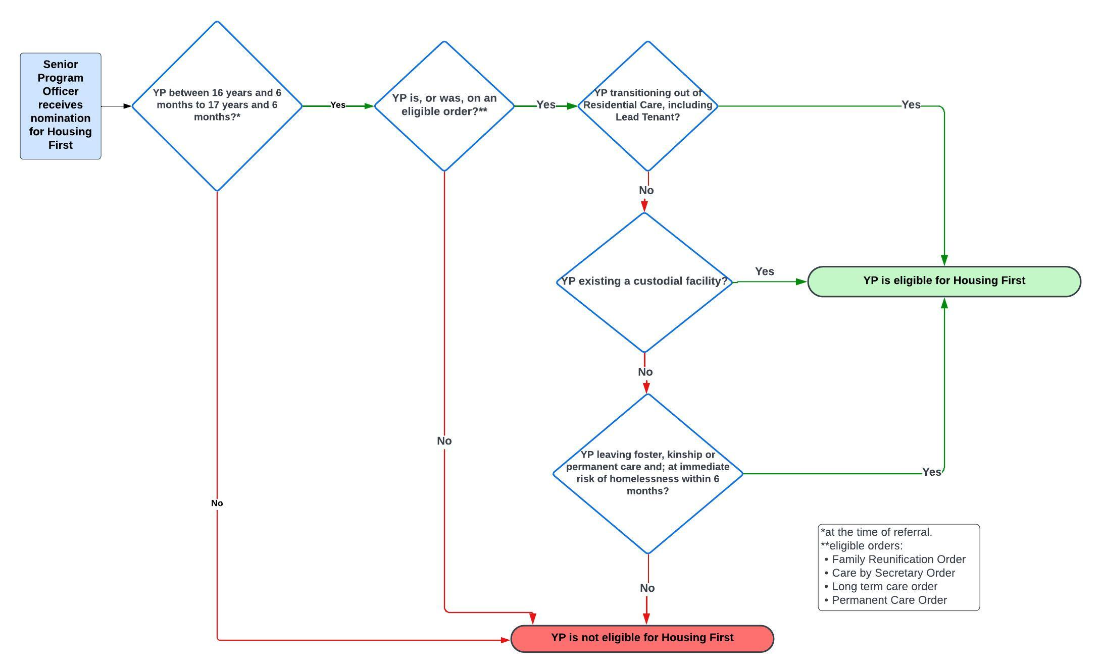

## 1.5. Program roles and responsibilities

Table 2: program roles and responsibilities

| Role | Responsibilities |
| --- | --- |
| Child Protection / Aboriginal Children in Aboriginal Care (ACAC) Practitioners | * hold case planning responsibility, including transition from care planning * liaise with Housing First Senior Program Officers regarding the suitability of a young person * nominate the young person to participate in Housing First * invite the Housing First Case Worker to care team meetings[4] * work collaboratively with the care team to support the young person’s participation in the program. |
| Housing First Senior Program Officers | * provide operational support at a divisional level to both internal and external stakeholders * promote the initiative within their division * assess nominations from Child Protection and ACAC practitioners * confirm that a nomination should proceed to referral in consultation with their Divisional Care Services Manager. * refer the young person to Housing First by submitting the CRIS-to-CRISSP referral * consult with the Housing First Service Provider to confirm referral acceptance * advise Child Protection or ACAC practitioner of the outcome of referrals and record these details on CRIS * maintain divisional level program data * support the collection and collation of data required for Payment by Results and evaluation purposes. |
| Housing First Case Worker | * primary support to the young person during their participation in Housing First. * directly engage and support the young person to achieve their identified goals and set them up for success in adulthood * provide case work support to young people alongside their care team to support program objectives. |
| Housing First Accommodation Manager | * perform all functions and duties of a landlord, including:   + managing the rental agreement   + collecting rent for the property   + maintaining the property. |
| Housing First Tenancy Support Workers | * provide specialist support and secondary consultation to Housing First Case Workers regarding at risk tenancies * build networks and opportunities that lead to access to suitable housing for young people in their third year on the program (and beyond). |
| Agency Performance and System Support (APSS) | * oversee and manage service agreements of organisations delivering Housing First case work and brokerage * enter funding on SAMS2 and monitor agency performance including flexible funding expenditure. |

# 2. Program supports

Housing First has 5 components of support.

Figure 2: Components of Housing First support

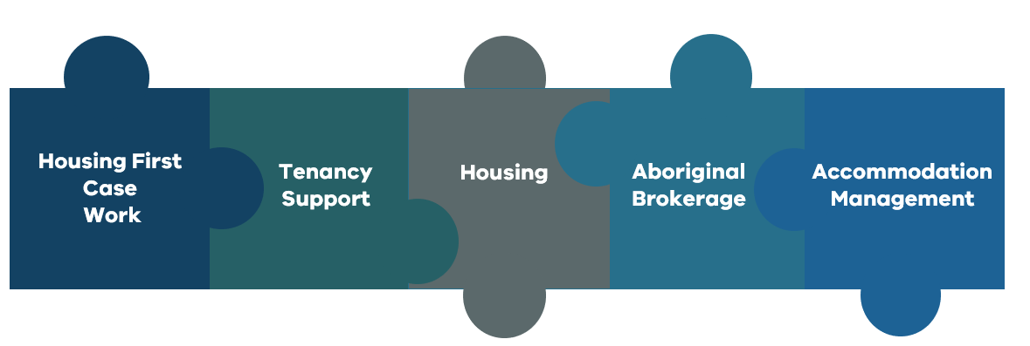

**Housing First Case Work**

* flexible hours of case work to support young people

**Tenancy Support**

* expert advice and guidance to support case workers in supporting clients in at-risk tenancies
* support for transitioning to an alternative housing arrangement at the end of the 2-year housing period

**Housing**

* 2 years of housing in accommodation provided by a Registered Housing Agency

**Aboriginal brokerage**

* flexible funds of $10,000 per Aboriginal young person to support their connection to culture and community.

**Accommodation Management**

* property management relating to the young person’s home
* includes all landlord functions such as rent collection and maintenance of the property.

This chapter details the requirements and implementation guidance for the 5 components of Housing First support.

## 2.1. Case work

Housing First case work hours are in addition to hours funded via Better Futures and Home Stretch.

The Better Futures Development Coach delivers Housing First case work hours for all stage 1 participants.

Stage 2 Housing First case work hours are delivered by:

* Anglicare Victoria in the North and West areas for non-Aboriginal participants
* Melbourne City Mission led Consortia in the East and South areas for non-Aboriginal participants
* the young person’s Better Futures Aboriginal Community Controlled Organisation (ACCO) for Aboriginal participants.

### Requirements

The Housing First Case Worker:

* responds creatively and flexibly to support the development of the young person’s independent living skills
* supports the young person to achieve their leaving care goals
* is a member of the care team
* facilitates the communication of essential information across Housing First supports. This includes:
  + young person’s engagement preferences
  + worker safety concerns
  + changes in young person’s circumstances.
* works with the care team to help the young person achieve their goals on the 15+ Care and Transition Plan.
* drafts and implements a Housing First Support Plan within 2 months of the 15+ Care and Transition Plan end date.
* delivers case work support that aligns with the Better Futures Advantaged Thinking Practice Framework
* collaborates with the other supports in place for the young person, such as supports funded via a Targeted Care Package, Home Stretch or the National Disability Insurance Scheme
* supports the young person to transition to alternative accommodation by the end of their housing period.

**When multiple services are in place, the focus of Housing First case work will be on activities to support housing stability and maintenance of the tenancy.**

Table 3: Housing First case work hours

| Housing First phase | Housing First case work hours | Home Stretch hours | Total hours of support |
| --- | --- | --- | --- |
| In reach period | 130 hours | N/A | N/A |
| Housing period – year 1 | 260 hours | 75 hours Home Stretch (prorated from Home Stretch commencement date) | Up to 335 hours |
| Housing period - Year 2 | 156 hours | 75 hours Home Stretch | Up to 231 hours |
| Post-reach period - year 3 | 104 hours | 75 hours Home Stretch | Up to 179 hours |

## 2.1.1 Housing First Support Plan

The Housing First Support Plan is developed collaboratively with the young person. The Support Plan is a critical document which helps to guide the young person’s engagement with Housing First.

### Requirements

* all young people must have a Housing First Support Plan in place within 2 months of their 15+ Care and Transition Plan ending upon leaving care.
* the Support Plan must be formally reviewed annually from date of commencement.
* the Support Plan must identify goals and actions to develop independent living skills. Use these tools to guide the Support Plan:
  + WOMBAT Everyday Life Skills assessment (or similar)
  + Better Futures Outcomes Tracking System question set.
* the Housing First Case Worker should consult with the Tenancy Support Worker for goals relating to the transition to alternative accommodation at the end of their time in Housing First accommodation.

#### Support Plan mandatory domains

Table 4: Support Plan mandatory domains and suggested outcome areas

| Domain | Connections | Housing and living skills | Health and wellbeing | Education | Employment |
| --- | --- | --- | --- | --- | --- |
| Outcome Area | * Social presentation * Relationships and networks * Cultural connections * Co-habitation * Conflict resolution | * Managing personal finances * Personal safety * Managing legal affairs * Transport * Cooking * Housekeeping * Tenancy obligations and management * Future housing * Home ownership * Planning for a move | * Physical health * Pregnancy/ parenting (if appropriate) * Mental health * Self-care and wellbeing * Alcohol and drugs * Disability * Sexual diversity * Preventative health | * Education or training | * Pathways to seeking employment * How to apply for a job * Understanding employment obligations |

### Implementation guidance

#### Support Plan template

A template has been developed to assist Housing First case workers in developing the Support Plan. The use of this template is optional. Case workers may use an alternative template if the mandatory domains are included.

The template can be found on the [Housing First providers website](https://providers.vic.gov.au/housing-first)[5].

#### Considerations for completing the Housing First support plan

* end goal for the young person’s program participation is to obtain stable, long-term housing in an alternative accommodation setting. The Support Plan actively progresses towards this goal.
* use the WOMBAT Everyday Life Skills assessment (or similar) & the Better Futures Outcomes Tracking System (OTS) question set to prompt your plans and actions
* seek secondary consultation from the Tenancy Support Worker to help inform goals
* collaborate with other supports in place for the young person to complement and leverage their service
* make sure the young person is engaged in developing this plan to empower them to exercise agency and increase their self-management
* build on the young person’s aspirations and strengths
* use dot points and plain English
* specify who will have primary responsibility for each planned action
* specify when the service will be provided, or the action taken
* determine the next review date for the young person’s Housing First Support plan review, subject to their needs and circumstances but no later than 12 months.

## 2.2. Tenancy support

The tenancy support function commenced in Stage 2 Housing First delivery, from February 2025.

Tenancy support is delivered by dedicated Tenancy Support Workers, who:

* provides subject matter expertise to Housing First Case Workers on how to support at-risk tenancies
* works with Housing First supports to prevent tenancy breakdown
* brokers partnerships and creates local opportunities to enable young people to move into stable housing at the end of their housing period
* works with the Housing First Case Workers to develop tenancy support goals. Goals will be included in the Housing First Support Plan.

## 2.2.1. Annual Tenancy Support Directions Plan

### Requirements

* the Tenancy Support Directions Plan must be submitted to the organisation’s Agency Performance and System Support (APSS) Advisor by 15 July of each year.

### Implementation guidance

The tenancy support provider develops the Annual Tenancy Support Directions Plan. The Plan outlines the scope and intention of the organisation’s tenancy support function over the next financial year. The plan demonstrates the areas in which the organisation will be focussing their tenancy support work.

The Tenancy Support Directions Plan is submitted on the department approved template, available from the organisation’s APSS Advisor.

## 2.2.2. Annual Tenancy Support Outcomes Report

### Requirements

* the Tenancy Support Outcomes Report must be submitted to the organisation’s APSS Advisor by 30 June each year

### Implementation guidance

The tenancy support provider develops the Annual Tenancy Support Outcomes Report to attest to the work undertaken in the previous financial year. The report demonstrates how the organisation has focussed their tenancy support work, including:

* the tenancies supported to prevent tenancy breakdown
* case worker capability development
* networks and pathways developed

The Tenancy Support Outcomes Report is submitted on the department approved template, available from the organisation’s APSS Advisor.

## 2.3. Housing

The central tenet of Housing First is the guarantee of housing for each program participant. Homes Victoria provide Housing First properties, which are managed by a Registered Housing Agency.

Housing First properties are a mix of one- or two-bedroom dwellings. Some young people will share their two-bedroom property with another program participant.

Young people are provided a rental home, subject to their adherence to the rental agreement and program rules. Failure to adhere to these rules may result in eviction from the Housing First home. If a young person is evicted from their Housing First property, the provision of Housing First case work support continues in their new living arrangement for the duration of the program.

## 2.4. Brokerage for Aboriginal young people

Housing First has dedicated places for Aboriginal young people due to their overrepresentation in the leaving care population. Aboriginal young people participating in Housing First have access to a flexible fund payment of $10,000. This funding supports Aboriginal young people to access culturally safe services, reconnect with community, and to have agency over their transition goals and decisions.

The young person’s Housing First service provider brokers this funding once the young person moves into their housing. Expenditure of the flexible funding is determined in consultation with the young person and detailed in their Housing First Support Plan.

## 2.5. Accommodation management

Registered Housing Agencies provide accommodation management on behalf of Homes Victoria.

Accommodation management refers to all functions associated with allocating and managing a tenancy. Operational guidance and policy for Accommodation Managers are out of scope of this document. Accommodation managers refer to the Homes Victoria Accommodation Managers Operational Guidelines for detailed information.

## 2.6. Complementary supports

Housing First case work supports leverage existing Targeted Care Package, Better Futures and Home Stretch service delivery. All Housing First participants have active Better Futures service delivery.

### Better Futures/Home Stretch

Home Stretch is delivered via the Better Futures program and supports every eligible Victorian young person in care to transition to adulthood. This includes young people on a Family Reunification Order, a Care by Secretary Order, a Long-term Care Order or a Permanent Care order who are leaving care services/permanent care from 16 years of age.

Home Stretch funding does not replace other discretionary funding, such as the Commonwealth Transition to Independent Living Allowance (TILA). For further information, please refer to the [Australian Government Department of Social Services Website](https://www.dss.gov.au/our-responsibilities/families-and-children/benefits-payments/transition-to-independent-living-allowance-tila)[6].

Melbourne City Mission administers the TILA program in Victoria. For further information, or to support a young person to apply for TILA, please refer to the [Melbourne City Mission website](https://www.mcm.org.au/services/homelessness/frontyard/services/leaving-care/transition-to-independent-living-allowance)[7].

# 3. Nomination and referral

Housing First delivery is in 2 stages:

* Stage One of Housing First delivered from late-2024 until early 2025 supports 38 young people, including at least 10 Aboriginal young people.
* Stage Two of Housing First delivered from early 2025 supports 187 young people, including at least 47 Aboriginal young people.

This chapter details the requirements and implementation guidance for the nomination and referral of young people to Housing First.

## 3.1. Stage One

* Child Protection, Contracted or ACAC Case Managers consult with their divisional Housing First Senior Program Officer regarding the referral process.
* the Senior Program Officer creates a CRIS to CRISSP referral, attaching the manual referral form as supporting documentation
* the Better Futures provider creates a new Housing First service provision on CRISSP

## 3.2. Stage Two

There are two stages in referring a young person to Housing First.

The first stage is nomination. This is an informal stage whereby the Senior Program Officer becomes aware of a young person who may be suitable for referral to Housing First. During this stage, the Senior Program Officer explores the suitability of the young person for the program.

The referral stage is the formal process whereby the Senior Program Officer submits the electronic referral to the Housing First service provider via CRIS.

### Requirements

* consultation occurs between the Housing First Senior Program Officer, Child Protection/ACAC practitioner, or Case Manager to nominate a young person for Housing First
* during the nomination stage, the Senior Program Officer must consider and confirm:
  + whether the young person meets one of the three eligible cohorts. See section 1.4. Eligibility.
  + if the Division is on track to meet the 70/15/15 cohort split
  + that the young person has provided explicit consent for the program
  + that the Homes Victoria Client Risk Assessment has been completed.
* the Senior Program Officer should also consider:
  + the young person’s ability to meaningfully participate in the program
  + whether referrals have/or are going to be made to alternative leaving care pathways that better suit the young person’s needs[8]
  + the division’s ability to meet any additional requirements resulting from the Homes Victoria Client Risk Assessment (if applicable).
* if the Senior Program Officer accepts the nomination, they create the CRIS-to-CRISSP referral
* the Housing First service provider determines whether to accept the referral. To facilitate this decision, the service provider may:
  + seek further information to assess the referral
  + meet with the Senior Program Officer and the young person’s representative.
* the Housing First service provider accepts the referral on CRISSP.
* the Housing First service provider completes the Program Participation Agreement and the Data Collection and Consent form with the young person and saves to the electronic referral[9].

In circumstances where the Housing First service provider and Senior Program Officer are unable to resolve or mitigate the service provider’s concerns for providing service to the young person, the service provider may decline the referral. If this occurs, the Senior Program Officer must:

* communicate the referral outcome to the care team
* provide appropriate support to the care team to identify an alternative leaving care option.

Figure 4: Confirming nomination consideration process

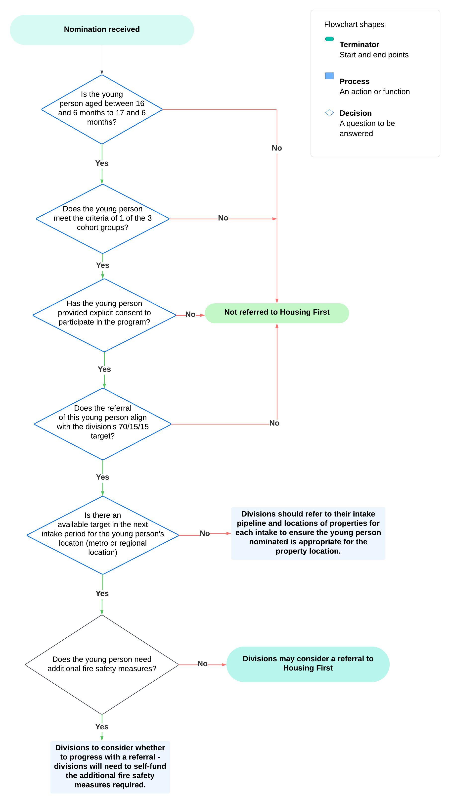

### Implementation guidance

#### Nomination stage

There are no mandated requirements for how the nomination stage should look for Housing First.

Each division will follow local arrangements to explore which young people may be suitable for Housing First.

Discussions that occur between the Housing First Senior Program Officers, care teams and other professionals in the nomination stage do not automatically result in a referral. It remains the discretion of the Housing First Senior Program Officers and Divisional Care Services Managers to accept a nomination for a young person, and progress the referral to the Housing First service provider.

#### Client consent

The department and Housing First service providers must adhere to their requirements under the *Privacy and Data Protection Act 2014.* In accordance with Information Privacy Principle 1, the young person must know how their information is being used and to whom it is being disclosed.

A referral cannot be made until the young person has provided explicit consent for the referral. The young person’s care team must have discussed Housing First as a leaving care option with the young person and sought their consent before progressing a referral. This includes ensuring that the young person is aware of the additional data collection and participation costs of Housing First compared to other leaving care options.

#### Intake numbers and locations

Each division has target numbers for each intake period. The Housing First Senior Program Officer must ensure that referrals adhere to their target numbers.

#### Fire safety requirements

The Client Risk Assessment must be completed during the nomination phase. If the young person’s circumstances change, further Client Risk Assessment’s must be completed.

Divisions must carefully consider referrals for young people with a history of arson or other fire-related behaviour that is considered high-risk by the department’s Client Risk Assessment.

The Housing First program does not provide funding for the installation of any additional fire safety measures above the Building Regulatory requirements and Capital Development Guidelines.

If the division determines a referral should progress for a young person who must have additional fire safety measures installed by the Homes Victoria Fire Safety Team, the division will fund all costs associated with these measures. This includes, but is not limited to:

* the cost of installation of additional fire safety measures, such as a fire sprinkler system
* the ongoing maintenance of the additional fire safety measures
* the de-commissioning of the additional fire safety measures at the end of the young person’s tenancy
* any additional costs incurred from the delay in handing back the property to Homes Victoria due to the de-commissioning of the additional fire safety measures

### Stage two referral process flow

Figure 5: Flow chart displaying the business flow of Stage Two Housing First referrals.



# 4. Service delivery

Housing First has three phases: an in-reach period, a housing period and a post-reach period. The total program duration per young person is 3 years and 6 months, with a minimum housing period of 2 years.

This chapter details the requirements and implementation guidance for each service delivery phase.

Figure 6: Housing First support journey

Figure 6 displays the housing first support journey.
Months 0-6 are the in-reach period, months 6-30 are the housing period and months 30-42 are the post-reach period. All participants receive a total of 42 months of support.

## 4.1. In-reach period

### Requirements

* all participants receive up to 6-months of in-reach support before entering their Housing First property, with a minimum in-reach period of 12 weeks. The division and Housing First service provider may negotiate a truncated in-reach period for exceptional circumstances.
* the Housing First Case Worker delivers Housing First case work support during the in-reach period.
* the Housing First Case Worker engages with the young person and their care team to help build the young person’s independent living skills and transition readiness.
* the Housing First Case Worker liaises with the care team to identify goals on the 15+ Care and Transition Plan that they will undertake
* the Housing First Case Worker undertakes the WOMBAT Early Life Skills Assessment tool (or similar tool) with the young person during the in-reach period, and annually thereafter. Outcomes of this Assessment tool guide support planning with the young person.
* the Housing First Case Worker provides expert guidance to the care team on identifying additional case work goals specific to the needs of the young person to meaningfully participate in Housing First. These goals may be the responsibility of the case worker or another member of the care team.
* the Housing First Case Worker supports the young person to complete and sign all required documents for their housing. This includes supporting the young person to complete:
  + Participant Housing Allocation Consent Form
  + Rental Agreement
* the Housing First Case Worker accompanies the young person to view the allocated property.
* the Housing First Case Worker supports the establishment of the home. This may include:
  + supporting the connection of utilities
  + assisting the young person to acquire personal household goods and furnishings, such as bedroom furniture and linens.[10]

#### Case work hours

* funding is based on 5 case work hours per week for six months (130 hours total)
* hours can be delivered flexibly, based on the needs and circumstances of the young person. This means that some young people may receive a consistent five hours of case work each week, while others may have a more intensive, focused period of in-reach
* when in-reach is conducted for less than six months, surplus hours will not be recouped by the department. The Housing First provider can utilise these hours to provide increased support during the housing period.[11]

### Implementation guidance

The in-reach period is a critical time that supports the development of a trusting relationship between the young person and their Housing First Case Worker.

The primary focus during the in-reach period is to support young person’s ‘transition readiness’. This includes, but is not limited to:

* enhancing the young person’s ability to meet their tenancy obligations
* enhancing their independent living skills
* preparing the young person for tenancy sign-up.

The in-reach period should complement actions and goals detailed in the 15+ Care and Transition Plan.

#### Supporting the connection of utilities

The young person is responsible for the connection and payment of utilities throughout their time in Housing First.

Utilities must be connected to all rented premises to comply with Victorian and local laws and regulations for residential dwellings. A utility provider cannot refuse to connect utilities based on a young person’s age.

Young people living in a shared accommodation will be supported by their Housing First Case Workers to negotiate responsibilities for utilities.

## 4.2. Housing period

### Requirements

* the young person will sign a 2-year fixed term rental agreement
* 30% of program participants may have their housing extended for a further 6 months, totalling 2 years and 6 months in the Housing First property
* in year 2 of the housing period, the Housing First Case Worker supports the young person to source alternative accommodation. This may include:
  + seeking secondary consultation with the Tenancy Support Worker to identify alternative housing options
* the Housing First Case Worker ensures the young person has moved to their alternative accommodation by the end of their two-year housing period.

#### Case work hours

* Housing First case work hours are in addition to Better Futures and Home Stretch hours.
* hours can be delivered flexibly, based on the needs and circumstances of the young person. This means that some young people may receive consistent hours each week, while others may have periods of more intense work.
* when a young person leaves their Housing First property before the two-year period, service providers continue to deliver the allocated hours to the young person in their new accommodation setting (see 5.4 Young people disengaged from Housing First).

Table 5: Case work hours during housing period

| Housing First phase | Housing First case work hours | Home Stretch hours | Total hours of support |
| --- | --- | --- | --- |
| Housing period (program months 7-18) | 260 hours | 75 hours Home Stretch (prorated from Home Stretch commencement date) | Up to 335 hours |
| Housing period (program months 19-30) | 156 hours | 75 hours Home Stretch | Up to 231 hours |

#### 6-month housing extension

30% of program participants who commence their housing period by July 2027 can have a 6-month housing extension.

The Housing First Case Worker contacts the Housing First Senior Program Officer to request a housing extension.

The Housing First Senior Program Officer must:

* consider the division’s percentage of participants eligible for a 6-month housing extension. Refer to Table 6.
* consider the exit plan for the young person into alternative accommodation at the end of their housing tenure
* liaise with Homes Victoria to confirm the ability of the property to be re-let for a further 6 months
* review the property pipeline for their division and determine the ability for the division to meet their participant needs.

Table 6: 6-month housing extension target per division[12]

| Division | Number of young people eligible for 6-month housing extension |
| --- | --- |
| North | 16 young people |
| West | 20 young people |
| South | 18 young people |
| East | 13 young people |

A truncated post-reach period proportionate to the housing extension applies. This ensures that all young people have a total program duration of 3 years and 6 months.

Once the Housing First Senior Program Officer approves the application for a 6-month extension, the Housing First Case Worker supports the young person to sign a fixed-term rental agreement for 6 months with the Accommodation Manager.

The Housing First Senior Program Officer keeps a record of all applications for a 6-month extension.

Figure 7: Housing First support journey for young people who receive a 6-month housing extension

Figure 7 displays the housing first support journey for young people who receive a 6 month housing extension.
Months 0-6 are the in-reach period, months 6-36 are the housing period and months 36-42 are the post-reach period. All participants receive a total of 42 months of support.

### Implementation guidance

#### Accommodation after Housing First

Young people must move to stable, alternative accommodation by the end of their second year in Housing First housing. A public housing application is recommended for all young people participating in Housing First as early as possible.

## 4.3. Post-reach period

The Housing First Case Worker conducts post-reach with the young person at their new accommodation or in the community. Post-reach ensures a gradual and supported transition for the young person to establish themselves in their ongoing accommodation.

### Requirements

* Housing First Case Worker supports the young person to maintain their alternative accommodation in a manner that promotes the young person’s independence
* Housing First Case Worker prepares the young person for Housing First program completion. This may include:
  + ensuring the young person is engaged in education, training or employment
  + referring the young person to enduring supports
  + empowering the young person to manage their affairs, such as health and social appointments

#### Case work hours

* Housing First case work hours are in addition to Better Futures and Home Stretch hours.

Table 7: case work hours during post-reach period

| Housing First phase | Housing First case work hours | Home Stretch hours | Total hours of support |
| --- | --- | --- | --- |
| Post-reach period  (program months 31-42) | 104 hours | 75 hours Home Stretch | Up to 179 hours |

### Implementation guidance

Activities undertaken in the post-reach period represent the goals worked towards throughout the program, with greater agency shown by the young person in managing their own affairs.

At the conclusion of their participation in Housing First, the young person should:

* reside in a safe and secure housing arrangement
* be engaged in education, training and/or employment
* know how to seek support from key health and social services to which they are entitled, including primary healthcare and mental health services
* have developed the life skills and knowledge that equips them to maintain and manage their own home environment
* feel connected to their peers/community and has established positive social connections.

## 4.4. Feedback and complaints

Service providers have an obligation under their Service Agreement with the department to have a complaints and feedback process. The Housing First service provider must inform the young person how they can raise a complaint when the provider accepts the Housing First referral.

# 5. Program participation

Participation in Housing First is voluntary and based on the young person’s agreement to:

* fulfil mutually agreed obligations
* the collection of data relating to service usage and outcomes
* meet financial obligations.

This chapter details the requirements and implementation guidance for participation in Housing First.

## 5.1. Mandatory forms

### Requirements

* the young person must sign the Program Participation Agreement prior to any Housing First case work being undertaken
  + a copy of the signed Program Participation Agreement must be provided to the Housing First Senior Program Officer.
* the young person, or their legal guardian, must sign the Data Collection and Consent form prior to any Housing First case work being undertaken
  + a copy of the signed Data Collection and Consent Form must be provided to the Housing First Senior Program Officer.
* the young person must sign the Homes Victoria Allocation Consent form during the in-reach period
* the young person must sign the rental agreement prior to moving into their Housing First property.

### Implementation guidance

#### Program Participation Agreement

A young person will enter into a Program Participation Agreement with their Housing First Case Worker. This agreement outlines the mutual obligations of both parties, including the young person’s commitment to:

* sharing relevant information about their circumstances and any concerns
* making reasonable efforts to keep contact details up to date to ensure ongoing engagement with the program
* making sure their own actions do not adversely impact on other Housing First participants or staff.

The Housing First Case Worker agrees to deliver individualised support with a focus on:

* building the young person’s capabilities to support independent living
* working with the young person and other existing support networks to identify, navigate and access relevant services and supports
* respecting young people’s privacy and rights, in line with applicable legislation and as outlined in their Service Agreement with the department
* working with a high degree of professionalism and consistent with standards of professional practice.

#### Data collection and consent form

Housing First is a pilot program and subject to evaluation. The collection of data is required to evaluate Housing First outcomes and support the department’s performance monitoring requirements.

Young people referred to Housing First must consent to the collection of their data for evaluation purposes. A Data Collection and Consent Form is part of the participation agreement and must be signed prior to service commencing.

Where a young person is under the age of 18 years and on a statutory order, Child Protection as the legal guardian must sign the Data Collection and Consent Form. The form must be signed by the young person once they turn 18 years old.

Data collection for young people who leave the program during the housing period will continue for the purpose of measuring outcomes payments.

#### Allocation Consent form

The Allocation Consent form is a Homes Victoria document which authorises the Accommodation Manager to contact the young person’s Housing First Case Worker.

The form must be completed during the young person’s in-reach period. The form is provided by Homes Victoria to the Housing First Senior Program Officer when a property has been confirmed for Housing First.

The Senior Program Officer is responsible for facilitating the completion of this form and its return to Homes Victoria.

The Accommodation Manager is unable to communicate with any member of the young person’s care team until the completed form has been provided to them by Homes Victoria.

## 5.2. Rent contribution

### Implementation guidance

#### Rent

The weekly standard rent will be re-assessed in March annually and adjusted in line with changes to Services Australia payment rates.

The Accommodation Manager must notify the renter at least four weeks prior to any change in the weekly standard rent payable.

## 5.3. Participant attrition

Participant attrition is when the young person removes consent to participate in the Housing First program. To determine if attrition has occurred, the Housing First Case Worker engages with the young person and determines:

* the young person’s intention in removing consent
* the reason/s for withdrawing consent
* the reason for withdrawing consent cannot be resolved or overcome to maintain the young person’s participation in the program.

Participant attrition is different to participant disengagement or eviction. See section 5.4 Young people disengaged from Housing First for requirements.

This section details the requirements for when a participant leaves the Housing First program during the in-reach or housing period.

## 5.3.1 Participant attrition during in-reach period

### Requirements

When a young person withdraws their consent to participate in Housing First during the in-reach period, the following must occur:

* Housing First Case Worker must notify the Housing First Senior Program Officer of the young person’s withdrawal
* Housing First Senior Program Officer works with the Housing First service provider to complete a reconciliation of funding to determine whether there is sufficient funding capacity to commence supporting another young person. This determination must consider:
  + the number of in-reach hours of support that were provided to the young person who withdrew consent; this will help to inform the number of unused funded in-reach hours available[13]
  + whether unused in-reach hours across multiple program participants can be used to fund a new in-reach period for another young person
  + the accommodation location for the target
* in circumstances where there are insufficient in-reach hours available to provide to a new program participant, a new young person is not able to commence support.
* the Housing First Senior Program Officer will keep a record of participant attrition.

### Implementation guidance

The participant target may be replaced when attrition occurs during the in-reach period. The Housing First Senior Program Officer and the Housing First Case Worker must confirm the number of in-reach hours remaining for this target. When the in-reach hours are insufficient to provide 12 weeks of in-reach, the Housing First Case Worker must consider whether unused in-reach hours for other program participants can be utilised to ensure the in-reach period meets minimum requirements. If the minimum in-reach period cannot be met, the target is unable to be replaced.

## 5.3.2 Participant attrition during housing period

### Requirements

When a young person exits Housing First during their 2-year housing period, the following must occur:

* the Housing First Case Worker must notify the Housing First Senior Program Officer
* the Housing First Senior Program Officer must liaise with Homes Victoria to confirm if the property can be re-let to a new program participant in the next intake period
* Homes Victoria to determine whether the property will be retained by the program and available for use in the next intake period.
* Housing First Senior Program Officer keeps a record of participant attrition.

### Implementation guidance

Eviction from a Housing First property does not mean participant attrition; attrition is defined as when a young person has explicitly withdrawn their consent for program participation. See section 5.5. Eviction from the Housing First property for requirements.

A program target cannot be replaced once the young person has entered the housing period.

Housing First Case Workers must report all program exits to the Housing First Senior Program Officer as soon as possible.

Figure 8: Participant attrition flowchart

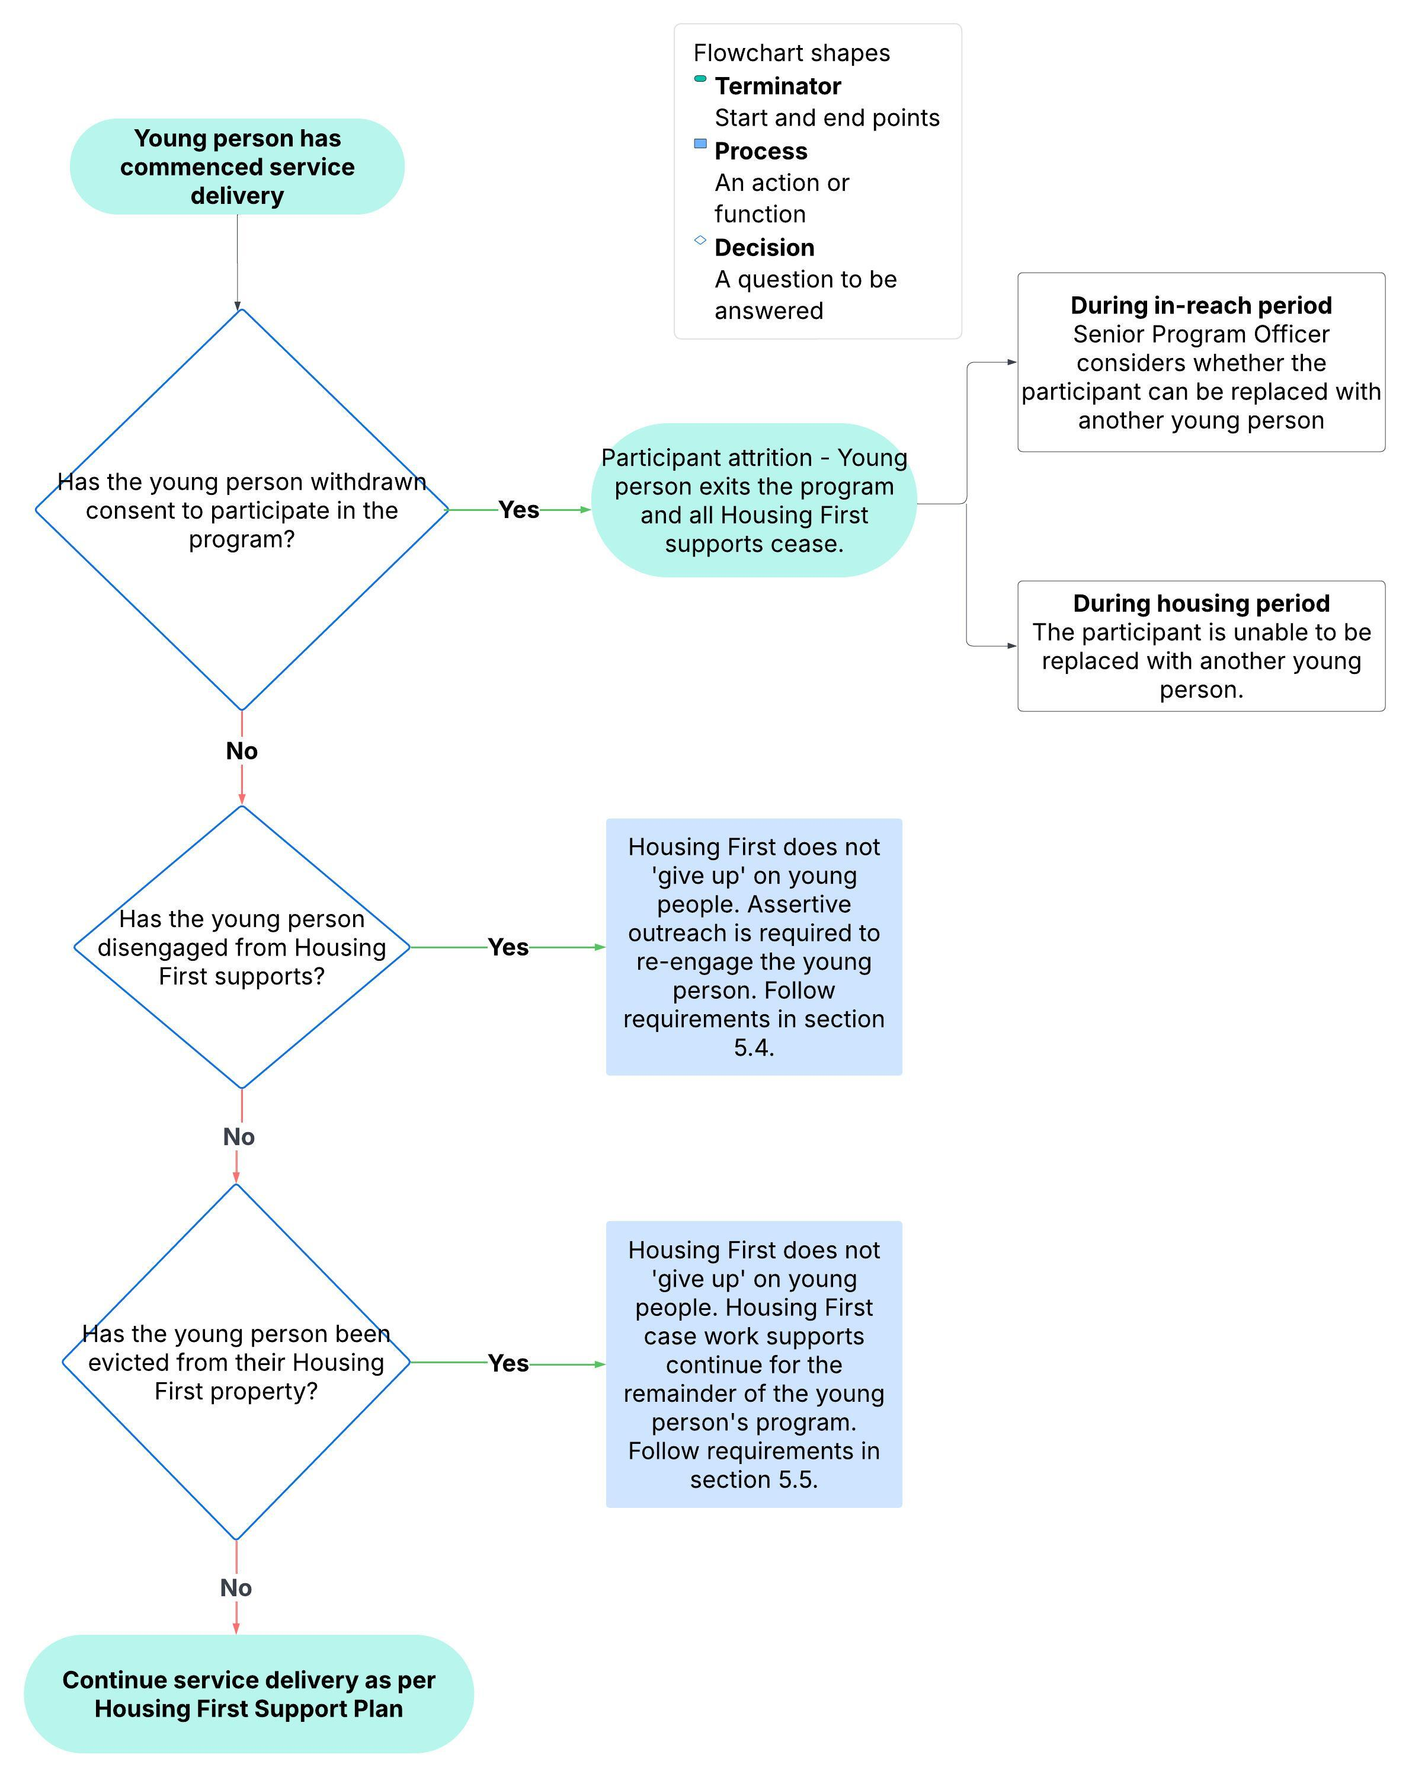

## 5.4 Young people disengaged from Housing First

### Requirements

A young person may disengage from the program for a variety of reasons. Disengagement may occur during any stage of Housing First.

A principle of Housing First is that we don’t ‘give up’ on young people. When a young person is disengaged from the program, they remain a program participant. The Housing First Case Worker must:

* provide assertive case work support to the young person. This should include assertive, persistent, repeated, innovative outreach to re-engage the young person
* use trauma-informed and Advantaged Thinking practice approaches to meet the young person where they are at, to tailor support plans to meet the young person’s needs.

In circumstances where the young person leaves the Housing First property and resides in a new accommodation setting, the Housing First Case Worker must:

* inform the divisional Housing First Senior Program Officer that the Housing First property is currently vacant
* work with the care team to encourage the young person to return to the Housing First property. This may include tailoring a support plan to include gradual re-establishment in the property
* the Housing First Senior Program Officer must liaise with the Homes Victoria Senior Project Manager to assess the status of the vacant property and period of absence.

### Implementation guidance

In circumstances where the young person leaves the Housing First property, the Housing First Case Worker must actively encourage the young person to safely return to the property. The young person has entered a rental agreement with the property provider, and their financial obligations continue, regardless of whether they are staying in the property.

The Housing First Senior Program Officer, Housing First Case Worker and Homes Victoria Senior Project Manager will work together on a case-by-case basis to assess the status of the vacant property and ability for the property to remain in the program.

#### 5.4.1 Young people temporarily absent from Housing First property

A Temporary Absence subsidy applies to a young person’s rental payment when they are absent from the home because they:

* are temporarily residing in a psychiatric, physical or drug and alcohol rehabilitation centre
* are temporarily in respite care due to unforeseen circumstances
* are on remand or incarcerated for a period of up to eight weeks
* are a victim of family violence and it is unsafe to remain at the property.

The young person or their Housing First case worker can apply to the Accommodation Manager for the temporary absence subsidy. Supporting evidence may be required to confirm eligibility for the subsidy.

An extension can be requested if the young person is unable to return after the eight-week period. Extensions are individually assessed by the Homes Victoria – Victorian Housing Register (VHR) Agency Engagement Team in consultation with the young person’s Housing First Case Worker and the Housing First Senior Program Officer.

If the young person does not return within the approved timeframe, or the extension application is not approved, the subsidy will be cancelled. This means that the standard rent payable will be charged.

Young people who are temporarily absent from their Housing First property retain all tenancy rights and responsibilities, as stipulated in their rental agreement.

## 5.5. Eviction from the Housing First property

The home provided by Housing First is contingent on the young person adhering to their rental agreement. Breaches of the agreement may lead to the young person being evicted from the Housing First property. In circumstances where the Accommodation Manager obtains a Warrant of Possession for the Housing First property, the young person will exit from Housing First housing but will remain a program participant. No other property will be provided by Housing First. It is the responsibility of the young person’s care team to support the young person to obtain alternative accommodation.

### Requirements

* the Accommodation Manager notifies the Housing First Case Worker that a Notice to Vacate has been granted by the Victorian Civil and Administrative Tribunal (VCAT)
* the Housing First Case Worker provides intensive support to the young person to address the significant tenancy concerns outlined in the Notice to Vacate. This may involve:
  + secondary consultation with the Tenancy Support Worker
  + collaborative work with the care team.
* the Accommodation Manager notifies the Housing First Case Worker that the tenancy issues have not been resolved and an Order of Possession is being sought
* the Housing First Case Worker should support the young person to attend the VCAT hearing and advocate for the young person
* if an Order of Possession is granted by VCAT, the Housing First Case Worker notifies the care team. The Housing First Case Worker and care team are to:
  + seek secondary consultation with the Tenancy Support Worker
  + liaise with the Accommodation Manager to determine if an agreement can be reached to prevent a Warrant of Possession being obtained.
* if the Accommodation Manager obtains a Warrant of Possession for the property, the Housing First Case Worker and care team are to:
  + support the young person in finding alternative accommodation
  + support the young person to move to their new accommodation.
* the Housing First Case Worker continues to provide case work support to the young person for the remaining time in the Housing First program.
* The Housing First Senior Program Officer keeps a record of evictions from Housing First properties.

## 5.6. Pets

Pets are an important support to young people and must be appropriately considered and planned for during the young person’s participation in Housing First.

### Requirements

* Housing First Case Workers educate and support young people to manage rental requirements as per the Residential Tenancies Act. This includes that the renter must seek permission from the landlord for the keeping of a pet at the rented premises
* all pets must comply with Victorian and local council requirements
* if the young person is residing in a shared property, dangerous dogs are not permitted at the Housing First property.[14]

#### When the young person is known to have a pet at time of referral to Housing First

* Housing First Case Workers set expectations with the young person on the appropriate care of pets, such as:
  + feeding
  + exercise
  + cleaning up after the pet
* Housing First Senior Program Officers consider the pet in the matching of an appropriate co-tenant to a shared property
* Housing First Case Workers ensure co-tenant expectations on the pet are included in the shared house rules
* Housing First Case Workers manage any disputes which arise between co-tenants relating to the pet at the premises.

#### When the young person obtains a pet after moving into a shared property

* the young person must notify the Accommodation Manager that they are keeping a pet at the property
* if the pet is in breach of the agreed house rules between co-tenants, the Accommodation Manager, Housing First Case Worker and operational division locally manage. This may include notifying the young person that the request is denied and commencing proceedings with VCAT
* if the pet is not in breach of house rules, the Housing First Case Worker ensures responsible pet ownership is part of their case work with the young person.

## 5.7. House rules

### Implementation guidance

All two and three-bedroom properties are gazetted as rooming houses. Up to two young people may share the home each with their own Rooming House Residency Agreement.

House rules support the co-living arrangements of the young people living in shared properties.

Prior to the second renter commencing their tenancy, the Accommodation Manager is required to engage with both young people and their Housing First Case Workers to develop and agree to house rules. House rules include co-living agreements, such as the payment of or contributions to utility bills.

# 6. Funding and evaluation

Housing First is partly funded under the Early Intervention Investment Framework and has a Payment by Results component. This chapter outlines the requirements and implementation guidance for the funding and evaluation of Housing First.

## 6.1 Funding

### Implementation guidance

The department enters funding in Service Agreements under the activity number 31652.

Agency Performance and System Support teams in Operations Divisions have been provided Housing First funding instructions.

## 6.2 Evaluation

Evaluation of Housing First will assess its implementation, outcomes and impact. Evaluators will work with service providers and, where required, build on existing monitoring and data collection.

Housing First evaluation draws on two reporting requirements:

* Early Intervention Investment Framework reporting
* Payment by Results approach
  1. Payment by Results for Community Services Organisations
  2. ACCO incentive payment.

Housing First providers are not required to capture baseline data for the purpose of Housing First evaluation.

## 6.2.1 Early Intervention Investment Framework reporting

Housing First aims to improve life outcomes for young people leaving care. The program is an Early Intervention Investment Framework (EIIF) initiative. EIIF funds initiatives designed to improve individuals’ outcomes.

Evaluation measures for EIIF relate to overall program evaluation of Housing First.

There are five measures for EIIF evaluation, detailed in table 9.

Table 8: Housing First EIIF evaluation reporting measures

| EIIF reporting measures | Definition | Data source |
| --- | --- | --- |
| Education and employment | The number of young people engaged in education or employment | Better Futures Outcomes Tracking System |
| Social Connectiveness | The self-reported rate of social connectiveness of young people | Better Futures Outcomes Tracking System |
| Housing | The proportion of participants in stable housing | Housing First program data |
| Health | The average number of emergency department presentations (triage categories 1-5) | Victorian Emergency Minimum Dataset |
| Justice | The average number of police incidents as the alleged offender | Victoria Police Law Enforcement Assistance Program (LEAP) |

### Implementation guidance

The Education and Employment, and Social Connectedness reporting measures are assessed against data captured via the Better Futures Outcomes Tracking System, WOMBAT Early Life Skills Assessment (or similar) and other data sources as determined appropriate. Completion of the Outcomes Tracking System is the responsibility of the Better Futures Development Coach.

The Health and Justice reporting measures are assessed against data provided by the Centre for Victorian Data Linkage. This is the same data used for the Payment by Results evaluation for Community Services Organisations. See section 6.2.2 for requirements and guidance.

## 6.2.2 Payment by Results for Community Services Organisations

Payment by Results (PbR) is an outcomes-based funding model which provides payments to CSOs that depend on improved client outcomes. PbR incentivises results-driven performance and focuses on the achievement of agreed outcomes. PbR only applies to CSOs delivering Stage 2 Housing First.

### Requirements

The PbR reporting requirements of service providers are to:

* update Housing First Senior Program Officers of young people’s status in the program
* advise Housing First Senior Program Officers of any changes to a young person’s personal identifier details
* provide on request relevant excerpts from case notes to support and evidence measurement

### Implementation guidance

The department’s Social Investment and Analytics Team calculate the payable outcomes. The Centre for Victorian Data Linkage provides deidentified data for Housing First participants and a like-control group.

The payable outcomes measures for Housing First are detailed in table 8.

Table 9: Housing First payable outcomes measures

| Payable outcomes measure | Definition | Data source |
| --- | --- | --- |
| Housing outcomes measure | The proportion of participants able to maintain stable housing over the measurement period, compared with a control group | Homelessness data collection |
| Health outcomes measure | The average number of emergency department presentations (triage categories 1-5) per person in the measurement period, compared with a control group | Victorian Emergency Minimum Dataset |
| Justice outcomes measure | The average number of police incidents as the alleged offender over the measurement period, compared with a control group | Victoria Police Law Enforcement Assistance Program (LEAP) |

## 6.2.3 Aboriginal Community Controlled Organisations incentive payment

Due to the small cohort size and dispersed allocation of Aboriginal young people to their Better Futures ACCO provider for Housing First, the Payment by Results model does not apply. Instead, ACCOs delivering Stage 2 Housing First will have access to an alternative incentivised outcomes approach via the payment of a bespoke outcomes measure.

***This section will be updated once this work has been finalised, in consultation with the Housing First – First Nations Consultation Group***

# 7. Mechanisms of oversight

## 7.1. Service agreements

The department uses service agreements to manage funding to organisations. The service agreement:

* establishes standard terms and conditions that apply to all funded organisations; and
* provides organisation-specific information on funding and payments in its schedules.

More information can be found on the [Funded Agency Channel](https://fac.dffh.vic.gov.au/service-agreement-requirements)[15].

The online search functionality requires the individual activity name or number. Use the relevant Housing First activity names or activity number **31652** to undertake the search.

To access funded activity descriptions, refer to the [department’s activity search website](https://providers.dffh.vic.gov.au/families-fairness-housing-health-activity-search)[16].

Performance and Reporting Practice Advice was updated in January 2025 for the Housing First activity 31652. Service providers must ensure they follow all information for the funded activity.

The Performance and Reporting Practice Advice can be found on the [Providers website](https://providers.dffh.vic.gov.au/housing-first-young-people-leaving-care-performance-and-reporting-practice-advice)[17].

### 7.1.1. Service Agreement Management System (SAMS2)

The department uses the SAMS2 system to process funding to organisations for delivery of services. SAMS2 has links to the Funded Agency Channel to capture all approved funding commitments processed. This information is accessed by funded agencies in FAC.

## 7.2. Client Relationship Information System for Service Providers (CRISSP)

The Client Relationship Information System (CRIS) is the client information and case management system used by Child Protection, ACAC and Contracted Case Managers.

The Client Relationship Information System for Service Providers (CRISSP) is a flexible client information and case management system used by service providers. CRISSP provides a range of functions to:

* record client information
* assist case management
* enable electronic reporting of data required by the department.

Housing First workers use CRISSP to:

* document and report on hours-of-service delivery
* record expenditure of brokerage for Aboriginal young people.

## 7.3. Service Delivery Tracking

Service Delivery Tracking (SDT) is an online tracking tool used by service providers to report monthly service delivery against their service agreement.

The SDT acquittal templates are available for updating and submission from the first day of the month, following the reporting month.

More information about SDT can be found on the [Funded Agency Channel website](https://fac.dffh.vic.gov.au/service-delivery-tracking)[18].

Reporting on Housing First brokerage funding for Aboriginal young people will be generated through a report on CRISSP and sent to the APSS Manager annually in the first week of July.

## 7.4. Client Incident Management System (CIMS)

The Client Incident Management System (CIMS) is an incident reporting and management system for department-delivered and department-funded services.

Incidents which occur during service delivery which result in harm to the client, or are reasonably likely to cause serious harm to a client, must be reported in CIMS.

More information on CIMS can be found on the [providers website](https://providers.vic.gov.au/cims)[19].

# 8. Legislation, frameworks and standards

## 8.1. Children, Youth and Families Act 2005

The *Children, Youth and Families Act 2005* (the Act) is the legislative framework to enable Housing First.

Housing First is one leaving care option available to young people. Leaving care supports are authorised under Section 16 G of the Act.

## 8.2. Social Services Regulation Scheme

Housing First is delivered by CSOs and ACCOs that are prescribed under the *Social Services Regulation Act 2021* and the Social Services Regulations 2023 (the regulations).

For information on requirements under the Social Services Regulation Scheme, refer to the [Social Services Regulation Reform](https://www.dffh.vic.gov.au/social-services-regulation-reform) webpage.[20].

## 8.3. Child Wellbeing and Safety Act 2005

The *Child Wellbeing and Safety Act 2005* establishes the regulatory framework for the Child Safe Standards and Reportable Conduct Scheme. The Child Wellbeing and Safety Act also provides an overarching framework for promoting positive outcomes for all children and young people and identifies a set of principles as the basis for development and provision of services.

Housing First service providers must adhere to their requirements under the Child Wellbeing and Safety Act.

## 8.5. Privacy and Data Protection Act 2014

The *Privacy and Data Protection Act 2014* outlines Information Privacy Principles that departments and service providers must follow. The principles set out standards for collecting and handling people’s personal information.

## 8.6. Charter of Human Rights and Responsibilities

The *Charter of Human Rights and Responsibilities Act 2006* (the charter) is Victorian law that sets out the basic rights, freedoms and responsibilities of all people in Victoria. The charter requires public authorities, to act consistently with the human rights in the charter.

The delivery of Housing First services must comply with the charter.

More information on the Charter of Human Rights and Responsibilities can be found on the [Victorian Equal Opportunity and Human Rights Commission website](https://www.humanrights.vic.gov.au/legal-and-policy/victorias-human-rights-laws/the-charter/).

## 8.7. Care and transition planning for leaving care framework

The Care and Transition planning for leaving care framework (the framework) aims to provide all practitioners involved in the delivery of case management, out-of-home care and post-care support with best practice approaches and processes to prepare and support young people transitioning from out-of-home care.

The framework can be accessed on the [department’s website](https://providers.dffh.vic.gov.au/care-and-transition-planning-leaving-care-framework-word).

8.8. Aboriginal and Torres Strait Islander cultural safety framework

The Aboriginal and Torres Strait Island cultural safety framework provides a continuous quality improvement model to strengthen the cultural safety of individuals and organisations. It aims to help the department and mainstream health, human and community services to strengthen their cultural safety by participating in a process of continuous learning and practice improvement.

The framework can be found on the [department’s website](https://www.dffh.vic.gov.au/publications/aboriginal-and-torres-strait-islander-cultural-safety-framework)

### 8.8.1. Wungurilwil Gapgapduir Aboriginal children and families agreement

Wungurilwil Gapgapduir, which means ‘strong families’ in Latji Latji, is a tripartite agreement between the Aboriginal community, Victorian Government and Community Service Organisations. It outlines a strategic direction to reduce the number of Aboriginal children in out-of-home care by building their connection to culture, Country and community.

Further information can be found on the [department’s website](https://www.dffh.vic.gov.au/publications/wungurilwil-gapgapduit-aboriginal-children-and-families-agreement).

## 8.9. Multi Agency Risk Assessment and Management Framework (MARAM) and Information Sharing Schemes

In 2018, the Victorian Government introduced family violence and information sharing reforms. These reforms promote the wellbeing of children and to keep women, children, and families safe from family violence. These reforms hold perpetrators accountable for their actions and behaviours. Professionals have increased ability and responsibility to collaborate with each other and better support the children and families they are working with. Child Protection and registered Care Service Providers are both prescribed under the MARAM framework and information sharing schemes.

More information can be found on the [Victorian Government website](https://www.vic.gov.au/maram-practice-guides-and-resources).

# 9. Department contacts

Table 10: Department contacts by division

| Division | Contact email |
| --- | --- |
| South Division | [South.HousingFirst@dffh.vic.gov.au](mailto:South.HousingFirst@dffh.vic.gov.au) |
| East Division | [East.HousingFirst@dffh.vic.gov.au](mailto:East.HousingFirst@dffh.vic.gov.au) |
| West Division | [West.HousingFirst@dffh.vic.gov.au](mailto:West.HousingFirst@dffh.vic.gov.au) |
| North Division | [North.HousingFirst@dffh.vic.gov.au](mailto:North.HousingFirst@dffh.vic.gov.au) |
| Central | [betterfuturescentral@dffh.vic.gov.au](mailto:betterfuturescentral@dffh.vic.gov.au) |

# Appendix - version history

|  |  |  |  |
| --- | --- | --- | --- |
| Version | Date | Comment | Version author |
| 1.0 | October 2024 | Interim model only | Housing First project team |
| 2.0 | June 2025 | Full model | Housing First project team |

1. https://homelessnessaustralia.org.au/homelessness-resources/housing-first/
2. https://www.bsl.org.au/services/youth/better-futures/
3. At the time of referral. In exceptional circumstances Divisions can negotiate with service providers the acceptance of a referral for a young person aged between 17 years and 6 months to 17 years and 9 months.
4. If the Housing First referral has been accepted by the service provider.
5. https://providers.vic.gov.au/housing-first
6. https://www.dss.gov.au/towards-adulthood
7. https://www.mcm.org.au/services/homelessness/frontyard/services/learving-care/transition-to-independent-living-allowance
8. There is limited budget availability to replace targets if a program participant exits the program early. Therefore, a referral should not be progressed to Housing First when an alternative, preferred leaving care pathway is being applied for, such as a referral to NDIS supported independent living.
9. This functionality will be available from June 2025. Divisions have established interim local arrangements for the saving of the Program Participation Agreement and Data Collection and Consent form until the IT upgrade has been completed.
10. Goods and furnishings should be purchased through the young person’s Targeted Care Package or Home Stretch Allowance. Funding for these items is not provided by Housing First.
11. This does not apply when the Housing First target has been replaced due to participant attrition. See section 5.4 for further information
12. Figures are for the life of the initiative.
13. A minimum of 12-weeks in-reach is required for all program participants
14. Dangerous dogs means dogs that have been declared dangerous by the local council under the *Domestic Animals Act 1994*.
15. https://fac.dffh.vic.gov.au/service-agreement-requirements
16. https://providers.dffh.vic.gov.au/families-fairness-housing-health-activity-search
17. https://providers.dffh.vic.gov.au/housing-first-young-epople-leaving-care-performance-and-reporting-practice-advice
18. https://fac.dffh.vic.gov.au/service-delivery-tracking
19. https://providers.dffh.vic.gov.au/cims
20. https://www.dffh.vic.gov.au/social-services-regulation-reform