

2021-22 Men’s Shed Funding Program
Grant guidelines
OFFICIAL
Contents
Minister’s message 2
Men’s sheds in Victoria 3
2021-22 Men’s Shed Funding Program 3
Grants 3
Eligibility 3
Auspicing 4
Projects 4
2:1 Funding ratio and in-kind contributions 5
Process and Timelines 5
More information 5

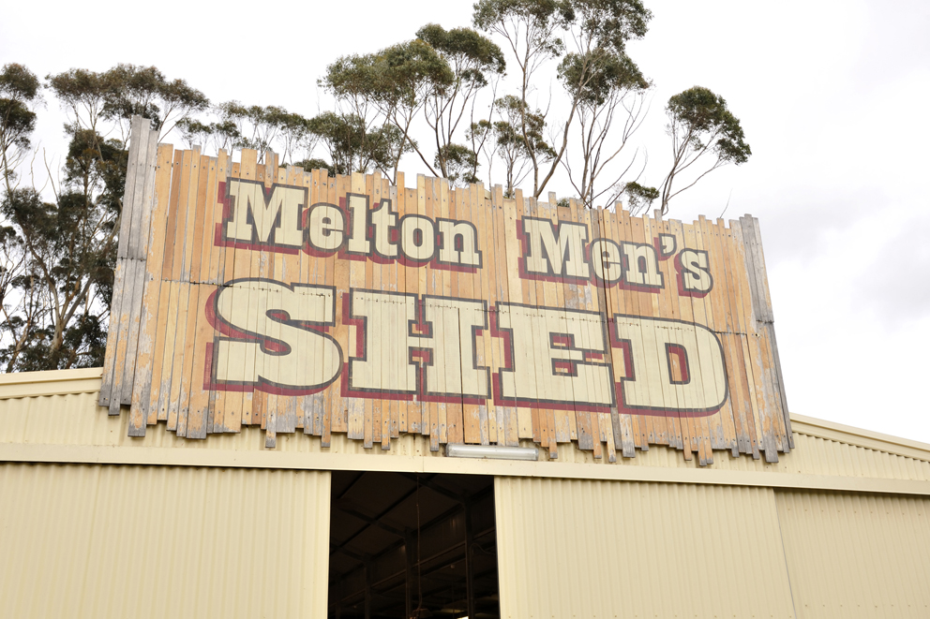

Minister’s message
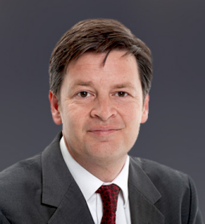
The Andrews Labor Government proudly continues to support men’s sheds. We recognise the important role that men’s sheds have in supporting men’s health and strengthening Victorian communities.
Men’s sheds are places where men can get together, work on common projects, form friendships and give back to their community. There are currently more than 360 communities throughout Victoria enjoying the benefits of having a local men’s shed.
When men’s sheds across Victoria closed in 2020, the Victorian Government stepped in and offered grants of $2,300 to every men’s shed in Victoria. These grants supported sheds to meet their immediate expenses while being unable to engage in their normal fundraising activities.
With the easing of restrictions, men’s sheds are carefully re-opening across Victoria and looking to the future.
I am very pleased to announce that the Victorian Government is releasing a new round of funding that will provide up to $872,000 in 2021-22 to men’s shed groups so they can build new men’s sheds or refurbish existing men’s sheds. This will enable these groups to create practical, engaging and welcoming spaces to work together and contribute to their local community.
Grants of up to $80,000 are available for capital projects to support the construction of new men’s sheds or refurbishment of existing men’s sheds across Victoria.
I look forward to announcing the successful recipients of this year’s men’s shed funding round later in the year.

The Hon. Luke Donnellan MP
Minister for Child Protection
Minister for Disability, Ageing and Carers

Men’s sheds in Victoria
Men’s sheds are safe and practical places for men to meet, make social connections and actively participate in their local communities.
Men’s sheds:
- are community based, non-profit organisations, accessible to all men, whose primary activity is the provision of a safe and friendly environment
- are often located in a shed or workshop space in a community-based setting
- provide a place for regular contact with other men and a range of activities that are determined by the participants
- partner with other organisations to share resources and build on existing services, and many undertake projects to assist the wider community. Partnerships can involve local businesses, councils, other government agencies, community groups, Aboriginal community controlled organisations and local clubs and associations
  - are supported by volunteers and are accessible and inclusive spaces.

2021-22 Men’s Shed Funding Program

Grants
Grants of up to $80,000 are available for
- the construction of new men’s sheds, including the conversion of a building that is not a men’s shed into a men’s shed
- the refurbishment, extension or upgrade of existing men’s sheds.

Eligibility
To be eligible for this funding round, applicants must:
- be an insured men's shed group
- be incorporated, or be auspiced by an incorporated organisation for the purposes of this application
- have evidence of being able to contribute to the project on a 2:1 basis
- be located in Victoria, not on private land
- be able to demonstrate a significant community need for the project
- not have already received $25,000 or more through the Victorian Government's Men's Shed Funding Program in the past five years.
If seeking $10,000 or over, the group must have:
- security of tenure in the form of a lease or licence of five years or more, or land ownership
- if auspiced, a memorandum of understanding (or equivalent) must be in place, outlining the agreed nature of the auspice arrangement
- a strategic plan in place that plans activities incorporating use of the new or refurbished facility
- a demonstrated need for the project in the community, established through community consultation, which is proportional to the grant amount requested
- detailed design plans and an understanding of building permit and planning requirements, including overlays
- support from key community partners.
Applicants must involve men’s shed participants in the project design and development phases.
Men’s shed projects must be completed within two years of funding approval.
The funded men’s shed must operate as a facility that is open to men in the wider community for a minimum period of five years.

Auspicing
To be eligible for funding through the Men’s Shed Funding Program, recipient organisations must be incorporated and have an Australian Business Number (ABN). If the men’s shed group is not incorporated with an ABN, it must either become incorporated or arrange for an incorporated organisation to manage the funds. This organisation will be the ‘auspice’ organisation for the grant application. If the application is successful, the grant will be paid to the auspice organisation.
Shed groups that enter into an auspice arrangement must have in place a Memorandum of Understanding (or equivalent) with their auspice organisation, specifying the nature of the auspice relationship and each organisation’s roles and responsibilities. The Memorandum of Understanding should also specify the ownership of all assets and funds, and a copy should be submitted with the grant application.
The Victorian Men’s Shed Association can provide detailed information about how to build a successful auspice arrangement and the components of a strong Memorandum of Understanding <http://www.vmsa.org.au>.

Projects
This funding can be used for the construction of a new men’s shed, which could mean transforming an existing community facility into a men’s shed, or the refurbishment of an existing shed.
Priority will be given to projects that are in proportion to the amount of demonstrated community need. This means that if a men’s shed group has 10 members, the type of project undertaken is likely to be smaller than a shed with 200 members. For new men’s shed groups, community need can be established through community consultation, partnerships with other local organisations and assessment of what other community resources are available in the local area.
The men’s shed grants will not fund:
- applications that are submitted after the closing date
- men’s sheds that have received more than $25,000 funding through the Victorian Government’s Men’s Shed Funding Program in the past five years
- projects that have already been allocated funding through the Men’s Shed Funding Program
- leases or site purchases
- requests for retrospective funding where projects have commenced or are completed prior to receiving funding approval
- projects that fail to incorporate disability or public access requirements
- projects that require ongoing funding from the Victorian Government
- projects that do not reflect the principles of community inclusion and appropriate access by community members
- projects over $10,000 that do not have a security of tenure (lease or land ownership) for at least five years
- costs to cover existing debt or budget deficits
- operational costs including but not limited to shed coordination costs
- costs not directly related to building and construction
- equipment or free-standing furniture or resources, such as vehicles, tools and chairs
- projects that are unlikely to be completed within two years
- projects that do not have adequate insurance cover (note: these grants do not come with insurance cover)
- projects that do not address the reduction of social isolation in men.

2:1 Funding ratio and in-kind contributions
For every $2 of funding provided under the men’s shed grant from the Victorian Government, at least $1 must be matched from other sources.
Other sources may include funding and support from the men’s shed group, other government organisations, businesses, philanthropic organisations, the local council or community fundraising.
Realistically costed in-kind expenses and contributions such as voluntary labour and donated materials can be claimed in the project budget up to 25 per cent of the total project cost.
Applicants should describe the type of voluntary labour and in-kind support that is expected to be contributed to the project in the application.
For example:
If a grant of $80,000 is sought, the total project cost would be at least $120,000. The applicant will need to provide at least $40,000 towards the project from other sources.
Some of that funding may be in the form of in-kind contributions, such as volunteer labour. In-kind contributions up to 25 per cent of the total project cost may be applied.
If the total project cost is $120,000 then the maximum in-kind contribution would be $30,000, leaving a minimum financial contribution from the shed or other sources of $10,000.
This figure would vary if the total project cost was higher, or if the in-kind contribution was lower.

Process and Timelines
Applications close for this funding round at 5pm, 30 June 2021.
If you are successful in your application you will be notified in September 2021 and asked to invoice the Department of Families, Fairness and Housing for the grant amount. Payments will be processed upon receipt of the invoice and funds are usually transferred 30 days from the date of the invoice.
Two simple reports will be required (a progress report in June 2022 and a final report upon project completion). Simple templates will be provided by email for these reports and they can be submitted by emailing the report to mens.sheds@dhhs.vic.gov.au. The final report includes a financial acquittal for the project so please keep records of all income and expenditure for this purpose.

More information
If you have questions about the program or application process, please
- see the Victorian Government’s Men’s Sheds Program webpage <https://providers.dhhs.vic.gov.au/mens-shed-program>.
- email men’s sheds <mens.sheds@dhhs.vic.gov.au>
- phone: 03 8633 4765.
The Victorian Men’s Shed Association can provide information on setting up a new men’s shed, or auspicing, fundraising, governance or where to find insurance advice. Contact Derek O’Leary, Chief Executive Officer:
- mobile 0418 34 8888
- email the Chief Executive Officer <ceo@vmsa.org.au>.

To receive this document in another format phone 03 8633 4765 using the National Relay Service 13 36 77 if required, or email Men’s Sheds <mens.sheds@dhhs.vic.gov.au>
Authorised and published by the Victorian Government, 1 Treasury Place, Melbourne
© State of Victoria, Department of Families, Fairness and Housing, March 2021
ISBN 978-1-76096-192-3 (pdf/Word/online)
Available at Men’s Shed Program <https://providers.dhhs.vic.gov.au/mens-shed-program>.

