

|  |
| --- |
| Fire and emergency preparedness and response procedures and training framework 2018 |
|  |

|  |
| --- |
|  |
| To receive this publication in an accessible format [email Fire Services team](mailto:fireriskmanagementunit@dhhs.vic.gov.au) <fireriskmanagementunit@dhhs.vic.gov.au>  Authorised and published by the Victorian Government, 1 Treasury Place, Melbourne.  © State of Victoria, Department of Health and Human Services, April 2018  ISBN 978-1-76069-351-0 (pdf/online)  Available at [Fire risk management procedures and guidelines](http://providers.dhhs.vic.gov.au/fire-risk-management-procedures-and-guidelines) < http://providers.dhhs.vic.gov.au/fire-risk-management-procedures-and-guidelines> |
|  |

Contents

1.0 Introduction 1

1.1 General 1

1.2 The purpose of this framework 2

1.3 Objectives 2

1.4 Interpretations 3

1.5 Definitions 3

1.6 Policies 3

1.6.1 Fire and emergency management policies, procedures and programs 3

1.6.2 NOTES: 4

1.7 Responsibilities 4

1.8 Occupational health and safety duties of the department 4

1.9 Concurrent duties of building owners and others 6

1.10 Duties of individuals 6

1.11 Fire and Emergency Review Panel 6

1.11.1 Establishment and membership of the Fire and Emergency Review Panel 6

1.11.2 Membership of Fire and Emergency Review Panel 6

1.11.3 Role and authority of the Fire and Emergency Review Panel 7

1.11.4 Quorum of a meet*i*ng 7

1.11.5 Process for making application to the Fire and Emergency Review Panel 7

2.0 Applicability of the framework 11

2.1 General 11

2.2 Emergency planning requirements for facilities and facilities subject to the Capital Development Guidelines – Series 7 Fire Risk Management 11

3.0 Emergency planning for staffed facilities 13

3.1 Applicable capital development guidelines 13

3.2 Emergency management 13

3.2.1 General 13

3.2.2 Emergency planning committee 14

3.2.3 Emergency response team 17

3.3 Emergency colour codes 23

3.3.1 General 23

3.3.2 Specific emergency 23

3.4 Emergency preparedness 24

3.4.1 General 24

3.4.2 Emergency management plan 24

3.4.3 Risk assessment 26

3.4.4 Media management plan 27

3.4.5 Pharmaceuticals, supplies and equipment 27

3.4.6 Facility evacuation diagrams 27

3.4.7 Evacuation route and assembly areas 29

3.4.8 Distribution of the emergency management plans 29

3.5 Emergency response training and exercises 30

3.5.1 General 30

3.5.2 Initial testing and implementation 31

3.5.3 Ongoing program 31

3.5.4 Emergency response team briefing 32

3.5.5 Observer’s checklist 32

3.5.6 Emergency preparedness and response exercise debriefing session 32

3.5.7 An emergency during an emergency preparedness and response exercise 32

3.6 Responding to specific emergencies 33

3.6.1 General 33

3.6.2 For fire/smoke (response colour code ‘RED’) 35

3.6.3 For medical emergency (response colour code ‘BLUE’) 38

3.6.4 For bomb threat (response colour code ‘PURPLE’) 39

3.6.5 Emergency response team for infrastructure and other internal emergencies (response colour code ‘YELLOW’) 41

3.6.6 For personal threat (armed or unarmed persons threatening injury to others or themselves, or illegal occupancy) (response colour code ‘BLACK’) 42

3.6.7 For an external emergency (response colour code ‘BROWN’) 43

3.6.8 For evacuation (response colour code ‘ORANGE’) 45

3.6.9 Clearing an emergency code 46

3.7 Debriefing and emergency management plan post-incident review 46

3.7.1 Debriefing 46

3.7.2 Emergency management plan in review 46

3.8 Training 47

3.8.1 General 47

3.8.2 Training program 47

4.0 Emergency planning for staffed residential facilities 48

4.1 Applicable capital development guidelines 48

4.2 Emergency management 48

4.2.1 General 48

4.2.2 Emergency planning committee 49

4.2.3 Emergency officers / staff members 52

4.3 Emergency colour codes 53

4.3.1 General 53

4.3.2 Specific emergency 53

4.4 Emergency preparedness 54

4.4.1 General 54

4.4.2 Emergency management plan 55

5.0 Emergency planning for staffed residential facilities 57

5.1 Fire risk assessment 57

5.1.1 Media management plan 57

5.1.2 Pharmaceuticals, supplies and equipment 57

5.1.3 Facility evacuation diagrams 58

5.1.4 Evacuation route and assembly areas 59

5.1.5 Distribution of the plans 60

5.2 Emergency preparedness and response exercises 60

5.2.1 General 60

5.2.2 Initial testing and implementation 61

5.2.3 Ongoing program 61

5.2.4 Staff briefing 62

5.2.5 Observer’s checklist 62

5.2.6 Emergency preparedness and response exercise debriefing session 62

5.2.7 An emergency during an emergency preparedness and response exercise 63

5.3 Responding to specific emergencies 63

5.3.1 General 63

5.3.2 For fire/smoke (response colour code ‘RED’) 64

5.3.3 For medical emergency (response colour code ‘BLUE’) 67

5.3.4 For bomb threat (response colour code ‘PURPLE’) 68

5.3.5 For infrastructure and other internal emergencies (response colour code ‘YELLOW’) 69

5.3.6 For personal threat (armed or unarmed persons threatening injury to others or themselves, or illegal occupancy) (response colour code ‘BLACK’) 70

5.4 Debriefing and emergency management plan review 71

5.4.1 Debriefing 71

5.4.2 Emergency management plan in review 72

5.5 Training 72

5.5.1 General 72

6.0 Emergency planning for non-staffed residential facilities 73

6.1 Applicable capital development guidelines 73

6.2 Emergency management 73

6.2.1 General 73

6.2.2 Facility emergency planning committee 74

6.3 Emergency prevention, preparedness and response 76

6.3.1 General 76

6.3.2 Emergency management plan 76

6.3.3 Risk assessment 78

6.3.4 Media management plan 78

6.3.5 Evacuation diagrams 79

6.3.6 Evacuation route and assembly areas 80

6.3.7 Distribution of the plans 81

6.4 Responding to specific emergencies 81

6.4.1 General 81

6.4.2 For fire/smoke 82

6.4.3 For bomb threat (response colour code ‘PURPLE’) 85

6.4.4 For infrastructure and other internal emergencies 86

6.4.5 For personal threat (armed or unarmed persons threatening injury to others or themselves, or illegal occupancy) (response colour code ‘BLACK’) 86

6.5 Debriefing and emergency management plan post incident review 87

6.5.1 Debriefing 87

6.5.2 Emergency management plan in review 88

6.6 General Information 88

6.6.1 Fire Safety for public housing tenants 88

Definitions 89

Tables

Table 1 Roles and responsibilities 8

Table 2 Typical description of the guidelines 11

Table 3 Selection criteria for emergency response team members 18

Table 4 Actions to be undertaken by the emergency response team members prior to an emergency event 19

Table 5 Actions to be undertaken by the emergency response team members on becoming aware of an emergency 20

Table 6 Actions to be undertaken by the emergency response team members after an emergency 22

Table 7 Emergency response team identification 22

Table 8 Emergency colour codes 23

Table 9 Arrangement 27

Table 10 Emergency colour codes 51

Table 11 Arrangement criteria for evacuation diagrams 56

Table 12 Arrangement criteria for evacuation diagrams 77

Table 13 Skills and competencies for Emergency Planning Committee members 100

Figures

Figure 1 Fire and emergency preparedness and response procedures and training framework 12

Figure 2 Structure of the emergency management. 14

Figure 3 Structure of the emergency preparedness 24

Figure 4 Structure of the emergency management plan 26

Figure 5 Specific emergencies 33

Figure 6 Standard fire orders 36

Figure 7 ‘HOT-UP’ 38

Figure 8 Structure of the emergency management 47

Figure 9 Structure of the emergency preparedness 52

Figure 10 Structure of the emergency plan 54

Figure 11 Specific emergencies 62

Figure 12 Standard fire orders 65

Figure 13 Structure of the emergency management 72

Figure 14 Structure of the emergency plan 76

Figure 15 Specific emergencies (AS 3745) 80

Figure 16 Standard fire orders 82

Figure 17 Department of Health and Human Services fire safety training strategy for 24 hour residential care staff 96

Figure 18 Facility and occupant characteristics in determining emergency response team numbers 98

Figure 19 Bomb threat check list for telephone operators 101

Figure 20 Example of an emergency evacuation exercise observer’s checklist 103

# Introduction

## General

This framework has been prepared to provide a generic framework for the management of fire and other potential emergencies, including evacuations in properties owned by the Department of Health and Human Services and in which departmental staff provide supported accommodation services and other properties as determined by the department. The framework enables appropriately qualified and experienced professionals to prepare fire and emergency management procedures and training programs to acceptable standards in specific settings.

The framework is to be considered a guideline for minimum standards, and does not replace the need for a full risk assessment, which must detail how fire and emergencies (including evacuation procedures and training) will be developed and implemented based on the hazards and risks for individual hospitals and other facilities.

The framework may also be provided as a resource document for other properties as determined from time to time by the department. While the document contains reference to hospitals and other facilities, the framework is provided for information only, and the department does not mandate adherence to its requirements.

The framework may also be applied to other facilities (other than bed-based properties), in a modified form and complying with Australian Standard AS 3745-2010 and AS 4083-2010.

This framework:

* + 1. focuses on the policies and procedures of the Department of Health and Human Services with respect to fire and emergency management planning, procedures and training
    2. provides guidance to programs, regions and facilities, and to individuals or organisations planning, documenting or delivering fire and emergency management procedures and training
    3. details a fire and emergency control organisation management structure that should be in place
    4. provides the structure for developing fire and emergency preparedness and response procedures
    5. outlines the minimum demonstrated competencies required by a competent person
    6. outlines training to be provided to staff.

The use of the framework is subject to the following:

* + 1. The framework does not constitute specific fire and emergency safety systems advice.
    2. In addition to the requirements indicated in this framework, owners and operators of facilities may be subject to various statutory, common law and contractual obligations. They should seek specific legal, technical and operational advice on the existence and scope of these obligations.
    3. Reference should also be made to the Department of Health and Human Services Capital Development Guidelines Series 7 – Fire Risk Management dated August 2013 as amended, including any practice notes and advisory notices as published by the department.
    4. Demonstration of competence.

AS 3745 – 2010 expects the involvement of a competent person in:

emergency planning committees to develop emergency plans and emergency response procedures;

all training and skills retention activities to be conducted or supervised by a competent person.

A competent person is defined by AS 3745-2010 as:

A person who has acquired through training, education, qualification, experience, or a combination of these, the knowledge and skill enabling him/her to correctly perform the required task.

## The purpose of this framework

The *Capital Development Guidelines – Series 7- Fire Risk Management* and the *Fire and Emergency Preparedness and Response Procedure and Training Framework* provides the department policy, procedures and processes to manage the risks to life due to fire in certain types of buildings which are owned, operated or funded by the department. It is one of a series of documents together with the Capital Development Guidelines – Series 7 Fire Risk Management dated August 2013.

As part of its service provision mandate, the department is committed to providing safe and secure buildings and work environments for its staff and customers/clients/occupiers. A critical part of this commitment is the development of a *Fire and Emergency Preparedness and Response Procedure and Training Framework*

Over the past 10 years there have been significant improvements in the engineering and the fire and emergency management systems installed in the department’s residential services offering 24-hour supported accommodation, in Disability Services, Out of Home Care, Director of Housing and Secure Services and other facilities that are owned, operated or funded (see Appendix 1 for further detail).

These improvements have removed the necessity for staff to manage all aspects of a fire or other emergency situations. The framework, underpinned by the principal of primacy of life, now focuses on safe place and safe people. The safety of people as a first priority is addressed through safe engineering controls and efficient emergency management, supported through an effective evacuation procedure and allowing the installed equipment to manage any fire and many of the potential emergencies within department facilities. The use of first-attack emergency equipment by staff is no longer recommended as part of fire and emergency management unless the fire is small enough to the extinguished by a single fire extinguisher suitable for the type of fire.

## Objectives

The purpose of this document is to set minimum standards for:

* documenting or delivering fire and emergency management procedures and training
* management structures that should be in place
* content of fire and emergency management procedures
  + the training and exercising that should be provided.

This framework has been prepared to provide a generic framework for the management of fire and emergencies in facilities and facilities by:

1. presenting a common risk management methodology based on AS/NZS ISO 31000:2009 Risk Management – principles and guidelines
2. identifying appropriate means for Department of Health and Human Services and its employees to satisfy their duty of care and the department’s objectives and legal responsibilities with respect to fire and emergency management procedures and training
3. identifying the responsibilities of management and staff with respect to fire and emergency management procedures and training
4. ensuring the framework is consistent with the department’s Capital Development Guidelines Series 7 – Fire Risk Management in nominated types of facilities, as outlined in Figure 1.

Reference should also be made to the Department of Health and Human Services Capital Development Guidelines Series 7 – Fire Risk Management.

**NOTES:**

1. This is a framework document, rather than a set of procedures. It sets out standards to be reached, rather than instructions on how to reach them. This is necessary because of the range and number of different facilities within the department’s jurisdiction.
2. The steps in its implementation are as follows:
   * + 1. Each relevant division of the department is to revise or develop their own risk-based standard/procedures, for each of the programs for which they hold policy responsibility, and to meet the standards set out by this framework.
       2. Facilities ensure compliance with department procedures (which meet the requirements of the framework).
3. Other facilities described in the framework should use this document as a resource document without the intervening processes described above. The purpose of its development should be borne in mind when using the framework this way.

## Interpretations

In this guideline, unless the contrary appears:

* headings are for convenience only, and do not affect interpretation
* a reference to a statute or other law includes regulations and other instruments under it and consolidations, amendments, re-enactments or replacements of any of them
* words in the singular include the plural and vice versa
* where a word or phrase is defined, its other grammatical forms have a corresponding meaning
  + mentioning anything after include, includes or including does not limit what else might be included.

## Definitions

Words and expressions used in this document that are shown in italics are defined terms. Section 6.0 of this document lists definitions used in this document.

## Policies

Chief executives and general managers of services, agencies, networks and other facilities are responsible for ensuring the implementation of appropriate risk-based fire and emergency management measures and procedures required to satisfy statutory requirements and the appropriate Department of Health and Human Services guidelines.

In addition to ensuring that all statutory requirements and department guidelines are observed, chief executives and general managers must ensure that appropriate fire and emergency management policies, procedures and programs of work for maintaining, monitoring and, if appropriate, improving fire and emergency management at their premises, are in place.

### Fire and emergency management policies, procedures and programs

Each facility, all residential facilities, a facility or group of facilities must have:

1. A fire and emergency management plan defining the fire safety and emergency response strategy and procedures, including evacuation of the facility or facilities (except for single dwellings which may have a generic plan covering all single dwellings within a program area). Each fire and emergency management plan must have a set of procedures included as an appendix based on the site or facility-specific hazards and risks for each facility, and the plan must form part of the inspection or fire and emergency safety compliance audit.
2. A program of rectification works or new/amendment of procedures, should be established after an inspection or fire and emergency safety compliance audit or, if required, a risk assessment be conducted to determine any gaps in fire protection systems and measures or emergency management procedures. This should also ensure an adequate level of physical and human measures designed to prevent the occurrence of fire and other potential emergencies as far as practicable. If fire or emergency does occur, measures must be provided for allow for early detection and warning, and if required, to quickly control the emergency or suppress and stop the spread of fire. That is, extinguishment of the fire if small enough to extinguish with a single fire extinguisher or the closure of a door to confine the fire to a room of origin or fire compartment. Records must be retained of all maintenance undertaken.
3. If the facility chief executive officer, general manager or facility manager are not satisfied all potential fire and emergency hazards and risk have been identified or understood, a full or partial risk assessment shall be undertaken in conjunction with the fire and emergency safety compliance audit by a competent person.
4. The facility or facilities emergency planning committee shall be responsible for the establishment of fire and emergency management plan including procedures to address all hazards and risks identified from a risk assessment for the facility, and the required response actions to be taken. This should include but not be limited to:

raising an alarm in case of fire

dynamic risk assessment to determine methods for the movement or evacuation of occupants to a safe location in an orderly manner

attempt fire-fighting if safe to do so, or confinement of the room of origin or compartment affected to slow the fire spread

emergency notifications and reporting through the departments chain of command

formally recording staff training and exercises.

### NOTES:

For single dwellings, the emergency planning committee may have responsibility across a number or all of the single dwellings within a program area.

Plans to respond to fires and other emergencies shall be reviewed at least yearly to take account of changes in the structure of facilities, their functions, fire protection and emergency management measures, including the storage and handling of dangerous goods, occupants and contents, and any other hazards and risks identified during the risk assessment process.

## Responsibilities

Table 1 outlines the responsibilities of management, staff, and tenants with respect to the management of fire and emergencies in properties in which the Department of Health and Human Services owns, provides or fund services which provide bed-based care or sleeping accommodation for clients under its care.

## Occupational health and safety duties of the department

The department, as an employer, has duties and obligations under the *Occupational Health and Safety Act 2004* that are directly related to what the department do and who may be affected by activities of the department. The Occupational Health and Safety Act 2004 requires the department as an employer, so far as is reasonably practicable, to maintain a working environment that is safe and without risks to the health of its employees (which may include contractors and subcontractors).

The department also has a duty to ensure, so far as is reasonably practicable, that other people, which includes *clients*, visitors, contractors and other members of the public) are not put at risk to their health or safety from the way in which the department conducts its responsibilities (for example, when operating facilities and providing services, directly or through others).

The department may also have a duty where a person has some management or control of a particular workplace. In this case, there is a duty under the Occupational Health and Safety Act 2004 to ensure, so far as is reasonably practicable, that the workplace (for example, building and surrounding areas) and the means of entry and exit are safe and without risks to health. This duty applies to premises that are a workplace of the department or other people, even where the department does not have staff at the location.

The department must comply with its duties to the extent to which it has control over relevant matters (for example, the workplace, the people carrying out or affected by activities for the department or under its direction). The department cannot contract out of these duties, but may comply with the duties through the activities of contractors engaged by it.

The Occupational Health and Safety Act 2004 requires the department to eliminate or reduce risks to health and safety so far as is reasonably practicable. The Act case law provide that what is ‘reasonably practicable’ is that which is reasonably able to be done at the particular time and in the particular circumstances. This is to be determined having regard to all relevant matters including the following:

1. likelihood of the hazard or risk eventuating
2. degree of harm that would result if the hazard or risk eventuated
3. knowledge – including what a person ought to know – about the hazard or risk and any ways of eliminating or reducing the hazard or risk
4. availability and suitability of ways to eliminate or reduce the hazard or risk
5. cost of eliminating or reducing that hazard or risk.

For the purpose of this framework, hazards and risks maybe defined as:

* hazards – a source of potential harm (AS/NZS 4360:2004),
  + risk – the chance of something happening that will have an impact on these frameworks objectives (AS/NZS 4360:2004).

**NOTES:**

1. A risk is often specified in terms of an event or circumstances and the consequences that may flow from it.

Risk is measured in terms of a combination of an event and their likelihood.

The degree of harm that may result from a fire and other emergencies can be multiple fatalities, meaning that considerable efforts must be made to eliminate or minimise the likelihood of a fire or other emergency occurring through prevention and preparedness (for example, choice of building materials, active and passive fire protection available and regulation of activities within buildings), response procedures and to minimise the consequences in terms of harm to the health and safety of people from the fire (for example, through training, exercising and response using active and passive fire protection measures, timely evacuation and so on).

The framework and supporting Capital Development Guidelines – Series 7 Fire Risk Management dated August 2013 have been developed to assist in identifying the particular measures that may be used in relation to a building to achieve these outcomes.

To fulfil these obligations in relation to fire and other emergencies, the department must be able to show that it has assessed all potential hazards and risks and, insofar as is practicable, taken all steps to treat and/or mitigate any hazards and risks to health and safety to an acceptable level.

It is important to understand that achieving absolute safety is not attainable; however, it should be the goal of every facility. For the purpose of this framework, acceptable level of risk, otherwise known as residual risk is defined as:

The level of human and/or material injury and loss that is considered tolerable by a community or authorities in view of social, regulation and economic impact after implementation of risk mitigation and treatments.

The duties of the department under the Occupational Health and Safety Act 2004 are ongoing. This means that changes in circumstances – including changes in the building, its use or the client and staff profiles – must be identified, the implications for ongoing fire and emergency management must be considered and measures taken to immediately address changes in all identified hazards and risks.

## Concurrent duties of building owners and others

A building owner or manager may also have duties under the Occupational Health and Safety Act 2004 and requirements under the building regulationsand BCA provisions, *Planning and Environment Act 1987*, Dangerous Goods Storage and Handling Regulations, *Country Fire Authority* *Act 1958* and *Metropolitan Fire Brigades Act 1958* and Regulations and the *Emergency Management Act 2013*. Those duties are concurrent with the duties placed on the department.

The fact that another person has a duty does not relieve the department of its duties. A failure by another person to comply with their duties and obligations will not excuse a failure by the department to meet its duties and obligations.

In many cases, the department can meet its duties under the Occupational Health and Safety Act 2004 by taking steps to confirm compliance by the building owner or manager or other person, or by cooperating with the building owner or manager (for example, in *evacuation exercises* conducted by them). All confirmation must be in writing and signed by the building owner or most senior manager.

## Duties of individuals

Every employee has a duty under the Occupational Health and Safety Act 2004 to take reasonable care for their own health and safety and that of others while at work. Reasonable care is what would be expected of a reasonable person in the position of the employee in the circumstances. This will depend on the role, control, influence, knowledge and resources of the individual. In short, reasonable care requires an employee to do their job properly, and with care.

The duty of an employee is also concurrent with the duties of the department and compliance by every employee is critical to compliance by the department. It is for this reason that the Occupational Health and Safety Act 2004 specifically requires employees, as part of their duty, to cooperate with their employer with respect to any action taken by the employer to comply with a requirement under the Act. This means that every employee must comply with the policies, procedures and instructions of the department.

The executive management and other managers within the department may be liable for a breach by the department that is attributable to the failure by them to take reasonable care in their role. For this reason, they will be concerned to ensure that the department has appropriate policies and procedures in place, such as this *Fire and emergency management procedures and training framework*, those procedures are exercised and to ensure that compliance with the framework is being monitored.

## Fire and Emergency Review Panel

### Establishment and membership of the Fire and Emergency Review Panel

1. Under the guidelines, the Fire and Emergency Review Panel is established.
2. Members of the Fire and Emergency Review Panel are listed in Section 1.11.2. Some members are automatically appointed due to their position within the department, relevant authority or organisation. The following members are appointed by the secretary of the department:

a person who is an Australian lawyer (within the meaning of the *Legal Profession Act 2004*) of at least five years standing

person experienced in emergency management having at least five years’ experience.

### Membership of Fire and Emergency Review Panel

The Fire and Emergency Review Panel consists of the following members:

1. secretary or deputy secretary – Department of Health and Human Services (chairperson)
2. emergency management commissioner, Emergency Management Victoria
3. director, Department of Health and Human Services or delegate (deputy chairperson)
4. assistant director, Department of Health and Human Services or delegate
5. manager, Fire Services Management Unit, Department of Health and Human Services or delegate (registrar)
6. chief officer MFB or delegate
7. chief fire officer CFA or delegate
8. person experienced in emergency management having at least five years’ experience.
9. person who is an Australian lawyer (within the meaning of the Legal Profession Act 2004) of at least five years standing.

### Role and authority of the Fire and Emergency Review Panel

The role of the Fire and Emergency Review Panel is to ensure compliance with these guidelines and the objectives of the department. The Fire and Emergency Review Panel operates under the department, and has the authority to:

1. vary the guidelines, in exceptional circumstances
2. make determinations or orders on any matter related to the operation of or compliance with the guidelines
3. resolve matters of technical interpretation, disputes or inconsistencies in the application of the guidelines.

### Quorum of a meet*i*ng

A quorum of the Fire and Emergency Review Panel shall consist of the following positions:

1. chairperson or deputy chairperson
2. registrar
3. chief officer or delegate of MFB and/or chief fire officer or delegate of the CFA (depending on the matter/property and the mandate of the relevant authority)
4. a person who is an Australian lawyer (within the meaning of the Legal Profession Act 2004) if the matter requires legal interpretation or a determination as decided by the chairperson or deputy chairperson
5. a person experienced in emergency management having at least five years’ experience.

### Process for making application to the Fire and Emergency Review Panel

1. The application must be accompanied by all necessary documentation as indicated in the application form and information sheet. These documents are available on [Fire risk management procedures and guidelines](http://providers.dhhs.vic.gov.au/fire-risk-management-procedures-and-guidelines) <http://providers.dhhs.vic.gov.au/fire-risk-management-procedures-and-guidelines>.
2. An application will not be processed until all the mandatory information has been provided.
3. Roles and responsibilities

| Role | Responsibilities |
| --- | --- |
| Chief executive officers and managers | Chief executive officers and managers of services and other facilities and facilities all have responsibilities for the effective management of fire and other emergencies based on the facility risk assessment. They must ensure development of a fire and emergency management plan for their facility or facilities, ongoing compliance with all relevant Acts and regulations, standards and the department guidelines for fire and emergency management. Where appropriate, they must also ensure that programs of investment in fire and emergency management with particular emphasis on prevention, preparedness, mitigation and response are properly accounted for in the business plans for their areas of responsibility. |
| Line managers | All line managers have responsibilities to ensure the effective implementation of the facility fire and emergency management plan based on the facility risk assessment and/or fire and emergency management compliance audit.  Line managers are responsible for ensuring all staff are aware of the fire and emergency management policies and procedure and are observed by them at all times. They shall make provision to ensure every member of staff participates in an appropriate level of fire and emergency management training and exercises.  Line managers must also:   1. arrange training and exercises to establish a satisfactory level of performance associated with raising an alarm in case of fire and other potential emergencies specific to the facility 2. assess if the fire can be quickly and safely extinguished using a single fire extinguisher only; and if not, contained within the room or compartment 3. assess if an emergency other than fire can be quickly resolved using emergency procedures or requires emergency services intervention 4. implement and facility or fire compartment evacuation procedures 5. notify Fire Services Team of any fire or emergency within 48 hours and ensure a fire or emergency incident report is completed 6. record and document fire, emergency response and evacuation training. |
| Nominated emergency coordinator | For each facility, or group of facilities, a member of staff shall be nominated to have fire and emergency management planning and operational responsibilities including but not be limited to the implementation of the following preparedness and response activities:   1. ensuring the prevention, preparedness and response of the fire and emergency management plan are in place, and all measures and procedures established for the premises based on the facilities risk assessment or fire and emergency management compliance audit 2. identify areas that require supplementary plans and prepare them in consultation with appropriate staff and competent persons 3. ensure, where appropriate, emergency officers are designated and appropriate delegations are in place to manage specific emergencies at all times 4. ensure that all physical areas (for example, car parks, roofs, corridors, stairwells, plant rooms, gardens, toilets and so on) are the responsibility of a nominated person 5. ensure that all new, temporary and casual staff or contract labour are familiarised with relevant aspects of the emergency management plan at the time of appointment 6. ensure all facility staff participate regularly in fire and emergency management training and exercise 7. attend or arrange for a delegate to attend all fire and emergency management training and exercises 8. maintain, review and update the emergency management plan as required 9. in the event of a fire or other emergency, conduct a dynamic risk assessment 10. prepare reports for line manager or general manager of all fires or other emergency incidents occurring on site or in the facility 11. brief the line manager and/or general manager or nominated senior staff member on the fires or emergency and make all necessary arrangements to isolate or make safe the affected room, facility or area 12. provide the line manager or nominated senior staff member the fire or emergency incident report, including false alarms, who must then provide to the department through the region and program, with a copy to the Fire Services Team. 13. ensure that a yearly report is prepared and presented to the regional executive informing them of the current state of fire safety in all premises for which the department/agency is responsible 14. ensure all fire protection and emergency equipment is serviced and tested regularly in accordance with relevant standards and manufacturers specifications/recommendations 15. ensure that a certificate of fire and emergency management compliance is completed yearly or alternatively as prescribed in these guidelines 16. chair and/or participate in the emergency planning committee or equivalent if such a committee is provided for a facility (under the Occupational Health And Safety Act 2004, all facilities should have an emergency planning committee; the one committee may be responsible for multiple facilities).   The nominated fire services officer may also be nominated emergency coordinator or deputy emergency coordinator for a facility, facility or group of facilities. |
| Emergency officers/staff | All designated emergency officers and staff have duties and responsibilities in respect to facility risk management and if required, fire and emergency management. Effective training and participation in exercises such as evacuation techniques and procedures, are vital to ensuring efficient and effective fire and emergency management.  Emergency officers, where appointed, shall have clearly defined responsibilities depending on the size, function and layout of the facility, and shall be under the control of the emergency coordinator.  Where appropriate, the emergency officer shall take responsibility for a defined physical area or functional unit (or both) and shall:   1. ensure that the emergency management plan for the facility and any supplementary procedures are understood by all staff who are working in the area or unit 2. continually monitor and review staff work practices, and attend to any poor maintenance or housekeeping practices 3. have an excellent knowledge of the area, including egress routes, the locations of fire and emergency equipment and the presence of dangerous goods and other hazardous substances 4. be able to undertake a dynamic risk assessment in the event of a fire or emergency within their area and immediately report the incident to the emergency coordinator and if required, contact the emergency services 5. be available for briefing fire officers, police and other emergency services during a fire or other emergency 6. be aware of the implications of a fire or other emergency at an adjoining area and take the appropriate action after consultation with the emergency coordinator and/or emergency services.   Staff must participate in training and exercises to establish a satisfactory level of performance associated with:   1. raising the alarm in case of fire 2. the fire and emergency response mitigation and response procedures detailed in the emergency management plan to be followed in a particular facility or group of facilities 3. the responsibilities and duties of the emergency coordinator and emergency officer for their area. 4. evacuation of occupants in an emergency to a safe location. |
| Tenants in director of housing rental properties | For Director of Housing residential tenancy agreements, the residents are entitled to quiet enjoyment of the facility. There is, therefore, limited scope for training in fire and emergency management and therefore could be impractical to impose rigorous fire and emergency management regimes.  The Department of Health and Human Services will discharge its duty of care with respect to human factors, by the provision of educational materials in various languages and programs and fire procedures as appropriate. |

# Applicability of the framework

## General

This framework applies to all facilities in which the Department of Health and Human Services owns, operates or funds which provide bed-based care or sleeping accommodation for clients under its care, but does not include typical domestic-style dwellings and low-, medium- and high-rise multi-dwelling facilities used for public housing stock for individual rental agreements with tenants or accommodation facilities used as boarding facilities, guest facilities, hostels or the like, rooming facilities as defined in the *Residential Tenancies Act 1997* and crisis accommodation.

The framework applies to facilities and facilities that are subject to the Capital Development Guidelines – Series 7. Table 2 summaries the typical description of each guideline.

1. Typical description of the guidelines

| Guideline | Typical description |
| --- | --- |
| 7.3 | Facilities which provide accommodation and education for children or young adults (typically under 18 years, although may be up to 21 years) who are subject to a court order for secure welfare. |
| 7.4 | Domestic-style residential care facilities providing accommodation for up to eight *clients* who may have physical and/or intellectual disabilities and have 24-hour staffing (may be sleepover) when *clients* are present. |
| 7.5 | Larger residential accommodation facilities requiring 24-hour care which provide accommodation for:   1. more than eight *clients* who may have physical and/or intellectual disabilities 2. more than eight *clients* who are children or young adults (typically under 18 years, but up to 21 years) 3. accommodation for the aged who may not necessarily require assistance to evacuate the facility 4. mental health facilities. |
| 7.6 | A facility or part thereof used on a 24-hour basis for medical, obstetrical or surgical care of four or more inpatients and includes acute hospitals. |
| 7.7 | Small domestic style facility providing accommodation for up to eight *clients* where no more than one *client* requiring assistance to evacuate in an emergency and there is 24-hour staffing (may be sleepover) when *clients* are present. |
| 7.11 | Facilities used for short-term emergency (contingency) accommodation where the department is awarded care of a child by order to the secretary where occupation of the facility will not exceed six months. |
| 7.12 | Temporary facilities set up to provide any of the above types of care in the period after a declared emergency. |

## Emergency planning requirements for facilities and facilities subject to the Capital Development Guidelines – Series 7 Fire Risk Management

Figure 1 outlines the sections within this framework which document the requirements for the management of fire, emergencies and evacuations in those facilities and facilities covered by the Department of Health and Human Services Capital Development Guidelines – Series 7.

1. Fire and emergency preparedness and response procedures and training framework

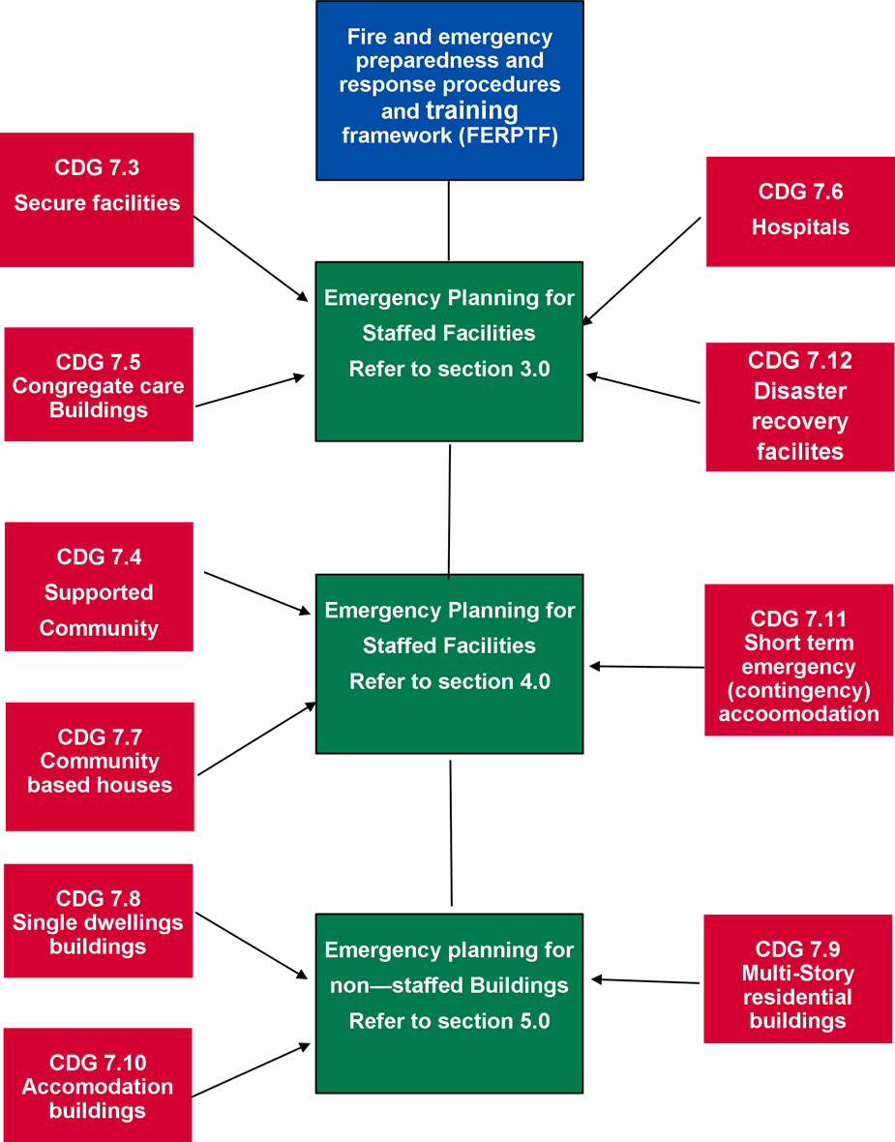

# Emergency planning for staffed facilities

## Applicable capital development guidelines

The requirements detailed in this section shall be applied to the following facilities covered by the Capital Development Guidelines (Guideline) – Series 7:

1. Guideline 7.3 – Secure Facilities
2. Guideline 7.5 – Congregate Care Facilities
3. Guideline 7.6 – Hospitals
4. Guideline 7.12 – Disaster Recovery Facilities.

## Emergency management

### General

All facilities listed in Section 3.1 above shall have an emergency planning committee and, where appropriate, an emergency control organisation (ECO).

Chief executive officers and managers shall ensure:

1. an emergency planning committee is established
2. the emergency planning committee has adequate resources and expertise to carry out the responsibilities as stated in Section 3.2.2 below.
3. Structure of the emergency management.

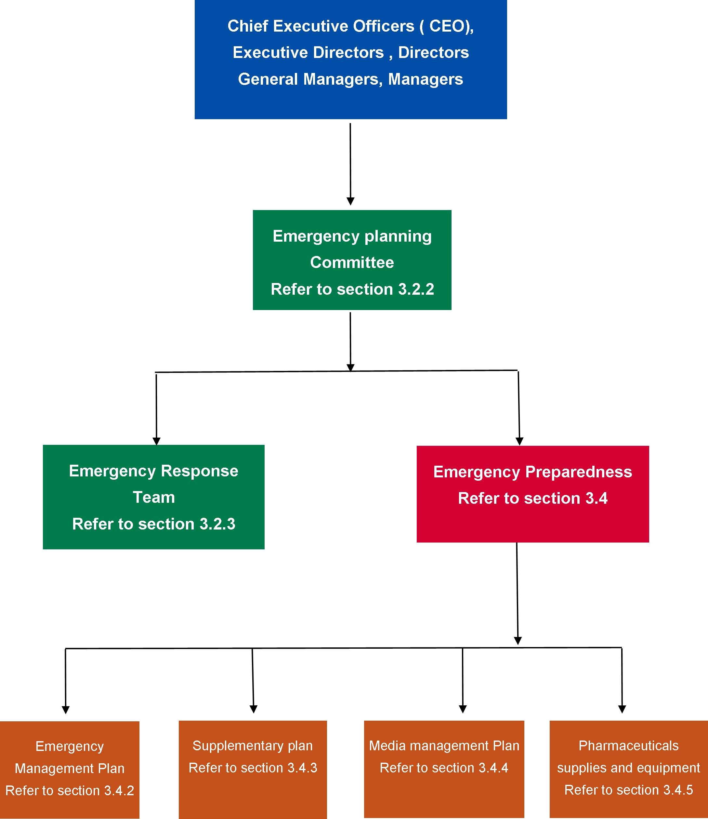

Facility owners, managers, emergency coordinators, occupiers and employers should obtain professional advice on the level of indemnity provided to emergency planning committee members. The emergency planning committee members should be advised of the level of indemnity provided.

### Emergency planning committee

* + - 1. Forming of the emergency planning committee

The emergency planning committee shall be formed for each facility by the emergency coordinator where appointed or person/s responsible for the safety and emergency management of the facility or its occupants and visitors. Depending on the nature of the particular facilities, the emergency planning committee may be formed either for an individual facility, or group of facilities. The emergency planning committee membership shall be appropriate and reflect the level of hazards and risks for the particular facilities based on a risk assessment.

Those responsible for a facility or its occupants shall ensure that the emergency planning committee has adequate resources and expertise to enable the development and implementation of the emergency management plan.

**NOTES:**

* + - * 1. The emergency planning committee should ensure applicable legislative requirements are met; that is, Building Act and Regulations, Occupational Health and Safety Act, maintenance provisions of the Building Regulations, Dangerous Goods (Storage and Handling) Regulations, Country Fire Authority Act or Metropolitan Fire Brigades Act.
        2. Those responsible for a facility or its occupants should ensure that leases include obligations to participate in emergency activities, including fire and emergency preparedness, response and evacuation exercises.
        3. Resources include time, finance, equipment and personnel.
        4. Facility owners, agents, occupiers, lessors, or employers are typically those responsible for a facility and its occupants.
        5. The emergency planning committee should consider the need for appointment of specialist expert advice.

The emergency planning committee, where necessary, in collaboration with facility owners, managers, occupiers, employers and contractors, shall be responsible for the development, implementation and maintenance of the emergency management plan, which includes fire and emergency preparedness, response and evacuation procedures and related training. This may be undertaken in conjunction with relevant external emergency services.

**NOTE:** If the emergency planning committee becomes aware of features of the facility that prevents the safe evacuation of the occupants and visitors and is beyond the emergency planning committee capacity to resolve, the emergency planning committee must immediately notify the most senior manager for the facility.

The emergency planning committee shall consist of not less than two people who shall be representative of the stakeholders in a facility one of which shall be management and include the emergency coordinator where appointed. Other members of the committee should comprise of emergency officers and specialist facility personnel, such as the maintenance engineer. There would also be value having a facility staff member who is also a Country Fire Authority or Victoria State Emergency Service volunteer.

At least one member of the emergency planning committee shall be a competent person who has acquired through training, education, qualification, experience, or a combination of these, the knowledge and skill enabling them to correctly perform the required task.

A competent person is a person who has acquired through training, education, qualification, experience, or a combination of these, the knowledge and skill enabling them to correctly perform the required task.

Evidence of a competent person can be demonstrated by proving participation in a recognised industry accreditation schemes that have been established to independently assess competence and industry experience in fire and emergency management or relevant post graduate qualifications in fire, risk and emergency management and/or fire engineering.

**NOTES:**

* + - * 1. External contractors, consultants or others engaged by the facility to provide specialist advice should not be members of the emergency planning committee, but may attend emergency planning committee meetings.
      1. Responsibilities

The duties of the emergency planning committee shall include but not be limited to the following:

1. ensure a risk assessment has been completed to identifying events that could reasonably produce emergency situations and the minimum mitigation and treatment strategies, programs and procedures to achievable a level of acceptable risk
2. develop an emergency management plan in accordance with Section 3.4.2, which must include prevention, preparedness, response (including evacuation) and recovery
3. ensure that resources and expertise are provided to enable the development and implementation of the emergency management plan

**NOTE:** Resources include time, finance, equipment and personnel.

1. nominate the validity period for the emergency management plan, including the evacuation diagram

**NOTE:** The validity period should not exceed five years but may be less than five yearly, depending on the requirements of a maintenance cycle, a major change to the facility or an accreditation regime.

1. ensure that the emergency management plan is readily identifiable and available to the appropriate persons
2. establish an emergency response team to operate in accordance with the emergency management plan
3. if deemed necessary, establish a specialist emergency response team
4. authorise, or having authorised, release and implement the emergency management plan. The following shall apply to the implementation process:
5. based on a risk assessment as detailed above:
6. awareness of the emergency management procedures – information about the procedures shall be disseminated to all staff and where required occupants
7. training – a formalised training schedule shall be developed to ensure that training is provided to emergency response team members and facility staff and where appropriate occupants. The training program shall be based on the fire and emergency prevention, preparedness and response procedures and be in accordance with Section 3.8
8. testing the emergency procedures – the emergency planning committee should ensure that the emergency procedures are tested in accordance with Section 3.5
9. review of procedures – the effect of the procedures on an organisation should be monitored at all stages of the implementation process. Amendments shall be made to rectify any deficiencies or inaccuracies that are identified in the procedures
10. establishing arrangements and procedures to ensure the continuing operation of the emergency response team.

**NOTE:** For example, resignation, holidays, training of deputies and so on.

1. ensure that the register of emergency response team members is current and readily available
2. establish strategies to ensure visitors and contractors are made aware of fire and emergency preparedness and response procedures
3. ensure that the fire and emergency prevention, preparedness, response and recovery procedures remain viable and effective by reviewing, and testing the emergency management plan and procedures at least annually
4. ensure that the emergency management plan is reviewed at the end of the validity period, after an emergency, an exercise, or any changes that affect the emergency management plan such as facility extension, alterations
5. ensure that a permanent record of events for each fire and emergency is compiled and retained
6. identify and rectify deficiencies and opportunities for improvement in the emergency management plan and emergency response procedure.
   * + 1. Meetings

The emergency planning committee shall meet at least every six months.

A record of emergency planning committee meetings shall be made and retained at the facility and provided upon request by the department, Worksafe or the relevant fire service.

**NOTE:** This may include minutes of meetings, communication, financial position, reports and specialist advice.

### Emergency response team

* + - 1. Forming of the emergency response team

An emergency response team shall be appointed by the emergency planning committee if deemed appropriate to the facility based on the risk assessment and to direct and control the implementation of the emergency management procedures

The emergency response team shall consist of an emergency coordinator as a minimum. The following positions shall be included if they are deemed necessary by the emergency planning committee and in accordance with the requirements of the department:

1. deputy emergency coordinator
2. communications officer and deputy
3. emergency officers and deputies
4. wardens and deputies.

Other emergency response team positions may be incorporated into the emergency response team, for example, runners, stair wardens, roll call wardens, traffic wardens, section wardens.

An up-to-date register of all emergency response team members shall be kept readily available, with or via the emergency coordinator.

The number of emergency response team members shall be determined in accordance with:

1. the size of the facility, floor or area
2. the number of occupants and visitors
3. the installed occupant warning equipment
4. the fire engineered and life safety features of the facility.

The positions and number of emergency response team members shall be considered by the emergency planning committee.

**NOTES:**

1. Guidance on determining emergency response team numbers is given in Appendix 2.
2. In single tenancies, the emergency response team may consist of one person, who would be the ‘emergency coordinator’.
   * + 1. Authority

During emergencies, instructions given by the emergency response team personnel shall take precedence over the normal management structure. Once the emergency service arrives at the facility, the emergency coordinator or deputy must meet the incident controller at the front of the facility, provide a briefing on the fire or emergency and seek direction for the ongoing role of the emergency response team.

**NOTES:**

1. Nothing in this clause is intended to override or change the legislative responsibility of the facility owners, managers, occupiers and employers in ensuring the safety of all occupants and visitors to the facility.
2. Authority given to the emergency response team to act during an emergency must be acknowledged by the facility managers, and staff as part of the emergency management planning activities
3. The emergency response team should ensure that the appropriate people (such as senior management) have been advised of the authority of the emergency response team during emergencies.
4. This authority is intended to ensure that, during an emergency situation, protection of life takes precedence over asset protection, and business continuity.
   * + 1. Selection criteria for emergency response team members

The selection criteria nominated in Table 3 shall be used to assist the EMC to determine membership for the emergency response team.

1. Selection criteria for emergency response team members

| Emergency response team position | Section criteria for emergency response team members |
| --- | --- |
| Emergency coordinator | The person should:   1. be capable of performing their duties 2. be capable of undertaking a dynamic risk assessment 3. be capable of leading and taking command and control of emergency response team 4. display effective decision-making skills 5. demonstrate the capability to remain calm under pressure 6. be available to undertake their appointed duties 7. be capable of effectively communicating with staff, occupants, visitors and the emergency services 8. be very familiar with the facility 9. be available to undergo relevant and ongoing training. |
| Communication officer | The person should:   1. be capable of performing their duties 2. display effective decision-making skills 3. demonstrate the capability to remain calm under pressure 4. be available on site to undertake their appointed duties 5. be capable of effectively communicating with staff, occupants and visitors 6. be available to undergo relevant and ongoing training. |
| Emergency officers | The person should:   1. be appointed consistent with the level of their day-to-day responsibilities 2. be capable of undertaking a dynamic risk assessment 3. be capable of performing their duties 4. have leadership qualities and the ability to provide command 5. display effective decision-making skills 6. demonstrate the capability to remain calm under pressure 7. be available on site to undertake their appointed duties 8. be capable of effectively communicating with staff, occupants and visitors 9. be capable of deputising for other positions on the emergency response team 10. be available to undergo relevant and ongoing training. |
| Wardens | The person should:   1. be capable of performing their duties 2. have leadership qualities and provide command 3. be available to undertake their appointed duties 4. be capable of communicating with staff, occupants and visitors 5. be capable of deputising for other positions 6. be available to undergo relevant and ongoing training. |
| Deputies | The appointment of deputies shall be considered, to ensure the effective functioning of the emergency response team. Persons appointed as deputies shall have the same capabilities and personal attributes as required for the substantive position. |

* + - 1. Primary roles and duties

The primary role of the emergency response team is to give top priority to the safety of the staff, occupants and visitors of the facility during an emergency response and evacuation. Protection of life shall take precedence over asset protection and business continuity during an emergency.

The emergency response team members shall have clearly documented emergency prevention, preparedness, response and post-emergency recovery duties and responsibilities as listed in Table 4, Table 5 and Table 6 respectively.

1. Actions to be undertaken by the emergency response team members prior to an emergency event

| Emergency response team position | Emergency preparedness |
| --- | --- |
| Emergency coordinator and deputy emergency coordinator | The person should:   1. maintain a current register and contact details of emergency response team members 2. replace emergency response team members when a position becomes vacant 3. conduct regular training and exercises 4. ensure the emergency preparedness and response procedures are kept up to date 5. attend meetings of the emergency planning committee, as appropriate 6. attend training and emergency exercises, as required by the emergency planning committee 7. ensure personal emergency response team identification tabards and helmets are available. |
| Communication officer | The person should:   1. ensure personal proficiency in operation of facility warning and communication equipment if installed 2. maintain records and logbooks and make them available for emergency response 3. ensure that emergency response team members are proficient in use of the facility warning and communication systems and equipment 4. ensure that emergency warning and communication contact details are up to date 5. attend training and emergency exercises, as required by the emergency planning committee. |
| Emergency officers | The person should:   1. confirm sufficient wardens for area of responsibility 2. coordinate the completion of personal emergency evacuation plan documentation 3. report on deficiencies of emergency preparedness and equipment 4. ensure that wardens have communicated the emergency preparedness and response procedures to all occupants within their nominated areas 5. ensure that occupants are aware of the identity of their wardens 6. coordinate safety practices and procedures (for example, turn off oxygen supplies, clear all access and egress paths, ensure clear access to first-attack firefighting equipment and disposal of rubbish) by wardens throughout their area of responsibility 7. practise use of specialised equipment 8. attend training and emergency exercises, as required by the emergency planning committee 9. ensure personal emergency response team identification tabards and helmets are available. |
| Wardens | The person should:   1. ensure that all occupants are aware of the emergency preparedness and response procedures 2. carry out safety practices (for example, turn off oxygen supplies, clear all access and egress paths, ensure clear access to firefighting first-attack equipment and disposal of rubbish) 3. practise use of specialised equipment 4. ensure personal emergency response team identification tabards and helmets are available 5. attend training and emergency exercises, as required by the emergency planning committee. |

1. Actions to be undertaken by the emergency response team members on becoming aware of an emergency

| Emergency response team position | Emergency response |
| --- | --- |
| Emergency coordinator | The person should:   1. respond and take command and control, as appropriate 2. conduct a dynamic risk assessment to ascertain the nature of the emergency and implement appropriate response actions 3. ensure that facility emergency warning and communications system has been activated and the appropriate emergency services have been notified 4. ensure all emergency officers are advised of the situation, as appropriate 5. if necessary, after evaluation of the affected room, compartment or floor, and using all of the information and resources available, based on direction from the emergency service, initiate an action plan in accordance with the emergency preparedness and response procedures and control entry to the affected areas 6. monitor the progress of the evacuation and record all actions taken in an incident log 7. brief the emergency services incident controller upon arrival on type, scope and location of the emergency and the status of the evacuation, any persons unaccounted for and act on all directions given by the incident controller. |
| Deputy emergency coordinator | The deputy emergency coordinator shall assume the responsibilities normally carried out by the emergency coordinator if the emergency coordinator is unavailable, and otherwise assist as required. |
| Communication officer | The person should:   1. obtain a briefing from the emergency coordinator or deputy to ascertain the nature and location of the emergency 2. confirm that the emergency warning and communication system has been activated and the appropriate emergency service has been notified 3. notify appropriate emergency response team members 4. transmit instructions and information 5. record a log of all events that occurred during the emergency 6. act as directed by the emergency coordinator or deputy. |
| Emergency officers | The person should:   1. implement the emergency preparedness and response procedures for their floor or area 2. ensure that the emergency coordinator and appropriate emergency service have been notified 3. direct wardens to check the floor or area for any abnormal situation 4. commence evacuation if the circumstances on their floor or area warrant this, or on the emergency coordinator’s command 5. communicate with the emergency coordinator by whatever means available and act on instructions 6. advise the emergency coordinator as soon as possible of the circumstances and action taken 7. co-opt persons as required to assist a warden during an emergency 8. confirm that the activities of wardens have been completed and report this to the emergency coordinator or deputy |
| Wardens | The person should:   1. carry out activities as set out in the emergency preparedness and response procedures and as directed by the emergency officers 2. operate the warning and communication systems in place 3. in the case of a fire, close the impacted room or fire compartment once everyone has been evacuated to restrict its spread 4. check that any fire doors and smoke doors are properly closed 5. close or open other doors in accordance with the emergency response procedures 6. search the floor or area to ensure all people have evacuated and immediately advise the floor warden this function is of greater importance than a later physical count of those evacuated 7. ensure orderly flow of people into protected or safe areas (for example, stairways) and if possible to an outside assembly area 8. assist occupants with disabilities 9. act as leader of groups moving to nominated assembly areas 10. report status of required activities to the floor or area warden on their completion. |

1. Actions to be undertaken by the emergency response team members after an emergency

| Emergency response team position | Post-emergency |
| --- | --- |
| Emergency coordinator | The person should:   1. when the emergency incident is rendered safe by the emergency service incident controller or if they did not respond, the emergency coordinator, notify all emergency response team members to have occupants return to their normal location, as appropriate 2. organise a debrief with emergency response team members and, where appropriate, with any attending emergency service 3. compile a post-incident report for the emergency planning committee and management. |
| Communication officer | The person should collate records of events during the emergency for the debrief and ensure they are secured for future reference. |
| Emergency officers and wardens | The persons should:   1. compile a report of the actions taken during the emergency for the debrief 2. clean and service used specialised equipment 3. replace specialised equipment as necessary. |
| NOTE | The re-entry and post emergency actions should be done in collaboration with the facility owners, managers, occupiers and employers. |

3.2.3.5 Identification

Emergency response team members shall be identifiable by the use of coloured tabards and elements listed in Table 7 during all emergency situations.

1. Emergency response team identification

| Emergency response team position | Coloured apparel to be worn in an emergency | AS 2700 colour code | Colour settings for printing |
| --- | --- | --- | --- |
| Emergency coordinator | A white helmet or hat labelled ‘Emergency coordinator’ or a reflective white tabard labelled (in black lettering) ‘Emergency coordinator’. | N14 | RGB – 255,255,255  CMYK – 0,0,0,0 |
| Deputy emergency coordinator | A white helmet or hat labelled ‘Deputy emergency coordinator’, or a reflective tabard labelled (in black lettering) ‘Deputy emergency coordinator’. | N14 | RGB – 255,255,255  CMYK – 0,0,0,0 |
| Communication officer | Badge with name and position and identification as ‘Communication officer’. | N14 | RGB – 255,255,255  CMYK – 0,0,0,0 |
| Emergency officers | A yellow helmet or hat labelled ‘Floor, zone or emergency officer’ and floor, zone or area of appointment, or a reflective tabard labelled (in black lettering) ‘Floor, zone or emergency officer’ and floor, zone or area of appointment. | Y26 | RGB – 255,215,0  CMYK – 0,16,100,0 |
| Wardens | A red helmet or hat labelled ‘Warden’ and floor, zone or area of appointment or a reflective white tabard labelled (in black lettering) ‘Warden’ and floor, zone or area of appointment. | R13 | RGB – 277,66,52  CMYK – 0,71,77,11 |
| Fire response officer or team | A red helmet or hat, labelled ‘Fire response officer’ or position of appointment or a reflective white tabard labelled (in black lettering) ‘Fire response officer’ or position of appointment. | R13 | RGB – 277,66,52  CMYK – 0,71,77,11 |
| First aid officers (where applicable) | Follow emergency management requirement using white cross on a green background. | G21 | RGB – 14,171,114  CMYK – 62,0,22,33 |

## Emergency colour codes

### General

The facility must use the standard notification, identification and activation systems detailed in Table 8 for all emergencies and appropriate to the facility’s size and function, available technology and communications systems.

### Specific emergency

Where a colour code is used for a specific emergency, the colour codes listed in Table 8 shall be applied.

1. Emergency colour codes

| Emergency | Colour | AS 2700  colour code | Colour settings for printing |
| --- | --- | --- | --- |
| Fire/smoke | Red | R13 | RGB – 277,66,52  CMYK – 0,71,77,11 |
| Medical emergency | Blue | B22 | RGB – 0,47,167  CMYK – 98,84,0,0 |
| Bomb threat | Purple | P12 | RGB – 128,0,128  CMYK – 66,87,0,0 |
| Infrastructure and other internal emergency | Yellow | Y26 | RGB – 255,215,0  CMYK – 0,16,100,0 |
| Personal threat | Black | N61 | RGB – 0,0,0  CMYK – 0,0,0,100 |
| External emergency | Brown | X54 | RGB – 150,75,0  CMYK – 0,50,100,41 |
| Evacuation | Orange | X13 | RGB – 255,127,0  CMYK – 0,50,100,0 |

Colour codes for emergencies in a facility, other than those listed, must not be used as they may lead to confusion.

A colour-coded ready reference flip chart or booklet that reflects the above emergencies and colour codes must be conveniently located proximal to all staff (for example, telephones and work stations). They must also include the Australian Bomb Data Centre form and the offender description form.

**NOTES:** These forms are set out in Appendix 4 and Appendix 5 respectively and may be reproduced.

Facilities must utilise the above colour codes when producing printed matter pertaining to emergency management planning.

Facilities should utilise all forms available to them to communication and disseminate this information.

## Emergency preparedness

### General

The facility shall have preparedness plans to respond to emergencies. The emergency planning committee of the facility shall oversee emergency prevention, preparedness, response, and recovery, relevant to its size and function, as shown in Figure 3.

1. Structure of the emergency preparedness

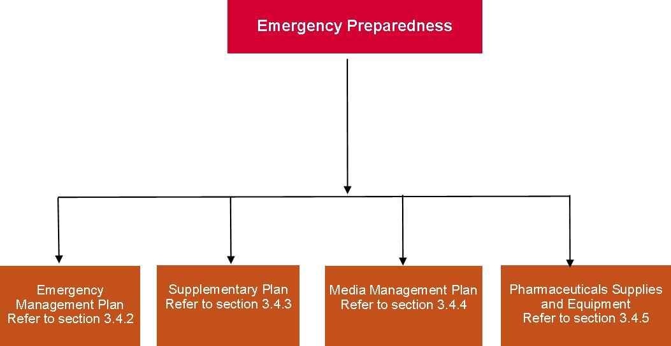

Consideration should be given to the following phases:

1. **Alert:** emergency possible – increase level of preparedness.
2. **Standby:** emergency imminent – prepare for implementation of response.
3. **Response:** emergency situation exists – implement response according to facility plans and in collaboration with other facilities as necessary.
4. **Stand down:** emergency abated – return to usual business.

Consideration should be given to the environmental consequences of any incident, plan or action pertaining to this standard.

### Emergency management plan

An emergency management plan must be developed and maintained for each facility and/or group of facilities by the emergency planning committee (including a competent person). The facility shall ensure that, for consistency, all emergency management plans are developed and registered in conjunction with other relevant agencies and the emergency services, for example, Department of Health and Human Services, police, fire and ambulance services, disaster management units and local governments.

The structure of the emergency management plan must be based on the facility risk assessment and Figure 4 containing, but not be limited to, the following elements:

* + 1. a clear statement of authority, purpose and scope
    2. information on the structure and purpose of the emergency planning committee
    3. identification of the facilities to which it applies
    4. identification of all hazards and risks, and their locations
    5. description of prevention and mitigation measures in place to treat the risk
    6. descriptions of the fire and emergency management measures and systems, of the facility
    7. separate sections for the following:

the emergency preparedness and response procedures, in accordance with Section 3.6

the evacuation diagram, in accordance with Section 3.4.6

training and exercising arrangements, in accordance with Section 3.8

* + 1. a statement of the extent of distribution of the emergency management plan or excerpts from the emergency management plan
    2. a record of distribution, including where personal emergency evacuation plans (personal emergency evacuation plans) for people with disabilities are held (for example, personal emergency evacuation plans should be held by the relevant warden)
    3. details of the hours of occupancy of the facility
    4. the emergency planning committee nominated validity period for the emergency management plan
    5. the date of issue or amendment date on each page of the emergency management plan

If an electronic format is used for the emergency management plan, at least one printed copy shall be available on site.

1. Structure of the emergency management plan

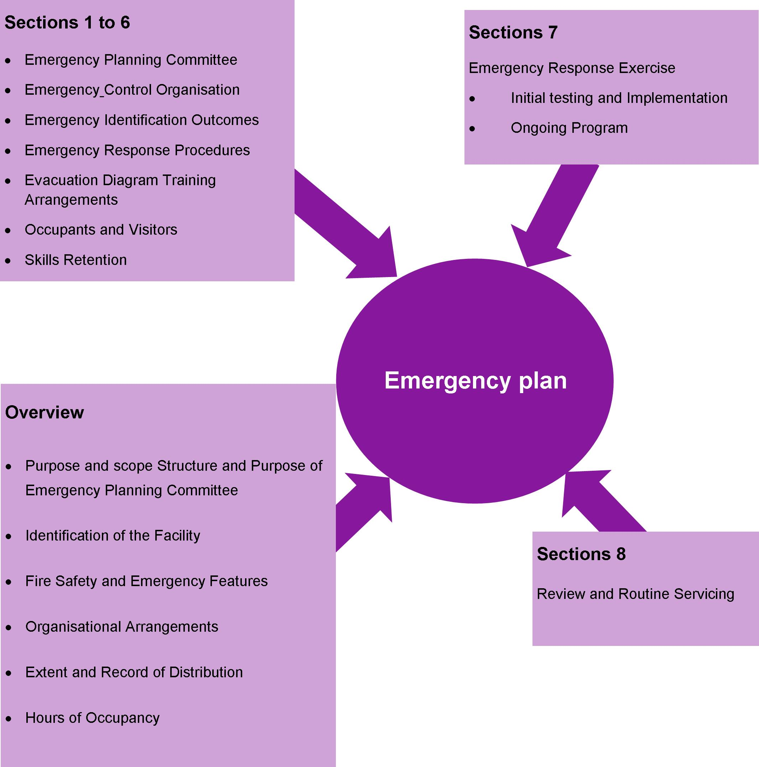

### Risk assessment

The facility risk assessment shall be based on National Emergency Risk Assessment Guidelines because it provides a contextualised, emergency-related risk assessment method consistent with the Australian Standards AS/NZS ISO 31000:2009 Risk management – principles and guidelines. The risk assessment must be undertaken for each facility by a competent person in fire, risk and emergency management. The outcomes of the risk assessment will depend on the facility’s function, location and environment and will identify hazards and risks that warrant specific mitigation and planning within the facility’s emergency management plan.

Examples of hazards and risks that may require the development of supplementary plans are:

* + 1. severe weather (for example, cyclones, storms, extremes in temperature)
    2. bushfires and grass fires
    3. floods
    4. hazardous materials
    5. transport incidents
    6. industrial incidents
    7. pandemics
    8. storage, handling or transport of chemical, biological and radiological substances
    9. earthquakes
    10. storm surges
    11. tsunamis (depending on the facility location from the ocean).

### Media management plan

A media management plan shall be developed to support emergency management plans. The media management plan should deal with:

* + 1. contact with the media during the emergency
    2. preparing and releasing media statements by authorised persons
    3. providing a media briefing area.

### Pharmaceuticals, supplies and equipment

Each facility shall:

* + 1. have appropriate pharmaceuticals, supplies and equipment for the various emergencies to ensure a rapid and effective response
    2. ensure that pharmaceuticals, supplies and equipment are located at suitable places within the facility to ensure a rapid effective response
    3. ensure that there is an appropriate means of storing and transporting the pharmaceuticals, supplies and equipment to the site of the emergency
    4. have protocols for the cleaning, restocking and maintenance of all pharmaceuticals, supplies and equipment.

### Facility evacuation diagrams

* + - 1. Arrangement criteria

Evacuation diagrams shall be provided and arranged in accordance with the criteria listed in Table 9, Section 3.4.6.2, and Section 3.4.6.3.

1. Arrangement

| Arrangement criteria | Requirements |
| --- | --- |
| Number and location | Evacuation diagrams shall be displayed in locations where occupants and visitors are able to view the diagrams. The location within the facility and number of evacuation diagrams shall be determined by the emergency planning committee. |
| Position | The evacuation diagram shall be positioned at a height consistent with the requirements of Australian Standard AS3745 |
| Orientation | Individual evacuation diagrams shall have the correct orientation with regard to the direction of egress and its location to the ‘YOU ARE HERE’ point. Where an assembly area diagram is included, the assembly diagram area shall have the same orientation to the rest of the diagram. |

* + - 1. Minimum elements

The following shall be included in each evacuation diagram:

1. a pictorial representation of the floor or area

**NOTES:**

1. Excludes external elements such as fences, roads, landscaping, external facilities, and so on, unless part of the exit pathway.
2. For facilities with larger floor areas, the pictorial representation should be prepared in sections or areas so that no more than two (2) exits are shown on each pictorial representation.
3. the title ‘EVACUATION DIAGRAM’
4. the ‘YOU ARE HERE’ location
5. the designated exits in the facility, which shall be green
6. the following communications equipment, where installed:

warden intercommunication points (warden intercommunication points), if provided, which shall be red

manual call points (manual call points), if provided, which shall be red and emergency call points (emergency call points), which shall be coloured white, or have a black border

main controls/panels for the occupant warning equipment

1. hose reels, which shall be red
2. hydrants, which shall be red
3. extinguishers, which shall be red with an additional appropriate colour as specified in AS/NZS 18411
4. fire blankets, which shall be coloured red
5. fire indicator panel (fire indicator panel)
6. refuges, if present
7. validity date
8. location of assembly areas, either stated in words or pictorially represented
9. a legend, which shall reflect the symbols used.

The minimum size of the evacuation diagram with only minimum elements shall be A4 (that is, 210 mm × 297 mm) with a pictorial representation of the floor or area, which shall be as a minimum:

* + 1. 200 mm × 150 mm

or

* + 1. an area of 30,000 mm².
       1. Optional elements

The following additional information should be considered by the emergency planning committee for inclusion on the evacuation diagram:

1. direction of opening of doors on designated exits
2. north, south east and west
3. first aid stations and kits (denoted by a white cross on a green background)
4. hazardous chemical store
5. spill response kits
6. emergency information as documented in the emergency management plan

**NOTE:** For example, emergency telephone numbers, emergency preparedness and response procedures, fire orders, and procedures for use of lifts in an evacuation during a fire emergency (where regulatory approval has been obtained).

1. paths of travel, coloured green
2. specialised evacuation devices, including stairwell evacuation devices, if provided
3. fire and smoke doors
4. hydrants, which shall be in red.

The minimum size of the evacuation diagram with minimum optional elements shall be A3 (that is, 297 mm × 420 mm) with a pictorial representation of the floor or area, which shall be as a minimum:

1. 300 mm × 200 mm

or

1. an area of 60,000 mm².

### Evacuation route and assembly areas

The evacuation route from the facility to the assembly area must:

* + 1. be easy to follow and take you to the assembly area preferable via two separate routes
    2. be free of obstructions and other hazards; that is, doors and gates easily opened (preferably in direction of travel away from the facility)

There shall be two (2) assembly areas for each facility, a primary and secondary assembly area. When determining the location of both areas, consider the following:

* + 1. Distance of travel to the assembly area: it must not be too far away and be easy to access.
    2. Try not to cross roads or streets, especially those that are busy. The emergency services will arrive at the facility using the street, and therefore could become hazardous to cross.
    3. The assembly area needs to be safe and secure. In the event of a fire, it must be a safe distance and up wind so that toxic smoke or debris from a fire will not cause harm, and be secure so that no one wanders off on their own.

**NOTE:** Up wind may involve moving away from the designated assembly area. If this occurs, it will be important to advise the emergency coordinator immediately.

* + 1. Shelter from adverse weather conditions if possible.

### Distribution of the emergency management plans

The plans developed in Sections 3.4.2 and 3.4.4 shall be distributed to members of the emergency planning committee. As a minimum, distribution of sections within the emergency management plan shall comply with the following:

* + 1. Sufficient information from the emergency preparedness and response procedures shall be distributed to members of the emergency response team to enable them to carry out their required duties.
    2. Sufficient information from the emergency preparedness and response procedures shall be distributed to facility staff and occupants if required to explain the actions they are to take during an emergency.
    3. The information shall be in a basic, easy-to-read format and distributed in accordance with emergency planning committee instructions. The emergency planning committee shall determine whether any additional distribution is needed.

## Emergency response training and exercises

### General

A program of site-specific emergency response training and exercises informed by the risk assessment shall be developed in collaboration with the facility owners, managers, staff, occupiers and employers of each facility to determine the effectiveness of the emergency management procedures, emergency response team actions and staff and occupants’ response, both when first developed and on an ongoing basis. These will be developed and conducted either by a competent person or under the supervision of a competent person.

There will be a requirement to first undertake training on the emergency prevention, preparedness and response parts of the plan, which should including some initial testing of fire and emergency safety systems and procedures to ensure all facility owners, managers, staff, occupiers and employers are familiar with the plan prior to implementation of the emergency preparedness and response exercises. This should include a full-scale evacuation in accordance with Section 5. The ongoing program of emergency training and preparedness / response exercises shall be in accordance with Section 5.

The following should apply for all emergency preparedness and response exercises (see Note 1):

* + 1. Emergency preparedness and response exercises should be consistent with the identified emergencies in the emergency management plan.
    2. Simple objectives and outcomes for emergency preparedness and response exercises should be identified (see Notes 2 and 3).
    3. Observers should be appointed for all emergency preparedness and response exercises. The observers shall use a checklist to record the details of the emergency preparedness and response exercise (see Notes 4 and 5).
    4. Each emergency preparedness and response exercise should be prefixed by an announcement that it is an exercise only.
    5. Debriefing sessions should be held in accordance with Section 2.
    6. A post-exercise report shall be forwarded to the emergency planning committee following each emergency preparedness and response exercise. The report shall include any deficiencies during the exercise and information regarding how long the evacuation to the designated assembly areas and other matters identified at the debriefing session.

**NOTES:**

1. Emergency preparedness and response exercise should be conducted during the operating hours of the facility to appropriately test the emergency response team, emergency preparedness and response procedures and responses of the staff, occupants and visitors.
2. An example of objectives for an emergency preparedness and response exercise is to gauge emergency response team response and to identify and correct any deficiencies in communication systems, training, emergency preparedness and response procedures, or their implementation.
3. The outcomes for emergency preparedness response exercise should include the following, as appropriate to the emergency preparedness and response procedures:
   * + 1. Emergency response team initiates the emergency procedure without waiting for instructions.
       2. Emergency response team responds to alarms.
       3. Emergency response team searches their allocated area without delay.
       4. Emergency response team reports the location of any occupants and visitors with a disability.
       5. Simulated calls made to the emergency service, as appropriate.
       6. Effective emergency response team communication.
       7. The designated location for controlling the emergency is staffed immediately by the emergency coordinator.
       8. The evacuation sequence is carried out in accordance with the procedures.
4. An observer’s role is to observe and note the action taken by emergency response team members and occupants during the evacuation exercise
5. An example of an observer’s checklist is provided in Appendix 6.

### Initial testing and implementation

Once the emergency planning committee has established that the emergency preparedness and response procedures are satisfactory and workable and the emergency response team has been trained, the emergency preparedness and response procedures should be tested within the first 12 months. The first emergency preparedness and response exercise should include an evacuation exercise (see Note 1).

When the emergency response team and procedures have been proven to be satisfactory, a first large-scale evacuation involving the emergency services (if possible) should be held.

The emergency response team, in collaboration with the facility owners, managers, staff, occupiers and employers, should arrange for occupants to be notified before the evacuation exercise takes place. Adequate planning time, including the proposed date, shall be given.

All occupants and emergency response team shall have participated in an evacuation exercise in the first 12 months of the implementation of the emergency preparedness and response procedures.

**NOTES:**

1. If the facility is large or a multi-storey facility, a partial evacuation may be undertaken to test the emergency preparedness and response procedures and the emergency response team in the first instance.
2. Notification may be carried out by various members of the emergency response team facility owners, managers, staff, occupiers and employers, thus enabling the occupants to identify their wardens and become aware of their responsibilities.
3. Realistic performance targets may be considered as a measure of the procedures’ effectiveness.
4. The emergency response team should be briefed to give extra assistance to staff during the initial evacuations.
5. It should be accepted by management that the emergency preparedness and response procedures be properly tested, and that all emergency response team members have sufficient training to ensure their effectiveness in an emergency situation. In less complex facilities this may only be a matter of sounding the alarm, having people walk to the assembly area and accounting for people. With the experience gained from the first evacuation, subsequent evacuation exercises will become more realistic.

### Ongoing program

Following the implementation phase, a program of site-specific emergency preparedness and response exercises shall be developed for each facility. A program of evacuation exercises shall be included.

The size and configuration of the facility, together with the type of occupancy, will determine the type and time interval between emergency preparedness and response exercises. These may be conducted either as partial emergency preparedness and response exercises or a total exercise covering the entire facility. All areas of a facility shall participate in at least one emergency preparedness and response exercise in each 12-month period.

All occupants of the floors or areas involved in the emergency preparedness and response exercise shall take part, unless the emergency planning committee grants a written exemption prior to conducting the emergency response exercise.

**NOTES:**

1. The aim of emergency preparedness and response exercises is to have all occupants participate in at least one exercise per year consistent with the nature of the facility and its identified emergencies.
2. For training purposes, exemptions may be treated by the emergency response team as refusals for the emergency preparedness and response exercise.
3. Where exemptions are given, the emergency response team should report the exempted occupants to the emergency coordinator.

### Emergency response team briefing

When planning any emergency preparedness and response exercise, consideration shall be given to briefing the emergency response team. The briefing may address, but not be limited to the following:

* + 1. the location of the planned scenario
    2. the identity of the participating emergency officers and wardens
    3. the type of alarms and alarm system (if installed) to be used
    4. actions that the emergency response team is to take in response to the alarm signals
    5. the method of reporting the emergency for the exercise
    6. the evacuation routes to be taken
    7. the location of assembly or designated alternative areas that provide safe refuge – internally or externally
    8. occupants who have approved exemptions prior to the exercise
    9. for the purpose of the exercise, notification of any current or simulated temporary hazards within the facility and known systems failure relating to systems and equipment
    10. what is required at the completion of the exercise.

**NOTE**: There is also value not advising the emergency response team what the scenario will be until the commencement of the exercise to create an environment of uncertainty and pressure.

### Observer’s checklist

An observer’s checklist shall be prepared for the specific facility where the evacuation exercises take place.

**NOTES:**

1. The checklist should be completed for each evacuation exercise and should provide the basis for discussion at the debriefing.
2. An example of a checklist is given in Appendix 6.

### Emergency preparedness and response exercise debriefing session

Immediately after an emergency and preparedness and response exercise, the emergency response team and other key participants shall attend a debriefing session facilitated by the emergency coordinator.

Where an evacuation exercise is conducted, the observer’s checklist shall be analysed during debriefing sessions, and any deficiencies shall be reported to the emergency planning committee.

The emergency planning committee shall arrange the amendment of the procedures, where necessary, and disseminate the information to all emergency response team members.

### An emergency during an emergency preparedness and response exercise

A predetermined word or phrase, for example, ‘NO DUFF’, shall be disseminated to all emergency response team members, for use when an actual emergency incident takes place during an exercise. The word or phrase shall signify that the emergency preparedness and response exercise has been terminated and that the emergency response team are to stand by for further instruction.

**NOTE:** The word or phrase may be repeated in groups of three to overcome background noise and other distractions.

## Responding to specific emergencies

### General

This section outlines emergency responses to specific emergency codes as shown in Figure 5.

1. Specific emergencies

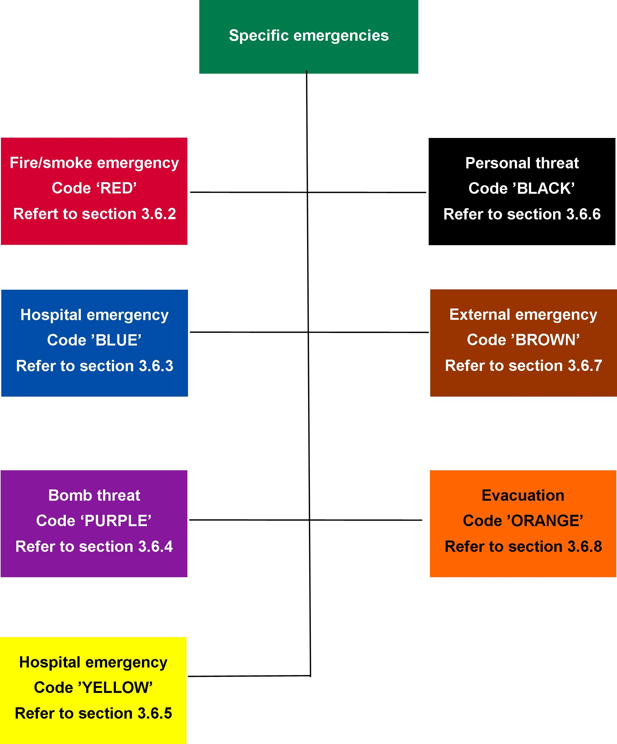

Emergency procedures flip charts, as detailed in Section 3.6.2 to Section 3.6.8, shall be prepared as part of the fire and emergency management plan and its procedures and, where appropriate, evacuation procedures. An abbreviated format which may be incorporated into security identification badges and/or onto stickers attached to telephones may also be prepared.

### For fire/smoke (response colour code ‘RED’)

* + - 1. General

A staff member who discovers an emergency, in this scenario a fire, or who is alerted to a fire, shall carry out the following:

* + 1. activate the internal warning and communications system, if provided
    2. ensure the immediate safety of anyone within the vicinity of the fire/smoke
    3. take measures to ensure that fire brigade is notified

**NOTE:** The fire service should be informed of all incidents of fire or suspicion of fire (for example, smell of smoke).

* + 1. attempt to extinguish the fire is safe to so using a single fire extinguisher, and if not, close the room door to reduce fire and smoke spread
    2. take measures to ensure that the emergency coordinator, area emergency officer or any emergency response team members are notified.
       1. Action plan

It is vital that staff realise that their own safety and that of others, must be their primary concern.

This is best achieved by evacuation of the facility first, before any attempt is made to extinguish the fire – unless the fire is minor and can be easily extinguished using a single fire extinguisher suitable for the type of fire. Where there is a smouldering small fire or a fire on the stove, actions such as turning off the power/heat may stop the fire spread or create extra time to evacuate and reduce the risk of the fire becoming larger; however, these actions should not be taken if there is any risk to life or injury.

The fire safety principle of the Department of Health and Human Services regards life safety of people with a disability and its staff as the highest priority. To achieve this principle, the evacuation of all occupants must be the priority over the extinguishment of the fire unless extinguishing the fire is the most expedient approach to life safety; that is, persons are unable to move the patient due to being on life support, during an operation and so on.

The installed sprinkler system is designed to stop the spread of fire throughout the facility and may suppress the fire depending on fuel loads and type.

When practising emergency evacuation procedures, staff should take into consideration the mobility capabilities of people in the facility, along with any medications which may impair their ability to evacuate.

Consider bedrooms close to exit doors of the facility for people who are totally dependent on assistance during evacuation.

The order in which people should be evacuated is as follows:

1. mobile and capable to evacuate themselves — first group evacuated
2. people that can be evacuated with little assistance – second group evacuated
3. people that are totally dependent on assistance – third group evacuated.

The reason for this order of evacuation is to remove the maximum number of people from the area as quickly as possible. If evacuation is the primary response, then all available resources must be committed to this response.

Remember: the safety of staff and others depends on a swift and orderly evacuation of the facility in an emergency.

The following actions should be considered in the action plan during an emergency:

* + 1. Attempt to isolate the affected room or area to reduce the spread of fire or smoke to other areas
    2. Evacuate all persons from immediate danger to a safer location. Moving people out of a room or fire compartment and closing the door should be the initial response.
    3. Consideration of the number of staff likely to be on duty at different times.
    4. Ensure all rooms and areas have been checked for people. Make sure the room is closed and mark the door to indicate it has been checked.
    5. Identify the location of the telephone, and whether 000 can be programmed into it for a ‘quick’ dial.
    6. Call the emergency services on 000 to inform them of the emergency and advise if there is immediate threat to life (for example, if persons are trapped). This will allow the fire brigade to ensure they provide the appropriate emergency response.
    7. Ensure that the emergency exit from each room of the area is clear. Consider the distance to outside doors and possibility of escape through windows.
    8. Consider security devices on doors and windows which will prevent them being used for escape or evacuation.
    9. Keep the route to your assembly area free from obstruction (such as locked gates, rubbish bins and cars).
    10. Establish two evacuation assembly areas. This is important because you may not be able to use one assembly area due to the nature of the emergency or the weather conditions (for example, toxic smoke).
    11. Consider access to your facility and the location of arriving emergency vehicles. Ensure your assembly areas are away from these areas.
    12. Consider the welfare of people with a disability during an emergency evacuation and how this should be managed. This includes medication and medical instructions.
    13. If confronted with smoke, crawl low to the ground to either a fire isolated stairwell or different fire or smoke compartment and eventually to the outside. Close doors quickly when exiting rooms and fire/smoke compartments to prevent smoke travel.

A person’s response in an emergency is often difficult to predict. Their behaviour can change due to a change in routine, fear (evacuation at night, bedtime), effects from medication, heat and smoke, and the confusion of having different people (emergency services) in their area.

The circumstances of the emergency will frighten and confuse most people, and they may need intensive care, support and supervision depending on their age, medical or physical disabilities, dependence on others to evacuate and so on.

The number of staff on duty will vary between each different facility. It is therefore essential that training and exercising is based on credible scenarios informed by the risk assessment and reflects the different staffing and that all staff are clear on their roles and responsibilities.

* + - 1. Procedures for fire

During a fire event, it is vital that all emergency officer’s wardens and staff are able to respond immediately to ensure the safety of everyone.

The use of standard fire orders will achieve a uniform approach in all facilities. The standard fire orders are shown in Figure 6.

In the event of a fire, emergency officer’s wardens and staff should:

1. Assist anyone in immediate danger. At all times consider their own safety before taking any action and consider what hazards may exist in the room.
2. Attempt to extinguish the fire if it is small enough to be extinguished using one fire extinguisher by a trained person.
3. Close the door. This will prevent the spread of smoke and fire. Remember: smoke is the biggest killer in a fire. By preventing smoke spread, staff will gain more time to evacuate the area.
4. Call the fire brigade on 000 and give the following information:
   * + 1. name and position (of person making call)
       2. name of facility, address (with suburb/state)
       3. nearest cross road
       4. description of the occupant and numbers in the facility, including any disabilities
       5. type and size of the fire
       6. indication if anyone is missing or trapped inside.

**NOTE:** If there are other emergency officers, wardens and staff in the facility, they must also be notified by warning and communications systems, and if provided, other preplanned emergency notification systems (for example, pager, phone, manually operated siren and so on).

1. Evacuate to assembly area. There should be two (2) assembly areas in the emergency procedures: a primary area and a secondary area. A secondary area is used when wind direction or other considerations do not allow staff to use the primary area (for example, if there is toxic smoke).
2. Remain at the assembly area and ensure everybody is accounted for. This is vital to ensure that everyone is safely out of the facility, if not, the incident controller must be immediately advised so search and rescue is given the highest priority. No one should be allowed to leave the assembly area until the incident controller advises it is safe to do so.
3. Standard fire orders

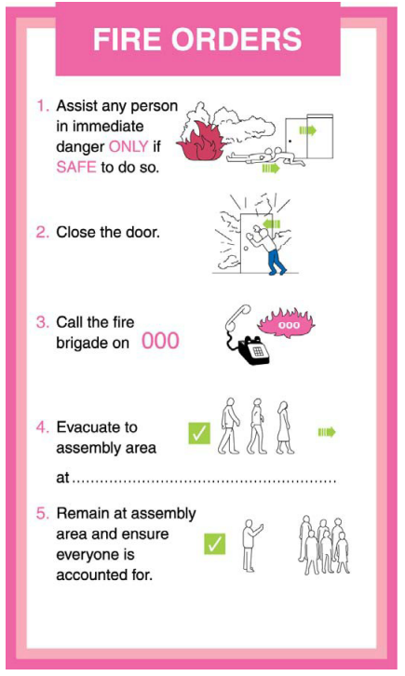

Under NO circumstances is anyone to re-enter the facility once it is evacuated without the permission of the incident controller.

These basic steps must be included in the event of a fire.

Rescue of persons in the fire affected area should only be attempted if it is safe to do so. If a person who is attempting to remove or rescue a person feels they are becoming overwhelmed by smoke or are injured (for example, back injury), they must put their own safety first.

Fire orders should be displayed in a prominent location near the front door of the area and in the office area where applicable.

### For medical emergency (response colour code ‘BLUE’)

* + - 1. General

The facility shall be able to respond effectively to a medical emergency on site, by having:

* + 1. a medical emergency action plan
    2. staff trained in basic life support, and with access to emergency advanced life support (ALS)
    3. appropriate pharmaceuticals and equipment.
       1. Medical emergency action plan

The medical emergency action plan shall include the following:

* + 1. a method of raising an alarm
    2. a method of alerting and notifying appropriate staff
    3. means of obtaining appropriate equipment if it is not at hand
    4. protocols for basic life support involving one person, two persons and a team of people providing the resuscitation
    5. an agreed protocol for deciding when to discontinue basic life support
    6. an agreed protocol for determining continuing care.
       1. Trained staff

Clinical staff shall have training in basic life support and, as appropriate, advanced life support (ALS).

Ongoing training for skills maintenance shall be in place.

**NOTE:** Consideration should also be given to training of staff, in basic life support.

### For bomb threat (response colour code ‘PURPLE’)

* + - 1. General

This clause provides basic guidance on planning and response in case of a bomb threat. The information contained in this clause is not sufficient, in itself, to adequately plan for a bomb threat.

Bomb threat is a serious public risk of modern times. Each bomb threat could be a prank or a credible warning of an impending bomb attack. Usually, they are committed by individuals seeking to create a state of alarm and confusion, but may also be a terrorist intending to cause significant harm or damage. Therefore, it is important that all facilities have considered the potential risk of a bomb threat at the facility and undertake the proper site-specific planning in consultation with Victoria Police.

* + - 1. Bomb threats

Bomb threats may include but are not limited to the following forms:

* + 1. ***Written threat*** – if a bomb threat is received in writing and determined as credible, it should be placed along with any envelope in a container and police called immediately. Every possible effort has to be made to retain all evidence and handle minimally. Such evidence must be protected to be evaluated by police. Evidence that may be available includes fingerprints, handwriting, printed, electronic or typed material, DNA and postmarks.
    2. ***Telephone threat*** – an accurate analysis of the telephone threat can provide valuable information on which to base recommendations, action and subsequent investigation. The person receiving the bomb threat by telephone should not disconnect the call, and as soon as possible, should complete the information required on a bomb threat checklist. The bomb threat checklist should be available to telephonists and other persons who regularly accept incoming telephone calls. It is important to note that any information obtained from the caller will be extremely valuable to assist police in determining their response.

**NOTE:** Appendix 4 provides an example of a typical phone/bomb threat checklist.

* + 1. ***Suspect object*** – a suspect object is any object found in the facility and deemed a possible threat by virtue of its characteristics, location and circumstances. Once a suspect object has been identified and determined credible, it must not be handled. The police should be notified immediately and the area immediately evacuated.
    2. ***Suspect mail*** – all staff responsible for handling mail and incoming goods should be trained in the identification and subsequent safe handling and isolating suspect mail items and incoming goods. Once a suspect mail has been identified and determined credible, it must not be handled. Police should be notified immediately and the room or area evacuated. If the suspect mail contains any suspect powder or liquid, the fire brigade must also be notified.
       1. Suspect objects

1. **Identifying an object as suspect**

Suspect objects may be encountered by any facility. It is not possible to provide a definitive list of indicators that would cause an object to be considered suspect. The following questions provide a means of assessing if an object should be considered suspect:

* + 1. Is the object unidentified?
    2. Is the object unusual or foreign to its environment?
    3. Does the object have an unusual chemical smell?
    4. Is the object obviously a bomb?
    5. Is the object hidden or concealed in any way?
    6. Has there been any unauthorised access to the area?
    7. Has there been a perimeter breach?

This series of questions may be remembered using the mnemonic, ‘HOT-UP’ as shown in Figure 7.

1. ‘HOT-UP’

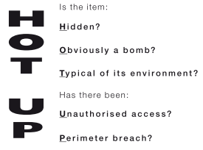

1. **Actions to be taken**

The following actions should be considered when dealing with a suspect object:

* + 1. Once a suspect object has been identified and determined credible, it must not be handled. The room or area must be evacuated.
    2. The emergency coordinator is to be informed.
    3. The emergency coordinator or deputy to complete a dynamic risk assessment and determine if police and fire brigade are to be notified.

**NOTE:** If in doubt, always take the conservative approach and call the police and fire brigade.

* + 1. Respond to the directions of police or fire brigade.

**NOTE:** Care should be exercised, with for example, mobile phones, radio sets, wireless technology transmission and the like, in situations where a suspect object has been identified which could be a bomb to prevent accidental detonation. Such equipment should not be used until clearance is given by the police.

* + - 1. Training

Suspect mail articles have many similarities in common with other ‘suspect objects’, which may be encountered by any facility.

All occupants responsible for handling mail or other objects coming into the facility should be trained in the identification and subsequent handling of suspect mail articles and other objects.

### Emergency response team for infrastructure and other internal emergencies (response colour code ‘YELLOW’)

* + - 1. General

This clause describes an event that impacts the facility and may be caused by an internal or external event which may adversely affect service delivery and/or safety of persons requiring a response.

Examples include but are not limited to failure of, or disruption to, electricity, medical gases, water, information communication and technology systems, damage to structure, or incidents involving hazardous substances.

* + - 1. Electricity

In the event of electrical failure, the emergency management plan must provide immediate response to protect patients that are on life support or other electrically operated medical equipment. This may involve the relocation of patients to an area supplied with electricity from an alternative source.

* + - 1. Medical gases (oxygen, air, other gases and suction)

This failure may involve reticulated systems, and the emergency management plan shall document the location of cylinders and regulators and their main and local isolation values. Alternatively, it is also important to include the relocation of portable medical gases and suction pumps and the quickest method of transporting this equipment to patients in need.

* + - 1. Water

In the event of a water supply failure all efforts should be made to conserve water until an alternative supply can be sourced. The emergency management plan should include provisions for alternative water supplies, notification of the water authority and determining the extent and time lime to restore water supply. In the event of loss of water supply on sever and above bushfire days, vulnerable facilities should consider notifying the fire brigade and discuss deployment of fire appliances to the facility to provide protection.

* + - 1. Information communication and technology

Information communication and technology systems are an essential component of any emergency response, both within the facility and with external agencies. Emergency management planning should include the provision of alternative information communication and technology systems in the event of a failure of the primary systems.

* + - 1. Hazardous substances incidents

The emergency management plan should be consistent with the Dangerous Goods Act and Dangerous Goods (Storage and Handling) Regulations and relevant standards and based on the facility risk assessment. Such incidents include the leakage or spillage of hazardous substances, including flammable and combustible liquids and gases, corrosive, toxic, biological and radioactive substances. Safe work practices shall be implemented to ensure that:

* + 1. All hazardous substances are stored and handled in accordance with Victorian legislation and standards which includes but are not limited to depending on the type and quantities of the hazardous/dangerous substance:

Occupational Health and Safety Act 2004

Occupational Health and Safety Regulations 2007

Dangerous Goods Act 1985

Dangerous Goods (Storage and Handling Regulations) 2012

Relevant standards; that is, AS 1940-2004 – The storage and handling of flammable liquids.

* + 1. If hazardous substances are present , have material safety data sheets at the facility which are easily accessible.
    2. Appropriate staff are trained in the safe storage and handling of hazardous substances.
    3. Excess stocks are not held.
    4. Appropriate training and equipment is developed and exercised and are part of the emergency management plan to manage victims of any hazardous and dangerous material incidents.
    5. Depending on quantities being stored, appropriate equipment for containment is provided, and that methods for such containment are known and understood.

**NOTE**: In the event of dense smoke or hazardous/dangerous airborne pollution, consideration should be given to shutting down air handling systems to prevent intake or circulation of contaminants or flammable gases.

* + - 1. Structural damage

The emergency management plan should consider the following:

* + 1. response arrangements based on a dynamic risk assessment of disruption to physical surroundings. This includes assessment of all potential impacts, and the introduction of associated hazards as a result of those impacts (for example, electrical hazards, gas leaks)
    2. relocation of services
    3. security of the area and so on.

### For personal threat (armed or unarmed persons threatening injury to others or themselves, or illegal occupancy) (response colour code ‘BLACK’)

* + - 1. General

Planning for these types of emergencies must be done in consultation with the police or other specialist advisors approved by the department and should be specific to the facility. The planning should be consistent with the facility’s security standard operating procedure.

Managers/supervisors and emergency coordinators are responsible for coordinating the response to such incidents.

Where police are involved, staff should provide such assistance as may be required and within their physical capabilities.

Managers/supervisors and emergency coordinators can contribute in a practical way to the satisfactory resolution of these emergencies by ensuring police and security guards have been called, withdrawal of their staff where necessary, supervising the locking up of offices, securing records, files, cash and other valuable property while at the same time promoting an air of confidence and calm.

* + - 1. Unarmed confrontation

Unarmed confrontations may arise where there is a threat to others by an unarmed person confronting them in a violent or threatening manner, or where a person threatens to commit suicide. The facility shall have preparedness and response plans to deal with such emergency situations. The proper evaluation and management of the aggressive, agitated, violent or threatening patients/residents/clients can decrease assaults.

The planning process should involve appropriate medical, nursing, administrative and security staff. Staff specialised in mental health are important in such planning, with the aim of minimising the risk of injury to staff, patients and others.

* + - 1. Armed confrontation

Appropriate advice, warning of the danger of exacerbating an armed confrontation, shall be included in emergency management plan produced by the facility. The following warning is suggested: ‘UNDER NO CIRCUMSTANCES SHOULD STAFF, PATIENTS OR VISITORS PLACE THEMSELVES IN FURTHER JEOPARDY’.

The emergency management plans shall direct staff to undertake the following procedures:

* + 1. If possible, immediately notify the police, relevant manager/supervisor and emergency coordinator.
    2. Obey the offender’s instructions, but do only what they are told and nothing more, and do not volunteer any information.
    3. Stay out of danger if not directly involved and to leave the room, area or facility if it is safe to do so, then raise the alarm.
    4. Follow internal notification and escalation procedures if able to do so without danger.
    5. Carefully observe any vehicle used by the offenders, taking particular note of registration numbers, types and colours, number of occupants and their description.
    6. Preserve the crime scene until the police have checked the area for evidence.
    7. If safe to do so, observe the offenders and note the speech, mannerisms, clothing, scars or any other distinguishing features such as tattoos. Record these observations and personal account of events in writing, as quickly as possible after the armed confrontation.

**NOTE:** An example of a typical form to record this information is provided in Appendix 5.

* + 1. Ask all witnesses to remain until the police arrive, and explain to the witnesses that their view of what happened, however fleeting, could provide vital information. Witnesses are not to discuss the incident until statements have been provided to police.
    2. If a witness advises they must leave prior to police arrival, attempts should be made to get their contact details.
    3. Manage all members of the media, and allow only the delegated person for the facility to make statements.
       1. Illegal occupancy

The facility shall, where appropriate, incorporate within their emergency management plans, after consultation with police, responses in the event of an area/department being subjected to illegal occupancy. In accordance with such plans, as soon as it is realised a problem is imminent or occurring, the emergency coordinator or manager/supervisor shall take the following actions:

* + 1. Notify the police and request assistance.
    2. Ensure security and if appropriate, emergency response team members have been alerted.
    3. Initiate action to:

restrict illegal occupants to affected area

restrict facility occupants’ and visitors’ access to affected area

request occupants and visitors of unaffected areas to remain at their location unless otherwise advised

implement specific facility security protocols.

### For an external emergency (response colour code ‘BROWN’)

* + - 1. General

Facilities identified by the Department of Health and Human Services as being responsible for the provision of an emergency response team shall comply with the relevant operational guidelines.

An external emergency is declared when the resources of the facility are required as part of a health response to an emergency that has taken place external to the facility and has been included within the municipal council municipal emergency management plan after consultation and approval form the department and facility chief executive officer.

The response may include: reception of multiple casualties, reception of patients transferred from other facilities, deployment of teams, as directed by the department, Department of Health and Human Services policy, local municipal council or emergency services.

Examples include but are not limited to aircraft crash, train crash, bus crash, structural collapse, explosions, natural disaster and emergency at another facility.

Facilities shall include in the emergency management plans, external emergency responses which the scope and form of which is to be determined in liaison with the department and be consistent with the municipal emergency management plan.

An external emergency shall be declared:

* + 1. on the request of the department or local municipal council or emergency services; for example, when a large number of casualties present at the facility unannounced

or

* + 1. on receipt of information from a credible source.

In these events, the declaration shall be communicated to the department.

On declaration of the external emergency, the emergency coordinator shall activate and implement the facility’s external emergency response plan.

Exact location, type of incident, hazards present, access to site/area, number of casualties, emergency services on scene are required.

* + - 1. External emergency response plan

The external emergency response plan should address the following aspects:

* + 1. external response (if applicable):

provide one or more teams

maintain portable medical equipment and supplies in kit form

install and maintain communication equipment such as multiple phone links

* + 1. internal response (if casualty reception is anticipated):

carry out a plan for clearing the emergency department of non-urgent cases

carry out a plan for rapid discharge of non-urgent cases from hospital beds

carry out special procedures for labeling casualties, and medical record keeping

adopt security measures as follows:

* + - 1. supply information to the police for release to relatives and the media

**NOTE:** Police will normally have the sole authority to release information on fatalities.

* + - 1. restrict the entry of unauthorised persons
      2. provide facilities for relatives of victims
      3. instigate procedures for handling personal effects enabling receipt and protection of patients’ valuables when many casualties arrive simultaneously
    1. prepare for mass casualty reception:

recall and ongoing staff management strategies

emergency department reception area expansion capability

medical equipment resupply system.

All facility staff and emergency response team who may be required to perform duties during a mass casualty situation shall be made fully aware of what is required of them during the various stages of an alert. To assist in this awareness, the emergency response plan should include details of staff duties, to which they report, the area of responsibility, and a clear assembly point or location to which they should report.

### For evacuation (response colour code ‘ORANGE’)

* + - 1. General

Evacuation involves the movement of patients, staff and other personnel within or from the facility in as rapid and safe a manner as possible (see also Section 5.4.8.2 and 5.4.8.3).

* + - 1. Assessing the situation

The situation should be assessed by a senior staff member, present in the area at the time, before the decision to evacuate is made, having regard to the:

* + 1. seriousness and relevance of the threat to human safety
    2. proximity of hazards that may be relevant to the situation
    3. nature and type of patient in the involved area.
       1. Authority to evacuate

The authority to order evacuation of an immediate area shall rest with the emergency coordinator or senior staff member present in that area at the time. The overall facility evacuation should be vested in the emergency response team members who would act on the direction of the emergency coordinator or senior staff member. Advice may be provided by staff such as wardens, medical officers, nursing staff, engineering, department heads, or the senior representative, if present, or from the fire brigade or police.

Designation of specific patients/residents/clients for immediate evacuation should be made by the emergency coordinator after consultation with the nurse-in-charge at the time or medical officer (or both).

* + - 1. Stages in evacuation

Evacuation should be conducted in three distinct stages according to the severity of the emergency, as follows:

* + 1. ***Stage 1*** – removal of people from the immediate danger area; for example, removing people from a room that is on fire, hazardous/dangerous substance spill/leak or is alleged to have a bomb in it.
    2. ***Stage 2*** – removal to a safer area. This may be to an adjoining compartment protected by fire and smoke doors on the same level, or to another, preferably, lower level.
    3. ***Stage 3*** – complete evacuation of a facility. Should the emergency necessitate evacuation of the entire facility, the resources of all available staff will be required to assist in the movement of patients and visitors to a designated assembly area or alternative safe place identified by the emergency coordinator. Ambulant patients and visitors should be evacuated first.

**NOTE:** Once the fire brigade and police arrive, the incident controller must be immediately advised of the evacuation, how many people have been evacuated and how many still need to be evacuated and their state of health and mobility, and the location of the assemble area/s. This will assist the incident controller to determine their incident action plan and priorities.

* + - 1. Egress routes

The presence of fire or smoke (or both) in an emergency may govern the choice of evacuation routes and prohibit the use of nearby exits, in which case the nearest accessible exit should be used. For this purpose, prior staff training and knowledge of the facility layout is of paramount importance, and will play a vital role in controlling any necessary evacuations.

Lifts must not be used in a fire emergency unless authorised by the incident controller. Electric power may fail or be switched off, causing people to be trapped in a lift. The lift shaft could act as a chimney and thus contribute to the spread of fire, heat and smoke to other parts of the facility.

Fire-isolated stairs, fire escapes and other safe routes should be used if safe to do so ..

* + - 1. Other considerations

The special needs of mobility-impaired staff should be assessed to make plans appropriate to their level of incapacity should an evacuation be necessary.

Saving records pertinent to immediate patient care is important, but time should not be spent doing this at the expense of evacuating people.

Equipment used for evacuation, such as wheelchairs, evacuation devices and blankets may be necessary.

Good communication is essential during the evacuation process with rapidly changing staff/‌patient/‌resident/‌client locations, as well as dealing with the emergency that led to evacuation.

A head count shall be conducted both during and after the evacuation is complete. Maintaining a head count during an evacuation will assist with allocating resources depending how many persons need evacuating at a given time. This will also assist the incident controller in development of their incident action plan and allocation of emergency services resources.

* + - 1. Patient/resident/client care following evacuation

Patient/resident/client care will probably require an extraordinary effort by staff and emergency services until such time as the patients/residents/clients can be returned to their ward, found alternative accommodation within the facility or transported to another facility.

### Clearing an emergency code

After consultation with incident controller from the controlling agency, the emergency coordinator shall indicate ‘stand down’ and advise of subsequent action.

For the stand down notification, the relevant colour code shall be followed by the words ‘stand down’ (for example, CODE BLUE, STAND DOWN).

Staff called upon to assist in the emergency, but not involved in recovery operations, shall resume normal duties.

## Debriefing and emergency management plan post-incident review

### Debriefing

* + - 1. Operational debriefing

Operational post-incident debriefing shall be conducted as soon as practicable after every emergency or training exercise. The intention to hold a debriefing should be communicated when clearing the emergency code.

Debriefing has two purposes:

* + 1. to review emergency management plan preparedness and response and identify lessons learned
    2. to identify and initiate any necessary changes to the emergency management plan as part of the continuous improvement process.
       1. Post-incident support

Emergencies may have adverse short- and long-term effects on personnel directly and indirectly involved. Provision for identification and management of adverse effects should be an integral part of emergency management planning.

### Emergency management plan in review

Plans should be reviewed annually and after each exercise or actual emergencies. When such reviews are undertaken, reference to any established performance outcomes (for example, ward evacuation time) will be beneficial.

## Training

### General

All staff are to receive adequate and appropriate training in fire and emergency prevention, preparedness, response and recovery procedures.

### Training program

* + - 1. Residential care staff
      2. All new staff must successfully complete the fire safety induction program as part of their induction training and are required to maintain and review their fire and emergency management skills and knowledge.

The emergency planning committee of the following facilities shall adopt the fire safety training strategy provided in Appendix 1 for all residential care staff:

* + 1. Guideline 7.3 – Secure Services
    2. Guideline 7.5 – Congregate Care Facilities.
       1. Emergency planning committee and emergency response team members

Emergency planning committee members are required to undertake training as part of the role of a manager of a residential facility.

An online emergency planning committee learning program is undertaken by all members. This package includes the following units from the Public Safety Training Package.

**NOTE:** the subjects listed below will be reassessed from time to time as required; refer to practice notes for current subjects and courses:

* PUAWER001B – Identify, prevent and report potential workplace emergency situations
* PUAWER002B – Ensure workplace emergency prevention procedures, systems and processes are implemented
* PUAWER003B – Manage and monitor workplace emergency procedures, equipment and other resources
* PUAWER004B – Respond to workplace emergencies
* PUAWER005B – Operates as part of an emergency control organisation
* PUAWER006B – Lead an emergency control organisation
* PUAWER007B – Manage and emergency control organisation.

# Emergency planning for staffed residential facilities

## Applicable capital development guidelines

The requirements detailed in this section shall be applied to the following facilities covered by the Capital Development Guidelines – Series 7, Fire Risk Management dated August 2013:

* + 1. Guideline 7.4 – Supported Community Based Facilities
    2. Guideline 7.7 – Community Based Facilities
    3. Guideline 7.6 – Short Term Emergency (Contingency) Accommodation.

## Emergency management

### General

All facilities listed in Section 4.0 above shall have an emergency planning committee and, where appropriate, an emergency response team.

Chief executive officers (CEOs) and managers shall:

* + 1. ensure an emergency planning committee is established
    2. ensure the emergency planning committee has adequate resources to carry out the responsibilities as stated in Section 4.2.2 below.

Figure 8 outlines the structure of the emergency management.

1. Structure of the emergency management

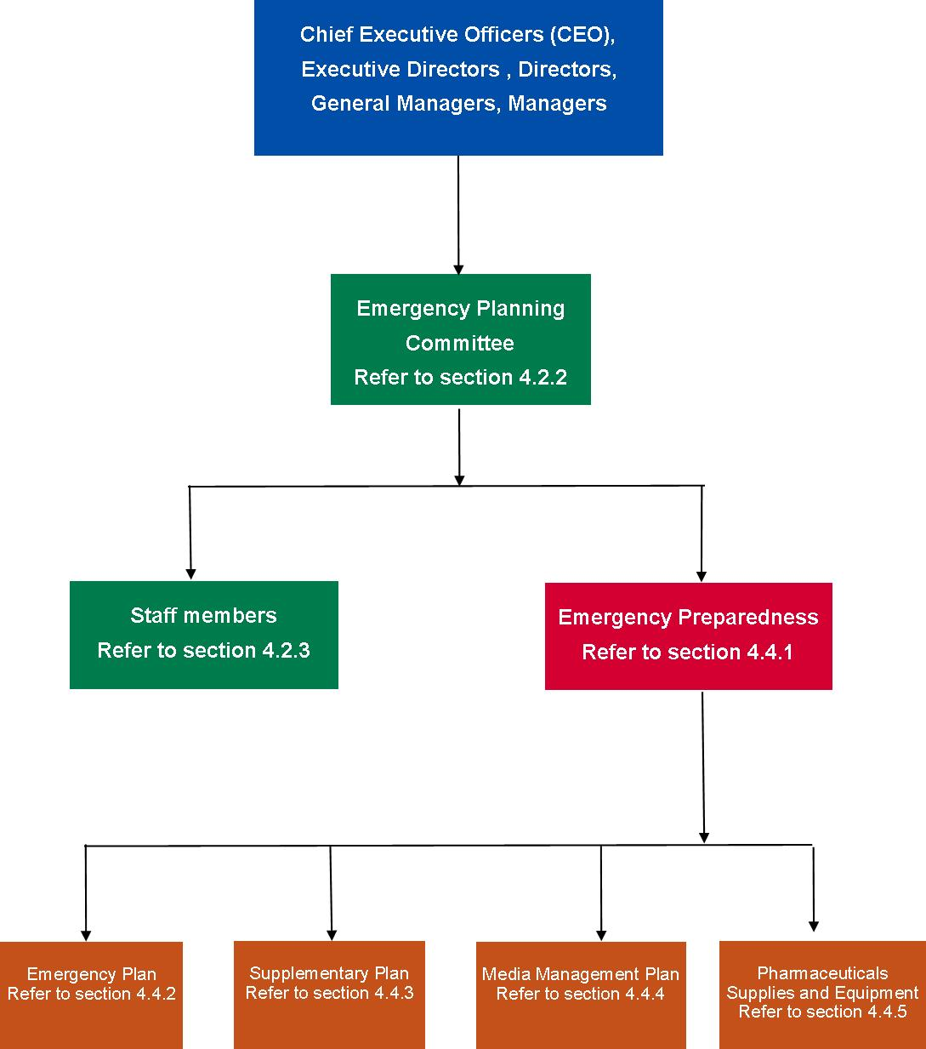

### Emergency planning committee

* + - 1. Forming of the emergency planning committee

The emergency planning committee shall be formed for each facility by the emergency coordinator, where appointed, or persons responsible for the safety and emergency management of the facility or its occupants and visitors. Depending on the nature of the particular facility or facilities, the emergency planning committee may be formed either for an individual facility or group of facilities. The emergency planning committee membership shall be appropriate and reflect the level of hazards and risks for the particular facility or facilities based on a risk assessment.

Those responsible for a facility or its occupants shall ensure that the emergency planning committee has adequate resources and expertise to enable the development and implementation of the emergency management plan.

**NOTES:**

1. The emergency planning committee should ensure applicable legislative requirements are met; that is, Building Act and Regulations, Occupational Health and Safety Act, and the maintenance provisions of the Building Regulations Dangerous Goods (Storage and Handling) Regulations if applicable.
2. Those responsible for a facility or its occupants should ensure that leases include obligations to participate in emergency activities, including fire and emergency preparedness and response and evacuation exercises.
3. Resources include time, finance, equipment and personnel.
4. Facility owners, agents, occupiers, lessors, or employers are typically those responsible for a facility or its occupants.
5. The emergency planning committee should include a competent person to provide specialist expert advice.

The emergency planning committee, where necessary, in collaboration with facility owners, managers, staff, occupiers, employers and contractors, shall be responsible for the development, implementation and maintenance of the emergency management plan. This should include fire and emergency preparedness, response and evacuation procedures and related training. This may be undertaken in conjunction with relevant emergency services.

**NOTE:** If the emergency planning committee becomes aware of features of the facility that prevents the safe evacuation of the occupants and visitors, and is beyond the emergency planning committee’s capacity to resolve, the emergency planning committee must immediately notify the most senior person responsible for the facility.

The emergency planning committee shall consist of not less than two people who shall be representative of the stakeholders in a facility, one of which shall be management and include the emergency coordinator, where appointed. Other members of the committee should comprise of emergency officers and specialist facility personnel, unless the facility is owned or occupied and operated by a single person, in which case the emergency planning committee may be the sole person who is the owner/occupant.

At least one member of the emergency planning committee shall be a competent person who has acquired through training, education, qualification, experience, or a combination of these, the knowledge and skill enabling them to correctly perform the required task.

**NOTES:**

1. The effectiveness of an emergency planning committee with respect to all occupants includes the extent to which it provides for occupants with a disability.
2. External contractors, consultants or others engaged by the facility to provide specialist advice should not be members of the emergency planning committee, but may attend emergency planning committee meetings.
   * + 1. Responsibilities

The duties of the emergency planning committee shall include but not be limited to the following:

* + 1. Ensure a risk assessment has been completed to identifying events that could reasonably produce emergency situations and the minimum mitigation and treatment strategies, programs and procedures to achieve a level of acceptable risk.
    2. Develop an emergency management plan in accordance with Section 4.4.2. The emergency management plan must include prevention, preparedness, response (including evacuation) and recovery.
    3. Ensure that resources and expertise are provided to enable the development and implementation of the emergency management plan.

**NOTE:** Resources include time, finance, equipment and personnel.

* + 1. Nominate the validity period for the emergency management plan, including the evacuation diagram.

**NOTE:** The validity period should not exceed five years but may be less than five yearly, depending on the requirements of a maintenance cycle, a major change to the facility or an accreditation regime.

* + 1. Ensure that the emergency management plan is readily identifiable and available to the appropriate persons.
    2. Train all staff members to operate in accordance with the emergency management plan.
    3. If deemed necessary, establish a specialist emergency response team (ERT).
    4. Authorise, or having authorised, release and implement the emergency plan. The following shall apply to the implementation process:

conduct a risk assessment of the facility based on the above

***awareness of the emergency management procedures*** – information about the procedures shall be disseminated to staff and occupants

***training*** – a formalised training schedule shall be developed to ensure that relevant training is provided to emergency response team members and facility occupants. The training program shall be based on fire and emergency prevention, preparedness and response procedures and be in accordance with Section 5.5

***testing the emergency procedures*** – the emergency planning committee should ensure that the emergency procedures are tested in accordance with Section 5.2

***review of procedures*** – the effect of the procedures on an organisation should be monitored at all stages of the implementation process. Amendments shall be made to rectify any deficiencies or inaccuracies that are identified in the procedures

* + 1. Ensure that the register of all staff members is current and readily available.
    2. Establish strategies to ensure visitors and contractors are made aware of emergency preparedness and response procedures.
    3. Ensure that the fire and emergency prevention, preparedness, response and recovery procedures remain viable and effective by reviewing, and testing the emergency management plan at least annually.
    4. Ensure that the emergency management plan is reviewed at the end of the validity period, after an emergency, an exercise or any changes that affect the emergency management plan such as facility extensions and alterations.
    5. Ensure that a permanent record of events for each emergency is compiled and retained.
    6. Identify and rectifying deficiencies and opportunities for improvement in the emergency management plan.
       1. Meetings

The emergency planning committee shall meet at least annually.

A record of emergency planning committee meetings shall be made and retained in accordance with the department’s policy requirements.

**NOTE:** This may include minutes of meetings, communication, financial position, reports and specialist advice.

### Emergency officers / staff members

The fire safety training strategy developed by the Department of Health and Human Services is underpinned by the principle of primacy of life, and therefore focuses on Safe Place and Safe People, to remove the necessity for staff to manage all aspects of a fire or other potential emergency situations. The safety of people as a first priority is addressed throughout hazard and risk mitigation controls, supported through an effective preparedness, response and evacuation procedures and in terms of fire, providing fire protection equipment to allow an attempt to extinguish any fire. The use of first-attack fire-fighting equipment by staff is no longer recommended as part of fire and emergency management unless it can be safely achieved by using one portable fire extinguisher or fire blanket.

The priority role for emergency officers if appointed and all staff members is to evacuate people safely and rely on the installed active fire protection equipment if installed to control the fire. All emergency officers and staff members will be trained in the same level of fire safety skill and knowledge as nominated in Section 5.5.2.

Typical duties in an emergency or alarm include:

* + 1. The assumption by the designated on-duty person to assume control of the facility. If appointed, this would be the emergency coordinator, emergency officer or most senior staff person.
    2. In case of a fire, extinguish the fire or close the door to prevent fire spread and smoke travel, if the fire is small and can be easily extinguished by a single fire extinguisher or fire blanket.
    3. Initiate an evacuation of the facility.
    4. Ensure the relevant emergency services are notified.
    5. Initiate response of additional resources as necessary.
    6. Coordinate the evacuation and assist as necessary in the removal of the occupants.
    7. Ensure a roll call of all occupants, staff and visitors is carried out and verify all persons are accounted for.

**NOTE:** If a person or persons are not accounted for and it is no longer safe to enter the facility, the incident controller must be advised immediately upon arrival.

* + 1. If safe to do so, check that all areas have been cleared.
    2. Provide a situation report to the emergency services on arrival, and provide specific emergency information relating to the location and type of fire, any hazardous conditions and materials, if any persons are missing or trapped.
    3. Brief the emergency planning committee or emergency coordinator where necessary.
    4. If necessary, relocate occupants to a more appropriate assembly/holding area.
    5. Complete an incident report.

For the emergency management plan and procedures to be effective, supervisors need to take responsibility for a number of matters. Ensure that the following steps have been taken:

* + 1. That regular emergency preparedness and response procedures including evacuation exercises policy states that it is highly desirable that each staff member participate in a minimum of one **evacuation exercise per year**. Consideration should also be given to evening, night and weekend exercises.
    2. All installed active and passive fire protection equipment is regularly maintained to the required standards; that is, smoke alarms, residential/ domestic sprinkler systems and portable fire extinguishers by a qualified practitioner, and be checked each week by completing the weekly checklist.
    3. All staff are trained and skills are regularly maintained via ongoing skills maintenance. All new staff are made aware of the emergency management plan and procedures (refer to the orientation checklist) within the first month of their commencement.
    4. Good facility housekeeping practices are maintained, for example, means of escape are not locked or blocked; areas are kept free of rubbish.
    5. Facility evacuation plans are developed and displayed.
    6. Emergency evacuation aids are in place and all staff can operate the aids.
    7. All relevant documentation on people with a disability is up to date, including levels of mobility and medication information.
    8. Emergency contact numbers are correct and up to date.
    9. The local fire brigade knows if your facility has any special features that may affect the control of an emergency. They should know about security devices fitted, Perspex in window frames, door locks, oxygen cylinders or reticulated supply and so on.
    10. Any faults that have been brought to your notice are reported and rectified at the earliest possible time.
    11. All staff must know the process to report faults.
    12. All staff know the location of installed fire protection equipment. It is also important that all staff are familiar with this equipment, its purpose and operation.
    13. An incident report form is completed whenever a fire or other emergency occurs, and that this information is passed on to the relevant line manager as soon as possible.
    14. If supervisors are concerned about any issues regarding fire or other potential emergencies in the facility, they should report them to their line manager.

## Emergency colour codes

### General

The facility shall develop standard notification, identification and activation systems to be used in an emergency. They should be appropriate to the facility’s size and function, available technology and communications systems.

### Specific emergency

Where a colour code is used for a specific emergency, the colour codes listed in Table 10 shall be applied.

1. Emergency colour codes

| Emergency | Colour | AS 2700  colour code | Colour settings for printing |
| --- | --- | --- | --- |
| Fire/smoke | Red | R13 | RGB – 277,66,52  CMYK – 0,71,77,11 |
| Medical emergency | Blue | B22 | RGB – 0,47,167  CMYK – 98,84,0,0 |
| Bomb threat | Purple | P12 | RGB – 128,0,128  CMYK – 66,87,0,0 |
| Infrastructure and other internal emergency | Yellow | Y26 | RGB – 255,215,0  CMYK – 0,16,100,0 |
| Personal threat | Black | N61 | RGB – 0,0,0  CMYK – 0,0,0,100 |
| External emergency | Brown | X54 | RGB – 150,75,0  CMYK – 0,50,100,41 |
| Evacuation | Orange | X13 | RGB – 255,127,0  CMYK – 0,50,100,0 |

Colour codes for emergencies in a facility, other than those listed, shall not be used because they may lead to confusion.

A colour-coded ready reference flip chart or booklet that reflects the above emergencies and colour codes shall be conveniently located proximal to all staff (for example, telephones and work stations). They shall also include the Australian Bomb Data Centre form and the offender description form.

**NOTES:** These forms are set out in Appendix 4 and Appendix 5 respectively and may be reproduced.

Facilities shall utilise the above colour codes when producing printed matter pertaining to emergency planning.

Facilities should utilise all forms of communication to disseminate this information.

## Emergency preparedness

### General

The facility shall have emergency management plans for all potential emergencies. The emergency planning committee of the facility or facilities shall oversee all aspects of the plan. In terms of emergency preparedness, the functions as shown in Figure 9 should apply.

1. Structure of the emergency preparedness

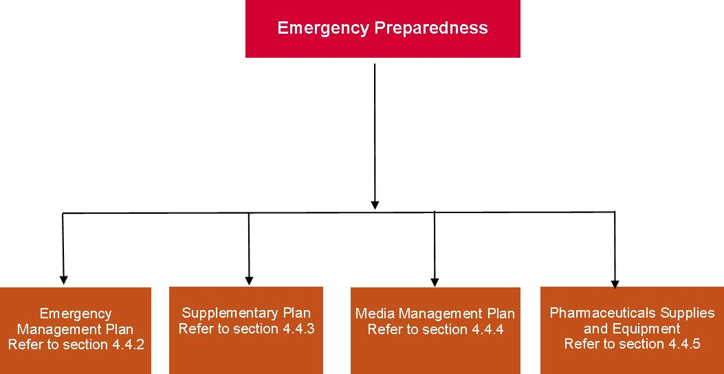

Consideration should be given to the following phases:

* + 1. **Alert:** emergency possible – increase level of preparedness and consider response options, including evacuation.
    2. **Standby:** emergency imminent – prepare for implementation of response and if required, evacuation as per emergency management plan.
    3. **Response:** emergency situation exists – undertake a dynamic risk assessment and implement response according to type and severity of the emergency, implement the most appropriate response as per the emergency management plan and in if time permits, in collaboration with the emergency services.
    4. **Stand down:** emergency abated – return to usual business.

### Emergency management plan

An emergency management plan must be developed and maintained for each facility and/or group of facilities. The facility shall ensure that, for consistency, all emergency management plans are developed and registered in conjunction with other emergency services, for example, Department of Health and Human Services, police, fire and ambulance services, disaster management units and municipal council. There should also be discussion with the municipal council emergency management department to give consideration of incorporating the facility emergency management plan into the municipal emergency management plan or at least making reference to it.

The structure of the emergency management plan must be in accordance with the facility risk assessment and include prevention, preparedness, response and recovery and the items in Figure 10 containing, but not be limited to, the following elements:

* + 1. a clear statement of authority, purpose and scope
    2. information on the structure and purpose of the emergency planning committee, emergency coordinator and emergency officers if appointed and staff
    3. identification of the facilities to which it applies
    4. identification of all hazards and risks and their locations
    5. description of prevention and control measures in place to mitigated the hazards and risks
    6. descriptions of the fire and emergency safety measures and systems for the facility
    7. the emergency preparedness for the facility
    8. separate sections for the following:

the emergency preparedness and response procedures, in accordance with Section 5.3

the evacuation diagram, in accordance with Section 5.1.3

training and exercising arrangements, in accordance with Section 5.5

* + 1. a statement of the extent of distribution of the emergency management plan or excerpts from the emergency management plan
    2. a record of distribution, including where personal emergency evacuation plans for people with disabilities are held (for example, personal emergency evacuation plans should be held by the relevant warden)
    3. details of the hours of occupancy of the facility
    4. the emergency planning committee nominated validity period for the emergency management plan
    5. the date of issue or amendment date on each page of the emergency management plan

If an electronic format is used for the emergency plan, at least one printed copy shall be available on site.

1. Structure of the emergency plan

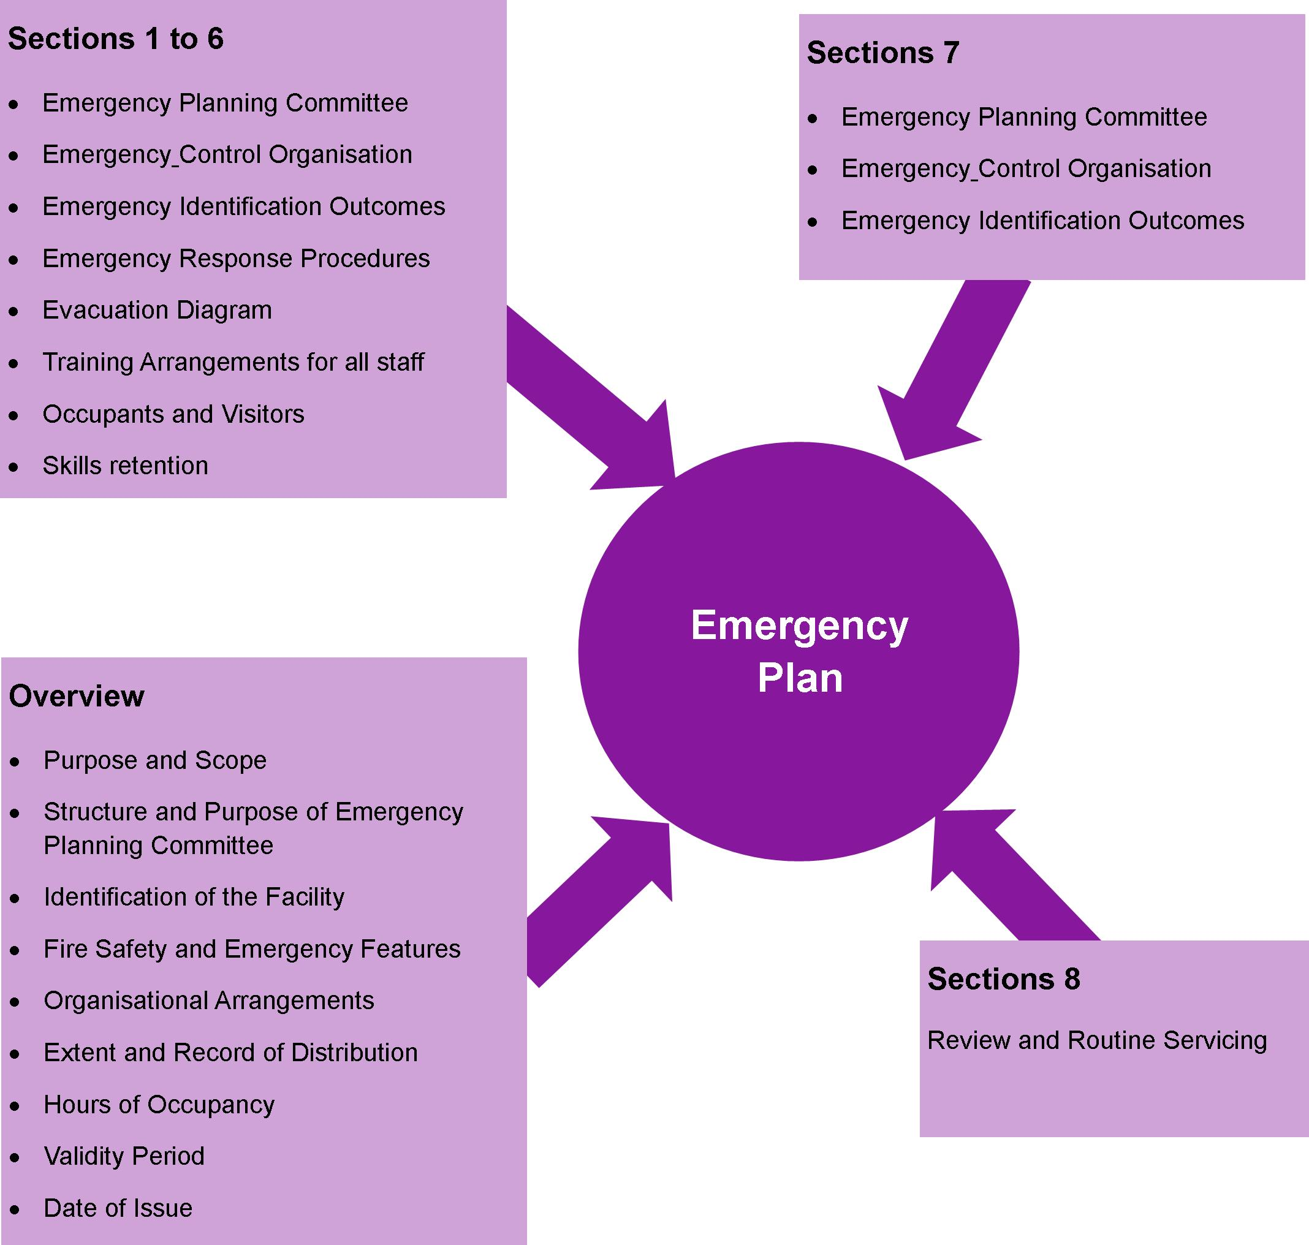

# Emergency planning for staffed residential facilities

## Fire risk assessment

The facility risk assessment shall be based on National Emergency Risk Assessment Guidelines because it provides a contextualised, emergency-related risk assessment method consistent with the Australian Standards AS/NZS ISO 31000:2009 Risk management – principles and guidelines. The risk assessment must be undertaken for each facility by a competent and experienced person in risk and emergency management person. The outcomes of the risk assessment will depend on the facility’s function, location and environment and will identify those hazards that warrant specific risk mitigation and planning within the facility’s emergency management plan.

Examples of hazards that may require the development of supplementary plans are:

* + 1. severe weather (for example, cyclones, storms, extremes in temperature)
    2. bushfires and grass fires
    3. floods
    4. hazardous materials
    5. transport incidents
    6. industrial incidents
    7. pandemics
    8. storage, handling or transport of chemical, biological and radiological substances
    9. earthquakes
    10. storm surges
    11. tsunamis (depending on the facility location to the ocean).

### Media management plan

A media management plan shall be developed to support emergency plans.

The media management plan should deal with:

* + 1. contact with the media during the emergency
    2. preparing and releasing media statements by authorised persons
    3. providing a media briefing area.

### Pharmaceuticals, supplies and equipment

Each facility shall:

* + 1. have appropriate pharmaceuticals, supplies and equipment for the various emergencies to ensure a rapid and effective response
    2. ensure that pharmaceuticals, supplies and equipment are located at suitable places within the facility to ensure a rapid effective response
    3. ensure that there is an appropriate means of storing and transporting the pharmaceuticals, supplies and equipment to the site of the emergency
    4. have protocols for the cleaning, restocking and maintenance of all pharmaceuticals, supplies and equipment.

### Facility evacuation diagrams

* + - 1. Arrangement criteria

Evacuation diagrams shall be provided and arranged in accordance with the criteria listed in Table 11, Section 5.1.3.2 and Section 5.1.3.3.

1. Arrangement criteria for evacuation diagrams

| Arrangement criteria | Requirements |
| --- | --- |
| Number and location | Evacuation diagrams shall be displayed in locations where occupants and visitors are able to view the diagrams. The location within the facility and number of evacuation diagrams shall be determined by the emergency planning committee. |
| Position | The evacuation diagram shall be positioned within a zone at a height not less than above the plane of the finished floor. |
| Orientation | Individual evacuation diagrams shall have the correct orientation with regard to the direction of egress and its location to the ‘YOU ARE HERE’ point. Where an assembly area diagram is included, the assembly diagram area shall have the same orientation to the rest of the diagram. |

* + - 1. Minimum elements

The following shall be included in each evacuation diagram:

* + 1. a pictorial representation of the floor or area

**NOTES:**

Excludes external elements such as fences, roads, landscaping, external facilities and so on, unless part of the exit pathway.

For facilities with larger floor areas, the pictorial representation should be prepared in sections or areas so that no more than two (2) exits are shown on each pictorial representation.

* + 1. the title ‘EVACUATION DIAGRAM’
    2. the ‘YOU ARE HERE’ location
    3. the designated exits in the facility, which shall be green
    4. the following communications equipment, where installed:

warden intercommunication points, if provided, which shall be red

manual call points, if provided, which shall be red and emergency call points, which shall be coloured white, or have a black border

main controls/panels for the occupant warning equipment

* + 1. hose reels, which shall be red
    2. hydrants, which shall be red
    3. extinguishers, which shall be red with an additional appropriate colour as specified in AS/NZS 18411
    4. fire blankets, which shall be coloured red
    5. fire indicator panel, if provided
    6. refuges, if present
    7. validity date
    8. location of assembly areas either stated in words or pictorially represented
    9. a legend, which shall reflect the symbols used.

The minimum size of the evacuation with only minimum elements shall be A4 (that is, 210 mm × 297 mm) with a pictorial representation of the floor or area, which shall be as a minimum:

* + 1. 200 mm × 150 mm

or

* + 1. an area of 30,000 mm².
       1. Optional elements

The following additional information may be considered by the emergency planning committee for inclusion on the evacuation diagram:

* + 1. direction of opening of doors on designated exits
    2. north, south, east west
    3. first aid stations and kits (denoted by a white cross on a green background)
    4. hazardous chemical store
    5. spill response kits
    6. emergency information as documented in the emergency management plan

**NOTE:** For example, emergency telephone numbers, emergency preparedness and response procedures, fire orders, and procedures for use of lifts in an evacuation during a fire emergency (where regulatory approval has been obtained).

* + 1. paths of travel, coloured green
    2. specialised evacuation devices, including stairwell evacuation devices, if provided
    3. fire and smoke doors
    4. hydrants, which shall be in red.

The minimum size of the evacuation diagram with minimum optional elements shall be A3 (that is, 297 mm × 420 mm) with a pictorial representation of the floor or area, which shall be as a minimum:

* + 1. 300 mm × 200 mm

or

* + 1. an area of 60,000 mm².

### Evacuation route and assembly areas

The evacuation route from the facility to the assembly area must:

* + 1. be easy to follow and take you to the assembly area
    2. be free of obstructions and other hazards (for example, tree branches and so on)
    3. have gates easily opened (preferably in direction of travel away from the facility).

There shall be two (2) assembly areas for each facility, a primary and a secondary assembly. When determining the location of both areas, consider the following:

* + 1. Distance of travel to the assembly area: it must not be too far away and be easy to access.
    2. Try not to cross roads or streets, especially those that are busy. The emergency services will arrive at your facility using the street and therefore could become hazardous to cross
    3. The assembly area needs to be safe and secure, in the event of a fire, it must be a safe distance and up wind so that toxic smoke or debris from a fire will not cause harm and be secure so that no one wanders off on their own.

**NOTE:** Up wind may involve moving away from the designated assembly area. If this occurs, it will be important to advise the emergency coordinator or senior duty manager immediately.

* + 1. Shelter from adverse weather conditions if possible.

### Distribution of the plans

The plans developed in Sections 4.4.2 and 5.1.1 shall be distributed to members of the emergency planning committee. As a minimum, distribution of sections within the emergency management plan shall comply with the following:

* + 1. Sufficient information from the emergency preparedness and response procedures shall be distributed to members of the emergency response team to enable them to carry out their required duties.
    2. Sufficient information from the emergency preparedness and response procedures shall be distributed to facility staff and occupants to explain the actions they are to take during an emergency.
    3. The information shall be in a basic easy-to-read format and distributed in accordance with emergency planning committee instructions.

The emergency planning committee shall determine whether any additional distribution is needed.

## Emergency preparedness and response exercises

### General

A program of site-specific emergency preparedness and response training and exercises shall be developed in collaboration with the facility owners, managers, staff, occupiers and employers from each facility. To determine the effectiveness of the emergency preparedness and response procedures, the emergency response team actions and staff occupants’ response should be consulted when first developed and exercised on an ongoing basis.

There will be a requirement to first undertake training on the emergency prevention, preparedness and response parts of the emergency management plan. This should including some testing of fire and emergency management systems and procedures to ensure all facility owners, managers, staff, occupiers and employers are familiar with the plan prior to conducting the emergency preparedness and response exercises. This should include a full-scale evacuation in accordance Section 5. The ongoing program of emergency preparedness and response exercises shall be in accordance with Section 4.

The following should apply for all emergency preparedness and response exercises (see Note 1):

* + 1. Every exercise should be consistent with the identified emergencies in the emergency management plan based on the facility risk assessment.
    2. Simple objectives and outcomes for emergency preparedness and response exercises should be identified (see Notes 2 and 3).
    3. Observers should be appointed for all exercises. The observers shall use a checklist to record the details of the exercise (see Notes 4 and 5).
    4. Each exercise should be prefixed by an announcement that it is an exercise only.
    5. Debriefing sessions should be held in accordance with Section 2.
    6. A post-exercise report shall be forwarded to the emergency planning committee following each exercise. The report shall include any deficiencies during the exercise and information regarding how long the evacuation to the designated assembly area and other matters identified at the debriefing session.

**NOTES:**

1. Emergency preparedness and response exercises should be conducted during the operating hours of the facility to appropriately test the staff, emergency preparedness and response procedures and responses of the occupants and visitors.
2. An example of objectives for an exercise is to gauge staff response and to identify and correct any deficiencies in communication systems, training, emergency preparedness and response procedures, and their implementation.
3. The outcomes for exercises should include the following, as appropriate to the emergency preparedness and response procedures:
   * + 1. staff initiates the emergency procedure without waiting for instructions
       2. staff responds to alarms
       3. staff searches their allocated area without delay
       4. staff reports the location of any occupants and visitors with a disability
       5. simulated calls made to the emergency service, as appropriate
       6. effective staff communication
       7. the designated location for controlling the emergency is staffed immediately by the supervisor, manager or most senior staff
       8. the evacuation sequence is carried out in accordance with the procedures.
4. An observer’s role is to observe and note the action taken by staff and occupants during the evacuation exercise.
5. An example of an observer’s checklist is provided in Appendix 6.

### Initial testing and implementation

Once the emergency planning committee has established that the emergency preparedness and response procedures are satisfactory and workable and staff have been trained, the procedures should be tested within the first 12 months. The first emergency preparedness and response exercise should include an evacuation exercise (see Note 1).

The emergency planning committee, in collaboration with the facility owners, managers, staff, occupiers and employers, should arrange for occupants to be notified before the evacuation exercise takes place. Adequate planning time, including the proposed date, shall be given.

All occupants and staff shall have participated in an evacuation exercise in the first 12 months of the implementation of the emergency preparedness and response procedures.

**NOTES:**

1. Notification may be carried out by various members of the facility owners, managers, staff, occupiers and employers, thus enabling the occupants to identify their staff and become aware of their responsibilities.
2. Realistic performance targets may be considered as a measure of the procedures’ effectiveness.
3. Staff should be briefed how to get extra assistance during the initial evacuations.
4. It should be accepted by management that the emergency preparedness and response procedures be properly tested, and that all staff members have sufficient training to ensure their effectiveness in an emergency situation. In less complex facilities this may only be a matter of sounding the alarm, having people walk to the assembly area and accounting for people. With the experience gained from the first evacuation, subsequent evacuation exercises can become more realistic.

### Ongoing program

Following the implementation phase, a program of site-specific emergency preparedness and response exercises shall be developed for each facility. A program of evacuation exercises shall be included.

The size and configuration of the facility, together with the type of occupancy, will determine the type and time interval between exercises. These may be conducted either as partial exercises or a total emergency preparedness and response exercise covering the entire facility. All areas of a facility shall participate in at least one exercise in each 12-month period.

All occupants of the floors or areas involved in the exercise shall take part, unless the emergency planning committee grants a written exemption prior to conducting the emergency response exercise.

**NOTES:**

1. The aim of emergency preparedness and response exercises is to have all occupants participate in at least one exercise per year consistent with the nature of the facility and its identified emergencies based on the risk assessment.
2. For training purposes, exemptions may be treated by the staff as refusals for the emergency preparedness and response exercise.
3. Where exemptions to remain are given, staff should report the exempted occupants to the supervisor, manager or most senior staff.

### Staff briefing

When planning any emergency preparedness and response exercise, consideration shall be given to briefing the staff. The briefing may address, but not be limited to the following:

* + 1. the location of the planned scenario
    2. the identity of the participating emergency officers or staff
    3. the type of alarms and alarm system (if installed) to be used
    4. actions that the staff is to take in response to the alarm signals
    5. the method of reporting emergencies for the exercise
    6. the evacuation routes to be taken
    7. the location of assembly or designated alternative areas that provide safe refuge, internally or externally
    8. occupants who have approved exemptions prior to the exercise
    9. for the purpose of the exercise, notification of any current or simulated temporary hazards within the facility and known systems failure relating to systems and equipment
    10. what is required at the completion of the exercise.

**NOTE:** There is also value not advising the staff what the scenario will be until the commencement of the exercise to create an environment of uncertainty and pressure.

### Observer’s checklist

An observer’s checklist shall be prepared for the specific facility where the preparedness and response exercises take place.

**NOTES:**

1. The checklist should be completed for each exercise, and should provide the basis for discussion at the debriefing.
2. An example of a checklist is provided in Appendix 6.

### Emergency preparedness and response exercise debriefing session

Immediately after an emergency response exercise, staff and other key participants shall attend a debriefing session facilitated by the supervisor or manager.

Where an evacuation exercise is conducted, the observer’s checklist shall be analysed during debriefing sessions and any deficiencies shall be reported to the emergency planning committee.

The emergency planning committee shall arrange the amendment of the procedures, where necessary, and disseminate the information to all staff.

### An emergency during an emergency preparedness and response exercise

A predetermined word or phrase, for example, ‘NO DUFF’ shall be disseminated to all staff members, for use when an actual emergency incident takes place during an exercise. The word or phrase shall signify that the emergency preparedness and response exercise has been terminated and that staff are to stand by for further instruction.

**NOTE:** The word or phrase may be repeated in groups of three to overcome background noise and other distractions.

## Responding to specific emergencies

### General

This section outlines emergency responses to specific emergency codes as shown in Figure 11.

Emergency procedures flip charts, as detailed in Section 5.3.2 to, shall be prepared as part of the fire, emergency and evacuation procedures and, where appropriate, fire response procedures shall also be prepared. An abbreviated format which may be incorporated into security identification badges and/or onto stickers attached to telephones may also be prepared.

1. Specific emergencies

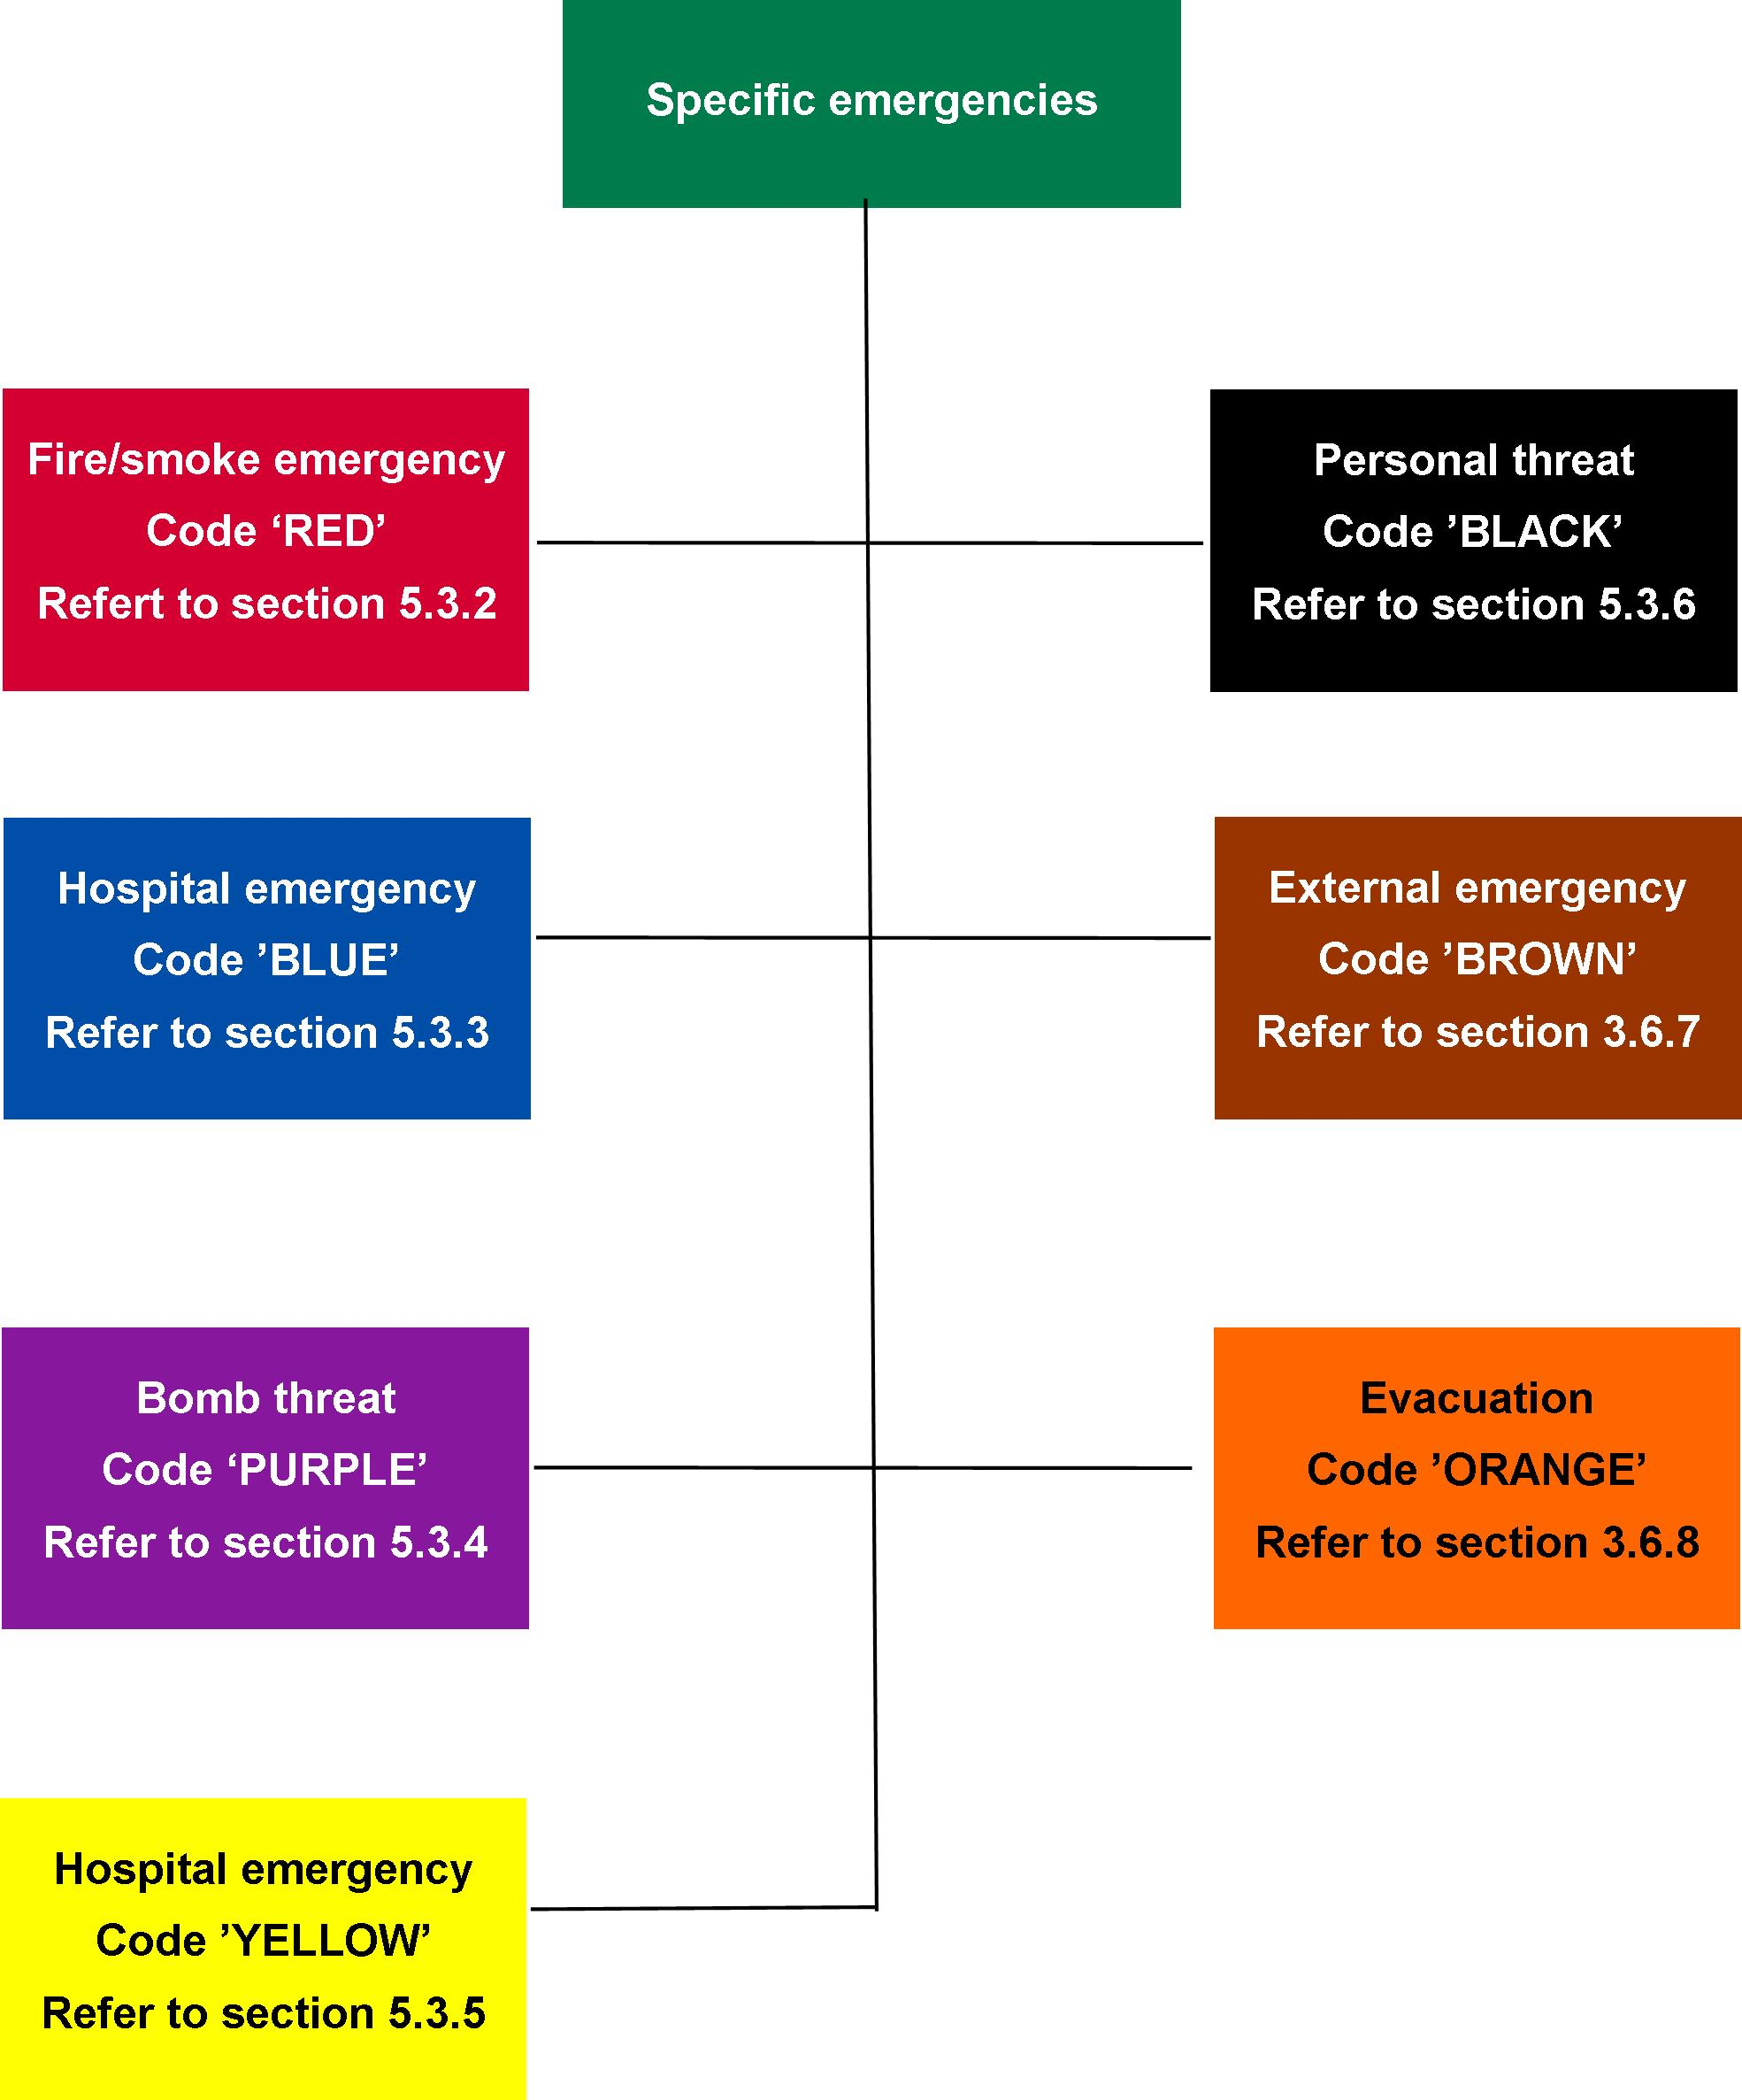

### For fire/smoke (response colour code ‘RED’)

* + - 1. General

A staff member who discovers an emergency, in this scenario a fire, or who is alerted to it, shall carry out the following:

* + 1. Ensure the immediate safety of anyone within the vicinity of the fire/smoke.
    2. Take measures to ensure that fire brigade is notified.

**NOTE:** The fire brigade should be informed of all incidents of fire or suspicion of fire (for example, smell of smoke).

Attempt to extinguish the fire if safe to do so using one portable fire extinguisher or fire blanket, and if not, close the room door to reduce fire spread and smoke travel.

* + 1. Take measures to ensure that the supervisor, manager or most senior staff is notified.
       1. Action plan

It is vital that staff realise that their own safety and that of others must be their primary concern.

This is best achieved by evacuation of the facility first before any attempt is made to extinguish the fire – unless the fire is minor and can be easily extinguished using a single fire extinguisher or fire blanket. Where there is a smouldering fire or a fire on the stove, actions such as turning off the power/gas may stop the fire spread or create extra time to evacuate and reduce the risk of the fire becoming larger; however, these actions should not be taken if there is any risk to life. The fire safety principle of the Department of Health and Human Services regards primacy of life. To achieve this principle, the evacuation of all occupants must be the priority over the extinguishment of the fire unless extinguishing the fire is the most expedient approach to life safety; that is, they are unable to move a person due to a disability or other health condition.

The installed sprinkler system is designed to stop the spread of fire throughout the facility and may suppress the fire depending on the fuel loads and type.

When practising emergency evacuation procedures, staff should take into consideration the mobility capabilities of people in the facility, along with any medications which may impair their ability to evacuate.

Consider bedrooms close to exit doors of the facility for people who are totally dependent on assistance during evacuation.

The order in which people should be evacuated is as follows:

1. people closest to the fire or emergency
2. people mobile and capable to evacuate themselves
3. people that can be evacuated with little assistance
4. people that are totally dependent on assistance

The reason for this order of evacuation is to remove the maximum number of people most at risk from the home as quickly as possible.

Remember: the safety of you and others depends on a swift and orderly evacuation of the facility in an emergency.

The following principles shall be considered in the action plan:

* + 1. First, attempt to isolate the affected room or area to reduce its spread to other areas
    2. Evacuate all persons from immediate danger to a safer location.
    3. Move people out of a room on fire and close the door, then immediately go outside.
    4. Consider the number of staff likely to be on duty at different times.
    5. Ensure all rooms and areas have been checked for people. Make sure it is closed.
    6. Identify the location of the telephone and if 000 can be programmed into it for a ‘quick’ dial.
    7. Call the emergency services on 000 to inform them of the emergency and advise if there is immediate threat to life (for example, persons trapped) This will allow the fire brigade to ensure they provide the appropriate emergency response.
    8. Ensure that the emergency exit from each room of the facility is clear. Consider the distance to outside doors and possibility of escape through windows.
    9. Consider security devices on doors and windows which will prevent them from being used for escape or evacuation.
    10. Keep the route to your assembly area free from obstructions, such as locked gates and cars.
    11. Establish two evacuation assembly areas. This is important because you may not be able to use one assembly area due to the nature of the emergency or the weather conditions (for example, toxic smoke).
    12. Consider access to your facility and the location of arriving emergency vehicles. Ensure your assembly areas are well away from these areas.
    13. Consider the welfare of people with a disability during an emergency evacuation and how this should be managed. This includes medication and medical instructions.
    14. If confronted with smoke, crawl low to the ground to the outside. Close doors quickly when exiting rooms to prevent smoke travel.

A person’s response in an emergency is often difficult to predict. Their behaviour can change due to a change in routine (fear – evacuation at night, bedtime), effects from medication, of heat and smoke, and the confusion of having different people (emergency services) in their home.

The circumstances of the emergency will frighten and confuse most people, and they may need intensive care, support and supervision depending on their age, medical or emotional condition or if they are dependent on others to evacuate.

The number of staff on duty will vary between facilities. It is therefore essential that training and exercises are based on a credible scenario reflecting the different staffing and that all staff and occupants are clear on their role and responsibilities.

* + - 1. Procedures for fire

During a fire event, it is vital that all staff are able to respond immediately to ensure the safety of everyone.

The use of standard fire orders will achieve a uniform approach in all facilities. The standard fire orders are shown in Figure 12.

In the event of a fire event, staff and occupants should:

1. Assist anyone in immediate danger. Staff and occupants should at all times consider their own safety before taking any action and consider what hazards may exist in the room.
2. Attempt to extinguish the fire if it is small enough to be extinguished using a single portable fire extinguisher or fire blanket by a trained person.
3. Close the door. This will prevent the spread of smoke and fire to other parts of the facility. Remember: smoke is the biggest killer in a fire. By preventing smoke spread, staff will gain more time to evacuate the facility.
4. Call the fire brigade on 000 and give the following information:
   * + 1. name and position (of person making call)
       2. name of facility, address (with suburb/state)
       3. nearest cross road.
5. Provide a description of the occupants and numbers in the facility including people with disabilities
   * + 1. The type and size of the fire
       2. Indicate if anyone is missing or trapped inside.
6. Evacuate to assembly area. There should be two (2) assembly areas in the emergency procedures: a primary area and a secondary area. A secondary area is used when wind direction or other considerations do not allow staff to use the primary area (for example, if there is toxic smoke).
7. Remain at the assembly area and ensure everybody is accounted for. This is vital to ensure that everyone is safely out of the facility. If not, the incident controller must be immediately advised so search and rescue is given the highest priority. No one should be allowed to leave the assembly area until the incident controller advises it is safe to do so.

**NOTE**: If there are other staff or occupants in the facility, they must also be notified through preplanned warning systems, such as a manually operated siren or loud audible device; that is, a smoke alarm and so on.

1. Standard fire orders



Under NO circumstances is anyone re-enter the facility once it is evacuated.

These basic steps must be included in the event of a fire.

Rescue of persons in the fire-affected area should only be attempted if it is safe to do so. If a person attempting to remove or rescue a person feels they are becoming overwhelmed by smoke or become injured (for example, back injury), they must put their own safety first.

Fire orders should be displayed in a prominent location near the front door of the facility and in the office, area where applicable.

### For medical emergency (response colour code ‘BLUE’)

* + - 1. General

The facility shall be able to respond effectively to a medical emergency on site, by having:

* + 1. an medical emergency action plan
    2. staff trained in basic life support, and with access to emergency advanced life support (ALS)
    3. appropriate pharmaceuticals and equipment.
       1. Medical emergency action plan

The medical emergency action plan shall include the following:

* + 1. a method of raising an alarm
    2. a method of alerting and notifying appropriate staff
    3. means of obtaining appropriate equipment if it is not at hand
    4. protocols for basic life support involving one person, two persons and a team of people providing the resuscitation
    5. an agreed protocol for deciding when to discontinue basic life support
    6. an agreed protocol for determining continuing care.
       1. Trained staff

Staff shall have training in basic life support and, as appropriate, advanced life support (ALS).

Ongoing training for skills maintenance shall be in place.

**NOTE:** Consideration should also be given to training of staff, other than staff in basic life support.

### For bomb threat (response colour code ‘PURPLE’)

* + - 1. General

This clause provides basic guidance on planning and response in case of a bomb threat. The information contained in this clause is not sufficient, in itself, to adequately plan for a bomb threat and therefore further advice from a competent person or Victoria Police should be sought.

Bomb threat is a serious public nuisance of modern times. Each bomb threat could be a prank or a warning of an impending bomb attack. Usually, they are committed by individuals seeking to create a state of alarm and confusion. Therefore it is important that all facilities have considered the potential risk of a bomb threat at the facility and undertake proper site specific planning in consultation with police if a bomb threat is possible.

* + - 1. Threats

Bomb threats may include but are not limited to the following forms:

* + 1. ***Written threat*** – if a bomb threat is received in writing and considered as credible, it should be placed along with any envelope in a container and police called immediately. Every possible effort has to be made to retain all evidence and handle minimally. Such evidence must be protected to be evaluated by police. Evidence that may be available includes fingerprints, handwriting, printed, electronic or typed material, DNA and postmarks.
    2. ***Telephone threat*** – an accurate analysis of the telephone threat can provide valuable information on which to base recommendations, action and subsequent investigation. The person receiving the bomb threat by telephone should not disconnect the call, and as soon as possible, should complete the information required on a bomb threat checklist. The bomb threat checklist should be available to telephonists and other persons who regularly accept incoming telephone calls. It is important to note that any information obtained from the caller will be extremely valuable to assist police in determining their response.

**NOTE:** An example of a typical phone/bomb threat checklist is provided in Appendix 4.

* + 1. ***Suspect object*** – a suspect object is any object found in the facility and deemed a possible threat by virtue of its characteristics, location and circumstances. Once a suspect object has been identified and determined credible, it must not be handled. Police must be notified immediately and the area immediately evacuated.
    2. ***Suspect mail or object*** – all staff responsible for handling mail and incoming goods should be trained in the identification and subsequent safe handling isolating suspect mail items and incoming goods. Once a suspect mail or object has been identified and determined credible, it must not be handled. Police must be notified immediately and the area or facility evacuated. If the suspect mail or object contains any suspect powder or liquid or is emitting and chemical odour, the fire brigade must also be called.
    3. Identify an object as suspect

Suspect objects may be encountered by any facility. It is not possible to provide a definitive list of indicators that would cause an object to be considered suspect. The following questions provide a means of assessing if an object should be considered suspect:

* + 1. Is the object unidentified?
    2. Is the object unusual or foreign to its environment?
    3. Does the object have an unusual chemical smell
    4. Is the object obviously a bomb?
    5. Is the object hidden or concealed in any way?
    6. Has there been any unauthorised access to the area?
    7. Has there been a perimeter breach?

### For infrastructure and other internal emergencies (response colour code ‘YELLOW’)

* + - 1. General

This clause describes an event that impacts the facility and may be caused by an internal or external event which may adversely affect service delivery and/or safety of persons requiring a response.

Examples include but are not limited to failure of, or disruption to, electricity, medical gases, water, information communication and technology systems, damage to structure, or incidents involving hazardous substances.

* + - 1. Electricity

In the event of electrical failure, the emergency management plan must provide immediate response to protect patients that are dependent on electrically operated medical equipment and may involve the relocation of patients to an area supplied with electricity from an alternative source.

* + - 1. Medical gases (oxygen, air, other gases and suction)

This failure may involve reticulated systems, and the emergency management plan shall document the location of cylinders and regulators and their isolation values. Alternatively, it is important to include the relocation of portable suction pumps and the quickest method of transporting this equipment to residents/clients in need.

* + - 1. Water

In the event of a water supply failure, all efforts should be made to conserve water until an alternative supply can be sourced. The emergency management plan should include provisions for notification to the water authority and to determine the extent and time line to restore water supply.

* + - 1. Information communication and technology

Information communication and technology systems are an essential component of any emergency response, both within the facility and with external agencies. Emergency management planning should include the provision of alternative information communication and technology systems in the event of a failure of the primary systems.

* + - 1. Hazardous substances incidents

The emergency management plan should refer to all hazardous and dangerous substances identified in the risk assessment and potential incident. Such incidents include the leakage or spillage of hazardous or dangerous substances, including flammable and combustible liquids and gases, corrosive and toxic substances. Safe work practices shall be implemented to ensure that:

* + 1. appropriate staff are trained in the safe storage and handling of hazardous and dangerous substances
    2. excess stocks are not held
    3. stocks are properly stored and appropriately labelled
    4. substances are properly handled
    5. material safety data sheets are readily available
    6. appropriate equipment or a plan to manage victims of any hazardous materials incident is available
    7. appropriate training, equipment and as part of the emergency response plan for containment of the incident is provided and that methods for such containment are known and understood.

**NOTE**: In the event of dense smoke or hazardous airborne pollution, consideration should be given to shutting down air handling systems to prevent intake or circulation of contaminants.

* + - 1. Structural damage

The emergency management plan should consider the following:

* + 1. response based on a dynamic risk assessment of disruption to potential implications and impact. This includes assessment of impacts on other hazards and risks as a result of those impacts (for example, electrical hazards, gas leaks)
    2. relocation of services
    3. security of the area.

### For personal threat (armed or unarmed persons threatening injury to others or themselves, or illegal occupancy) (response colour code ‘BLACK’)

* + - 1. General

Planning for these emergencies may be done in consultation with the police or other specialist advisors approved by the department, and should be specific to the likelihood of a threatening person attending the facility. The planning should be consistent with the facility’s security standard operating procedure.

Managers, supervisors, and most senior staff are responsible for coordinating the response to such incidents.

Where police are involved, staff should provide such assistance as may be required and within their physical capabilities.

Managers, supervisors, and most senior staff can contribute in a practical way to the satisfactory resolution of these emergencies by ensuring police have been called, withdrawal of their staff where necessary, supervising the locking up of offices, securing records, files, cash and other valuable property while at the same time promoting an air of confidence and calm.

* + - 1. Unarmed confrontation

Unarmed confrontations may arise where there is a threat to others by an unarmed person confronting them in a violent or threatening manner, or where a person threatens to commit suicide. The facility shall have a response plan to deal with such emergency situations. The proper removal and management of the aggressive, agitated, violent or threatening patients/residents/clients can decrease assaults.

The planning process should involve appropriate medical, nursing, administrative and security staff. Staff specialised in mental health are important in such planning, with the aim of minimising the risk of injury to staff, residents/clients and others.

* + - 1. Armed confrontation

Appropriate advice, warning of the danger of exacerbating an armed confrontation, shall be included in the emergency management plan produced by the facility. The following warning is suggested ‘UNDER NO CIRCUMSTANCES SHOULD STAFF, RESIDENTS/CLIENTS OR VISITORS PLACE THEMSELVES IN FURTHER JEOPARDY’.

The emergency management plan shall direct staff to undertake the following procedures:

* + 1. Obey the offender’s instructions, but do only what they are told and nothing more, and do not volunteer any information.
    2. Stay out of danger if not directly involved and leave the facility if it is safe to do so, then immediately call police.
    3. Follow internal notification and escalation procedures if able to do so without danger.
    4. Carefully observe any vehicle used by the offenders, taking particular note of registration numbers, types and colours, and number of occupants and their description.
    5. Preserve the crime scene until the police have checked the area for evidence.
    6. If safe to do so, observe the offenders and note the speech, mannerisms, clothing, scars or any other distinguishing features such as tattoos. Record these observations and personal account of events in writing, as quickly as possible, after the armed confrontation.

**NOTE:** An example of a typical form to record this information is provided in Appendix 5.

* + 1. Ask all witnesses to remain until the police arrive, and explain to the witnesses that their view of what happened, however fleeting, could provide vital information. Witnesses are not to discuss the incident until statements have been provided to police.
    2. Manage all members of the media, and allow only the delegated person for the facility to make statements.
       1. Illegal occupancy

The facility shall, where appropriate, incorporate within their emergency management plan, after consultation with police, responses in the event of the facility being subjected to illegal occupancy. In accordance with such plans, as soon as it is realised a problem is imminent or occurring, the emergency coordinator or duty manager shall take the following actions:

* + 1. notify the police and request assistance
    2. ensure appropriate managers, supervisors, or most senior staff have been alerted
    3. initiate action to:

restrict illegal occupants to affected area

restrict facility occupants’ and visitors’ access to affected area

request occupants and visitors of unaffected areas to remain at their location unless otherwise advised

implement specific facility security protocols.

## Debriefing and emergency management plan review

### Debriefing

* + - 1. Operational debriefing

Operational post-incident debriefing shall be conducted as soon as practicable after every emergency or training exercise.

Debriefing has two purposes as follows:

* + 1. to review emergency management plan response and identify lessons learned
    2. to identify and initiate any necessary changes to the emergency management plan as part of the continuous improvement process.
       1. Post-incident support

Emergencies may have adverse short- and long-term effects on personnel directly and indirectly involved. Provision for identification and management of adverse effects should be an integral part of emergency management planning.

### Emergency management plan in review

Plans should be reviewed regularly and after exercise or actual emergencies. When such reviews are undertaken, reference to any established performance outcomes (for example, ward evacuation time) will be beneficial.

## Training

### General

All staff to receive adequate and appropriate training in fire prevention, preparedness and response, fire and emergency risk management and emergency procedures. The Fire Safety Induction Program provides the Department of Health and Human Services (DHHS) staff with the necessary fire and emergency response skills to evacuate people safely for a residential facility and to comply with the relevant departmental fire safety checks of the residence and the installed equipment training program.

All department and community service organisations staff working in 24-hour supported accommodation must complete the Fire Safety Induction Program as part of their induction training program. All residential staff are required to maintain and review their ongoing fire and emergency response skills and knowledge.

Staff should be supported to undertake the online Fire Safety Induction Program training program or participate in face-to-face workshop sessions

* + - 1. Residential care staff

The emergency planning committee shall adopt the fire safety training strategy provided in Appendix 1 for all residential care staff.

* + - 1. Emergency planning committee members

Emergency planning committee (EPC) members are required to undertake training as part of the role of a manager of a 24-hour residential facility.

An online emergency planning committee learning program is undertaken by all members. This package includes the following units from the public safety training package.

**NOTE:** the subjects listed below will be reassessed from time to time as required; refer to practice notes for current subjects and courses.

* PUAWER003B – Manage and monitor workplace emergency procedures, equipment and other resources
* PUAWER005B – Operates as part of an emergency control organisation
* PUAWER006B – Lead an emergency control organisation
* PUAWER007B – Manage and emergency control organisation.

# Emergency planning for non-staffed residential facilities

## Applicable capital development guidelines

The requirements detailed in this section shall be applied to the following facilities covered by the Capital Development Guidelines – Series 7:

* + 1. Guideline 7.8 – Single Dwellings
    2. Guideline 7.9 – Multi-Storey Residential Facilities
    3. Guideline 7.10 – Accommodation Facilities.

## Emergency management

### General

All facilities listed in Section 6.0 above shall have an emergency planning committee and, where appropriate, emergency officers.

Chief executive officers (CEOs) and managers shall:

* + 1. ensure an emergency planning committee is established
    2. ensure the emergency planning committee has adequate resources and expertise to carry out the responsibilities as stated in Section 4.2.2.2

1. Structure of the emergency management

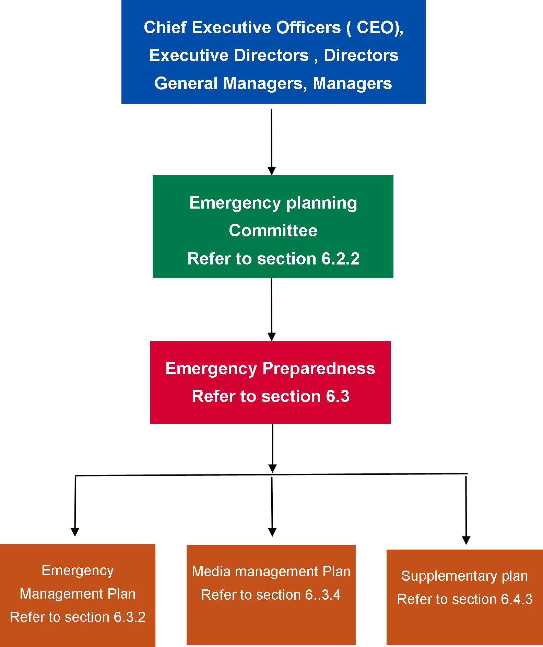

### Facility emergency planning committee

* + - 1. Forming of the emergency planning committee

The emergency planning committee shall be formed for each facility or group of facilities by the senior person or persons responsible for the facilities or its occupants and visitors. Depending on the nature of the particular facilities, the emergency planning committee may be formed either for an individual or group of facilities. The emergency planning committee membership shall be appropriate for the facility’s specific hazards and risks based on a risk assessment by a competent person.

Those responsible for a facility or its occupants shall ensure that the emergency planning committee has adequate resources and expertise to enable the development and implementation of the facility’s emergency management plan.

**NOTES:**

1. The emergency planning committee should ensure applicable legislative requirements are met; that is, Facility Act and Regulations, Country Fire Authority or Metropolitan Fire Brigades Act, Occupational Health and Safety Act and the maintenance provisions of the Building Regulations.
2. Those responsible for a facility or its occupants should ensure that leases include obligations to participate in emergency activities, including fire and emergency preparedness and response exercises.
3. Resources include time, finance, equipment and personnel.
4. Facility owners, agents, occupiers, lessors, or employers are typically those responsible for a facility or its occupants.
5. The emergency planning committee should include a competent person to provide specialist expert advice.

The emergency planning committee, where necessary, in collaboration with facility owners, managers, occupiers’ employers and contractors, shall be responsible for the development, implementation and maintenance of the emergency management plan. This includes emergency prevention, preparedness and response procedures and related training. This may be undertaken in conjunction with relevant emergency services.

**NOTE:** If the emergency planning committee becomes aware of features of the facility that prevents the safe evacuation of the occupants and visitors and is beyond the emergency planning committee to resolve, the emergency planning committee must immediately notify the most senior person responsible for the facility.

The emergency planning committee shall consist of not less than two people, who shall be representative of the stakeholders in a facility, one of which must be management, unless the facility is owned or occupied and operated by a single person, in which case the emergency planning committee may be the sole person who is the owner/occupant.

At least one member of the emergency planning committee shall be a competent person who has acquired through training, education, qualification, experience, or a combination of these, the knowledge and skill enabling them to correctly perform the required task.

**NOTES:**

1. For most organisations, the emergency planning committee would comprise management, tenants and an emergency coordinator, if appointed. The effectiveness of an emergency planning committee with respect to all occupants includes the extent to which it provides for occupants with a disability.
2. External contractors, consultants or others engaged by the organisation to provide specialist advice should not be members of the emergency planning committee, but may attend emergency planning committee meetings.
   * + 1. Responsibilities

The duties of the emergency planning committee shall include but are not limited to the following:

* + 1. Ensure a risk assessment has been completed by a competent person to identify hazards and risks that could reasonably produce emergency situations and recommend appropriate mitigation and treatment strategies, programs and procedures for consideration by the emergency planning committee.
    2. Develop an emergency management plan in accordance with Section 6.3.2 based on the risk assessment.
    3. Ensure that resources and expertise are provided to enable the development and implementation of the emergency management plan.

**NOTE:** Resources include time, finance, equipment and personnel.

* + 1. Nominate the validity period for the emergency management plan including the evacuation diagram.

**NOTE:** The validity period should not exceed five years but may be less than five yearly, depending on the requirements of a maintenance cycle, a major change to the facility or an accreditation regime.

* + 1. Ensure that the emergency management plan is readily identifiable and available to the appropriate persons.
    2. If deemed necessary, establish a specialist emergency response team and provide training for all members of the team to operate in accordance with the emergency management plan.
    3. Authorise, or having authorised, release and implement the emergency management plan. The following shall apply to the implementation process:

based on a risk assessment of the facility to identify all potential hazards and risks and develop an emergency management plan:

***awareness of the emergency prevention, preparedness and response procedures*** – information about the procedures shall be disseminated to all staff and occupants

***training*** – all staff and long-term occupants are provided training on the fire and emergency prevention, preparedness and response procedures. Depending on the size and level of installed fire protection and emergency management procedures, training may only involve a one to two-hour awareness session by a competent person

***testing the emergency management plan or parts thereof*** – the emergency planning committee should ensure that the emergency management plan is tested

***review of emergency management plan*** – the effect of the emergency management plan should be monitored at all stages of the implementation process. Amendments shall be made to rectify any deficiencies or inaccuracies that are identified in the procedures.

* + 1. Ensure that the fire and emergency prevention, preparedness and response procedures remain viable and effective by reviewing and testing the emergency management plan and evacuation procedures at least annually and after each exercise.
    2. Ensure that a permanent record of events for each fire and emergency is compiled and retained.
    3. Identify and rectify deficiencies and opportunities for improvement in the emergency management plan.
       1. Meetings

The emergency planning committee shall meet at least every six months.

A record of emergency planning committee meetings shall be made and retained in accordance with the department policy.

**NOTE:** This may include minutes of meetings, communication, financial position, reports and specialist advice.

## Emergency prevention, preparedness and response

### General

Each facility must have plans to alert and respond to emergencies. The emergency planning committee of the facility shall oversee emergency prevention, preparedness and response relevant to its size and function based on the risk assessment. A key part of the preparedness and response procedures must be the development and implementation of an alerting system that reflects the facilities size and number of staff, occupants and visitors. The alerting system may include the operation of smoke alarms and manually operated siren.

Upon hearing one of the alert systems, response procedures may involve all staff and/or occupants checking each room/area within close proximity and/or allocated to them, and all persons evacuate the facility to the designated assembly point. This should be in the front of the facility to allow for a quick head count and identify if anyone is missing. This will ensure the fire brigade and other emergency services can be notified once the facility has been evacuated.

### Emergency management plan

An emergency management plan shall be developed and maintained for each facility and/or group of facilities based on the risk assessment by a competent person. The emergency planning committee shall ensure that, for consistency, all emergency management plans are developed and registered in conjunction with other relevant agencies, for example, Department of Health and Human Services, police, fire and ambulance services, disaster management units and if appropriate, the municipal council.

The structure of the emergency management plan shall be in accordance with Figure 14 containing, but not be limited to, the following elements:

* + 1. a clear statement of authority, purpose and scope
    2. information on the structure and purpose of the emergency planning committee
    3. identification of the facility to which it applies
    4. identification of all hazards, risk and their location
    5. description of prevention and control measures in place to mitigate the risk
    6. descriptions of the fire and emergency management measures and systems of the facility, and the organisational arrangements for the facility
    7. separate sections for the following:

the emergency preparedness and response procedures, in accordance with Section 6.4

the evacuation diagram, in accordance with Section 6.3.5

training and exercise arrangements

* + 1. a statement of the extent of distribution of the emergency management plan
    2. the emergency planning committee nominated validity period for the emergency management plan
    3. the date of issue or amendment date on each page of the emergency management plan.

If an electronic format is used for the emergency management plan, at least one printed copy shall be available on site.

1. Structure of the emergency plan

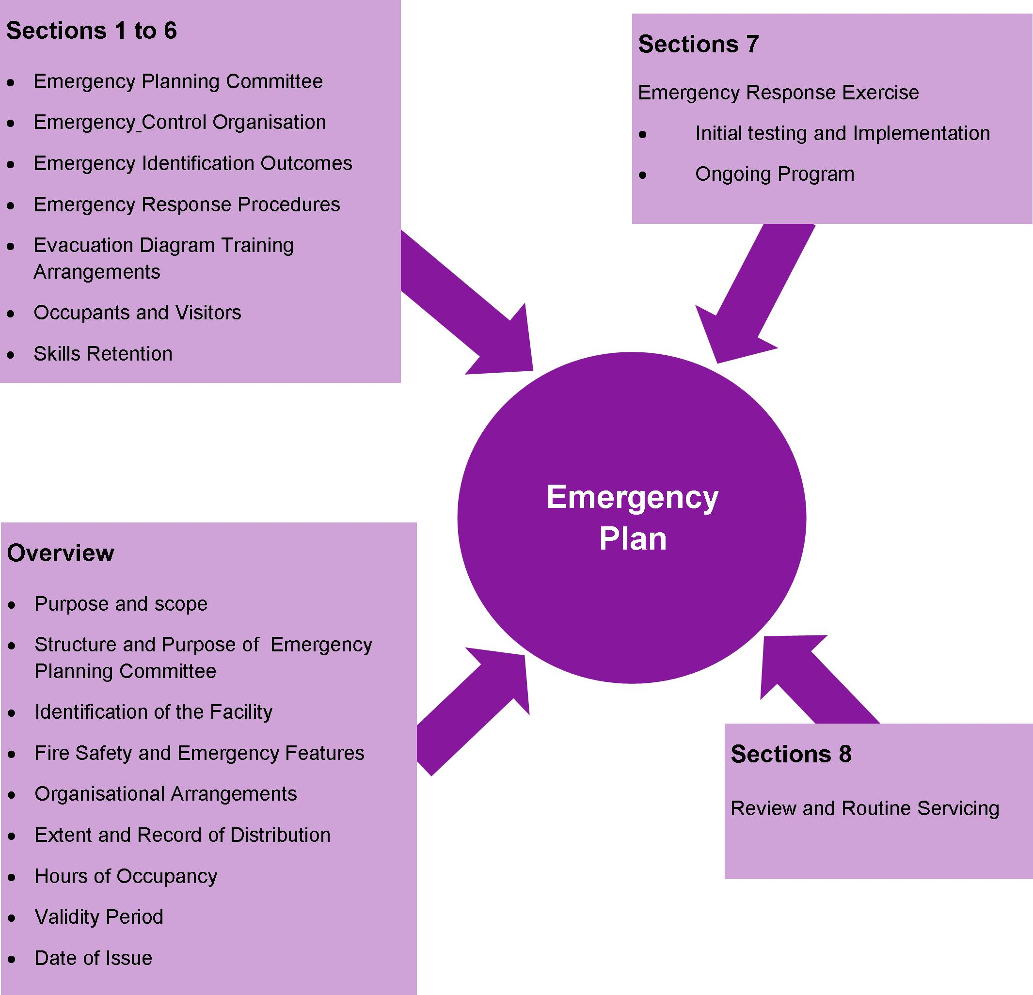

### Risk assessment

The facility risk assessment shall be based on National Emergency Risk Assessment Guidelines because it provides a contextualised, emergency-related risk assessment method consistent with the Australian Standards AS/NZS ISO 31000:2009 Risk management – principles and guidelines. The risk assessment must be undertaken for each facility by a competent person. The outcomes of the risk assessment will depend on the facility’s function, location and environment, and will identify those hazards that warrant specific risk mitigation and planning within the facility’s emergency management plan. Examples of hazards and risks that may require the development of supplementary plans are:

* + 1. severe weather (for example, cyclones, storms, extremes in temperature)
    2. bushfires and grass fires
    3. floods
    4. hazardous materials
    5. transport incidents
    6. industrial incidents
    7. pandemics
    8. storage, handling or transport of dangerous goods substances
    9. earthquakes
    10. storm surges.

### Media management plan

A media management plan shall be developed to support emergency management plans.

The media management plan should deal with:

* + 1. contact with the media during the emergency
    2. preparing and releasing media statements by authorised persons
    3. providing a media briefing area.

### Evacuation diagrams

* + - 1. Arrangement criteria

Evacuation diagrams shall be provided and arranged in accordance with the criteria listed in Table 12, Section 6.3.5.2 and Section 6.3.5.3.

1. Arrangement criteria for evacuation diagrams

| Arrangement criteria | Requirements |
| --- | --- |
| Number and location | Evacuation diagrams shall be displayed in locations where occupants and visitors are able to view the diagrams. The location within the facility and number of evacuation diagrams shall be determined by the emergency planning committee. |
| Position | The evacuation diagram shall be positioned within a zone at a height not less than above the plane of the finished floor. |
| Orientation | Individual evacuation diagrams shall have the correct orientation with regard to the direction of egress and its location to the ‘YOU ARE HERE’ point. Where an assembly area diagram is included, the assembly diagram area shall have the same orientation to the rest of the diagram. |

* + - 1. Minimum elements

The following shall be included in each evacuation diagram:

* + 1. a pictorial representation of the floor or area

**NOTES:**

Excludes external elements such as fences, roads, landscaping, external facilities, and so on, unless part of the exit pathway.

For a facility with larger floor areas, the pictorial representation should be prepared in sections or areas so that no more than two (2) exits are shown on each pictorial representation.

* + 1. the title ‘EVACUATION DIAGRAM’
    2. the ‘YOU ARE HERE’ location
    3. the designated exits in the facility, which shall be green
    4. the following warning and communications equipment, where installed:

warden intercommunication points (warden intercommunication points), if provided, which shall be red

manual call points, if provided, which shall be red and emergency call points, which shall be coloured white, or have a black border

main controls/panels for the occupant warning equipment, if provided

manual operated alarm

smoke alarms.

* + 1. hose reels, which shall be red, if provided
    2. hydrants, which shall be red, if provided
    3. extinguishers, which shall be red with an additional appropriate colour as specified in AS/NZS 18411
    4. fire blankets, which shall be coloured red
    5. fire indicator panel, if provided
    6. refuges, if present
    7. validity date
    8. location of assembly areas, either stated in words or pictorially represented
    9. a legend, which shall reflect the symbols used.

The minimum size of the evacuation diagram with only minimum elements shall be A4 (that is, 210 mm × 297 mm) with a pictorial representation of the floor or area, which shall be as a minimum:

* + 1. 200 mm × 150 mm

or

* + 1. an area of 30,000 mm².
       1. Optional elements

The following additional information should be considered by the emergency planning committee for inclusion on the evacuation diagram:

* + 1. direction of opening of doors on designated exits
    2. north, south, east and west
    3. first aid stations and kits (denoted by a white cross on a green background)
    4. hazardous chemical store
    5. spill response kits
    6. emergency information as documented in the emergency management plan

**NOTE:** For example, emergency telephone numbers, emergency preparedness and response procedures, fire orders, and procedures for use of lifts in an evacuation during a fire emergency (where regulatory approval has been obtained).

* + 1. paths of travel, coloured green
    2. specialised evacuation devices, including stairwell evacuation devices, if provided
    3. fire and smoke doors
    4. hydrants, which shall be in red.

The minimum size of the evacuation diagram with minimum optional elements shall be A3 (that is, 297 mm x 420 mm) with a pictorial representation of the floor or area, which shall be as a minimum:

* + 1. 300 mm x 200 mm

or

* + 1. an area of 60,000 mm².

### Evacuation route and assembly areas

The evacuation route from the facility to the assembly area must:

* + 1. be easy to follow and take you to the assembly area
    2. be free of obstructions and other hazards (for example, tree branches and so on)
    3. have doors and gates easily opened (preferably in direction of travel away from the facility)
    4. provide another way around the facility should the route be blocked by the fire.

There shall be two (2) assembly areas for each facility, a primary area and a secondary area. When determining the location of both assembly areas, consider the following:

* + 1. Distance of travel to the assembly area: it must not be too far away.
    2. Try not to cross roads or streets, especially those that are busy. The emergency services will arrive at the facility using the street and therefore could become hazardous to cross
    3. The assembly area needs to be safe and secure, in the event of a fire, it must be a safe distance and up wind so that toxic smoke or debris from a fire will not cause harm and secure so that no one wanders off on their own.

**NOTE:** Up wind may involve moving away from the assembly area which is most likely in the front of the facility. If this occurs, it will important to advise the incident controller immediately upon the arrival of the fire brigade.

* + 1. Shelter from adverse weather conditions.

### Distribution of the plans

The plans developed in Sections 6.3.2 and 6.3.4 shall be distributed to members of the emergency planning committee. As a minimum, distribution of sections within the emergency management plan shall comply with the following:

* + 1. Sufficient information from the emergency preparedness and response procedures shall be distributed to members of the emergency planning committee (where provided) to enable them to carry out their required duties.
    2. Sufficient information from the emergency preparedness and response procedures shall be distributed to facility staff and occupants to explain the actions they are to take during an emergency.
    3. The information shall be a basic easy-to-read format and distributed in accordance with the emergency planning committee instructions.

The emergency planning committee shall determine whether any additional distribution is needed.

## Responding to specific emergencies

### General

This section outlines emergency responses to specific emergency codes as shown in Figure 15.

1. Specific emergencies (AS 3745)

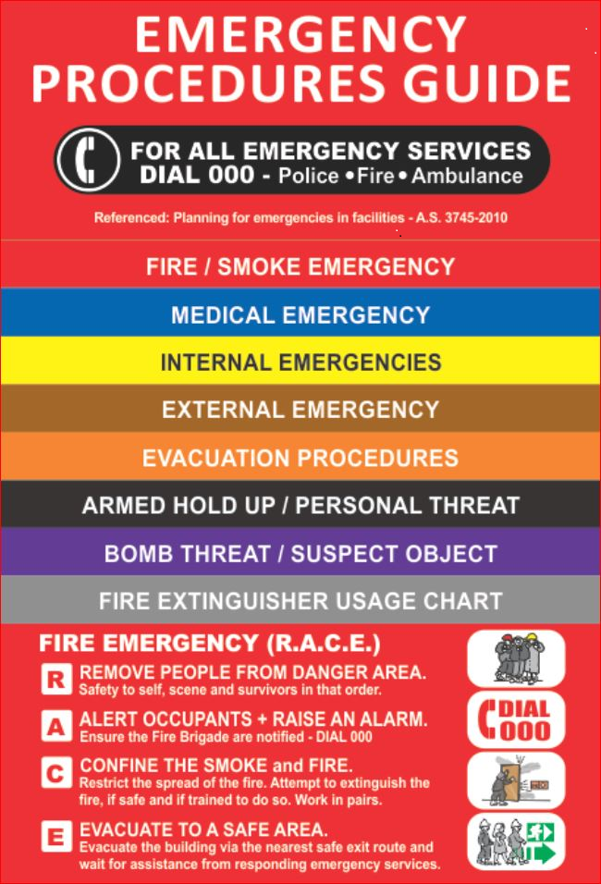

### For fire/smoke

* + - 1. General

An occupant who discovers fire, or is alerted to it, shall carry out the following:

* + 1. activate the internal warning and communication system if smoke alarms have not activated; that is, a manually operated alerting system
    2. ensure the immediate safety of anyone within the vicinity of the fire/smoke
    3. close the door of the room affected to prevent fire spread and smoke travel
    4. take measures to ensure that fire brigade is notified

**NOTE:** The fire brigade should be informed of all incidents of fire or suspicion of fire (for example, smell of smoke).

* + 1. attempt to extinguish the fire if safe to do so using one portable fire extinguisher or fire blanket, and if not, close the room door to reduce fire spread and smoke travel
    2. take measures to ensure that the supervisor, manager or most senior staff is notified.
       1. Action plan

It is vital that staff and occupants realise that their own safety and that of others must be their primary concern.

This is best achieved by evacuation of the facility first, before any attempt is made to extinguish the fire – unless the fire is minor and can be easily extinguished using a single portable fire extinguisher or fire blanket if available. Where there is a smouldering fire or a fire on the stove, actions such as turning off the power/gas may stop the fire spread or create extra time to evacuate and reduce the risk of the fire becoming larger; however, these actions should not be taken if there is any risk to life or injury.

The fire safety principle of the Department of Health and Human Services regards primacy of life over the extinguishment of the fire, unless extinguishing the fire is the most expedient approach to life safety; that is, they are unable to evacuate a person due to disabilities or injury. To achieve this principle, the evacuation of all occupants must be the priority over the extinguishment of the fire.

The installed sprinkler system is designed to stop the spread of fire throughout the facility and may suppress the fire depending on fuel loads and type.

Consider bedrooms close to exit doors of the facility for people who are totally dependent on assistance during evacuation.

The order in which people should be evacuated is as follows:

1. people closest to the fire or emergency
2. people mobile and capable to evacuate themselves
3. people that can be evacuated with little assistance
4. people that are totally dependent on assistance

The reason for this order of evacuation is to remove the maximum number of people most at risk from the home as quickly as possible.

Remember: the safety of you and others depends on a swift and orderly evacuation of the facility in an emergency.

The following principles shall be considered in the action plan during an emergency:

* + 1. First attempt to isolate the affected room or area to reduce its spread to other areas
    2. Evacuate all persons from immediate danger to a safer location. Move people out of a room or area on fire and close the door.
    3. Consider the number of occupants within the facility.
    4. Ensure all rooms and areas have been checked for people and close the door. This will reduce the likelihood of fire or smoke entering the room.
    5. Identify the location of the telephone, and if 000 can be programmed into it for a ‘quick’ dial.
    6. Call the emergency services on 000 to inform them of the emergency and advise if there is immediate threat to life (for example, if persons are unaccounted or trapped). This will allow the fire brigade to ensure they provide the appropriate emergency response.
    7. Ensure emergency exits from the facility are clear. Consider distance to outside doors and the possibility of escape through windows.
    8. Consider security devices on doors and windows which will prevent them from being used for escape or evacuation.
    9. Keep the route to your assembly area free from obstruction such as locked gates and cars.
    10. Establish two evacuation assembly areas. This is important because you may not be able to use one assembly area due to the nature of the emergency or the weather conditions (for example, toxic smoke).
    11. Consider access to your facility and the location of arriving emergency vehicles.
    12. Consider the welfare of people with a disability during an emergency evacuation and how this should be managed. This includes medication and medical instructions.
    13. If confronted with smoke, crawl low to the ground to a clear area and eventually outside. Close doors quickly when exiting rooms to prevent fire spread and smoke travel.

A person’s response in an emergency is often difficult to predict. Their behaviour can change due to a change in routine (fear of evacuation at night, bedtime), effects from medication, heat and smoke, and the confusion of having different people (emergency services) in their home.

The circumstances of the emergency will frighten and confuse most people, and they may need first aid care, support and supervision depending on their age, medical or physical or mental disabilities, or their dependence on others to be evacuated.

* + - 1. Procedures for fire

During a fire event, it is vital that all occupants within the facility are able to respond immediately to ensure the safety of everyone.

The use of standard fire orders will achieve a uniform approach in all facilities. The standard fire orders are shown in Figure 16.

1. Standard fire orders



In the event of a fire event, staff and occupants should:

1. Assist anyone in immediate danger. Staff and occupants should at all times consider their own safety before taking any action and consider what hazards may exist in the room.
2. Attempt to extinguish the fire if it is small enough to be extinguished using a single portable fire extinguisher or fire blanket by a trained person.
3. Close the door. This will prevent the spread of smoke and fire to other parts of the facility. Remember: smoke is the biggest killer in a fire. By preventing smoke spread, staff will gain more time to evacuate the facility.
4. Call the fire brigade on 000 and give the following information:
   * + 1. name (of person making call)
       2. name of facility, address (with suburb/state)
       3. nearest cross road.
5. Describe the occupants and number of people in the facility, including people with disabilities
   * + 1. Describe type and size of the fire.
       2. Indicate if anyone is missing or trapped inside.

**NOTE:** If there are other staff or occupants in the facility, they must also be notified through pre-planned warning systems, such as a manually operated siren or loud audible device (for example, smoke alarm and so on).

1. Evacuate to assembly area. There should be two (2) assembly areas in the emergency procedures: a primary area and a secondary area. A secondary area is used when wind direction or other considerations do not allow staff to use the primary area (for example, if there is toxic smoke).
2. Remain at the assembly area and ensure everybody is accounted for. This is vital to ensure that everyone is safely out of the facility. If not, the incident controller must be immediately advised so search and rescue is given the highest priority. No one should be allowed to leave the assembly area until incident controller advises it is safe to do so.

### For bomb threat (response colour code ‘PURPLE’)

* + - 1. General

This clause provides basic guidance on planning and response in case of a bomb threat. The information contained in this clause is not sufficient, in itself, to adequately plan for a bomb threat and therefore further advice from a competent person or Victoria Police should be sought.

Bomb threat is a serious public nuisance of modern times. Each bomb threat could be a prank or a warning of an impending bomb attack. Usually, they are committed by individuals seeking to create a state of alarm and confusion. Therefore, it is important that all facilities have considered the potential risk of a bomb threat at the facility and undertake proper site specific planning in consultation with police if a bomb threat is possible.

* + - 1. Threats

Bomb threats may include but are not limited to the following forms:

* + 1. ***Written threat*** – if a bomb threat is received in writing and considered credible, it should be placed along with any envelope in a container and police called immediately. Every possible effort has to be made to retain all evidence. Evidence that may be available includes fingerprints, handwriting, printed, electronic or typed material, DNA and postmarks.
    2. ***Telephone threat*** – an accurate analysis of the telephone threat can provide valuable information on which to base recommendations, action and subsequent investigation. The person receiving the bomb threat by telephone should not disconnect the call, and as soon as possible, should complete the information required on a bomb threat checklist. The bomb threat checklist should be available to telephonists and other persons who regularly accept incoming telephone calls.

**NOTE:** An example of a typical phone/bomb threat checklist is provided in

Appendix 4.

* + 1. ***Suspect object*** – a suspect object is any object found in the facility and deemed a possible threat by virtue of its characteristics, location and circumstances. Once a suspect object has been identified and determined credible, it must not be handled. Police must be notified immediately and the facility evacuated.
    2. ***Suspect mail or object*** – All staff responsible for handling mail and incoming goods should be trained in the identification and subsequent safe handling of suspect mail items and incoming goods. Once a suspect mail or object has been identified and determined credible, it must not be handled. Police must be notified immediately and the facility evacuated. If the suspect mail or object contains any suspect powder or liquid or is emitting and chemical odour, the fire brigade must also be called.

1. **Identifying an object as suspect**

Suspect objects may be encountered by any facility. It is not possible to provide a definitive list of indicators that would cause an object to be considered suspect. The following questions provide a means of assessing if an object should be considered suspect:

* + 1. Is the object unidentified?
    2. Is the object unusual or foreign to its environment?
    3. Does the object have an unusual chemical smell
    4. Is the object obviously a bomb?
    5. Is the object hidden or concealed in any way?
    6. Has there been any unauthorised access to the area?
    7. Has there been a perimeter breach?

### For infrastructure and other internal emergencies

* + - 1. General

This clause describes an event that impacts the facility and may be caused by an internal or external event which may adversely affect service delivery and/or safety of persons requiring a response.

Examples include but are not limited to failure of, or disruption to, electricity, water, information communication and technology systems, damage to structure, or incidents involving hazardous substances or flammable liquids/materials.

* + - 1. Electricity

In the event of electrical failure, the emergency management plan may involve the relocation of occupants to another facility if the electricity supply is going to be out for a significant amount of time. Information on electricity outages can be obtained by contacting the facilities local provider or visiting their website using a smart phone.

* + - 1. Hazardous substances incidents

The emergency management plan should refer to the department’s policy. Such incidents include the leakage or spillage of hazardous and dangerous substances, including flammable liquids, gases or corrosive materials. Safe work practices shall be implemented to ensure that:

* + 1. staff and occupants are trained in the safe handling of hazardous and dangerous substances
    2. excess stocks are not held
    3. stocks are properly stored and appropriately labelled
    4. substances are properly handled
    5. material safety data sheets are readily available if required.

**NOTE**: In the event of dense smoke or hazardous airborne pollution, consideration should be given to shutting down air handling systems to prevent intake or circulation of contaminants.

### For personal threat (armed or unarmed persons threatening injury to others or themselves, or illegal occupancy) (response colour code ‘BLACK’)

* + - 1. General

Planning for these types of emergencies should be done in consultation with the police or other specialist advisors and should be specific to the likelihood of a threatening person attending the facility. The planning should be consistent with the facility’s security standard operating procedure.

* + - 1. Unarmed confrontation

Unarmed confrontations may arise where there is a threat to others by an unarmed person confronting them in a violent or threatening manner, or where a person threatens to commit suicide. The facility shall have response plans to deal with such emergency situations. The proper removal and management of the aggressive, agitated, violent or threatening residents/clients can decrease assaults.

The planning process should involve appropriate emergency services, administrative and security staff.

* + - 1. Armed confrontation

Appropriate advice, warning of the danger of exacerbating an armed confrontation, shall be included in emergency management plan produced for the facility. The following warning is suggested ‘UNDER NO CIRCUMSTANCES SHOULD STAFF, RESIDENTS/CLIENTS OR VISITORS PLACE THEMSELVES IN FURTHER JEOPARDY’.

The emergency management plans shall direct staff to undertake the following procedures:

* + 1. Obey the offender’s instructions, but do only what they are told and nothing more, and do not volunteer any information.
    2. Stay out of danger if not directly involved and leave the facility if it is safe to do so, then immediately call police.
    3. Follow internal notification and escalation procedures if able to do so without danger.
    4. Carefully observe any vehicle used by the offenders, taking particular note of registration numbers, types and colours, and number of occupants and their description.
    5. Preserve the crime scene until the police have checked the area for evidence.
    6. If safe to do so, observe the offenders and note the speech, mannerisms, clothing, scars or any other distinguishing features such as tattoos. Record these observations and personal account of events in writing as quickly as possible after the armed confrontation has left.

**NOTE:** Appendix B provides an example of a typical form to record this information.

* + 1. Ask all witnesses to remain until the police arrive, and explain to the witnesses that their view of what happened, however fleeting, could provide vital information. Witnesses are not to discuss the incident until statements have been provided to police.
    2. Manage all members of the media, and allow only the delegated person for the facility to make statements.
       1. Illegal occupancy

The facility where appropriate, incorporated within their emergency management plan, after consultation with police, include responses in the event of the facility being illegally occupied. In accordance with such plans, as soon as it is realised a problem is imminent or occurring, the senior duty person shall take the following actions:

* + 1. Immediately notify the police and request assistance.
    2. Ensure other occupants have been alerted.
    3. Initiate action to:

restrict illegal occupants to affected area

restrict facility occupants’ and visitors’ access to the affected area

request occupants and visitors of unaffected areas to remain at their location unless otherwise advised

implement specific facility security protocols.

## Debriefing and emergency management plan post incident review

### Debriefing

* + - 1. Operational debriefing

Operational post-incident debriefing shall be conducted as soon as practicable after every emergency or training exercise.

Debriefing has two purposes:

* + 1. to review emergency management plan preparedness and response and identify lessons learned
    2. to identify and initiate any necessary changes to the emergency management plan as part of the continuous improvement process.
       1. Post-incident support

Emergencies may have adverse short- and long-term effects on personnel directly and indirectly involved. Provision for identification and management of adverse effects should be an integral part of emergency planning.

### Emergency management plan in review

Plans should be reviewed regularly and after exercise or actual emergencies. When such reviews are undertaken, reference to any established performance outcomes (for example, evacuation time) will be beneficial.

## General Information

### Fire Safety for public housing tenants

Information available on [Fire safety for public housing tenants](http://www.housing.vic.gov.au/fire-safety-public-housing-tenants) <http://www.housing.vic.gov.au/fire-safety-public-housing-tenants>.

# Definitions

**Armed person**

A person who is in possession, or claims to be in possession of a weapon or dangerous article.

**NOTE:** Where it is strongly suspected that a person is carrying a weapon or dangerous article, they should be treated as an armed person.

**Assembly areas**

The designated places where people assemble during the course of an evacuation.

**Boarding facility**

A boarding facility, guest facility, hostel or the like in which more than six unrelated persons would ordinarily reside, but full-time staff is not provided.

**Bomb**

A device of any size or shape, which can look obvious or be camouflaged, may vary in its sophistication, and may not necessarily explode (that is, incendiaries, toxic/noxious substances, sharps, animals/reptiles). May be referred to as an improvised explosive device.

**NOTE:** Specific types of bombs are described in Appendix B, Paragraph B8.

**Bomb threat**

A threat, written or verbal, delivered by electronic, oral, or other medium, threatening to place or use an explosive, chemical, biological, or radiological device at a time, date, place or against a specific person or organisation. It is not necessary for any other action to be taken by the offender.

**Facility**

A structure occupied by people, which may or may not have staff present at any time and includes a single dwelling and Director of Housing rental properties.

**Class**

A single dwelling being:

* + 1. a detached facility

or

* + 1. one of a group of two or more attached dwellings, each being a facility, separated by a fire-resisting wall, including a row facility, terrace facility, town facility or villa unit.

**NOTE:** This definition is taken from the Building Code of Australia.

**Community-based facilities**

Facilities of a typical domestic type construction and layout with 24-hour staff accommodating no more than eight (8) clients, of which no more than one client requires assistance to evacuate the facility during an emergency.

**Competent person**

A competent person is a person who has acquired through training, education, qualification, experience, or a combination of these, the knowledge and skill enabling them to correctly perform the required task.

Evidence of a competent person can be demonstrated by proving participation in a recognised industry accreditation schemes which have been established to independently assess competence and industry experience in fire and emergency management or relevant postgraduate qualifications in fire, risk and emergency management and/or fire engineering.

**Confrontation**

A situation involving high risk of injury by a person (or persons) who may or may not be armed.

**Congregate care facility**

A ‘single residential care facility’ as defined in the *Facility Regulations* with 24-hour onsite support or care staff and accommodating more than eight (8) *clients* where 10 per cent or more of the *clients* require significant (or physical) assistance to evacuate the facility during an emergency. If a hospital or major part of a hospital is predominantly used for the 24-hour accommodation of the aged or those with mental illness or intellectual disabilities the parts providing these services may be treated as *congregated care facilities*. The models of care and support include:

* accommodation for the aged
* nursing homes
* geriatric facilities
* accommodation for people with disabilities
* training centers providing 24-hour care
* nursing homes
* large shared supported accommodation
* community residential units
* mental health facilities
* community care units
* secure extended care units
  + psychiatric units.

**Emergency**

An event that arises internally, or from external sources, which may adversely affect the occupants or visitors in a facility, and which requires an immediate response.

**Editor**

A competent person or persons engaged by the emergency planning committee to prepare a facility fire and emergency preparedness and response procedures manual.

**Emergency coordinator**

The person who is in charge of emergency management, planning and operations. This may or may not be the person in charge of the health care facility, depending on local circumstances and timing.

**NOTE:** Some facilities may wish to use terms other than ‘emergency coordinator’.

**Emergency mitigation**

Measures taken to decrease the likelihood of emergencies occurring and the associated impacts on people, the facility and the environment.

**Emergency officer**

A person available on site, with clearly defined responsibilities and appropriate authority in relation to the facility’s emergency plans.

**NOTE:** Some facilities may wish to use terms other than ‘emergency officer’.

**Emergency operation centre**

An area or centre from where the emergency is coordinated.

**NOTE:** Some facilities may wish to use terms other than ‘emergency operations centre’

**Emergency plan**

The written documentation of the emergency arrangements for a facility, generally made during the planning process. It consists of the prevention, prevention and response activities, and includes the agreed emergency roles, responsibilities, strategies, systems and arrangements. Consideration should also be given to include recovery as part of the emergency management continuum.

**Emergency planning committee (EPC)**

Persons responsible for the documentation and maintenance of an emergency plan.

**Emergency preparedness**

The arrangements made to ensure that, should an emergency occur, all those resources and services that are needed to cope with the effects can be efficiently mobilised and deployed.

**NOTE:** Examples of emergency preparedness are: the membership, structure and duties of the emergency planning committee; emergency identification; the appointment of an emergency response team; development and maintenance of emergency procedures; training; organising the temporary removal of people and property from a threatened location; facilitating timely and effective rescue.

**Emergency prevention**

The measures taken to eliminate the incidence of emergencies. These include the regulatory and physical measures to ensure that emergencies are prevented.

**NOTE:** Examples of emergency prevention are the implementation of suitable policies and procedures, regular maintenance and servicing of appliances, alarm systems, plant and equipment; training in the safe use of installed equipment; correct storage practices; good facility keeping measures such as the reduction or removal of excessive fuel loads.

**Emergency response exercise**

A site-specific exercise implanted to determine the effectiveness of the emergency preparedness and response procedures.

**External emergency**

An event that arises external to the facility and may necessitate allocation of resources to an external site or preparation for reception of a significant number of victims (or both).

**Facility**

A facility, structure or workplace that is, or may be occupied by people (occupants).

**Emergency preparedness and response procedures**

A documented scheme of assigned responsibilities, actions and procedures within a designated section of the emergency plan, to respond to and manage emergencies.

**Emergency response team**

Specialist personnel, appointed to attend specific incidents, to contain, control or eliminate the emergency using emergency response equipment.

**Evacuation**

The orderly movement of people from a place of danger.

**Evacuation diagram**

Emergency and evacuation information about the facility, comprising a pictorial representation of a floor or area and other relevant emergency response information.

**Evacuation exercise**

An emergency preparedness and response exercise in which the exercise simulates an emergency that requires an evacuation.

**Event**

Is the occurrence of a particular set of circumstances.

**NOTES:**

* 1. The event can be certain or uncertain.
  2. The event can be a single occurrence or a series of occurrences.

**Facility**

A facility, structure or workplace that is, or may be, occupied by people (occupants).

**Facility operational incidents**

Facility operational incidents are non-life threatening and may not require the activation of the emergency response team (for example, computer failure, escalator failure, blocked toilets).

**Field exercise**

A simulation activity in which the emergency control organisation and external emergency management agencies take action in a situation, with deployment of personnel and other resources to achieve maximum realism. It is conducted actually on the ground, in real time, but under controlled conditions, as though it were a real emergency. It would normally include involvement of fire-fighting appliances and crews, police, ambulances and the State Emergency Service. It may involve these agencies attending under simulated emergency conditions. It may also involve clients/residents, staff or volunteers acting as clients/residents, participating in the exercise to add realism.

**Fire risk assessment**

An assessment of the potential for the realisation of an unwanted fire event, which is a function of the hazard, its probability and consequences. A fire risk assessment is one or more, but normally a combination, of:

* a qualitative analysis
* a quantitative analysis
* a regulatory assessment.

Depending on the particular application. *Fire risk assessments* can be undertaken byaccredited fire safety engineers for specific facilities, or may form part of the specific technical outcomes of a guideline.

**Fire safety plan**

A document that defines the fire safety strategy for a facility in terms of the required levels of performance, design parameters and maintenance requirements for each physical or human measure/factor.

**Fire safety strategy**

A combination of physical essential safety measures and human measures/factors including maintenance and management in use systems which have been specified to achieve nominated *fire services management* objectives.

**Hazard**

A source of potential harm.

**Health care facility (referred to as ‘facility’ in this document)**

A hospital, nursing home, residential care or other facility that provides health care services.

**Hospital**

A facility or part thereof used on a 24-hour basis for medical, obstetrical or surgical care of four or more inpatients and includes acute hospitals.

**Human factors (measures or precautions)**

Occupant characteristics, management practices, emergency control organisation, training and the like that may impact on fire safety. Human measures or precautions typically relate to facilities/facility management issues.

**Impaired person**

A person with physical, intellectual, cognitive or sensory impairment, either temporary or permanent, who requires assistance during emergency evacuation.

**Internal emergency**

An event that impacts the facility and may be caused by an internal or external event and may adversely affect service delivery and/or safety of persons, requiring a response.

**Medical emergency**

Any event in which trained personnel are required to respond to a medical crisis.

**Multi-storey housing**

A facility containing two or more sole occupancy units, each being a separate dwelling, and includes flats and apartments contained in facilities of two or more storeys. Guideline 7.9 Fire Risk Management in Multi-Storey Housingis applicable.

**Nominated fire servicers officer**

A senior manager normally reporting directly to a chief executive officer (CEO) who has overall responsibility for fire risk management. The nominated fire services officer may have responsibility for more than one facility or facility and may carry out other duties in addition to those required of the nominated fire services officer.

**Nursing home**

For the purpose of this framework, a nursing home is considered to fall under the same category of facility as congregate care. Guideline 7.5 Fire Risk Management in Congregate Care Facilitiesis applicable.

**Occupant**

A person attending a facility on a permanent or temporary basis, such as an employee, contractor, student or resident, but not a visitor.

**Occupant warning equipment**

Systems and devices that operate to alert people within a facility to an emergency.

**NOTES:**

* 1. Examples of occupant warning equipment are emergency warning and intercommunication systems), sound systems for emergency purposes, smoke alarms, pagers, visual warning systems including strobe lights, hand-held alarm devices and intercom systems.
  2. Occupant warning equipment may operate as part of a fire detection and alarm system, and may function in conjunction with other emergency detection systems, such as those for storms, earthquakes and bomb threats.

**Occupant/visitor with a disability**

A person who requires:

* + 1. more time or different forms of communication, compared with other occupants, to respond to an emergency

or

* + 1. assistance to respond to an emergency or evacuate from a facility.

**NOTES:**

The definition above is taken from the Commonwealth Disability Discrimination Act 1992.

* 1. ‘Disability’ includes but is not limited to the meaning given in Section 4(1), subsections (a) to (h) for ‘disability’, within the Commonwealth *Disability Discrimination Act 1992*.
  2. ‘Occupant/visitor with a disability’ also includes an associate of a person with a disability, as defined in the Commonwealth Disability Discrimination Act 1992, or a companion animal.

**Patient**

Includes terms such as, but not limited to, patient, inpatient, outpatient, resident of the facility and client.

**Personal emergency evacuation plan**

An individualised emergency management plan designed for an occupant with a disability who may need assistance during an emergency.

**Physical factors (measures or precautions)**

Fire protection equipment or systems, lining materials, architectural layout, egress provisions and the like that may impact on fire safety. Physical measures or precautions generally relate to capital works.

**Refuge**

An area on a floor or area that is specifically designed to protect people from heat, smoke and toxic gases and which provides direct access to an exit.

**NOTES:**

* 1. An area of refuge is intended to facilitate a safe delay in egress from the floor or area, thus constituting a space for people to await assistance for their evacuation.
  2. Refuges are normally nominated by the relevant certifier.

**Relevant fire safety engineer**

An engineer, who as a minimum is eligible for registration on the Institution of Engineers Australia NPER scheme and is registered under the class of fire safety engineer by the Victorian Facility Control Commission.

**Reviewer**

A competent person or persons other than the editor engaged by the emergency planning committee to review the fire and emergency prevention, preparedness and response procedures based on the facility risk assessment before implementation.

**Risk assessment**

The overall process of risk identification, risk analysis and risk evaluation. See also ‘Fire risk assessment’.

**Risk**

The chance of something happening that will have an impact on objectives.

**NOTES:**

* 1. A risk is often specified in terms of event or circumstances and the consequences that may flow from it.
  2. Risk is measured in terms of a combination or the consequences of an event and their likelihood.

**Secure facility**

A facility or group of facilities within confines of a complex for which egress to a street is required through a secure control centre or any other facility that has a functional relationship to it. This includes a facility or part of a facility that provides sleeping facilities and is occupied by persons who are generally prevented from taking self-preservation action, due to security measures not under their control. A secure facility includes an education/training facility, recreational facility, work shed or office within the secure perimeter of the facility. Examples include correctional institutions, detention centres, secure welfare facilities, prisons, community residential centres and substance abuse centres

**Shall**

Indicates that a statement is mandatory.

**Should**

Indicates a recommendation to be followed but is not mandatory.

**Single dwelling**

A detached facility or one or more attached dwellings, each being a facility separated by a fire-resisting wall. Refer to Capitol Development Guideline 7.8 Fire Risk Management in Single Dwellings is applicable.

**Small residential facility**

Small residential facilities are those facilities covered by Department of Health and Human Services Guideline 7.4 Fire Risk Management for Supported Community-Based Facilities and Guideline 7.7 Fire Risk Management in Community-Based Facilities, in which a minimum of one worker (employee, casual or agency) shall be on duty at any one time.

**Staging area**

An area in a facility where occupants and visitors are intended to gather in preparation for an evacuation.

**Structure**

1. A facility (fixed or transportable) mast, tower, a steel or reinforced concrete construction, structural cable or telecommunications structure, underground works (including shafts and road, rail, telecommunications and interconnecting tunnels).
2. A railway line, airfield, dock or harbour, water storage or supply system, electricity or gas generation facility, transmission or distribution facility; or production, storage or distribution facilities for heavy industries; or fixed plant.

**Supplementary plans**

Plans that augment the specific responses described in the emergency plan, with information about patient dependency, the types of hazards prevalent in a particular work area/ward or specific responses necessary in relation to particular hazards or emergencies.

**Supported community-based facility**

Facilities of a typical domestic type, construction and layout which may be on separate sites or grouped together on one site with 24-hour onsite support or care staff accommodating no more than eight (8) clients, and where more than one of the residents within that facility requires significant (or physical) assistance to evacuate the facility during an emergency.

**Table-top exercise**

An indoor discussion which may feature a model of the area on which a prepared scenario is played out, or simply using a projected map, not in real time. The model or map may be used to illustrate the deployment of resources but no resources are actually deployed. Additionally, responses may be prepared in syndicate, in plenary, or under the guidance of a facilitator who maintains the pace and asks probing questions.

**Tactical exercise**

A simulation used to relate theory and/or emergency management arrangements to a simulated operational situation. This would be aimed at allowing emergency control personnel to be trained and tested in problem-solving and decision-making techniques as well as applying operational procedures without actually deploying resources other than emergency control organisation members to a field situation. It may also involve clients/residents, staff or volunteers acting as clients/residents, participating in the exercise to add realism.

**Test**

Confirmation of correct function or performance of a component or system.

**Visitor**

A person who is within a facility who is temporarily visiting the facility and is *not*:

* + 1. employed at or for the facility, either on a permanent casual, temporary, contracting basis
    2. a resident/inmate

or

* + 1. studying at the facility.

**NOTE:** Visitors include customers and clients.

**Warden intercommunication point**

The location on a floor or evacuation zone, that includes a handset provided through which instructions can be received from the intercommunication panel via the emergency intercom system.

**Workplace**

Any place where work is, or is to be, performed by:

* + 1. a person engaged for work for gain or reward, or on a voluntary basis
    2. a person conducting a business or undertaking
    3. as defined by the relevant Commonwealth, state and territory occupational health and safety statutes for the definition of ‘workplace.’

**NOTES:**

For example, offices, shops, factories, construction sites, stadiums and hospitals. It also includes many other types of less obvious workplaces, such as mines, underground tunnels, railway stations, care facilities, gaols and so on.

1. Fire safety training strategy for residential care staff

Residential services of the Department of Health and Human Services offer 24-hour supported accommodation, in Disability Services, Out of Home Care and Secured Serviced. Significant improvements have occurred over the past 10 years in including fire and emergency management planning and building safety systems installed in these facilities. To support these advances, a fire safety training strategy has been developed by the department based on the principle of primacy of life. The safety of people as a first priority is addressed through risk mitigation and treatment and strategies supported by an effective emergency management planning process including prevention, preparedness and response procedure. The use of first attack emergency equipment by staff is no longer recommended as part of fire and emergency management unless a fire is small enough that it can be extinguished using one portable fire extinguisher or fire blanket.

The emergency management training strategy will ensure staff are equipped with the required skills and knowledge in fire and emergency prevention, preparedness and response by:

* + 1. Continuing to mandate that all staff undertake skills based induction training (prior to undertaking their first shift in a residential accommodation facility).
    2. It is highly desirable that staff participate in ongoing skills maintenance activities including:
  1. completing a fire and emergency management orientation checklist (on their first shift at a new work location);
  2. completing at least once, a weekly fire and emergency management checklist a year; and

and

* 1. participating in at least one preparedness and response including evacuation exercise a year.
     1. Making available online resources for staff to review and maintain their ongoing fire and emergency management skills and knowledge.

**NOTE:** Staff will not be formally reassessed as competent every two years.

The fire safety training strategy outlined in Figure 18 comprises the following requirements:

* + 1. An induction program including face-to-face workshop or self-paced learning (e-learning) to be completed by all new residential care Department of Health and Human Services staff and non-Department of Health and Human Services staff (agencies and so on), including casual staff, prior to their first shift. A certificate of completion will be available after successful completion of the assessments with the staff being recognised as a skilled worker.

[Fire Safety Induction Training Program](https://providers.dhhs.vic.gov.au/fire-safety-induction-program) <https://providers.dhhs.vic.gov.au/fire-safety-induction-program> .

**Access the course directly on the** e-learning [Fire Safety Induction Program on-line portal](http://dhhs.e3learning.com.au/) <http://dhhs.e3learning.com.au/>.

* + 1. All residential care staff need to review and maintain their fire and emergency management skills by:

completing a fire and emergency management safety orientation checklist during their first shift at a new facility; link to the checklist

conducting at least one weekly fire and emergency management equipment checklist a year. See [Fire safety induction program for 24 hour supported accommodation](https://providers.dhhs.vic.gov.au/fire-safety-induction-program-24-hour-supported-accommodation) <https://providers.dhhs.vic.gov.au/fire-safety-induction-program-24-hour-supported-accommodation>.

participating in at least one preparedness and response including evacuation exercise a year. Staff will only be required to participate in at least one exercise per year for one location, and not at every residential unit in which the staff work the exercise can be desktop discussions without client participation. It is up to the managers/supervisors of the facility to determine the need for client participation

staff reviewing the online resources in [Fire Safety Induction Program on-line portal](http://dhhs.e3learning.com.au/) <http://dhhs.e3learning.com.au/> as required.

1. Department of Health and Human Services fire safety training strategy for 24 hour residential care staff

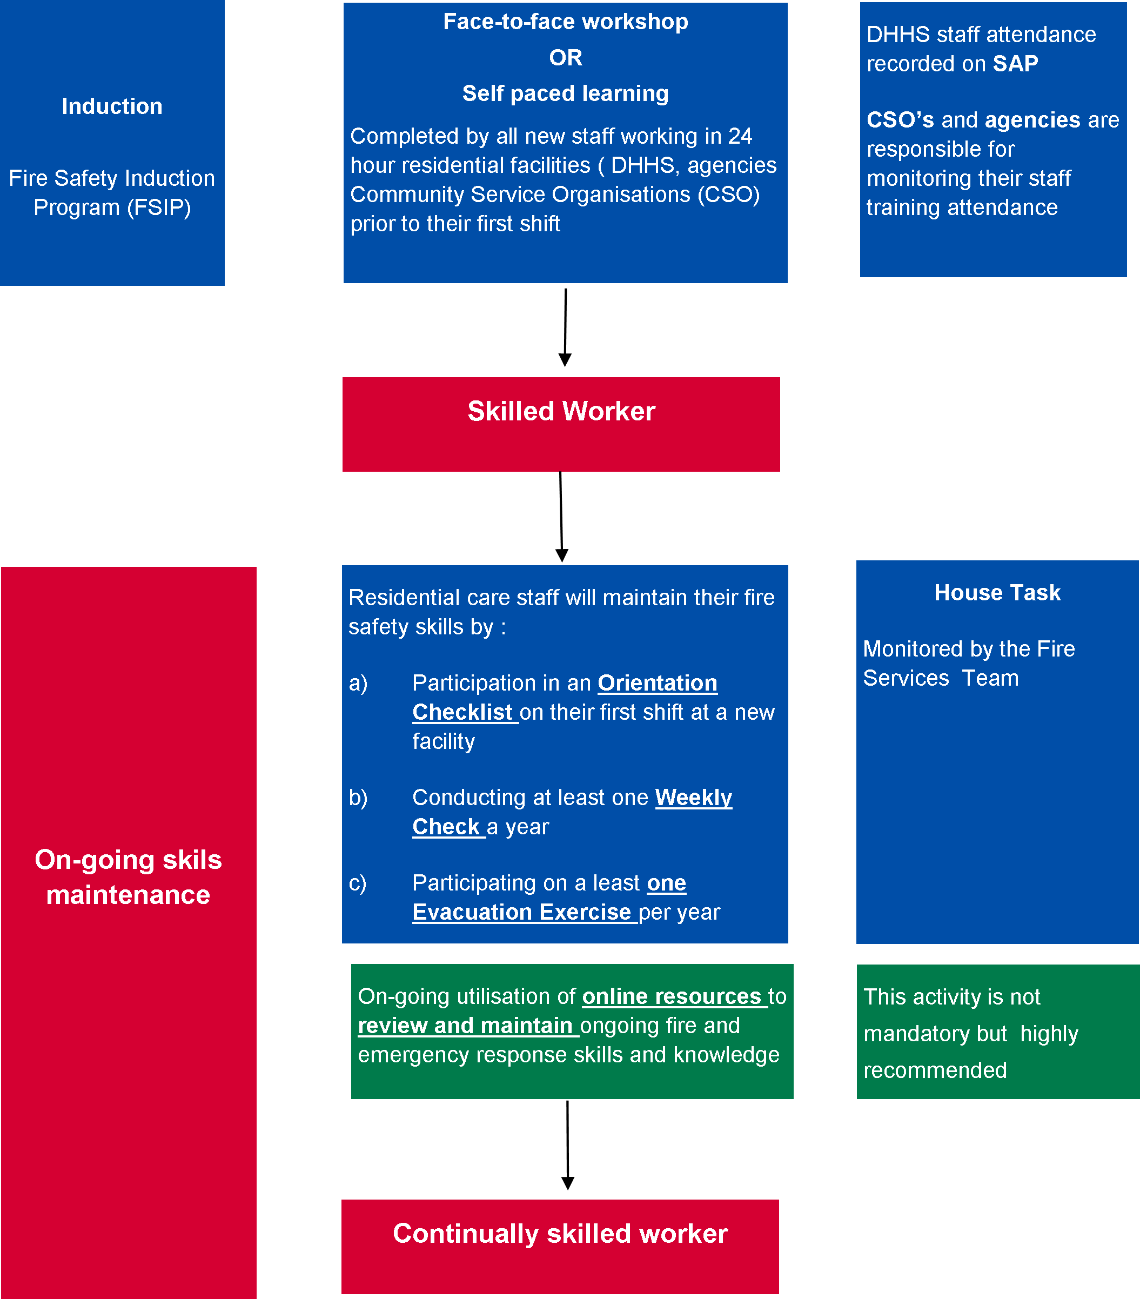

**NOTE:**

1. Department of Health and Human Services division training coordinators will be responsible for organising the training for DHHS staff.
2. Community service organisations and agencies will be responsible for organising the training for their newly recruited staff.
3. Staff are responsible for maintaining their ongoing fire and emergency prevention, preparedness and response skills. It is recommended that staff discuss their training requirements with their supervisor/manager to ensure their emergency management skills are maintained and if required, updated.
4. All new staff are expected the complete, as a minimum; the fire safety induction training program in a face-to-face workshop or via an online learning program (fire safety induction program) prior to undertaking their first shift in 24-hour supported residential accommodation facility
5. The use of first fire attack equipment by staff is no longer recommended as part of fire and emergency management with the exception of small fires which can be easily be extinguished by one fire extinguisher or fire blanket. The safety of people is a first priority which is addressed throughout risk mitigation strategies and controls, supported through an effective emergency management planning and procedures and installed passive and active fire protection equipment to manage any fire.
6. The use of fire extinguishers and fire blankets for attacking a fire will be explained in the induction program.
7. Managers will be able to access the online learning management system (LMS) to track and report the training of their staff.
8. Explanation or guidance in the use of the e-learning system may be provided to staff having difficulty in using the system. Assistance to complete the assessments is not allowed. Any concerns or difficulty in completing the training should be discussed with the relevant managers/supervisors.
9. The Department of Health and Human Services , Fire Services Team will be tracking the funded organisation compliance annually via annual emergency management competency certificate.

The online Fire Safety Induction Program resources are available on the [Fire Safety Induction Program on-line portal](http://dhhs.e3learning.com.au/) <http://dhhs.e3learning.com.au/>.

1. Guidance on determining emergency response team numbers

A sufficient number of emergency response team members need to be appointed to ensure that whenever the facility is occupied, emergency response team members are available to respond to a facility emergency and to enable the facility to be assessed and if required, evacuated quickly and efficiently without compromising any occupants’ and visitors’ safety.

The number of emergency response team members required for a facility will vary depending on the facility’s risk assessment which will consider all potential hazards and risks for each facility and include structural and occupant/visitor characteristics.

1. Facility and occupant characteristics in determining emergency response team numbers

| Facility structural characteristics | Occupant and visitor characteristics |
| --- | --- |
| 1. Occupancy, including:   facility classification  facility usage, particularly unusual uses.   1. Location, including:   proximity to other facilities and boundaries  proximity to other hazards (for example, bushfire-prone area)   1. Size and shape, including:   number and size of floors/zones/areas  layout  egress.   1. Structure, including:   construction materials  openings, shafts and ducts  ventilation and air movement.   1. Unusual features. 2. Hazards to occupants and visitors. 3. Fire safety measures. 4. Management and use. 5. Training of occupants. 6. Maintenance frequency and adequacy of maintenance regimes. 7. Firefighting concerns. | 1. Number, gender, age, location and state (for example, awake or asleep, intoxicated or sober, unconscious or fully conscious). 2. Physical attributes (for example, mobility, speed of travel). 3. Hearing ability. 4. Vision ability. 5. Mental attributes. 6. Level of understanding. 7. Potential emergency behaviour. 8. Ability to interpret cues. 9. Ability to take and implement decisions independently. 10. Level of assistance required (for example, requires full assistance, requires some assistance or does not require assistance). 11. Level of assistance available. 12. Shift schedules. 13. Staff, occupant and visitor numbers and type at any time in facility. 14. Emergency training for example trained or untrained. 15. Occupant (group) roles (for example, parent or child, teacher or student, nurse or patient, staff or customer). 16. Activity at the outbreak of fire (for example, asleep or awake). 17. Working in a noisy environment. 18. Watching a performance. 19. Familiarity with the facility (for example, unfamiliar, relatively familiar or familiar). |

In addition, to the above, the risk assessment will consider the following:

* + 1. previous fire safety audits
    2. fire and emergency history
    3. fire safety and risk engineering reports
    4. existing fire safety plans
    5. method of warning occupants and visitors
    6. evacuation strategy (staged, horizontal and so on)
    7. use of evacuation routes
    8. use of lifts.

Once a risk assessment has been completed and all of the necessary information has been analysed, an emergency management plan for the facility will be completed which will inform determining the appropriate number of emergency response team members to be selected.

The risk assessment shall be based on National Emergency Risk Assessment Guidelines because it provides a contextualised, emergency-related risk assessment method consistent with the Australian Standards AS/NZS ISO 31000:2009 Risk management – principles and guidelines. The risk assessment must be undertaken for each facility by a competent person. The outcomes of the risk assessment will depend on the facility’s function, location and environment and will identify those hazards that warrant specific risk mitigation and planning within the facility’s emergency management plan

1. Training courses for emergency planning committee and emergency response team members

Online emergency planning committee training is available on [Fire safety induction program for 24 hour supported accommodation](https://providers.dhhs.vic.gov.au/fire-safety-induction-program-24-hour-supported-accommodation) <https://providers.dhhs.vic.gov.au/fire-safety-induction-program-24-hour-supported-accommodation>.

Emergency planning committee (EPC) members are required to undertake training as part of the role of a manager of a 24-hour residential facility.

An online emergency planning committee learning program is required to be undertaken by all members. This package includes the following units from the public safetytraining package.

**NOTE:**

The subjects listed below will be reassessed from time to time as required; refer to practice notes for current subjects and courses.

* PUAWER001B – Identify, prevent and report potential workplace emergency situations
* PUAWER002B – Ensure workplace emergency prevention procedures, systems and processes are implemented
* PUAWER003B – Manage and monitor workplace emergency procedures, equipment and other resources
* PUAWER004B – Respond to workplace emergencies
* PUAWER005B – Operates as part of an emergency control organisation
* PUAWER006B – Lead an emergency control organisation
* PUAWER007B – Manage and emergency control organisation.

1. Skills and competencies for Emergency Planning Committee members

| Skills | Competencies identified as covering some of the skills | Training module |
| --- | --- | --- |
| Emergency identification and analysis | PUAWER001B PUAWER002B  PUAWER003B PUAWER004B  PUAWER005B PUAWER006B  PUAWER007B PUAWER008B | 6 |
| Identify safety systems and equipment | PUAWER001B PUAWER002B  PUAWER003B PUAWER004B  PUAWER007B | 9 |
| Occupant characteristic (s) | PUAWER005B  PUAWER006B  PUAWER007B | Gap ( to be determined ) |
| Human behaviour in an emergency situation | PUAWER005B  PUAWER006B | Gap ( to be determined |
| Risk management, develop and implement emergency plans and procedures | PUAWER003B  PUAWER007B | 4,7,8.12 |
| Relevant legislation, codes and standards | PUAWER003B  PUAWER007B | 2,3,10,11,12,  13,14,15 |
| Plan training and train small groups | TAEDEL301AB PUAWER001B  PUAWER004B PUAWER005B  PUAWER006B | 5 |

1. Bomb threat check list for telephone operators

An example of a typical phone threat and bomb threat checklist is provided below. It is reproduced from the Australian Bomb Data Centre Bomb Safety Awareness Kit, with the permission of the Australian Bomb Data centre.

1. Bomb threat check list for telephone operators

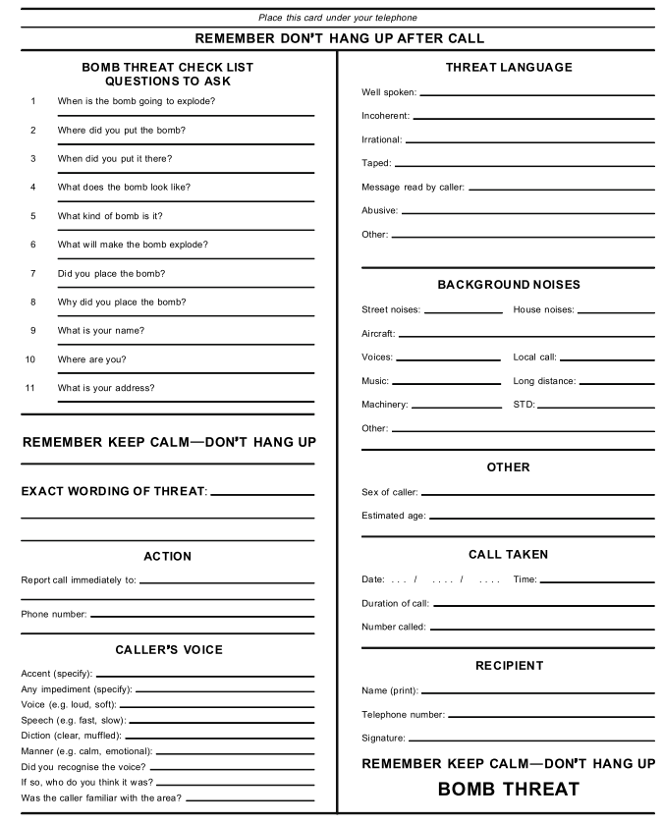

1. Form for description of offender

**Figure 20 Form for description of offender**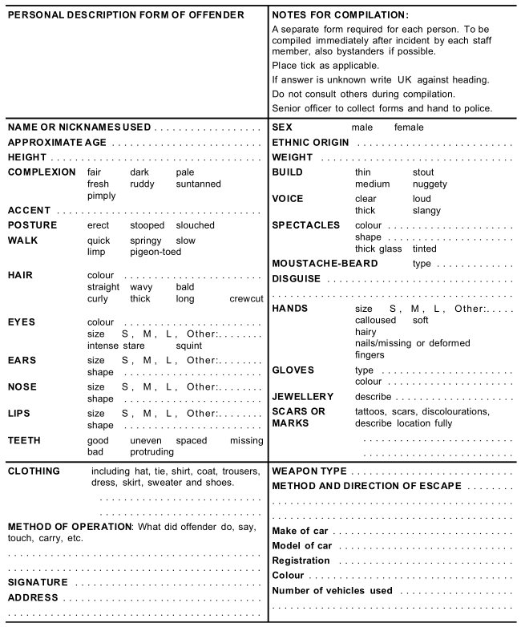

1. Example of an emergency evacuation exercise observer’s checklist
2. Example of an emergency evacuation exercise observer’s checklist

