

Human Services Standards Quality Forum feedback
Summary of feedback – 10 October 2016

Human Services Standards Quality Forum feedback

Introduction
The Department of Health and Human Services (the department) Standards and Regulation Unit (SRU) facilitated a quality forum on 10 October 2016, to provide organisations which had undertaken an independent review against the Human Services Standards (Standards) (gazetted as the Department of Health and Human Services Standards), with the opportunity to provide feedback on the process and share ideas for embedding quality and innovation.
As a result of previous feedback, a survey was sent out to participants prior to this year’s forum. Below is a summary of key feedback received from the survey and the forum. It is noted that in all areas there were mixed opinions given the range of people’s experiences and expectations.
SRU has provided some notes in this document (under the heading SRU response) to respond to the queries where it could. Feedback continues to be considered by SRU and continues to be provided to relevant stakeholders for their consideration
SRU would like to thank participants for attending the forum and providing this information.

Feedback from survey and forum

Q.1 Choice of independent review body
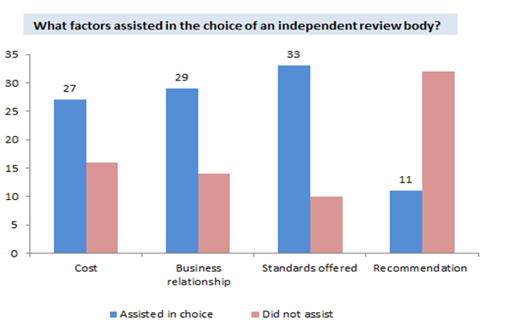
- When choosing an independent review body, 76.7 per cent of organisations considered the standards the independent review body offered, 67.4 per cent of organisations considered a previous or current business relationship and 62.8 per cent of organisations considered the cost.
- Approximately a quarter (25.6 per cent) of organisations considered a recommendation from someone else when choosing an independent review body.

Q.2 Has your organisation ever changed its independent review body?
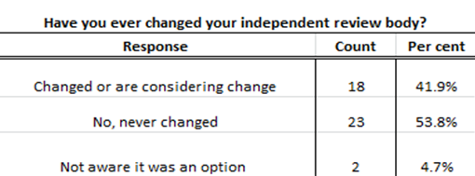

- More than half of organisations had never changed their independent review bodies, while 18 organisations had changed their independent review bodies in the past or were considering changing in the future.
- Only two organisations were unaware it was an option.

SRU response
  - Organisations considering changing their independent review body or needing more information should contact SRU via email at: hsstandards@dhhs.vic.gov.au
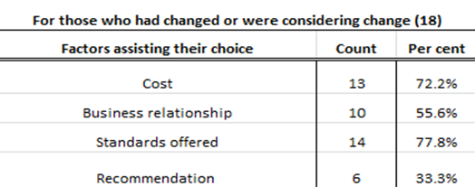
  - Where an organisation had changed or was considering changing their independent review body, cost and standards offered were the factors most frequently assisting them in their choice.

Q.3 Was your organisation able to locate the funded activity numbers for activities in scope of the independent review against the Human Services Standards?
  - Thirty-nine of forty-three (90.7 per cent) organisations responding to the survey could locate the funded activities in scope of the review.

Forum discussion
- Prior to your review, liaise with your department Local Engagement Officer (LEO), your finance person or the Funded Agency Channel (FAC) to clarify what activities are in scope for your review.
- If you have a complex service agreement and work in partnerships or sub-contracting arrangements, clarify with the department prior to submitting your scope to your independent review body (IRB).
- Double check your scope review prior to submitting to your IRB.
  - Break down the Effective Full Time (EFT) staff against each activity number or link EFT with client numbers.

SRU response
- Organisations should contact the person in the organisation responsible for managing their Service Agreement for details regarding the funded activity numbers. The organisation’s departmental local area contact will also be able to provide the organisation with this information.
  - SRU still receives reports with missing activity numbers and National Disability Insurance Agency (NDIA) registration groups.

Q.4 Were any of the following Department of Health and Human Services tools useful?
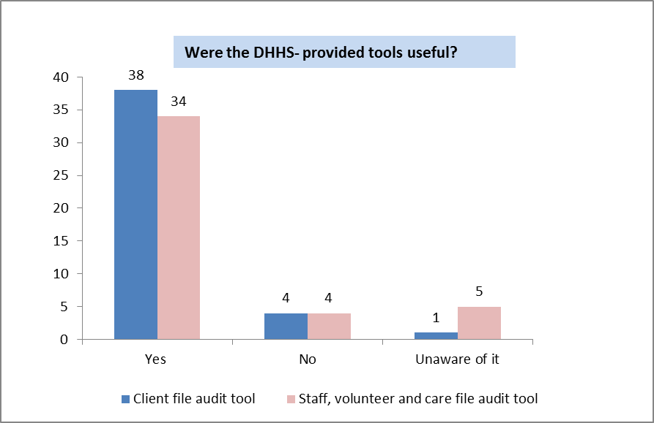
  - There was a positive view of the department provided tools with 38 organisations (88.4 per cent) stating that the client file audit tool was useful and 34 organisations (79.1 per cent) stating that the staff, volunteer and carer file tool was useful.
See links below for file audit tools:
Staff, volunteer and carer file audit tool
http://www.dhs.vic.gov.au/__data/assets/word_doc/0015/722013/Staff,-volunteerand-carer-file-audit-tool-11_2016.doc
Client file audit tool
http://www.dhs.vic.gov.au/__data/assets/word_doc/0017/722015/Human-Services-Standards-client-file-audit-tool.doc
Aboriginal culture resources were popular with organisations but a substantial number (up to 37.2 per cent) of organisations were unaware that the tools existed.
See link below to the Aboriginal culturally informed addendum to the Human Services Standards evidence guide:
http://www.dhs.vic.gov.au/__data/assets/pdf_file/0011/649667/Human_Services_Standards_evidence_guide_092015.pdf

Q.5 Have the review reports met your organisation’s expectations/needs?
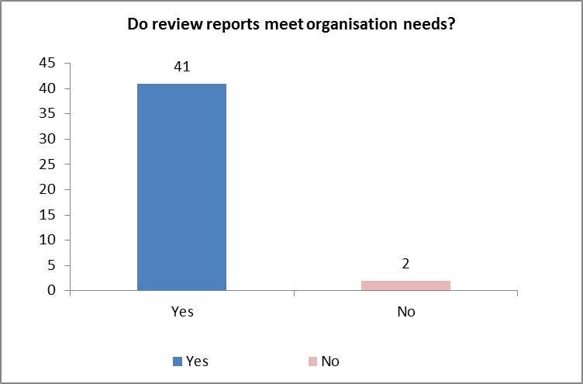
- Forty-one survey respondents felt that their review reports met their needs.
  - Two survey respondents said that their review reports did not meet their needs.

Q.6 Was the process required for non-conformities and notifiable issues easy to understand and complete?
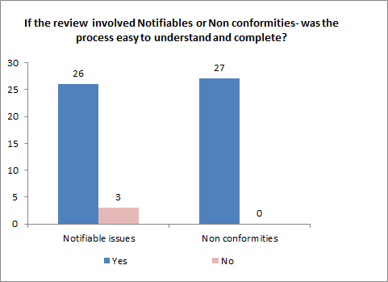
  - The majority of survey respondents reported that these processes were easy to understand and complete.
See link below for information on notifiable issues in the Human Services Standards Policy:
http://www.dhs.vic.gov.au/about-the-department/documents-and-resources/policies,-guidelines-and-legislation/human-services-standards

Q.7 Is your organisation required to meet other accreditations/certifications?
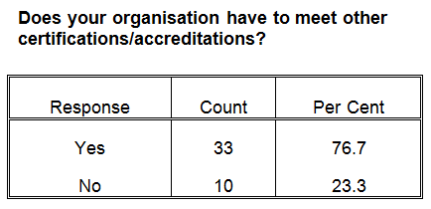
- Thirty-three organisations (76.7 per cent) were required to meet more than one certification/accreditation.
  - Where organisations did have to meet additional certification/accreditations, nine organisations (27.3 per cent) had to meet four or more additional certifications or accreditations.

Forum discussion
- Organisations need to be prepared.
- Organisations should have the evidence ready for auditors.
- Costs can be high.
- Participants stated it would be useful:
  - if there was recognition across standards to limit duplication
  - if the various standards could be mapped
  - to match cycles across the standards
  - to have a National Framework.

SRU response
Please refer to the IRB information on the department’s website, including the factsheet for selecting an independent review body:
http://www.dhs.vic.gov.au/about-the-department/documents-and-resources/reports-publications/human-services-standards-independent-review-bodies

Q.8 In regard to multiple reviews, how many additional accreditation/certification reviews does your organisation undertake?
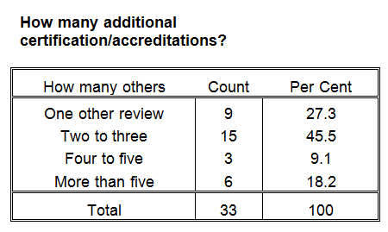

Q.9 Was your organisation able to combine some or all of its additional reviews?
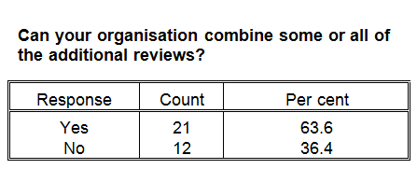
  - While the majority of organisations were able to combine their reviews, 12 organisations (36.4 per cent) were not able to.
Q.10 Was your organisation satisfied with the communication and the service provided by your independent review body?
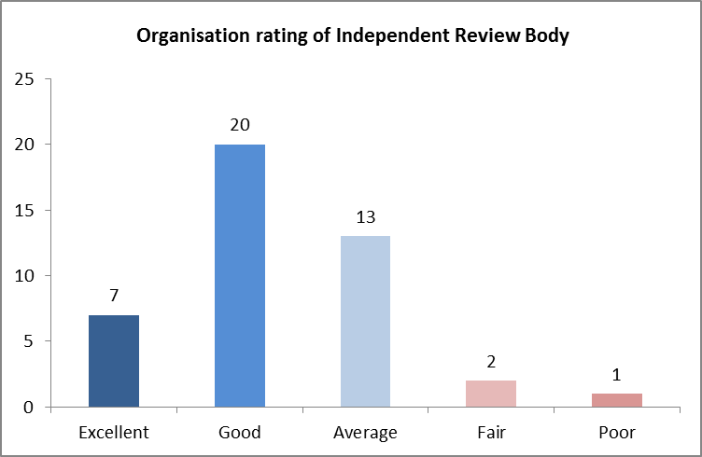
  - More than half (62.8 per cent) of survey respondents rated their independent review body either good or excellent.
Q.11 Was your organisation satisfied with the communication and the service provided by the Standards and Regulation Unit?
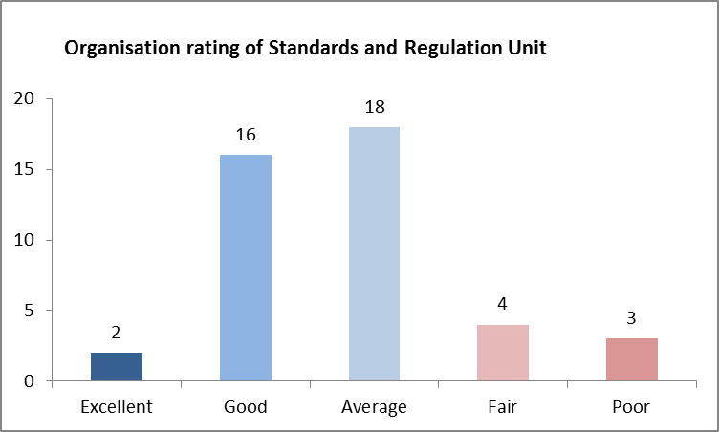
- Thirty-six of forty-three survey respondents rated SRU between fair and good.
  - Seventy-nine per cent of survey respondents found SRU email updates informative.

SRU Response
- SRU provides website updates, SRU updates, policy and tool updates and is reviewing its website for accessibility within the department’s guidelines.
  - Organisations wanting to be provided with these updates should email SRU at: hsstandards@dhhs.vic.gov.au

Q.12 Is your organisation satisfied with the communication and service provided by the department local office?
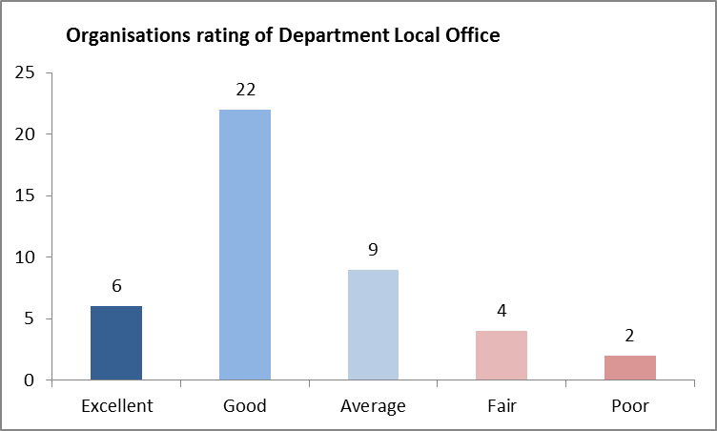
  - Just under two thirds (65.1 per cent) of respondents rated their department local office as either good or excellent.

Q.13 What is your organisation’s awareness of the following standards?
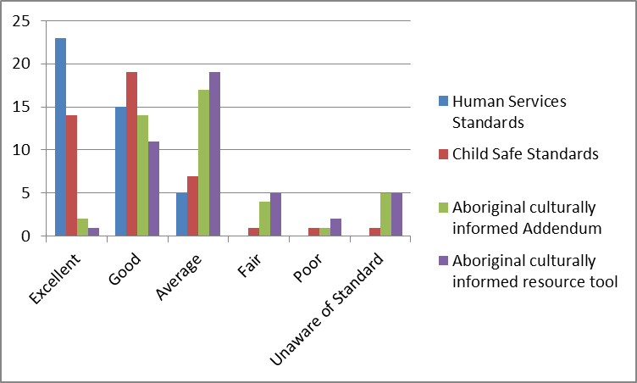
  - There was considerable variability in organisations’ knowledge of the four Standards and tools, with the Human Services Standards being well known and Child Safe Standards reasonably well known. Aboriginal culturally informed resources were less well known.

Q.14 Are you aware of the Aboriginal culturally informed addendum and Aboriginal culturally informed resource tools?

Survey response
- Thirty-seven per cent of survey respondents stated they were not aware of the Aboriginal culturally informed resource tool.
- Fifty-one per cent of survey respondents stated they had poor to average awareness of the Aboriginal culturally informed addendum.
- Sixty per cent of survey respondents stated they had poor to average awareness of the Aboriginal culturally informed resource tool.
  - Eleven per cent of survey respondents stated they were unaware of the Aboriginal culturally informed addendum and Aboriginal culturally informed resource tools.

Forum discussion
- Organisations are at different stages of using these tools.
- There are varying degrees of awareness and understanding of these tools.
- Participants recommended that the addendum expands to include Cultural and Linguistic Diversity, particularly newly arrived migrants and refugees, established migrant groups and the inclusion of other sub groups such as youth and Lesbian, Gay, Bisexual Transgender, Intersex and Queer communities.
- The tools are useful and supported the organisation in responding to other cultures.
  - Others felt that the tools are lengthy, repetitive, broad and not user-friendly.

SRU response
The department has developed culturally informed resource tools to provide guidelines for improved Aboriginal inclusion and access. Organisations are strongly encouraged to establish partners with their local Aboriginal Community Controlled Organisations (ACCOs) or Aboriginal Community Controlled Health Organisation (ACCHO) to assist their service planning and delivery.
For further information, organisations should contact their Local Engagement Officer, Aboriginal Partnership and Planning Officer and/or Senior Aboriginal Health Partnership Officer.

See links below for the following tools:
Child Safe Standards
http://www.dhs.vic.gov.au/about-the-department/documents-and-resources/policies,-guidelines-and-legislation/child-safe-standards-resources
Human Services Standards
http://www.dhs.vic.gov.au/about-the-department/documents-and-resources/policies,-guidelines-and-legislation/human-services-standards
Aboriginal culturally informed addendum to Human Services Standards evidence guide
http://www.dhs.vic.gov.au/__data/assets/pdf_file/0011/649667/Human_Services_Standards_evidence_guide_092015.pdf

Innovation and Sharing Ideas

Forum discussion
- Have Quality/Standards as a standing agenda item at team meetings.
- Have Quality and Risk as a standing agenda item at Executive Meetings and as a Key Performance Indicator.
- Review one of the Standards criteria per program team meeting (builds knowledge and understanding of the standards, encourages continuous improvement and staff can review the effectiveness of existing processes and practices).
- Make quality everyone’s business/responsibility.
- Have strong leadership/champion.
- Consistent commitment to reflect on practice and organisational systems, adapt practices and systems, support staff, listen to clients and make change.
- Use simple and easy to understand procedures (visual – use flow charts), so everyone can understand.
- Have cross program working groups to identify gaps, improve communication, and review policies.
  - Have robust quality systems in place to improve accountability, consistency, standardisation and transparency.

Presentation
In addition to discussing the survey and key areas, Connections UnitingCare (Connections) presented on Quality at Connections. The presentation provided an overview of the Connections Quality Management System (QMS) and how this system supports the organisation to maintain accreditation against several standards.
SRU would like to thank Connections for their generosity in sharing their story on embedding quality. Participants commented that it was important to hear from a peer and were grateful for Connections to share their learnings, experiences and processes.

To receive this publication in an accessible format phone (03) 9096 2745 or email hsstandards@dhhs.vic.gov.au
Authorised and published by the Victorian Government, 1 Treasury Place, Melbourne.
© State of Victoria, Department of Health and Human Services December, 2016

