

|  |
| --- |
| Family violence case management program requirements and crisis response model  Implementation overview V.4 (updated in March 2023) |

This document gives an overview of implementation activity for the case management program requirements and family violence crisis response model. It outlines key steps for Family Safety Victoria (FSV), working in partnership with Safe and Equal, as well as key activities to be undertaken by in-scope family violence service providers.

## Key updates and messages – March 2023

* The program requirements and key documents comprising the crisis response model are now available on the [Working with victim survivors](https://providers.dffh.vic.gov.au/working-victim-survivors-family-violence) < https://providers.dffh.vic.gov.au/working-victim-survivors-family-violence> landing page of the DFFH Service Providers website.
* **Family violence crisis response model:** All service providers in scope for the family violence crisis response model must align their operations with their roles, responsibilities and requirements under all components of the model from 1 August 2023. Earlier alignment is encouraged and will be supported.
* **Refuge eligibility and prioritisation framework:** FSV will finalise an interim statewide referral process (including an interim referral form) in May 2023 for commencement in June 2023. All in scope service providers should embed the eligibility and prioritisation criteria in their practice. Refuge providers should also increase their use of the Family Violence Accommodation Register.
* **Local family violence motel coordination projects:** FSV will convene a statewide workshop in April 2023, with representatives from all local projects, focused on the development of strategies to maintain system development beyond the projects. Projects will be finalised by July 2023.
* **Case management program requirements:** All in scope service providers should have updated their internal policy and procedure documents in line with their action plans. Service providers should now be reviewing and updating these action plans to incorporate any further actions required to embed the program requirements into their service delivery approach.

## Case management program requirements – released in December 2021

The family violence case management program requirements set out expectations for specialist family violence services in delivering case management for victim survivors. They aim to promote a response to victim survivors that is consistent, equitable, accessible and high-quality, no matter where they live or what support they need. The program requirements also set out the expectations for specialist family violence services providing a crisis response.

## Family violence crisis response model – released in November 2022

The family violence crisis response model has been developed to improve the way the family violence system works together to support victim survivors in crisis. The model outlines a concept of shared responsibility that promotes coordinated responses to victim survivors that are consistent, clearly communicated and jointly managed by the services involved. It also prioritises crisis support provided at the local level, where possible, and in line with victim survivor choice and safety. The model prioritises culturally safe responses and self-determination for Aboriginal victim survivors experiencing family violence crisis.

The crisis response model includes:

* [Family violence case management program requirements](https://providers.dffh.vic.gov.au/case-management-program-requirements) <https://providers.dffh.vic.gov.au/case-management-program-requirements> (these include requirements for crisis responses) – for Safe Steps, local family violence support services (including targeted services) and family violence accommodation services (refuges).
* [Roles and responsibilities in providing emergency accommodation](https://providers.dffh.vic.gov.au/roles-and-responsibilities-providing-emergency-accommodation-family-violence-crisis-responses)   
  <https://providers.dffh.vic.gov.au/roles-and-responsibilities-providing-emergency-accommodation-family-violence-crisis-responses> – for Safe Steps, The Orange Door, local family violence support services (including Aboriginal family violence services and other targeted services) and family violence accommodation services (refuges)
* [Roles and responsibilities after hours](https://providers.dffh.vic.gov.au/roles-and-responsibilities-after-hours-family-violence-crisis-responses) <https://providers.dffh.vic.gov.au/roles-and-responsibilities-after-hours-family-violence-crisis-responses> – for funded after-hours services – Safe Steps, Local Family Violence After Hours Services and Family Violence Accommodation Services (refuges).

FSV is also developing a monitoring and evaluation (M+E) framework for the crisis response model. The M+E framework will help monitor demand and evaluate alignment with and effectiveness of the model.

## Key system enablers – implemented in 2022 and 2023

The following key system enablers will support specialist family violence services to implement and align with the program requirements and crisis response model:

* The [Victorian family violence refuge eligibility and prioritisation framework](https://providers.dffh.vic.gov.au/victorian-family-violence-refuge-eligibility-and-prioritisation-framework) <https://providers.dffh.vic.gov.au/victorian-family-violence-refuge-eligibility-and-prioritisation-framework> which clarifies the model of referral, prioritisation and placement for family violence accommodation services (refuges).
* The Orange Door and Safe Steps Interface Guidance – which provides guidance across The Orange Door network and Safe Steps on their key operational interfaces, including coordination of crisis responses to victim survivors across both business and after hours.
* Key considerations for motel placement and relationship management – which provides guidance on identifying suitable motels, setting up and maintaining relationships with moteliers, and managing issues and incidents
* Local Family Violence Motel Coordination Projects – which aim to strengthen local area coordination of motel use for family violence emergency accommodation
* Enhancements to the Family Violence Accommodation Register (to improve access and usability) – which will help Safe Steps and refuge services to coordinate referrals to refuge and maintain equity of access for victim survivors in crisis.

## Funding and resourcing

The activities and service responses in scope for the case management program requirements and crisis response model are resourced through a mix of existing, ongoing and additional, fixed-term funding. Consecutive State Budgets since 2016 have included significant and sustained increases in funding to the specialist family violence service sector, including to:

* expand the volume and type of crisis accommodation properties available to respond to victim survivors
* increase the capacity of specialist family violence crisis and case management services
* expand family violence crisis brokerage to all local family violence support services.

This is complemented by additional investment from other sources, including the National Partnership on Family, Domestic and Sexual Violence Responses.

Total funding (in 2022–23) to specialist family violence services for crisis and case management responses for victim survivors has increased by more than 60 per cent since 2019–20. This is in addition to the significant increase in funding and service system capacity provided by the statewide roll out of The Orange Door, which was completed in October 2022.

Funding to support implementation of the case management program requirements and crisis response model was also allocated to all in-scope service providers in 2022.

## Key implementation milestones from November 2022

| Timeline | Milestones (delivered) |
| --- | --- |
| **November 2022** | Crisis response model   * FSV released outstanding crisis response model documentation: R&R for emergency accommodation, R&R for after hours and FAQs. * FSV and Safe and Equal hosted information sessions on the crisis response model (including Refuge eligibility and prioritisation framework). * Service providers identify and begin actions to embed their roles and responsibilities.   Key system enablers   * FSV released the Refuge eligibility and prioritisation framework and hosted information sessions. * FSV finalised updates to the Family Violence Accommodation Register. * All Local Motel Coordination Project lead service providers appointed project facilitators, established project groups and completed planning documents, including priority actions. |
| **December 2022 – February 2023** | Case management program requirements   * Service providers finalised operational and procedural documentation updates and started preliminary activities to embed the program requirements.   Crisis response model   * Service providers progressed actions to implement the crisis response model by aligning operations with their roles and responsibilities. * FSV and Safe and Equal provided support with preparation and change management.   Key system enablers   * FSV convened meeting with representatives from metro-based Local Motel Coordination Projects and statewide services. * FSV released communique for lead service providers of Local Motel Coordination Projects providing advice on engagement with statewide services along with other guidance responding to emerging issues. * Local Motel Coordination Projects finalise local system development action plans. |
| **Timeline** | **Milestones (planned)** |
| **By end April 2023** | Case management program requirements   * Service providers review their action plan for completeness and update with further actions to fully embed the program requirements.   Crisis response model   * FSV and Safe and Equal finalise and distribute an implementation readiness checklist – for local family violence support services (including Aboriginal family violence services and other targeted services) and family violence accommodation services (refuges).   Key system enablers   * FSV hosts a workshop for all Local Motel Coordination Projects to support strategies to maintain system development. |
| **By end May 2023** | Crisis response model   * Service providers notify their local DFFH Area (APSS) of any significant challenges related to alignment with the model from August 2023   Key system enablers   * Finalisation of an interim statewide refuge referral process that supports the Refuge eligibility and prioritisation framework for use from June 2023. |
| **By end June 2023** | Crisis response model   * FSV confirms any agreed staging and transitional arrangements for August to December 2023. * FSV and Safe and Equal provide support with preparation and change management.   Key system enablers   * **Service providers commence alignment with the Refuge eligibility and prioritisation framework, including increased use of the Family Violence Accommodation Register by all refuges across the state.** * Local Family Violence Motel Coordination Projects deliver final report.   Funding and resourcing   * Initial 2023–24 family violence crisis brokerage funding allocations confirmed. |
| **By end July 2023** | Crisis response model   * FSV and Safe and Equal provide support with preparation and change management. |
| **From August 2023** | Crisis response model   * **Service providers commence operating in alignment with their roles, responsibilities and requirements under all components of the crisis response model.** |
| **September - December 2023** | Crisis response model   * FSV and Safe and Equal provide implementation support and monitoring (in line with the M+E framework). * Any staging and transitional arrangements reviewed, with statewide alignment required by the end of December 2023**.**   Key system enablers   * FSV progresses work to enhance the statewide refuge referral process.   Funding and resourcing   * Final 2023–24 family violence crisis brokerage funding allocations confirmed. |
| **By end June 2024** | Crisis response model   * FSV and Safe and Equal provide implementation support and monitoring (in line with the M+E framework).   Key system enablers   * FSV implements the enhanced statewide refuge referral process. |

The following diagaram provides a visual representation of the reform projects and timelines as described in this document.

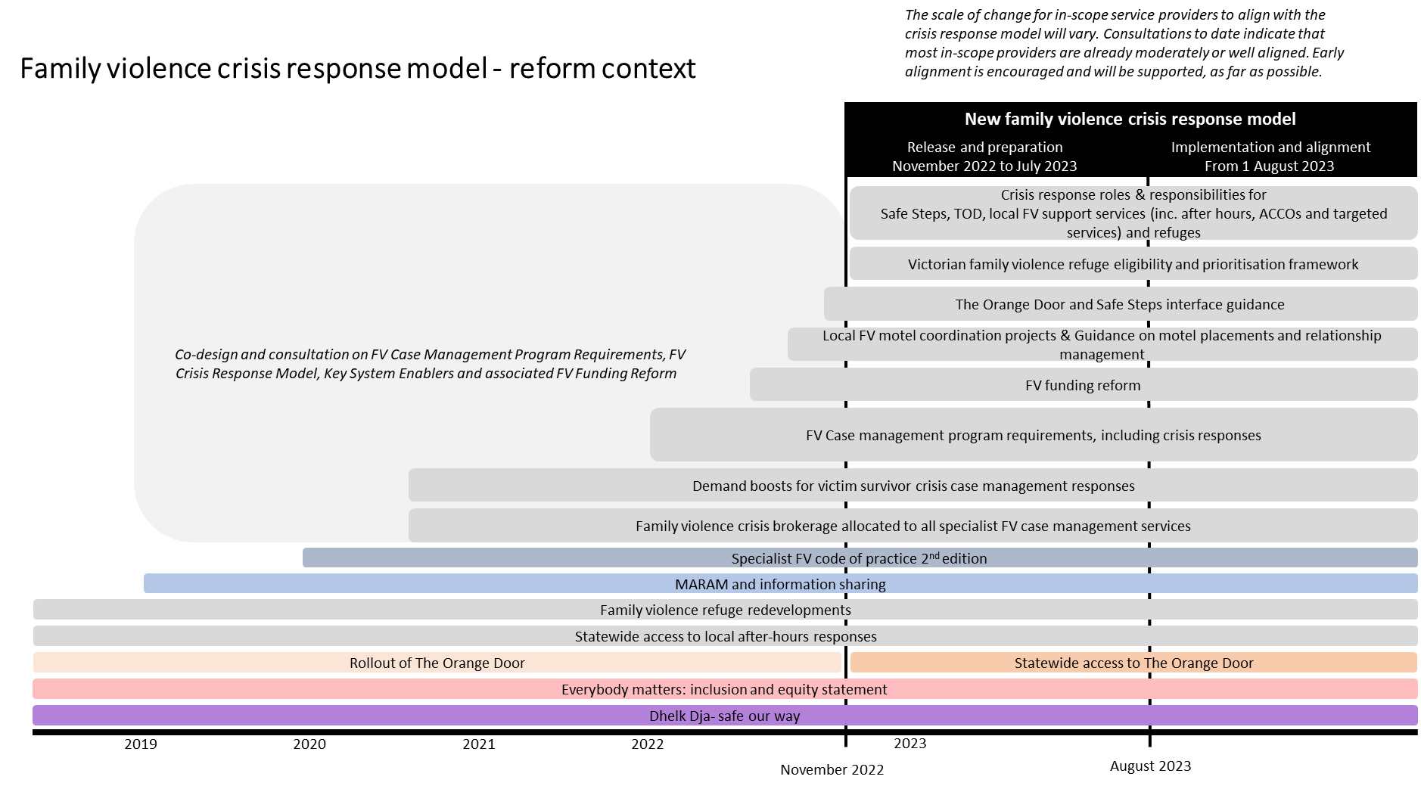

## Appendix: Implementation milestones delivered from 2019 to October 2022

| Timeline | Milestones (delivered) |
| --- | --- |
| **2019 to 2021** | Case management program requirements   * Co-design began in 2019–20; sector consultations over 2021 * Released in December 2021   Crisis response model   * Co-design began in 2019–20; sector consultations, including with ACCOs, over 2021   Funding and resourcing   * Family violence crisis brokerage allocated to all local family violence support services across the state, including ACCOs, from 2020 * Demand boosts allocated for family violence crisis brokerage and case management in 2020–21 and 2021–22, including to ACCOs |
| **January to July 2022** | Case management program requirements   * FSV held agency information sessions on program requirements * Service providers self-assessed their alignment of existing operations and procedural documentation with the program requirements using a self-audit tool   Crisis response model   * Consultation between March and June with the Specialist FV Sector Advisory Group, ACCOs and Safe and Equal on revised crisis response model   Key system enablers   * Consultation with Specialist FV Sector Advisory Group and Safe and Equal on Victorian family violence refuge eligibility and prioritisation framework, including updated refuge application form, and Key considerations for motel placement and relationship management * Consultation with Safe Steps and Safe and Equal on The Orange Door and Safe Steps Interface Guidance * Local Family Violence Motel Coordination Projects set up, including a Statewide Reference Group   Funding and resourcing   * Allocation of funding to support Local Motel Coordination Projects (in each Department of Families, Fairness and Housing Area) * Demand boosts (supported by National Partnership Agreement) for crisis case management services allocated over 2021–22 and 2022–23 * Initial 2022–23 family violence crisis brokerage funding allocations confirmed |
| **August - October 2022** | Case management program requirements   * Service providers completed and provided an action plan to local Agency Performance and Systems Support that, at a minimum, incorporates changes to align their operations and procedural documentation with the program requirements and identify other actions needed to embed the requirements   Crisis response model   * Consultation with the Victim Survivors' Advisory Council, ACCOs and the Specialist FV Sector Advisory Group on R&R for emergency accommodation, R&R for after hours and FAQs * FSV finalises outstanding crisis response model documentation: R&R for emergency accommodation, R&R for after hours and FAQs   Key system enablers   * FSV finalises the Victorian family violence refuge eligibility and prioritisation framework * Most Local Motel Coordination Projects appointed project facilitators and commenced data collection and planning. * Key considerations for motel placement and relationship management finalised and released * The Orange Door and Safe Steps Interface Guidance finalised and commenced   Funding and resourcing   * Two years of additional funding (2022–23 and 2023–24) allocated to respond to increasing demand for crisis case management services, including for the crisis response model * Final 2022–23 family violence crisis brokerage funding allocations confirmed |