

|  |
| --- |
| Emergency Planning Committee  Participant manual |
|  |

Department of Health

To receive this publication in an accessible format [email Centre for Learning and Professional Development](mailto:learning@dhhs.vic.gov.au) <learning@dhhs.vic.gov.au>

Authorised and published by the Victorian Government, 1 Treasury Place, Melbourne.

© State of Victoria, Department of Health and Human Services, April 2019.

Available from the department’s website < <https://providers.dhhs.vic.gov.au/fire-safety-induction-program-24-hour-supported-accommodation>>

>

Contents

1. Introduction 5

What is an Emergency Planning Committee? 5

2. Standards and requirements 6

2.1 Fire risk management 6

2.2 Capital Development Guidelines 7

2.3 Fire & Emergency Response Procedures Training Framework 9

2.4 Australian Standard 3745:2010 Planning for emergencies in facilities 9

2.5 Fire Service Agreement 10

3. Emergency Planning Committee 11

3.1 Emergency Planning Committee Definition 11

3.2 Emergency Planning Committee Scope 11

3.3 Emergency Planning Committee Membership 11

3.4 Emergency Planning Committee Roles and Responsibilities 12

4. Establish and implement an Emergency Plan 13

4.1 Establish and implement the Emergency Plan 13

4.2 Emergency Management Planning 13

4.3 Emergencies 14

4.4 Emergency Response Procedures Manual 16

4.4 Emergency Response Procedures Manual 19

5. Hazard Management 23

5.1 Identifying Hazards 23

5.2 Analysing Hazards 23

6. Planning for and managing human behaviour 26

6.1 Human Behaviour 26

6.2 Planning for Human Behaviour 26

6.3 Training for Human Behaviour 26

6.4 Evacuation Packs 27

7. Establish an Emergency Control Organisation 29

7.1 What is the Emergency Control Organisation 29

7.2 ECO Structure 29

7.3 ECO Authority 29

7.4 ECO Roles and Responsibilities 29

7.5 ECO Identification 32

7.6 ECO training schedule 33

8. Bushfire Survival Plans 35

8.1 Bushfire Overview 35

8.2 Bushfire Survival Plans 35

8.3 Victorian Fire Risk Register – Bushfire (VFRR-B) 36

8.4 DHHS Bushfire Response: Clients and Services Policy 36

8.5 Total Fire Ban Days 37

8.6 Fire Danger Rating scale 37

Extreme 38

Severe 38

Very high, high, low-moderate 38

8.7 Emergency Information and Warnings 39

8.8 How Bushfires occur 40

8.9 Bushfire Behaviour 40

8.10 Bushfire Procedures 42

9. Wrap up 44

Thank you 44

Remember 44

# 1. Introduction

Welcome to the **E**mergency **P**lanning **C**ommittee Training Course The purpose of this training is to give you clear guidelines on your role in developing and updating residential Fire and Emergency Response Procedures and, where relevant, Bushfire Survival Plans

## What is an Emergency Planning Committee?

A group or committee consisting of at least 2 people responsible for the development, implementation and maintenance of the emergency plan, emergency response procedures and related training in a building or facility.

# 2. Standards and requirements

## 2.1 Fire risk management

The Department of Health and Human Services (DHHS) is committed to providing safe and secure buildings for its staff and clients

Fire is a serious safety risk, and DHHS recognises the risk can be greater where accommodation is provided or impairments exist with clients

To ensure effective Fire Risk Management (FRM) the **primary objectives** of DHHS’s approach to FRM includes:

* Keeping people in DHHS facilities (clients, staff and visitors) safe from illness or injury due to fire
  + Complying with relevant fire safety and occupational health and safety laws

Other FRM objectives include:

* Maintaining DHHS services to the Victorian community
* Minimising disruption to DHHS operations
  + Protecting assets

**Life safety takes precedence over asset protection**

Effective FRM relies on a complex interaction between a range of factors including:

* Client and staff profiles
* Building type and use
* Building compliance
* Fire safety measures such as fire alarm, detection, suppression, and life safety and emergency exit lighting
  + Emergency management measures such as fire and emergency evacuation plans, emergency procedures and fire emergency procedures training

DHHS’s approach to FRM is the process of determining whether an appropriate level of fire safety is achieved by undertaking:

* Fire safety audits
* Fire safety compliance checks
  + Fire risk assessments (where necessary)

Key components of DHHS’s FRM include the Capital Development Guidelines (CDG’s) and the Fire and Emergency Response Procedures and Training Framework (FERPTF)

## 2.2 Capital Development Guidelines

The Capital Development Guidelines (CDGs) outline DHHS policies, procedures and processes designed to manage the risks to life due to fire in certain types of buildings or facilities which are owned, operated or funded by DHHS.

The comprise the following documents:

* **Guideline 7.0** - First time users
* **Guideline 7.1** - Policy and procedure
* **Guideline 7.2** - Engineering guidelines
* **Guideline 7.3** - Secure facilities
* **Guideline 7.4** - Supported community based houses
* **Guideline 7.5** - Congregate care facilities
* **Guideline 7.6** - Hospitals
* **Guideline 7.7** - Community based houses
* **Guideline 7.8** - Single dwellings
* **Guideline 7.9** - Multi-storey housing
* **Guideline 7.10** - Accommodation buildings
* **Guideline 7.11** - Short Term Emergency Accom.
  + **Guideline 7.12** - Disaster recovery facilities

The CDG’s set out requirements for:

* Physical fire safety measures (fire alarm, detection, suppression systems)
* Emergency management
* Emergency Evacuation Diagrams
* Emergency Procedures Manuals
  + Fire and Emergency Training

### Applicability of CDG’s

Buildings which do not provide bed-based care or sleeping accommodation for clients are not required to comply with the Guidelines unless they intrinsically form part of a building or facility that does.

In this course we focus on the following facility types:

* Guideline 7.3 - Secure Facilities
* Guideline 7.4 - Supported community-based houses
* Guideline 7.5 - Congregate Care Facilities
* Guideline 7.7 - Community-based houses
  + Guideline 7.11 - Short Term Emergency (Contingency) accommodation

**CDG 7.3 Secure Facilities**

Secure Facilitates provide accommodation and education for children or young adults (typically under 18 years) who are subject to a court order for secure welfare.

**CDG 7.4 Supported Community-Based Houses**

The key characteristics of Supported Community-based houses include:

* Domestic style residential care buildings
* Accommodation for up to 8 clients who may have physical and/or intellectual disabilities
  + 24 hour staffing (may be sleep-over or up right active) when clients are present

Note: Staff are not considered clients.

**CDG 7.5 Congregate Care Facilities**

* Congregate Care Facilitates are larger residential accommodation buildings requiring 24 hour care which provide accommodation for:
* More than 8 clients who may have physical and/or intellectual disabilities or
* More than 8 clients who are children or young adults (typically under 18 years, but up to 21 years) or
* Accommodation for the aged who may not necessarily require assistance to evacuate or
  + Mental health facilities

**CDG 7.7 Community-Based Houses**

The key characteristics of Community-based houses include:

* Small domestic style buildings
* Accommodation for up to 8 clients, where generally no more than 1 client requires assistance to evacuate in an emergency
  + 24 hour staffing (may be sleep-over or up right active) when clients are present

**CDG 7.11 Short Term Emergency (contingency) Accommodation**

Short term emergency accommodation includes buildings/facilities provided for children and young people in out-of-home care or persons with a disability assigned to the Department.

Occupation of these buildings is limited to a maximum of 6 months for clients.

## 2.3 Fire & Emergency Response Procedures Training Framework

The Fire and Emergency Response Procedures and Training Framework (FERPTF) provides a set of standards and guidelines for the management of emergencies including:

* Fire safety training (FSIP)
* Fire and emergency response procedures
  + Organisational structures for emergency management

All properties covered by the FERPTF must have an Emergency Planning Committee (EPC) and an Emergency Control Organisation (ECO).

The FERPTF is consistent with:

* The Occupational Health and Safety Act 2004
* The Occupational Health and Safety Regulations 2007
  + Australian Standard 3745:2010 - Planning for emergencies in facilities.

## 2.4 Australian Standard 3745:2010 Planning for emergencies in facilities

*AS3745* outlines the minimum requirements for the establishment, validation and implementation of an emergency plan for a facility.

It aims to ensure safety of occupants of that facility and its visitors leading up to, and during an emergency.

The standard includes the following:

* The formation, purpose, responsibility and training of the emergency planning committee
* Emergency identification
* The development of an emergency plan
* The development of emergency response procedures
  + The establishment, authority and training of an emergency control organisation and
  + The testing and validation of emergency response procedures
  + Emergency related training (e.g. Warden or Fire extinguisher training)

### Activity 1 – Evacuation Diagrams

**Discussion**

In groups using the activity booklet identify at least 1 minimum element in relation to the construction of Evacuation diagrams as listed in AS3745.

## Evacuation diagram2.5 Fire Service Agreement

The CEO of an organisation is required to sign off a certificate of compliance annually for every residential facility. This will state that the facility is compliant with all fire safety and risk management audits and practices.

An EPC must be aware of their responsibility to ensure compliance with the relevant components of the Agreement is met.

# 3. Emergency Planning Committee

## 3.1 Emergency Planning Committee Definition

All DHHS facilities must have an EPC. The Fire and Emergency Response Procedure and Training Framework defines the EPC as:

*“A committee responsible for establishing an emergency plan, setting up the Emergency Control Organisation and establishing a training, drill and exercise regime.”*

## 3.2 Emergency Planning Committee Scope

In regards to:

* Secure Facilities with LESS than 21 clients (CDG 7.3)
* Supported community-based houses (CDG 7.4)
* Congregate Care Facilities (CDG 7.5) and
  + Community-based houses (CDG 7.7),

the FERPTF specifies the following requirements for the EPC:

“An EPC shall be appointed for the facility/building, may have responsibilities for more than one building or facility and would not normally work in the facility/building.

The EPC must be available to the Chief Warden and Nominated Fire Risk Management Officer and should visit the facility at least once per calendar year.”

For Secure Facilities with MORE than 20 clients:

“An Emergency Planning Committee shall be appointed for the facility/building consisting of management and staff from the facility/building.”

## 3.3 Emergency Planning Committee Membership

The EPC should include members of the senior management team responsible for the facility or group of facilities and the Nominated Fire Risk Management Officer.

NOTE: The EPC of any given facility reserves the ability to engage subject matter experts to assist in their scope.

### Activity 2 – EPC

**Discussion**

In groups outline experts or officials that may be consulted to assist with the EPC scope?

## 3.4 Emergency Planning Committee Roles and Responsibilities

The responsibilities of the EPC are consistent with those outlined in AS3745:2010

**Supported community-based houses (CDG 7.4) and Community-based houses (CDG 7.7)**

* Establish and implement emergency plans for each facility.
* Establish the ECO for the facility.
* Arrange for appropriate training.
* Review the effectiveness of the emergency arrangements and evacuation exercises (including client capabilities).
  + Establish first aid procedures.

**Supported community-based houses (CDG 7.4) and Community-based houses (CDG 7.7)**

In the event of an emergency:

* Establish plans for the continued operation of the facility involved in an emergency
* Ensure that the media is dealt with (usually through the Media Unit)
* Provide briefings for relatives where necessary
* Prepare announcements to staff
  + Establish and maintain liaison with senior executives.

**Secure facilities (CDG 7.3) and Congregate Care facilities (CDG 7.5)**

* Establish and implement an emergency plan.
* Ensure personnel are appointed to all positions on the ECO.
* Arrange for the training of the ECO in accordance with DHHS policy.
* Review the effectiveness of the ECO and evacuation exercises.
* Establish an Emergency and Fire Control Centre where required.
  + Establish first aid procedures as part of the emergency plan.

**Secure facilities (CDG 7.3) and Congregate Care facilities (CDG 7.5)**

In the event an emergency:

* Receive briefings and provide support to the Chief Warden as necessary
* Provide technical information to the Chief Warden
* Establish plans for the continued efficient operation of the facility
* Ensure that the media is dealt with usually through the Media Unit
* Provide structured briefings for relatives
* Prepare announcements to staff
* Establish and maintain liaison with senior executives of the organisation

Post incident/ emergency:

* Consider participating in debrief at facility
* Review the incident response
* Ensure the procedures adequately addressed the emergency
* Review the procedures as required
* Ensure staff and wardens in place were prepared for response
* Review training as required

# 4. Establish and implement an Emergency Plan

## 4.1 Establish and implement the Emergency Plan

Creating an emergency plan is a critical role of the EPC.

Generic DHHS procedures for small residential facilities are documented in the “Fire and Emergency Response Procedures Manual”

* Template used for community-based and supported community-based facilities (CDG 7.7, CDG 7.4)
* Must be modified to suit location
  + Has user guide for use to prepare manual

## 4.2 Emergency Management Planning

Generally, emergency management planning is organised around four phases:

### Prevention

Prevention is the result of strategies and services to reduce the frequency or lessen effects of emergency incidents.

Strategies include:

* Fire safety audits
* Housekeeping
* Electrical checks
* Safe cooking
* Smoke free
* Obstruction free egress
* Client behaviours
  + - Hoarding
      * Arson
* Storage of combustibles
* Fire awareness
  + - No electric blankets
      * No portable heaters*

### Preparedness

Preparedness is the result of strategies and services to position people in the workplace to respond to emergency events quickly and effectively.

Strategies include:

* Preparing emergency plan
* Maintaining emergency equipment
* Establishing Emergency Control Organisation
* Identifying suitable emergency assembly area/s
* Emergency training
* Emergency exercises/drills

### Response

Activities designed to contain, control or minimise the immediate impacts of an emergency

Strategies include: **RACE**

* Removing persons in immediate danger
* Alerting the emergency services and residents/clients or visitors/contractors
* Contain the incident by limiting access of suppressing
  + Evacuating the facility proceeding to a designated safer place

### Recovery

Activities designed to minimise disruption to a facility post incident occurrence

Strategies include:

* Counselling for residents and staff (C.I.S)
* Debriefing ECO members and other staff
* Briefings for relatives
* Preparing a report for senior executives
  + Reviewing the effectiveness of response procedures

## 4.3 Emergencies

What is an emergency?

* “a serious, unexpected, and often dangerous situation requiring immediate action” (Oxford Dictionary)
  + “Any event (internal or external) which may adversely affect persons and which requires an immediate response” (AS 3745)

### Building Emergencies - can occur at any time

**Human**

* Bomb, Bomb Threat
* Building Invasion
* Armed Intrusion
* Personal Threat
* Chemical, biological Radiological/nuclear
* Civil disorder
* Medical Emergency
* Arson
  + Explosion

**Natural**

* Bushfire/Grass fire
* Cyclones incl. storm surge
* Earthquake
* Explosion
* Fire and Smoke
* Flood
  + Severe weather/storm

**Technological**

* Hazardous substances incidents
* Industrial incidents
* Electrical incidents
* Structural instability
* Transport incidents
  + Toxic emissions

### Further Developments of Emergency Situations

* Air contamination
* Hazardous materials
* Danger of explosion
* Risk of cross-infection
* Environmental impacts
* Risk of threatening behaviour
* Injury
* loss of life or property
* Loss of communications
* Structural collapse
* Loss of containment
* Exposures
* Vapours, fumes, gases
* Reaction of people to the emergency
  + Spread of hazard/incident area

### Activity 3 – Emergency Identification

**Discussion**

In groups analyse the following facilities determining:

* Emergencies likely to impact them and
  + Further developments

Facility 1



Facility 2

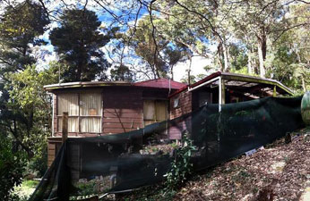

Facility 3

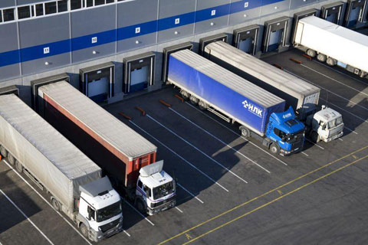

## 4.4 Emergency Response Procedures Manual

### Command & Control

The procedures should consider the options given to the leaders of an Emergency Control Organisation (ECO) in AS3745 including:

* Evacuation (Full / Partial)
  + - Fire, internal hazards
* Shelter in place
  + - Weather events, external hazards
* Lock down
  + - Civil disturbance, gunman loose in area, protests
  + No immediate action required (stand-by)
    - * Waiting for confirmation of incident

### Characteristic of the facility

The characteristics of the facility should be considered when developing emergency response procedures, including:

* Construction type
  + - Brick veneer
      * Weatherboard
* Layout
  + - Location of kitchen, laundry, bedrooms
* Fire safety measures
  + - Passive fire protection (fire rated doors walls)
      * Active fire protection (sprinkler systems)

### Client and staff profiles

Client and staff profiles should also be taken into account when developing emergency response procedures.

**Staff profile:**

|  |  |
| --- | --- |
| Staffing Profile | Staffing arrangement |
| Type 1 | No staff present |
| Type 2 | Staff present only as required |
| Type 3 | 24hr staff – sleepover |
| Type 4 | 24hr staff – active night |

**Client profile:**

|  |  |  |  |  |  |
| --- | --- | --- | --- | --- | --- |
| Ambulant (Type 1) | Ambulant (Type 2) | Ambulant (Type 3) | Non-ambulant (Type 4) | Non-ambulant (Type 5) | Non-ambulant (Type 6) |
| Able to respond to an alarm.  Able to independently evacuate without staff present. | Able to respond to an alarm.  Can evacuate with staff intervention or evacuate independently with a delay.  Evacuation plan may include providing verbal instructions, limited physical assistance. | Not able to understand or respond to an alarm but, can evacuate with staff intervention. | Able to understand and respond to an alarm but, may not be able to evacuate independently or, will take extra time to evacuate independently.  They will require verbal instructions and substantial physical assistance. | Not able to understand or respond to an alarm and not able to evacuate without physical assistance.  The client will require verbal instructions and substantial physical assistance from staff to evacuate. | Cannot be evacuated (i.e. on life support or similar). |

### Duties and responsibilities:

The emergency response procedures should detail the actions to be taken in an emergency by staff, occupants and visitors, including the duties of the ECO.

### Communication:

The response procedures should include the methods of warning and communication to be used during an emergency, including the communications equipment.

### Emergency Service Organisations (ESO’S)

ESO’s have a statutory responsibility for the control and suppression of particular incidents as determined by the Emergency Management Act and manual.

While one ESO may have control, support agencies will assist the control agency to combat some incidents (e.g. POL CFA AV MVA)

### Victoria Police

Control Agency for incidents such as:

* Aircraft, marine, rail or road incidents
* Food supply, critical infrastructure damage
* Explosive device
* Heatwave
* Cave, land, mine rescue
  + Threats against person/s, property, environment

### Fire Service – Country Fire Authority Metropolitan Fire Brigade

Control Agency for incidents such as:

* Fire
* Gas leakage
* Building, rail, road, trench rescue
* Hazmat or dangerous goods incidents
* Lifts, cranes, scaffolding and amusement structures
* Pollution inland waters
* Explosion
  + Pressure vessels

### Ambulance Victoria

Control Agency for incidents such as:

* Emergency medical care
  + Emergency medical transport

### State Emergency Service

* Control Agency for incidents such as:
* Earthquake
* Flood
* Storm
* Tsunami
  + Building, rail, aircraft, industrial, and road rescue (depending on location)

**Emergency Management Victoria: A statutory body that coordinates emergency management policy.**

The Emergency Management Commissioner leads the coordinated response of Victoria’s emergency management sector. This includes most large scale, complex emergencies such as:

* Fires
* Floods
* Storms
* Earthquakes
* Structural collapses
  + Chemical Spills

EMV are currently reviewing the FERPTF for DHHS to ensure compliance with relevant standards and legislation including actions/involvement on high risk bushfire days.

### Activity 4 – Emergency Control Agencies

**Discussion**

In groups list emergency service organisations likely to be in attendance at the following incidents:

* Motor vehicle accident
* Fire
* Earthquake
  + Chemical spill

### Emergency control point:

Consideration should be given to identifying an Emergency Control Point (ECP).

An ECP is defined as a location from which the ECO can control the response and liaise with ESO’s.

### Activity 5 – Emergency Control Point

**Discussion**

In the event that a facilities Emergency Control Point has been compromised by fire where would a default position be recommended?

## 4.4 Emergency Response Procedures Manual

### Emergency response equipment:

The response procedures must include instructions on the use of emergency response equipment in the facility.

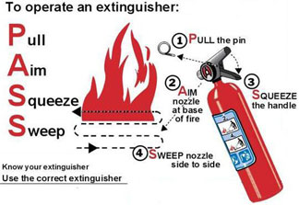

Portable fire extinguishers: dry chemical

Using the Brooks Alarm 2000 or Other Fire Indicator Panels?

Can staff operate and interpret these systems?

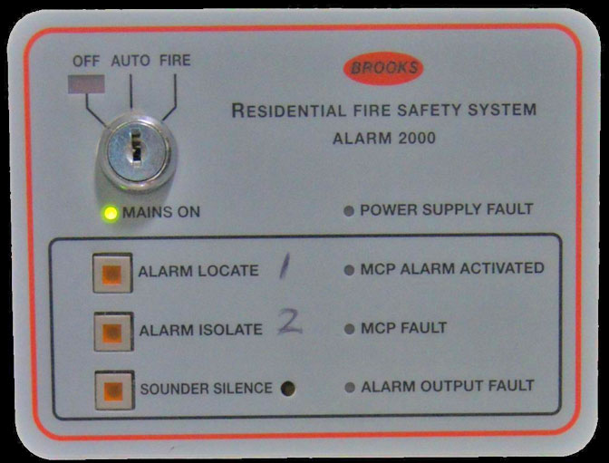

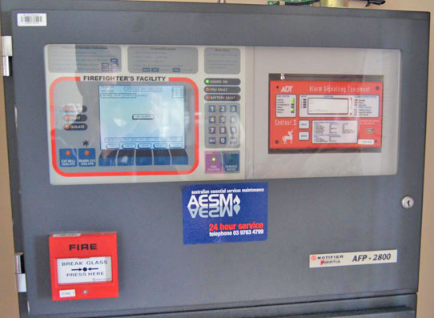

### What warning systems exist for the site?

* Alert Tone (Beep – Beep)
  + - Stand-by
* Evacuation Tone (Whoop – Whoop)
  + - Evacuate

### Emergency response equipment:

Residential fire sprinkler systems

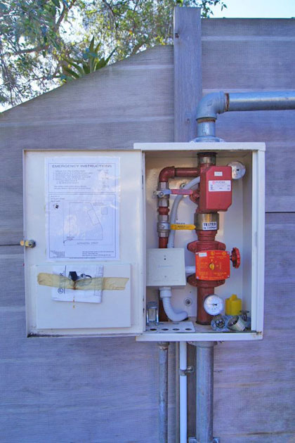

### Emergency Assembly Area(s) selection

The assembly area should be located in a position that provides protection from the emergency for the evacuees. Other factors to take into consideration include:

* The route being safe and free from obstructions
* Accessible by the impaired
* Access for emergency services not hindered and
  + Allowing for further movement by evacuees

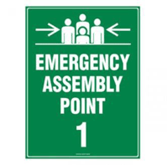

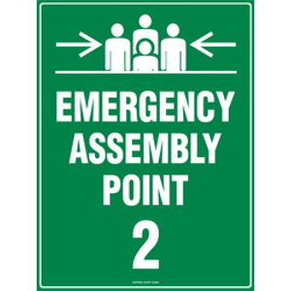

### Order of evacuation

* Ambulant
  + - people who don’t require assistance
* Semi Ambulant
  + - people who may require assistance
* Non Ambulant
  + - * people who require assistance

### Client Evacuation Management Plans

As identified in ‘client profiles’ some occupants may have trouble responding to an alarm, requiring instruction or physical assistance.

AS3745 requires the development of Personal Emergency Evacuation Plans (PEEP) for people who require assistance to evacuate.

The DHHS Manual Template provides for development of ‘Resident Evacuation Management Plans’.

Important consideration should be given to developing PEEP’s Pre-emergency.

**Pre – Emergency:**

* Ensure PEEP’s completed for all persons requiring them
* Position least ambulant or impaired in rooms nearest the emergency exits
* List requirements for action (mobility aids, hoists)
  + Store copies of PEEP’s in Evacuation Packs

Important consideration should be given to developing PEEP’s Pre-emergency.

**Post – Emergency:**

* Review the effectiveness of the PEEP
  + Discuss with client if necessary

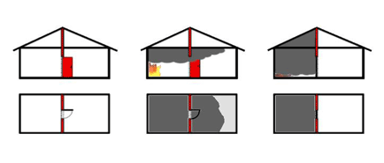

* Integral building system
* Contain fire, smoke and heat
  + Rated up to 4 hours

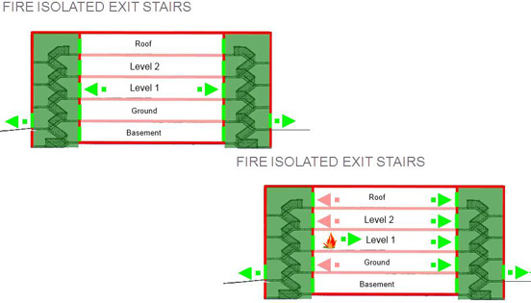

# 5. Hazard Management

## 5.1 Identifying Hazards

**What is a hazard?**

A hazard is something that can cause harm, e.g. electricity, chemicals, working up a ladder, noise stress, etc.

**What is a risk?**

A risk is the chance, high or low, that any hazard will actually cause somebody harm.

A number of factors should be taken into account when identifying risks and potential emergencies in your facilities including:

* The size and complexity of the facility
* Physical safety measures installed
* Occupant and staff profiles (staffing hours if at all)
* The location of the facility
* The number and nature of visitors
  + Proximity of commercial or industrial sites

## 5.2 Analysing Hazards

Hazard analysis involves developing an understanding of hazards by considering what causes the hazards and then assessing the level of risk associated with the hazard.

**Likelihood VS Consequence**

The Fire and Emergency Response Procedures Manual Template User Guide provides a set of criteria to label and rate the likelihood and consequence.

Likelihood:

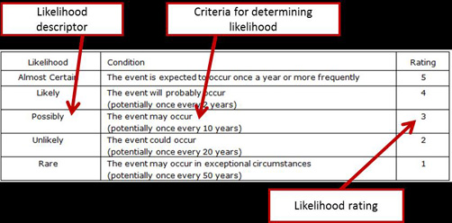

When considering the consequence the DHHS risk analysis process applies an impact rating to both occupants and the facility.

Consequence:

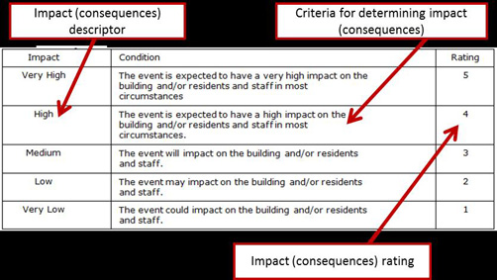

Once likelihood and consequence has been determined the risk analysis process assigns a rating:

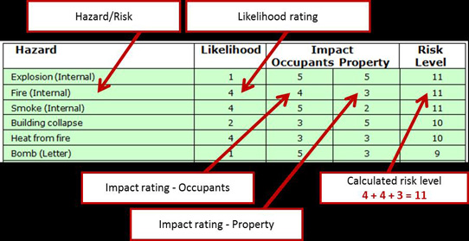

Once likelihood and consequence has been determined the risk analysis process assigns a rating:

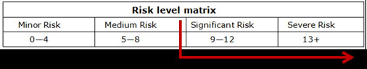

Hazards rated as “Significant” or “severe” MUST be developed and included in the Fire and Emergency Response Procedures

# 6. Planning for and managing human behaviour

## 6.1 Human Behaviour

In an emergency such as a fire, lives are saved if people can be evacuated before the conditions in the environment become fatal. Time is critical. Therefore, human behaviour in the first moments of an emergency can directly impact the success of an evacuation.

## 6.2 Planning for Human Behaviour

Understanding how people may react in an emergency will help you plan appropriate emergency and evacuation procedures, and help DHHS staff deal effectively with people in an emergency

Research reveals that:

* While movies may show panic, in a real emergency panic itself is quite rare.
* Disbelief is one of the most common behaviours
  + People tend to take ‘cues’ from others causing delay even in the presence of clear messages or alarms

Further dynamics to consider include:

* Exit using familiar exits – emergency exits perceived as unsafe, unknown
* Freeze, flight, fight, fright (panic)
* Help syndrome
* Need for clear messages and alarms
* Search for an ‘Expert’ and ‘Official’
  + ‘Sheep mentality’

Post video we can agree with research that concludes the time to make a decision and the quality of the decision is improved when:

* Clear, consistent emergency warnings and information is given
* Information and warnings are provided by an ‘official source’ (ECO, manager)
  + Individuals have received training or have experience in what to do during an emergency

## 6.3 Training for Human Behaviour

A number of strategies can be implemented to promote more effective human behaviour in the event of an emergency including:

* Staff orientation
* Client orientation
  + Fire safety training, and evacuation drills and exercises

### Staff orientation

Before commencing work at a facility, staff should receive an orientation on the arrangements in place for the evacuation and care of residents including:

* Emergency procedures
* Location of emergency equipment
* Location of exit paths and assembly areas, and
  + Client profiles

### Client orientation

Residents or clients should also receive orientation on the arrangement in place for the evacuation of the facility and the location of emergency exits.

### Fire safety training

Regular fire safety training and evacuation drills and exercises will help staff to recognise an emergency situation and implement procedures.

ECO’s have a positive impact on human behaviour by:

* Providing clear relevant information
* Acting and speaking with authority
* Remaining calm and focused; and
  + Wearing ECO identification

### Evacuation exercises

Where appropriate, clients should participate in evacuation exercises to ensure familiarity with:

* Emergency warnings
* Emergency signals
* Evacuation procedures
* The building layout
* Emergency exits and routes

## 6.4 Evacuation Packs

Evacuation packs must be provided for each residential building in each facility.

They should include:

* ECO Identification
* emergency procedures and evacuation plans
* profiles for people with a disability
* emergency telephone numbers
* house plan showing bedroom locations
* Torch (no ‘wind-up’ torches)
* First Aid Kit
  + Incentives (gum, lollies)

### Activity 6 – Refusals to Evacuate

**Discussion**

In groups discuss how you would expect ‘refusals to evacuate’ to be managed in the following categories:

* A client
* A co-worker
  + A visitor

# 7. Establish an Emergency Control Organisation

## 7.1 What is the Emergency Control Organisation

The FERPTF defines the ECO as:

“A structured organisation which organises an appropriate response to emergency situations.”

Australian Standard 3745 Planning for emergencies in facilities defines the ECO as:

“ A person or persons appointed by the Emergency Planning Committee to direct and control the implementation of the facility’s emergency response procedures.”

## 7.2 ECO Structure

In large or complex facilities, the ECO usually includes a range of positions including:

* Chief Wardens
* Deputy Chief Wardens
* Communication Officers
* Area / Floor Wardens
* Wardens
  + First Aid Officers

For small residential facilities (CDG 7.4 & 7.7) the ECO will normally consist of the most senior staff member on duty

## 7.3 ECO Authority

The EPC should ensure that occupants are advised of the ECO’s authority.

AS3745 states:

“During emergencies, instructions given by the emergency control organization (ECO) personnel shall take precedence over the normal management structure.”

The authority is intended to ensure life safety is the key priority in an emergency, above other considerations such as asset or environmental protection

## 7.4 ECO Roles and Responsibilities

The following slides explain the expected roles and responsibilities of members of the ECO as defined in AS3745:2010 Planning for emergencies in facilities.

### Chief Warden

**Pre-Emergency :**

* Maintain a current register of ECO members
* Notify/Replace members when appropriate
* Arrange / organise evacuation exercises
* Ensure emergency response procedures are maintained
* Be a member of the EPC*
  + Ensure ECO identification and resources are available

**Emergency :**

* Move to the Emergency Control Point (ECP/FIP) and take control
* Ascertain the nature of the emergency
* Determine appropriate action (What / Where / How BIG / People at risk)
* If necessary initiate emergency response procedures
* Ensure the appropriate emergency service has been notified
* Ensure the Area Wardens are advised of situation
* Monitor progress and maintain incident log
* Brief the emergency services personnel upon arrival, on the type, scope & location of the emergency and then act on the senior officer’s instructions
* Brief the On-call Manager and EPC

**Post Emergency:**

* Consider occupants to return/reoccupy if safe to do so
  + - Liaise with emergency services
* Notify appropriate services to reinstate services to building
* Consider possible damage to facility
  + - can you re-occupy?
    - If not, what happens to occupants
* Injured occupants
* Attend debrief with Emergency Service if applicable
* Debrief ECO
* Compile incident reports for
  + - EPC
      * DHHS
* Organising other support services as required
  + Identify opportunities for improvement for further training

### Communications Officer

**Pre-Emergency:**

* Training in communications equipment
  + - Personal
      * Wardens
* Maintain records and logbooks
* Ensure currency of emergency contact information
* Attend training and exercises
* Ensure communications equipment is operational

**Emergency:**

* Act as directed by the Chief Warden
* Ascertain the nature and location of the emergency
* 7.4 ECO Roles and Responsibilities
* Confirm Emergency Services notified
* Notify the appropriate ECO members
* Transmit & record instructions and information
* Record an incident log

**Post Emergency:**

* Collate records of events during the emergency
* Participate in debrief
* Secure records for future reference
* Attend further training if required

### Floor / Area Warden

**Pre-Emergency:**

* Confirm sufficient Wardens for area
* Report equipment deficiencies
* Ensure Wardens communicate emergency procedures to all occupants within area
* Ensure occupants are:
  + - Informed of procedures
      * Aware of who wardens are
* Coordinate safety practices by Wardens
* Attend training and exercises
* Ensure ECO identification available

**Emergency:**

* Implement the emergency procedures for floor or area
* Ensure the appropriate emergency service has been notified
* Direct Wardens to check the floor or area for any abnormal situation
* Commence evacuation if the circumstances on their floor or area warrant this
* Communicate with the Chief Warden by whatever means available and act on instructions
* Advise the Chief Warden as soon as possible of the circumstances and action taken
* Co-opt persons as required to assist a Warden during an emergency
* Confirm that the activities of Wardens have been completed and report this to the Chief Warden

**Post Emergency:**

* Report on actions taken during the emergency at debrief
* Report on any near misses, incidents, injuries and/or illnesses

### Warden

**Pre-emergency:**

* Ensure occupants aware of emergency procedures
* Carry out safety practices
* Ensure you have ECO identification
* Attend training as required by EPC

**Emergency:**

* Act as Floor/Area Wardens if required
* Operate communications systems in place
* Check fire/smoke doors are closed
* Close other open doors (in accordance with your procedures)
* Search floor/area to ensure occupants are evacuated
* Ensure orderly flow of people into protected areas (i.e. stairwells)
* Assist occupants/visitors with a disability
* Act as leader of groups moving to assembly areas
* Monitor occupants/visitors at assembly area
* Report back to Floor/Area Warden

**Additional responsibilities:**

* Monitor Assembly area
  + - Is it safe?
* Monitoring condition of occupants
  + - Injuries/illnesses/near misses
* Logistics
  + - Food/Water
* Communication with Chief Warden
  + - Persons unaccounted for
    - Current conditions of assembly area
    - All clear to return to building

**Post-emergency:**

* Report on actions taken during the emergency at debrief
* Report on any near misses, incidents, injuries and/or illnesses

**Post initial response activities:**

* Assist with recovery activities
* Assisting with authorised restoration of normal activity
* Participating in debriefing
* Restricting entry to danger areas
* Requests for emergency services or specialist response team
  + Relocating or providing welfare services for evacuated persons

## 7.5 ECO Identification

The following identification is referenced for use by the ECO as specified in AS3745

* Helmets
* Caps/Hats
* Vests
  + Tabards

**Single storey deployment**

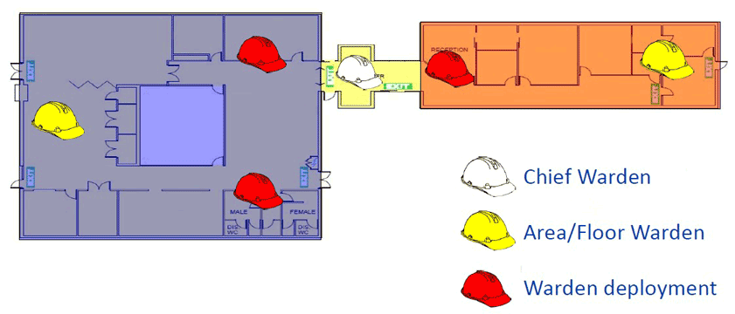

**Multi-level deployment**

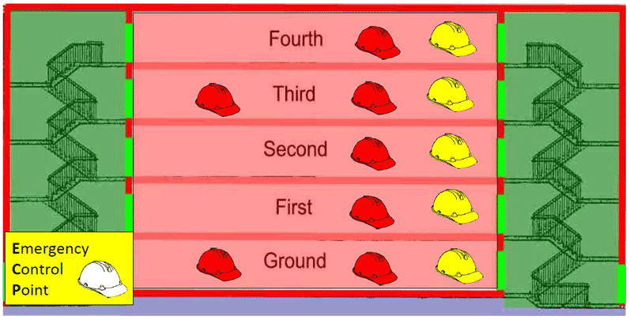

## 7.6 ECO training schedule

Training schedule

* Within one month of start
  + - All Occupants
* Upon commencement of ECO duties
  + - ECO Members
* Every six months (skills retention)
  + - ECO Members
* Every 12 months
  + - Occupants
    - Evacuation
    - Exercises
    - Emergency Response Team
* Every 2 years
  + - First Attack
    - Fire Fighting

# 8. Bushfire Survival Plans

## 8.1 Bushfire Overview

Victoria is one of the most bushfire-prone areas in the world. Bushfire poses a major risk to life and property.

In the 2009 ‘Black Saturday’ fires:

* 173 people were killed
* 414 people injured
  + 2,100 houses destroyed displacing 7,562 people.

The basic weather conditions on the day.

* 46oC temp.
* 100km/h wind
  + Drought

Bushfire risk is influenced by:

* The location and accessibility of the property
* The amount and type of surrounding vegetation
* The condition and placement of buildings
* The availability of water
* The physical capabilities of people with a disability

## 8.2 Bushfire Survival Plans

Bushfire Survival Plans are required for all DHHS facilities likely to be at risk from bushfire including facilities that:

* Are in geographical areas that CFA consider are in the Victorian Fire Risk Register - Bushfire (VFRR-B) extreme risk category (updated quarterly)
  + Are assessed as facilities at risk from bushfire based on regional assessment or advice from an expert or authority

**Bushfire Survival Plans should include the following:**

* Preparing and maintaining the property through the fire danger period in Victoria
* Triggers to enact the Bushfire Survival Plan
* Emergency procedures during and after a bushfire
* Actions for different fire danger rating days
* Relocation procedures (if applicable)
* Returning to the facility
  + Fire and emergency contacts

## 8.3 Victorian Fire Risk Register – Bushfire (VFRR-B)

The VFRR-B is a process in which representatives from:

* Local government
* Fire services
* Public land managers
* Utilities
  + Community groups

Map assets at risk from bushfire and assess the level of risk to the asset.

Assets may include (but are not limited to):

* Residential areas
* Children’s services
* Hospitals
* Flora
* Fauna
* Aged-care
* Infrastructure
* Commercial industry
  + Tourism events

Agency representatives are to record the current treatments which are carried out to mitigate the risk to the asset.

The VFRR-B has been facilitated in 67 of the 79 municipalities, 5 Alpine Resorts and French Island. Metropolitan Municipalities do not require a bushfire risk assessment.

The VFRR-B supports and informs Municipal Fire Management Plans.

## 8.4 DHHS Bushfire Response: Clients and Services Policy

Bushfire Survival Plans for facilities located in the VFRR-B extreme risk areas (or other identified high risk facilities) require a relocation plan to form part of the Fire and Emergency Response Procedures (leaving Early).

The relocation plan is to be compliant with the most recent version of the ‘*DHHS Bushfire Response: Clients and Services Policy*’ unless a formal exemption is approved by a senior department officer.

**Relocation Plans (leaving early) should include:**

* Leaving early trigger (usually Code Red fire rating)
* Leaving early time
* Daylight hours or night prior
* Staffing of transport cannot be guaranteed on the morning of a Code Red day
* Relocation destination or destinations
  + Relocation route – more than one route may be determined depending on the destination and bushfire risk involved

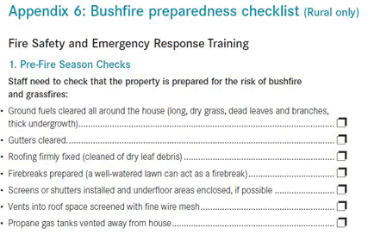

## 8.5 Total Fire Ban Days

### What is a Total Fire Ban (TFB)?

A TFB is a set of legal restrictions on what activities can or can not occur in a particular district for that day. It aims to reduce the activities that may start a fire.

On or before TFB days:

* Evacuation Plans should be in place
  + Local fire brigade and police should know of your plans and the evacuation requirements of all occupants.

**What are the TFB districts?**

Victoria is divided up into 9 districts. TFB days are determined by these districts or statewide bans may be declared.

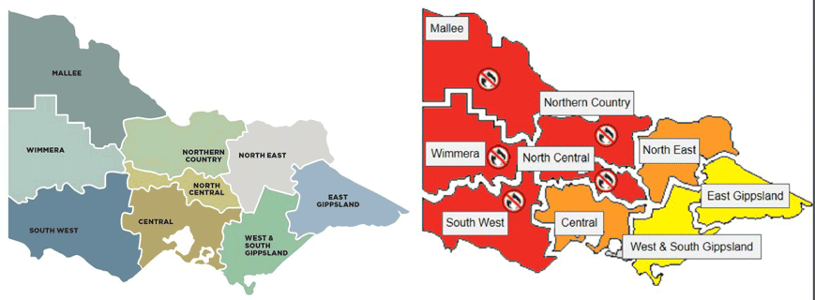

## 8.6 Fire Danger Rating scale

**What is the Fire Danger Rating (FDR) Scale?**

The Fire Danger Rating Scale is designed to indicate how dangerous a fire would be if it started.

A high rating does not mean a fire will occur, it emphasises the high risk of fire to those people in the forecast area.

Ratings are forecast using the Bureau of Meteorology data for up to four day in advance based on weather and environmental conditions such as fuel load.

## Extreme

**What does it mean?**

These are the worst conditions for a bush or grass fire.

Homes are not designed or constructed to withstand fires in these conditions.

The safest place to be is away from high risk bushfire areas.

**What should I do?**

Leaving high risk bushfire areas the night before or early in the day is your safest option - do not wait and see.

Avoid forested areas, thick bush or long, dry grass and know your trigger - make a decision about:

* When you will leave
* Where you will go
* How you will get there
* When you will return
  + What if you cannot leave

## Severe

**What does it mean?**

Expect extremely hot, dry and windy conditions.

* If a fire starts and takes hold, it will be:
* Uncontrollable
* Unpredictable and fast moving.
  + Spot fires will start, move quickly and come from many directions.

Some homes may provide protection such as those that are situated and constructed or modified to withstand a bushfire, that are well prepared and actively defended, may provide safety.

You must be physically and mentally prepared to defend in these conditions.

**What should I do?**

Consider staying with your property only if you are prepared to the highest level.

This means your home needs to be situated and constructed or modified to withstand a bushfire, you are well prepared and you can actively defend your home if a fire starts.

If you are not prepared to the highest level, leaving high risk bushfire areas early is your safest option.

Be aware of local conditions and seek information by listening to your emergency broadcasters

## Very high, high, low-moderate

**What does it mean?**

If a fire starts, it can most likely be controlled in these conditions and homes can provide safety.

Be aware of how fires can start and minimise the risk.

Controlled burning off may occur in these conditions if it is safe - check to see if permits apply.

**What should I do?**

* Check your bushfire survival plan.
* Monitor conditions.
* Action may be needed.
  + Leave if necessary.

## 8.7 Emergency Information and Warnings

Where can I go to obtain information during an emergency or on a high risk day?

Victorian Bushfire Information Line - 1800 240 667.

VicEmergency website - www.emergency.vic.gov.au

FireReady app

Emergency Radio Broadcasters - 3AW 693 (metropolitan)

CFA Facebook and Twitter accounts

### VicEmergency Website

A single all-emergencies website for Victorians with real time Google map display of incidents and warnings across Victoria including (but not limited to):

* Fires
* Floods
* Storms
* Power outages
* HAZMAT incidents
  + Traffic incidents

VicEmergency displays icons depicting different emergencies, and different levels of warnings, on a map.

Warnings may also be issued from other sources such as FM or AM radio frequencies

Level of warnings include:

**Advice**

An incident is occurring or has occurred in the area. Access information and monitor conditions.

### Level of warnings:

**Watch and act / Warning**

An emergency is heading toward you. Conditions are changing and you need to take action now to protect yourself and your family.

**Emergency warning**

You are in imminent danger and need to take action now. You will be impacted.

Emergency Warnings made via television or radio may be played following the SEWS tone.

**Evacuation**

An evacuation is recommended or procedures are in place to evacuate.

Evacuation messages made via television or radio may be played following the SEWS tone.

## 8.8 How Bushfires occur

Fires are often explained using the ‘Fire triangle/pyramid’

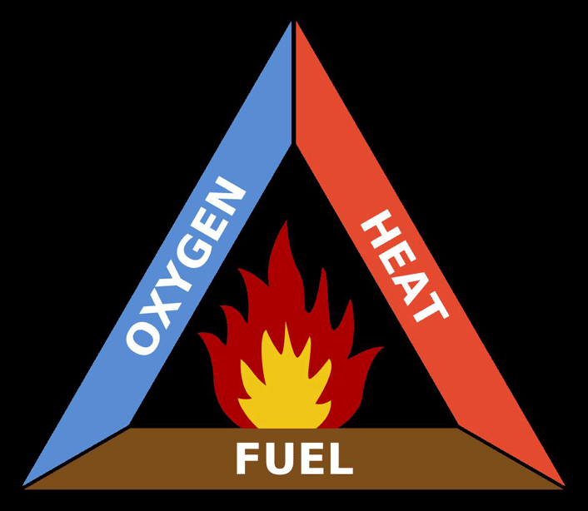

**Oxygen**: A fire cannot start or continue to burn without oxygen.

**Heat**: Without enough heat, a fire cannot start or continue to burn

**Fuel**: Without a supply of fuel, a fire will stop

Bushfires can occur naturally or as a result of human activity whether accidental or deliberate.

Accidental causes may include:

* Arcing powerlines
* Campfires
* Cigarettes
* Maintenance or industrial activities
  + Controlled burns that have breached containment

## 8.9 Bushfire Behaviour

Bushfires spread as a result of burning embers, radiant heat and direct flame contact.

Grassfires tend to be fast moving, have a low to medium intensity and primarily damage crops, livestock and farming infrastructure, such as fences

Bushfires tend to move slower, but produce more heat. Fire in the crowns of a tree canopy can move rapidly.

### Fire spreads in four ways

**Convection**

Air drawn into the fire is superheated causing it to rise, carrying with it the products of incomplete combustion (embers etc.)

Example:Spot fires away from fire

**Conduction**

The transmission of heat through solid objects.

Example:Heat transmitted through steel beams and columns igniting combustible material on the other side.

**Direct Burning**

The action of applying direct flame or energy contact to combustible materials.

Example: A match to a piece of paper

**Radiation/ Radiant Heat**

The transfer of heat from the heat source surface onto another combustible surface. When the heat is great enough it can ignite combustible material or surface.

Example: Open fireplace radiating onto drying rack or curtain.

Protection from Radiant Heat

People can protect themselves from radiant heat by:

* Moving away from the fire as far as possible.
* Doubling the distance reduces the radiant heat load by four
* Taking shelter behind a solid non-transparent object
* Covering exposed skin
  + - Appropriate clothing:
    - Wide-brimmed hat
    - Eye protection (e.g. smoke goggles)*
    - Mask*
    - Long-sleeved collared shirt and long pants made from natural fibre to protect from radiant heat
    - Gloves
      * Sturdy boots and wool socks

Bushfire behaviour, such as intensity and the speed and direction of spread, is determined by three main factors:

* Fuel
* Topography
* Weather
  + - Wind
    - Temp
    - Humidity
      * Drought

**Fuel**

The main source of fuel is vegetation. The fuel type, quantity, arrangement and moisture content will influence fire behaviour

Common fuel types include:

* Grass
* Plantation forest trees
* Ground litter (leaves, bark, branches)
  + Bush/scrub (eucalypts with understorey vegetation)

**Topography**

The lay of the land will greatly effect fire behaviour. Fires accelerate up hill and slow down hill. The aspect of a hill may also determine the type of vegetation.

The speed of a fire front doubles with every 10 degree increase of slope.

**Weather**

Bushfires are most likely to start or continue when ambient temperature is high. The higher the temperature the less heat needed to ignite fuels.

On dry days or long periods of drought the moisture of fuels evaporates quickly making it even easier to ignite.

* Wind influences the:
  + - Speed at which a fire spreads
    - Direction & size of fire front
    - Intensity of a fire – wind provides more oxygen
    - Likelihood of spotting – burning pieces of leaves, twigs and bark the wind carries

## 8.10 Bushfire Procedures

Action to take in bushfires or grass fires – on foot

* Walk across and downhill
* Try to get around and behind the fire
* Look for possible refuges to protect yourself from radiant heat, such as:
* man-made structures such as pipes or train bridges
* running streams or pools
* eroded gullies free of scrub
  + holes made by fallen trees

Action to take in bushfires or grass fires – in vehicle

* Avoid bushfire danger
  + - When approaching smoke across the road, slow down at once.
    - Do not drive through smoke when visibility is severely impaired.
      * Wait for someone to come through from the other side who can give you the all clear.
* Drive slowly, switch on your headlights and watch out for:
  + - firefighting vehicles or personnel on the road, and
      * fallen trees across the road.

Action to take in bushfires or grass fires

Trapped in a car

* + Do not leave the car.
  + Park in the best area of bare ground available, such as:
    - against an embankment in a cutting
    - in a gravel pit or roadside clearing
      * an areas with the least amount of scrub alongside
  + Never park under trees.

You should:

* turn lights on
* close all windows and vents
* lie down on the floor below window level
* shield yourself from radiant heat, with a woolen blanket or thick clothing
  + stay in your car until the fire front has passed

Car safety items

* When travelling in the country always carry:
  + - Water bottle
    - Phone
    - Large woollen blanket in the boot
      * First Aid Kit

# 9. Wrap up

## Thank you

**We have addressed the following outcomes**

* DHHS standards and requirements
* Emergency Planning Committee
* Establish and implement an emergency plan
* Hazard management
* Planning for and managing human behaviour
* Establish an Emergency Control Organisation
  + Bushfire survival plans

## Remember

* Plan
* Do
* Check
* Adjust