

|  |
| --- |
| Emergency Planning Committee  Answer manual |
|  |

Department of Health

To receive this publication in an accessible format [email Centre for Learning and Professional Development](mailto:learning@dhhs.vic.gov.au) <learning@dhhs.vic.gov.au>

Authorised and published by the Victorian Government, 1 Treasury Place, Melbourne.

© State of Victoria, Department of Health and Human Services, April 2019.

Available from the department’s website <https://providers.dhhs.vic.gov.au/fire-safety-induction-program>

Contents

Activity 1 – Evacuation diagrams 4

Activity 2 – EPC Scope 4

Question 1 5

Question 2 5

Question 3 5

Question 4 5

Question 5 5

Question 6 5

Activity 3 – Emergency profiling 6

Question 7 6

Question 8 6

Question 9 7

Question 10 7

Question 11 7

Question 12 7

Activity 4 – Emergency control agencies 7

Activity 5 – Emergency control point 8

Activity 6 – Refusals to evacuate 8

# Activity 1 – Evacuation diagrams

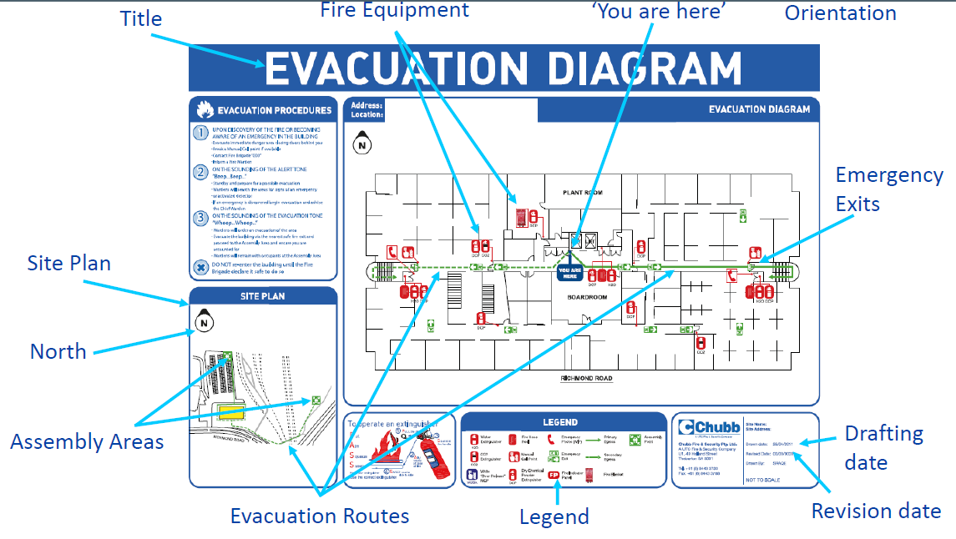

* Title
* Fire equipment
* ‘You are here’
* Emergency exits
* Drafting
* Date
* Revision date
* Legend
* Evacuation routes (minimum of 2)
* Assembly areas
* North orientation
* Site Plan
  + Must be A3 size

# Activity 2 – EPC Scope

* MFB & CFA
* Chubb
* Senior Management
* Local council
* FES (Fire equipment services)
* DHHS fire risk management unit
* Building conveyor

## Question 1

* Establishing an emergency plan setting up the ECO, establishing training, drills and exercise regime
* Responsible for development, implementation and maintenance of the emergency plan, emergency response procedures and related training
* Organise emergency plans, ECO, training, review, first aid procedure, briefings, announcements, liase with management

## Question 2

* + Not participating in training exercises

## Question 3

* Supported community based houses

## Question 4

* + All of the above

## Question 5

* Remove anyone in immediate danger
* Alert emergency services, residents/clients, visitors, contractors
* Contain the incident
* Evacuate

## Question 6

* Loss of life or property
* Loss of communications/utilities
* Contamination air/water
* Traffic accident
* Toxic emission
* Danger of explosion
* Environmental impact
* Behaviours of concern
* People’s reaction

# Activity 3 – Emergency profiling

|  |  |  |
| --- | --- | --- |
| Facility | Possible Emergency | Further development |
| Facility 1. Petrol station | Fuel spill  Explosion/fire  Armed robbery  Vehicle accident  L.P.G  Arson  Hazardous spill | Loss life  Car jacking  Environmental contamination  Injury  Inhalation  Vapours  Loss property  Car accident  Toxic gasses  Structure collapse |
| Facility 2. House in bushland | Bushfire  Housefire  Storm/ severe weather  Tree fall on house  Snakes  Medical emergency | Loss life  Loss house  Loss communication  Loss power  Loss utilities  Injury to residents  Structure collapse |
| Facility 3. Truck depot | Truck accident  Forklift accident  Fire  Chemical  Crushed  Bomb threat | toxic emissions  loss life  injury  inhalation  loss property  vapours  Truck roll |

## Question 7

* + All of the above

## Question 8

Emergency control organisation – A structured organisation which organise an appropriate response to emergency

## Question 9

* + Client prescription medication

## Question 10

* Hard hat
* Cap
* Tabard
* Hi-Viz vest
* White
* Yellow
* Red
* Green

## Question 11

* Radiation heat
* Weather
* Fuel
* Topography
* Location
* Accessibility
* Speed & direction
* Likelihood of spotting

## Question 12

* Code red

# Activity 4 – Emergency control agencies

**Motor vehicle accident**

* Vic Police
* CFA & MFB
* Ambulance
* ESS

**Fire**

* CFA & MFA
* Ambulance
* Vic Police
* SES

**Earthquake**

* SES
* Ambulance
* Vic Police
* MFB & CFA

**Chemical spill**

* CFA & MFB
* Ambulance
* Vic Police
* SES
* EPA

# Activity 5 – Emergency control point

* Mimic panel in residential building as secondary location
* Primary ECP @ F.I.P in telemarketing building
* Reception
* Jackie’s office (if accessible/safe)
* Open place assembly point
* Neighbours building

# Activity 6 – Refusals to evacuate

**A client**

* Ask client to leave 3 times verbal, if direct career able to guide out let chief warden know
* Explanation
* Incentive

**Co-worker**

* Direct 3 times to leave, 3rd time touch on shoulder to persuade to leave, let chief warden know
* Ask to leave witness/backup
* Lead by example
* Leave for emergency services responder

**A visitor**

* Direct 3 times verbally, let the chief warden know
* Ask to leave witness/backup
* Lead by example
* Leave for emergency services responder