

|  |
| --- |
| Client incident report webform user manual  Client Incident Management System |
| September 2020 |

|  |  |  |
| --- | --- | --- |
| Version | Date | Author |
| Version 1.0 | 1 November 2017 | Operations Performance and Quality branch |
| Version 1.1 | 1 October 2018 | Operational Performance and Quality branch |
| Version 2.0 | 1 September 2019 | CIMS API Enhancements Project |
| Version 2.1 | 1 September 2020 | Operational Performance and Quality branch |

|  |
| --- |
| To receive this publication in an accessible format phone 1300 024 863, using the National Relay Service 13 36 77 if required, or [email the client incident management system team](https://providers.dhhs.vic.gov.au/cims) <CIMS@dhhs.vic.gov.au>  Authorised and published by the Victorian Government, 1 Treasury Place, Melbourne.  © State of Victoria, Department of Health and Human Services September 2020.  Available at [client incident management system](https://providers.dhhs.vic.gov.au/client-incident-management-guide-cims-word) <https://providers.dhhs.vic.gov.au/cims>  ISBN 978-1-76069-632-0 (pdf/online/MS word)  Available at [client incident management system](https://providers.dhhs.vic.gov.au/cims) <https://providers.dhhs.vic.gov.au/cims> |

Contents

1 About this document 5

1.1 Overview 5

1.2 Purpose 5

1.3 Scope 5

2 Client Incident Management System Users 6

2.1 Unregistered Users 6

2.2 Registered Users 6

3 Accessing CIMS incident report webform 7

4 Reporting a client incident 8

4.1 Creating a new client incident report 8

4.2 Service details screen 8

4.3 No address match 10

4.4 Reporting officer screen 11

4.5 Incident dates screen 12

4.6 Incident description screen 14

4.7 Clients involved incident screen 16

4.8 Others involved in the incident 23

5 Submitting your client incident report 26

5.1 Completing the declaration and acknowledgement 26

6 Downloading a client incident report 29

6.1 Download the incident report 29

6.2 Saving the file 30

7 Saving a draft client incident report 31

8 Understanding the confirmation email 32

9 Returning to a saved client incident report 33

10 Appendix A: Department service area maps 34

10.1 List of department service areas 35

11 Appendix B: Sample client incident report 36

# About this document

## Overview

The Department of Health and Human Services (the department) has developed a client incident management system (CIMS) that focuses on the most serious incidents and strengthens processes to respond to and manage client incidents.

CIMS aims to:

ensure that timely and effective responses to client incidents address client safety and wellbeing

ensure effective and appropriate investigation of client incidents

ensure effective and appropriate review of client incidents

learn from individual incidents and patterns of client incidents, to reduce the risk of harm to clients, and improve the quality of services and the service system

ensure accountability of service providers to clients

protect and maintain the personal and sensitive information of clients, service provider staff, carers and others from whom a service provider collects personal information for the purposes of client incident reporting.

The department has developed the Client Incident Management System as an end-to-end system for the management of client incidents and reporting to the department divisional offices.

There are there are two components to the information technology of the department-built client incident management system:

CIMS incident report webform

CIMS client incident register (CIR)

All service providers must own, manage and maintain a client incident register to capture information regarding client incidents.

Some in-scope service providers use their own systems to report client incidents before submitting those reports to the department divisional offices via the CIMS application program interface (CIMS API V2)

## Purpose

The purpose of this document is to support in-scope service providers and in-scope department delivered services using the **CIMS incident report webform** component of the department-built CIMS.

The service provider is responsible for keeping the client incident register up-to-date, and for monitoring trends and patterns.

## Scope

The Client incident report webform user manual is a guide to support service provider staff using the CIMS **incident report webform** to capture and report client incidents.

# Client Incident Management System Users

There are two broad user categorisations in the CIMS: unregistered users and registered users.

## Unregistered Users

Unregistered users are not authorised users of the CIMS client incident register. Unregistered users interact with CIMS by lodging client incident reports via the CIMS incident report webform.

## Registered Users

Registered users are service provider or department staff that have been authorised to use the CIMS client incident register.

Registered users are responsible for reviewing, updating and endorsing incident reports prior to those reports being submitted to the department divisional office.

# Accessing CIMS incident report webform

The CIMS incident report webform is the interface through which all department and service provider staff using the Client Incident Register, create and submit client incident reports to CIMS.

The CIMS incident report webform can be accessed from the [CIMS website](https://cims.vic.gov.au/#/introduction) < <https://cims.vic.gov.au/#/introduction>>.

From the CIMS webform landing page the user may either:

Create a new client incident report, or

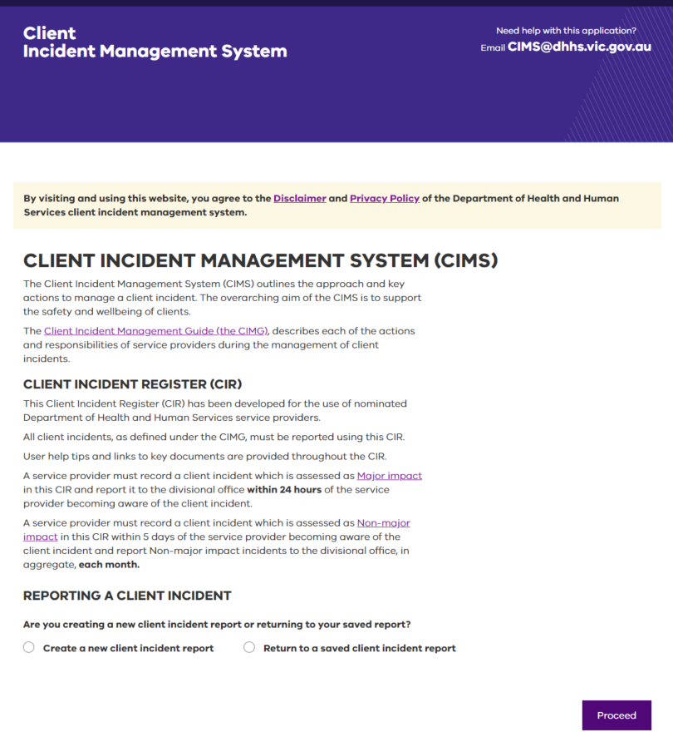Return to a saved client incident report.

Figure 1: Webform landing page

# Reporting a client incident

## Creating a new client incident report

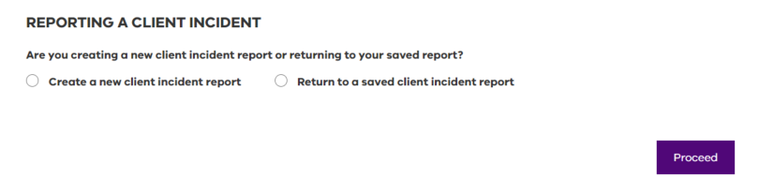

Figure 2: Creating a new client incident report

1. Select **Create a new client incident report**.

Select **Proceed**.

* 1. The **Service details** screen will display.

1. Most fields are mandatory, meaning that they must be completed. If you have missed a mandatory field, you will receive a prompt to complete it before you can move on to the next step.
2. CIMS provides tips and navigational tools along the way to assist with completing the client incident report:

|  |  |
| --- | --- |
| Image displays warning symbol for when a validation has failed | Is a reminder that information is missing and must be completed before you can move to the next screen |
| Image displays what is this text which describes content required in each field | Provides tips or further information about the details you need to provide. Selecting the link will reveal the tip. |
| Image displays field example that requires data to be entered | Some fields contain a list of items for selection that are the only responses allowed. |

Refer to Returning to saved client incident report to return to a saved incident report.

## Service details screen

The **Service details** screen (as shown in figure 3: Service details screen) contains information about the organisation delivering the service to the client at the time of the incident or the organisation that was delivering the service at the time the incident was disclosed; organisation name, address of service delivery, area, program and service type.

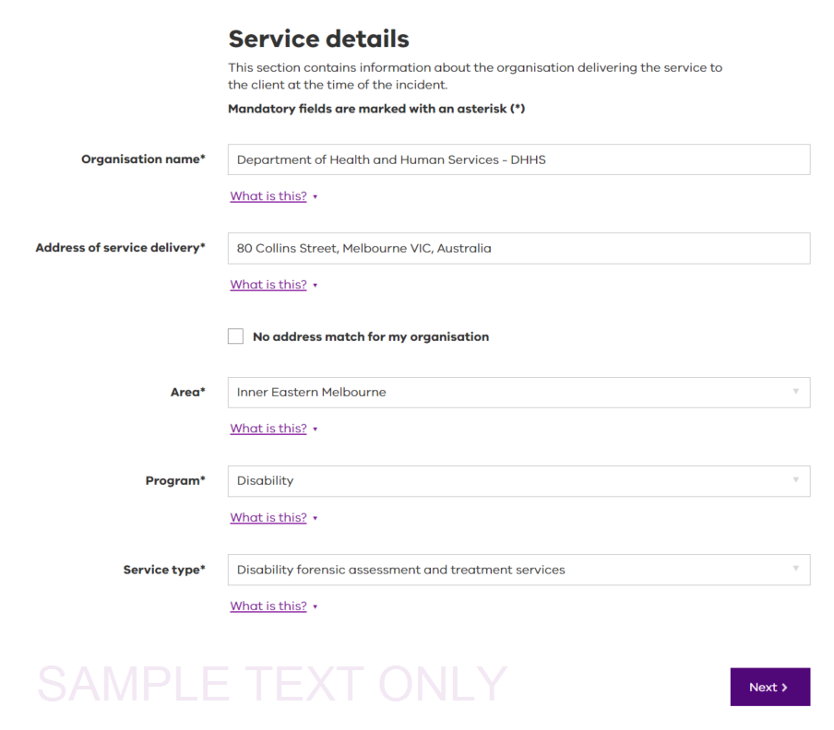Figure 3: Service details screen

1. Enter the **Organisation name**.

Incidents occurring or being disclosed to services provided by the department should use the organisation name of Department of Health and Human Services.

For department funded organisations, select the organisation by typing in the first few letters of the organisations name until it appears in the drop-down list.

Contact the organisation’s management to enquire about the process of completing an incident report if the organisation’s name cannot be located.

1. Enter the Address of service delivery.

The address of service delivery is where the service was provided to the client at the time of the incident or incident disclosure. Addresses entered will be validated by Google.

For residential services, enter the facility’s full street address rather than the facility’s name.

For kinship or foster care, enter the full street address of the kinship or foster care placement.

For department statutory client protection services, the office address of the case manager should be used.

|  |
| --- |
| Note: it is important that the correct address is selected. If the address is not listed, double check the spelling or the details of the location. If there is no match for the address, see the No address match section. |

1. Select the **Area** of the service provided from the drop-down list available.

Area refers to the department service area where the service is delivered. The address identified in the **address of service delivery** field should be within the department service areas. Refer to Appendix A: Department Service Area Maps.

1. Select the Program that was being provided to the client at the time of the incident or incident disclosure from the drop-down list available.
2. Select the Service type the organisation was providing to the client at the time of the incident or incident disclosure from the drop-down list available.
3. Once all the fields have been completed, select Next. Incomplete fields will need to be completed before progressing to the Reporting Officer screen.

|  |
| --- |
| Note: if you close the webform now, any details you have entered will be lost and you will need to start again. It is best practice to continue completing your client incident report while the details are fresh in your mind and to avoid losing work. |

## No address match

It is important that the correct address is selected. Double check the spelling of the address before entering it manually if the address required is not listed. 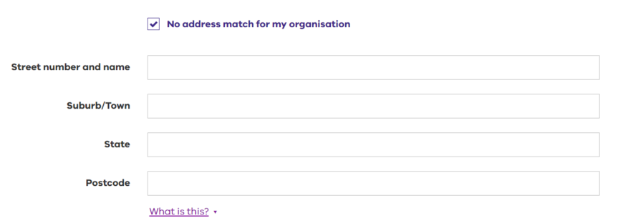

Figure 4: Manual address screen

Follow these steps to manually enter an address:

* 1. Select the **No address match for my organisation** checkbox to display fields for manual entry of an address.
  2. Enter the **Street number and name**.
  3. Enter the **Suburb/Town**.
  4. Enter the **State** relevant to the address.
  5. Enter the **Postcode** relevant to the address.

|  |
| --- |
| Note: addresses entered here are single use only. You must enter them again if you are making additional incident reports for the same address. |

## Reporting officer screen

This section contains information about the person responsible for completing the incident report. This person will be referred to as the incident reporting officer.

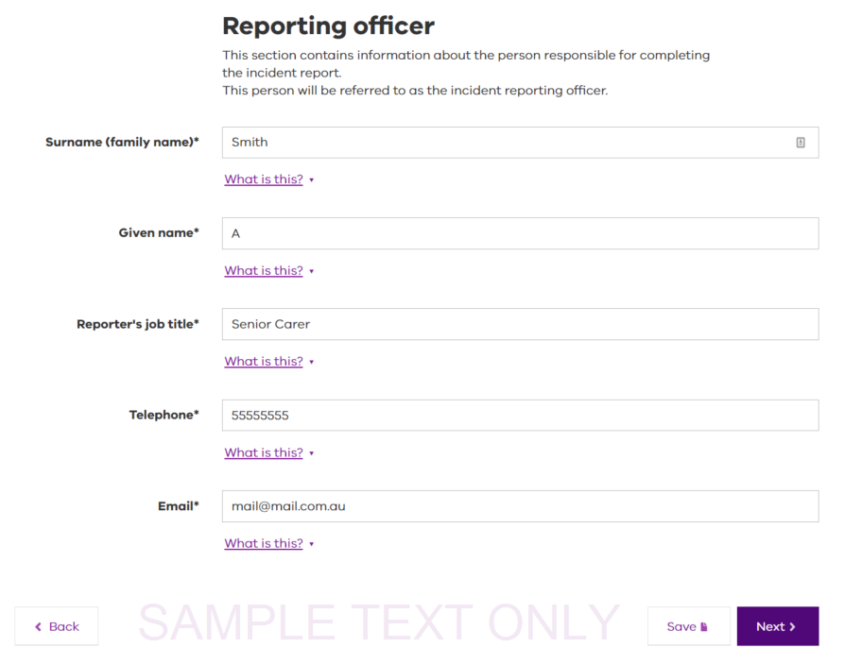

Figure 5: Reporting officer screen

The following details for the incident reporting officer are to be entered:

* 1. The Surname (family name).
  2. The Given name.
  3. The Reporter’s job title.
  4. The Telephone number.

|  |
| --- |
| Note: telephone numbers must be between 8 and 15 digits with no spaces. |

* 1. The Email address.
     + - The incident reporting officer will need to enter the best business email address to be contacted on.
  2. Select Next to continue to the incident dates screen.

|  |
| --- |
| Note: if you need to review or make changes to the **service details** screen of your report, select the **Back** button. |

The incident report can be saved for later completion once the reporting officer details have been entered. To save an incident report for later completion, select the **Save** button. An email will be sent to the incident reporting officer’s listed email address with a temporary link and password that will enable them to access the saved incident report.

Refer to Saving a draft client incident report for further information.

## Incident dates screen

This section contains information about the date and time that the incident occurred, and when the service provider became aware of it.

1. Enter the **Date of incident**.

This is the date the incident occurred. If the exact date is unknown, enter an estimated date of when the incident occurred.

|  |
| --- |
| Using **Date and Time accuracy**:   * The exact date and time of the client incident if the incident reporting officer witnessed the incident. * An estimated date and time of the client incident if the reporting officer did not witness the incident or is not clear about the details. * As I was told should be used if the client discloses the incident to the reporting officer and the reporting officer did not witness the incident. |

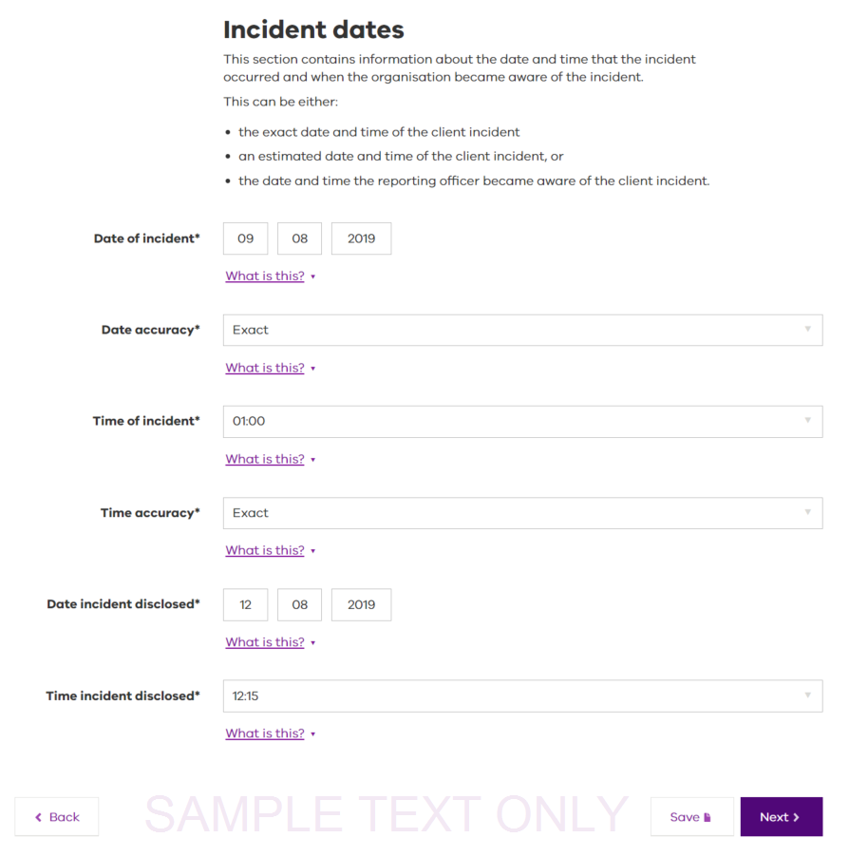

Figure 6: Incident dates screen

1. Select the Date accuracy field.

Select the date accuracy as either exact, estimated or as I was told based on the most appropriate situation of how the reporting officer became aware of the incident.

1. Select the **Time of incident** field.

Select a time from the drop-down list that is the closest time to the time the incident occurred or is known to have occurred to the nearest 15 minutes.

|  |
| --- |
| Note: time is recorded using a 24-hour clock with 15-minute intervals, for example 3:15 pm in the afternoon is recorded as 15:15. |

1. Select the Time accuracy field.

Select the time as either exact, estimated, or as I was told based on the most appropriate for how the reporting officer became aware of the incident.

|  |
| --- |
| Note: The Date incident disclosed, and the Time incident disclosed will be different from Date of incident and Time of incident where the incident occurred on a previous date to the service provider becoming aware of it.  If the reporting officer witnessed the incident, the Date incident disclosed will be the same as the Date of incident, and the Time incident disclosed will be the same as the Time of incident.  Regardless of how much time has passed since the incident occurred, a client incident report must be raised in accordance with the Client incident management guide. |

1. Enter the Date incident disclosed.

This is the date the incident reporting officer first became aware of the incident; either the date they witnessed the incident or the date they found out about it.

1. Enter the Time incident disclosed.

This is the time the incident reporting officer first became aware of the incident; either the time they witnessed it or the time they found out about it.

1. Select Next to continue creating the client incident report and to display the incident description screen.

|  |
| --- |
| Note:  Select Back if you need to review or make changes to the previous pages of your report.  Select Save if you need to leave your incident report at the completion of the incident dates screen and the information you have entered so far will be recorded.  Refer to Saving a draft client incident report for further information. |

## Incident description screen

This section contains information about the incident. An incident description should be a brief, factual account of the incident and the key action taken by staff in response to the client incident.

Details about the incident should include:

where the incident occurred (location and setting)

how the incident occurred

who was involved or alleged to be involved

any impact to clients

risk of future impact to clients

The incident description must be factual and use objective language. If you require further information or guidance on completing the client incident report, talk to your line manager or refer to the CIMS helpline.

1. Enter the **Location of incident**.

This is the physical location of where the incident occurred and is more specific than an address. Where possible, it should include a short description of the location as well as the location address.

1. Enter the Incident description.
   * + - Write a factual account of the client incident. This field has a limit of 5,000 characters.

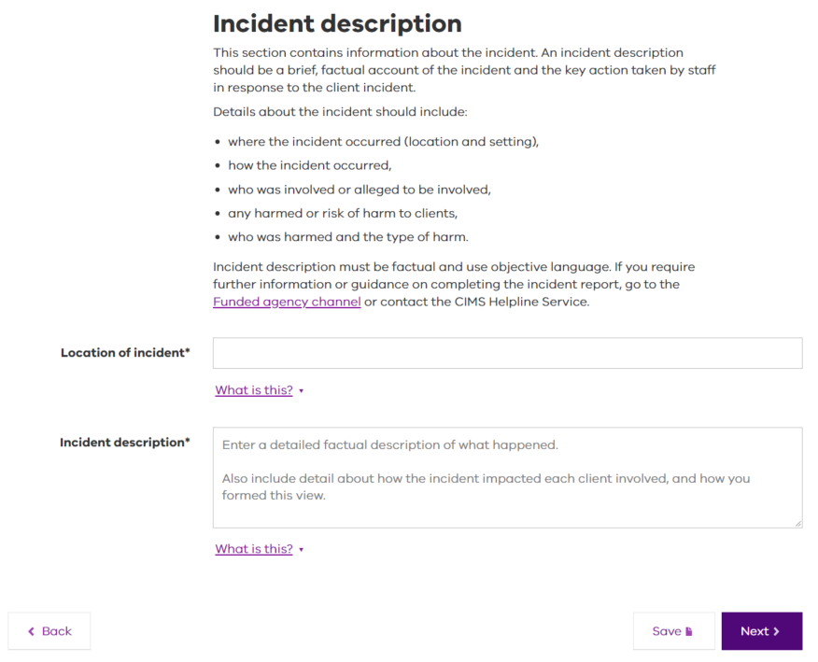

Figure 7: Incident description screen

|  |
| --- |
| Note: when recording the description of the incident, it is important to be precise and to remain focussed on the incident itself. While some incidents can be distressing, it is important that recording is factual without emotive content.  Only details of the incident and actions completed in response at the time the incident report is created should be included within the description field. |

1. Select Next to continue creating the client incident report and to display Clients involved in incident screen.

|  |
| --- |
| Note:  Select **Back** if you need to review or make changes to the previous pages of your report.  Select **Save** if you need to leave your incident report at the completion of the **incident dates** screen and the information you have entered so far will be recorded.  Refer to Saving a draft client incident report for further information. |

## Clients involved incident screen

This section contains information about all the clients involved in the incident that were also assessed as being impacted by the incident.

A client can be involved in an incident as a participant, witness, victim or alleged perpetrator, depending on the incident type.

Every client involved and assessed as impacted in the incident **must** have a separate record created under the **clients involved incident** screen.

|  |
| --- |
| Note: Others involved in the incident, including clients who might have witnessed the incident but have not been impacted by the incident, staff or carers, are recorded separately in the Others involved in the incident section. |

The functions available on the **clients involved incident** screen are:

|  |  |
| --- | --- |
| Add client to incident | Select **Add client to incident** to add clients impacted by the incident. |
| Next | Select **Next** if adding client(s) has been finalised and to continue completing this client incident report. The **Others involved in incident** screen is displayed. |
| Back | Select **Back** to return to the **Incident description** screen. |
| Save | Select **Save** to leave CIMS and plan to return to the report later. This is not best practise and should be avoided.  For further information to save your report, refer to Saving a draft client incident report. |
| Edit | Select **Edit** to open the incident to review its content or make changes as required. |
| Delete | Select **Delete** to remove the client from the incident report. If you delete the client, all records entered for this client will be removed.  The client’s name and date of birth are displayed for confirmation of the delete request. Select either:  **Cancel** – to cancel the action. The client record will not be removed.  **Remove** – the client and all his or her details will be removed. |

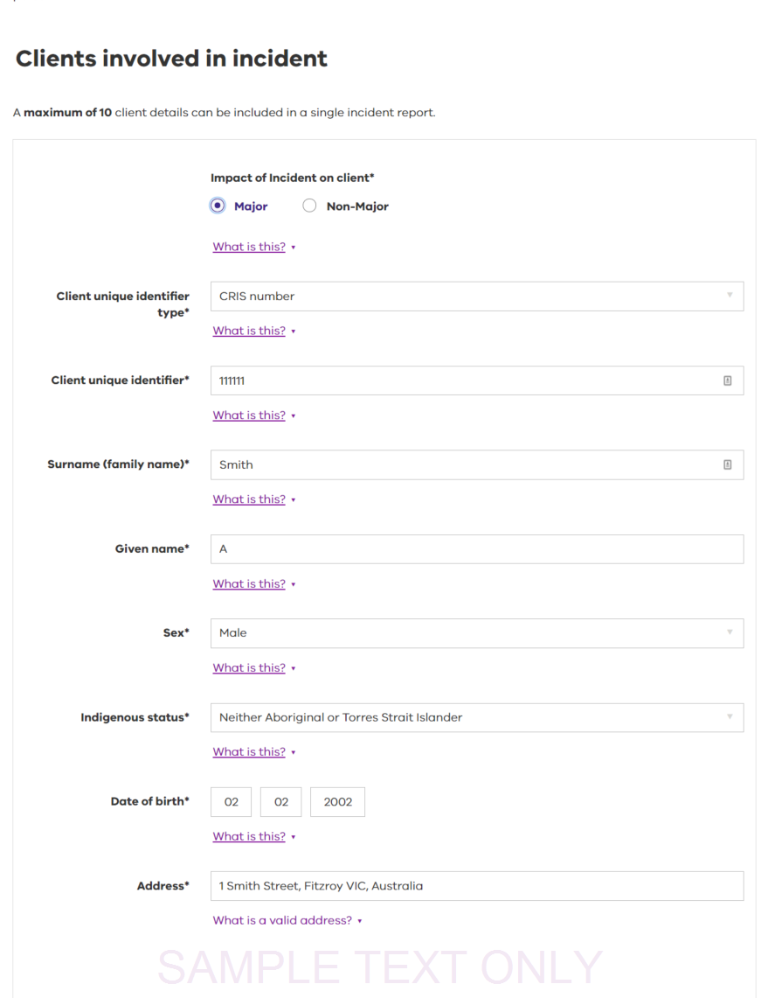

Figure 8: Clients involved in incident screen

1. Select the relevant Impact of incident on client.

Select whether the incident had a Major or Non-major impact on the client. For more details, please refer to the [*Client Incident Management Guide*](mailto:CIMS@dhhs.vic.gov.au) <https://providers.dhhs.vic.gov.au/client-incident-management-guide-cims-word>.

1. Select the Client unique identifier type field from the list for the client impacted.

|  |
| --- |
| Note: client unique identifier types are:   * CRIS/CRISSP – the Client Relationship Information System for department users or service providers (external users to the department) * NDIS number – National Disability Insurance Scheme * Other external – number allocated by service provider * HiiP ID – housing services * Not applicable – client does not have a department or NDIS issued unique identification number |

1. Enter the Surname (family name) of the client impacted.
2. Enter the Given name of the client impacted.

The given name should match the official name under which services are delivered. Abbreviations or preferred names should not be used.

Select the **Sex** field relevant to the impacted client.

Select the **Indigenous status** field relevant to the client impacted.

If the indigenous status of the client impacted is unknown, or you do not have permission to disclose this information, select ‘non stated/inadequately described’.

Enter the **Date of birth** of the client impacted.

If the impacted client’s date of birth is unknown, enter an approximate date. For example, if you think the client is 42 in 2017, enter the date as 01/01/1975.

Enter the **Address of the impacted client**.

This address is the client’s most recent, primary place of residence. If unknown, enter the organisation’s address. Addresses will be validated by Google.

|  |
| --- |
| Note: it’s important that you select the correct address. If the address you’re looking for is not listed, double check your spelling or the details of the location. If there is no match for the address you’re looking for, see the No address match section. |

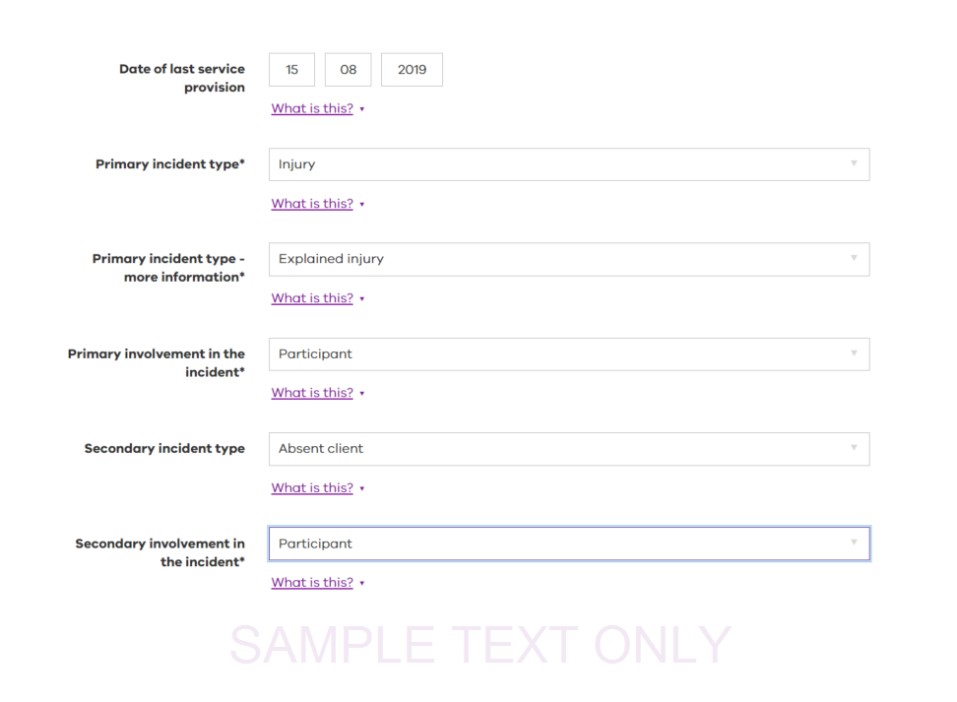

Figure 9: Clients involved in incident screen continued

1. Enter the **Date of last service provision**.

This is the date that the organisation last provided a service to the client. If the service is providing a current or ongoing service to the client, enter the date the report is created.

Select the **Primary incident type** field that best describes the circumstances that cause the most impact on the client.

|  |
| --- |
| Note: when selecting an option here, remember that some incidents have a secondary effect.  For example, a client may have been physically abused and is traumatised as a result. In this instance, the **Primary incident type** would be Physical abuse, and the **Secondary incident type** might be Emotional/psychological trauma. |

Select the **Primary incident type – more information** field that either reflects the client’s primary involvement in the incident or provides further details of an injury to the client.

This field is required when the incident type relates to neglect or abuse; sexual, physical, emotional/psychological or financial abuse; or if the incident type is injury.

Select whether the primary incident type is a case of an alleged:

Staff to Client – a staff member acted against the client.

Client to Client – a client acted against another client.

Other to Client – someone other than a staff member or client acted against the client.

Or, select whether the injury to the client is:

Explained (i.e. the result of a known cause), or

Unexplained (i.e. the cause of the injury is unknown).

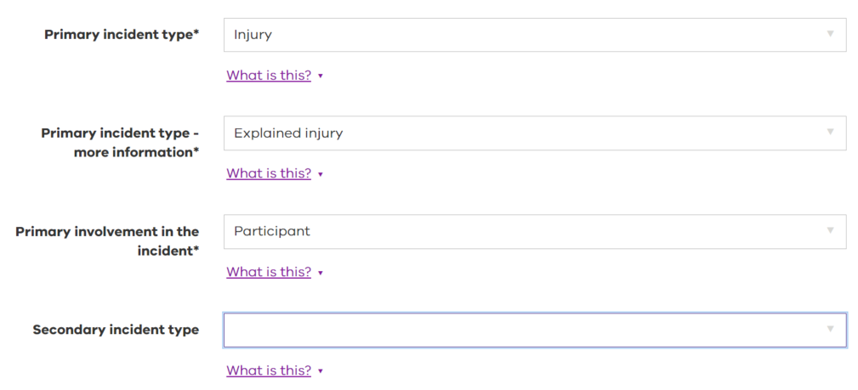

Figure 10: Clients involved in incident screen continued

1. Select the **Primary involvement in the incident** field to best reflect the role of the client in their primary involvement in the incident.

Select from the list whether the client is a victim (was abused or traumatised), witness (saw the abuse) or is the subject of the allegation (carried out the abuse) of the incident. Participant is an option where the incident type does not relate to neglect or abuse. If the client had more than one role, identify the primary involvement related to the incident type selected.

Select the **Secondary incident type** field if applicable to best reflect the secondary circumstances that cause further impact on the client.

This is applicable when the client has experienced more than one type of incident and is impacted in more than one way.

|  |
| --- |
| Note: you cannot select the same option for the **Secondary incident type** as the **Primary incident type**.  For example, a client may have been sexually exploited and is traumatised as a result. In this instance, the **Primary incident type** would be sexual exploitation, and the **Secondary incident type** might be emotional/psychological trauma. |

Select the **Secondary involvement in the incident** field to best reflect the role of the client in their secondary involvement in the incident. The fields are similar to primary involvement in the incident.

.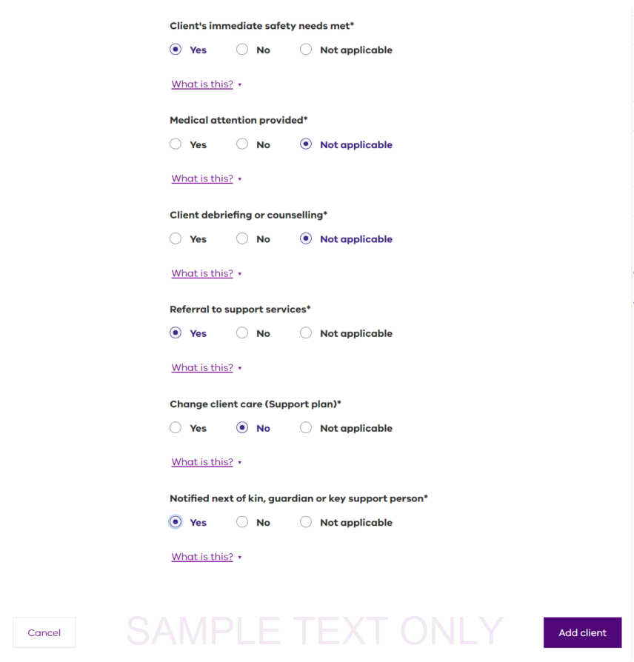

Figure 10: Clients involved in incident screen continued

|  |
| --- |
| Note: the following section has a number of statements. Each statement requires a response of either **Yes**, **No** or **Not applicable as listed**. |

**Client’s immediate safety needs met**.

Determining if the client’s immediate safety needs have been met, should include consideration as to whether the client is in a safe and secure environment and whether the danger has been removed.

Select ‘Not applicable’ if the client’s role in the incident did not affect their safety needs.

**Medical attention provided**.

The provision of medical attention relates to the client. However, if staff or any other person requires immediate medical attention, you should call a medical practitioner or ambulance, or transport the injured person (if it is safe and appropriate to do so) to the nearest hospital accident and emergency department or medical service.

Select ‘Not applicable’ if there was no need to consider medical attention as part of the immediate incident response.

**Client debriefing or counselling**.

The provision of debriefing or counselling relates to the client as part of the immediate incident response. Select ‘Not applicable’ if there was no need for consideration of client debriefing or counselling as part of the immediate incident response.

**Referral to support services**.

Select if the client has been referred to, or received other support services, in immediate response to the incident. The client, if the client can provide informed consent, or his or her key support person should be asked whether they wish to contact specialist/victim services such as crisis care, counselling, advocacy, a legal information service or a lawyer.

Select ‘Not applicable’ if there was no need for referral to support services as part of the immediate incident response.

**Change client care (support plan)**.

Select whether the client’s care or support plan has been changed in response to the incident.

Select ‘Not applicable’ if there was no need for change to the client’s care or support plan as part of the immediate incident response, or if the client does not have a support plan.

**Notified next of kin, guardian or key support person**.

Select whether the client’s next of kin, guardian or key support person has been contacted in response to the incident.

Select ‘Not applicable’ if there was no need to notify next of kin, guardian or a key support person as part of the immediate incident response.

Select **Add client** to add the client’s details to the incident report and to return to the **Clients involved in incident** screen.

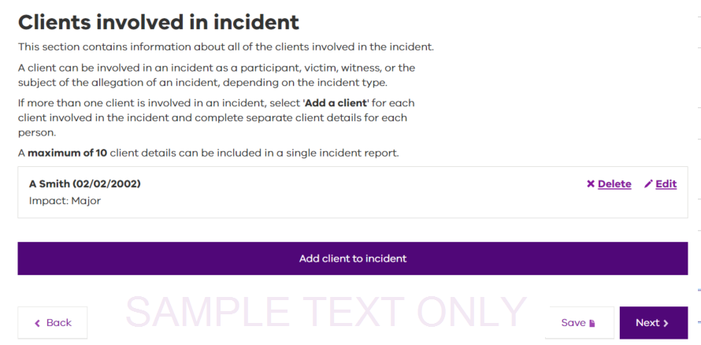

Figure 11: Clients involved in incident screen continued

A listing of all clients involved in the incident will be displayed. Others involved in the incident, who are **not** clients or clients that were not impacted by the incident, are recorded later in the Others involved in the incident section.

A maximum of 10 clients can be attached to a single incident report. If there are more than 10 clients, additional reports will need to be created. The incident numbers for all reports will need to be recorded in the incident description.

## Others involved in the incident

This section contains information about all the other people involved in the incident.

Other people involved in the incident may include staff, carers, clients (not impacted by the incident), volunteers or members of the general public. Other people may be involved in the incident as participants, alleged perpetrators or witnesses, depending on the incident type.

|  |
| --- |
| Note: do not record the details of clients involved and impacted by the incident here. For information about recording client details refer to Clients involved in the incident. |

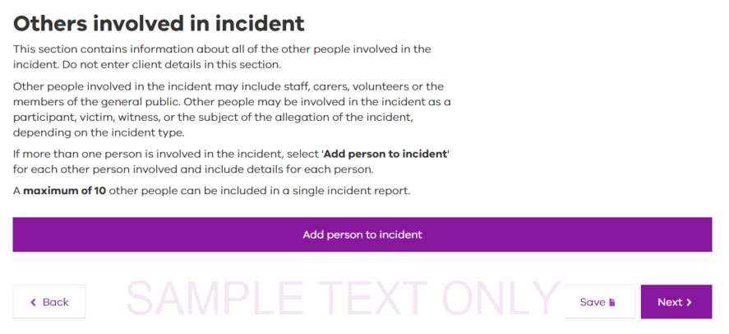

Figure 12: Others involved in the incident screen

|  |
| --- |
| Note: you may add a maximum of 10 other people to a single incident. If you have more than 10 additional people involved, create two reports and record the incident numbers for both in the incident descriptions. |

Functions available on the **Others involved in incident** screen are:

|  |  |
| --- | --- |
| Next | Select **Next** if there are no other people to add to the incident report. The **Declaration and acknowledgement** screen is displayed. |
| Back | Select **Back** if you wish to return to the **Clients involved in incident** screen. |
| Save | Select **Save** to leave CIMS and plan to return to the report later. This is not best practise and should be avoided.  For further information to save your report, refer to Saving a draft client incident report. |

Select **Add person to incident** to display fields for the other person’s details and involvement.

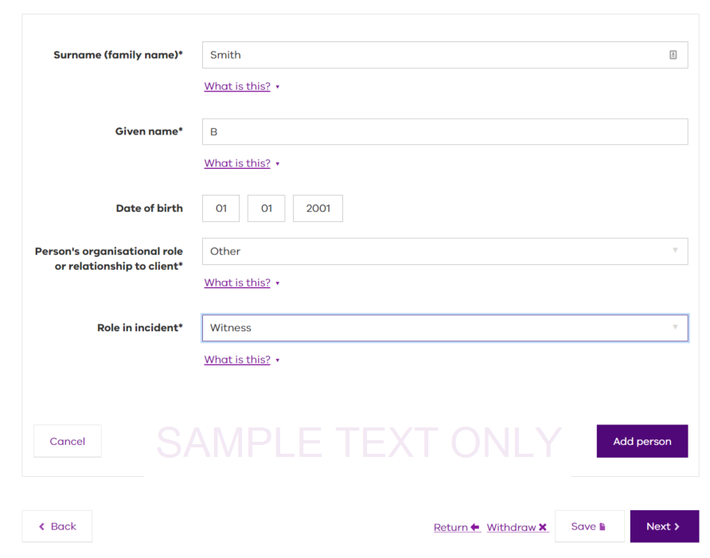

Figure 13: Others involved in incident screen continued

The others involved in the incident screen shows details of other people involved; surname, given name, date of birth, personal organisational role or relationship to the client and the role in the incident:

* 1. Enter the **Surname (family name)**.
  2. Enter the **Given name**.
  3. Enter the **Date of birth**.

This is the other person’s date of birth. If the date is unknown, enter an approximate date. For example, if you think the person is 42 in 2017, enter the date as 01/01/1975.

* 1. Select in the **Person’s organisational role or relationship to client** field to select an option.

This is where you indicate the person’s relationship with the client impacted.

|  |
| --- |
| Note: examples of the other person involved in the incident and what his or her relationship to the client was:   * Carer – was the other person a Carer to the impacted client? * Paid Staff – was the other person a paid staff member of an organisation to the impacted client which includes Kinship and Foster carers. * Other – all others, including family members, clients (not impacted by the incident) and members of the public or friends of the client impacted. |

5. Select the **Role in incident** field to best reflect the role of the other person.

The other person may be a witness, participant, victim or the subject of the allegation of the incident.

1. Select **Add person** to confirm and save the information entered for the other person involved in the incident. The list of other people involved will display.
2. Select **Add person to incident** to add more people, other than clients impacted, to the incident.
3. Once all others involved have been added, select **Next** to proceed to the **Declaration and acknowledgement** screen to submit the incident report.

# Submitting your client incident report

It is good practice to review all the details completed within the client incident report before finalising.

Select the **Back** button to review all details within the incident report. Confirm the details for the incident, clients and other people present at the time the incident occurred if identified as being correct and accurately documented.

Functions available on the **Declaration and acknowledgement** screen are:

|  |  |
| --- | --- |
| Back | Select **Back** if you wish to return to the **Others involved in incident** screen. |
| Submit | When you Select the **Submit** button, you are confirming your understanding and acknowledgement of the declaration, and submitting your incident report for review and approval.  After submitting the client incident report, your manager or his/her delegated authority will receive notification of the incident report and will be required to review and approve it. |

## Completing the declaration and acknowledgement

Upon acceptance of the incident report details being correct, the incident reporting officer will be prompted to complete the declaration to acknowledge the accuracy.

The acknowledgement by the incident reporting officer is also declaring they understand that they are responsible for the information that will be saved and submitted to the next level of authorisation within their organisation for further progression.

Therefore, it is important that the incident reporting officer reads the declaration on the **Declaration and acknowledgement** screen to ensure it is understood before accepting or contacts their line manager for assistance.

To complete the **Declaration and acknowledgement**, and submit your report:

1. Tick the declaration box where it says, **By ticking this box I understand and acknowledge my responsibilities set out above in relation to this client incident report**.
2. Tick the **I’m not a robot** checkbox and complete further steps as directed.
3. Select **Submit**.

You will receive a message confirming your incident was successfully submitted and the incident report reference.

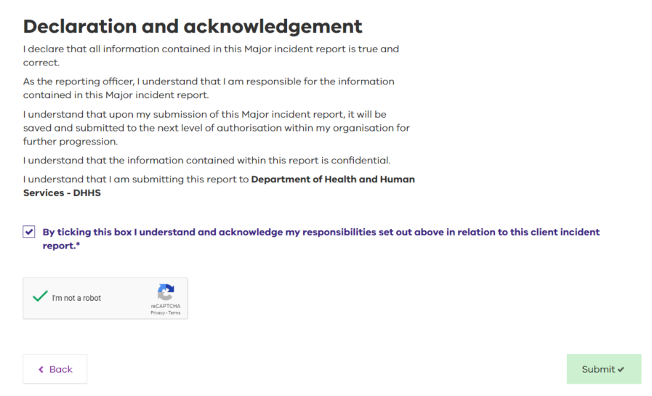

Figure 14: Declaration and acknowledgement

|  |
| --- |
| Note: The **I’m not a robot** checkbox is a system function that helps to ensure the security and integrity of the incident reporting program. You cannot proceed if this box is not checked. |

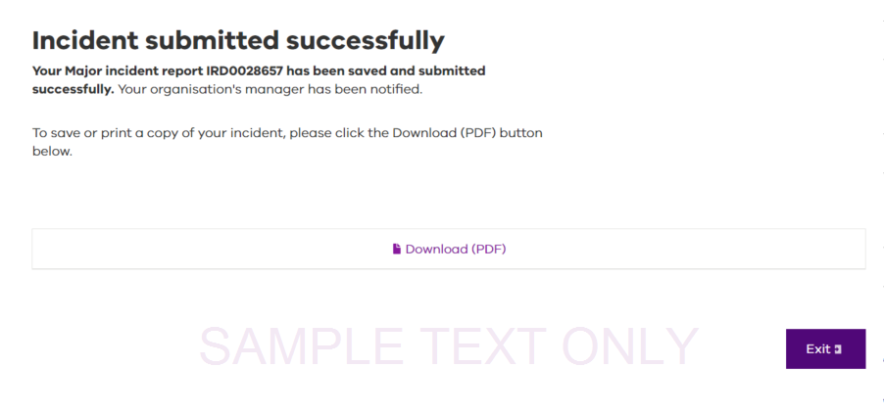

Figure 15: Incident submission screen

|  |
| --- |
| Note: access will not be available to unregistered incident reporting officers once the incident report has been submitted. Therefore, no further editing or changes are available following submission. |

# Downloading a client incident report

A copy of the incident report can be downloaded in PDF, if required, following it’s submission by the incident reporting officer. Incident report details must be kept in a secure location to ensure that unauthorised people cannot access the report. It is encouraged for incident reporting officers to check with their service provider’s record keeping requirements to ensure the printed copy is stored appropriately.



Figure 16: Declaration and acknowledgement

## Download the incident report

Select **Exit** to leave CIMS if a print version of the report is not required.

Choosing to save or download the report by:

1. Selecting **Download (PDF) for options**:

to open the report, see Opening the file

to save the report, see Saving the file

to cancel the request if you do not wish to print or view the report.



### 6.1.1 Opening the file

1. Select **Open**. The file is converted to a PDF that you can view. From here you can close or save it. To close, continue to Step 2. To save the file, go to Step 3.
2. To close the file go to **File > Exit** or Select the Image of a red box with a white cross in the middle to reflect exit function as described in 6.1 download your incident report. at the top of the page.
3. To save the file, go to **File > Save As**.
4. Select a location to save your file to.
5. Overwrite the File name if you wish to give the file a specific name. Select Save.
6. Select Save.

## Saving the file

Saving a client incident report raises privacy issues. It is not always advisable to save the file to a location on your computer. Check with your service provider to ensure compliance with privacy regulations.

To proceed in saving a PDF version of the incident report:

1. Select **Save**. The file is converted to a PDF and is downloaded to your computer. Prompts will be asked to:
   * + **Open** – go to Step 2
     + **Open folder** – go to Step 3
     + **View downloads** – go to Step 4.



1. Select **Open**. The file is converted to a PDF and available to be viewed. For further information, see Opening the file on the previous page.
2. Select **Open folder**. A folder opens, displaying a PDF file. Double Select the file name to open and view the document.
3. Select **View downloads**. A **View downloads** screen opens displaying the downloaded file.
4. Select **Open** to view the file. For more information, refer to Opening the file on the previous page.

To view a sample of the report, go to Appendix B: Sample client incident report.

# Saving a draft client incident report

A client incident report can be saved before submission at varying stages of entering the incident report details to enable further editing at a later time.

If you wish to continue to complete your incident report, select **Back** and continue recording the incident report details or if you wish to save your incident report and return to it later, proceed to Step 1:

1. Re-enter your email address in Confirm email address.

|  |
| --- |
| Note: the email address entered must match the email address recorded on the reporting officer screen. If the email address provided does not match, an error message will appear. |

1. Select the **I’m not a robot** checkbox.

|  |
| --- |
| Note: the I’m not a robot checkbox is a system function that helps to ensure the security and integrity of the incident reporting program. You cannot proceed if you don’t check this box. |

Select **Save & close**.

This function saves your incident report as a draft. It is not yet complete. You now have seven days in which to complete your client incident report.

|  |
| --- |
| Note: if you do not complete your draft incident report in seven days from the date you saved it, all details entered to that point will be deleted and you will need to start the report again. |

Once you have saved your draft client incident report, you will receive the following message:

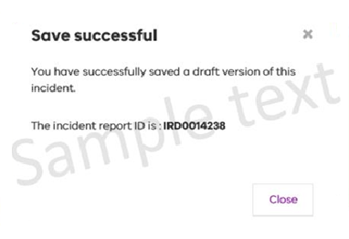

Figure 18: Save successful screen

The incident report ID is a unique, system-generated number that references your report. At this time you will receive an email confirming the draft of your report.

Don’t delete this email as it is needed to finalise the draft incident report.

# Understanding the confirmation email

After you have saved your draft client incident report, you will receive a confirmation email. You cannot reply to the email, however contact details are highlighted at the bottom of the email message if help is required.

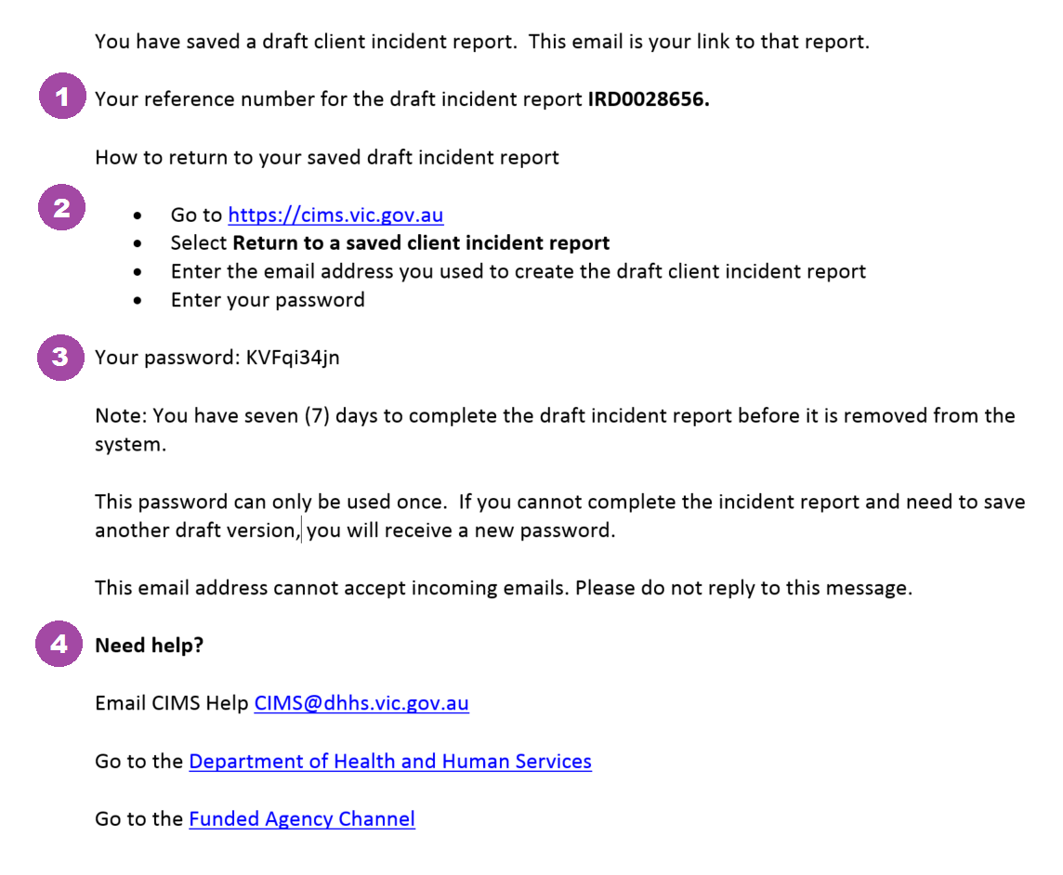

Figure 19: Confirmation email

There are several important elements to the confirmation email that you must be aware of:

1. A reference number to identify the incident in CIMS and all its associated documentation.
2. A link that must be used when returning to a previously created client incident report.
3. A password that must be used in conjunction with the link previously mentioned whenever you need to access the client incident report.
4. Notes and contact details for accessing further assistance if needed.

For assistance with returning to a saved draft client incident report, continue to the next section in this manual.

# Returning to a saved client incident report

CIMS enables you to either create a new client incident report, or return to one you created earlier for completion.

Refer to your confirmation email to open a draft client incident report.

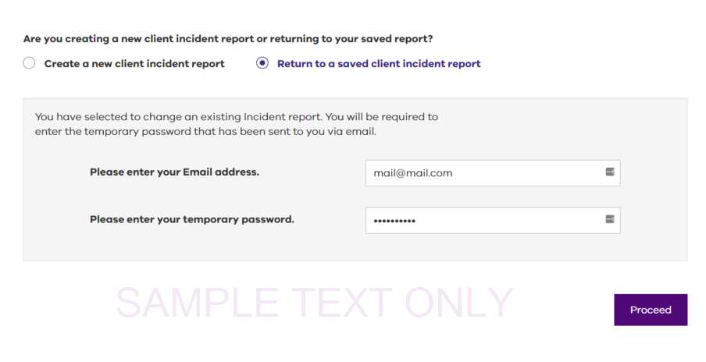

Figure 20: Return to a saved client incident report

1. Select the radio button **Return to a saved client incident report**.
2. Enter your **Email address**.
3. Enter your **temporary password**.

This is the password provided in your confirmation email, (see point 3 in Understanding the confirmation email.

Select **Proceed**.

To return to the **Service details** screen on the draft client incident report.

# Appendix A: Department service area maps

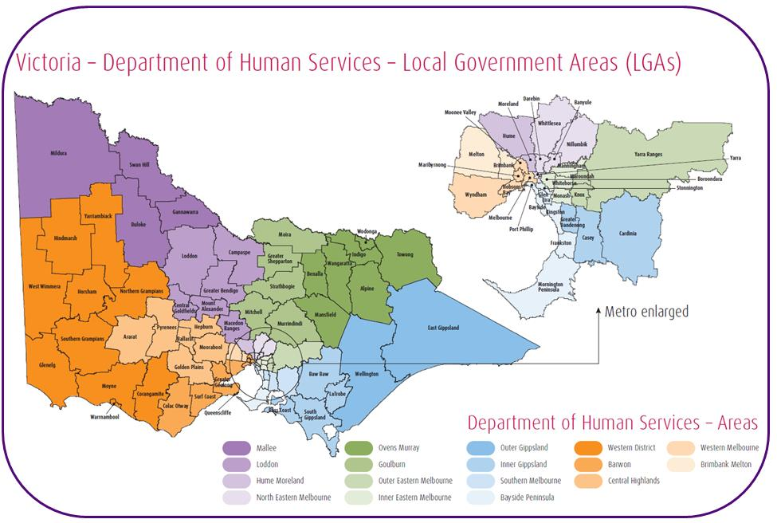

Figure A.1 Department service area maps – metropolitan

Image shows a colour-coded map of Victoria showing the Department of Human Services areas as listed below.


Figure A.2 Department service area maps - regional

## List of department service areas

1. Barwon
2. Bayside Peninsula
3. Brimbank Melton
4. Central Highlands
5. Goulburn
6. Hume Moreland
7. Inner Eastern Melbourne
8. Inner Gippsland
9. Loddon
10. Mallee
11. North East Melbourne
12. Outer Eastern Melbourne
13. Outer Gippsland
14. Ovens Murray
15. Southern Melbourne
16. Western Melbourne
17. Wimmera South West

# Appendix B: Sample client incident report

The following diagrams show a sample of a printed PDF copy of a completed client incident report as outlined in Downloading a client incident report.

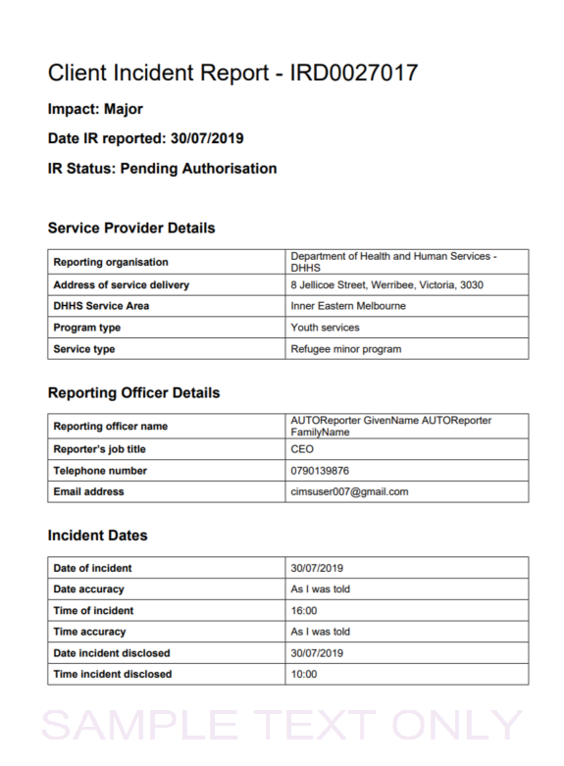

Figure B: **Sample client incident report**

