

|  |
| --- |
| Client incident management system  Policy update 1-2020  Incident reporting timelines, automatic determination of follow-up actions, submitting case review reports, and terminology changes |
| 20 December 2019 |

|  |
| --- |
|  |
| To receive this publication in an accessible format [email the client incident management system team](mailto:CIMS@dhhs.vic.gov.au) <CIMS@dhhs.vic.gov.au>.  Authorised and published by the Victorian Government, 1 Treasury Place, Melbourne.  © State of Victoria, Australia, Department of Health and Human Services December 2019.  Except where otherwise indicated, the images in this publication show models and illustrative settings only, and do not necessarily depict actual services, facilities or recipients of services.  Available at [client incident management system](https://providers.dhhs.vic.gov.au/cims) <https://providers.dhhs.vic.gov.au/cims> |
|  |

Contents

Client incident management system: policy update 1-2020 4

Using and applying this update 4

Process and timeframes for submitting incident reports 4

Determining follow-up actions after a major impact incident 5

Providing case review reports to the department 7

Replacing ‘alleged perpetrator’ with ‘subject of allegation’ 8

Summary of reporting requirements 8

# Client incident management system: policy update 1-2020

Client incidents that occur during service delivery and result in harm to a client are required to be reported to the Department of Health and Human Services (the department) by all in-scope services in the client incident management system (CIMS).

## Using and applying this update

This policy update supports the operation of the CIMS and is applicable from 3 February 2020. It should be read in conjunction with the Client incident management guide (the guide) and related summary documents, operational updates, and addenda that provide specific guidance for nominated program areas and service types.

The guidance provided in this update supersedes requirements and terminology in the guide and related documents in relation to:

* the steps and timeframes for the submission of major and non-major impact incident reports
* the determination of follow-up actions after a major impact incident
* submission of case review reports to the department
* the use of the term ‘alleged perpetrator’.

For service providers using the department-built client incident register to capture and transmit incident-related information to the department, the changes outlined in this policy update are applicable from 3 February 2020.

Service providers that have chosen to use the application program interface (API) to submit client incident information from their existing IT platforms to the department are required to update their standalone systems by 1 July 2020. Operational guidance will be provided to support the adoption of policy changes from 3 February 2020 while these standalone systems are updated.

Policy changes will not be applied retrospectively.

## Process and timeframes for submitting incident reports

Incident reports for major impact incidents and non-major impact incidents must be finalised and submitted to the department in the CIMS IT **within three business days** of the incident occurring, or of the service provider becoming aware of the incident.

The timeframes for reporting client incidents in the CIMS IT are separate to service providers responding to an event or circumstance to ensure the safety of the clients involved.

When responding to an incident, service providers must always act to ensure that:

* the safety and wellbeing of clients is the first priority and any issues impacting on the immediate safety of clients are always be addressed prior to reporting, and throughout the management of an incident
* relevant parties, including Victoria Police, child protection and other operational staff, are alerted in a timely way to significant client events (by phone, email or another system, as appropriate).

The high-level process for reporting major and non-major impact incidents is illustrated in Figure 1.

Figure 1: High-level process and timelines for reporting major and non-major impact incidents

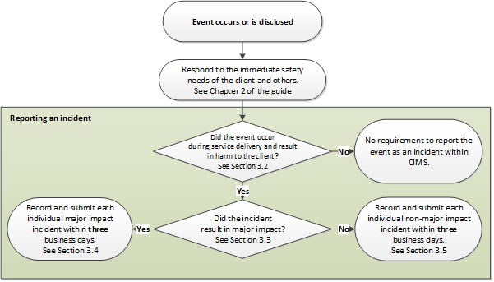

Note: Diagram includes references to chapters and sections of the Client incident management guide.

## Determining follow-up actions after a major impact incident

Under the CIMS, all major impact incidents must be subject to either an investigation or review (case review or root cause analysis review).

An investigation **must be undertaken** for incidents assessed as major client impact with one or more of the following incident types:

* physical, sexual (including sexual exploitation), financial, or emotional/psychological (including cultural) abuse where the subject of the allegation is a staff member, volunteer, or client
* poor quality of care
* injury – unexplained.

Other major impact incident types and incidents involving allegations of abuse where the subject of the allegation is not a staff member, volunteer, or client will not be investigated under the CIMS. These incidents must instead be subject to a case review or a root cause analysis review.

Once the relevant incident parameters for a major impact incident have been established and the incident report has been endorsed by the department, service providers should automatically initiate an investigation or review, as outlined in the business rule matrix in Table 1. Service providers should note that:

* if one client meets the criteria for investigation, the incident will automatically progress to investigation irrespective of the incident parameters for any other clients included in the incident report
* for all incidents meeting the criteria for investigation, service providers will be asked prior to submitting the incident report to nominate an investigation manager and to confirm whether the investigation is proposed to be jointly managed with the department.

The department will confirm that the business rules have been correctly applied when quality assuring incident reports. There is no requirement for service providers to submit a rationale for the outcome chosen or to provide investigation plans to the department.

Table 1: Business rule matrix for determining follow-up action after a major impact incident

| Incident impact | Incident type | Client involvement | Additional parameters | Follow-up action |
| --- | --- | --- | --- | --- |
| Major | Physical abuse | Victim | * Incident type - more information is: staff to client or client to client | Investigation |
| Major | Sexual abuse | Victim | * Incident type - more information is: staff to client or client to client | Investigation |
| Major | Sexual exploitation | Victim | * Incident type - more information is: staff to client or client to client | Investigation |
| Major | Financial abuse | Victim | * Incident type - more information is: staff to client or client to client | Investigation |
| Major | Emotional / psychological abuse | Victim | * Incident type - more information is: staff to client or client to client | Investigation |
| Major | Poor quality of care | Victim | * Incident type - more information is: staff to client | Investigation |
| Major | Injury | Participant | * The injury is unexplained | Investigation |
| Major | Incident types other than abuse (staff to client or client to client), poor quality of care, or unexplained injury | Any | * Service processes and systems were not, or do not appear to be, a significant causal or contributing factor | Case review |
| Major | Incident types other than abuse (staff to client or client to client), poor quality of care, or unexplained injury | Any | * Service processes and systems were, or appear to be, a significant causal or contributing factor | Root cause analysis |

Note: If one client meets the criteria for investigation, the incident will automatically progress to investigation irrespective of the incident parameters for any other clients included in the incident report

Note: Where Injury is given as either the primary or secondary incident type, it will be further classified in CIMS IT as resulting from known cause/s (explained injury) or from unknown cause/s (unexplained injury).

In instances where the information and evidence available (such as CCTV footage) enables a conclusion to be reached during the initial follow up and assessment as to whether allegations can (or cannot) be substantiated, service providers can continue to use the *Investigation outcome and case review* template or *Investigation outcome and root cause analysis* template to advise the department of the investigation outcome (substantiated or not substantiated), the rationale for not further investigating, the evidence that supports that outcome, and the approach and findings of the subsequent review.

A summary of the follow-up process is outlined in Figure 2.

Figure 2: Follow-up actions after a major impact incident

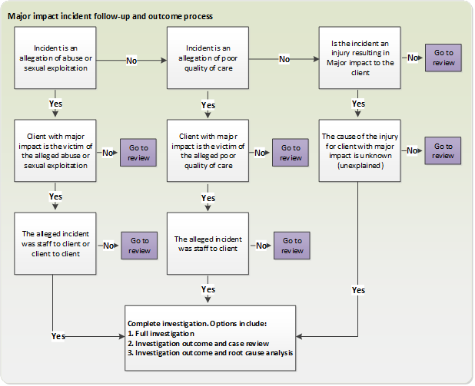

Note: References to staff members also include people who are volunteers

## Providing case review reports to the department

Approximately 65 per cent of major impact incidents under the CIMS progress to case review.

Service providers are required to have robust, documented processes in place for carrying out or commissioning incident reviews under the CIMS to answer one or both of the following questions:

* Did the service provider respond with appropriate actions to manage the incident?
* Why did the incident happen, and what can be changed to reduce the likelihood of similar or related incidents in the future?

The department is responsible for contract management and regulatory oversight activities to ensure that service providers are discharging their obligations regarding incident reviews. This may include audits and inspections of records and reports, and reviewing the extent to which recommended actions have been implemented. The department is also responsible for program and system-level performance analysis.

To support the department in efficiently discharging its system steward role, the **outcomes of all case reviews will be made available to the department** in the CIMS IT. This will enable the department to attest that case reviews are being completed in a timely manner, and to the expected standard.

Consistent with service provider and departmental responsibilities under the CIMS, case review documents and outcomes will **not be subject to a dedicated quality assurance process**, and will not require endorsement by the department.

## Replacing ‘alleged perpetrator’ with ‘subject of allegation’

Across the health and human services sector, services and professionals use a range of terms for individuals who have caused or allowed the abuse, neglect or maltreatment of another person. Under the CIMS, the term ‘alleged perpetrator’ will be no longer be used, and ‘subject of allegation’ will be used in its place, consistent with the Commission for Children and Young People’s Reportable Conduct Scheme.

‘Subject of allegation’ is consistent with the policy intent of the CIMS, and better reflects the vulnerability of clients who may have experienced violence, abuse or neglect previously.

## Summary of reporting requirements

A summary of key timeframes for incident and outcome reports for service providers are listed in Table 2.

Table 2: Key incident reporting timeframes for service providers

| Task | Timeframe for submission in CIMS IT |
| --- | --- |
| Final submission of major impact incident report | * Within three business days of becoming aware of incident |
| Final submission of non-major impact incident report | * Within three business days of becoming aware of incident |
| Completion of full Investigation report | * Within 28 business days of incident report endorsement |
| Completion of *Investigation outcome and case review* report | * Within 28 business days of incident report endorsement |
| Completion of *Investigation outcome and root cause analysis* report | * Within 60 business days of incident report endorsement |
| Completion of case review report | * Within 21 business days of incident report endorsement |
| Completion of root cause analysis report | * Within 60 business days of incident report endorsement |

Note: ‘Business day’ denotes Monday to Friday, excluding public holidays

| Version | Date | Author |
| --- | --- | --- |
| Version 1.1 | 20 December 2019 | Operational Performance and Quality Branch |