gft

|  |
| --- |
| Changing Places Survey 2019  Results and analysis |
|  |

|  |
| --- |
| Changing Places Survey 2019  Results and analysis |
|  |

|  |
| --- |
|  |
| To receive this publication in an accessible format phone (03) 8644 5972, using the National Relay Service 13 36 77 if required, or email [changingplaces@dhhs.vic.gov.au](mailto:changingplaces@dhhs.vic.gov.au).  Authorised and published by the Victorian Government, 1 Treasury Place, Melbourne.  © State of Victoria, Australia, Department of Health and Human Services January 2020.  **ISBN** 978-1-76069-187-5 **(pdf/online/MS word)** |
|  |

Contents

Introduction & survey approach 6

Method 6

Limitations 6

Results 7

Survey demographic response frequencies 7

Response by state 7

Response by age 8

Response by gender 8

Response by disability 8

Themes 9

What has been the impact of Changing Places (including Marveloo) on people with disabilities, families and carers (participation, economic, social)? 9

Changing Places users 9

Life before and after Changing Places 10

Future Builds 12

Opportunities for improvement 14

User experiences of Marveloo 15

Appendix 1 – Specific sites for locations of Changing Places facilities 18

Specific locations for Changing Places 18

# Introduction & survey approach

During 2019, the Department of Health and Human Services’ Centre for Evaluation and Research undertook a national survey of Changing Places users as part of a broader evaluation of the Changing Places initiative. The aim of the survey was to gather information and experiences from people with disabilities, their families and carers who use Australian Changing Places facilities.

Changing Places facilities are larger than standard accessible toilets, with extra features and more space to meet the needs of people with a disability and their carers. Each facility has a height adjustable, adult-sized changing bench, a tracking hoist system, and space for two people either side of a peninsula toilet.

The Marveloo is portable toilet which incorporates many of the features of Changing Places toilets. These toilets are available for use at events and festivals.

The user survey was opened on 6 May 2019 for four weeks closing on 31 May. The survey had a total of 187 completions. At the time the survey was undertaken, there were 81 accredited Changing Places facilities open across Australia: 36 in Victoria, 28 in Western Australia, 9 in New South Wales, 7 in Queensland, 1 in South Australia.

# Method

The survey sought to gain feedback on the following:

1. Use and opinion on Changing Places and the Marveloo in general and specific locations
2. Desired locations for future Changing Places builds
3. Desired events for Marveloo presence
4. Insight into how Changing Places impacted user’s lives
5. Issues and challenges with Changing Places and the Marveloo

# Limitations

A number of limitations impact the analysis of the survey*:*

* The small survey response numbers restricted the ability to generalise the findings and to undertake robust statistical analysis. Additionally, not all respondents answered every survey question, resulting variable completion for each question. This means that it is difficult to make generalisations from the data when there are small numbers of respondents.
* The Changing Places design is a relatively new concept, so it is possible that some of the responses related to other toilet facilities like Adult Change facilities which have some but not all of the same features as a Changing Places.

# Results

## Survey demographic response frequencies

#### Graph 1:Response by reason for interest in Changing Places

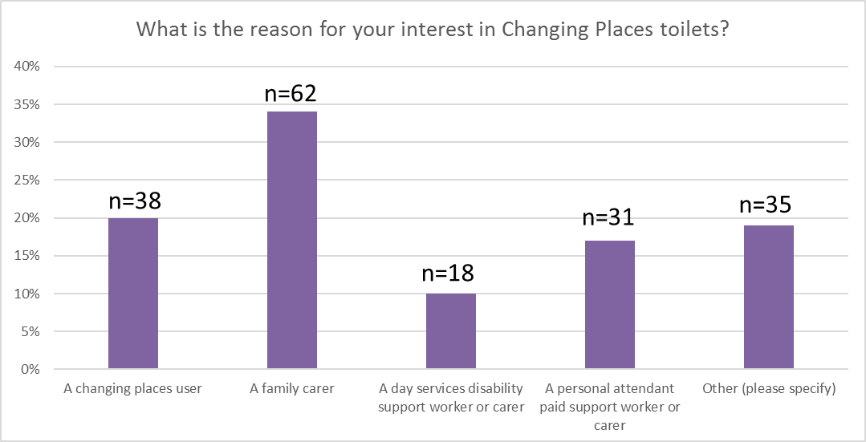

A total of 187 respondents completed the user survey. Most were family carers (34%), followed by those self-identifying as people with a disability (20%), then paid support workers (16.5%), and day services workers (10%). Around one-fifth (20.5%) fell into the other category which included teachers, interested venue owners, friends, and disability support workers.

## Response by state

#### Table 1: Response by state

|  |  |
| --- | --- |
| State | Number of responses |
| Victoria | 108 |
| Queensland | 23 |
| New South Wales | 11 |
| South Australia | 24 |
| Western Australia | 19 |
| Tasmania | 2 |
| **TOTAL** | **187** |

More than half the respondents for this national survey were from Victoria. That Australian Changing Places originated in Victoria, has a strong advocacy base, and the most Changing Places facilities may factor into the strong response from that state. Victorian data has been extracted to compare the response rates of Victorian users against the national data. Response rates from the other states are too small which precludes detailed analysis. The findings detailed in this report focus on Victoria and the rest of Australia.

## Response by age

#### Graph 2: Response by age

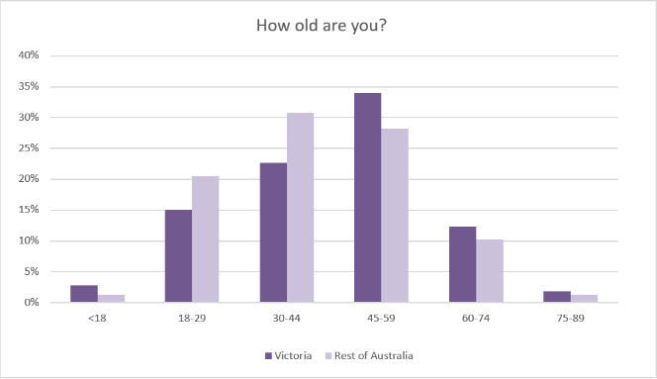

## Response by gender

#### Graph 3 Response by gender

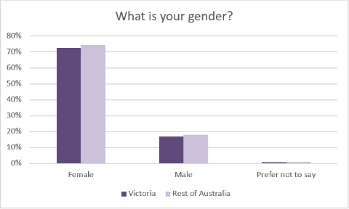

The respondents to the user survey were mostly female (80%). This is unsurprising given in most families, women often fulfil the caring role of those with a disability and paid carers tend to be women (Carers Australia 2019). Disability services are female dominated professions (National Disability Services 2017). 18.5% respondents were male, and less than 2% (3 people) preferred not to say.

## Response by disability

A total of 154 respondents shared their disability type. Cerebral palsy emerged as the most frequently mentioned disability type (30%) that uses Changing Places**.** Other conditions included autism, para/quadriplegia, muscular dystrophy, intellectual disabilities, and multiple sclerosis. Incontinence was frequently mentioned as a reason for needing to use Changing Places.

# Themes

## What has been the impact of Changing Places (including Marveloo) on people with disabilities, families and carers (participation, economic, social)?

* What have their experiences with Changing Places and the Marveloo been? What could be better (design, access, cleanliness, knowing where to find)?

### Changing Places users

Of the 187 respondence, 118 said they had used a Changing Places previously, 59 said they had not, 4 said they didn’t know, and 6 said it wasn’t applicable. The following feedback on the facilities is based on just under two-thirds (63%) of all survey respondents.

#### Graph 4: Response by aspect of Changing Place toilet used

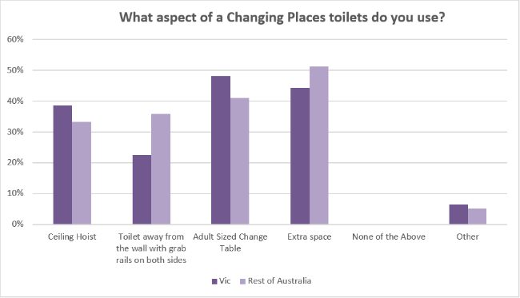

The chart above represents responses from users about which aspects of the Changing Places facility they used. Most had used the extra space (74.5%), the change table (71%) and the ceiling hoist (57%).

### Most frequently visited Changing Places

On average, most survey respondents had visited one or two locations. Most of these were close to where they lived in their local community.

The most frequently visited Changing Places were: Eastland Shopping Centre, Melbourne Zoo, Melbourne Cricket Ground, Lilydale Lake, Ringwood Lake, Shepparton and Elizabeth Quay in Perth.

**Table 2: Most frequently visited Changing Places ranked by number of users**

| **Location** | **Number of users** |
| --- | --- |
| Eastland Shopping Centre | 23 |
| Melbourne Zoo | 15 |
| Lilydale Lake | 13 |
| Melbourne Cricket Ground (MCG) | 9 |
| Ringwood Lake | 7 |
| Shepparton | 7 |
| Flinders St Station* | 6 |
| Elizabeth Quay | 6 |
| Frankston George Pentland Botanic Gardens | 6 |
| Brisbane Domestic Airport | 4 |
| Yarra Glen | 4 |

* *The Flinders St Station facility is an accessible adult change facility rather than a Changing Place and is located at Travellers Aid, Flinders Street.*

### Benefits of Changing Places

Overall, there was a high level of satisfaction with facilities. Survey respondents commented on how Changing Places has made a difference in their lives.

*“Was very impressed the 1st time we used one, just made everything so much easier and comfortable. Extremely happy with all the ones we have used, great facilities and easy to access.”* (carer)

*“They are great, making being out much more pleasant and manageable.”* (carer)

*“They are absolutely amazing and life changing for everyone involved.”* (user)

Themes that were repeatedly expressed included: Independence/Freedom, going out into the community more often/for longer periods or time, dignity and privacy, feeling part of the community, and safety/cleanliness.

**Graph 5: Benefits of Changing Places toilets** 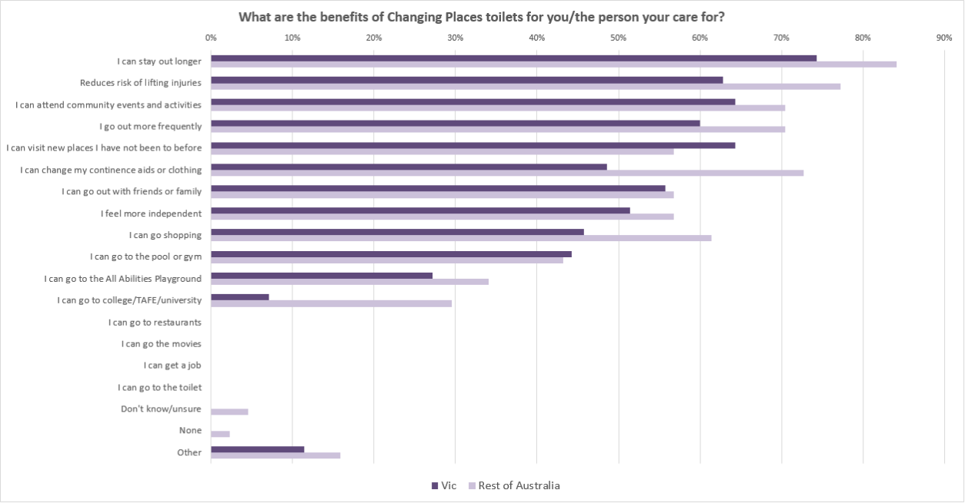

Some people stated they visited particular venues to use the Changing Places facility. They often plan their day within close proximity to the venue.

## Life before and after Changing Places

A total of 103 respondents to the user survey answered, “What difference has Changing Places made in your life?” Key themes that emerged from this question included:

Freedom/independence

Social Inclusion

Able to stay out longer

Able to go to new place

Minimising risk of lifting injuries for carers

Increased safety for users who may been changed on unhygienic public toilet floors

More dignity and privacy for users

Increased confidence in users and carers to spend longer times in the community

*“My daughter can go out with one person and get changed with dignity and cleanliness. If there is no adult change facility, then it's being changed on the floor and two people to lift her back in her wheelchair.”* (carer)

*“Can plan out in the community for my daughter to help reduce isolation and depression. She can come and go shopping, have coffee without having to cut trip short”* (carer)

*“Can be just like everyone else & go to the bathroom when I need to which means I'm able to attend more events and increase my social activities and interaction.”* (user)

*“It means that we can continue to have as normal as possible life not just be at home”* (user)

*“It’s provided a safer, sanitary and more enjoyable experience out in the community”* (user)

*“It has allowed me to have choice in my life.”* (user)

**Graph 6: Frequency of leaving an event early due to absence of Changing Place toilet**

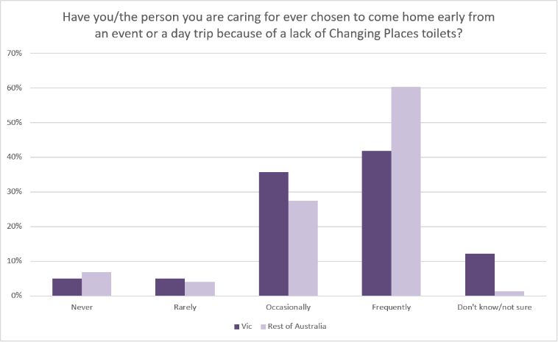

Half the people responding to this question, noted that they have to come home early from events if there are no Changing Places or other appropriate facilities.

*“When my daughter was between the ages of approx. 8 to 15 years of age we had to plan our outings around her PEG feeds and therefore her toileting issues. We did not want her siting in a wet and/or soiled continence product for any longer than she had to. Due to a lack of changing facilities we were unable to change her in a way that gave her privacy and dignity. This affected how long we were able to stay out as a family or only one parent could take the siblings while the other parent stayed with our daughter. Doesn't make for a great deal of family time where you can be out and about all together. Travelling to Qld theme parks was a prime example. So many moments missed by one of us parents.”* (carer)

**Graph 7: Influence of Changing Place on decision making and planning**

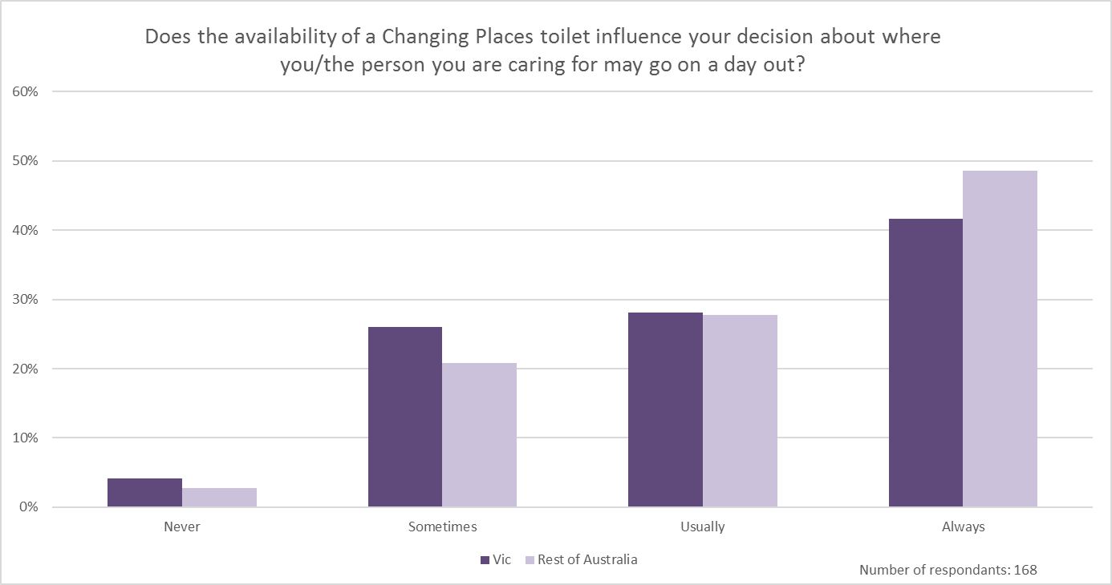

Just under half (43%) the respondents said the availability of a Changing Places facility frequently determined their plans to go out. 28% said usually, 24% said sometimes, 2% said rarely (3 people) and 3.5% said never (6 people). A high number of respondents noted the importance of knowing about the location of Changing Places facilities either at their destination or on the way. Having an up-to-date and reliable way to source this information was welcomed by most users and carers.

*“We have chosen not to go out because of lack of facilities in general.”* (carer)

**Graph 8: Frequency of manual handling injury rates amongst respondents**

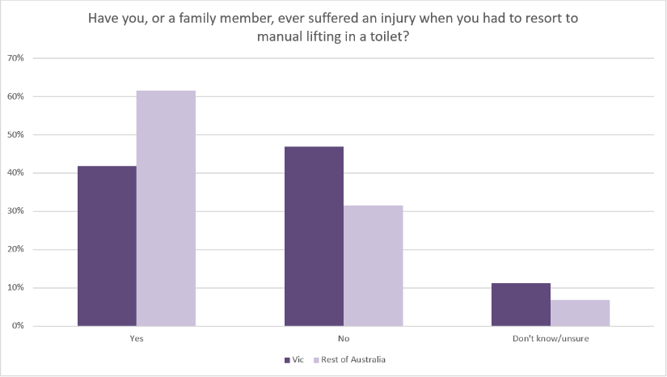

Almost two-thirds (60%) of respondents noted that they or a family member/carer had suffered an injury due to manual handling in non- Changing Places facilities. Protecting the physical wellbeing of carers has been one of the significant benefits of these types of facilities.

## Future Builds

It was uniformly agreed in the survey that Changing Places should be as widely available as standard public toilets.

*“We need more of them. Every disabled toilet should have the same facilities as a changing place.” (user)*

### Requested locations

User survey participants were asked to rank location types where they felt Changing Places were most needed in communities.

Respondents were asked to nominate their preferred sites for new Changing Places. Across Australia, a total of 233 nominations for Changing Places were received including 127 nominations for sites in Victoria.

**Table 3: Number of nominated new sites ranked by state**

| **State** | **Number of nominations** |
| --- | --- |
| Victoria | 127 |
| South Australia | 45 |
| Western Australia | 21 |
| Queensland | 18 |
| New South Wales | 15 |
| Tasmania | 4 |
| Australian Capital Territory | 1 |

### Frequently nomination locations

The most frequently nominated locations are included in the table below. The full list nominated locations Can be found in *Appendix 1:Specific sites for locations of Changing Places facilities.*

**Table 4: Most frequently nominated new sites ranked by frequency of nominations.**

| **Location (outside Victoria)** |  | **Number of nominations** |
| --- | --- | --- |
| Melbourne Airport - Domestic and International |  | 8 |
| Chadstone Shopping Centre (N.B Chadstone opened in August 2019) |  | 7 |
| Ocean Grove Nature Reserve |  | 6 |
| Westfield Knox |  | 5 |
| Flinders St Station |  | 4 |
| Hilary’s Boat Harbour (WA) |  | 4 |
| Rundle Mall, Adelaide (SA) |  | 4 |
| Westfield Marion, Oaklands Park (SA) |  | 4 |
| Geelong City Centre |  | 3 |

**Graph 9: Type of locations Changing Places are needed the most in Victoria**

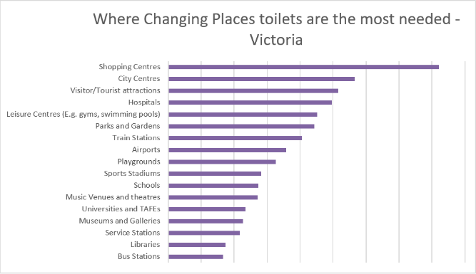

**Graph 10: Type of locations Changing Places are needed the most in Australia**

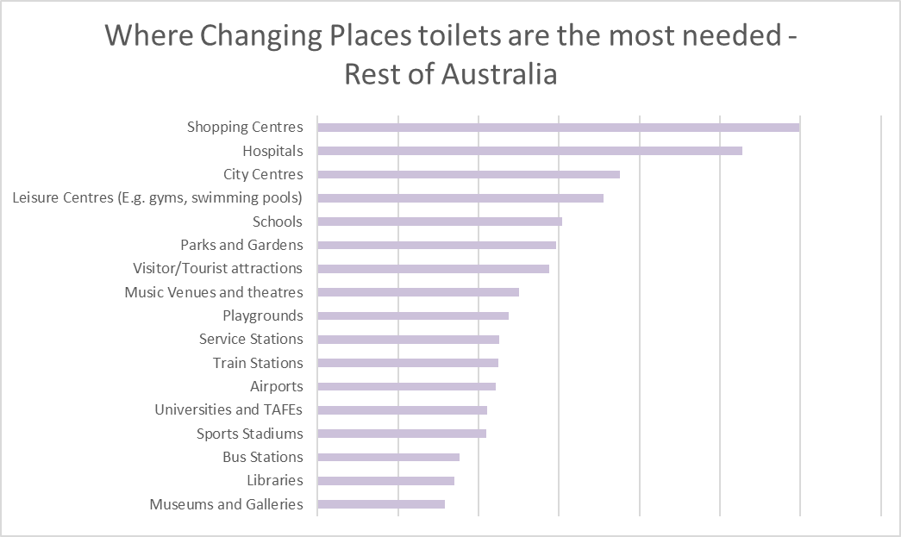

Most people wanted to see Changing Places in shopping centres, hospitals, city centres and leisure centres. Bus stations, service stations, and libraries were less commonly mentioned. These rankings may reflect the frequency with which respondents visit certain locations. As noted above, these rankings may reflect the practice of visiting a Changing Places in a particular venue then visiting other places nearby.

### Changing Places and hospitals

A specific question about Changing Places within hospitals was asked of users in the survey.

**Graph 11: Location within hospital for placement of a Changing Place facility**

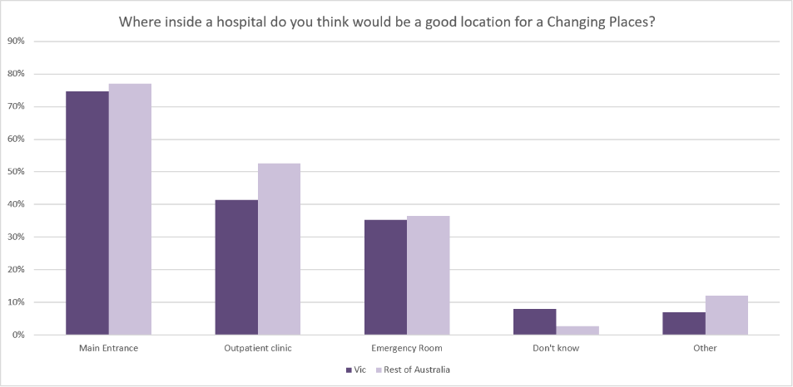

Respondents said that the main entrance was the best place to locate a Changing Places facility (75.5%) followed by the outpatient clinic (47%) and the emergency room (36%). Other locations suggested included the café and one on every ward. However, some survey comments revealed a range of opinions about potential hospital Changing Places.

## Opportunities for improvement

Several perceived issues and challenges with Changing Places surfaced in the user survey.

**Graph 12: Frequency of Changing Places toilets being unavailable for use**

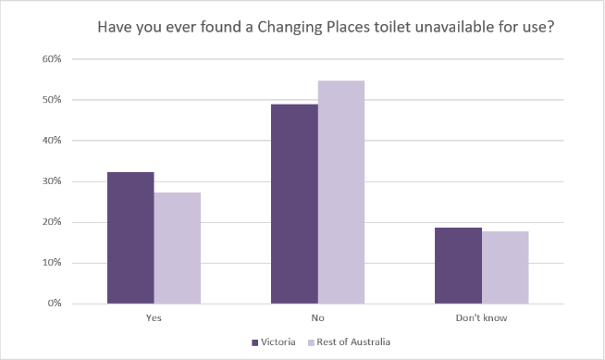

In the survey, users were asked if they have ever found a Changing Place unavailable for use. Just under one third (31%) said yes. Fifty respondents note a range of reasons. These include:

*Not vacant - being used by another Changing Places user*

*being used inappropriately by people/persons who could use other facilities*

*vandalism/damage*

*not clean*

*door is locked and user didn’t have a key/key or door did not work*

*being used as a storage room*

*equipment was not working and/or broken*

no Changing Places available in the respondent’s area

Some of these remarks were echoed in the final survey question inviting additional comment.

According to users, venues differ in maintenance standards and knowledge among venue staff. This was particularly the case for transport hubs and shopping centres. As noted by one respondent:

*“The Changing Places is dirty, general staff doesn’t know what or where it is*.” (carer)

There were also two streams of thought about whether the door should be locked or unlocked. Some respondents wanted it locked to protect against misuse, while others wanted unlocked, so they could gain easy access. Comments throughout the user survey about Master Locksmith Association Keys (MLAK), the door, and open access to the facility suggest some possible issues:

Some respondents are not aware of being able to purchase their own MLAK and rely on obtaining a key from their venue.

Not all venues are using the MLAK system, with some keeping their Changing Places unlocked and open access.

These possibilities suggest some opportunities to improve publicity about MLAK to the public, and to consider further consultations with venues to understand their policies on whether to keep a Changing Places locked or unlocked.

# User experiences of Marveloo

**Graph 13: respondent awareness of the Marveloo**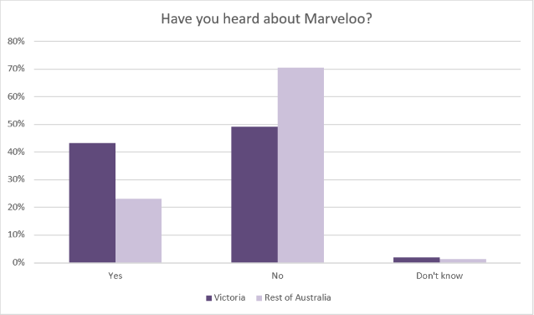

**Graph 14: Respondent use of Marveloo**

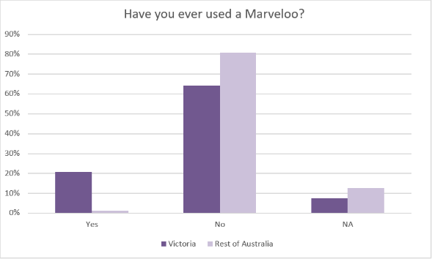

A total of 175 responded to the question “Have you ever used a Marveloo?”. 134 people said No, 23 said yes, and 18 said Not Applicable. The feedback below is based on the experiences of 23 people in Australia.

Respondents mentioned 14 different events and festivals where they had used a Marveloo.

**Table 5: Marveloo use at festival and events**

|  |  |
| --- | --- |
| **Location Name** | **Mentions** |
| Begonia Festival Ballarat | 3 |
| City of Geelong | 1 |
| Disability Expo Melbourne | 2 |
| Music event (unspecified) | 1 |
| International Day of Persons with a Disability - Mornington Civic Centre, All Abilities day | 1 |
| Golden Plains Shire Event | 1 |
| Carlton Exhibition Centre | 1 |
| MCG | 1 |
| Great Australian Rally 2019 | 1 |
| Wagga Wagga | 1 |
| Garden Show (Unspecified) | 1 |
| Coburg Night Market | 1 |
| Grand Prix | 1 |
| City of Whitehorse events (Unspecified) | 1 |
| Don't know or other | 3 |
| Total | 20 |

18 respondents nominated events and festivals where they would like to see a Marveloo.

**Table 6: Festivals or events where respondents would like a Marveloo**

|  |
| --- |
| **Event name (location if specified)** |
| A Day on the Green and other outdoor functions |
| Ballarat Begonia Festival |
| Children’s Christmas concerts such as Variety Club children’s events |
| Children’s music events such as the Wiggles or Play School |
| ChillOut Festival (Daylesford) |
| Festivals held in the City of Knox |
| Melbourne Cricket Ground |
| Melbourne International Arts Festival (various Melbourne CBD locations) |
| Melbourne International Comedy Festival (various Melbourne CBD locations) |
| Melbourne International Flower and Garden Show (Carlton Gardens) |
| Melbourne Show (Melbourne Showgrounds) |
| Music festivals (general) |
| Rural areas |
| St Kilda Festival (St Kilda) |
| Sydney Royal Easter Show (Sydney Showground, Olympic Park) |
| The Waterfront Festival (Frankston) |
| Outdoor events (general) |
| VIVID Sydney (Darling Harbour) |

Feedback on the design was generally positive with some remarks about the size and ease of use.

Comments for aspects that could be improved were

*“Yet to see ours used.”* (council staff)

*“Was a bit smelly”* (user)

*“The only thing I don't like about the Marveloo is that there is only one toilet available...often it is at events where there are a lot of wheelchair users so one toilet is not sufficient. Maybe the space could be used more efficiently, and two toilets could be provided”* (carer)

*“no shower”* (advocate)

*“Too small for motorised wheelchairs”* (user)

*“They are very expensive to hire and sometimes you have to take management of waste disposal”* (council staff)

*“I felt a little unsure on my feet, but that is better than the alternative*” (user)

A total of 25 respondents when asked “Would the availability of a Marveloo at an event or festival influence whether or not you went to the event?”, 17 said it definitely would, 7 said it probably would, and 1 said it would not.

The benefits of Marveloo were detailed by 24 respondents. The main benefits were being able to stay longer, it made festivals accessible and enjoyable, spending time with friends and families, feeling more independent and reducing injury among carers.

**Graph 15: Benefits of the Marveloo**

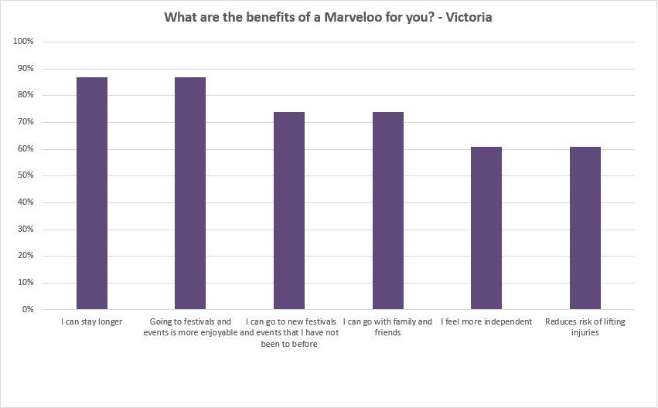

# Appendix 1 – Specific sites for locations of Changing Places facilities

## Specific locations for Changing Places

**Survey question: Please tell us your suggestions for where you would like to see a Changing Places toilet**.

Please tell us much detail as you can about the venue, address and location. You can list up to three.

A total of 233 nominations were cast across Australia including 127 nominations for Victorian sites.

| **Metropolitan LGA; regional city / town or State (if outside Victoria)** | **Total Nominations** | **Location** |  |
| --- | --- | --- | --- |
| **Bendigo** | **2** | Bendigo Specialist School | 1 |
|  |  | Bendigo Hospital | 1 |
|  |  |  |  |
| **Cardinia** | **1** | Tynong North, Gumbuya World | 1 |
|  |  |  |  |
| **Casey** | **2** | Churchill National Park | 1 |
|  |  | Clyde Bullarto Road Shopping Centre | 1 |
|  |  |  |  |
| **Central Goldfields** | **1** | Maryborough Hospital | 1 |
|  |  |  |  |
| **Frankston** | **2** | Frankston Train Station | 2 |
|  |  |  |  |
| **Geelong** | **25** | Ocean Grove Nature Reserve | 6 |
|  |  | Geelong City Centre | 3 |
|  |  | Avalon Airport | 2 |
|  |  | Geelong Bellarine Aquatic Centre | 2 |
|  |  | Geelong Waterfront | 2 |
|  |  | Westfield Geelong | 2 |
|  |  | Serendip Sanctuary | 2 |
|  |  | Geelong Heritage Centre | 1 |
|  |  | Moorabool St Geelong | 1 |
|  |  | Geelong Train Station | 1 |
|  |  | Geelong West | 1 |
|  |  | Ocean Grove Surf Beach | 1 |
|  |  | Waurn Ponds Shopping Centre | 1 |
|  |  |  |  |
| **Golden Plains** | **3** | Bannockburn Heart Play space | 2 |
|  |  | Bannockburn Library | 1 |
|  |  |  |  |
| **Hepburn Shire** | **3** | Clunes Town Centre | 1 |
|  |  | Creswick Town Centre | 1 |
|  |  | Daylesford Town Centre | 1 |
|  |  |  |  |
| **Hobsons Bay** | **1** | Williamstown | 1 |
|  |  |  |  |
| **Hume** | **1** | Sunbury City Centre | 1 |
|  |  |  |  |
| **Knox** | **8** | Westfield Knox | 5 |
|  |  | Knox Ozone | 1 |
|  |  | Knox King's Park | 1 |
|  |  | Knox Leisure Works | 1 |
|  |  |  |  |
| **Mansfield** | **2** | Mt Buller Alpine Resort | 1 |
|  |  | Mt Stirling Alpine Resort | 1 |
|  |  |  |  |
| **Melbourne** | **20** | Flinders St Station | 4 |
|  |  | Docklands / Marvel Stadium | 2 |
|  |  | Melbourne CBD | 2 |
|  |  | Royal Botanical Gardens, Melbourne | 2 |
|  |  | Southern Cross Train Station | 2 |
|  |  | Alfred Hospital | 1 |
|  |  | Bourke St Mall | 1 |
|  |  | Crown Casino | 1 |
|  |  | MCG (Changing Place opened in 2016) | 1 |
|  |  | Melbourne Zoo (Changing Place opened in 2016) | 1 |
|  |  | Parliament Station | 1 |
|  |  | Royal Melbourne Hospital | 1 |
|  |  | Southbank Museum precinct | 1 |
|  |  |  |  |
| **Mildura** | **3** | Mildura | 1 |
|  |  | Mildura Aerodrome Ovals | 1 |
|  |  | Mildura Riverfront, Hugh King Drive | 1 |
|  |  |  |  |
| **Monash** | **4** | Monash Medical Centre | 2 |
|  |  | Jells Park | 1 |
|  |  | Monash Hospital | 1 |
|  |  |  |  |
| **Mornington Peninsula** | **4** | Rosebud shopping precinct | 1 |
|  |  | Sorrento Ferry | 1 |
|  |  | Sorrento Beach | 1 |
|  |  | Sorrento Quay | 1 |
|  |  |  |  |
| **Murrundindi** | **2** | Eildon, Lakeside Camp Ground | 1 |
|  |  | Yea | 1 |
|  |  |  |  |
| **Shepparton** | **9** | Mooroopna Shopping Centre | 1 |
|  |  | Shepparton Deakin Reserve | 1 |
|  |  | Shepparton Kialla Riverside Plaza | 1 |
|  |  | Shepparton Lake Foreshore | 1 |
|  |  | Shepparton Marketplace Shopping Centre | 1 |
|  |  | Shepparton Mall | 1 |
|  |  | Shepparton Sports Stadium, Numurkah Road Shepparton | 1 |
|  |  | Shepparton Train Station | 1 |
|  |  | Shepparton Victoria Park Lake Precinct | 1 |
|  |  |  |  |
| **Stonnington** | **7** | Chadstone Shopping Centre (Changing Place opened in 2019) | 7 |
|  |  |  |  |
| **Strathbogie** | **1** | Euroa | 1 |
|  |  |  |  |
| **Surf Coast** | **3** | Torquay Foreshore | 2 |
|  |  | Lorne Foreshore | 1 |
|  |  |  |  |
| **Wangaratta** | **1** | Wangaratta | 1 |
|  |  |  |  |
| **Wyndham** | **1** | Werribee Zoo (Changing Place opened in 2019) | 1 |
|  |  |  |  |
| **Yarra Ranges** | **7** | Healesville Sanctuary (Changing Place opened in 2019) | 2 |
|  |  | Chirnside Park Shopping Centre | 1 |
|  |  | Healesville Near Shopping Centre and New Park | 1 |
|  |  | Healesville Queens Park | 1 |
|  |  | Lilydale station | 1 |
|  |  | Mount Dandenong | 1 |
|  |  |  |  |
| **National Parks & Reserves** | **4** | You Yangs Regional Park | 2 |
|  |  | Wilsons Promontory National Park | 2 |
|  |  |  |  |
| **Melbourne Airport** | **8** | Melbourne Airport | 8 |
|  |  |  |  |
| **South Australia** | **45** | Rundle Mall, Adelaide | 4 |
|  |  | Westfield Marion, Oaklands Park | 4 |
|  |  | Adelaide Oval | 2 |
|  |  | Adelaide Zoo | 2 |
|  |  | Port Lincoln Foreshore | 2 |
|  |  | Whyalla Hospital | 2 |
|  |  | Whyalla Westland Shopping Centre | 2 |
|  |  | Adelaide Library | 1 |
|  |  | Adelaide North Terrace | 1 |
|  |  | Adelaide Women’s and Children’s Hospital | 1 |
|  |  | Cowell Service Station | 1 |
|  |  | Clare Main Street | 1 |
|  |  | Freeling FARM Centre | 1 |
|  |  | Hewett Community Playground, Rosella Circuit | 1 |
|  |  | Kadina Library and TAFE | 1 |
|  |  | Kadina, Victoria Square Park | 1 |
|  |  | Kapunda 'Lions Park', Hill St | 1 |
|  |  | Nuriootpa | 1 |
|  |  | Port Adelaide Corner Lipson and St Vincent Streets | 1 |
|  |  | Port Lincoln Hospital | 1 |
|  |  | Port Lincoln Nautilis Theatre and Arts Centre | 1 |
|  |  | Port Lincoln | 1 |
|  |  | Prospect, Prospect Oval | 1 |
|  |  | SA Art Gallery and SA Museum | 1 |
|  |  | Tanunda | 1 |
|  |  | Victor Harbor | 1 |
|  |  | Wallaroo Public Toilets | 1 |
|  |  | Westfield Colonnades, Noarlunga Centre | 1 |
|  |  | Westfield Tea Tree Plaza, Modbury | 1 |
|  |  | Westland West Lakes | 1 |
|  |  | Whyalla | 1 |
|  |  | Whyalla Cinema | 1 |
|  |  | Whyalla Middleback Theatre | 1 |
|  |  | Whyalla, uptown | 1 |
|  |  |  |  |
|  |  |  |  |
| **Western Australia** | **21** | Hilary's Boat Harbour | 4 |
|  |  | Curtain University, Bentley Campus | 1 |
|  |  | Fremantle | 1 |
|  |  | Fremantle Fishing Boat Harbour | 1 |
|  |  | Kununurra | 1 |
|  |  | Margaret River | 1 |
|  |  | Monkey Mia Visitor Centre | 1 |
|  |  | Murdoch University, Murdoch campus | 1 |
|  |  | North west WA | 1 |
|  |  | Perth City Centre | 1 |
|  |  | Perth Queen Elizabeth II Medical Centre | 1 |
|  |  | Royal Perth Hospital | 1 |
|  |  | Rockingham Beach | 1 |
|  |  | Rottnest Island | 1 |
|  |  | South west WA | 1 |
|  |  | South Perth | 1 |
|  |  | University of WA, Crawley campus | 1 |
|  |  | Whiteman Park | 1 |
|  |  |  |  |
| **Queensland** | **18** | Westfield Carindale | 2 |
|  |  | Brisbane Airport | 1 |
|  |  | Brisbane CBD | 1 |
|  |  | Brisbane Entertainment Centre | 1 |
|  |  | Brisbane Queen Street Mall | 1 |
|  |  | Brisbane Roma Street Station | 1 |
|  |  | Cairns Esplanade | 1 |
|  |  | Cairns Tobruk Memorial Pool | 1 |
|  |  | Eumundi Markets | 1 |
|  |  | Gold Coast | 1 |
|  |  | Gold Coast Airport | 1 |
|  |  | Gunalda Service Station Bruce Highway | 1 |
|  |  | North Queensland Stadium | 1 |
|  |  | Queensland Performing Arts Centre | 1 |
|  |  | Sunshine Coast Beach | 1 |
|  |  | Townsville The Strand, | 1 |
|  |  | Townsville Willows Shopping Centre | 1 |
|  |  |  |  |
| **New South Wales** | **15** | Gosford Public Hospital | 2 |
|  |  | Batemans Bay village centre | 1 |
|  |  | Castle Towers Shopping Centre | 1 |
|  |  | Central Coast Northern end | 1 |
|  |  | Gosford RSL | 1 |
|  |  | John Hunter Hospital | 1 |
|  |  | Leeton NSW | 1 |
|  |  | Maitland Hospital | 1 |
|  |  | Rouse Hill Town Centre | 1 |
|  |  | Randwick Children’s Hospital | 1 |
|  |  | Sydney Aquarium | 1 |
|  |  | Umina Beach Peninsula Recreation Precinct | 1 |
|  |  | Westmead Children's Hospital | 1 |
|  |  | Yass | 1 |
|  |  |  |  |
| **Tasmania** | **4** | Burnie Regional Art Gallery | 1 |
|  |  | Hobart | 1 |
|  |  | Northern Tasmania | 1 |
|  |  | Southern Tasmania | 1 |
|  |  |  |  |
| **Australian Capital Territory** | **1** | Westfield Tuggerah | 1 |
|  |  |  |  |
| **Non-specific or multiple location** | **4** | Deakin University Campuses (Changing Places open at Burwood and Waurn Ponds campuses) | 1 |
|  |  | Bellarine Peninsula | 1 |
|  |  | City Square | 1 |
|  |  | Hospital Out-patient clinics | 1 |
|  |  |  |  |
| **TOTAL NOMINATIONS** | **233** |  |  |