Care and transition planning for leaving care: Victorian Practice Framework


If you would like to receive this publication in another format, please email leavingcare@dhs.vic.gov.au
This document is also available on the Internet at the Leaving care page on the Department of Human Services website
© Copyright State of Victoria 2012.
This publication is copyright. No part may be reproduced by any process except in accordance with the provisions of the Copyright Act 1968.
ISBN 978-0-7311-6535-3.
Authorised and published by the Victorian Government, 50 Lonsdale Street, Melbourne.
0170712_DHS7992_07/12

Contents
1. Introduction 4
Legislative and policy context 4
2. Integrated planning 6
Case Planning 6
Care Teams 6
Looking After Children 6
3. Three phases of transition planning and support 8
4. Guiding principles for transition planning 10
Principle: Transition planning practice should be inclusive of young people, their family and
significant others 10
Principle: Care teams are central to developing, monitoring and reviewing transition planning processes 10
Principle: Transition planning processes should be well coordinated and tailored to the individual needs
and circumstances of the young person 10
5. The preparation phase 12
Best practice tasks of the preparation phase 12
Additional specific focus at 15 years 12
Additional specific focus from 16 to 18 years 13
The care and transition plan 13
Preparation phase 14
6. The transition phase 16
Best practice tasks of the transition phase 16
The final transition plan 17
Transition phase process 17
7. The post-care support phase 20
Best practice tasks of the post-care phase 20
Post-care support phase 21
8. Resources and links 23
8.1 Practice resources and checklists that accompany the Framework 23
8.2 Department of Human Services policy and practice advice 23
8.3 Victorian resources for young people leaving care 24
8.4 National resources for young people leaving care 25

1. Introduction
Young people from 15 years of age who are transitioning from living in out-of-home care to independence are a particularly vulnerable group in our community. They often have to develop independent living skills and manage on their own much earlier than other young people. It is therefore critical that they receive significant planning and support to help them develop the skills to become independent over time.
Young people who leave out-of-home care in Victoria do so from the context of their period of time in care, where they have been provided care and support designed to address their particular histories and needs. The transition planning process aims to prepare them for their future and the capacity to live a good life.
The Transition planning for leaving care framework (the Framework) aims to provide all practitioners involved in the delivery of case management, out-of-home care and post-care support with:
- best practice approaches and processes to prepare and support young people transitioning from out-of-home care
- a strong, developmentally-based framework that supports children and young people to develop the skills and resources to grow into mature young adults able to participate fully in community life
- a flexible, accessible service planning response that provides a bridge for young people from care to post-care services, and to independence.
The Victorian Practice Framework is one of a set of resources to support transition planning which also include:
- Guide to developing 15+ Care and Transition Plans
- Looking After Children 15+ Care and Transition Plan.
The Framework supports the Commonwealth, state and territory governments’ priority to improve the experience for young people transitioning to independence as identified in the National Framework for Protecting Australia’s Children 2009–2020. The Framework should be used in conjunction with Transitioning from out-of-home care to independence: A nationally consistent approach to planning and the other Victorian transition planning resources listed above. These resources focus on working with young people, as well as working for them.

Legislative and policy context
In Victoria, the Children Youth and Families Act 2005 (section 16) establishes a requirement for young people under the age of 21 who were subject to custody or guardianship orders on their sixteenth birthday to be provided with services to support them to make the transition to independent living. These services include:
- the provision of information about available resources and services
- financial assistance
- assistance in obtaining accommodation or setting up a residence
- assistance with education and training
- assistance with finding employment
- assistance in obtaining legal advice
- assistance in gaining access to health and community services
- counselling and support.
The Framework provides guidance to help care providers and case managers comply with the legislative requirements through thorough high-quality transition planning, review and recording processes for young people from 15 years of age. Other important policies and frameworks that support the legislative requirements include:
- best interest case practice model – which informs and supports professional practice in family services, child protection and placement and support services to achieve positive outcomes for children and families
- planning for leaving care (Advice Number 1418) – this advice provides Child Protection practitioners and community service organisations with the practice standards, procedures and processes required to prepare and support young people transitioning from care
- Looking After Children practice framework – provides the Victorian practice framework for considering how each child or young person’s needs will be met while they are in out-of-home care. It is used In out-of-home care in accordance with the Best interests case practice model cycle of information gathering, assessment, planning, implementation and review.

2. Integrated planning
Transition planning for leaving out-of-home care is not an isolated activity and must be strongly connected to other planning processes for young people.
It is particularly important that the statutory requirements of case planning undertaken by Child Protection, and the care planning responsibilities managed by care teams in community service organisations is congruent; particularly in the goals and actions required to assist the young person to move on from the custody or guardianship of the state in a safe and sustainable manner.

Case Planning
In Victoria, planning for young people on custody or guardianship orders is founded upon the Best Interest Case Practice Model. This model guides Child Protection case planning, a statutory role specified in the Children, Youth and Families Act (section 166). Case plans contain all decisions made in the best interests of the child or young person particularly with regard to their safety, stability and development.

Care Teams
Every young person in out-of-home care or receiving placement support from a kinship service provided by a community service organisation (CSO) is expected to have a specifically constituted out-of-home care team.
A care team is defined as the group of people who jointly provide the care for a young person while that young person is in out-of-home care. The out-of-home care team is specifically focussed on how the young person’s needs can best be met and should always include:
- the young person’s CSO based key worker or case manager – who is generally expected to lead the care team
- the young person’s child protection practitioner OR the CSO based contracted case manager
- the young person’s primary carer(s) (foster carers, key residential workers, kinship carers, or lead tenants)
- the young person’s parents or significant other (if appropriate)
- any other adult who plays a significant role in caring for the young person such as an Aboriginal community member, youth justice worker, Take Two practitioner.
Out-of-home care teams are expected to use the Looking After Children care management processes for providing good care.

Looking After Children
For those children and young people in out-of-home care, Looking After Children provides the practice framework for good care management. Each young person should have up-to-date Looking After Children essential information records, assessment and progress records, and either a care and placement plan (0–14 years) or a 15+ care and transition plan.
It is vital that, as young people move through adolescence, their assessment and progress record is updated and acted upon.
When young people in out-of-home care reach 15 years of age, the Looking After Children 15+ assessment and progress record and the 15+ care and transition plan must be completed as ‘living documents’, designed to reflect the young person’s developmental needs and the actions undertaken to respond to them as they grow and mature through to 18 years of age.
Care teams should consider updating the assessment and progress records more frequently (six monthly instead of annually) for those aged 16 years and older to track progress during the critical preparation and transition period and to better inform the 15+ care and transition plan. The 15+ care and transition plan must be undertaken at least six monthly to ensure planning and actions are still consistent with the case plan and the young person agrees and is engaged with the plan.
The diagram below demonstrates the interconnection between case planning, the Looking After Children framework and transition planning.
Figure 1: Interconnection between case planning, the Looking After Children framework and transition planning
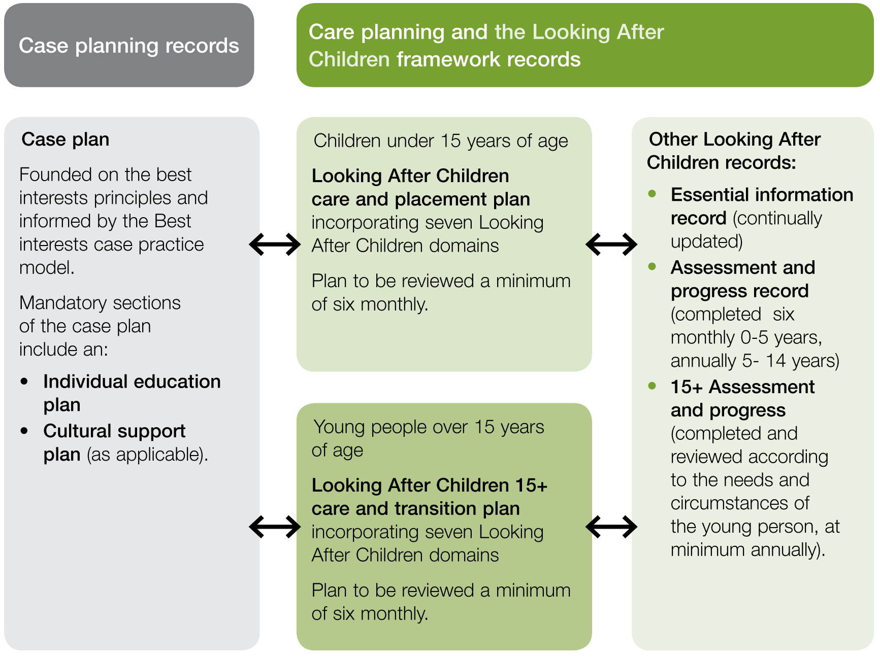
Description of Figure 1
Figure 1 is a diagram that represents how the case planning process and the Looking After Children framework records intersect for the purposes of planning for children and young people in out-of-home care.
Child protection has the statutory case planning role informed by best interests principles found in the Best Interests Case Practice Model.
It is important to note that the mandatory sections of the case plan include:
- Individual education plans
- Cultural support plans (as applicable).
The case plan process is connected to the care plan development. There are two type of care plans:
- for children under 15 years of age, the Looking After Children care and placement plan incorporating seven Looking After Children domains – plan to be reviewed a minimum of six monthly; or
- for young people over 15 years of age, the Looking After Children 15+ care and transition plan incorporating seven Looking After Children domains – plan to be reviewed a minimum of six monthly.
The Looking After Children records comprise:
- the Essential information record (continually updated)
- the Assessment and progress record (completed six monthly 0–5 years, annually 5–14 years)
- the 15+ Assessment and progress (completed and reviewed according to the needs and circumstances of the young person, at minimum annually).

3. Three phases of transition planning and support
Preparation for leaving care and transitioning to independence starts the moment a child or young person enters care and must be a part of the planning process throughout their time in care. “Effective models of support must take account of the need to provide a continuum of care for children so that they can make a graduated transition from care to increasing independence as they mature and grow”.
As a young person reaches mid to late adolescence more concerted transition planning efforts need to take place.
A young person’s “development of practical, emotional and interpersonal living skills and independence” happens along a continuum of three overlapping phases, each with a specific focus of support to guide care teams in their planning.
The three phases of transitioning from care are:
- Preparation – for leaving care through provision of a high quality, stable system of care and coordinated planning and practice tailored to meet the individual needs of the young person while in care. This includes a developmental approach to the promotion of life skills. Preparation for the transition to adulthood should occur throughout the whole time a child is in out-of-home care while more specifically focussed preparation for leaving care is required from the age of 15 years.
- Transition – occurs during the final 12 months of the young person’s custody or guardianship order to formalise plans and support arrangements after the cessation of their orders for the final time. The safety and capacity for young people to live sustainably post-care must be paramount in this planning phase.
- Post-care support – the culmination of a young person’s transition planning, with the necessary appropriate accommodation, employment or study in place and income to live sustainably. The young person, most importantly, needs to be aware of the post-care supports available, how to access them and be supported to do so if required.
According to Mendes (2011), best practice leaving-care planning aims to promote effective transitions for young people that lead to positive community engagement in areas such as housing, education, employment, health, social and family relationships, and networks.
It is an ongoing and dynamic process based on the level of maturity and skill development of the individual young person. It is supported by flexible plans, monitoring of progress and regular review to update the plan in response to changing needs and circumstances.
Figure 2: The three phases of transitioning from care
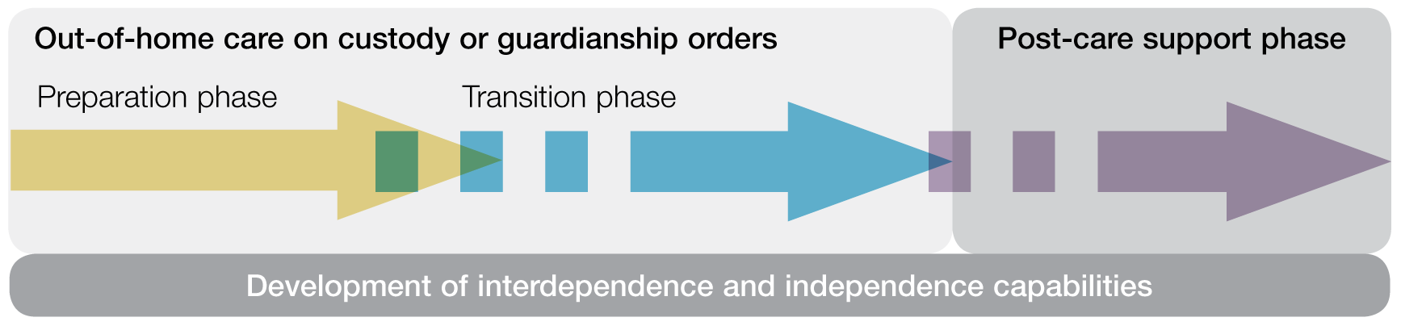
Description of Figure 2
The flow chart demonstrates the three overlapping phases in the development of a young person’s move to adulthood and independence capabilities.
The flow chart begins with the preparation phase, when the young person is in out-of-home care on child protection custody or guardianship orders. The preparation phase continues through the transition phase as arrangements are undertaken for the young person’s safe and sustainable life after the expiration of their child protection orders. The final stage is the post-care support phase, when the young person’s child protection orders have lapsed for the final time. Preparation, transition and post-care supports through to 21 years of age will help the young person move successfully toward adulthood.

4. Guiding principles for transition planning
There are three overarching guiding principles that should inform all practitioners working with young people transitioning from care. These principles apply across all three phases of preparation, transition planning and post-care support.

Principle: Transition planning practice should be inclusive of young people, their family and significant others
This can be achieved by ensuring:
- the young person is central to all planning and is an informed and influential participant
- the young person is supported to engage in their transition planning, and their wishes influence decisions
- where possible the young person’s family and significant others are supported to establish or maintain safe and effective connections and are involved in the transition process.

Principle: Care teams are central to developing, monitoring and reviewing transition planning processes
This can be achieved by ensuring:
- transition planning occurs from 15 to 18 years of age, with regular reviews to bring plans up to date and align them with the young person’s circumstances and wishes
- the care team is inclusive of the young person, family and carers and core membership includes those significant to the day-to-day care and support of the young person
- the young person has a say in core membership of the care team and additional members are invited or informed as required for coordination purposes
- care teams are trauma-informed and culturally sensitive
- the care team actively works to connect with and include the young person through periods of disengagement
- the care team identifies a key worker to work with the young person on transition planning and develops strategies to engage the young person in the process
- the care team aligns transition planning to the young person’s case plan and 15+ care and transition plan with detailed goals, actions, responsibilities and timeframes.

Principle: Transition planning processes should be well coordinated and tailored to the individual needs and circumstances of the young person
This can be achieved by ensuring:
- roles and responsibilities are clear and coordinated, supporting access to appropriate and integrated service responses at each transition stage
- all the Looking After Children life domains are considered and included in planning
- comprehensive assessment and flexible planning is based on the young person’s unique needs, concerns and wishes
- professional development, quality supervision and support are provided to workers and care staff
- planning is regularly reviewed and responsive to changing circumstances, is flexible, provides a safety net and includes contingencies
- the young person’s progress against the goals identified for their personal growth and wellbeing is regularly reviewed.

5. The preparation phase
Preparation for leaving care takes place throughout the young person’s time in care, and it remains the focus right up until the young person’s custody or guardianship order ceases for the final time. It is a continuous planning and assessment process that must formally commence by the time the young person reaches 15 years of age, intensifying in the period leading up to exit from care.
The purpose of the preparation phase is to provide a high quality, stable therapeutic system of care that develops and promotes social and personal skills, education, vocational training and preparation for long term sustainable employment. The young person should be encouraged to connect and be proud of their culture and where appropriate connect with their family of origin. Community involvement that provides opportunities to widen their experiences and meet suitable mentors is also to be encouraged.
The preparation phase of transition planning is undertaken by the out-of-home care team. It involves both the young person and the services necessary to ensure their future transition is safe and sustainable. Strategies and supports to engage the young person in the process in a meaningful way are developed by the care team.

Best practice tasks of the preparation phase
- provide clear and purposeful guidance and modelling of independent living skills for the young person
- build on the Looking After Children approach using up to date essential information records, assessment and progress records and care and placement plans (0–18 years)
- ongoing reviews of care and placement plans incorporating follow up actions identified in assessment and progress records (0–18 years)
- If the young person has a suspected disability or cognitive delay, discuss with Disability Client Services whether a Target Group Assessment is required to determine eligibility.
- focus on stability of care, permanency planning and therapeutic care practices
- develop emotional and interpersonal skills
- ensure therapeutic support is provided where indicated
- explore, develop and consolidate family and significant others’ relationships
- attend to cultural needs and connections
- ensure health and educational assessments are undertaken with follow up actions
- ensure life story records work is undertaken and ongoing
- provide carer education and support as indicated
- remember to reward achievements, however small.

Additional specific focus at 15 years
- commence the 15+ assessment and progress record and develop a 15+ care and transition plan
- engage the young person in discussion about their hopes and ambitions for the future
- develop community engagement and connection skills
- develop core life skills such as budgeting, cooking and self-care including social and sexual health
- attend to education and vocational training
- be aware in early transition planning of identified special needs – risks, vulnerabilities or disengagement.

Additional specific focus from 16 to 18 years
- continue all the actions above
- focus on providing the young person with all necessary help to maintain school attendance or tutoring, or refer them to the Springboard program for additional assistance
- early planning to secure safe, affordable accommodation when the order expires
- if young person is pregnant or a parent, refer them to the Cradle to Kinder program
- ensure safe storage for identity documentation and electoral enrolment is explained and available.

The care and transition plan
From the age of 15, the care team must work with the young person, other relevant professionals (and their family where appropriate) to develop a care and transition plan. This plan is based on the seven domains in the Looking After Children framework, and it is designed to identify the strategies and actions required to build the young person’s independent living skills including:
- social skills to help the young person negotiate with peers and other adults in the community
- budgeting and managing money
- managing family and other relationships
- living with people and resolving conflict
- cooking, housekeeping and self-care
- understanding the rights and responsibilities of an adult.
This planning should also be recorded by child protection In the leaving care planning section of the Client Relationship Information System (CRIS).
There should be regular reviews of the care and transition plan (at a minimum six monthly) to assess progress against each goal. Changes to the plan will reflect goals achieved and ensure the young person continues to develop In a supported manner.

Preparation phase
Figure 3: Preparation phase process
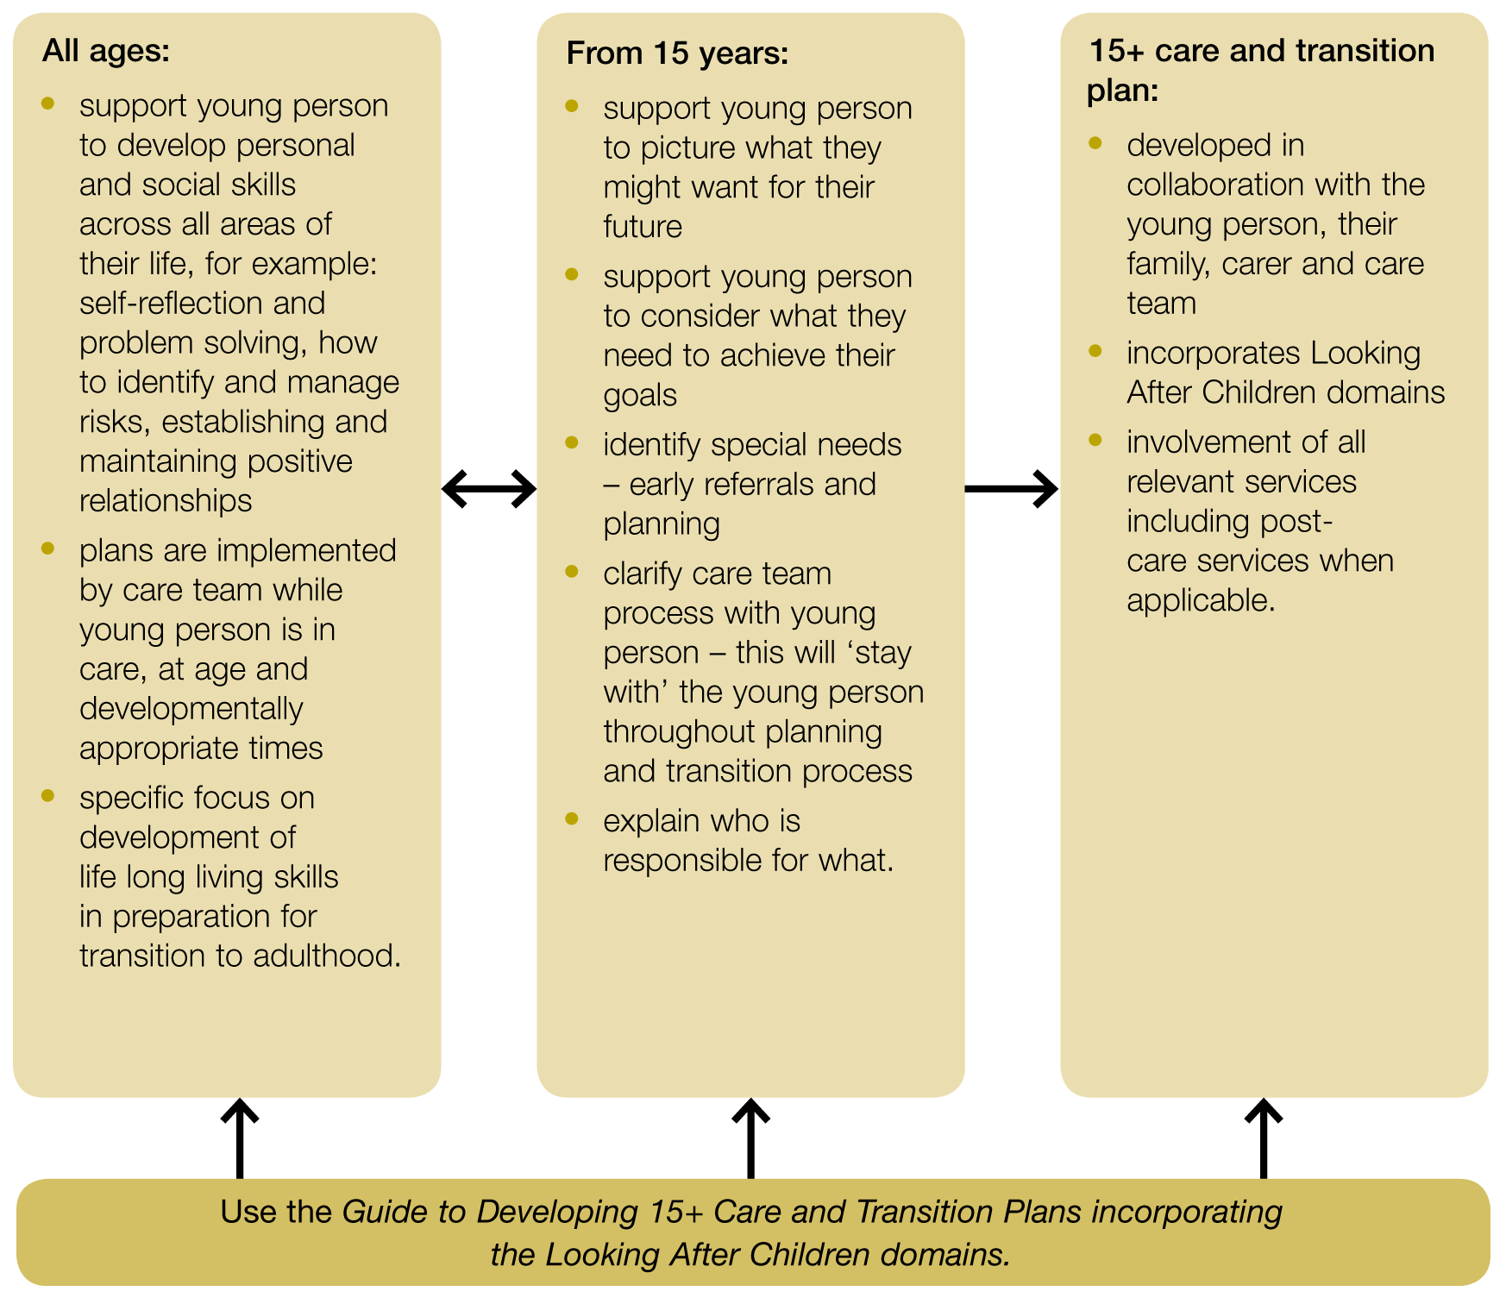
Description of Figure 3
The preparation phase process considers the needs of children and young people from 10 years of age, differentiated into three stages:
- All ages (10–18)
- From 15 years
- 15+ years care and transition plan.
The tasks within each stage are described below. Use the Guide to Developing 15+ Care and Transition Plans incorporating the Looking After Children domains for detailed guidance on undertaking these tasks.
All ages:
- support young person to develop personal and social skills across all areas of their life, for example: self-reflection and problem solving, how to identify and manage risks, establishing and maintaining positive relationships
- plans are implemented by care team while young person is in care, at age and developmentally appropriate times
- specific focus on development of life long living skills in preparation for transition to adulthood.
From 15 years:
- support young person to picture what they might want for their future
- support young person to consider what they need to achieve their goals
- identify special needs – early referrals and planning
- clarify care team process with young person – this will ‘stay with’ the young person throughout planning and transition process
- explain who is responsible for what.
15+ care and transition plan:
- developed in collaboration with the young person, their family, carer and care team
- incorporates Looking After Children domains
- involvement of all relevant services including post-care services when applicable.

6. The transition phase
The transition phase takes place in the last six to 12 months of the young person’s custody or guardianship order, when all plans are confirmed and agreed to by the young person. The purpose of the transition phase is to arrange and confirm the young person’s supports, living arrangements, and any other aspects that transcend their time in and after care. This may be related to but not confined to their health, parenting, personal wellbeing and legal matters. It should be undertaken by their case manager in close collaboration with the young person and the care team.
It is vital that everyone involved in this phase is collaborating positively with one clear goal, to ensure the young person’s transition and post-care way of life provides them with capacity for safe and sustainable choices, and that they know where to get assistance when needed.

Best practice tasks of the transition phase
- ensure the young person is engaged in the transition planning in a meaningful way. If the young person is not engaging in the process the care team needs to develop strategies to ensure the young person has influence over the planning process
- develop the final care and transition plan which needs frequent review and confirm all arrangements are in place including well-defined accommodation arrangements and contingencies
- continue reviews of progress and action plan recommendations
- consolidate core life skills
- continue early planning to secure safe, affordable accommodation
- consolidate engagement in education, training and/or employment
- assist the young person to bring health arrangements (including counselling and therapeutic supports) up to date
- assess personal skills development and take action as required, for example; how to apply for support, how to safely disclose care-leaver status where necessary
- check post care and/or adult services are in place for example disability services or adult mental health services,
- ensure the young person has the required identity documents (100 points) and other important documents
- attend to financial support – facilitate access to Centrelink if required
- consolidate relationships with family members, significant others, friendship networks, partner and mentors
- consolidate community engagement and connections
- assist to access personal items, furniture and utilities. Refer the young person to (and follow-up for acceptance) the region’s Post-Care Information and Referral Services, Leaving Care Helpline (1300 532 846) and Transition to Independent Living Allowance (TILA) (visit the Transition to Independent Living Allowance website)
- if young person is pregnant or a parent with a child up to 4 years of age, refer them (and follow-up for acceptance) into the Cradle to Kinder program
- invite region’s post-care support services to care team meetings as part of the transition planning process.
- include the young person in a meeting with Post-Care Support, Information and Referral Service (PCSIRS) to:
- help the young person get to know the location and workers of the PCSIRS
- let the PCSIRS know about the young person’s needs and arrangements
- discuss and agree on tasks and outstanding issues.
- support is provided to caseworkers and carers to help them support the young person through the transition

The final transition plan
At least six months before the expiry of the young person’s custody or guardianship order for the final time, they should agree to a final transition plan which confirms:
- safe and sustainable accommodation
- education or employment arrangements
- sustainable and adequate income
- access to health services such as medical, dental and other specialist services e.g. mental health

Transition phase process
- meetings involving their case manager, care provider and region’s post-care support service to determine tasks and confirmed arrangements
- post-care financial support
- opportunities for links with other young people through post-care support and advocacy (such as Create Foundation).
This final transition plan should be recorded in the 15+ care and transition plan template. This planning should also be recorded by Child Protection in the leaving care planning section of the Client Relationship Information System (CRIS).
Figure 4: Transition Phase
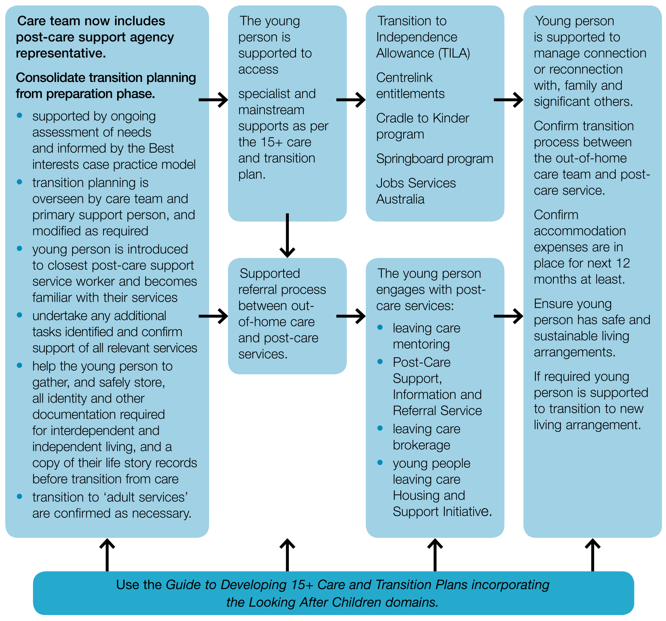
Description of Figure 4
Care team now includes post-care support agency representative.
Consolidation of preparation considerations and progression of transition planning:
- Supported by ongoing assessment of needs and informed by the Best interests case practice model.
- Transition planning is overseen by care team and primary support person, and modified as required.
- Young person is introduced to closest post-care support service worker and becomes familiar with their services.
- Undertake any additional tasks identified and confirm support of all relevant services.
- Help the young person to gather, and safely store, all identity and other documentation required for interdependent and independent living, and a copy of their life story records before transition from care.
- Transition to ‘adult services’ are confirmed as necessary.
- The young person is supported to access specialist and mainstream supports as per the 15+ care and transition plan. This will include:
- Supported referral process between out-of-home care and post-care services.
- Transition to Independence Allowance (TILA)
- Centrelink entitlements
- Cradle to Kinder program
- Springboard program
- Jobs Services Australia.
- The young person engages with post-care services such as:
- leaving care mentoring
- Post-Care Support, Information and Referral Service
- leaving care brokerage
- young people leaving care Housing and Support Initiative.
- Young person is supported to manage connection or reconnection with, family and significant others.
- Confirm transition process between the out-of-home care team and post-care service.
- Confirm accommodation expenses are in place for next 12 months at least.
- Ensure young person has safe and sustainable living arrangements.
- If required young person is supported to transition to new living arrangement.
Remember to use the Guide to Developing 15+ Care and Transition Plans incorporating the Looking After Children domains.

7. The post-care support phase
The post-care phase occurs after a young person’s custody or guardianship order expires for the final time. The purpose of the post-care phase is to ensure the young person is supported following their transition from out-of-home care through continuing access to support, resources and involvement by care and post-care agencies.
The post–care support phase must be anticipated in the transition phase with post-care support services and significant others in the young person’s life invited to participate in final transition planning activities. The young person should be clear about post-care supports available to them with particular emphasis on their individual circumstances.

Best practice tasks of the post-care phase
- check that the young person agrees with the referral to the post-care support, information and referral service and involve them in meetings. If they agree to the referral, arrange a comprehensive handover to the Post-Care Support, Information and Referral Service of completed arrangements and outstanding issues (should be minimal)
- ensure the young person’s out-of-home care provider is part of the post-care support planning processes
- ensure the post-care support service is part of the care team meeting prior to transition where possible
- ensure the young person knows how to seek supports if required with regard to:
- accommodation – knows where to access support to access or retain suitable accommodation
- relationships important to the young person
- services important to develop or maintain independence, which may include:
- Springboard program (visit the Springboard – intensive education and employment support for young people leaving care page on the Department of Human Services website)
- education, vocation and employment services
- Cradle to Kinder program
- specialist and mainstream services including health services, financial counselling, parenting classes, recreational or personal development opportunities
- targeted, intensive, specialised support and/or counselling specific to pre-care or in-care experience, for example mental health services or disability services.
- Leaving Care Helpline 1300 532 846
- Leaving care page on the Department of Human Services website

Post-care support phase
Figure 5: Post-care support phase process
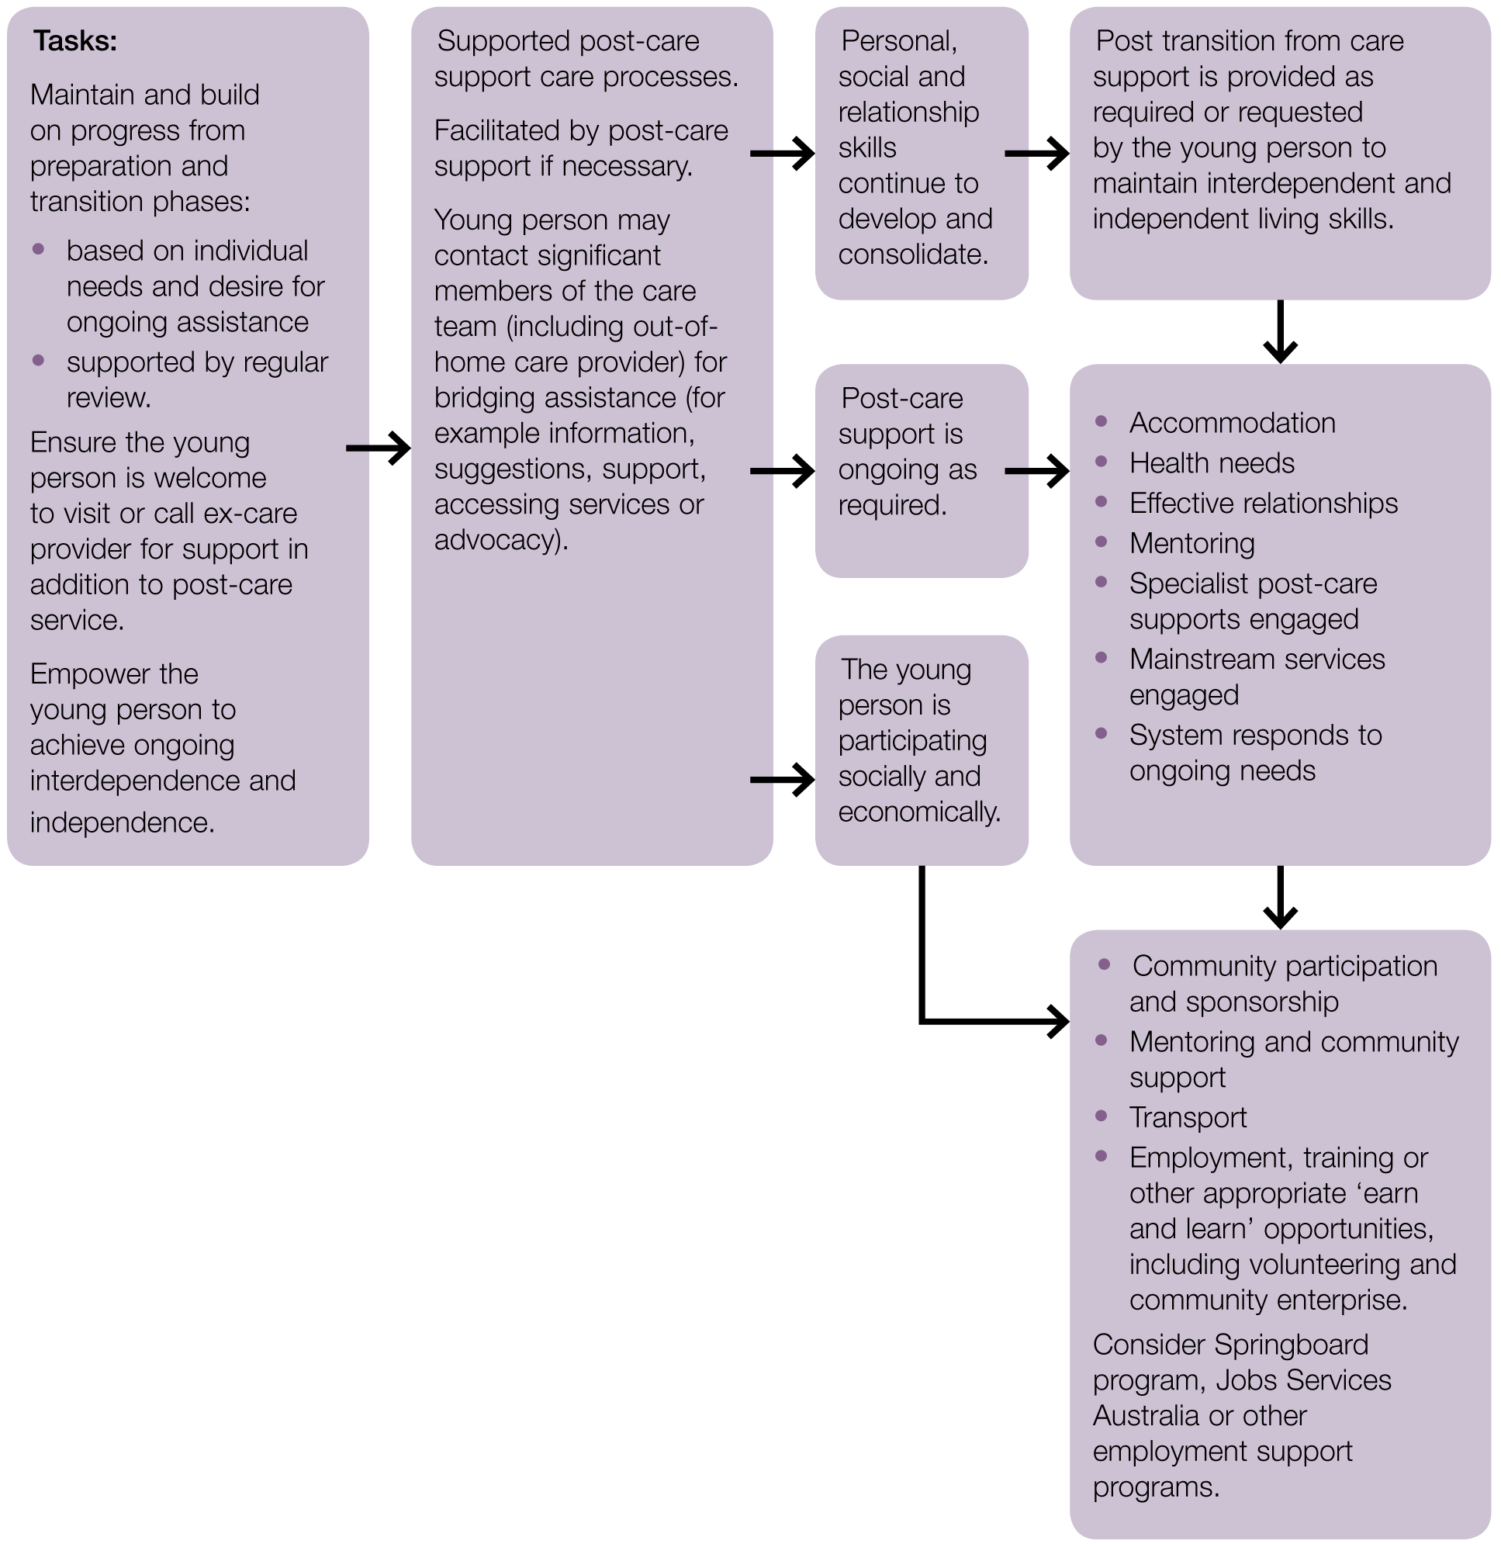
Description of Figure 5
Tasks:
- Maintain and build on progress from preparation and transition phases:
- based on individual needs and desire for ongoing assistance
- supported by regular review.
- Ensure the young person is welcome to visit or call ex-care provider for support in addition to post-care service.
- Empower the young person to achieve ongoing interdependence and independence.
Supported post-care support care (Facilitated by post-care support if necessary)
- Young person may contact significant members of the care team (including out-of-home care provider) for bridging assistance (for example information, suggestions, support, accessing services or advocacy).
- Personal, social and relationship skills continue to develop and consolidate.
- Post-care support is ongoing as required.
- The young person is participating socially and economically.
- Post-care support services are able to provide, as required or requested by the young person, the following services so the young person may maintain interdependent and independent living:
- Stable and safe accommodation
- Access to specialist health services
- Relationship guidance
- Mentoring and community support
- Education and/or employment supports
Information on transition and post-care support services may be found at the Leaving care page on the Department of Human Services website

8. Resources and links

8.1 Practice resources and checklists that accompany the Framework
- Looking After Children records page on the Department of Human Services website
- Guide to developing care and transition planning: incorporating developmental stages in the Looking After Children domains
- Essential Information Record (Looking After Children)
- 15 + Assessment and Progress Record (Looking After Children)
- 15+ Care and Transition Plan (Looking After Children)
- Looking After Children Framework for disability service providers – Implementation of Looking After Children in disability services is a key requirement of the Disability Services and Children, Youth and Families work plan to align policy and operating frameworks for children and young people with a disability in out-of-home care – available at the Looking After Children Framework for disability service providers page on the Department of Human Services website
- Things that Matter checklists – available at the Leaving care page on the Department of Human Services website
- Things that matter: a checklist for carers
- Things that matter when planning for a young person transitioning from state care: a checklist for case planners and case managers

8.2 Department of Human Services policy and practice advice
- Adolescents and their families – best Interest case practice model – Best interests case practice model – summary guide page on the Department of Human Services website
- Planning for leaving care, Child Protection practice advice no. 1418 – Planning for leaving care section of the Child Protection Practice Manual on the Department of Human Services website
- Best interests case practice advice, Child Protection practice advice no. 1481 – Best interests case practice advice no. 1481 – PDF download page on the Department of Human Services website
- High-risk adolescents: practice requirements, Child Protection practice advice no. 1014 – High risk youth (HRY) – practice requirements section of the Child Protection Practice Manual on the Department of Human Services website
- Supporting a child who must change placements, Child Protection practice advice no. 1457 – Supporting a child who must change placements section of the Child Protection Practice Manual on the Department of Human Services website
- Individual education plans, Child Protection practice advice no. 1419 – Individual education plans section of the Child Protection Practice Manual on the Department of Human Services website
- The Children, Youth and Families – Disability Services Operating Framework recognises that children with a disability who are placed in out of home care are particularly vulnerable and describes new processes to be put in place to ensure integrated and seamless service responses. The framework describes the requirements around collaborative planning for young people with a disability living in out-of-home care who are transitioning to adulthood. (Children, Youth and Families – Disability Services Operating Framework – PDF download from the Department of Human Services website)
- Transitioning from out-of-home care: support for Aboriginal young people – guidance for regions, Department of Human Services, February 2012 – Leaving care page on the Department of Human Services website
- Protocol between Child Protection and the Victorian Aboriginal Child Care Agency (VACCA) 2002 – Aboriginal Child Specialist Access Support Service must have input throughout planning – Aboriginal Child Placement Principle Guide 2002 page on the Department of Human Services website
- Out-of-home care education commitment – a partnering agreement between the Department of Human Services, Department of Education and Early Childhood Development, Catholic Education Commission of Victoria and Independent Schools Victoria – Individual education plans section of the Child Protection Practice Manual on the Department of Human Services website
- Protocol Between Child Protection and Juvenile Justice (2012)

8.3 Victorian resources for young people leaving care

CREATE Foundation website resources
- Create Foundation website
- Create Your Future website
- What’s the Plan page on the Create Foundation website

Things that Matter checklist
- Things that matter to young people leaving care – Young Care Leavers page on the Department of Human Services website

Services for young people whose transitioning from care up to 21 years of age
- Leaving Care Help Line (phone 1300 532 846) – is managed by Melbourne City Mission’s Frontyard program and connects young people to their nearest post-care support program or assists with immediate issues including crisis accommodation
- Leaving Care Mentoring Program – aims to provide young people transitioning from care with the opportunities to interact with adults in community settings and to promote personal relationships that mitigate against social isolation by the friendship continuing after the young person has left care – Leaving care page on the Department of Human Services website
- Transitioning from Out-of-home care: Support for Aboriginal young people – This program will be provided by selected Aboriginal Community Controlled Organisations (ACCO) in each DHS region to provide support services for eligible Aboriginal young people who are either transitioning from care, including kinship care, or who are living independently in the community and require support. More information may be found at the Transitioning from out-of-home care support for Aboriginal young people page on the Department of Human Services website
- Young People Leaving Care Housing and Support Initiative – is DHS housing program that provides support for young people transitioning from out-of-home care who are at risk of homelessness, with nomination rights to a limited number of transitional housing places. The target group is young people on custody or guardianship orders in out-of-home care at risk of homelessness at cessation of their orders. Service support provides limited access to alternative housing and support, ability to live in supported accommodation, limited community connections, assessed as able to live independently within two years.
- Springboard: Intensive education and employment support for young people leaving care – is available in all DHS regions and provides intensive one-on-one support to young people who are disengaged from education, training or employment – Springboard – intensive education and employment support for young people leaving care page on the Department of Human Services website
- Zero tuition fees for accredited training (Department of Education and Early Childhood Development) – initiative will provide free tuition for accredited training courses from Certificate 1 to Diploma level for young Victorians who are currently subject to custody or guardianship orders and living in out-ofhome care, and those who have left care up to 22 years of age. Young people will need to meet the Victorian Training Guarantee eligibility criteria in addition to current or previous custody or guardianship orders. Non tuition fees that are charged by training providers will still need to be paid – see financial assistance section below. Leaving care page on the Department of Human Services website
- Post-Care Support Information and Referral Services are available in each DHS region – Young Care Leavers page on the Department of Human Services website or the Leaving Care Help Line 1300 532 846.

Financial assistance
- Child Protection Client Expenses funding – while the young person aged 16–18 years is on a custody or guardianship order, regardless of where they are living, Child Protection Client Expenses will cover basic requirements for example adequate clothing, footwear, toiletries or dental treatment
- Transition Brokerage – while on custody or guardianship orders, from 16 years of age young people are eligible for brokerage funding that may purchase services or materials that would benefit their individual personal or vocational development for example education resources, life-skills education, recreation and hobbies (creating community connections)
- Accessed via case managers
- Post-Care Brokerage – Post Care Brokerage may be used for any purpose that will assist the young person to achieve and/or maintain their independence. Brokerage may contribute to accommodation costs, health and dental care that cannot be covered by Medicare, education, training and employment (for non ex-residential care young adults), access to health and community services, life-skills education and connections to community – Young Care Leavers page on the Department of Human Services website
- Springboard Brokerage – Brokerage funding is managed by the Springboard service provider to enable flexible, creative responses to meet young people’s individual education, training or employment support needs and to overcome barriers to their participation (ensuring this does not duplicate existing brokerage and funding sources) – Springboard – intensive education and employment support for young people leaving care page on the Department of Human Services website

8.4 National resources for young people leaving care
- Transition to Independence Allowance (TILA) – Commonwealth-funded grant of $1,500 available to all young people aged between 15 and 25 years who are preparing to, or have exited, care not more than 24 months previously. TILA can only be accessed once as a lump sum and it is recommended that workers assist young people leaving care to access TILA as soon as is possible post-care. Access to TILA is not a prerequisite in accessing Victoria’s Leaving Care brokerage for eligible young people (refer financial assistance section above). Visit the Transition to Independent Living Allowance website.
- CREATE Foundation Create Your Future scheme – awards grants of $300 to $3,000 to successful applicants by club CREATE members aged 15 to 25 years with a statutory experience. Categories are: accommodation/living, education/ training, driving lessons subsidy, health and wellbeing, laptops for education/ training, travel/conferences, other (items such as clothing, uniforms for employment, computer equipment/software). Visit the Create Foundation website.
- Kids Helpline is a free, confidential, telephone and online counselling service specifically for young people aged between 5 and 25. Telephone 1800 55 1800 or visit the Teens and Young Adults section of the Kids Helpline website.

Independence is defined as ‘the development of practical, emotional and interpersonal living skills that enable us to cope physically and emotionally and form effective social relationships’ (Dixon J and Stein M 2005, Leaving care: through care and aftercare in Scotland, Jessica Kingsley, London). This is often referred to as interdependence.
Available at the Looking After Children records page on the Department of Human Services website
Available at the Looking After Children records page on the Department of Human Services website
National Framework for Protecting Australia’s Children 2009–2020, Attorney-General’s Department, Commonwealth of Australia, Canberra, 2009. Available at the Protecting Children is Everyone’s Business page on the Department of Family, Housing, Community Services and Indigenous Affairs website
Transitioning from out-of-home care to Independence: A Nationally Consistent Approach to Planning, Department of Families, Housing, Community Services and Indigenous Affairs together with the National Framework Implementation Working Group, Commonwealth of Australia, Canberra, 2011. Available at the Transitioning from out of home care to independence page on the Department of Family, Housing, Community Services and Indigenous Affairs website
The Best Interests Case Practice Model documents are available at the Best interests case practice section of the Child Protection Practice Manual on the Department of Human Services website
Planning for leaving care, Advice 1418, Updated September 2009, Department of Human Services. Available at the Planning for leaving care section of the Child Protection Practice Manual on the Department of Human Services website
Further information about LAC is available at the Looking After Children in Practice page on the Department of Human Services website
Maunders D, Liddell M, Lidell M and Green S 1999, Young people leaving care and protection, National Youth Affairs Research Scheme, Hobart.
Dixon J and Stein M 2005, Leaving care: through care and aftercare in Scotland, Jessica Kingsley, London.
Adapted from Transitioning from out-of-home care to Independence: A Nationally Consistent Approach to Planning, Department of Families, Housing, Community Services and Indigenous Affairs together with the National Framework Implementation Working Group, Commonwealth of Australia, Canberra, 2011. Available at the Transitioning from out-of-home care to Independence: A Nationally Consistent Approach to Planning (2011) page on the Department of Family, Housing, Community Services and Indigenous Affairs website
Mendes P, Johnson G and Moslehuddin B 2011, Young People leaving state out-of-home care: a research-based study of Australian policy and practice, Australian Scholarly Publishing. Melbourne.

