
A brief outline of the practice modules
Victorian and Aboriginal Family Preservation and Reunification Response
OFFICIAL

This document has been prepared by the Centre for Evidence and Implementation (CEI) and the Victorian Aboriginal Child Care Agency (VACCA).
8 June 2021

To receive this document in another format, phone 03 9456 4285, using the National Relay Service 13 36 77 if required, or email the Children, youth and families team, <childrenyouthfamilies@dffh.vic.gov.au >.
Authorised and published by the Victorian Government, 1 Treasury Place, Melbourne.
© State of Victoria, Australia, Department of Families, Fairness and Housing, June 2021.
Except where otherwise indicated, the images in this document show models and illustrative settings only, and do not necessarily depict actual services, facilities or recipients of services.
In this document, ‘Aboriginal’ refers to both Aboriginal and Torres Strait Islander people. ‘Indigenous’ or ‘Koori/Koorie’ is retained when part of the title of a report, program or quotation.

Contents
Introduction 6
Purpose of this document 6
Definitions 6
Victorian Family Preservation and Reunification Practice Elements, Cultural Elements and Modules 7
A note on the practice modules 7
Practice modules 7

Introduction

Purpose of this document
The purpose of the document is to:
- introduce the general approach of using evidence-based practice elements and modules
- outline the Victorian and Aboriginal Family Preservation and Reunification Response (the Response) practice modules, including the cultural elements
A more detailed document that outlines the element selection and practice module design processes, and that provides a detailed rationale and description of each practice element and cultural element will be provided to agencies in coming months.
This document focuses specifically on the practices to be embedded within the Response. For broader information on the Response, refer to the Response Operational Start up Guide <https://providers.dffh.vic.gov.au/victorian-and-aboriginal-familypreservation-and-reunification-response>.
Information on the implementation framework provided to support the practice modules can be found in the Implementation Starter Kit. An updated Implementation Starter Kit will be issued prior to 1 August 2021. In the meantime, the current Implementation Starter Kit can be accessed at <https://providers.dffh.vic.gov.au/victorian-and-aboriginal-familypreservation-and-reunification-response>

Definitions
This document uses the terms ‘practice elements’, ‘cultural elements’ and ‘practice modules’.
‘Practice elements’ refers to the specific techniques and practices that are supported by evidence and can be clearly, behaviourally described. The term ‘common elements’ is not used in this document, although it is often used interchangeably with the term ‘practice elements’.
‘Cultural elements’ refers to discrete, culturally informed techniques and strategies to be used by practitioners when working with Aboriginal children and families. These practices and techniques are commonly used when working with Aboriginal families to achieve outcomes that are important to Aboriginal people.
These elements have been put together in particular ways to form ‘practice modules’ which aim to achieve particular outcomes and address the needs of the target cohorts of the Response.

Victorian Family Preservation and Reunification Practice Elements, Cultural Elements and Modules

A note on the practice modules
The practice elements presented in the practice modules are a subset of all possible practices that can be used to support vulnerable children and families. These have been chosen as they have good evidence that they will meet the needs of the children and families we will be working with through the Response. New practice modules will be developed over time and the existing modules will be adapted, refined and further developed to provide a holistic and effective intervention for families with high levels of vulnerability.
All of the practices identified can be used by practitioners in a flexible manner as needed and in conjunction with other effective strategies. They can be used to complement and strengthen existing approaches, ensuring consistency in evidence-informed practices across the service system.

Practice modules
The foundational practices to be implemented in the Response are identified in Figure 1, with blue text showing the cultural elements. The intervention practice modules are shown in Figure 2. A full list of practice elements and cultural elements within all modules is provided in Table 1.
Figure 1. Foundational practice modules to be implemented in the Response
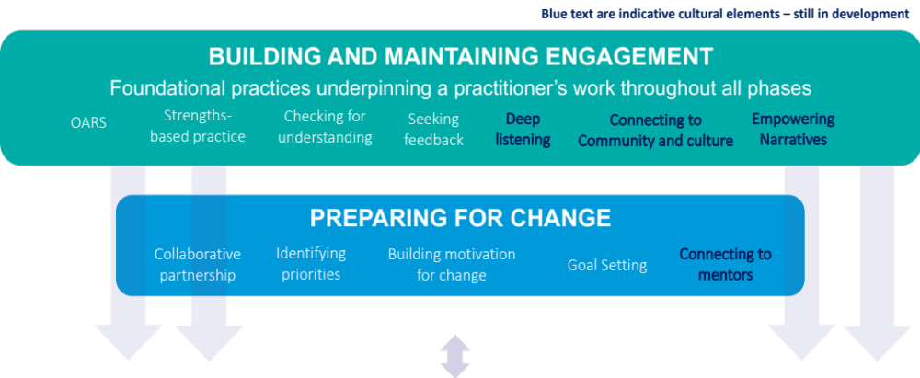

Figure 2. Practice modules to be implemented in the Response
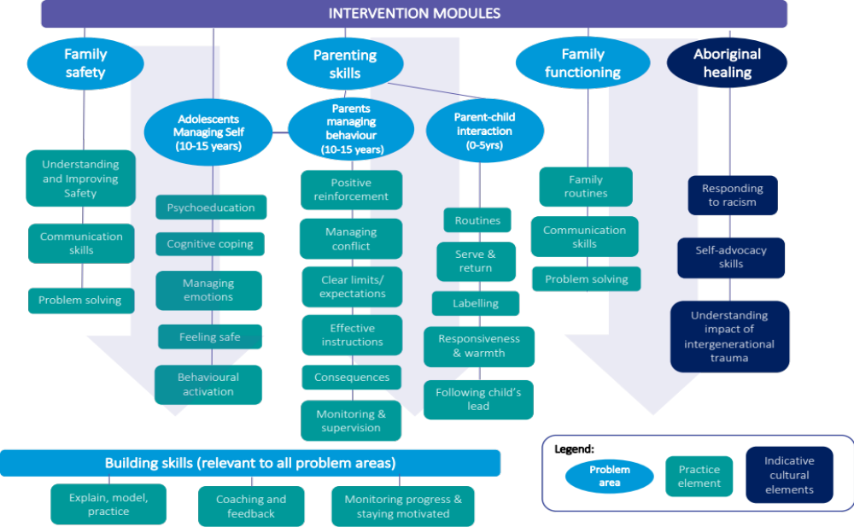

Foundational practice modules

Building and maintaining engagement module
OARS (open-ended questions, affirmations, reflections & summaries)
Objective: to ensure families feel heard, understood and respected as well as supported and empowered to make decisions for themselves. | OARS stands for Open-ended questions, Affirmations, Reflections, and Summaries. OARS are conversation techniques that can be used to build engagement with families. OARS are critical skills for building engagement at the beginning and throughout the working relationship with a family to support communication and maintain engagement.
Strengths-based practice
Objective: to draw on strengths and abilities as a starting point for planning/preparing for change and addressing child safety and wellbeing, identify strengths to solve subsequent problems and for families to feel an increased sense of self-efficacy to make positive changes in their lives. | Strengths-based practice is a way of working that focuses on identifying and using the existing strengths of families to overcome challenges. Considering that conversations in child welfare settings are often focused on weaknesses/needs of the family, this practice element is essential in combating a lack of self-efficacy. Identifying strengths also provides a starting point for the support practitioners can provide to families.
Checking for understanding
Objective: to prevent misunderstandings between families and practitioners that may impact or damage engagement. Families can therefore better understand and retain information given to them, which they can use for the benefit family goals. | Checking for understanding refers to the practice of routinely checking that family members have understood discussions, information, or decisions relevant to them. Practitioners can check for understanding by asking the family member to repeat information, key decisions or actions in their own words. Families receiving placement prevention and reunification services are often experiencing high levels of stress, trauma or other issues which may impact on their ability to process, understand and remember information. They are also often involved with multiple services and may have several practitioners working with them at any one time which can result in a lack of clarity or confusion about service provision. Checking for understanding ensures that family members understand, can fully benefit from, and participate in services.
Seeking feedback
Objective: to empower and equip families to provide honest feedback to practitioners and encourage a collaborative relationship where both parties are clear on expectations and desired outcomes. | Obtaining regular feedback is a powerful way of improving practitioner skills and maintaining engagement with families. It is a prevention strategy to ensure that the family has a platform to raise issues or concerns about the partnership itself and the work being done. By getting direct feedback on how the service is experienced by the family, practitioners can identify aspects of the service that are less effective and work to improve them. The benefits of feedback are not limited to the practitioner; the opportunity to provide meaningful feedback is empowering for families as it enables them to contribute more to the partnerships with practitioners, and ensure the service is meeting their needs and priorities.
Deep Listening (cultural element)
Objective: to provide a space for two-way learning where the family feels heard by the practitioner and allowing communication to be led by the family to support the development of a collaborative relationship. | Deep Listening is an important practice to help develop an interpersonal relationship between practitioners and families from the very start of family engagement with the service. By establishing trust and mutual respect from the outset, Aboriginal families are more likely to engage with activities and provide information the practitioner needs to deliver the service. Practitioners need to observe tone, body language and reflect back where appropriate. When this relationship has been established, Aboriginal families are more likely to have meaningful conversations and participate in information gathering for assessment and case planning. Deep listening is achieved by asking questions to invite conversation and then relying on non-verbal active listening skills to encourage elaboration.
Connecting to community and culture (cultural element)
Objective: to support families to maintain, strengthen and build connection as a source of protection, sense of belonging, identity and to build resilience. | ‘Connecting to Community and Culture’ refers to the practice of supporting Aboriginal families to maintain, strengthen and/or build their connections. Aboriginal people can belong to many Countries and language groups and may have lost connection with their Community due to previous forcible removal from traditional lands, family history of adoption, removal of children (Stolen Generations), the broader impact of past policies and practices and colonisation or family circumstances. Some Aboriginal people may not be aware of the ways in which they can connect with the local community where they live or feel uncomfortable doing so, whereas others will be strongly connected to both Culture and their Community.  Practitioners can support these connections by providing information about significant events and gatherings, provide an introduction to local Aboriginal Community members or support families to access local Aboriginal programs, services and organisations that can establish a sense of belonging and connect with their local Aboriginal Community. The practitioner should respect and understand the protective factors of Culture and ensure the facilitation of Cultural connection as a means to heal trauma and enable preservation and reunification.
Empowering narratives (cultural element)
Objective: to support families to develop empowering narratives focused on truth telling, strength and resilience. | Empowering narratives is an important practice to support Aboriginal families to feel in control of their future, feel resilient and build a strong sense of pride. Practitioners should work with a lens of intergenerational trauma and understanding the continuing cycle of disadvantage that has come from that. This practice enables families to understand the ways in which past policies and practices have impacted upon their lives and their parenting and encourages families to tell stories of strength and resilience. The ongoing impacts of trauma sometimes create silence within Aboriginal families, whereby it is difficult to discuss the past and current impacts and what they look like within individuals, families, and communities.

Preparing for change module
Collaborative Partnership
Objective: to ensure that families feel like they are equal partners in the therapeutic relationship and their strengths and ideas are acknowledged and leveraged. Therefore, family members are clear on their role, and the role of the practitioner in their working relationship. | A collaborative relationship is one where practitioners and families work together as equals in a mutually agreed upon and respectful way. Family-practitioner partnerships should be based on the understanding that each partner has complementary expertise: the family members are regarded as experts on their own particular circumstances, on their children and their family, whereas practitioners are experts in their particular discipline bringing skills, strategies and ideas to support the family.  The practitioner’s role is to prepare for and seek collaboration from the family members involved. As the partnership starts there is a focus on clarifying each role and supporting family autonomy through providing meaningful choices and using specific questions and reflections. When the practitioner provides an opportunity for family members to contribute to their own solutions, exercise their autonomy, and exercise choice in decision making, it reduces the power imbalance between families and the practitioner.
Identifying Priorities
Objective: to ensure that families feel their priorities, needs, and values are understood, respected, and attended to.  As such, families are less likely to feel overwhelmed by the issues they are facing but rather feel motivated to work on their identified priorities. | This practice element focuses on how practitioners can work in partnership with families to identify their needs and priorities and be responsive to these needs. This involves understanding what families value most and what issues are most important to them and their children, as well as identifying the most important issues for them to address. Importantly, considering many families have multiple and complex issues, this practice element focuses on helping them work out which problems might be worked on first, while keeping other issues in mind. Practitioners help families identify and consolidate issues to work on by taking them through a decision-making process. These priorities then form the basis for the collaborative work between the practitioner and families.
Building Motivation for Change
Objective: to assist families to engage with the change process and with the practitioner by being supported to harness and build their own motivation for change. | Building motivation for change focuses on harnessing and building a family’s own motivation for change. Motivation for change comes from within individuals. It is the practitioner’s job to listen for the family’s motivation for change and encourage them to think further about that possible change. This includes helping them weigh up the options for change, exploring their reasons for change and respecting their own decisions regarding change. Families maintain autonomy and choice in decision making through exploring options and making informed decisions about change.
Goal Setting
Objective: to provide, from the outset, clarity about the direction for the collaborative work that will be undertaken with the practitioner. | Goal setting is the process of specifying and documenting something a family wishes to work towards. It is a practice associated with achievement in many domains of life. Goals are a signpost for where families want to get to, rather than a roadmap for how to get there.  The process of goal setting involves practitioners taking families through a collaborative process that helps them to identify and prioritise goals and break them down into manageable steps. It allows practitioners and families to identify potential obstacles while also working out how to monitor progress and celebrate achievements on goal completion, to build further motivation.
Connecting to mentors (cultural element)
Objective: to support families to connect to mentors to build, maintain and strengthen resilience and aspirations. | ‘Connecting to Aboriginal mentors’ refers to the practice of seeking opportunities for families to connect with Aboriginal mentors, including Elders, role models and Respected Community leaders and members where appropriate. As part of the Preparing for Change module, Connecting to mentors is an important step in supporting the family to connect to stories of resilience, of Aboriginal peoples and cultures along with families seeing themselves reflected in spaces that support change such as aspiration of employment or healthy relationships.

Building skills module
Explain Model Practise
Objective: to support family members while they are learning a new skill or part of a skill in a safe environment prior to using the skills in their daily life. | Explain, model and practise is a hands-on and active teaching and learning strategy that goes beyond reading about a skill, or talking about a skill, and provides family members with opportunities to directly observe, and then practise skills within a supportive setting. In this way, practitioners can help create ‘close-to-real-life’ experiences and later use this skill set to develop and practise the skills introduced across all practice modules.  Explain, model and practise places emphasis on learning via observation and practice. It is an effective skill-building strategy that models behaviours that you can watch somebody perform (for example, how to bath a baby safely). It is not an effective strategy for improving knowledge of a particular topic (for example, what is, or is not, a safe sleeping environment for a baby).
Coaching and Feedback
Objective: to provide family members with timely, specific feedback to support skill development. In addition, family members can increase confidence in self-evaluation and receiving feedback. | Coaching is a collaborative conversation between a practitioner and family member and aims to provide a clear description of what was done well and what may require improvement. This description can be derived from both self-evaluation (observations made by the family member about their own use of a skill) and through the practitioner offering their own feedback. Feedback provided by practitioners is given in a way that supports the family member to decide what may require improvement.  Coaching conversations may occur while the family member is practising the skill or afterwards. If conducted while practising the skill it is likely to comprise brief reminders, prompts or encouragement in a way that does not interrupt or intrude on their use of the skill. A coaching conversation conducted afterwards aims to help the family member reflect on what went well, troubleshoot problems and identify what to do differently next time.
Monitoring Progress
Objective: to assist family members to develop skills to track their own progress over time and see how their actions have helped them improve their skills and progress towards their goals. | Monitoring progress aims to help family members to monitor their own progress once they have learnt a new skill and have started using it. The practitioner helps the family member to identify what to monitor and how to monitor it. Using this knowledge, they also help the family member to make iterative improvements when using the skill. Family members are supported to create tailored monitoring tools to help track their own progress over time and they work with the practitioner to anticipate and respond to setbacks along the way, and to celebrate improvements as they build their proficiency.

Intervention modules

Family functioning and family safety modules*
Family Routines
Objective: to assist family members to establish routines for increased predictability and stability in the home environment. | Routines are the preparation, order and timing of daily activities. Routines help families complete daily activities and can help with stability and predictability in the home. They also help families to develop connections and strengthen relationships and can help reduce stress and conflict around everyday activities. Having regular and predictable daily routines can help children to cope with stressful events and promote resilience in the face of family stressors. For children exposed to family violence, neglect or changing care arrangements, stability and predictability is particularly important. Predictable and regular routines also promote child wellbeing and development. Regular family routines and rituals for spending time together can also help foster positive interactions between adult family members and children. Overall, having regular, predictable routines around daily family activities can help children to feel safe and secure.
Communication Skills
Objective: for families to develop improved communication skills and resolve problems more collaboratively. In building these skills, families will have increased confidence to communicate effectively within the family, as well as communicate effectively with services to meet their family’s needs. | ‘Communication skills’ refers to the practice of introducing families to the skills and behaviours that can facilitate more positive interpersonal communication and build healthy relationships within their family. While this practice guide is targeted towards interactions within families, the skills and behaviours that facilitate more positive interpersonal communication are transferrable and can be used in all relationships.
Problem Solving
Objective: for families to build self-efficacy and confidence regarding their ability to solve problems by learning a structured problem-solving process. The process can be applied to any problem which the family member feels motivated to solve. | This element focuses on developing problem-solving techniques to enhance family members’ ability to apply these skills in different areas of their lives.  The practitioner teaches problem solving skills using a structured and stepwise approach, to define problems, brainstorm, and develop solutions in terms that make them manageable. In partnership, the practitioner and family member develop an action plan for how to address specific problems that will be monitored and reviewed overtime.
Understanding and Improving Safety*
Objective: to support family members to develop a plan designed to enhance safety in the home.  It is anticipated that this practice will be used with families who are not intending/ are unable to leave the home or while they await engagement for a specialist service.  The focus is on empowering family members to do what is within their control for an increased sense of safety within the home – it is not about shifting responsibility for ceasing threatening or violent behaviour away from perpetrators. | This is an evidence-informed approach that values the knowledge of family members about their unique situation and reinforces their autonomy, their voice and their choice to make informed decisions about the immediate safety of themselves and their children.  Understanding and improving safety is a two-part process:  Part 1: Understanding safety. This involves gathering specific information about current situations where family members feel that their safety is threatened.  Part 2: Developing a safety improvement plan. This involves developing concrete strategies to prevent or minimise threats to the safety of all family members.
*Due to the complexity of the Family safety module and the need for it to complement the MARAM framework, it is currently under review.

Parenting modules
The subsequent modules are under development and this process will include consultation with the sector from the outset to ensure the appropriate use of language, techniques and applications to the complex cohort of families participating in the Response. The practice elements below are indicative.

Adolescent managing self module
Psycho-education (adolescent)
Objective: to provide the young person with information about trauma impact, trauma reminders and hope for recovery. | Collaborating with the adult family members, practitioners plan and tailor education about the impacts of trauma on the young person. The plan is tailored in a way that relates to the specific traumatic experiences of the adolescent. After making a stepped plan to educate the adolescent, the practitioner and adult family members slowly introduce them to information. This process includes a clear plan from the practitioner about when and how to pause or stop the psychoeducation process, as needed.
Psycho-education (parent) | see Managing behaviour module on page 19.
Managing emotions
Objective: to equip young persons with practical strategies to reduce the experience of anxiety and stress and increase their confidence in managing their effects. | Young persons are supported to develop skills and strategies to reduce states of distress, often associated with trauma. In the first instance, practitioners raise awareness of the young person’s ability to change from a state of stress to a state of relaxation.  Then they work with the young person to understand and apply relaxation interventions including 1) deep, slow breathing, 2) muscle relaxation, and 3) picturing a peaceful scene. These techniques can be practised throughout the module and will assist the young person as they progress through it.
Cognitive coping
Objective: to support the young person to understand the link between thoughts, feelings and behaviour and to gain confidence in identifying and countering thoughts that have led to distress. | Cognitive coping is a structured, collaborative therapeutic approach in which distressed individuals are taught how to identify, evaluate, and modify their ‘automatic’ thoughts, evaluations, and beliefs that often lead them to experience distress and hopelessness.
Behavioural activation
Objective: to assist the young person to increase behaviours that are linked to more positive emotions and a sense of happiness, especially when they may have previously engaged in or been involved in behaviour that lead to negative emotions. | Based on the premise that behaviour impacts emotions, practitioners help the young person to identify and increase behaviours that positively impact their emotions. Practitioners start by educating the young person on the basic idea of behavioural activation. Then, practitioners help them explore specific behaviours that bring about positive and negative emotions. After identifying these behaviours, the practitioner helps the young person to create and enact a plan to increase behaviours that positively impact emotions and/or reduce behaviours that negatively impact mood.
Feeling safe
Objective: to enhance the sense of safety of young persons dealing with complex trauma. It is often the final component of trauma-focused treatment. However, this process can be started at any point that it is required and is ongoing, especially where there are remaining threats to safety or stability. | This practice is about promoting resilience - enhanced by all parties around the young person, most notably, adult family members. And it is for this reason that it is recommended that the latter undertake the Managing behaviour module concurrently.  Young persons are supported to identify strategies for their own plan to enhance safety, which may include, identifying adults they are willing to turn to for help, increase adult family members’ use of behavioural responses that enhance their sense of safety and identification of enrolment in "safe activities".

Parents managing behaviour module
Psycho-education (parent)
Objective: to enhance understanding of adult family members around trauma, trauma responses and associated behaviours. This includes an understanding of how they may increase responses that avoid escalation of adolescent behaviour and support the young person as they work through the practices in the Managing self module. | Practitioners talk with adult family members about trauma and the impact on young people. Specifically, practitioners start off by normalising the process of talking about trauma with adolescents and discuss the adult family members’ understanding of the topic. As a collaborative team, they discuss thoughts and perceptions about adolescent trauma and coping (e.g. normalising symptoms). After these discussions, practitioners describe adolescent-specific intervention components and discuss supportive actions the adult family members can engage in during the therapeutic process.
Positive reinforcement
Objective: to enhance the ability of adult family members to respond positively when they notice the young person behaving well thus encouraging increased frequency of positive behaviour. | The focus is to equip parents with techniques to identify positive behaviour from the young person and to provide a form of reward, by way of reinforcement. This practice enables parents to shift the focus from behaviour that may be perceived as negative or challenging.
Conflict Management
Objective: to enhance parental ability to manage conflict and prevent behavioural escalation by understanding ways of relating to other family members in the context of conflict. | Practitioners work collaboratively with carers and adolescents, teaching strategies and techniques for managing conflict. This includes increasing awareness of the triggers and warning signs of anger and developing skills that support each family member to self-monitor and self-instruct. This assists family members to recognise their internal thoughts, feelings and physiological response when a triggering event occurs, enabling them to respond in a way that does not involve aggression.
Setting clear expectations/ limits
Objective: This practice benefits both adult and young family members.  Parents/carers develop an increased ability to set clearly defined limits and structure for their child(ren).  The young person develops a clearer understanding of expectations, limits and consequences | Practitioners works collaboratively with adult family members and the young person to develop age-appropriate routines, rules and structure. This includes setting clear and consistent limits, being open to negotiation and offering choices rather than taking full control. Taking an interest in the young person’s concerns, choices and preferences allows the parent/ carer to offer appropriate guidance and support. With the practitioner’s guidance, adult family members help the young person to make positive choices to promote safe and responsible behaviour.
Effective instructions
Objective: to increase self-efficacy in adult family members in successfully delivering instructions to children/ young persons with a focus on avoiding conflict and providing opportunities to succeed before enforcing consequences. | The focus of this practice is to build skills in adult family members around delivering instructions effectively to gain cooperation and compliance. Techniques are outlined regarding gaining the child/ young person’s attention, modulating voice, repeating instructions and staying calm with opportunities to practise throughout.
Natural and logical consequences
Objective: to assist the building of trust between adults and young persons based on fair and consistent consequences. | Adult family members are supported to enhance their ability to deliver consequences in a consistent, proportionate and time-limited manner. This assists the young person’s understanding of predictable consequences for their behaviour.
Monitoring and supervision
Objective: to build parental  understanding of triggers and consequences of low monitoring and supervision and to have a concrete plan for monitoring and supervision going forward.  This also assists the young person to understand expectations, rewards and consequences to their behaviour. | The practitioner works collaboratively with the adult family member to identify and understand barriers to monitoring and supervision in order to develop a monitoring plan. This element works in conjunction the strategies in limit setting and includes steps for the adolescent and adults to follow. The plan may also include peers or community members that agree to support the safety and well-being of the young person. The role of the adult is key in driving the implementation of the plan.

Parent – child interactions module
Routines
Objective: to build healthy routines and reduce stress during routine interactions between adult family members and children and encourage positive interactions. | Predictable routines are beneficial for children’s wellbeing and can help buffer against other disruptions in the child’s life, such as parental conflict or exposure to a traumatic event. Predictable and consistent routines can also prevent or minimise child behaviour problems from occurring. Practitioners assist the adult family members to develop routines for everyday activities (sleeping, feeding, etc) and assess strengths and areas for improvement.
Serve and return
Objective: to strengthen the parent/carer-child relationship through increased connection with children by being ‘tuned in’ to the child’s interests and when they initiate interactions. | The back-and-forth interactions between a parent and child are essential to building attachment and increasing the child’s curiosity and exploration of their environment. Serve and return is an evidence-based way of interacting with young children that focuses on waiting for the child to interact and then ‘returning serve’ in a way that encourages the child to serve more.  Practitioners work with parents to develop the skill of responding to the child’s cues. Parents are supported to identify when a child is interested in something and then respond to the child in a supportive way, aiming to extend the back-and-forth interaction. This practice aims to increase everyday positive interactions between carers and children, promote language development, and social skills such as turn-taking.
Labelling
Objective: to increase positive interactions with children leading to enhanced connection. This promotes increased child engagement during activities and child language development. | Practitioners work collaboratively with parents teaching them how to use descriptive statements or give information about objects, events and activities that are occurring around them. Practitioners also help carers to listen and talk more to strengthen a child’s curiosity, encourage imaginative ideas and to promote language development. These activities aim to increase the quality and quantity of parent-child conversation, increase the child’s self-esteem and improve the parent-child bond and attachment.
Responsiveness and warmth
Objective: to increase positive interactions between parent and child through enhanced adult responsiveness to child emotions and needs. | Warm and responsive parenting is linked with a number of child wellbeing outcomes. Parent–child interactions that are characterised by warmth and positive attention help a child feel good about themselves. In this element, practitioners guide parents in ways to increase warmth and positive attention including describing objects, places and activities that occur around them or their child; extending on what a child has said; making eye contact and having the correct body language; and, increasing physical contact. Children also learn, from modelling, how to be warm and responsive to others.
Following the child’s lead
Objective: to increase connection with children, particularly when there are minimal positive interactions occurring between parents and children. This aims to increase attachment behaviours from children, encourage curiosity and enhance language uptake. | Being able to follow a child’s lead and share a child’s interest is a foundational skill for warm and responsive parenting and can support positive parent-child interactions. Practitioners help encourage parents to notice what things interest their child by utilising skills such as observe, wait and listen in order to follow the child’s lead. Carers are also taught how to limit requests, instructions or commands and how to make comments about what the child is doing and to find opportunities to join in with the child’s play. When a parent/ carer follows a child’s lead this results in more enjoyment in play, as the child is free to lead, and the parent is not instructing or directing the child, which can increase the potential for negative interactions to occur.

Aboriginal healing

Aboriginal healing module
Self-advocacy
Objective: to build families’ confidence and capacity to identify and express their needs, wants, views and interests. | The self-advocacy element focuses on building families’ confidence and capacity to identify and express their needs, wants, views and interests.  Self-advocacy is a vital component of self-determination for Aboriginal families. The practice of self-advocacy aligns with strengths and rights-based approaches and is captured in the United Nations Declaration on the Rights of Indigenous Peoples (UNDRIP). Self-advocacy is critical to an Aboriginal family’s healing journey and to improving health and wellbeing outcomes.
Understanding the Impacts of Intergenerational Trauma
Objective: to increase families’ understanding of the impacts of intergenerational trauma and supporting families on their healing journey through building pathways to positive change. | Intergenerational trauma impacts all components of the determinants of Aboriginal Social and Emotional Wellbeing. Intergenerational trauma is a major contributing factor to higher rates of family involvement with Child Protection, justice, health, housing, family violence and other systems. It can also be compounded with personal, community and other traumas. Understanding the context of intergenerational trauma on Aboriginal families and approaching practice with a trauma-informed lens is critical to supporting the healing journey. Addressing the pervasive impacts of Intergenerational trauma is also an important precursor to self-determination.  Practitioners should support families to understand how the cycles of intergenerational trauma affect them and their family, noting that the manifestations of this trauma will look different for each family and each person.
Responding to Racism
Objective: to support families to respond to racism. | Responding to racism and supporting families to respond to racism in a culturally informed way is vital to a family’s healing journey. This is because race and identity are inherently interlinked, and a family feeling comfortable to be themselves is a step towards healing and making positive change.  Practitioners should support families to understand what racism looks like, that racism is not okay and that they have a right to be themselves and practice their culture without being discriminated against.

