
Client incident management system
Application program interface (API) Specification
Version 1.1

Department of Health
Client incident management system
Application program interface (API) specification
Revision History
The latest version of this document is available on the funding agency channel at <https://www.dhs.vic.gov.au/funded-agency-channel/about-service-agreements/incident-reporting>

Version | Date | Summary of Changes
1.0 | 28th April, 2017 | Final version of CIMS API specification.  Includes all requirements from the Stage 1 API document that was released in February 2017 to Vendors.
1.1 | 23rd May, 2017 | Changed the style guide for the document  CR2127 - Added an additional validation rule for the data entity  Client – secondaryOutcome which affects the API end point

To receive this publication in an accessible format email CIMS <CIMS@dhhs.vic.gov.au>
Authorised and published by the Victorian Government, 1 Treasury Place, Melbourne.
© State of Victoria, Department of Health and Human Services May 2017.
ISBN/ISSN 978-0-7311-7210-8
Available on New client incident management system <http://www.dhs.vic.gov.au/about-the-department/plans,-programs-and-projects/projects-and-initiatives/cross-departmental-projects-and-initiatives/client-incident-management-system>

Contents
1 Introduction 6
1.1 Purpose 6
1.2 Scope 6
1.3 Audience 6
1.4 Reference documents 6
1.5 Assumptions and dependencies 6
1.6 Terms and definitions 7
2 API interface architecture 8
2.1 Overview 8
2.2 Interface details 9
2.3 Interface access and testing 10
2.4 Changes to the CIMS platform and/or API interface 15
3 Incident report end points 16
3.1 Incident report end points 16
3.2 Business rules for the incident report end points. 16
3.3 API entity list (POST/PUT - Incident) 18
3.4 API entity list (GET - Incident) 20
3.5 Incident report entity list details 21
4 Follow-up recommendation end points 43
4.1 Follow-up recommendation end points 43
4.2 Business rules for the follow-up recommendation end points. 43
4.3 API entity list (POST/PUT – Investigation recommendation) 46
4.4 API entity list (POST/PUT – Root cause analysis recommendation) 47
4.5 API entity list (POST/PUT – Case review recommendation) 47
4.6 API entity list (GET – Follow up) 48
4.7 Follow-up recommendation entity list details 49
5 Follow-up outcome end points 57
5.1 Follow-up outcome end points 57
5.2 Business rules in regards to the API follow-up outcome end points. 57
5.3 API entity list (PUT – Investigation outcome) 59
5.4 API entity list (PUT – RCA outcome) 59
5.5 Follow-up outcome entity list details 60
6 Reference data end points 66
6.1 Follow-up outcome end points 66
6.2 Business rules in regards to the API reference data end points. 66
6.3 API entity list (GET – Incident reference data) 67
6.4 Reference data entity list details 68
7 Appendix A – Example of reference data end points 70
8 Appendix B – Example of API emails 72

Introduction

Purpose
The purpose of this document is to specify the business rules and technical details for the CIMS API interface for external service providers and third party vendors.

Scope

In scope
This document covers the business logic behind submitting Incident reports and outcomes to the department via the Application program interface (API). This document applies to Service providers using their own Client incident registers submitting the incident reports and outcomes via an API.

Audience
The audience for this document includes:
- External software / Risk management software vendors
- DHHS staff and management
- DHHS support

Reference documents
The following documents should be read together with this document.
 | Document Name | Issuing organisation
1 | Client Incident Management Guide | DHHS – Final Draft Dec 2016

Assumptions and dependencies
The following assumptions were made in the preparation of this document.
- The business logic documented here will be used as the basis for any enhancement of the CIMS API functionality.

Terms and definitions
Terms | Definitions
BTIM | Business Technology & Information Management
CIMS | Client Incident Management System
CIR | Client Incident Register – The service provider component of CIMS
CSO | Community Service Organisations
DHHS | Department of Health and Human Services
Major incident | A Major impact to a client has occurred. Refer to the ‘Client Incident Management Guide’ for more details.
Non-Major incident | A Non-Major impact to a client has occurred. Refer to the ‘Client Incident Management Guide’ for more details.
Restricted incident report | An incident report can be flagged as ‘Restricted access’. Only senior delegates can view and update the incident report.
RnA | Reporting and Analytics – The Funder regulator component of CIMS.
SAMS | Service Agreement management system
SP | Service Provider – Can be either Internal or External.

API interface architecture

Overview
The following diagram is a high level overview of the API interface architecture.

Figure 1 - API interface architecture
Service providers are required to have their own client incident management system to be able to store and transmit client incident information, investigations and reviews. Service providers are required to submit client incident information electronically, via the API.
The API will enable service providers with appropriate platforms to continue to use their IT systems to record and submit client incidents. The service provider will require a Rest API client on their systems to interface to the DHHS CIMS API. Note: Microsoft products such as Word/Excel/Access do not constitute an appropriate platform.
All ‘Major impact’ incidents will be reported on an individual basis to the divisional office by the service provider, within 24 hours of becoming aware of the incident.
All ‘Non-Major impact’ incidents will be reported in batch to the divisional office on a monthly basis, within five working days of the end of month (for example, January’s Non-major impact incidents will reported between working day one and working day five of February).

Action type | Timeline to report to Divisional office
Major Incident report | 24 hours
Major Incident Follow-up recommendation | 72 hours
Major incident investigation outcome | 28 business days from Follow-up action acceptance by the department
Major incident investigation Root Cause Analysis outcome | 60 business days from Follow-up action acceptance by the department
Non-Major Incident report | Monthly, within 5 working days of the end of the month

Interface details
Architecture/Protocol | RESTful API
Message Format | JSON (JavaScript Object Notation)
Response Status | Standard HTTP Status codes
Transport | HTTPS with Mutual Authentication
The CIMS API interface is RESTful API interface. The interface supports standard HTTP methods (e.g. GET, POST and PUT) for one or more resources. All messages are in JSON format.
Only one response is issued per request. The response will include standard HTTP status code to indicate success or failure and relevant data and error messages where applicable. (Refer to the validation section of the data entities listed below for examples of the validation messages that may be returned)
The interface will authenticate external applications through Mutual SSL Authentication mechanism.
There are two certificates involved, one on DHHS side and one on the client side. The API endpoints within the same environment will all present the same server certificate, which should be accepted by the clients. Service providers, when connecting to our endpoints, will have to present their own client certificate.
If the same vendor is submitting incidents on behalf of multiple service providers, the vendor must use a different client certificate for each service provider.
The interface will allow external systems to submit incidents to CIMS for review. Any further communication regarding the submitted incident will be managed through email notifications workflows.
The interface will allow external systems to submit updates to the incidents if it is deemed necessary and hence requested during the review. An email notification requesting updates will be sent to a nominated email address as part of the review process.
There are two categories of client incidents - ’Major impact’ and ‘Non-major impact’. Some data is not required for ‘Non-major impact’ incidents. For these instances it is noted in the specification.

Interface access and testing
Swagger, which is an open source framework tool that helps design, build, document and consume the RESTful API:
The links to ‘swagger’ for CIMS API Non-production environment are:
- Swagger user interface <https://cims-dev-staging.azurewebsites.net/swagger>
  - Swagger definition <https://cims-dev-staging.azurewebsites.net/swagger/docs/v1>
The links to ‘swagger’ for CIMS API Production environment are:
- Swagger user interface <https://api.cims.vic.gov.au/swagger>
  - Swagger definition <https://api.cims.vic.gov.au/swagger/docs/v1>
The Service providers can commence testing the CIMS API via the non-production environment once this link has been enabled.
All connections to the CIMS API endpoints and swagger documentation URL will be secured with Mutual SSL. Upon connection and during establishment of the Transport Layer Security (TLS) handshake, DHHS servers will present its server certificate and will request for a client certificate to be presented by the client. If the client does not present a client certificate, the TLS handshake will not be completed, and connection will fail. If a client certificate is presented, DHHS servers will establish the TLS connection but will proceed to further validate the client certificate. If validation fails, DHHS servers will return a response with a status code of unauthorised (403).
It is requested that clients accept the server certificate presented by DHHS servers as a trusted certificate.
Service Providers will need to provide a client certificate to DHHS, according to the requirements below. This client certificate needs to be shared only with the certificate’s public key. Client certificate requirements are, according to the environment:

Non-production environment
- Self-signed client certificates will be accepted;
- Client certificates should be exchanged with DHHS without their private keys;
  - Client certificates cannot be shared across different organisations.

Production environment
- Client certificates will need to be issued by a Trusted Certificate Authority;
- Client certificates should be exchanged with DHHS without their private keys;
  - Client certificates cannot be shared across different organisations.
Client certificate’s private keys are not to be shared with any parties, including DHHS. It is the Service Provider’s responsibility to ensure that client certificate’s private keys are not shared with any parties.
DHHS will not permit the same client certificate to be shared across non-production environments and production environments.
DHHS will require one client certificate per Service provider. Service Providers cannot share the same client certificate.
When client certificates expire, new client certificates will need to be issued by the Service provider and provided to DHHS, without the private keys.

Figure 2 - List of API end points in Swagger view
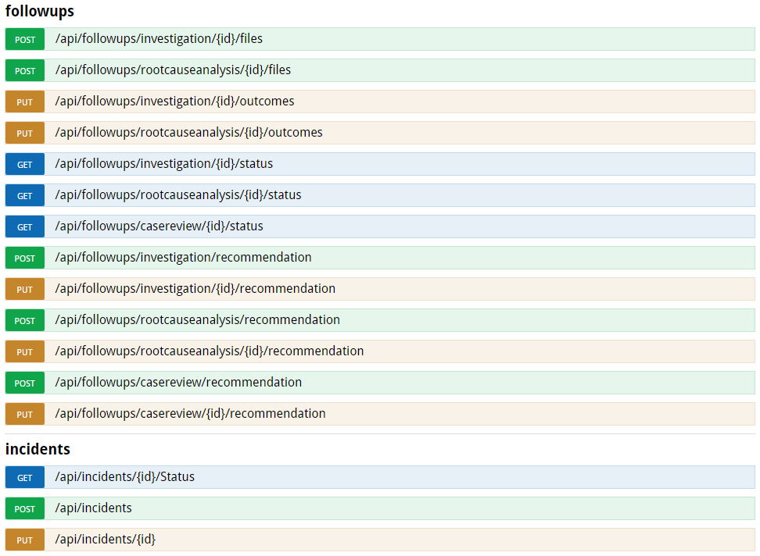

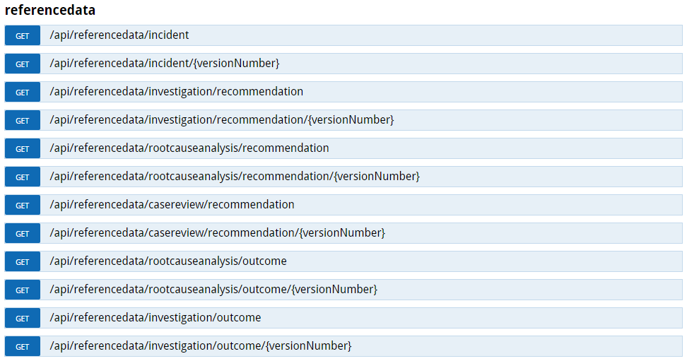
Description of API end points
API End Point | Operation | Description
/api/incidents | POST | Create new Incident report.
/api/incidents/{id} | PUT | Update existing incident report.
/api/incidents/{id}/Status | GET | Get incident status and withdrawal information.
/api/followups/investigation/recommendation | POST | Create a new follow-up that is flagged as an investigation. The follow-up will already be created with the recommendation data.
/api/followups/investigation/{id}/recommendation | PUT | Update an existing follow-up that is flagged as an investigation. Only the recommendation data of the follow-up will be updated.
/api/followups/investigation/{id}/files | POST | Add files to an existing follow-up that is flagged as an investigation.
/api/followups/investigation/{id}/outcomes | PUT | Update an existing follow-up that is flagged as an investigation. Only the outcome data of the follow-up will be updated.
/api/followups/investigation/{id}/status | GET | Get the status, withdrawal information, due date and revised due date of a follow-up that is flagged as an investigation.
/api/followups/rootcauseanalysis/recommendation | POST | Create a new follow up that is flagged as a root cause analysis. The follow up will already be created with the recommendation data.
/api/followups/rootcauseanalysis/{id}/recommendation | PUT | Update an existing follow up that is flagged as a root cause analysis. Only the recommendation data of the follow up will be updated.
/api/followups/rootcauseanalysis/{id}/files | POST | Add files to an existing follow-up that is flagged as a root cause analysis.
/api/followups/rootcauseanalysis/{id}/outcomes | PUT | Update an existing follow up that is flagged as a root cause analysis. Only the outcome data of the follow up will be updated.
/api/followups/rootcauseanalysis/{id}/status | GET | Get the status, withdrawal information, due date and revised due date of a follow-up that is flagged as a root cause analysis.
/api/followups/casereview/recommendation | POST | Create a new follow up that is flagged as a case review. The follow up will already be created with the recommendation data.
/api/followups/casereview/{id}/recommendation | PUT | Update an existing follow up that is flagged as a case review. Only the recommendation data of the follow up will be updated.
/api/followups/casereview/{id}/status | GET | Get the status, withdrawal information, due date and revised due date of a follow-up that is flagged as a case review.
/api/referencedata/incident | GET | Gets the latest version of the reference data used by the application when creating/updating an incident report.
/api/referencedata/incident/{versionNumber} | GET | Gets a specific version of the reference data used by the application when creating/updating an incident report.
/api/referencedata/investigation/recommendation | GET | Gets the latest version of the reference data used by the application when creating/updating the recommendation data of a follow-up that has been flagged as an investigation.
/api/referencedata/investigation/recommendation/{versionNumber} | GET | Gets a specific version of the reference data used by the application when creating/updating the recommendation data of a follow-up that has been flagged as an investigation.
/api/referencedata/investigation/outcome | GET | Gets the latest version of the reference data used by the application when creating/updating the outcomes data of a follow-up that has been flagged as an investigation.
/api/referencedata/investigation/outcome/{versionNumber} | GET | Gets a specific version of the reference data used by the application when creating/updating the outcomes data of a follow-up that has been flagged as an investigation.
/api/referencedata/rootcauseanalysis/recommendation | GET | Gets the latest version of the reference data used by the application when creating/updating the recommendation data of a follow-up that has been flagged as a root cause analysis.
/api/referencedata/rootcauseanalysis/recommendation/{versionNumber} | GET | Gets a specific version of the reference data used by the application when creating/updating the recommendation data of a follow-up that has been flagged as a root cause analysis.
/api/referencedata/rootcauseanalysis/outcome | GET | Gets the latest version of the reference data used by the application when creating/updating the outcomes data of a follow-up that has been flagged as a root cause analysis.
/api/referencedata/rootcauseanalysis/outcome/{versionNumber} | GET | Gets a specific version of the reference data used by the application when creating/updating the outcomes data of a follow-up that has been flagged as a root cause analysis.
/api/referencedata/casereview/recommendation | GET | Gets the latest version of the reference data used by the application when creating/updating the recommendation data of a follow-up that has been flagged as a case review.
/api/referencedata/casereview/recommendation/{versionNumber} | GET | Gets a specific version of the reference data used by the application when creating/updating the recommendation data of a follow-up that has been flagged as a case review.

Changes to the CIMS platform and/or API interface
Changes will occur periodically based on business requirements and or policy changes. These changes may impact reference data, entity data fields or business rules. Where possible the Service Provider should ensure that their Client incident register is flexible and configurable to accommodate any future changes.
The API Interface is version controlled so any changes will have a lead time to allow Service Provider systems to make the changes to their systems.
If DHHS determines that:
- It will make a functional change (such as a change to the CIMS application and/or the API interface); and
  - that change is likely to affect the Service providers that use the API interface,
DHHS will, prior to making the change, inform the Service Providers of the change and any impact it may have on the Service Providers.
DHHS will detail the type of change;
- Reference data change – this would be changes to values such as Program/service type, impact types etc.
- Entity data fields required – Additional/removal of data that is required to be captured for an incident report or follow-up.
  - Business rule/System impact – Changes required to the API to cater for internal system changes that impact the way the API functions.
DHHS will take reasonable steps to resolve any concerns that either party may have about any functional changes proposed. Each party will work cooperatively and in good faith to support the other party with the implementation of a functional change.

Incident report end points

Incident report end points
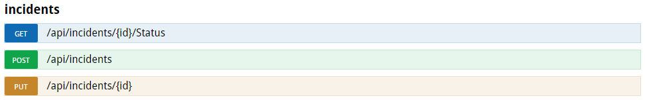

Business rules for the incident report end points.
The organisation name must match the organisation name within the Service Agreement management system (SAMS) for the funded organisation and the organisation must be a registered organisation within CIMS.
The External incident id must be supplied by the vendor to ensure matching capabilities between the Service providers system ID and the CIMS Incident report id.
The incident reported date is mandatory.
The reference version number must be supplied and will be verified by the system to determine the reference data that is being used.
An incident report should only be submitted once using the ‘POST – incident’ end point.
On a successful POST the ‘IncidentID’ and ‘IncidentReferenceNumber’ are returned. The ‘IncidentID’ must be included for any PUT or GET requests as part of the URL.
The incident report can be resubmitted with changes using the ‘PUT – Incident’ end point if the department has withdrawn the incident report (DHHS Incident report status = ‘Withdrawn’).
- The ‘IncidentID’ supplied on a successful POST must be supplied in the PUT URL.
The incident report status and withdrawal information can be retrieved using the ‘GET – incident’ end point. This data can be useful to gauge the progress of the incident report in the department.
- The ‘IncidentID’ supplied on a successful POST must be supplied in the GET URL.

Figure 3 - Example of a successful response
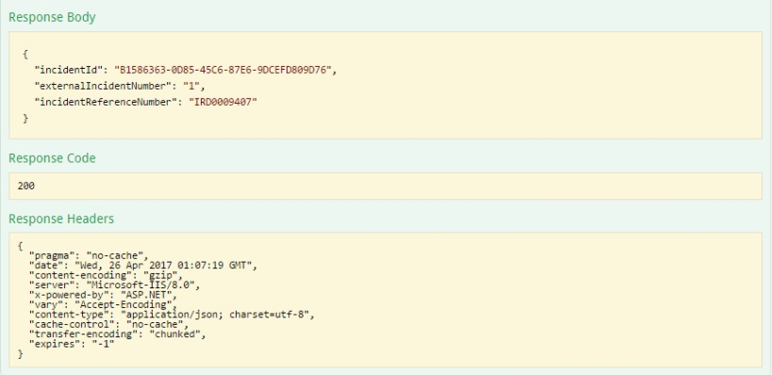
Figure 4 - Example of an unsuccessful response
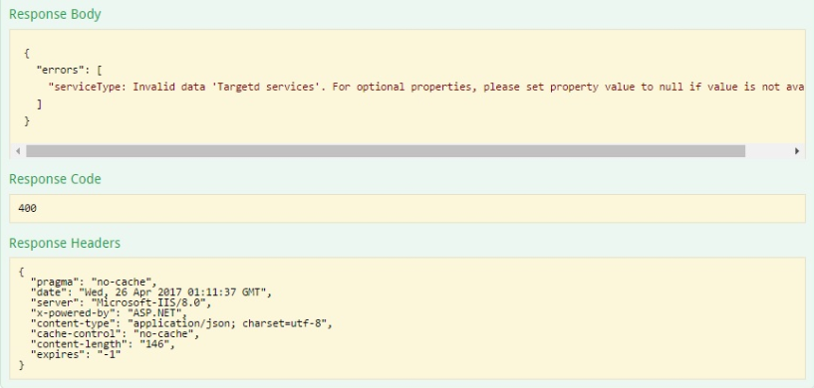

API entity list (POST/PUT - Incident)
The following table lists all of the Data Fields that belong to the CIMS Incident API entity when creating/updating an incident report.
The data entity list for the POST/PUT is the same however the URL for the PUT contains the unique ‘IncidentID’ so the system knows which incident report is being updated.
Refer to section 3.5 for a detailed description of the Incident reporting data fields.
Data from Service Provider/s
externalIncidentId
reportedDate
referenceVersion
Incident Report - organisationName
Incident Report - organisationAddressStreetNumberAndName
Incident Report - organisationAddressSuburb
Incident Report - organisationAddressState
Incident Report - organisationAddressPostCode
Incident Report - dhhsArea
Incident Report - program
Incident Report - serviceType
Incident Report - incidentDate
Incident Report - incidentDateAccuracy
Incident Report - incidentTime
Incident Report - incidentTimeAccuracy
Incident Report - incidentDisclosedDate
Incident Report - incidentDisclosedTime
Incident Report - incidentLocation
Incident Report - incidentDescription
Incident Report - briefSummaryOfIncident
Incident Report - reportedToPolice
Incident Report - policeInvestigationInitiated
Incident Report - staffStoodDown
Incident Report - officerSurname
Incident Report - officerGivenName
Incident Report - officerRole
Incident Report - dateCompleted
Incident Report - officerPhoneNumber
Incident Report - officerAccessRestricted
Incident Report - officerEmail
Incident Report - officerComment
Incident Report - majorDelegateSurname
Incident Report - majorDelegateGivenName
Incident Report - majorDelegateRole
Incident Report - majorAuthorisationDate
Incident Report - majorDelegatePhone
Incident Report - majorDelegateEmail
Client - impactType
Client - sourceSystem
Client - sourceSystemId
Client - surname
Client - givenName
Client - sex
Client - indigenousStatus
Client - birthDate
Client - addressStreetNumberAndName
Client - addressSuburb
Client - addressState
Client - addressPostCode
Client - lastServiceDate
Client - primaryIncidentType
Client - primaryAllegedPerpetratorVictim
Client - primaryRoleInIncident
Client - secondaryIncidentType
Client - secondaryAllegedPerpetratorVictim
Client - secondaryRoleInIncident
Client - immediateSafetyNeedsMet
Client - medicalAttentionProvided
Client - debriefingOrCounselling
Client - referralToSupportServices
Client - supportPlanChanged
Client - carerNotified
Staff - surname
Staff - givenName
Staff - relationToClient
Staff - incidentRole
Staff - birthDate

API entity list (GET - Incident)
The following table lists all of the Data Fields that belong to the CIMS Incident API Entity when getting the status of an existing incident report.
Refer to section 3.5 for a detailed description of the Incident reporting data fields.
Data from Service Provider/s
statusCode
statusDescription
withdrawalReason
withdrawalDetails

Incident report entity list details
The following is a detailed description of all of the incident reporting data fields.

externalIncidentId
Question Text | N/A
Description | This is the unique External Incident ID from the Service providers Client Incident Register. This is used a business reference when discussing incident reports with the department.
Data Type | string (max 200 characters)
Data Format
Required | Yes
Validations
Valid values

reportedDate
Question Text | N/A
Description | This is the Date that the incident report was created in the service providers Client Incident register.
Data Type | datetime
Data Format | yyyy'-'MM'-'dd'T'HH':'mm':'ss'.'fffffffK  2017-04-28T10:19:58.8042495+10:00  2017-04-28T00:19:58.8042495Z
Required | Yes
Validations
Valid values

referenceVersion
Question Text | N/A
Description | The reference data version number. This is the version number of the reference data that was used for this incident report. When sending a request to the POST /api/incidents endpoint, it should always be the latest referenceVersion retrieved by the GET /api/referencedata/incident endpoint. When sending a request to the PUT /api/incidents/{id} endpoint, it should be the same referenceVersion that was used when the incident was first created.
Data Type | integer
Data Format
Required | Yes
Validations
Valid values

organisationName
Question Text | Organisation name
Description | Select the Department of Health and Human Services (DHHS) if the incident occurred in a service delivered directly by the department.  For DHHS funded organisations, select the organisation that was delivering the service to the client at the time of the incident. If you cannot find your organisation's name, contact the CIMS Helpline Service.
Data Type | string (max 200 characters)
Data Format
Required | Yes
Validations
Valid values | The service providers organisation name.

organisationAddressStreetNumberAndName
Question Text | Address of service delivery
Description | Enter the address where the service was being provided to the client at the time of the incident.  Note: For residential services, enter the facility's full street address rather than the facility's name.  For kinship or foster care, enter the full street address of the kinship or foster care placement.  Addresses entered will be validated by Google.  If no match exists, you must manually enter the address.
Data Type | string (max 200 characters)
Data Format
Required | Yes
Validations
Valid values

organisationAddressSuburb
Question Text | Address of service delivery
Description | Enter the address where the service was being provided to the client at the time of the incident.  Note: For residential services, enter the facility's full street address rather than the facility's name.  For kinship or foster care, enter the full street address of the kinship or foster care placement.  Addresses entered will be validated by Google.  If no match exists, you must manually enter the address.
Data Type | string (max 200 characters)
Data Format
Required | Yes
Validations
Valid values

organisationAddressState
Question Text | Address of service delivery
Description | Enter the address where the service was being provided to the client at the time of the incident.  Note: For residential services, enter the facility's full street address rather than the facility's name.  For kinship or foster care, enter the full street address of the kinship or foster care placement.  Addresses entered will be validated by Google.  If no match exists, you must manually enter the address.
Data Type | string (max 200 characters)
Data Format
Required | Yes
Validations
Valid values

organisationAddressPostCode
Question Text | Address of service delivery
Description | Enter the address where the service was being provided to the client at the time of the incident.  Note: For residential services, enter the facility's full street address rather than the facility's name.  For kinship or foster care, enter the full street address of the kinship or foster care placement.  Addresses entered will be validated by Google.  If no match exists, you must manually enter the address.
Data Type | string (max 200 characters)
Data Format
Required | Yes
Validations
Valid values

dhhsArea
Question Text | Area
Description | Enter the DHHS service area where this service is delivered.  For information about DHHS service areas go to DHHS area maps
Data Type | string (max 200 characters)
Data Format
Required | Yes
Validations
Valid values | Refer to reference data options set “dhhsservicearea”.

program
Question Text | Program
Description | Select the type of program that your organisation was providing to the client at the time of the incident.
Data Type | string (max 200 characters)
Data Format
Required | Yes
Validations
Valid values | Refer to reference data options set "dhhsprogram".

serviceType
Question Text | Service type
Description | Select the type of service that your organisation was providing to the client at the time of the incident.
Data Type | string (max 200 characters)
Data Format
Required | Yes
Validations
Valid values | Refer to reference data options set "dhhsservicetype|program-<selected program>". Replace <selected program> with one of the valid values from the “Program” question.

incidentDate
Question Text | Date of incident
Description | Enter the date when the incident occurred. If the exact date is unknown, enter an estimated date or the date you first became aware of the incident.
Data Type | string (max 200 characters)
Data Format | dd/mm/yyyy
Required | Yes
Validations | - Valid date in "DD MM YYYY" format  - Date of incident can not be greater than today.  - Date of incident can not be greater than the date of report.  - Date of incident must be greater than all clients’ dates of birth.
Valid values

incidentDateAccuracy
Question Text | Date accuracy
Description | Select whether the date you provided is the exact or estimated date, or the date you first became aware of the incident.
Data Type | string (max 200 characters)
Data Format
Required | Yes
Validations
Valid values | Refer to reference data options set “accuracy”.

incidentTime
Question Text | Time of incident
Description | Select the time the incident occurred. If the exact time is unknown, enter an estimated time or the time you first became aware of the incident.
Data Type | string (max 200 characters)
Data Format
Required | Yes
Validations
Valid values | Refer to reference data options set “timeintervals”.

incidentTimeAccuracy
Question Text | Time accuracy
Description | Select whether the time you provided is the exact or estimated time, or the time you first became aware of the incident.
Data Type | string (max 200 characters)
Data Format
Required | Yes
Validations
Valid values | Refer to reference data options set “accuracy”.

incidentDisclosedDate
Question Text | Date incident disclosed
Description | Enter the date you first became aware of the incident. This could be the date you were told about the incident or the date you found out about it.
Data Type | string (max 200 characters)
Data Format | dd/mm/yyyy
Required | Yes
Validations | - Valid date in "DD MM YYYY" format  - Date incident disclosed can not be greater than today.  - Date incident disclosed can not be less than date of incident.
Valid values

incidentDisclosedTime
Question Text | Time incident disclosed
Description | Enter the time you first became aware of the incident. This could be the time you were told about the incident or the time you found out about it.
Data Type | string (max 200 characters)
Data Format
Required | Yes for Major incident  No for Non-Major incident
Validations
Valid values | Refer to reference data options set “timeintervals”.

incidentLocation
Question Text | Location of incident
Description | Enter the place where the incident occurred.
Data Type | string (max 200 characters)
Data Format
Required | Yes
Validations
Valid values

incidentDescription
Question Text | Incident description
Description | Enter a short, factual account of the client incident (maximum 5000 characters).
Data Type | string (max 5000 characters)
Data Format
Required | Yes
Validations
Valid values

Client - impactType
Question Text | Impact of Incident on client
Description | Select whether the incident had Major or Non-Major Impact on the client. Go to Major Impact or Non-Major Impact information for more details.
Data Type | string (max 200 characters)
Data Format
Required | Yes
Validations
Valid values | Refer to reference data options set "incidentimpactexcludeunknown".

Client - sourceSystem
Question Text | Client unique identifier type
Description | Enter, if known, the client's unique identifier (ID) type. The unique identifiers are those allocated for the DHHS systems CRISSP, CRISS, HiiP, NDIS number and Other external.
Data Type | string (max 200 characters)
Data Format
Required | Yes
Validations
Valid values | Refer to reference data options set "clientuniqueidentifiertype".

Client - sourceSystemId
Question Text | Client unique identifier
Description | Enter, if known, the client's unique identifier (ID). The ID may include a combination of numbers and letters.
Data Type | string (max 200 characters)
Data Format
Required | Yes
Validations
Valid values

Client - surname
Question Text | Surname (family name)
Description | Enter the client's surname (family name).
Data Type | string (max 200 characters)
Data Format
Required | Yes
Validations
Valid values

Client - givenName
Question Text | Given name
Description | Enter the client's given (first) name.
Data Type | string (max 200 characters)
Data Format
Required | Yes
Validations
Valid values

Client - sex
Question Text | Sex
Description | Select the client's sex. If unknown, select 'not stated/inadequately described'.
Data Type | string (max 200 characters)
Data Format
Required | Yes
Validations
Valid values | Refer to reference data options set "sex".

Client - indigenousStatus
Question Text | Indigenous status
Description | Select if the client is Aboriginal and/or Torres Strait Islander. If unknown or you do not have permission to disclose select 'not stated/inadequately described'.
Data Type | string (max 200 characters)
Data Format
Required | Yes
Validations
Valid values | Refer to reference data options set "indigenousstatus".

Client - birthDate
Question Text | Date of birth
Description | Enter the client's date of birth. If the date is unknown, enter an approximate date. For example, if you think the client is 42 years old, enter 01/01/1975.
Data Type | string (max 200 characters)
Data Format | dd/mm/yyyy
Required | Yes
Validations | - Valid date in "DD MM YYYY" format  - Date of birth can not be greater than today.  - Date of birth can not be greater than Date of incident.
Valid values

Client - addressStreetNumberAndName
Question Text | Address
Description | Enter the client's most recent, primary place of residence. If unknown, enter your organisation's address. Addresses will be validated by Google. If no match exists, enter the full street address manually.
Data Type | string (max 200 characters)
Data Format
Required | Yes
Validations
Valid values

Client - addressSuburb
Question Text | Address
Description | Enter the client's most recent, primary place of residence. If unknown, enter your organisation's address. Addresses will be validated by Google. If no match exists, enter the full street address manually.
Data Type | string (max 200 characters)
Data Format
Required | Yes
Validations
Valid values

Client - addressState
Question Text | Address
Description | Enter the client's most recent, primary place of residence. If unknown, enter your organisation's address. Addresses will be validated by Google. If no match exists, enter the full street address manually.
Data Type | string (max 200 characters)
Data Format
Required | Yes
Validations
Valid values

Client - addressPostCode
Question Text | Address
Description | Enter the client's most recent, primary place of residence. If unknown, enter your organisation's address. Addresses will be validated by Google. If no match exists, enter the full street address manually.
Data Type | string (max 200 characters)
Data Format
Required | Yes
Validations
Valid values

Client - lastServiceDate
Question Text | Date of last service provision
Description | Enter the date your organisation last provided a service to the client. If your service is providing a current or ongoing service to the client, enter today's date.
Data Type | string (max 200 characters)
Data Format | dd/mm/yyyy
Required | No
Validations | - Valid date in "DD MM YYYY" format  - Date of last service can not be greater than today.  - Date of last service can not be greater than Date of report.  - Date of last service should be greater than or equal to the client date of birth.
Valid values

Client - primaryIncidentType
Question Text | Primary incident type
Description | Select the primary incident type by choosing the incident type that best describes the circumstance that caused the most impact on the client. For more information go to the Funded Agency Channel.
Data Type | string (max 200 characters)
Data Format
Required | Yes
Validations
Valid values | Refer to reference data options set "primaryincidenttype".

Client - primaryAllegedPerpetratorVictim
Question Text | Primary incident type - more information
Description | Select whether the primary incident type is a case of an alleged 'staff to client' incident, 'client to client' incident or involves another person and the client (select 'other to client') .
Data Type | string (max 200 characters)
Data Format
Required | If answer for primaryIncidentType is  - Emotional/psychological abuse  - Financial abuse  - Inappropriate physical treatment  - Inappropriate sexual behaviour  - Physical abuse  - Poor Quality of Care  - Sexual Abuse
Validations
Valid values | Refer to reference data options set "primaryallegedperpetratortovictim|primaryincidenttype-<selected primaryincidenttype>".  Replace <selected primaryincidenttype> with a valid value specified on the “PrimaryIncidentType” question within the same client.

Client - primaryRoleInIncident
Question Text | Primary involvement in the incident
Description | Select if the client was a participant, victim, witness or alleged perpetrator of the incident. If the client had more than one role, identify their primary involvement in the incident.
Data Type | string (max 200 characters)
Data Format
Required | Yes if primaryIncidentType is answered
Validations
Valid values | Refer to reference data options set "primaryroleinincident|primaryallegedperpetratorvictim-<selected primaryallegedperpetratorvictim>|primaryincidenttype-<selected primaryincidenttype>".  Replace <selected primaryallegedperpetratorvictim> with a valid value specified on the PrimaryAllegedPerpetratorVictim question within the same client. If the “PrimaryAllegedPerpetratorVictim” question is not required, then the value should be replaced with “null”.  Replace <selected primaryincidenttype> with a valid value specified on the “PrimaryIncidentType” question within the same client.

Client - secondaryIncidentType
Question Text | Secondary incident type
Description | If applicable, select a secondary incident type. Select this option if the client experiences more than one type of impact. This is generally applicable in cases of complex incidents where multiple types of harm have occurred. For more information go to the Funded Agency Channel.
Data Type | string (max 200 characters)
Data Format
Required | No
Validations | - The primary and secondary incident type can not be the same for a client. Please change one of the incident types.
Valid values | Refer to reference data options set "secondaryincidenttype".

Client - secondaryAllegedPerpetratorVictim
Question Text | Secondary incident type - more information
Description | Select whether the secondary incident type is a case of an alleged 'staff to client' incident, 'client to client' incident or involves another person and the client (select 'other to client') .
Data Type | string (max 200 characters)
Data Format
Required | Yes if answer for secondaryIncidentType is  - Emotional/psychological abuse  - Financial abuse  - Inappropriate physical treatment  - Inappropriate sexual behaviour  - Physical abuse  - Poor Quality of Care  - Sexual Abuse
Validations
Valid values | Refer to reference data options set "secondaryallegedperpetratortovictim|secondaryincidenttype-<selected secondaryincidenttype>".  Replace <selected secondaryincidenttype> with a valid value specified on the “SecondaryIncidentType” question within the same client.

Client - secondaryRoleInIncident
Question Text | Secondary involvement in the incident
Description | Select if the client was a participant, victim, witness or alleged perpetrator of the incident. If the client had more than one role, identify their primary involvement in the incident.
Data Type | string (max 200 characters)
Data Format
Required | Yes if secondaryIncidentType is answered
Validations
Valid values | Refer to reference data options set "secondaryroleinincident|secondaryallegedperpetratorvictim-<selected secondaryallegedperpetratorvictim>|secondaryincidenttype-<selected secondaryincidenttype>".  Replace <selected secondaryallegedperpetratorvictim> with a valid value specified on the SecondaryAllegedPerpetratorVictim question within the same client. If the “SecondaryAllegedPerpetratorVictim” question is not required, then the value should be replaced with “null”.  Replace <selected secondaryincidenttype> with a valid value specified on the “SecondaryIncidentType” question within the same client.

Client - immediateSafetyNeedsMet
Question Text | Client's immediate safety needs met
Description | Select whether the organisation has met the client's immediate safety needs. To determine this you should consider whether the client is in a safe and secure environment and whether the source of danger has been removed.  Select 'Not applicable' if the client/s' role in the incident did not affect their safety needs.
Data Type | string (max 200 characters)
Data Format
Required | Yes
Validations
Valid values | Refer to reference data options set "yesnonotapplicable".

Client - medicalAttentionProvided
Question Text | Medical attention provided
Description | Select if the client has been provided with medical attention. If the client, a staff member or any other person requires immediate medical attention, you should call a medical practitioner or ambulance, or transport the injured person (if it is safe and appropriate to do so) to the nearest hospital accident and emergency department.  Select 'Not applicable' if there was no need to consider medical attention as part of the immediate incident response.
Data Type | string (max 200 characters)
Data Format
Required | Yes
Validations
Valid values | Refer to reference data options set "yesnonotapplicable".

Client - debriefingOrCounselling
Question Text | Client debriefing or counselling
Description | Select if the client has been provided debriefing or counselling. If the client has injuries that do not require immediate attention, the organisation should support the person to see a doctor for assessment and treatment of any injuries, including psychological trauma.  Select 'Not applicable' if there was no need for consideration of client debriefing or counselling as part of the immediate incident response.
Data Type | string (max 200 characters)
Data Format
Required | Yes for Major  No for Non-Major
Validations
Valid values | Refer to reference data options set "yesnonotapplicable".

Client - referralToSupportServices
Question Text | Referral to support services
Description | Select if the client has been referred to, or received other support services, in response to the incident. If the client can provide informed consent, the client (or his or her key support person) should be asked whether they wish to contact specialist/victim support services such as crisis care, counselling, advocacy, a legal information service or a lawyer.  Select 'Not applicable' if there was no need for referral to support services as part of the immediate incident response.
Data Type | string (max 200 characters)
Data Format
Required | Yes for Major incident  No for Non-Major incident
Validations
Valid values | Refer to reference data options set "yesnonotapplicable".

Client - supportPlanChanged
Question Text | Change client care (Support plan)
Description | Select whether the client's care or support plan has been changed in response to the incident.  Select 'Not applicable' if there was no need for change to the client's care or support plan as part of the immediate incident response.
Data Type | string (max 200 characters)
Data Format
Required | Yes for Major incident  No for Non-Major incident
Validations
Valid values | Refer to reference data options set "yesnonotapplicable".

Client - carerNotified
Question Text | Notified next of kin, guardian or key support person
Description | Select whether the client's next of kin, guardian or key support has been contacted in response to the incident.  Select 'Not applicable' if there was no need to notify next of kin, guardian or a key support person as part of the immediate incident response.
Data Type | string (max 200 characters)
Data Format
Required | Yes for Major incident  No for Non-Major incident
Validations
Valid values | Refer to reference data options set "yesnonotapplicable".

Other - surname
Question Text | Surname (family name)
Description | Enter the surname (family name) of any person, other than the client/s, involved in this incident. This could include staff, carers, witnesses, other participants, victims or alleged perpetrators.
Data Type | string (max 200 characters)
Data Format
Required | Yes
Validations
Valid values

Other - givenName
Question Text | Given name
Description | Enter the given (first) name of any person, other than the client/s, involved in this incident. This could include staff, carers, witnesses, other participants, victims or alleged perpetrators.
Data Type | string (max 200 characters)
Data Format
Required | Yes
Validations
Valid values

Other - birthDate
Question Text | Date of birth
Description | The date of birth of the person, other than the client/s, involved in this incident.
Data Type | string (max 200 characters)
Data Format | dd/mm/yyyy
Required | No
Validations | - Valid date in "DD MM YYYY" format  - Date of birth can not be greater than today.  - Date of birth can not be greater than Date of incident.
Valid values

Other - relationToClient
Question Text | Person's organisational role or relationship to client
Description | If the person involved in the incident is a staff member of the organisation then enter their job title. If the person is a carer, enter their relationship to the client. For example, carers could be an aunt, brother or foster carer. For all others, enter their relationship to the client.
Data Type | string (max 200 characters)
Data Format
Required | Yes
Validations
Valid values | Refer to reference data options set "personsorganisationalroleorrelationshiptoclient".

Other - incidentRole
Question Text | Role in incident
Description | Select whether the person was a witness, participant, victim or alleged perpetrator of the incident.
Data Type | string (max 200 characters)
Data Format
Required | Yes
Validations
Valid values | Refer to reference data options set "roleinincident".

briefSummaryOfIncident
Question Text | Brief summary of incident
Description | Enter a short description of the client incident (20 words or less).
Data Type | string (max 200 characters)
Data Format
Required | Yes
Validations
Valid values

reportedToPolice
Question Text | Reported to police
Description | Select whether the client incident has been reported to the police. Select 'No' if there was no need to report this incident to police.
Data Type | string (max 200 characters)
Data Format
Required | Yes
Validations
Valid values | Refer to reference data options set "yesno".

policeInvestigationinitiated
Question Text | Police investigation initiated
Description | Select whether the police are investigating the incident.
Data Type | string (max 200 characters)
Data Format
Required | Yes if ‘reportedToPolice’ is answered ‘Yes’  No for Non-Major incident
Validations
Valid values | Refer to reference data options set "yesno".

staffStoodDown
Question Text | Staff member stood down/removed
Description | Select whether any of the organisation's staff members have been stood down because of their involvement in the incident. This could include termination of a staff member's employment, the staff member having no contact with the client or a suspension of the staff member's employment.
Data Type | string (max 200 characters)
Data Format
Required | Yes
Validations
Valid values | Refer to reference data options set "yesnonotapplicable".

officerSurname
Question Text | Manager's surname
Description | Enter your surname (family name) as the manager reviewing this incident report.
Data Type | string (max 200 characters)
Data Format
Required | Yes
Validations
Valid values

officerGivenName
Question Text | Manager's given name
Description | Enter your given (first) name as the manager reviewing this incident report.
Data Type | string (max 200 characters)
Data Format
Required | Yes
Validations
Valid values

officerRole
Question Text | Manager's job title
Description | Enter your job or role title as the manager reviewing this incident report.
Data Type | string (max 200 characters)
Data Format
Required | Yes
Validations
Valid values

dateCompleted
Question Text | Manager's job title
Description | Enter the date that you reviewed this incident report.
Data Type | string (max 200 characters)
Data Format | dd/mm/yyyy
Required | Yes for Major incident  No for Non-Major incident
Validations | - Date is required. Format is DD MM YYYY.  - Please enter a valid date (the year must be greater than 1900). Format is DD MM YYYY.  - Date completed can not be greater than today.  - Date completed can not be less than the Date response completed.
Valid values

officerPhoneNumber
Question Text | Telephone number
Description | Enter the best telephone number to contact you on. The DHHS divisional office may need to contact you regarding the incident. Please enter numbers only, with no spaces.
Data Type | string (max 200 characters)
Data Format
Required | Yes for Major incident  No for Non-Major incident
Validations | - Phone number must be between 8 and 15 digits with no spaces.
Valid values

officerEmail
Question Text | Email
Description | Enter the best business email address to contact you on.
Data Type | string (max 200 characters)
Data Format
Required | Yes
Validations | - Valid email address in "person@email.com" format
Valid values

officerAccessRestricted
Question Text | Access restricted?
Description | Select YES to restricted access if you want ONLY the organisation's CEO or senior delegate to have access to this incident report.
Data Type | string (max 200 characters)
Data Format
Required | No
Validations
Valid values | Refer to reference data options set "yesno".

officerComment
Question Text | Key actions
Description | Enter comments about the immediate actions taken by the organisation in response to the incident. This includes what the organisation has done to prevent or ensure similar incidents in future.
Data Type | string (max 5000 characters)
Data Format
Required | Yes
Validations
Valid values

majorDelegateSurname
Question Text | Surname (family name)
Description | Enter your surname (family name) as the Chief Executive Officer or delegated authority approving the incident report for submission to DHHS.
Data Type | string (max 200 characters)
Data Format
Required | Yes
Validations
Valid values

majorDelegateGivenName
Question Text | Given name
Description | Enter your given (first) name as the Chief Executive Officer or delegated authority approving the incident report for submission to DHHS.
Data Type | string (max 200 characters)
Data Format
Required | Yes
Validations
Valid values

majorDelegateRole
Question Text | Job title
Description | Enter your role title or description as Chief Executive Officer or delegated authority approving the incident report for submission to DHHS.
Data Type | string (max 200 characters)
Data Format
Required | Yes
Validations
Valid values

majorAuthorisationDate
Question Text | Date completed
Description | Enter the date that you review and approve the incident report for submission to DHHS.
Data Type | string (max 200 characters)
Data Format | dd/mm/yyyy
Required | Yes for Major incident  No for Non-Major incident
Validations | - Please enter a valid date (the year must be greater than 1900). Format is DD MM YYYY.  - Date completed can not be greater than today.  - Date completed can not be less than the Date response completed.
Valid values

majorDelegatePhone
Question Text | Telephone number
Description | Enter the best telephone number to contact you on. Please enter numbers only, with no spaces.
Data Type | string (max 200 characters)
Data Format
Required | Yes for Major incident  No for Non-Major incident
Validations | - Phone number must be between 8 and 15 digits with no spaces.
Valid values

majorDelegateEmail
Question Text | Email
Description | Enter the best business email address to contact you on.
Data Type | string (max 200 characters)
Data Format
Required | Yes
Validations | - Valid email address in "person@email.com" format
Valid values

incidentId
Question Text | N/A
Description | This is the unique Incident GUID from DHHS. This will be used to match incident reports submitted to DHHS.
Data Type | string (max 200 characters)
Data Format
Required | Yes if updating an existing Incident report.
Validations
Valid values

statusCode
Question Text | N/A
Description | This is the unique Status code from DHHS.
Data Type | integer
Data Format
Required | No
Validations
Valid values

statusDescription
Question Text | N/A
Description | This is the unique Status description from DHHS.
Data Type | string (max 200 characters)
Data Format
Required | No
Validations
Valid values

withdrawalReason
Question Text | N/A
Description | This is the text value which provides a reason why DHHS withdrew the incident report.
Data Type | string (max 200 characters)
Data Format
Required | No
Validations
Valid values

withdrawalDetails
Question Text | N/A
Description | This is the text value which provides a reason why DHHS withdrew the incident report.
Data Type | string (max 5000 characters)
Data Format
Required | Yes if withdrawalReason entered.
Validations
Valid values

Follow-up recommendation end points

Follow-up recommendation end points
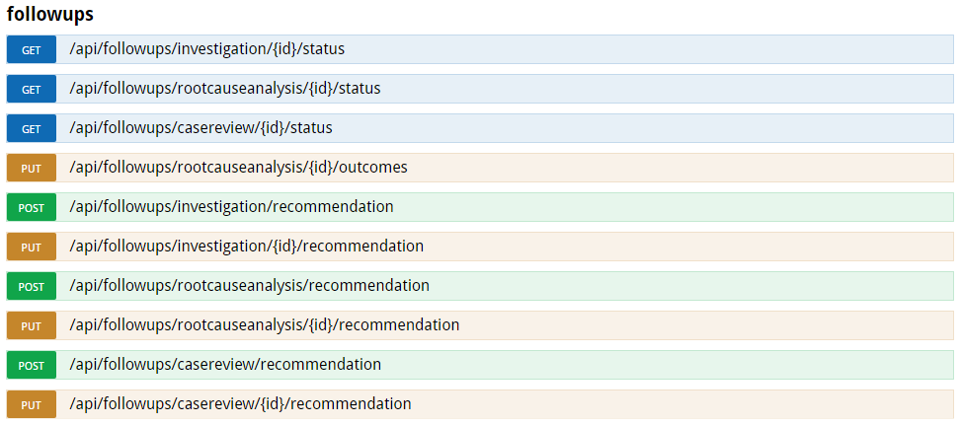

Business rules for the follow-up recommendation end points.
The Incident ID supplied on a successful POST to the /api/incidents endpoint must be supplied in the POST/PUT for all recommendation end points.
The External incident id must be supplied by the vendor to ensure matching capabilities between the Service providers system ID and the CIMS follow-up id.
The reference version number must be supplied and will be verified by the system to determine the reference data that is being used. When sending a POST request to any of the /api/followups/…/recommendation endpoints, the latest available reference version number must be used. The latest available version number can be obtained by sending a GET request to the respective endpoint, according to the table below.
Recommendation endpoint (POST) | ReferenceData endpoint (GET)
/api/followups/investigation/recommendation | /api/referencedata/investigation/recommendation
/api/followups/rootcauseanalysis/recommendation | /api/referencedata/rootcauseanalysis/recommendation
/api/followups/casereview/recommendation | /api/referencedata/casereview/recommendation
When sending a PUT request to any of the /api/followups/…/recommendation endpoints, the reference version number needs to be the same that was used when the recommendation was first created with the POST request.
A Follow-up recommendation should only be submitted once using the ‘POST’ end point.
When submitting an investigation recommendation, all clients that exist in the related incident report must be specified, together with their “investigated” status. The clients on the investigation recommendation will be matched to the clients on the related incident report by use of the “SourceSystem” and “SourceSystemId” fields as the key.
On a successful POST the ‘dhhsFollowUpId’ is returned. This must be included in the URL for any PUT or GET requests. This ‘dhhsFollowUpId’ must also be included in the URL when submitting outcomes through the relevant outcome endpoints.
The follow-up recommendation can be resubmitted with changes using the relevant ‘PUT’ endpoints if the department has withdrawn the follow-up recommendation (DHHS Follow-up status = ‘Rec Withdrawn’).
- The ‘dhhsFollowUpId’ supplied on a successful POST must be supplied in the PUT URL.
The Follow-up status, dates and withdrawal information can be retrieved using the ‘GET’ end points. This data can be useful to gauge the progress of the follow-up recommendation in the department.
- The ‘dhhsFollowUpId’ supplied on a successful POST must be supplied in the GET URL.

Figure 5 - Example of a successful response
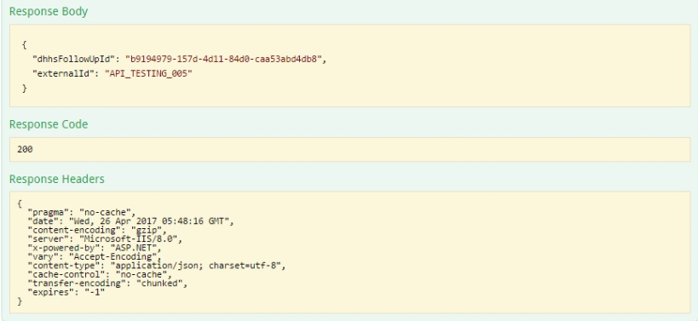
Figure 6 - Example of an unsuccessful response
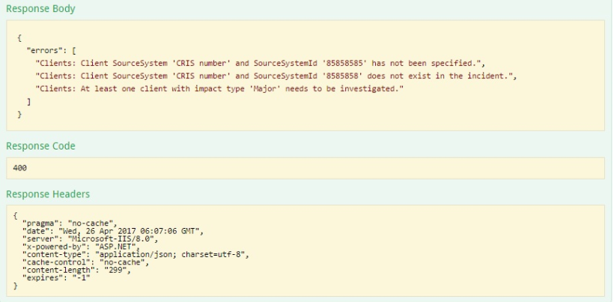

API entity list (POST/PUT – Investigation recommendation)
The following table lists all of the Data Fields that belong to the CIMS Follow-up API Entity when creating/updating a follow-up investigation recommendation.
The data entity list for the POST/PUT is the same however the URL for the PUT contains the unique ‘dhhsFollowUpId’ so the system knows which investigation recommendation is being updated.
Refer to section 4.7 for a detailed description of the Incident follow-up data fields.
Data from Service Provider/s
externalId
incidentId
referenceVersion
Recommendation Data
Recommendation Data - investigationType
Recommendation Data - jointInvestigationManagerGivenName
Recommendation Data - jointInvestigationManagerSurname
Recommendation Data - jointInvestigationManagerJobTitle
Recommendation Data - jointInvestigationManagerPhone
Recommendation Data - jointInvestigationManagerEmail
Recommendation Data - investigationManagerGivenName
Recommendation Data - investigationManagerSurname
Recommendation Data - investigationManagerPhone
Recommendation Data - investigationManagerEmail
Recommendation Data - rationale
Client - sourceSystem
Client - sourceSystemId
Client - investigated

API entity list (POST/PUT – Root cause analysis recommendation)
The following table lists all of the Data Fields that belong to the CIMS Follow-up API Entity when creating/updating a follow-up RCA recommendation.
The data entity list for the POST/PUT is the same however the URL for the PUT contains the unique ‘dhhsFollowUpId’ so the system knows which Root Cause Analysis recommendation is being updated.
Refer to section 4.7 for a detailed description of the Incident follow-up data fields.
Data from Service Provider/s
externalId
incidentId
referenceVersion
Recommendation Data - investigationType
Recommendation Data - jointInvestigationManagerGivenName
Recommendation Data - jointInvestigationManagerSurname
Recommendation Data - jointInvestigationManagerJobTitle
Recommendation Data - jointInvestigationManagerPhone
Recommendation Data - jointInvestigationManagerEmail
Recommendation Data - investigationManagerGivenName
Recommendation Data - investigationManagerSurname
Recommendation Data - investigationManagerPhone
Recommendation Data - investigationManagerEmail
Recommendation Data - rationale

API entity list (POST/PUT – Case review recommendation)
The following table lists all of the Data Fields that belong to the CIMS Follow-up API Entity when creating/updating a follow-up Case review recommendation.
The data entity list for the POST/PUT is the same however the URL for the PUT contains the ‘dhhsFollowUpId’ so the system knows which Case review recommendation is being updated.
Refer to section 4.7 for a detailed description of the Incident follow-up data fields.
Data from Service Provider/s
externalId
incidentId
referenceVersion
Recommendation Data - investigationManagerGivenName
Recommendation Data - investigationManagerSurname
Recommendation Data - investigationManagerPhone
Recommendation Data - investigationManagerEmail
Recommendation Data - rationale

API entity list (GET – Follow up)
The following table lists all of the Data Fields that belong to the CIMS Incident API Entity when getting the status of an existing incident follow-up detail.
Refer to section 4.7 for a detailed description of the Incident follow-up data fields.
Data from Service Provider/s
StatusCode
StatusDescription
WithdrawalReason
WithdrawalDetails
ProvisionalDueDate
RevisedDueDate
RevisedDueDateRationale

Follow-up recommendation entity list details
The following is a detailed description of all of the Follow-up Recommendation data fields.

externalId
Question Text | N/A
Description | This is the unique External ID from the Service providers Client Incident Register. This is used a business reference when discussing incident reports with the department.
Data Type | string (max 200 characters)
Data Format
Required | Yes
Validations
Valid values

incidentId
Question Text | N/A
Description | This is the unique Incident GUID from DHHS. This will be used to match incident reports submitted to DHHS.
Data Type | string (max 200 characters)
Data Format
Required | Yes if updating an existing Incident report.
Validations
Valid values

referenceVersion
Question Text | N/A
Description | The reference data version number. This is the version number of the reference data that was used for this incident follow-up. When sending a request to the POST /api/followups endpoint, it should always be the latest referenceVersion retrieved by the GET /api/referencedata/… endpoint. When sending a request to the PUT /api/followups/…/{id} endpoint, it should be the same referenceVersion that was used when the incident was first created.
Data Type | integer
Data Format
Required | Yes
Validations
Valid values

investigationType
Question Text | Investigation type
Description | Select the type of <investigation/root cause analysis> to be undertaken for this incident. Indicate if this <investigation/root cause analysis> is to be internally managed, externally managed or jointly-managed with the DHHS divisional office.
Data Type | string (max 200 characters)
Data Format
Required | Yes
Validations
Valid values | Refer to reference data options set "type".

investigationManagerGivenName
Question Text | Investigation manager’s given name
Description | Enter the given name of the DHHS investigation manager investigating the incident report.
Data Type | string (max 200 characters)
Data Format
Required | Yes
Validations
Valid values

investigationManagerSurname
Question Text | Investigation manager’s surname
Description | Enter the surname of the DHHS investigation manager investigating the incident report.
Data Type | string (max 200 characters)
Data Format
Required | Yes
Validations
Valid values

investigationManagerPhone
Question Text | Telephone
Description | Enter the best telephone number to contact the DHHS investigation manager on. Please enter numbers only, with no spaces.
Data Type | string (max 200 characters)
Data Format
Required | Yes
Validations | Phone number must be between 8 and 10 digits with no spaces.
Valid values

investigationManagerEmail
Question Text | Email
Description | Enter the best business email address of the DHHS investigation manager.
Data Type | string (max 200 characters)
Data Format
Required | Yes
Validations | Please enter a valid email address.
Valid values

jointInvestigationManagerGivenName
Question Text | Joint investigation manager’s name
Description | Enter the given name of the DHHS joint investigation manager investigating the incident report. If there is no joint investigation manager, leave blank.
Data Type | string (max 200 characters)
Data Format
Required | No
Validations
Valid values

jointInvestigationManagerSurname
Question Text | Joint investigation manager’s surname
Description | Enter the surname of the DHHS joint investigation manager investigating the incident report. If there is no joint investigation manager, leave blank.
Data Type | string (max 200 characters)
Data Format
Required | No
Validations
Valid values

jointInvestigationManagerJobTitle
Question Text | Job title
Description | Enter the job role or title of the DHHS joint investigation manager investigating the incident report. If there is no joint investigation manager, leave blank.
Data Type | string (max 200 characters)
Data Format
Required | No
Validations
Valid values

jointInvestigationManagerPhone
Question Text | Telephone
Description | Enter the best telephone number to contact the DHHS joint investigation manager on. Please enter numbers only, with no spaces.
Data Type | string (max 200 characters)
Data Format
Required | No
Validations | Phone number must be between 8 and 10 digits with no spaces.
Valid values

jointInvestigationManagerEmail
Question Text | Email
Description | Enter the best business email address of the DHHS joint investigation manager.
Data Type | string (max 200 characters)
Data Format
Required | No
Validations
Valid values

Client - SourceSystem
Question Text | Client unique identifier type
Description | Enter the client's unique identifier (ID) type. The unique identifiers are those allocated for the DHHS systems CRISSP, CRISS, HiiP, NDIS number and Other external.  The ‘SourceSystem’ and ‘<SourceSystemId>’ will both be used as a key to match a client that exists as part of the incident report that this investigation recommendation has specified on the “incidentId” data field.
Data Type | string (max 200 characters)
Data Format
Required | Yes
Validations | Client SourceSystem ‘<SourceSystem>’ and SourceSystemID ‘<SourceSystemId>’ has not been specified.  Client SourceSystem ‘<SourceSystem>’ and SourceSystemID ‘<SourceSystemId>’ does not exist in the incident.  At least one client with impact type ‘Major’ needs to be investigated.
Valid values | Refer to reference data options set ‘clientuniqueidentifiertype’

Client - SourceSystemId
Question Text | Client unique identifier
Description | Enter the client's unique identifier (ID). The ID may include a combination of numbers and letters.  The ‘SourceSystem’ and ‘<SourceSystemId>’ will both be used as a key to match a client that exists as part of the incident report that this investigation recommendation has specified on the “incidentId” data field.
Data Type | string (max 200 characters)
Data Format
Required | Yes
Validations | Client SourceSystem ‘<SourceSystem>’ and SourceSystemID ‘<SourceSystemId>’ has not been specified.  Client SourceSystem ‘<SourceSystem>’ and SourceSystemID ‘<SourceSystemId>’ does not exist in the incident.  At least one client with impact type ‘Major’ needs to be investigated.
Valid values

Client - Investigated
Question Text | N/A
Description | Set to True for clients that are too be investigated.
Data Type | bool
Data Format
Required | Yes –Investigation  No – Root Cause Analysis  No – Case review
Validations
Valid values | True  False

rationale
Question Text | Rationale
Description | Enter a descriptive rationale. The rationale should describe why you are recommending this approach including the rationale for the type of investigation chosen, the Investigation Manager selected and the clients included / excluded as alleged victims of this incident for this investigation.
Data Type | string (max 5000 characters)
Data Format
Required | Yes
Validations
Valid values

statusCode

Question Text | N/A
Description | This is the unique Status code from DHHS.
Data Type | integer
Data Format
Required | No
Validations
Valid values

statusDescription
Question Text | N/A
Description | This is the unique Status description from DHHS.
Data Type | string (max 200 characters)
Data Format
Required | No
Validations
Valid values

withdrawalReason
Question Text | N/A
Description | This is the text value which provides a reason why DHHS withdrew the incident recommendation/outcome.
Data Type | string (max 200 characters)
Data Format
Required | No
Validations
Valid values

withdrawalDetails
Question Text | N/A
Description | This is the text value which provides a reason why DHHS withdrew the incident recommendation/outcome.
Data Type | string (max 5000 characters)
Data Format
Required | Yes if withdrawalReason entered.
Validations
Valid values

provisionalDueDate
Question Text | N/A
Description | This is the due date for the incident report outcome.
Data Type | datetime
Data Format | yyyy'-'MM'-'dd'T'HH':'mm':'ss'.'fffffffK  2017-04-28T10:19:58.8042495+10:00  2017-04-28T00:19:58.8042495Z
Required | No
Validations
Valid values

revisedDueDate
Question Text | N/A
Description | This is the revised due date for the incident report outcome as agreed by DHHS and Service provider.
Data Type | datetime
Data Format | yyyy'-'MM'-'dd'T'HH':'mm':'ss'.'fffffffK  2017-04-28T10:19:58.8042495+10:00  2017-04-28T00:19:58.8042495Z
Required | No
Validations
Valid values

revisedDueDateRationale
Question Text | N/A
Description | The rationale should describe why the due date for the outcome has been revised.
Data Type | string (max 5000 characters)
Data Format
Required | No
Validations
Valid values

dhhsFollowUpId
Question Text | N/A
Description | This is the unique Followup GUID from DHHS. This will be used to match incident reports submitted to DHHS.
Data Type | string (max 200 characters)
Data Format
Required | Yes if updating an existing Incident Follow-up or getting a status update.
Validations
Valid values

Follow-up outcome end points

Follow-up outcome end points
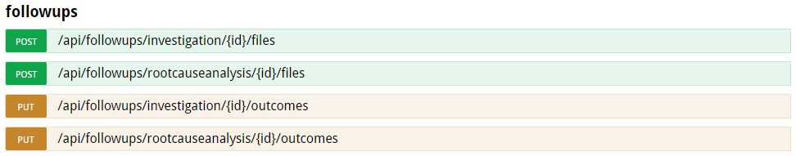

Business rules in regards to the API follow-up outcome end points.
A Follow-up outcome must be submitted using the ‘PUT’ /api/followups/…/{id}/outcomes endpoint.
The ‘dhhsFollowUpId’ supplied on a successful ‘POST’ of a follow-up recommendation must be supplied in the PUT for all outcome end points. Outcomes and Recommendations are sub-resources of the same follow-up; hence they share the same ‘dhhsFollowUpId’. An outcome cannot be submitted until you acquire a ‘dhhsFollowUpId’ by submitting a recommendation through the POST /api/followups/…/recommendation endpoint, and the recommendation has been approved by DHHS.
The External incident id must be supplied by the vendor to ensure matching capabilities between the Service providers system ID and the CIMS Incident report id.
The ‘POST’ /api/followups/…/{id}/files endpoints must be used to upload files related to an outcome before the outcome itself is updated through the ‘PUT’ /api/followups/…/{id}/outcomes endpoints. The only exception to this rule is when, in an investigation outcome, all clients have their “primaryOutcome” fields set to “Pending”.
The Follow-up outcome can be resubmitted with changes using the ‘PUT’ /api/followups/…/{id}/files endpoint until the department accepts the outcome, or if the department has withdrawn the follow-up outcome (DHHS Follow-up status = ’Outcome Received’, ‘Outcome On Hold’, ‘Outcome Withdrawn’).
- The ‘dhhsFollowUpId’ supplied on a successful PUT will be the same that has been supplied on the relevant recommendation.
The Follow-up status, dates and withdrawal information can be retrieved using the ‘GET’ end point. This data can be useful to gauge the progress of the follow-up outcome in the department.
  - The ‘dhhsFollowUpId’ supplied on a successful PUT must be supplied in the GET URL.
NOTE: Only the outcomes for investigations and root cause analysis need to be submitted to DHHS. Case review outcomes are not submitted.

Figure 7 - Example of a successful response
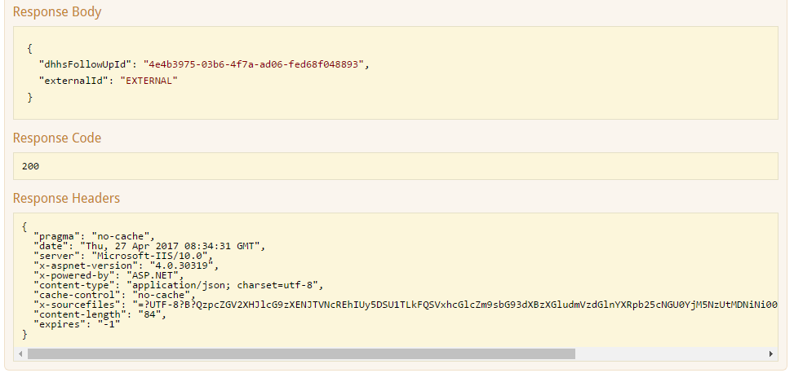

Figure 8 - Example of an unsuccessful response
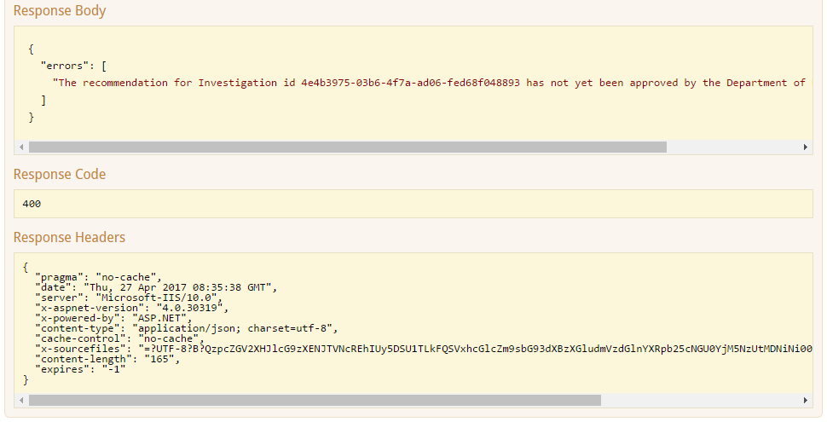

API entity list (PUT – Investigation outcome)
The following table lists all of the Data Fields that belong to the CIMS Follow-up Outcome API Entity when creating/updating a follow-up Investigation outcome.
Refer to section 5.5 for a detailed description of the Incident follow-up data fields.
Data from Service Provider/s
externalId
Client - sourceSystem
Client - sourceSystemId
Client - primaryOutcome
Client - secondaryOutcome
Client - primaryTheme
Client - primaryThemeAction
Client - primaryThemeDueDate
Client - primaryThemeSecondaryAction
Client - primaryThemeSecondaryDueDate
Client - secondaryTheme
Client - secondaryThemeAction
Client - secondaryThemeDueDate
Client - secondaryThemeSecondaryAction
Client - secondaryThemeSecondaryDueDate

API entity list (PUT – RCA outcome)
The following table lists all of the Data Fields that belong to the CIMS RCA outcome API entity when creating an RCA outcome.
Refer to section 5.5 for a detailed description of the incident follow-up data fields.
Data from Service Provider/s
externalId
outcomeData
primaryOutcome
theme1
theme2
theme3

Follow-up outcome entity list details
The following is a detailed description of all of the follow-up outcome data fields.

externalId
Question Text | N/A
Description | This is the unique External ID from the Service providers Client Incident Register. This is used a business reference when discussing incident reports with the department.
Data Type | String
Data Format
Required | Yes
Validations
Valid values

Client - sourceSystem
Question Text | Client unique identifier type
Description | Enter the client's unique identifier (ID) type. The unique identifiers are those allocated for the DHHS systems CRISSP, CRISS, HiiP, NDIS number and Other external.
Data Type | string (max 200 characters)
Data Format
Required | Yes
Validations | The ‘SourceSystem’ and ‘SourceSystemId’ will both be used as a key to match a client that exists as part of the recommendation that this investigation outcome applies to.
Valid values | Refer to reference data options set ‘clientuniqueidentifiertype’.

Client - sourceSystemId
Question Text | Client unique identifier
Description | Enter, the client's unique identifier (ID). The ID may include a combination of numbers and letters.
Data Type | string (max 200 characters)
Data Format
Required | Yes
Validations | The ‘SourceSystem’ and ‘SourceSystemId’ will both be used as a key to match a client that exists as part of the recommendation that this investigation outcome applies to.
Valid values

Client - primaryOutcome
Question Text | Outcome
Description | Select the primary outcome from the investigation by choosing the outcome that best describes the investigation findings in relation to the client and the incident.
Data Type | string (max 200 characters)
Data Format
Required | Yes
Validations
Valid values | Refer to reference data options set ‘outcomes’.

Client - secondaryOutcome
Question Text | Secondary Outcome
Description | If applicable, select this option if the findings from the investigation determine there is a secondary outcome in relation to the client and the incident.
Data Type | string (max 200 characters)
Data Format
Required | No
Validations | 1. Outcome and Secondary Outcome values cannot be the same.  2. Where the primary outcome is:  ‘Pending’  'Not substantiated - no further action'  ‘Not substantiated – further action required’  The secondary outcome field is not to be included.
Valid values | Refer to reference data options set ‘outcomes|outcomes-<selected outcomes>’.

Client - primaryTheme
Question Text | Primary Theme
Description | Select the primary theme that best describes the investigation findings in relation to the client and the incident.
Data Type | string (max 200 characters)
Data Format
Required | Yes if primaryOutcome is not ‘Not –substantiated – no further action required’ or ‘Pending’
Validations
Valid values | Refer to reference data options set ‘themes’.

Client - primaryThemeAction
Question Text | Primary Action
Description | Enter the primary action to be undertaken in response to the investigation findings and outcome.
Data Type | string (max 200 characters)
Data Format
Required | Yes if a primaryTheme has been entered.
Validations
Valid values

Client - primaryThemeDueDate
Question Text | Proposed completion date
Description | Enter the date the primary action will be completed by.
Data Type | string (max 200 characters)
Data Format | dd/mm/yyyy
Required | Yes if primaryThemeAction is entered
Validations | Please enter a valid date. Format is DD MM YYYY.  Date is required. Format is DD MM YYYY.  Proposed completion date must be today's date or a future date.
Valid values

Client - primaryThemeSecondaryAction
Question Text | Secondary action
Description | Enter the secondary action to be undertaken in response to the investigation findings and outcome.
Data Type | string (max 200 characters)
Data Format
Required | No
Validations
Valid values

Client - primaryThemeSecondaryDueDate
Question Text | Proposed completion date
Description | Enter the date the secondary action will be completed by.
Data Type | string (max 200 characters)
Data Format | dd/mm/yyyy
Required | Yes if primaryThemeSecondaryAction is entered.
Validations | Please enter a valid date. Format is DD MM YYYY.  Date is required. Format is DD MM YYYY.  Proposed completion date must be today's date or a future date.
Valid values

Client - secondaryTheme
Question Text | Secondary Theme
Description | Select the primary theme that best describes the investigation findings in relation to the client and the incident.
Data Type | string (max 200 characters)
Data Format
Required | No
Validations
Valid values | Refer to reference data options set ‘themes’.

Client - secondaryThemeAction
Question Text | Secondary Action
Description | Enter the secondary action to be undertaken in response to the investigation findings and outcome.
Data Type | string (max 200 characters)
Data Format
Required | Yes if a secondaryTheme has been entered.
Validations
Valid values

Client - secondaryThemeDueDate
Question Text | Proposed completion date
Description | Enter the date the action will be completed by.
Data Type | string (max 200 characters)
Data Format | dd/mm/yyyy
Required | Yes if secondaryThemeAction is entered
Validations | Please enter a valid date. Format is DD MM YYYY.  Date is required. Format is DD MM YYYY.  Proposed completion date must be today's date or a future date.
Valid values

Client - secondaryThemeSecondaryAction
Question Text | Secondary action
Description | Enter the secondary action to be undertaken in response to the investigation findings and outcome.
Data Type | string (max 200 characters)
Data Format
Required | No
Validations
Valid values

Client - secondaryThemeSecondaryDueDate
Question Text | Proposed completion date
Description | Enter the date the secondary action will be completed by.
Data Type | string (max 200 characters)
Data Format | dd/mm/yyyy
Required | Yes if secondaryThemeSecondaryAction is entered.
Validations | Please enter a valid date. Format is DD MM YYYY.  Date is required. Format is DD MM YYYY.  Proposed completion date must be today's date or a future date.
Valid values

primaryOutcome (RCA)
Question Text | Outcome
Description | Select the outcome from the root cause analysis by choosing the outcome that best describes the root cause analysis findings in relation to the client and the incident.
Data Type | string (max 200 characters)
Data Format
Required | Yes
Validations
Valid values | Refer to reference data options set ‘outcomes’.

theme1
Question Text | Theme 1
Description | Select the theme that best describes the Root Cause Analysis findings in relation to the client and the incident.
Data Type | string (max 200 characters)
Data Format
Required | No
Validations | Theme 3 and Theme 1 cannot be the same  Theme 2 and Theme 1 cannot be the same
Valid values | Refer to reference data options set ‘theme’.

theme2
Question Text | Theme 2
Description | Select the theme that best describes the Root Cause Analysis findings in relation to the client and the incident.
Data Type | string (max 200 characters)
Data Format
Required | No
Validations | Theme 2 and Theme 1 cannot be the same  Theme 3 and Theme 2 cannot be the same
Valid values | Refer to reference data options set ‘theme’.

theme3
Question Text | Theme 3
Description | Select the theme that best describes the Root Cause Analysis findings in relation to the client and the incident.
Data Type | string (max 200 characters)
Data Format
Required | No
Validations | Theme 3 and Theme 1 cannot be the same  Theme 3 and Theme 2 cannot be the same
Valid values | Refer to reference data options set ‘theme’.

dhhsFollowUpId
Question Text | N/A
Description | This is the unique Followup GUID from DHHS. This will be used to match incident report follow-up details submitted to DHHS.
Data Type | String
Data Format
Required | Yes
Validations
Valid values

Reference data end points

Follow-up outcome end points

Business rules in regards to the API reference data end points.
The reference data end points contain the reference data used by CIMS for implementing the business rules.
The service provider can use these end points to get the reference data to be used in their Client Incident management systems. The service provider can select a specific version of the reference data or get the latest version. The Service provider can then decide how to best use the reference data for generating the incident information required by CIMS application.
The reference data and any business rules associated with the reference data are included in the reference data end points, and have been further described on the relevant sections in this document, when describing the validation rules for each individual field of the POST/PUT endpoints.
When retrieving the reference data the reference ‘versionNumber’ can be blank or have a value.
- If it is blank then the latest reference data for the CIMS application is returned.
- If the ‘versionNumber’ is provided in the URL then the reference data for that specific version will be returned.
When submitting requests to POST /api/incidents, the latest reference version available from GET /api/referencedata/incidents should be used.
When submitting requests to POST /api/followups/<investigation/rootcauseanalysis/casereview>/recommendation, the latest reference version available from GET /api/referencedata/<investigation/rootcauseanalysis/casereview>/recommendation should be used.
DHHS will inform Service providers when a new version of the reference data has been released (the version number will be provided). The service providers can use the new version of the reference data immediately by using the new reference version number or they can continue to use the old version until their systems are ready.
DHHS will decommission old versions of the reference data after a certain period of time has elapsed.

API entity list (GET – Incident reference data)
The following table lists all of the Data Fields that belong to the CIMS investigation recommendation API entity when creating an investigation recommendation.
Data from DHHS
versionNumber
Entity data - Datatype
Entity data - usesOptionSet
Entity data - optionSetName
optionSets - name
optionSets - values

Reference data entity list details
The following is a detailed description of all of the Reference data fields.

versionNumber
Question Text | N/A
Description | This is the unique version number from DHHS. This is used to determine the version of the reference data that is being used by the service provider.
Data Type | number
Data Format
Required | No
Validations
Valid values

incidentData/recommendationData/outcomesData [Entity ID]
Question Text | N/A
Description | This is the name of the data entity.
Data Type | string
Data Format
Required | Yes
Validations
Valid values

EntityData - Datatype
Question Text | N/A
Description | The datatype of the entity.
Data Type | string
Data Format
Required | Yes
Validations
Valid values | string

EntityData - usesOptionSet
Question Text | N/A
Description | Indicates whether the data entity uses an option set or not.
Data Type | bool
Data Format
Required | Yes
Validations
Valid values | true  false

EntityData - optionSetName
Question Text | N/A
Description | The name of the option set for the data entity. Must match a name specified in the options sets name.
Data Type | string
Data Format
Required | Yes if usesOptionSet = true
Validations
Valid values

optionSets - name
Question Text | N/A
Description | The name of the option set for the data entity. Must match a name specified in the optionSetName within incident data.
Data Type | string
Data Format
Required | Yes
Validations
Valid values

optionSets - values
Question Text | N/A
Description | The values of the option set for the data entity. One or more values per option set name. Values are comma delimited.
Data Type | string
Data Format
Required | Yes
Validations
Valid values

Appendix A – Example of reference data end points
Example of the Program/Service type dependencies. (Sample set full set available via reference data endpoint)
Program
"name": "dhhsprogram",
"values": [
"Health",
"Housing and community building",
"Youth services"
]

ServiceType
"name": "dhhsservicetype|program-Housing and community building",
"values": [
"Department managed housing",
"Homelessness assistance",
"Long-term housing assistance"
]

Example of ther PrimaryIncidentType / PrimaryAlledgedPerpetratorVictim / PrimaryRoleInIncident dependencies. (Full set available via reference data endpoint)
Client – PrimaryIncidentType
"name": "primaryincidenttype",
"values": [
"Death",
"Emotional/psychological abuse",
"Emotional/psychological trauma",
"Escape from a secure facility"
]

Client – PrimaryAlledgedPerpetratorVictim
"name": "primaryallegedperpetratortovictim|primaryincidenttype-Emotional/psychological abuse",
"values": [
"Staff to Client",
"Client to Client",
"Other to Client"
]

Client – PrimaryRoleInIncident
"name": "primaryroleinincident| primaryallegedperpetratortovictim -Staff to Client| primaryincidenttype -Emotional/psychological abuse",
"values": [
"Victim",
"Witness"
]

Client – PrimaryRoleInIncident (Where PrimaryAlledgedPerpetratorVictim is not madatory)
"name": "primaryroleinincident|PrimaryAllegedPerpetratorVictim-null|PrimaryIncidentType-Death",
"values": [
"Paticipant"
]

Appendix B – Example of API emails
An email is sent to the Service Provider when an incident has been withdrawn by the divisional office. The email will contain the reason for the withdrawal.

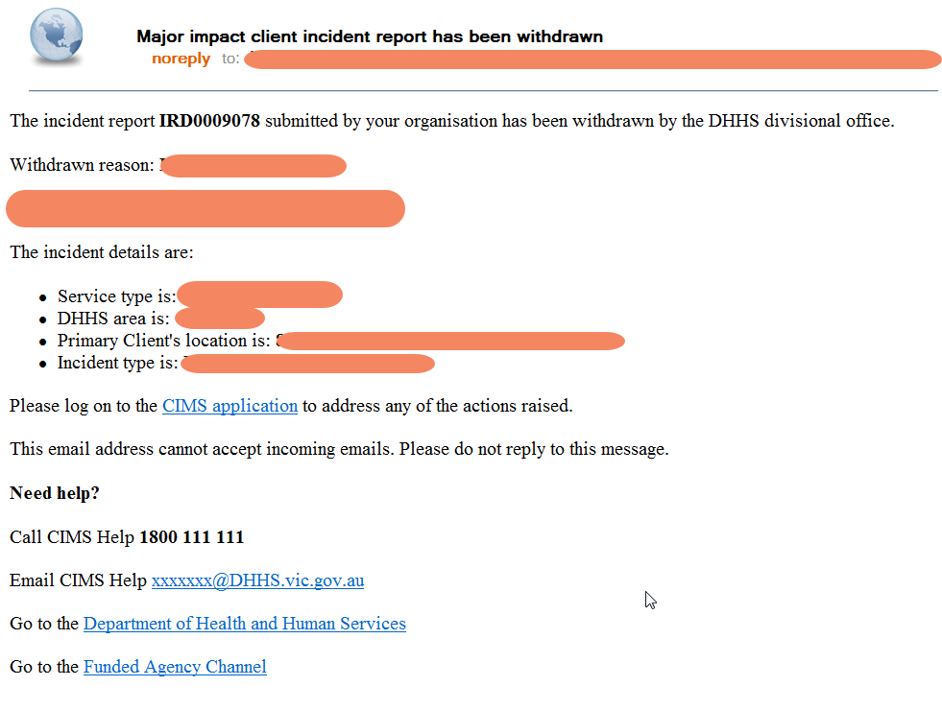

An email is sent to the Service Provider when a follow-up recommendation has been accepted by the divisional office.
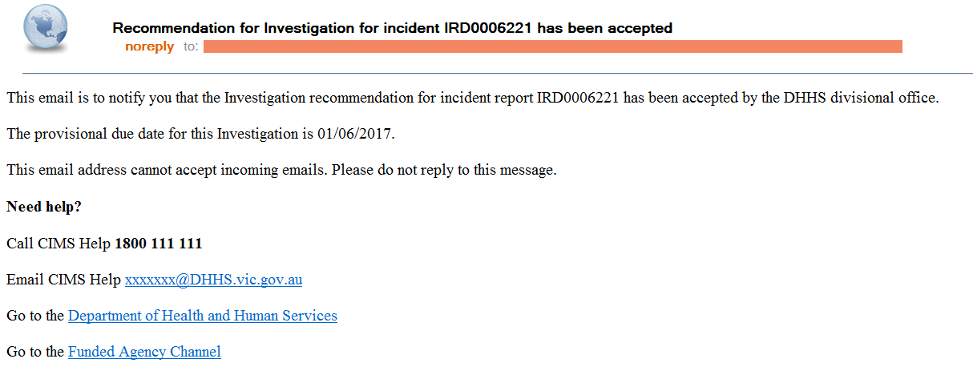
An email is sent to the Service Provider when a follow-up recommendation has been withdrawn by the divisional office.
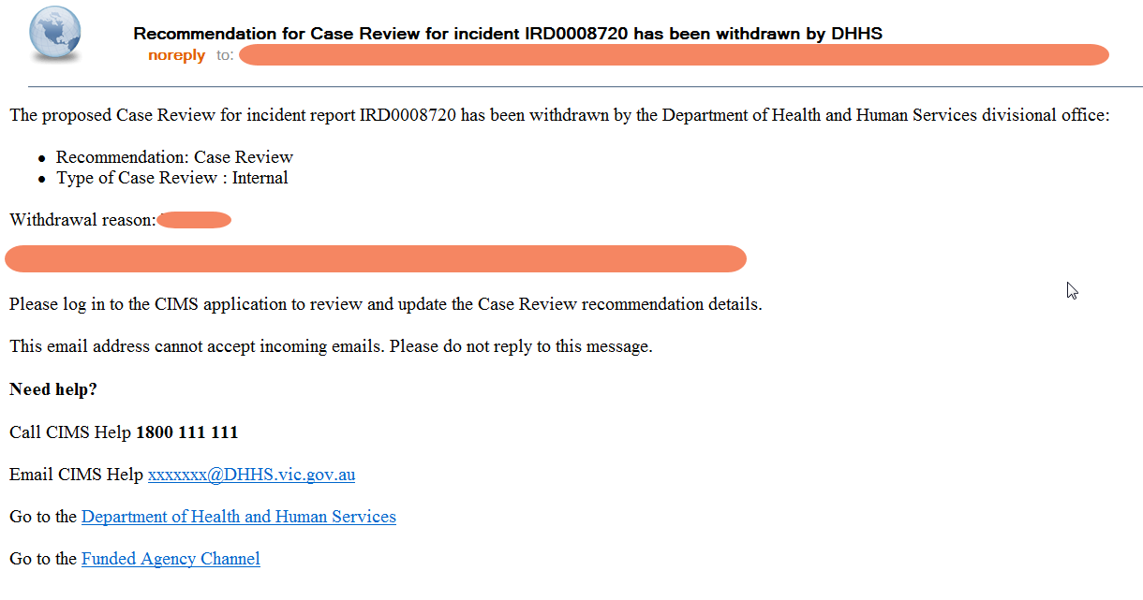

Refer to the ‘Client Incident Management Guide’ for the latest details on timelines.
minimum of 1 Client per incident report, maximum of 10 Clients per incident report
maximum of 10 Staff per incident report
The date/time format is ISO8601 compliant and follows the standard "yyyy'-'MM'-'dd'T'HH':'mm':'ss'.'fffffffK", where anything between single quotes are literal characters that cannot be removed nor replaced, and K stands for time zone information (such as +10:00 or Z, which stands for UTC)
The date/time format is ISO8601 compliant and follows the standard "yyyy'-'MM'-'dd'T'HH':'mm':'ss'.'fffffffK", where anything between single quotes are literal characters that cannot be removed nor replaced, and K stands for time zone information (such as +10:00 or Z, which stands for UTC)

