

|  |
| --- |
| Additional HDC Data Extract  How to Guide |

Contents

Background 2

Multi-Agency Risk Assessment and Management Framework (MARAM) 2

Accommodation Type 3

Family Violence Fund Type (e.g. FVCB, FSP etc) 4

Service hours 5

Program Field 7

Extracting and submitting the Additional HDC Data file 7

Standard SHS data file 7

Additional HDC data file 7

File Naming 8

File Submission Due Dates 10

Need help using SHIP or Validata™? 11

|  |
| --- |
| To receive this document in another format, phone 03 9085 0900, using the  National Relay Service 13 36 77 if required, or [email Family Safety Victoria](mailto:reception@familysafety.vic.gov.au) <reception@familysafety.vic.gov.au>.  Authorised and published by the Victorian Government, 1 Treasury Place, Melbourne.  © State of Victoria, Australia, Family Safety Victoria, July 2025.  **ISBN** 978-1-76130-855-0 **(pdf/online/MS Word)**  Available at <https://providers.dffh.vic.gov.au/additional-hdc-data-extract-how-guide> <https://providers.dffh.vic.gov.au/additional-hdc-data-extract-how-guide> |

# Background

The National Agreement on Social Housing and Homelessness (NASHH) requires funded service providers in Australia to make monthly client data submissions to the Australian Institute of Health and Welfare (AIHW) for the national minimum data set, by participating in the Specialist Homelessness Services Collection (SHSC). The family violence sector in Victoria receives funding under the NASHH and is required to provide the SHSC monthly data submissions under this agreement.

The AIHW provides funded services access to the Specialist Homelessness Information Platform (SHIP) to comply with the SHSC data requirements. Victoria has gradually added fields to SHIP version used by Victorian agencies (Vic-SHIP) to capture additional data that enhances our understanding of case management and client outcomes, providing more granular information in areas such as the type of support offered to clients.

To ensure the Department of Families Fairness and Housing (the department) has access to the additional data collected, an Additional Data Extract report that captures five data fields relating to the client’s accommodation type, program, funding type, service hours and MARAM risk assessments was implemented in 2024. Funded services were required to align themselves to the additional reporting requirements from 1 December 2024.

This How-to-guide is designed to assist the family violence sector (Vic-SHIP/SRS users) collect data consistently for the new five new fields.

## Multi-Agency Risk Assessment and Management Framework (MARAM)

**Purpose:** To provide further insights in client risk and assist in validating MARAM risk assessments via linkage to client outcomes in the HDC.

**What’s required:** There is no change to how MARAM risk assessments are completed in SHIP/SRS. Agencies **must** provide information such as age range for a person using family violence, relationship type between a victim survivor and the person using family violence, and risk level present for a victim survivor if they are not already doing so.

When a user has completed the MARAM tool, they must select ‘**Save Final’**. If a user does not select ‘Save Final’, the MARAM tool will be reported as incomplete, which is an inaccurate representation of the number of MARAM assessments being undertaken.

The MARAM tools have been designed to report on risk levels at different points in time. A risk assessment is a point-in-time assessment of the level of risk. Risk is dynamic and can change over time, which means that risk should be regularly reviewed, and any changes should inform future assessments. For example: a client arrives at a refuge and the risk level is determined to be ‘serious risk requiring immediate intervention’. Over time, and after receiving support from the agency, the risk level may show an improvement for the victim survivor.

## Accommodation Type

**Purpose:** To capture specific accommodation types (e.g. short term or emergency accommodation), and subtypes (e.g. hotel/motel, family violence refuge etc.) provided to clients.

**What’s required:** In the ‘Accommodation’ tab and under the ‘Edit Stay Details’ section, users are required to select an accommodation type from a drop-down list. When a user selects Short Term or Emergency Accommodation, it is expected that the respective ‘Subtype’ data field is selected, as shown in Figure 1.

Children and young people being accommodated with a victim survivor must be reported on and should be associated with the record and have their own support period.

Users should record where the client is residing, for example: Holiday Inn motel or Airbnb. Users must NOT record the address of the accommodation.

It is **compulsory** to record the accommodation exit date. Users are to complete this field when the client leaves the accommodation.

Figure 1:

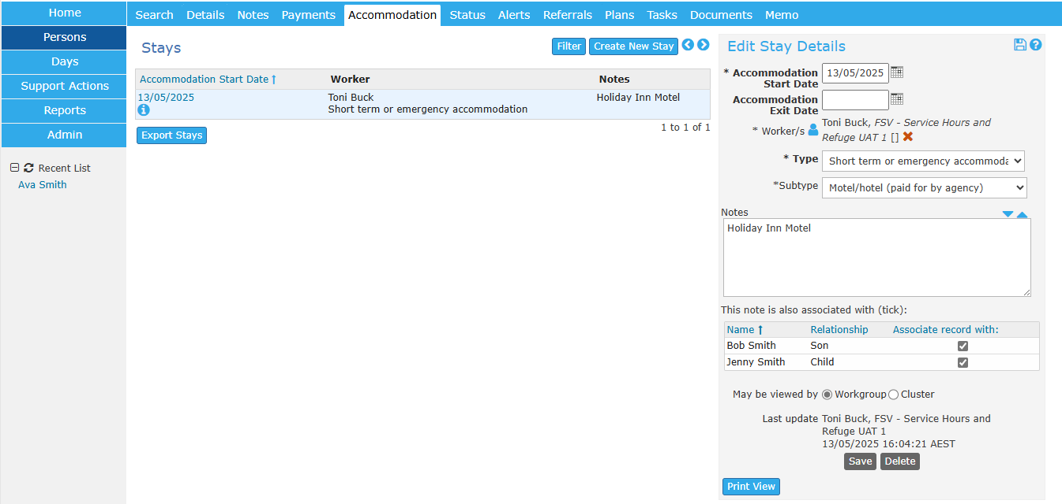

**Children and young people**

It is important that children and young people are recognised as victim survivors in their own right, including through the way their experiences are identified, recorded and captured by data. [The Victorian Family Violence Data Collection Framework](https://www.vic.gov.au/victorian-family-violence-data-collection-framework) provides consistent guidance for collecting family violence related data across government and funded services.

The framework highlights the importance of identifying and recording children and young people as individual victim survivors, rather than as secondary to adult cases. It also emphasises the need to incorporate children’s voices in data collection and service responses to ensure their experiences are accurately captured and addressed. Recording individual client records for children receiving support, such as accommodation, aligns with this approach and contributes to improved service visibility, accountability and outcomes.

The process to open a support period for family members is demonstrated in the following e-Learning module: [Support periods for family members](https://youtu.be/RSDzY-3aHTw)

## 

## Family Violence Fund Type (e.g. FVCB, FSP etc)

**Purpose:** To accurately report on expenditure incurred by the agency, to support individual clients.

**What’s required:** In the ‘Payments’ tab when creating a ‘New Payment’, users must ensure the appropriate Family Violence fund, Payment purpose and actual costs (rather than estimates) are accurately captured.

Users **must** record individual costs incurred separately in the Payment purpose. It is important to accurately reflect actual accommodation spends and ensure these align to the length of stay by including an end date in the Accommodation stay. This ensures average nightly accommodation costs are visible across the service system.

Users need to select the Family Violence Fund, as shown below in Figure 2.

Figure 2:

Users need to select the Payment purpose from the drop-down menu. Specialist family violence services will primarily use the ‘Payment for short term or emergency accommodation’ or ‘Other payments’ options.

Payments should **not** be grouped together under ‘Other payments’ for example Accommodation, transport and material aid must each be individually identified. Material aid may be entered under ‘Other payments’ where not referring to transport or accommodation or any of the categories listed in other payments as shown below in Figure 4.

Payment for emergency accommodation Figure 4: Payment for transport and material aid

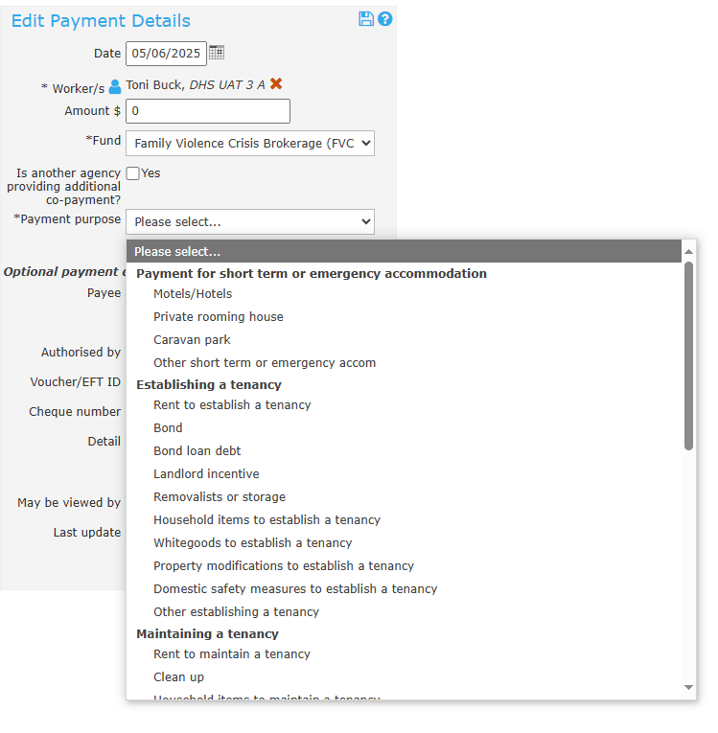 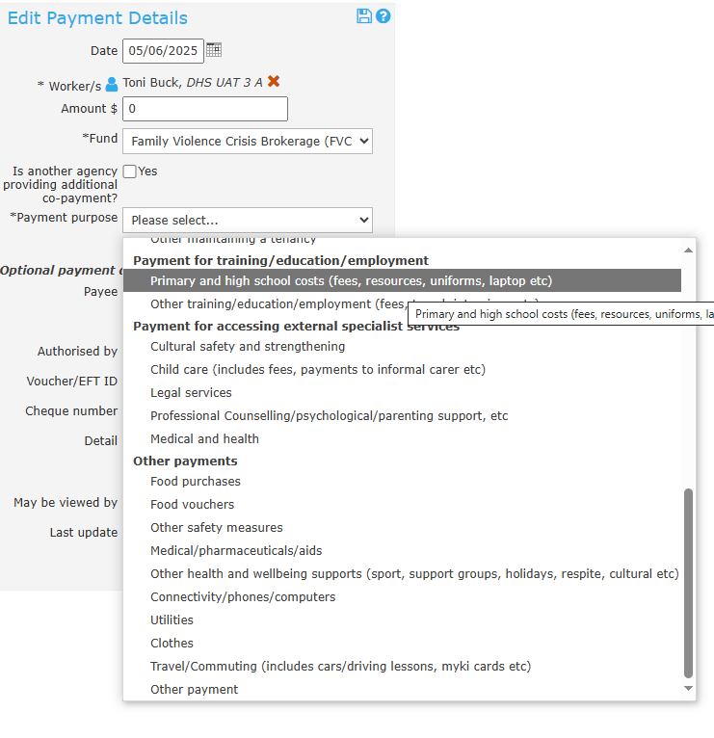

## Service hours

**Purpose:** To capture the time spent by case workers relating to a client to enable a better understanding of the intensity of case management, including direct and non-direct client support.

**What’s required:** Users must record any time spent working with a client including direct client contact, case work (or noting), secondary consultations and travel time in minutes.

Service hours is the **time spent by case workers**, not the time your clients receive. As an example, if a case worker provides one hour of time to two clients, only count one hour of time.

Service hours do **not include non-client** case worker time, such as attending supervision, attending training, undertaking administrative functions and organisational planning.

The total of all case workers’ time related only to client service delivery is an organisation’s service hours under the funding model.

Service hours are input into SHIP in the **case note** and in the **support actions** repositories. The support actions is a repository of actions undertaken where there is **no client record**.

If consent is provided, it is recommended to record any relevant information about a person within the case note. Where multiple case workers worked with, or on behalf of the client, you can add each case worker to the case note by clicking the **blue person icon**. However, only assign additional case workers when time duplication is anticipated, and if this time hasn't been documented in a separate case note for example in a two worker crisis response to a motel. The case note includes sections to record **time in minutes** by work type: **Contact**, **Case Work**, and **Travel**.

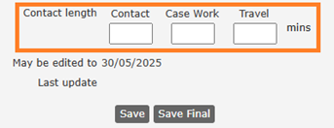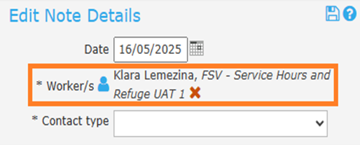

**Support actions within SHIP**

Support Actions is a repository for recording any information where there is no client record**.** Remember, they do not need a support period opened to still attach time to the case note.

Support Actions currently has the drop-down consultation types to include Secondary Consultations and Direct Person Consultations.

Secondary consultations

Secondary Consultations includes a consultation with a third party, or professional about a client where consent to obtain a client record is not provided. In these instances, record details about the consultation, the sector and the consultation length in this form

.

Direct person consultation

Direct person consultation includes a consultation with a client or group of clients, where consent to obtain the client(s) record is not provided. In these instances, record details about the consultation and the consultation length in this form.

Time can be entered in intervals – or by clicking other and entering a specific amount of time in minutes or hours – e.g., 17 minutes

## Program Field

**Purpose:** The purpose is to enable agencies to create program subtypes within the one workgroup to track performance such as service hours or payments for separate programs of work delivered by the agency such as Crisis Response versus Case Management, when both responses are provided by the same workgroup.

**What’s required:** Users must create their own Program drop downs and select the respective program to be able to develop accurate reports.

SHIP users with ‘Coordinator’ access can create **Program** options. The following e-learning modules demonstrates how to create Programs and ways to run associated reports: [Custom fields](https://youtu.be/QgKRpiliJQQ) and [How to identify and report on specific agency programs](https://www.aihw.gov.au/getmedia/5ae293c1-c3c2-4f9f-b26b-dd1b76e7ed7f/ship-how-to-identify-and-report-on-specific-agency-programs.pdf.aspx)

Once the Program field has been created, users will be able to select the field when entering a Case Note.

# Extracting and submitting the Additional HDC Data file

## Standard SHS data file

Standard SHS data file will continue to be downloaded by agencies and uploaded to Validata™ to comply with the Australian Institute of Health and Wellbeing (AIHW) requirements and to the Homelessness Data Collection (HDC) Secure Data Exchange (SDE) for the department’s requirements. The standard data file is required for every active workgroup and is due on the 10th business day of the following month.

## Additional HDC data file

The new additional HDC data file will only be submitted to the HDC Secure Data (SED) Exchange. To obtain access to the SDE please complete the form located at [SDE3 User Registration Form](https://forms.office.com/pages/responsepage.aspx?id=H2DgwKwPnESciKEExOufKBVFudyoDd5Gvp6XWoaRvjNUMEwwT05LT1RIWTRDRjZMNE8xTUVJWFJKRC4u&route=shorturl). You will need to know your Agency SAMS ID to complete the form.

The additional data file is required for every active workgroup and is due on the 10th business day of the following month.

Funded specialist family violence services will be required to generate two files each month per workgroup. Extracting the additional HDC data file is almost identical to extracting the standard data SHS file. Below are the steps for extracting the additional HDC data file and submitting it to the department.

**Step 1**: Click on the Reports button on the left sidebar and select the ‘HDC Extract (v1.0)’ report.

**Step 2**: Click on the Workgroup dropdown list and select the applicable workgroup to generate the report. For the purpose of this guide and as an example only, the workgroup to generate the additional SHS HDC extract file is ‘HDC UAT 1 A’.A screenshot of a computer

**Step 3:** Select the applicable ‘Month’ and ‘Year’ from the ‘Month of Interest’ and year drop down list.

**Step 4:** Click on the ‘Generate Report’ button. The report will be generated and saved in the **Results** tab. Go to Results to retrieve the report.

## File Naming

The standard and the additional HDC data file extracts will have similar file names based on the following format:

|  |  |  |
| --- | --- | --- |
| **Key:** | **shs** | Denotes the file type, whether it is SHS or HDC |
|  | **12345A** | Denotes the SHS ID or unique code for the workgroup |
|  | **2025** | Denotes the year of the particular extract, for example 2025 |
|  | **07** | Denotes the month of the particular extract, for example, 07 (July) |
|  | **xml** | Denotes the file type. Depending on your computer settings, users may or may not be able to see the file type |

The **Standard** SHS file extract will continue to be generated and submitted to Validata™ and the HDC with the following file name format:

**shs_extract_12345A_2025_07.xml**

The **Additional** HDC data file extract will be generated and submitted to the HDC Secure Data Exchange only and have a file name similar format:

**HDC_extract_12345A_2025_07.xml**

The inclusion of **HDC** in the file nameindicates that this is the additional data file extract.

**Renaming of files**

Agencies should **NOT** rename files as this causes confusion and difficulty in file analysis by the HDC Support Team. The original file name will have all the required identification details.

Where an agency has multiple workgroups, as in the illustration below; they will be required to submit one SHS and one HDC extract file for each working group to the HDC Secure Data Exchange.

In the above example, each month, six files will be extracted. For example, in July 2025, the six files will be:

**shs_extract_26900X_2025_07.xml**

**shs_extract_26902B_2025_07.xml**

**shs_extract_26904T_2025_07.xml**

**HDC_extract_26900X_2025_07.xml**

**HDC_extract_26902B_2025_07.xml**

**HDC_extract_26904T_2025_07.xml**

**Submitting the additional HDC data file extract to the Department**

The additional HDC file extract **MUST NOT** be submitted to Validata™ as these cannot be validated. The additional HDC file extracts must be uploaded to the Secured Data Exchange (SDE). If agencies are unable to upload the extract through SDE, the additional HDC file extract can be sent via an email to [HDC@support.vic.gov.au](mailto:HDC@support.vic.gov.au)

The **SHS extract files are the only file that needs to be validated and submitted to Validata™**, as is the current practice. After successful submission of the standard SHS file to Validata™, these SHS files will need to be uploaded to the Secured Data Exchange (SDE) as is current practice. If agencies are unable to upload the extract through the SDE, the standard SHS file extract can be sent via an email to [HDC@support.vic.gov.au](mailto:HDC@support.vic.gov.au)

Using the Victoria Family Violence agency example above, the three standard SHS files will need to be

submitted to Validata™ first and subsequently to HDC while the three Additional HDC extract files must only be submitted to the HDC.

|  |  |  |  |  |
| --- | --- | --- | --- | --- |
| **File name** | **Type** | **Validation Required** | **Validata™ Submission Required** | **Send to HDC Homelessness Data Collection** |
| **shs_extract_26900X_2025_07.xml** | SHS standard file extract | Yes | Yes | Yes |
| **shs_extract_26902B_2025_07.xml** | SHS standard file extract | Yes | Yes | Yes |
| **shs_extract_26904T_2025_07.xml** | SHS standard file extract | Yes | Yes | Yes |
| **HDC_extract_26900X_2025_07.xml** | HDC additional  file extract | No | No | Yes |
| **HDC_extract_26902B_2025_07.xml** | HDC additional  file extract | No | No | Yes |
| **HDC_extract_26904T_2024_07.xml** | HDC additional  file extract | No | No | Yes |

## File Submission Due Dates

The **due dates** for submission of the SHS and HDC extracts is 10 business days following the end of each month e.g. July 2025 data is required to be submitted by 18 August 2025 both through Validata™ and the HDC. The following table demonstrates the submission due dates for 2025

|  |  |
| --- | --- |
| **Reporting Month** | **SHS & HDC Extract Due Dates** |
| January 2025 | Friday 14 February |
| February 2025 | Monday 17 March |
| March 2025 | Monday 14 April |
| April 2025 | Wednesday 14 May |
| May 2025 | Monday 16 June |
| June 2025 | Monday 14 July |
| July 2025 | Thursday 14 August |
| August 2025 | Friday 12 September |
| September 2025 | Tuesday 10 October |
| October 2025 | Friday 14 November |
| November 2025 | Friday 12 December |
| December 2025 | Wednesday 14 January |

**Receipts/Email Confirmation for HDC Extract Files**

The HDC Support Team will track all incoming SHS and HDC extract files. When the HDC Support Team processes the incoming files, an email confirming receipt of the files will be sent out to workgroup managers confirming which workgroup and file (SHS or HDC) has been submitted for which month.

The subject line of the email receipt will contain all the required information to allow workgroup managers to keep a track of their submissions.

**Example:**

In the example of the Victoria Family Violence agency, the data custodian validates and submits three Standard SHS extracts at Validata™ and then sends the three Standard SHS extracts to the HDC Support Team, as per current practice.

The data custodian then generates the three Additional HDC extracts and sends them to the SDE or HDC Support team via email.

When the HDC Support team processes these files, the workgroup manager will receive six separate email receipts for the HDC extracts, see example below:

By looking at the subject line, the workgroup manager will be able to easily identify that for the month of July 2025, three Standard SHS data files and the three Additional HDC data files have been sent to the HDC. The email receipts are specific to either the SHS data file or the HDC data file being sent to the HDC and these clearly state the extract files reporting month, year, workgroup name, workgroup ID#, and the month they were submitted in.

**It is important that these email receipts are not confused with Validata™ email confirmations.** Agencies will also receive one email confirmation per file uploaded to Validata™, so in the above example three email confirmations will be received from the AIHW for the Standard SHS data files.

**Need help using SHIP or Validata™?**

For help with SHIP, email [apps@infoxchange.org](mailto:apps@infoxchange.org) or phone SHIP support on 1800 627 191 (option 1).

For help with the HDC Secure Data Exchange including access, please email your request to the HDC Support Team [HDC@support.vic.gov.au](mailto:HDC@support.vic.gov.au)

For help with Validata™ to upload extracts or resolve critical errors, email [homelessness@aihw.gov.au](mailto:homelessness@aihw.gov.au) or phone the AIHW SHS Hotline on 1800 627 191 (option 2).